Appendix S1
False Positive Catamenial Epilepsy Classification: A Simulation Study
Development and calibration of HORMONE-CYCLE and supplementary study methods

Table of Contents
Chapter 1. Development of HORMONE-CYCLE 3
1.1 Purpose, scope, and intended use 3
1.2 Evidence review and role of each source 3
1.3 Workflow and data hierarchy 6
1.3.1 Inputs and outputs 6
1.4 Age-specific patient-level parameters 6
1.5 Cycle length, phase timing, and bleeding 7
1.6 Daily hormone trajectories 8
1.7 Reproductive-stage and medical modifiers 8
1.7.1 Polycystic ovary syndrome 8
1.7.2 Early postmenarche 9
1.7.3 Perimenopause 9
1.7.4 Combined oral contraceptives 9
1.7.5 Intrauterine devices 9
1.7.6 Primary dysmenorrhea 9
1.8 Reproducibility and implementation limits 13
Chapter 2. Internal calibration and validation status of HORMONE-CYCLE 14
2.1 Evaluation terminology and design 14
2.2 Baseline calibration targets and tolerances 14
2.3 Modifier-scenario checks 17
2.4 Graphical calibration summary 19
2.5 Interpretation and remaining validation needs 20
Chapter 3. Additional analyses and methods augmenting the main results 21
3.1 Reproducibility, provenance, and simulator inputs 21
3.2 Assumption-by-assumption review 23
3.3 Menstrual-phase labeling and complete-cycle rules 25
3.4 Type C3 and inadequate-luteal-phase algorithm 25
3.5 Herzog seizure-frequency ratios and thresholds 25
Panel A — Type C1 26
Panel B — Type C2 26
Panel C — Type C3 27
Panel D — Sparse-comparator audit 27
3.6 Type C3 window-duration sensitivity 28
3.7 Investigator-selected minimum-data sensitivity 29
3.8 Model-concordant negative-binomial calibration checks 30
3.9 Mutually exclusive pattern decomposition 31
3.10 Simulator-feature associations 32
3.11 Realized simulation distributions 32
3.12 Interpretation of the supplementary analyses 38
References 38

Chapter 1. Development of HORMONE-CYCLE

1.1 Purpose, scope, and intended use
HORMONE-CYCLE is a custom, open-source simulator developed for this project. It generates reproducible daily menstrual-cycle, bleeding, ovulation, estradiol, and progesterone diaries from age, diary length, a seed, and optional modifiers. (1) HORMONE-CYCLE is the complete software title. The simulator supports method development, operating-characteristic studies, and controlled synthetic examples. Its outputs represent synthetic trajectories. Individual clinical forecasting falls outside the intended use.
The design follows a hierarchical simulation workflow and reports inputs, data-generating mechanisms, estimands, and reproducibility artifacts. (2–4) Population evidence constrains age-specific distributions, each synthetic person receives stable latent traits, each cycle receives a stochastic realization, and a daily renderer produces the final diary.

1.2 Evidence review and role of each source
Three primary data sources supplied the baseline quantitative targets: the Apple Women’s Health Study for age-specific cycle length and variability, the Natural Cycles cohort for cycle and phase timing, and daily laboratory measurements for estradiol and progesterone subphase values. (5–7) Condition-specific sources informed modifier direction and bounded magnitudes. Table A1 states exactly how each source entered development and evaluation. Development used aggregate quantities reported in the articles; participant-level source data were unavailable and were not used.

Appendix Table A1. Evidence provenance for HORMONE-CYCLE. “Reused” means that the same published result informed both parameter development and an internal calibration or directional check; these checks provide internal calibration evidence. Independent external validation requires held-out participant-level data.
Paper or evidence source | Population or data | Published result used | Use during development | Use during evaluation | Independence status
Li et al. (2023) (5) | 165,668 cycles from 12,608 Apple Women’s Health Study participants | Age-specific mean cycle length and a 7-day adjacent-cycle irregularity definition | Direct age-band timing targets; latent dispersion derived from the reported irregularity rate | Age-stratified internal target-reproduction checks | Development source reused internally
Bull et al. (2019) (6) | 612,613 ovulatory cycles from 124,648 Natural Cycles users | 29.3-day cycle, 4.0-day bleeding, 16.9-day follicular, and 12.4-day luteal means in Table 1 | Direct phase-timing targets and stable-luteal structure; the implemented 4.7-day bleeding mean is an investigator calibration setting | Phase-duration checks; simulated bleeding is compared with the published 4.0 ± 1.5-day distribution | Development source reused internally
Stricker et al. (2006) (7) | Daily samples from 20 healthy volunteers, synchronized to the luteinizing-hormone peak | Daily estradiol and progesterone series in Table 1B and Figure 1 | Seven derived interpolation anchors after unit conversion and investigator-selected subphase placement | Fourteen internal hormone smoke checks in 16 retained diaries | Development source reused in a limited internal check
Fraser et al. (2011) (8) | International expert terminology and normal bleeding framework | Standardized bleeding terminology | Bleeding interpretation and bounds | Contextual review | Context
Mortimer et al. (2026); Doi et al. (2005) (9,10) | Longitudinal cycle-pattern evidence and a hormone/regularity study in polycystic ovary syndrome | Longer and more variable cycles with attenuated luteal progesterone | Initial polycystic-ovary-syndrome modifier directions; numerical multipliers are calibrated constants | Context for internal directional checks | Development sources reused internally
Mortimer et al. (2026); Jarrett et al. (2020) (9,11) | 160,206 cycles from 15,586 participants; intensive ultrasound and hormone study | Age-dependent cycle differences and disordered follicle development in polycystic ovary syndrome | Later corroboration of the implemented profile | Directional scenario checks | Later corroboration
Venturoli et al. (1987) (12) | Adolescent hormonal-pattern and ovarian-morphology study | Irregularity and incomplete ovulation early after menarche | Initial early-postmenarche modifier directions; numerical constants are calibrated choices | Context for an internal stress test | Development source reused internally
World Health Organization study (1986); Zhang et al. (2008) (13,14) | Adolescent diary cohorts and a two-year daily hormone study | Longer, irregular, and incompletely ovulatory early-postmenarche cycles | Later corroboration of the implemented profile | Directional scenario checks | Later corroboration
Santoro and Randolph (2011) (15) | Review of menopause-transition endocrine evidence | Greater variability, more anovulation, and variable estradiol | Perimenopause modifier | Internal directional stress test | Development source reused internally
Edelman et al. (2014) (16) | Cochrane review of cyclic and continuous combined hormonal contraception | Ovulation suppression and regimen-specific bleeding patterns | Combined oral-contraceptive profiles | Internal directional and bounded stress tests | Development source reused internally
Xiao et al. (1995); Barbosa et al. (1995) (17,18) | Long-term levonorgestrel intrauterine-device hormone and ultrasound studies | Ovulation usually persists while bleeding and amenorrhea patterns change | Levonorgestrel intrauterine-device profile | Internal ovulation and amenorrhea checks | Development sources reused internally
Hubacher et al. (2006) (19) | Randomized copper intrauterine-device insertion study with literature context | Clinical context for copper-device effects | Initial source-registry context; the 1.2-day bleeding shift is an investigator calibration constant | No direct quantitative target | Development context
Faundes et al. (1980); Malmqvist et al. (1974) (20,21) | Copper-device cycle-hormone study and measured menstrual blood loss | Ovarian cycling persists and menstrual bleeding increases | Later corroboration of the copper-device profile | Internal ovulation and bleeding-direction checks | Later corroboration
Dawood (2006) (22) | Clinical review of primary dysmenorrhea | Predominantly ovulatory, prostaglandin-mediated pain phenotype | Small bleeding-duration modifier | Internal preserved-ovulation and bleeding checks | Development source reused internally

1.3 Workflow and data hierarchy
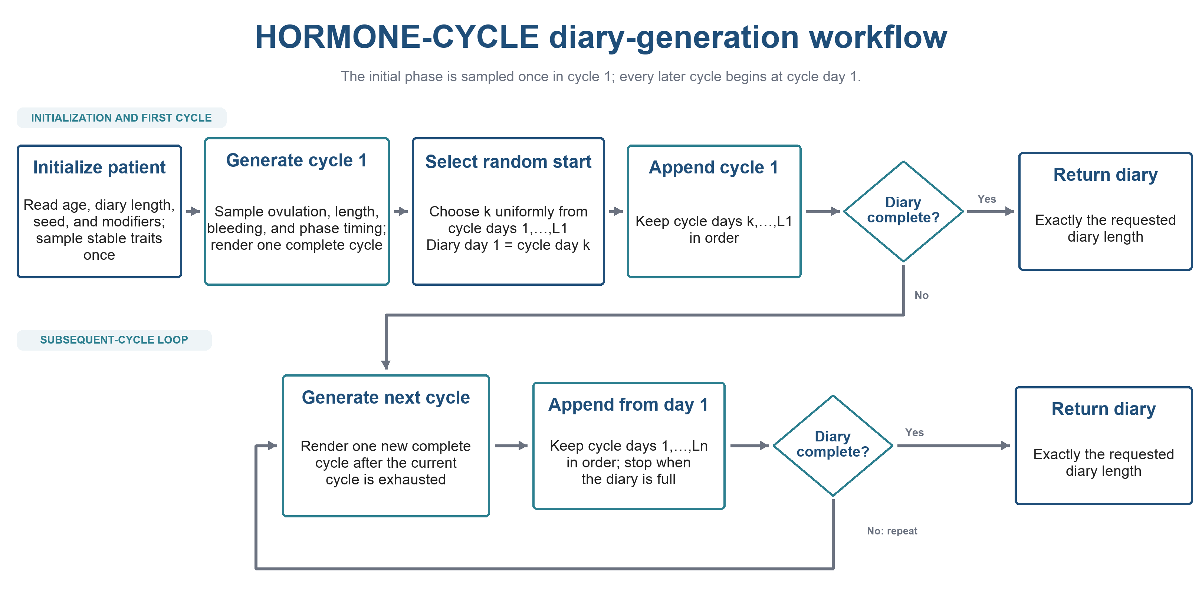
Appendix Figure A1. HORMONE-CYCLE diary-generation workflow. By default, cycle 1 is generated in full and diary day 1 is selected uniformly from its realized cycle days. Output then proceeds forward from that selected day through the remainder of cycle 1. If more diary days are required, the simulator generates the next complete cycle and appends its records from cycle day 1 in their original order. This cycle-level workflow repeats until the requested diary length is filled; only the final generated cycle may be partly retained. The initial phase is selected once, and no end-to-start wraparound or circular shift is used. An explicit cycle-day-1 option is available for applications that require diary day 1 to coincide with menstrual cycle day 1. A domain-separated random stream selects the initial cycle day so that this observation-boundary choice does not consume values from the patient-profile or cycle-generation random streams.

1.3.1 Inputs and outputs
The public simulation call accepts age in years, diary length in days, a random seed, and optional reproductive or medical modifiers. Input validation rejects nonfinite ages, nonpositive diary lengths, and incompatible modifier combinations. The default start mode generates cycle 1 in full, selects one of its realized cycle days with equal probability, and assigns that day to diary day 1. The optional cycle-day-1 mode retains the original observation boundary. After the initial selection, records are retained in chronological order without wrapping. Another cycle is generated only when the retained diary remains shorter than the requested length. Records from the final generated cycle are retained only until the exact requested number of days is reached. Each daily row contains the calendar-day index, cycle index, day within cycle, realized cycle length, estradiol in picograms per milliliter, progesterone in nanograms per milliliter, ovulation, and bleeding. Cycle summaries report phase lengths, ovulation day, ovulatory status, bleeding days, reproductive stage, and active modifiers.

1.4 Age-specific patient-level parameters
Age selects one of eight calibration bands. Each band supplies a published mean cycle length and the probability that two adjacent cycles differ by at least 7 days. Li et al. reported the age pattern from 165,668 cycles contributed by 12,608 participants. (5) The implementation converts the observable adjacent-cycle probability into a latent within-person standard deviation under a Gaussian cycle-length model.
$Δp=Pr\left(\left|L_{i}-L_{i-1}\right|≥7\right)=2\left[1-Φ\left(\frac{7}{\sqrt{2}σ_{L}}\right)\right]$ (1)
In Equation 1, Δp is the age-band target probability that two adjacent cycles differ in length by at least 7 days; Pr denotes probability; i indexes cycles; L_{i} and L_{i−1} are the lengths, in days, of adjacent cycles i and i−1; Φ is the cumulative distribution function of a standard normal random variable; and σ_{L} is the latent within-person standard deviation of cycle length, in days. The value of σ_{L} is solved numerically by bisection under the Gaussian cycle-length model. A person-specific mean is sampled around the age-band target, and a person-specific within-person standard deviation is sampled around the value obtained from Equation 1.
Stable person-level estradiol and progesterone amplitude multipliers follow lognormal distributions with coefficients of variation 0.18 and 0.22. The lognormal parameters are chosen so the multiplier has mean one.
$σ_{log}=\sqrt{ln\left(1+c^{2}\right)}$ (2)
$μ_{log}=-\frac{{σ_{log}}^{2}}{2}=-\frac{1}{2}ln\left(1+c^{2}\right)$ (3)
In Equations 2 and 3, c is the requested coefficient of variation of the positive multiplier, σ_{log} is the standard deviation on the natural-log scale, μ_{log} is the mean on the natural-log scale, and ln denotes the natural logarithm. These parameter choices give the lognormal multiplier an arithmetic mean of one.
Appendix Table A2. Age-specific baseline targets. Cycle-length and irregularity values are from Li et al. (2023) (5). Ovulation probabilities are investigator-selected calibration constants implemented in HORMONE-CYCLE. The two rows below age 20 share one Li target band and differ only in the implemented ovulation probability.
Age band (years) | Mean cycle length (days) | Adjacent-cycle difference ≥7 days | Baseline ovulation probability
<15 | 30.3 | 31.2% | 0.62
15–19 | 30.3 | 31.2% | 0.90
20–24 | 30.0 | 20.4% | 0.97
25–29 | 29.1 | 16.4% | 0.97
30–34 | 28.8 | 14.7% | 0.97
35–39 | 28.8 | 15.9% | 0.97
40–44 | 28.4 | 20.2% | 0.95
45–49 | 28.2 | 27.2% | 0.88
≥50 | 30.8 | 55.4% | 0.70

1.5 Cycle length, phase timing, and bleeding
For each cycle, ovulation is drawn from a Bernoulli distribution using the resolved person-level probability. Cycle length is drawn from a truncated Gaussian distribution centered on the person-specific mean, with a minimum of 18 days and a maximum of 120 days. Ovulatory cycles use a relatively tight luteal distribution centered on 12.4 days; the follicular interval absorbs the remaining cycle-length variation. Natural Cycles data reported a 29.3-day mean cycle, 16.9-day mean follicular phase, and 12.4-day mean luteal phase across 612,613 ovulatory cycles from 124,648 users. (6)
Bleeding duration is sampled around 4.7 days with a standard deviation of 1.0 day and is bounded to 0–12 days. The 4.7-day value is an investigator-selected calibration setting. Bull et al. reported a 4.0 ± 1.5-day mean bleeding duration in Table 1; the calibration assessment therefore compares the realized simulation with that published distribution. The International Federation of Gynecology and Obstetrics terminology provides the clinical interpretation framework for bleeding patterns. (8) The cycle-length bounds and dispersion values are transparent calibration choices.

1.6 Daily hormone trajectories
Ovulatory trajectories use seven control points derived from serum estradiol and progesterone medians measured daily in 20 healthy volunteers and synchronized to the luteinizing-hormone peak. (7) The simulator places those control points within each realized follicular and luteal interval. For a normalized position t between two adjacent points, the renderer uses the smoothstep function in Equation 4 and the interpolation in Equation 5.
$h\left(t\right)=3t^{2}-2t^{3},0≤t≤1$ (4)
$y\left(t\right)=\left[1-h\left(t\right)\right]y_{0}+h\left(t\right)y_{1}$ (5)
In Equations 4 and 5, t is the normalized position between adjacent control points and ranges from 0 at the first point to 1 at the second; h(t) is the smoothstep interpolation weight; y₀ and y₁ are the hormone concentrations at the first and second control points, respectively; and y(t) is the interpolated hormone concentration at position t.
Appendix Table A3. Implemented ovulatory hormone control points derived from the daily series in Table 1B and Figure 1 of Stricker et al. (2006) (7). Values were converted to the displayed units and assigned to seven investigator-defined interpolation positions. Estradiol is in picograms per milliliter and progesterone is in nanograms per milliliter.
Menstrual subphase | Estradiol target | Progesterone target
Early follicular | 42.9 | 0.44
Mid-follicular | 88.1 | 0.56
Preovulatory | 234.0 | 1.31
Ovulation | 141.0 | 1.43
Early luteal | 132.0 | 3.95
Midluteal | 117.0 | 11.02
Late luteal | 111.0 | 6.75

Anovulatory cycles use four lower-amplitude control points. Person-level hormone scales are multiplied by cycle-level lognormal scales with coefficients of variation 0.08 for estradiol and 0.10 for progesterone. Day-to-day continuity is produced by a first-order autoregressive noise process with coefficient 0.65.
$ε_{d}=0.65ε_{d-1}+η_{d}$ (6)
In Equation 6, d indexes days; ε_{d} is the fractional serial-noise state for one hormone channel on day d; ε_{d−1} is that channel’s state on the preceding day; and η_{d} is an independent, zero-mean Gaussian innovation for day d. The innovation standard deviation equals the person-specific noise scale for estradiol and 0.9 times that scale for progesterone. The coefficient 0.65 is an investigator-selected continuity parameter. Each interpolated hormone value is multiplied by 1 + ε_{d} before the final estradiol floor of 5 picograms per milliliter or progesterone floor of 0.05 nanograms per milliliter is applied.

1.7 Reproductive-stage and medical modifiers

1.7.1 Polycystic ovary syndrome
The polycystic-ovary profile lengthens cycles, increases cycle-to-cycle variation, reduces ovulation probability, and attenuates luteal progesterone. Mortimer et al. (2026) and Doi et al. supplied the initial direction-setting evidence. (9,10) Later age-stratified cycle data and intensive ultrasound and hormone sampling corroborated the implemented profile. (9,11)

1.7.2 Early postmenarche
The early-postmenarche profile lengthens cycles, increases variability, reduces ovulation, and shortens or attenuates luteal progesterone patterns. Venturoli et al. supplied the initial direction-setting evidence. (12) An adolescent multicenter study and a two-year daily hormone study later corroborated these directions. (13,14)

1.7.3 Perimenopause
The perimenopause profile increases cycle variability, lowers ovulation probability, attenuates progesterone, and increases hormone variability in accordance with menopause-transition evidence. (15)

1.7.4 Combined oral contraceptives
Cyclic and continuous combined oral-contraceptive profiles use fixed 28-day regimen cycles with suppressed endogenous-equivalent hormone curves. The cyclic profile generates scheduled withdrawal bleeding. The continuous profile generates amenorrhea or breakthrough bleeding. These behaviors follow the evidence summarized by Edelman et al. (16)

1.7.5 Intrauterine devices
The levonorgestrel-releasing intrauterine-device profile preserves ovulation in most cycles and reduces bleeding, with amenorrhea in a minority of cycles. Long-term hormone and ultrasound studies support these directions. (17,18) The copper intrauterine-device profile preserves ovarian cycling and increases bleeding duration. Hubacher et al. supplied contextual evidence in the initial source registry. (19) Hormone and measured-blood-loss studies later corroborated that profile. (20,21)

1.7.6 Primary dysmenorrhea
The primary-dysmenorrhea profile preserves ovulation and applies a small bleeding-duration shift. This implementation reflects the predominantly prostaglandin-mediated pain phenotype described in the clinical literature. (22)

Appendix Table A4. Core HORMONE-CYCLE parameter catalogue. The implemented rules were transcribed from src/hormone_cycler/hormone_constants.py, model.py, and types.py. The final column distinguishes direct or derived published quantities, calibrated constants, investigator choices, and software rules. Published timing and hormone anchors refer to Li et al. (2023), Bull et al. (2019), and Stricker et al. (2006) (5–7). These exact values describe version 0.1.0.
Parameter | Hierarchy | Implemented rule or value | Bounds, rounding, or transformation | Evidence classification
Software/runtime | Package | HORMONE-CYCLE version 0.1.0; Python ≥3.11 | Source archive and lock file | Open-source implementation
Random-number streams | Participant and cycle | Python random.Random; participant profile and cycle renderer each initialize a deterministic stream from the same seed | Exact reproducibility for fixed inputs | Implementation choice; sequence reuse is disclosed as a limitation
Age and stage | Participant | Age and resolved reproductive stage remain fixed for the requested diary | Age 12–<56 in calibration bands; public input is numeric | Study design and Li et al.
Participant mean cycle length | Participant | Truncated Gaussian centered on the Li age-band mean | Between-person standard deviation 2.4 (<20), 2.1 (20–29), 1.9 (30–44), or 2.5 (≥45) days; range 20–90 | Derived and calibrated from Li et al.
Within-participant cycle standard deviation | Participant | Truncated Gaussian around 0.92 times the value from Equation 1 | Sampling standard deviation max(0.3, 0.14 × derived value); range 1.2–20 days | Derived and calibrated from Li et al.
Natural-cycle length | Cycle | Truncated Gaussian around the participant mean and standard deviation; rounded to nearest day | 18–120 days | Bull et al. plus physiologic calibration bounds
Ovulation | Cycle | Bernoulli draw using the participant probability in Table A2 | Probability constrained to 0–0.99 | Investigator calibration constrained by age/stage evidence
Anovulatory cycle shift | Cycle | +1.5 days in reproductive stage; +2.5 early postmenarche; perimenopause +2.5 with probability 0.65 and −1.25 otherwise | Cycle standard deviation ×1.15 | Investigator calibration constants
Luteal duration | Cycle | Truncated Gaussian centered on 12.4 days; rounded to nearest day | Standard deviation 1.7 days; lower bound 9; upper bound cycle length −8 | Bull et al. plus calibration bounds
Follicular duration and ovulation day | Cycle | Cycle length minus luteal duration; ovulation day equals follicular duration | Follicular lower bound 7 days | Algorithmic consequence of the stable-luteal design
Bleeding duration | Cycle | Truncated Gaussian centered on 4.7 days with standard deviation 1.0 day; rounded to nearest day | 0–12 days | Investigator calibration setting; compared with Bull’s 4.0 ± 1.5-day distribution and Fraser terminology
Participant hormone amplitudes | Participant | Mean-one lognormal multipliers | Coefficient of variation 0.18 for estradiol and 0.22 for progesterone | Calibration to Stricker-derived control points
Cycle hormone amplitudes | Cycle | Mean-one lognormal multipliers applied to participant scales | Coefficient of variation 0.08 for estradiol and 0.10 for progesterone | Investigator calibration constants
Ovulatory control-point positions | Cycle/day | Early follicular day 1; midfollicular 0.45 × follicular length; preovulatory max(midpoint +1, ovulation −1); ovulation at follicular length | Early luteal max(1.5 days, 0.22 × luteal length); midluteal max(3 days, 0.55 × luteal length); late luteal cycle end −2 days | Derived placement of Stricker-based control points
Ovulatory hormone anchors | Cycle/day | Seven estradiol and progesterone values in Table A3 | Converted and rounded to two decimals | Derived from Stricker Table 1B and Figure 1
Anovulatory estradiol anchors | Cycle/day | 38, 86, 74, and 44 picograms per milliliter at day 1, 0.55 × cycle length, cycle end −3, and cycle end | Smooth interpolation between points | Investigator calibration constrained by anovulatory endocrine literature
Anovulatory progesterone anchors | Cycle/day | 0.35, 0.55, 0.75, and 0.40 nanograms per milliliter at the same four positions | Smooth interpolation between points | Investigator calibration constrained by anovulatory endocrine literature
Daily interpolation | Day | Cubic smoothstep interpolation in Equations 4 and 5 | Applied separately to estradiol and progesterone | Algorithmic choice
Daily serial noise | Day | First-order autoregressive state with coefficient 0.65; state begins at zero at each cycle | Estradiol innovation standard deviation equals participant noise scale; progesterone uses 0.9 × that scale | Investigator smoothing/calibration choice
Hormone reporting | Day | Values rounded to two decimal places | Estradiol floor 5 picograms per milliliter; progesterone floor 0.05 nanograms per milliliter | Reporting and physiologic floor choices
Anovulatory spotting | Cycle/day | Probability 0.25 in early-postmenarche or perimenopause anovulatory cycles; begins at 0.65 × cycle length | Duration 2 days | Investigator stress-test setting
Modifier combinations | Participant | Polycystic ovary syndrome, stage, intrauterine device, and dysmenorrhea adjustments apply sequentially; oral-contraceptive settings override timing and hormone profiles | Copper and levonorgestrel intrauterine devices are mutually exclusive; oral contraceptives cannot coexist with either device | Software validation rules
Diary start and completion | Run | Generate cycle 1 in full; select its first observed day uniformly; continue forward through subsequent cycles | Optional cycle-day-1 start; no wrapping; truncate only the final retained cycle at the requested diary length | Implementation rule

Appendix Table A5. Implemented modifier values and their evidence sources. The numerical multipliers are calibration constants unless the row states a direct published quantity. The cited papers support the direction or clinical context of each profile.
Modifier | Cycle-length effect | Cycle variability | Ovulation effect | Bleeding and hormone effects | Published evidence
Polycystic ovary syndrome | Mean ×1.30 (<25 years), ×1.22 (25–34), ×1.15 (≥35) | Variability ×1.55 | Probability ×0.48 | Progesterone amplitude ×0.58; bleeding +0.4 day | Mortimer et al.; Doi et al.; Jarrett et al. (9,9–11)
Early postmenarche | Mean +2.5 days | Variability ×1.25 | Maximum probability 0.55 | Estradiol ×0.92; progesterone ×0.72; bleeding +0.5 day | Venturoli et al.; World Health Organization study; Zhang et al. (12–14)
Perimenopause | Mean unchanged | Variability ×1.35 | Probability ×0.78 | Progesterone ×0.82; bleeding +0.6 day | Santoro and Randolph (15)
Copper intrauterine device | Cycle length unchanged | Cycle variability unchanged | Preserved | Bleeding +1.2 days; bleeding standard deviation +0.25 day | Hubacher et al.; Faundes et al.; Malmqvist et al. (19–21)
Levonorgestrel-releasing intrauterine device | Cycle length unchanged | Cycle variability unchanged | Maximum probability 0.82 | Bleeding −2.2 days with 0.8-day floor; amenorrhea probability 0.17 | Xiao et al.; Barbosa et al. (17,18)
Cyclic combined oral contraceptive | Fixed 28 days | Standard deviation 0.25 day | Suppressed | Mean scheduled withdrawal bleeding 4.0 days; suppressed endogenous-equivalent curves | Edelman et al. (16)
Continuous combined oral contraceptive | Fixed 28 days | Standard deviation 0.20 day | Suppressed | Amenorrhea probability 0.55; breakthrough bleeding modeled | Edelman et al. (16)
Primary dysmenorrhea | Cycle length unchanged | Cycle variability unchanged | Preserved | Bleeding +0.5 day; bleeding standard deviation +0.15 day | Dawood (22)

1.8 Reproducibility and implementation limits
Fixed inputs and a fixed seed produce identical diaries. Reproducibility records should preserve the repository commit, configuration, seed, requested diary length, age and modifier inputs, and the validation-report hash. The current implementation omits pregnancy, postpartum physiology, medication changes, secular trends, missing diary entries, bleeding intensity, laboratory-assay error, and mechanistic endocrine feedback. Modifier combinations are coarse profile transformations that support synthetic stress testing. Causal treatment effects remain outside the scope of the simulator.

Chapter 2. Internal calibration and validation status of HORMONE-CYCLE

2.1 Evaluation terminology and design
This chapter reports internal target reproduction and directional software stress tests. The same aggregate sources informed parameter development and evaluation. Independent external validation requires held-out participant-level data and remains future work.
The quality-control design follows established simulation-study reporting principles. (3,4) The baseline command was equivalent to “hormone_cycler validate --patients 10000 --days 365 --seed 7 --start-mode random.” The acceptance rules were encoded in src/hormone_cycler/hormone_constants.py before this reported execution. The run compared 19 distributional summaries from 10,000 synthetic participants with published aggregate targets. Fourteen hormone smoke checks used 16 retained diaries. Eight modifier scenarios tested code-defined directional or bounded behavior.
The primary sources used for parameter development were reused as evaluation targets. The results therefore establish internal distributional calibration and directional face validity. Independent external validation against unseen participant-level menstrual and hormone diaries remains outstanding. Table A1 records this source reuse explicitly.

2.2 Baseline calibration targets and tolerances
The 19 distributional checks comprise eight age-specific mean cycle lengths, eight age-specific irregularity probabilities, mean follicular and luteal intervals, and mean bleeding duration. Age-specific acceptance bands combine a minimum practical margin with the published confidence-interval half-width and a reconstruction allowance. The aggregate synthetic age distribution differs from the Bull et al. cohort, which was restricted to ages 18–45 and selected ovulatory cycles. The phase-duration comparison is therefore a structurally unmatched internal calibration check.
The 14 hormone checks compare seven estradiol and seven progesterone subphase summaries with Stricker-derived anchors. The validation implementation retained the first 16 generated diaries. All 16 came from the first age band, younger than 20 years. These checks confirm software output and approximate anchor reproduction in a small, age-concentrated sample. They do not establish population-level hormone validation.

Appendix Table A6. Complete internal calibration and hormone smoke-check results. Calibration targets are from Li et al. (2023), Bull et al. (2019), and Stricker et al. (2006) (5–7). The 19 distributional checks use 10,000 synthetic participants, 365 days per participant, seed 7, and a randomized menstrual starting phase. The 14 hormone checks use 16 retained diaries, all from the younger-than-20 age band. Every row met its code-defined acceptance band. The results do not constitute independent external validation. Duration metrics are in days; estradiol is in picograms per milliliter; progesterone is in nanograms per milliliter.
Metric | Simulated | Calibration target | Acceptance range | Result | Source and location | Simulation sample
Mean cycle length, age <20 | 30.58 | 30.30 | 29.65 to 30.95 | Pass | Li et al. (2023), age-stratified article tables | 10,000 synthetic participants
Adjacent-cycle difference of at least 7 days, age <20 | 30.8% | 31.2% | 26.9% to 35.5% | Pass | Li et al. (2023), age-stratified article tables | 10,000 synthetic participants
Mean cycle length, age 20–24 | 30.01 | 30.00 | 29.50 to 30.50 | Pass | Li et al. (2023), age-stratified article tables | 10,000 synthetic participants
Adjacent-cycle difference of at least 7 days, age 20–24 | 19.6% | 20.4% | 16.4% to 24.4% | Pass | Li et al. (2023), age-stratified article tables | 10,000 synthetic participants
Mean cycle length, age 25–29 | 29.00 | 29.10 | 28.60 to 29.60 | Pass | Li et al. (2023), age-stratified article tables | 10,000 synthetic participants
Adjacent-cycle difference of at least 7 days, age 25–29 | 16.0% | 16.4% | 12.4% to 20.4% | Pass | Li et al. (2023), age-stratified article tables | 10,000 synthetic participants
Mean cycle length, age 30–34 | 28.77 | 28.80 | 28.30 to 29.30 | Pass | Li et al. (2023), age-stratified article tables | 10,000 synthetic participants
Adjacent-cycle difference of at least 7 days, age 30–34 | 14.6% | 14.7% | 10.7% to 18.7% | Pass | Li et al. (2023), age-stratified article tables | 10,000 synthetic participants
Mean cycle length, age 35–39 | 28.68 | 28.80 | 28.30 to 29.30 | Pass | Li et al. (2023), age-stratified article tables | 10,000 synthetic participants
Adjacent-cycle difference of at least 7 days, age 35–39 | 16.0% | 15.9% | 11.9% to 19.9% | Pass | Li et al. (2023), age-stratified article tables | 10,000 synthetic participants
Mean cycle length, age 40–44 | 28.54 | 28.40 | 27.90 to 28.90 | Pass | Li et al. (2023), age-stratified article tables | 10,000 synthetic participants
Adjacent-cycle difference of at least 7 days, age 40–44 | 19.9% | 20.2% | 16.2% to 24.2% | Pass | Li et al. (2023), age-stratified article tables | 10,000 synthetic participants
Mean cycle length, age 45–49 | 28.40 | 28.20 | 27.60 to 28.80 | Pass | Li et al. (2023), age-stratified article tables | 10,000 synthetic participants
Adjacent-cycle difference of at least 7 days, age 45–49 | 26.1% | 27.2% | 23.2% to 31.2% | Pass | Li et al. (2023), age-stratified article tables | 10,000 synthetic participants
Mean cycle length, age ≥50 | 32.22 | 30.80 | 29.25 to 32.35 | Pass | Li et al. (2023), age-stratified article tables | 10,000 synthetic participants
Adjacent-cycle difference of at least 7 days, age ≥50 | 52.6% | 55.4% | 44.6% to 66.1% | Pass | Li et al. (2023), age-stratified article tables | 10,000 synthetic participants
Mean follicular interval | 16.82 | 16.90 | 15.90 to 17.90 | Pass | Bull et al. (2019), Table 1 | 10,000 synthetic participants
Mean luteal interval | 12.41 | 12.40 | 11.70 to 13.10 | Pass | Bull et al. (2019), Table 1 | 10,000 synthetic participants
Mean bleeding duration | 4.70 | 4.00 | 2.50 to 5.50 | Pass | Bull et al. (2019), Table 1 | 10,000 synthetic participants
Estradiol, early follicular | 44.69 | 42.90 | 32.17 to 53.62 | Pass | Stricker et al. (2006), Table 1B and Figure 1 | 16 retained diaries from the first age band (<20 years)
Progesterone, early follicular | 0.46 | 0.44 | 0.29 to 0.59 | Pass | Stricker et al. (2006), Table 1B and Figure 1 | 16 retained diaries from the first age band (<20 years)
Estradiol, mid follicular | 81.90 | 88.10 | 66.07 to 110.12 | Pass | Stricker et al. (2006), Table 1B and Figure 1 | 16 retained diaries from the first age band (<20 years)
Progesterone, mid follicular | 0.58 | 0.56 | 0.36 to 0.76 | Pass | Stricker et al. (2006), Table 1B and Figure 1 | 16 retained diaries from the first age band (<20 years)
Estradiol, pre ovulatory | 185.74 | 234.00 | 175.50 to 292.50 | Pass | Stricker et al. (2006), Table 1B and Figure 1 | 16 retained diaries from the first age band (<20 years)
Progesterone, pre ovulatory | 1.11 | 1.31 | 0.85 to 1.77 | Pass | Stricker et al. (2006), Table 1B and Figure 1 | 16 retained diaries from the first age band (<20 years)
Estradiol, ovulation | 130.77 | 141.00 | 105.75 to 176.25 | Pass | Stricker et al. (2006), Table 1B and Figure 1 | 16 retained diaries from the first age band (<20 years)
Progesterone, ovulation | 1.44 | 1.43 | 0.93 to 1.93 | Pass | Stricker et al. (2006), Table 1B and Figure 1 | 16 retained diaries from the first age band (<20 years)
Estradiol, early luteal | 124.60 | 132.00 | 99.00 to 165.00 | Pass | Stricker et al. (2006), Table 1B and Figure 1 | 16 retained diaries from the first age band (<20 years)
Progesterone, early luteal | 3.53 | 3.95 | 2.57 to 5.33 | Pass | Stricker et al. (2006), Table 1B and Figure 1 | 16 retained diaries from the first age band (<20 years)
Estradiol, mid luteal | 111.06 | 117.00 | 87.75 to 146.25 | Pass | Stricker et al. (2006), Table 1B and Figure 1 | 16 retained diaries from the first age band (<20 years)
Progesterone, mid luteal | 9.38 | 11.02 | 7.16 to 14.88 | Pass | Stricker et al. (2006), Table 1B and Figure 1 | 16 retained diaries from the first age band (<20 years)
Estradiol, late luteal | 102.98 | 111.00 | 83.25 to 138.75 | Pass | Stricker et al. (2006), Table 1B and Figure 1 | 16 retained diaries from the first age band (<20 years)
Progesterone, late luteal | 6.97 | 6.75 | 4.39 to 9.11 | Pass | Stricker et al. (2006), Table 1B and Figure 1 | 16 retained diaries from the first age band (<20 years)

2.3 Modifier-scenario checks
Each modifier was simulated separately against the same baseline reference. The checks assessed cycle length, irregularity, ovulation, bleeding, or amenorrhea according to the feature addressed by the source literature. Each scenario used 1,200 synthetic participants distributed equally across all age bands. The early-postmenarche and perimenopause scenarios are therefore not age-matched to their clinical populations. These results are software stress tests of the encoded modifier behavior.
Appendix Table A7. Modifier-scenario summary. Each scenario uses 1,200 synthetic participants distributed equally across all age bands. “Code-defined checks” counts the acceptance criteria listed individually in Table A8. Polycystic ovary syndrome is compared with Mortimer et al. (2026) and Jarrett et al. (2020) (9,11). Early postmenarche is compared with the World Health Organization adolescent study (1986) and Zhang et al. (2008) (13,14). Perimenopause is compared with Santoro and Randolph (2011) (15). Combined oral contraceptives are compared with Edelman et al. (2014) (16). The levonorgestrel-releasing intrauterine device is compared with Xiao et al. (1995) and Barbosa et al. (1995) (17,18). The copper intrauterine device is compared with Faundes et al. (1980) and Malmqvist et al. (1974) (20,21). Primary dysmenorrhea is compared with Dawood (2006) (22).
Scenario | Mean cycle (days) | Ovulatory cycles | Mean bleeding (days) | Irregularity | Amenorrhea | Code-defined checks
Baseline reference | 29.44 | 90.5% | 4.69 | 24.5% | 0.0% | Reference
Polycystic ovary syndrome | 36.12 | 42.7% | 5.11 | 47.2% | 0.0% | 3/3 passed
Cyclic combined oral contraceptive | 28.00 | 0.0% | 4.00 | 0.0% | 0.0% | 2/2 passed
Continuous combined oral contraceptive | 28.00 | 0.0% | 0.96 | 0.0% | 55.4% | 3/3 passed
Levonorgestrel-releasing intrauterine device | 29.64 | 80.1% | 2.08 | 24.8% | 17.4% | 2/2 passed
Copper intrauterine device | 29.47 | 90.9% | 5.88 | 24.5% | 0.0% | 2/2 passed
Perimenopause | 30.29 | 52.3% | 5.92 | 40.4% | 0.0% | 2/2 passed
Early postmenarche | 32.89 | 54.8% | 5.81 | 37.3% | 0.0% | 3/3 passed
Primary dysmenorrhea | 29.27 | 91.0% | 5.21 | 24.8% | 0.0% | 2/2 passed

Appendix Table A8. Auditable modifier-scenario criteria. Each comparison uses 1,200 synthetic participants distributed equally across the implemented age bands. Acceptance bounds were defined in the validation code and are investigator-selected unless the criterion names a direct published quantity. The supporting papers are named in the source column.
Scenario | Code-defined criterion | Simulated value | Acceptance range | Supporting paper | Result
Polycystic ovary syndrome | polycystic ovary syndrome should shift mean cycle length upward versus baseline | 36.12 days | ≥31.44 days | Mortimer et al. 2025 | Pass
Polycystic ovary syndrome | polycystic ovary syndrome should increase cycle irregularity | 47.2% | 32.5% to 100.0% | Mortimer et al. 2025 | Pass
Polycystic ovary syndrome | polycystic ovary syndrome should reduce ovulation frequency | 42.7% | 0.0% to 72.5% | Doi et al. 2005 | Pass
Cyclic combined oral contraceptive | 21/7 combined OCPs should suppress ovulation | 0.0% | 0.0% to 2.0% | Edelman et al. 2014 | Pass
Cyclic combined oral contraceptive | 21/7 regimens should preserve scheduled withdrawal bleeding | 4.00 days | 3.00 days to 5.00 days | Edelman et al. 2014 | Pass
Continuous combined oral contraceptive | Continuous combined OCPs should suppress ovulation | 0.0% | 0.0% to 2.0% | Edelman et al. 2014 | Pass
Continuous combined oral contraceptive | Continuous use should reduce bleeding days relative to cyclic use | 0.96 days | 0.00 days to 2.50 days | Edelman et al. 2014 | Pass
Continuous combined oral contraceptive | Continuous use should produce substantial amenorrhea/infrequent bleeding | 55.4% | 40.0% to 90.0% | Edelman et al. 2014 | Pass
Levonorgestrel-releasing intrauterine device | Long-term levonorgestrel-releasing intrauterine device users should remain ovulatory in most cycles | 80.1% | 70.0% to 90.0% | Xiao et al. 1995 | Pass
Levonorgestrel-releasing intrauterine device | Amenorrhea should occur in a clinically observable minority of levonorgestrel-releasing intrauterine device cycles | 17.4% | 10.0% to 25.0% | Xiao et al. 1995 | Pass
Copper intrauterine device | Copper IUDs should not materially suppress ovulation | 90.9% | 85.5% to 95.5% | Hubacher et al. 2009 | Pass
Copper intrauterine device | Copper IUDs should increase bleeding duration | 5.88 days | 5.19 days to 6.69 days | Hubacher et al. 2009 | Pass
Perimenopause | Perimenopause should increase cycle irregularity | 40.4% | 25.0% to 100.0% | Santoro et al. 2008 | Pass
Perimenopause | Perimenopause should reduce ovulation frequency | 52.3% | 45.0% to 80.0% | Santoro et al. 2008 | Pass
Early postmenarche | Peri-menarche cycles should be longer on average | 32.89 days | 30.00 days to 40.00 days | Venturoli et al. 1987 | Pass
Early postmenarche | Peri-menarche cycles should be more irregular | 37.3% | 28.0% to 100.0% | Venturoli et al. 1987 | Pass
Early postmenarche | Peri-menarche cycles should be frequently anovulatory | 54.8% | 30.0% to 60.0% | Venturoli et al. 1987 | Pass
Primary dysmenorrhea | Primary dysmenorrhea should remain mostly ovulatory | 91.0% | 82.5% to 98.5% | Dawood 2006 | Pass
Primary dysmenorrhea | Dysmenorrhea should mildly lengthen bleeding rather than strongly alter steroids | 5.21 days | 4.89 days to 5.89 days | Dawood 2006 | Pass

2.4 Graphical calibration summary
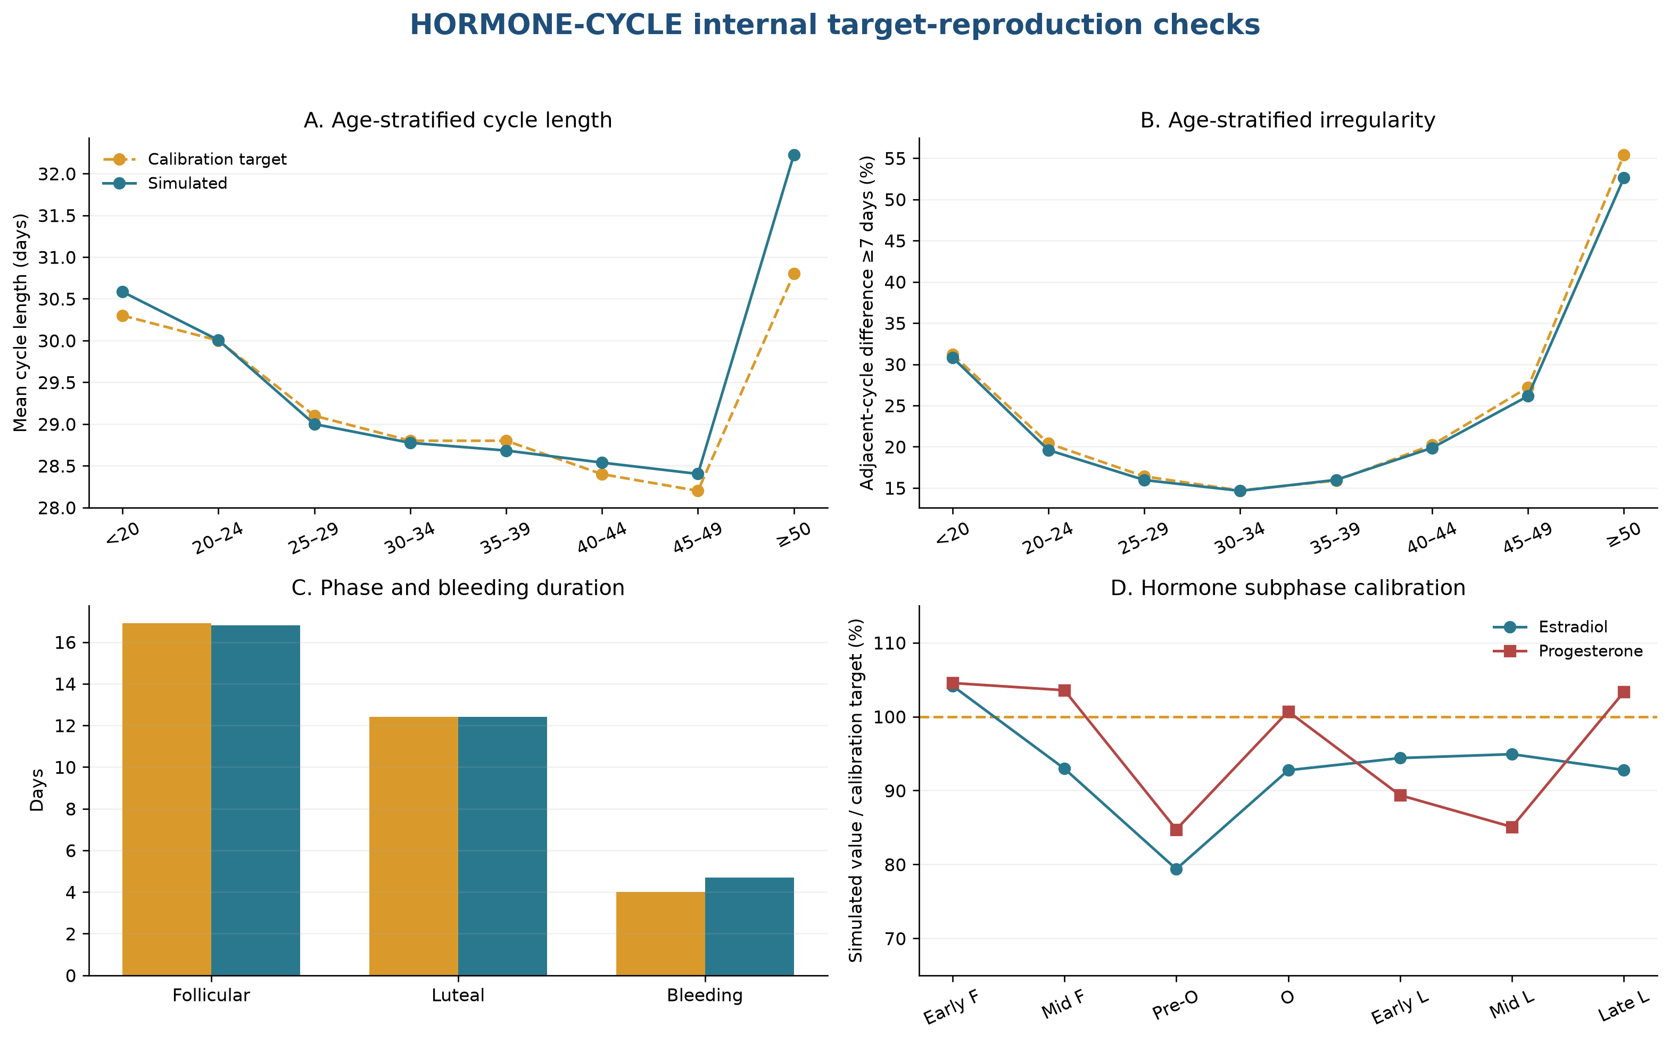
Appendix Figure A2. Internal observed-versus-target calibration. Panels A and B compare age-stratified cycle length and irregularity with Li et al. (2023); panel C compares follicular, luteal, and bleeding durations with Bull et al. (2019), including the published 4.0-day mean bleeding duration from Table 1; panel D compares estradiol and progesterone subphase summaries with Stricker et al. (2006) (5–7). Panels A–C use the 10,000-participant randomized-start run. Panel D uses 16 retained diaries, all from the younger-than-20 age band. Early follicular, mid-follicular, preovulatory, ovulatory, early luteal, midluteal, and late luteal phases are shown. These are internal calibration and software smoke checks using development sources.

2.5 Interpretation and remaining validation needs
The current checks show that the implementation reproduces its selected marginal targets and expresses the intended modifier directions. Joint patient-level fidelity, transportability to other populations, assay-specific error, and individual-cycle prediction remain untested. A future external validation should use held-out daily bleeding, ovulation, and hormone records; align phase definitions prospectively; report calibration by age and reproductive stage; and examine multivariate dependence, serial correlation, and between-person heterogeneity.

Chapter 3. Additional analyses and methods augmenting the main results
This chapter documents how HORMONE-CYCLE and the seizure-diary simulator were combined for the present false-positive study. It then reports the phase algorithms, ratio and regression methods, sensitivity analyses, and supplementary results.

3.1 Reproducibility, provenance, and simulator inputs
The completed primary simulation included 100,000 synthetic participants, 50,000 per cohort, followed for 36 months with master seed 20260505. HORMONE-CYCLE generated menstrual and hormone diaries. (1) The Cyclic Heterogeneous Overdispersed Clustered Open-source L-relationship Adjustable Temporally limited E-diary Simulator (CHOCOLATES) generated seizure diaries. The generators were run independently. HORMONE-CYCLE selected diary day 1 uniformly from the realized days of the first generated menstrual cycle and then continued forward without wrapping. The diaries were merged by calendar-day index. (2) Direct alignment preserved the original day ordering throughout the merge.
The reporting framework follows simulation-study guidance. (3,4) CHOCOLATES and HORMONE-CYCLE were designed to reproduce selected statistical features within and across synthetic patient populations through data-informed hierarchical sampling. Chapter 1 details the HORMONE-CYCLE evidence sources and transformations.
The completed manifest stores the analysis-code fingerprint ebcf21a3856156ce085b73960e92a9350f1d77696405c8b31eb02da87621b521 and configuration fingerprint 9241326bb38ef3c728b060c20bac22a8ed87485a3a61708d58bc74e72fd697b0. These Secure Hash Algorithm 256-bit fingerprints and all output-file hashes should accompany archived results. The study wrapper and HORMONE-CYCLE package declare version 0.1.0 and Python 3.11 or later. The full-run command was equivalent to “run_paper1_null_ce.py --config config_random_start_full.yaml --full,” and the archived machine-readable outputs are in outputs/random_start_full. The manifest records the complete configuration, assumptions, generated-file hashes, and dependency-facing analysis fingerprints.

Appendix Table S1. Simulator inputs, realized features, and evidence roles for the completed study. Literature sources are named in the source/rationale column; investigator-configured values are study assumptions. The named HORMONE-CYCLE, CHOCOLATES, seizure-rhythm, menstrual-cycle, and Herzog sources are cited here (1,2,5–7,23,24). “Simulator-native” means drawn directly by CHOCOLATES. “Multidien” denotes periods longer than 24 hours. “Audit spectrum” is a spectral estimate from retained daily audit data. “Interseizure constraints” are generator limits on simulated intervals between seizures. Hormone concentrations are written in nanograms per milliliter or picograms per milliliter.
Domain | Parameter | Cohort | Setting / sampling distribution | Level | Source / rationale | Realized target
Seizure | Monthly burden | Both | Simulator-native empirical distribution | Participant | Goldenholz & Westover 2023 | Realized seizures/month
Seizure | Overdispersion | Both | Simulator-native | Participant/day | Goldenholz & Westover 2023 | Audit daily variance/mean
Seizure | Clustering | Both | Simulator-native | Participant/day | Goldenholz & Westover 2023 | Audit next-day clustering proxy
Seizure | Multidien periods and amplitudes | Both | Simulator-native | Participant/day | Goldenholz & Westover 2023; Karoly et al. | Generator period and audit spectrum
Seizure | Interseizure constraints | Both | Simulator-native | Day | Goldenholz & Westover 2023 | Not separately stored
Menstrual | Age | Cohort-specific | {'healthy_ovulatory': {'age_range': [18.0, 45.0], 'force_ovulatory_cycles': True}, 'population': {'age_range': [13.0, 54.9], 'force_ovulatory_cycles': False}} | Participant | Investigator-configured study cohorts | Participant age
Menstrual | Cycle length and variability | Both | Literature-calibrated distributions | Participant/cycle | Li et al. 2023; Bull et al. 2019 | Mean and within-person SD
Menstrual | Bleeding duration | Both | Literature-calibrated | Cycle | Bull et al. 2019 | Available in simulator validation suite
Menstrual | Ovulation and phase timing | Cohort-specific | Age/stage/modifier-dependent | Participant/cycle | Bull et al. 2019; simulator literature registry | Ovulatory fraction
Menstrual | Hormone trajectories | Both | Interpolated daily reference medians | Cycle/day | Stricker et al. 2006 | Simulator validation suite
Menstrual | ILP rule | Population | Maximum P4 on O+5 to O+9 < 5.0 ng/mL; nonovulatory/missing cycles flagged | Cycle | Investigator operationalization; threshold requires biological citation | Audit ILP fraction
Menstrual | PCOS | Population | 0.1 | Participant | Investigator-configured stress-test rate | Participant prevalence
Menstrual | Peri-menarche | Population | 0.6 | Participant conditional on age <20 | Investigator-configured stress-test rate | Participant prevalence
Menstrual | Perimenopause | Population | 0.55 | Participant conditional on age ≥45 | Investigator-configured stress-test rate | Participant prevalence
Menstrual | Dysmenorrhea | Population | 0.12 | Participant | Investigator-configured stress-test rate | Not retained in participant summary
Menstrual | Contraception/IUD settings | Both | Available but not sampled in completed run | Participant | Simulator literature registry | Not applicable to completed run
Observation | Diary duration and start | Both | 36 months; diary day 1 sampled uniformly within the first generated menstrual cycle | Participant | Study design | 36 months with randomized starting phase
Observation | Missingness | Both | No diary missingness simulated | Day | Study-design simplification | Complete synthetic diaries
Null construction | Independent generators | Both | Separately seeded generators; HORMONE-CYCLE starts at a uniformly sampled first-cycle day; direct calendar-day alignment without wrapping | Participant | Study design | Direct alignment and randomized menstrual starting phase preserved
Null construction | Master seed | Both | 20260505 | Run | Reproducibility control | Manifested
Null construction | Phase modes | Both | strict_herzog, luteal_anchored_ovulatory | Analysis | Herzog criteria plus sensitivity | Both modes retained
Null construction | Cohort sizes | Cohort-specific | {'healthy_ovulatory': 50000, 'population': 50000} | Run | Monte Carlo design | 100,000 total

3.2 Assumption-by-assumption review
Within this section, menstrual (M), follicular (F), ovulatory (O), and luteal (L) identify cycle phases. Type C1 is the perimenstrual pattern, type C2 is the periovulatory pattern, and type C3 is the inadequate-luteal-phase pattern. Inadequate luteal phase (ILP) is the operational designation defined in Section 3.4.
Appendix Table S2. Assumptions, rationale, and implications for interpretation. The Herzog ratio definitions, thresholds, and inadequate-luteal-phase context derive from Herzog and colleagues (24,25).
Assumption | Rationale | Limitation / implication
Independent generators | Defines the false-positive estimand through independent seizure and hormone random streams. | True catamenial effects and false negatives fall outside this null simulation.
Direct calendar-day alignment | Preserves the separately seeded seizure and hormone outputs while HORMONE-CYCLE selects a uniformly random first-cycle start day. | No end-to-start wraparound is introduced; boundary exposure is randomized across menstrual phases.
36-month diaries | Provides long follow-up and permits shorter nested window comparisons. | Medication changes and secular trends fall outside the data-generating model.
Healthy ovulatory cohort | Provides a lower-heterogeneity reference in which C3 is not applicable. | This reference cohort represents ovulatory menstrual cycling under the configured age range.
Heterogeneous cohort | Stress-tests irregularity, anovulation, and configured modifiers. | Configured modifier rates serve as stress-test inputs; population prevalence estimation falls outside scope.
Strict Herzog phases | Preserves historical comparability with the original criteria. | The ovulatory interval expands in longer cycles; the luteal-anchored mode tests a fixed interval.
Unlabeled days | Matches the historical phase partition and prevents implicit reassignment. | Reduces observed denominators and can make short windows indeterminate.
Exact thresholds 1.69/1.83/1.62 | Uses the published distributional inflection points as the implemented thresholds. | Threshold performance remains dependent on sparse numerator and comparator counts.
Zero-comparator handling | Reports a positive numerator over a zero comparator as +infinity and reports 0/0 as undefined. | Makes the sparse-event vulnerability transparent rather than silently adding a continuity correction.
Inadequate-luteal-phase threshold <5 ng/mL | Operationalizes the ovulatory threshold used in the original Herzog phase study. | The cutoff captures one operational definition of luteal adequacy.
Nonovulatory cycles designated inadequate luteal phase | Matches the implemented C3 adapter and the C3 concept of inadequate luteal-phase cycles. | Type C3 sensitivity depends directly on the simulated prevalence of anovulation.
Minimum-data rule | Investigator-selected sensitivity to reduce classifications dominated by very sparse seizure counts. | The four-month or six-cycle and four-seizure-day cutoffs are pragmatic sensitivity settings.
Negative-binomial type C1/type C2 calibration | Checks rejection behavior with a model family concordant with the CHOCOLATES count process. | This analysis is a statistical calibration check for the simulator-based study.
Exploratory negative-binomial type C3 | Provides a separately specified follicular-versus-combined-phase contrast in ILP cycles. | Uses only the saved 1% daily audit sample and stricter eligibility.
Randomized diary boundary | Diary day 1 is selected uniformly from the realized days of the first generated menstrual cycle, after which generation proceeds forward. | The first and final observed cycles may be partial; analyses requiring complete cycles exclude them.
Stationary treatment and background risk | Keeps the null stationary and interpretable. | Limits transportability to clinical diaries with treatment changes or disease evolution.

3.3 Menstrual-phase labeling and complete-cycle rules
Phase labels were assigned to each complete menstrual cycle before any analysis-window subset was taken. Forward day counts from menstrual onset, with day 1 as the first bleeding day. Backward day equals the forward day minus the cycle length plus one, so the final cycle day is −1. Label priority is menstrual, follicular, ovulatory, and then luteal. Days outside the listed ranges remain unlabeled in the strict definition.
Appendix Table S3. Implemented strict Herzog and luteal-anchored sensitivity phase boundaries. Forward day is counted from menstrual onset and backward day from the next onset. Priority rules prevent overlapping labels. The luteal-anchored definition fixes the ovulatory interval immediately before the luteal phase and assigns the remaining nonmenstrual days to the follicular phase.
Phase | Strict Herzog definition | Luteal-anchored sensitivity
Menstrual (M) | Forward days 1–3 or backward days −3 to −1 | Same
Follicular (F) | Forward days 4–9 | All days not assigned to M, O, or L
Ovulatory (O) | Forward day ≥10 and backward day ≤−13 | Backward days −16 to −13
Luteal (L) | Backward days −12 to −4 | Backward days −12 to −4
Unlabeled | All remaining days | None

A complete cycle contains every daily row from cycle day 1 through its recorded cycle length. The exact three-cycle Herzog analysis additionally requires three complete cycles, each 23–35 days long. For combined phases, average daily seizure frequency is calculated as the total seizure count across all included phases divided by the total number of labeled days across those phases.

3.4 Type C3 and inadequate-luteal-phase algorithm
Type C3 is the inadequate-luteal-phase catamenial pattern. The present adapter is a custom operationalization. Herzog et al. used a single day-22 progesterone measurement and a 5-nanogram-per-milliliter threshold. (24) This study borrowed that threshold and defined the timing and aggregation algorithm separately.
The adapter designates a nonovulatory cycle or a cycle without a valid ovulation day as inadequate. For an ovulatory cycle, it takes the maximum progesterone concentration from days 5–9 after ovulation. If the interval reaches the diary boundary, it uses the available postovulation days. A maximum below 5 nanograms per milliliter is designated inadequate. A maximum of exactly 5 is therefore adequate in the implemented rule. Complete HORMONE-CYCLE daily outputs contain progesterone on every simulated day. The adapter also contains a defensive missing-field branch that designates the cycle inadequate; that branch was never exercised in this completed simulation and should be treated as an implementation limitation.
Type C3 applicability is evaluated within each analysis window. A pooled window is applicable when it contains at least one designated cycle. The completed study evaluated type C3 only in the heterogeneous cohort as a study-design applicability rule. The healthy cohort was omitted from type C3 reporting; enforced ovulation does not establish that low luteal progesterone is biologically impossible.

3.5 Herzog seizure-frequency ratios and thresholds
Average daily seizure frequency (ADSF) is the number of seizures in a phase divided by the number of labeled days in that phase. Menstrual (M), follicular (F), ovulatory (O), and luteal (L) denote the locally defined phases. The three ratios are shown in Equations 7–9. The exact thresholds 1.69, 1.83, and 1.62 correspond to published distributional inflection points. (24,25)
$C_{1}=\frac{ADSF\left(M\right)}{ADSF\left(F+L\right)}$ (7)
$C_{2}=\frac{ADSF\left(O\right)}{ADSF\left(F+L\right)}$ (8)
$C_{3}=\frac{ADSF\left(O+L+M\right)}{ADSF\left(F\right)}$ (9)
In Equations 7–9, C₁, C₂, and C₃ are the perimenstrual, periovulatory, and inadequate-luteal-phase Herzog ratios, respectively. ADSF(P) is the average daily seizure frequency pooled across every labeled day in the phase set P. M, F, O, and L denote menstrual, follicular, ovulatory, and luteal days. A plus sign inside ADSF denotes pooling of the named phase sets before dividing their combined seizure count by their combined number of labeled days.
A small comparator count can produce a large or undefined ratio. Positive infinity is defined and exceeds every finite threshold. Ratios of zero divided by zero and ratios with missing phase days are undefined.
The exact three-cycle analysis requires exactly three complete 23–35-day cycles and classifies a participant when at least two cycles are positive. (26)
Appendix Table S4. Cumulative distributions of Herzog seizure-frequency ratios in strict three-complete-cycle windows. Panels A–C show simulations; Panel A also shows the NIH Progesterone Trial baseline C1 distribution (n=294) reported by Herzog (2015). Ratio definitions originate from Herzog et al. (1997) (24,25). Simulation denominators at threshold zero include finite and positive-infinite ratios and exclude undefined ratios; the Herzog column uses all 294 participants. Simulation denominators are below 50,000 because zero-over-zero ratios, missing phase days, and eligibility failures are undefined or unavailable. Positive infinity is included at every applicable threshold.

Panel A — Type C1
Herzog ratio threshold (≥) | Healthy n | Healthy % | Heterogeneous n | Heterogeneous % | Herzog 2015, %  (n=294) (25)
0 | 43,545 | 100.00 | 43,602 | 100.00 | 100.00
1 | 19,611 | 45.04 | 19,624 | 45.01 | 66.67
1.69 | 11,847 | 27.21 | 11,939 | 27.38 | 38.10
2 | 10,740 | 24.66 | 10,778 | 24.72 | 34.35
3 | 6,005 | 13.79 | 6,037 | 13.85 | 21.43
4 | 4,585 | 10.53 | 4,660 | 10.69 | 17.35
5 | 3,360 | 7.72 | 3,396 | 7.79 | 14.97
6 | 3,085 | 7.08 | 3,119 | 7.15 | 12.24
7 | 2,888 | 6.63 | 2,915 | 6.69 | 10.54
8 | 2,534 | 5.82 | 2,543 | 5.83 | 8.16
9 | 2,467 | 5.67 | 2,466 | 5.66 | 7.48
10 | 2,303 | 5.29 | 2,312 | 5.30 | 6.46

Panel B — Type C2
Herzog ratio threshold (≥) | Healthy n | Healthy % | Heterogeneous n | Heterogeneous %
0 | 44,041 | 100.00 | 44,320 | 100.00
1 | 20,091 | 45.62 | 20,705 | 46.72
1.83 | 11,317 | 25.70 | 11,505 | 25.96
2 | 10,374 | 23.56 | 10,498 | 23.69
3 | 6,788 | 15.41 | 6,805 | 15.35
4 | 5,066 | 11.50 | 5,105 | 11.52
5 | 4,084 | 9.27 | 4,232 | 9.55
6 | 3,593 | 8.16 | 3,764 | 8.49
7 | 3,260 | 7.40 | 3,467 | 7.82
8 | 3,058 | 6.94 | 3,254 | 7.34
9 | 2,936 | 6.67 | 3,112 | 7.02
10 | 2,808 | 6.38 | 3,023 | 6.82

Panel C — Type C3
Herzog ratio threshold (≥) | Heterogeneous n | Heterogeneous %
0 | 16,716 | 100.00
1 | 10,316 | 61.71
1.62 | 8,789 | 52.58
2 | 8,340 | 49.89
3 | 7,761 | 46.43
4 | 7,500 | 44.87
5 | 7,372 | 44.10
6 | 7,316 | 43.77
7 | 7,271 | 43.50
8 | 7,241 | 43.32
9 | 7,213 | 43.15
10 | 7,200 | 43.07

Panel D — Sparse-comparator audit
Ratio | Cohort | Finite | Positive infinity | Undefined | At or above threshold | Positive-infinite share
Type C1 | Healthy ovulatory | 41,579 | 1,966 | 6,455 | 11,847 | 1,966 (16.6%)
Type C1 | Heterogeneous | 41,604 | 1,998 | 6,398 | 11,939 | 1,998 (16.7%)
Type C2 | Healthy ovulatory | 41,566 | 2,475 | 5,959 | 11,317 | 2,475 (21.9%)
Type C2 | Heterogeneous | 41,579 | 2,741 | 5,680 | 11,505 | 2,741 (23.8%)
Type C3 | Heterogeneous | 9,636 | 7,080 | 3,270 | 8,789 | 7,080 (80.6%)

Panel D audits pooled ratio status in the same strict three-cycle data used for panels A–C. The final exact Herzog classification separately requires at least two of three individual cycles to be positive. “Positive-infinite share” is the number of positive-infinite ratios divided by all pooled ratios at or above the applicable threshold.

3.6 Type C3 window-duration sensitivity
Type C3 is the inadequate-luteal-phase pattern. This sensitivity analysis varies the amount of observation available for that pattern.
Appendix Table S5. Windowed type C3 false-positive classifications in the heterogeneous cohort. All 50,000 heterogeneous-cohort participants were attempted. “Applicable” indicates at least one designated inadequate-luteal-phase cycle in the window. “Classifiable” additionally requires a defined ratio. “All-attempted rate” is positive divided by 50,000. The healthy ovulatory cohort was omitted under the study-design applicability rule described in Section 3.4.
Window | Applicable | Classifiable | Positive | Positive among classifiable, % (95% Wilson confidence interval) | All-attempted rate
1 month | 16,331 | 7,706 | 4,430 | 57.5% (56.4%–58.6%) | 8.9%
3 months | 22,162 | 16,194 | 8,737 | 54.0% (53.2%–54.7%) | 17.5%
4 months | 24,027 | 18,574 | 9,757 | 52.5% (51.8%–53.2%) | 19.5%
6 months | 26,685 | 21,860 | 10,700 | 48.9% (48.3%–49.6%) | 21.4%
9 months | 29,699 | 25,178 | 11,630 | 46.2% (45.6%–46.8%) | 23.3%
12 months | 32,096 | 27,703 | 12,238 | 44.2% (43.6%–44.8%) | 24.5%
18 months | 35,912 | 31,458 | 13,118 | 41.7% (41.2%–42.2%) | 26.2%
24 months | 38,560 | 33,999 | 13,438 | 39.5% (39.0%–40.0%) | 26.9%
36 months | 43,443 | 38,783 | 14,364 | 37.0% (36.6%–37.5%) | 28.7%
3 complete cycles | 19,986 | 16,716 | 8,789 | 52.6% (51.8%–53.3%) | 17.6%
6 complete cycles | 25,277 | 21,952 | 10,472 | 47.7% (47.0%–48.4%) | 20.9%
12 complete cycles | 31,090 | 27,560 | 11,903 | 43.2% (42.6%–43.8%) | 23.8%

3.7 Investigator-selected minimum-data sensitivity
The minimum-data thresholds are investigator-selected sensitivity settings. They represent the minimum amount of seizure information an investigator is willing to accept before classification. The analysis reports every setting; investigators select the sensitivity appropriate to their scientific question.
Appendix Table S6. Classification across observation windows and minimum seizure-day requirements. Each cohort contains 50,000 attempted participants. “Positive among classifiable” is positive divided by classifiable with a 95% Wilson score confidence interval. “All-attempted rate” is positive divided by 50,000 (27).
Cohort | Window | Minimum seizure days | Classifiable | Positive | Positive among classifiable, % (95% Wilson confidence interval) | All-attempted rate
Healthy ovulatory | 4 months | 2 | 43,188 | 16,547 | 38.3% (37.9%–38.8%) | 33.1%
Healthy ovulatory | 6 months | 2 | 45,261 | 15,140 | 33.5% (33.0%–33.9%) | 30.3%
Healthy ovulatory | 12 months | 2 | 47,522 | 11,846 | 24.9% (24.5%–25.3%) | 23.7%
Healthy ovulatory | 36 months | 2 | 49,193 | 5,585 | 11.4% (11.1%–11.6%) | 11.2%
Heterogeneous | 4 months | 2 | 43,102 | 16,482 | 38.2% (37.8%–38.7%) | 33.0%
Heterogeneous | 6 months | 2 | 45,198 | 15,214 | 33.7% (33.2%–34.1%) | 30.4%
Heterogeneous | 12 months | 2 | 47,510 | 11,922 | 25.1% (24.7%–25.5%) | 23.8%
Heterogeneous | 36 months | 2 | 49,168 | 5,581 | 11.4% (11.1%–11.6%) | 11.2%
Healthy ovulatory | 4 months | 3 | 40,269 | 14,934 | 37.1% (36.6%–37.6%) | 29.9%
Healthy ovulatory | 6 months | 3 | 43,129 | 13,931 | 32.3% (31.9%–32.7%) | 27.9%
Healthy ovulatory | 12 months | 3 | 46,362 | 11,181 | 24.1% (23.7%–24.5%) | 22.4%
Healthy ovulatory | 36 months | 3 | 48,777 | 5,338 | 10.9% (10.7%–11.2%) | 10.7%
Heterogeneous | 4 months | 3 | 40,158 | 14,878 | 37.0% (36.6%–37.5%) | 29.8%
Heterogeneous | 6 months | 3 | 43,147 | 14,101 | 32.7% (32.2%–33.1%) | 28.2%
Heterogeneous | 12 months | 3 | 46,394 | 11,310 | 24.4% (24.0%–24.8%) | 22.6%
Heterogeneous | 36 months | 3 | 48,763 | 5,361 | 11.0% (10.7%–11.3%) | 10.7%
Healthy ovulatory | 4 months | 4 | 37,627 | 13,656 | 36.3% (35.8%–36.8%) | 27.3%
Healthy ovulatory | 6 months | 4 | 41,140 | 12,936 | 31.4% (31.0%–31.9%) | 25.9%
Healthy ovulatory | 12 months | 4 | 45,268 | 10,657 | 23.5% (23.2%–23.9%) | 21.3%
Healthy ovulatory | 36 months | 4 | 48,359 | 5,133 | 10.6% (10.3%–10.9%) | 10.3%
Heterogeneous | 4 months | 4 | 37,366 | 13,514 | 36.2% (35.7%–36.7%) | 27.0%
Heterogeneous | 6 months | 4 | 41,163 | 13,115 | 31.9% (31.4%–32.3%) | 26.2%
Heterogeneous | 12 months | 4 | 45,278 | 10,741 | 23.7% (23.3%–24.1%) | 21.5%
Heterogeneous | 36 months | 4 | 48,333 | 5,150 | 10.7% (10.4%–10.9%) | 10.3%
Healthy ovulatory | 4 months | 6 | 32,717 | 11,488 | 35.1% (34.6%–35.6%) | 23.0%
Healthy ovulatory | 6 months | 6 | 37,514 | 11,380 | 30.3% (29.9%–30.8%) | 22.8%
Healthy ovulatory | 12 months | 6 | 43,128 | 9,709 | 22.5% (22.1%–22.9%) | 19.4%
Healthy ovulatory | 36 months | 6 | 47,556 | 4,807 | 10.1% (9.8%–10.4%) | 9.6%
Heterogeneous | 4 months | 6 | 32,624 | 11,426 | 35.0% (34.5%–35.5%) | 22.9%
Heterogeneous | 6 months | 6 | 37,492 | 11,487 | 30.6% (30.2%–31.1%) | 23.0%
Heterogeneous | 12 months | 6 | 43,131 | 9,809 | 22.7% (22.3%–23.1%) | 19.6%
Heterogeneous | 36 months | 6 | 47,503 | 4,814 | 10.1% (9.9%–10.4%) | 9.6%

3.8 Model-concordant negative-binomial calibration checks
The primary model-concordant calibration check uses a log-link negative-binomial generalized linear model for daily seizure counts. Participant-full-diary method-of-moments dispersion is used, with cycle fixed effects when the required complete cycles are available. Type C1 and type C2 one-sided Wald tests are adjusted by the Holm method within participant. (28) Type C1 is the perimenstrual contrast, type C2 is the periovulatory contrast, and type C3 is the inadequate-luteal-phase contrast. The Cyclic Heterogeneous Overdispersed Clustered Open-source L-relationship Adjustable Temporally limited E-diary Simulator (CHOCOLATES) uses an overdispersed count process. (2) Concordance is limited to the count family and log link. The regression does not reproduce CHOCOLATES clustering, multidien rhythms, or participant heterogeneity. The indicator IM equals 1 on menstrual days, the indicator IO equals 1 on ovulatory days, and both equal 0 otherwise.
$log\left(μ_{icd}\right)=β_{0}+β_{M}I_{M,icd}+β_{O}I_{O,icd}+γ_{c}$ (10)
In Equation 10, log denotes the natural logarithm; μ_{icd} is the expected seizure count for participant i, cycle c, and day d; i, c, and d index participants, cycles, and days, respectively; β₀ is the intercept; β_{M} and β_{O} are the log rate-ratio coefficients for menstrual and ovulatory days; I_{M,icd} and I_{O,icd} are the corresponding indicator variables for participant i on day d of cycle c; and γ_{c} is the fixed effect for cycle c. Follicular and luteal days form the reference category because both indicators equal 0 on those days.
The exploratory type C3 model restricts the data to complete simulator-designated inadequate-luteal-phase cycles and replaces the two phase indicators with one indicator for combined ovulatory, luteal, and menstrual days. Positivity requires a one-sided P value below .05 and a rate ratio of at least 1.62. The minimum data are four complete designated cycles and four seizure days. A robust Poisson model with heteroskedasticity-consistent covariance type 0 is attempted only when the negative-binomial fit raises an exception. Both models use a maximum of 100 iterations. Each daily row has one day of exposure, so no offset is required. Equation 11 defines the participant-specific negative-binomial dispersion.
$α_{i}=\left\{\begin{matrix}1 & if {\bar{y}}_{i}≤0 or s_{i}^{2}≤{\bar{y}}_{i} \\ max\left\{{10}^{-6},min\left[50,\frac{s_{i}^{2}-{\bar{y}}_{i}}{{{\bar{y}}_{i}}^{2}}\right]\right\} & if s_{i}^{2}>{\bar{y}}_{i}>0\end{matrix}\right.$ (11)
In Equation 11, α_{i} is the negative-binomial dispersion for participant i; i indexes participants; ȳ_{i} is the mean daily seizure count across participant i’s full diary; and s_{i}² is the sample variance of those daily counts. The implemented fallback sets α_{i} to 1 when ȳ_{i} is nonpositive or when s_{i}² does not exceed ȳ_{i}. Otherwise, the method-of-moments estimate is bounded below by 10⁻⁶ and above by 50 for numerical stability.
Equation 12 gives the exploratory type C3 model.
$log\left(μ_{icd}\right)=β_{0}+β_{OLM}I_{OLM,icd}+γ_{c}$ (12)
In Equation 12, log denotes the natural logarithm; μ_{icd} is the expected seizure count for participant i, cycle c, and day d; i, c, and d index participants, cycles, and days, respectively; β₀ is the intercept; β_{OLM} is the log rate-ratio coefficient comparing combined ovulatory, luteal, and menstrual days with follicular days; I_{OLM,icd} equals 1 for participant i on an ovulatory, luteal, or menstrual day d of cycle c and equals 0 on a follicular day; and γ_{c} is the fixed effect for cycle c.
The retained daily audit sample was selected independently within each cohort without replacement at a 1% fraction. NumPy’s default random-number generator used a deterministic 32-bit seed derived from master seed 20260505, the cohort name, and “audit_sample.” The heterogeneous-cohort seed was 529110050. The type C3 exploratory analysis attempted all 500 retained heterogeneous participants: 430 had ratio-level type C3 applicability, 205 met regression data requirements, 271 had fewer than four complete inadequate-luteal-phase cycles, and 24 had fewer than four seizure days. All 205 classifiable participants used the negative-binomial fit; no robust-Poisson fallback or regression failure occurred. 7 were positive.
Appendix Table S7. Exploratory type C3 negative-binomial calibration result in the retained 1% daily audit sample. All 500 retained heterogeneous participants were attempted; 430 were ratio-applicable, 205 were regression-classifiable, and 7 were positive. “All-attempted rate” is 7/500. The 95% Wilson interval describes Monte Carlo uncertainty under this configured simulation. No robust-Poisson fallback was used.
Attempted | Ratio type C3 applicable | Negative-binomial classifiable | Positive | Positive among classifiable, % (95% Wilson confidence interval) | All-attempted rate
500 | 430 | 205 | 7 | 3.4% (1.7%–6.9%) | 1.4%

3.9 Mutually exclusive pattern decomposition
Type C1 denotes the perimenstrual pattern, type C2 the periovulatory pattern, and type C3 the inadequate-luteal-phase pattern. Table S8 separates their mutually exclusive combinations.
Appendix Table S8. Mutually exclusive participant-window categories in 36-month strict-Herzog windows. Each cohort contains 50,000 attempted participants. “Windowed Herzog” uses the full 36-month diary. “Minimum-data” adds a minimum of four seizure days. Type C3 follows the heterogeneous-cohort applicability rule. Percentages may differ from 100% by rounding.
Cohort / definition | None | Indeterminate | C1 only | C2 only | C1+C2 | C3 only | C3 with C1 and/or C2
Healthy / windowed Herzog | 87.6% | 0.8% | 5.9% | 3.6% | 2.0% | N/A | N/A
Healthy / minimum-data | 86.5% | 3.3% | 5.4% | 3.1% | 1.8% | N/A | N/A
Heterogeneous / windowed Herzog | 63.4% | 0.8% | 3.9% | 2.0% | 1.2% | 24.2% | 4.6%
Heterogeneous / minimum-data | 62.4% | 3.3% | 3.5% | 1.6% | 1.0% | 24.0% | 4.2%

3.10 Simulator-feature associations
The machine-readable file tableS4_simulated_classification_associations.csv reports stratified false-positive classification rates and 95% Wilson score confidence intervals (27) across configured quintiles of age, seizure burden, cycle length and variability, ovulatory fraction, and dominant seizure-cycle period, plus configured binary modifiers. These descriptive results apply to the synthetic study population.

3.11 Realized simulation distributions
The figures in this section show simulated data. Polycystic ovary syndrome (PCOS) and inadequate luteal phase (ILP) are written in abbreviated form within selected panel labels.
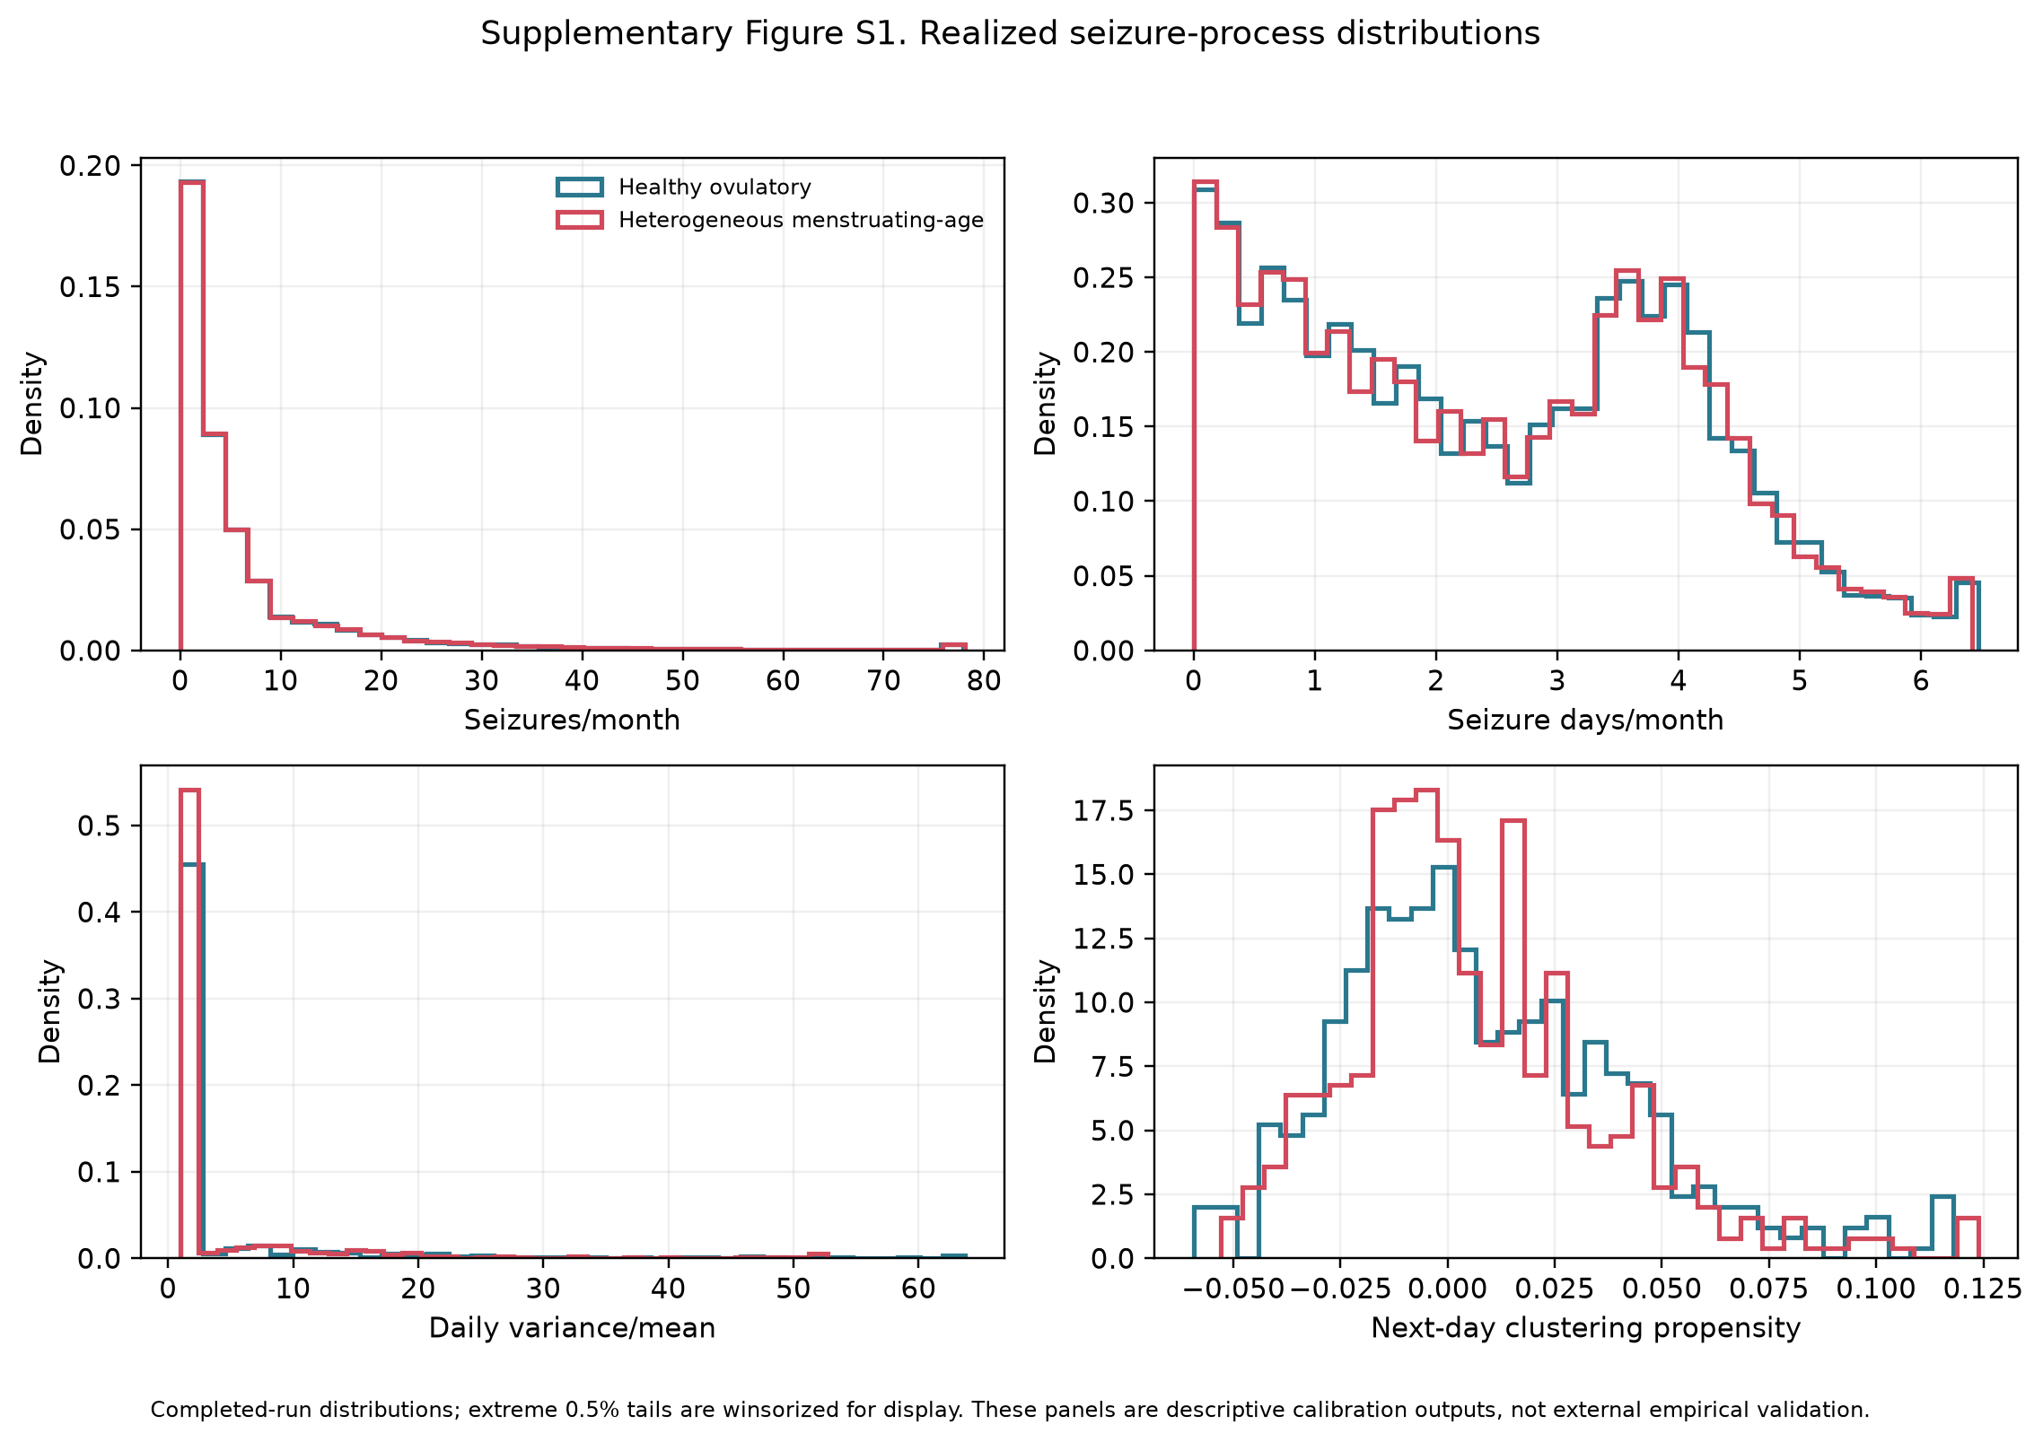
Supplementary Figure S1. Realized seizure-process distributions. Seizures per month and seizure days per month use all 50,000 participants in each cohort. Daily count variance divided by mean and next-day clustering propensity use the retained 1% daily audit sample of 500 participants per cohort. All panels display simulated data; monthly measures use 30-day months.
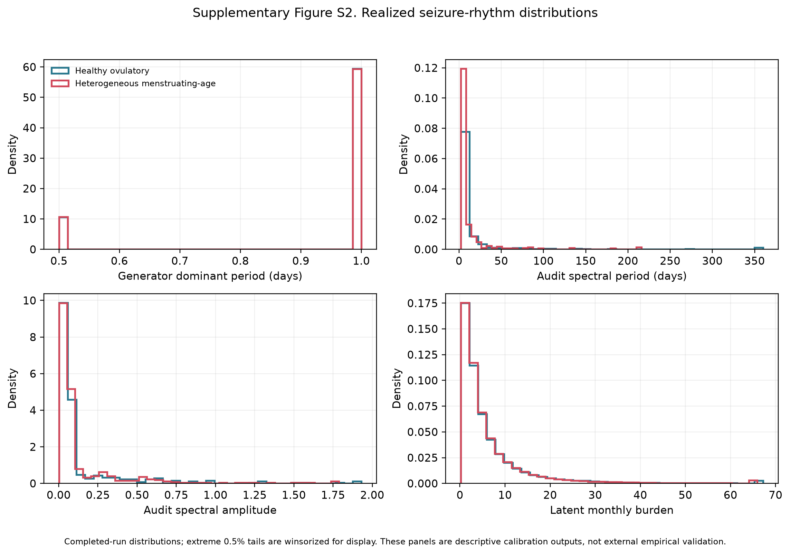
Supplementary Figure S2. Realized seizure-rhythm distributions. Generator-reported dominant period and latent monthly seizure burden use all 50,000 participants per cohort. Spectral period and amplitude use the retained 1% daily audit sample of 500 participants per cohort. Period is in days, spectral amplitude is in seizures per day, and burden is in seizures per 30-day month. All panels display simulated data.
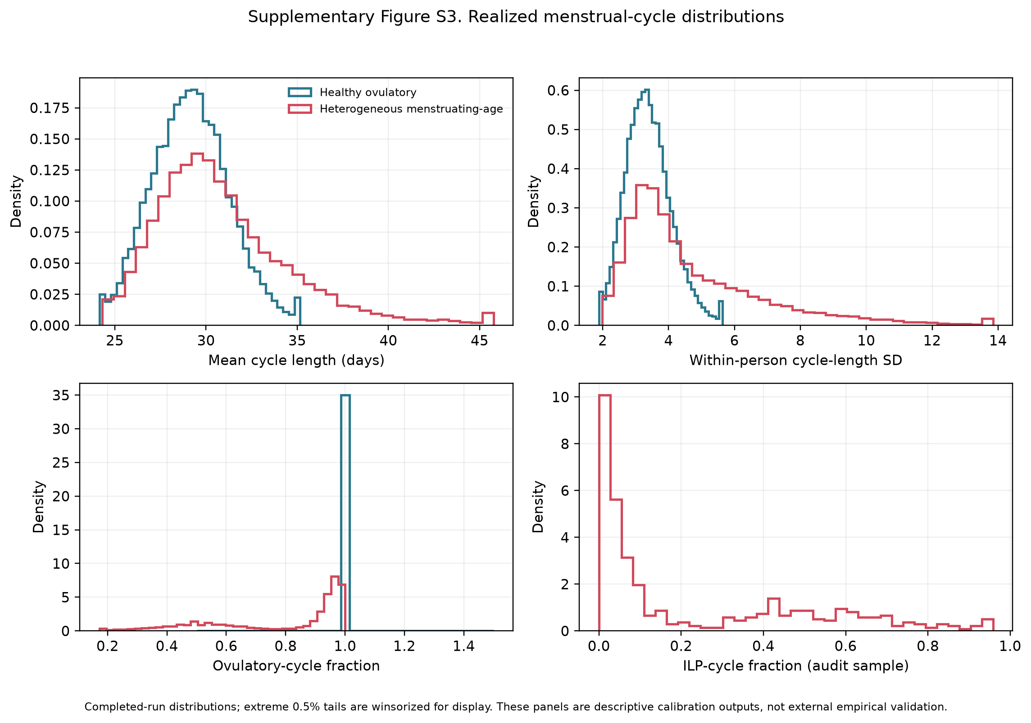
Supplementary Figure S3. Realized menstrual-cycle distributions in all 50,000 participants per cohort. Panels show mean cycle length in days, within-participant cycle-length standard deviation in days, ovulatory-cycle fraction, and inadequate luteal phase (ILP) fraction. The healthy cohort was generated with ovulation required. All panels display simulated data.
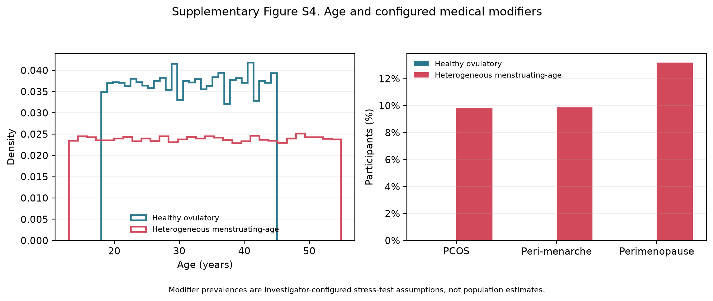
Supplementary Figure S4. Age and configured modifiers among all 50,000 participants per cohort. Polycystic ovary syndrome (PCOS) is abbreviated within the panel. Ages are in years. Modifier frequencies are investigator-configured heterogeneity stress-test settings and do not estimate population prevalence. All panels display simulated data.
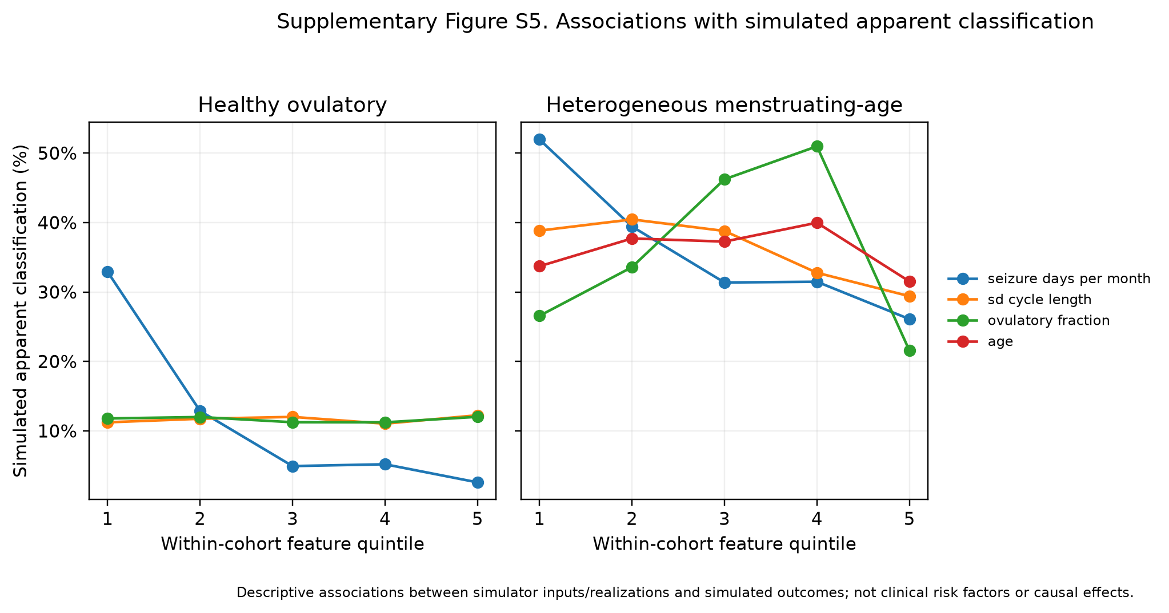
Supplementary Figure S5. Associations with false-positive classification under the independent null model across within-cohort feature quintiles. Each cohort contains 50,000 attempted participants; individual points use the classifiable denominator for the displayed definition. Error bars are 95% Wilson score confidence intervals. The display is descriptive and applies to the synthetic study population.

3.12 Interpretation of the supplementary analyses
The supplementary analyses quantify apparent catamenial classification under independence. They separate the perimenstrual (type C1), periovulatory (type C2), and inadequate-luteal-phase (type C3) patterns; preserve classifiable and all-attempted denominators; and show how diary duration, minimum-data requirements, ratio denominators, and inadequate-luteal-phase prevalence affect the estimates. Medication changes and secular trends are outside the simulation scope and remain limitations for translation to longitudinal clinical diaries.

References
1. Daniel Goldenholz. HORMONE-CYCLE [Python] [Python 3.11+]. GoldenholzLab; 2026. Available from: https://github.com/GoldenholzLab/catamenial-epilepsy-sim.git
2. Goldenholz DM, Westover MB. Flexible realistic simulation of seizure occurrence recapitulating statistical properties of seizure diaries. Epilepsia. 2023 Feb;64(2):396–405. doi:10.1111/epi.17471
3. Monks T, Currie CSM, Onggo BS, Robinson S, Kunc M, Taylor SJE. Strengthening the reporting of empirical simulation studies: introducing the STRESS guidelines. J Simul. 2019;13(1):55–67. doi:10.1080/17477778.2018.1442155
4. Burton A, Altman DG, Royston P, Holder RL. The design of simulation studies in medical statistics. Stat Med. 2006 Dec 30;25(24):4279–92. doi:10.1002/sim.2673 PubMed PMID: 16947139.
5. Li H, Gibson EA, Jukic AMZ, Baird DD, Wilcox AJ, Curry CL, et al. Menstrual cycle length variation by demographic characteristics from the Apple Women’s Health Study. NPJ Digit Med. 2023;6(1):100. Located at: 37248288. doi:10.1038/s41746-023-00848-1
6. Bull JR, Rowland SP, Scherwitzl EB, Scherwitzl R, Danielsson KG, Harper J. Real-world menstrual cycle characteristics of more than 600,000 menstrual cycles. NPJ Digit Med. 2019;2:83. Located at: 31482137. doi:10.1038/s41746-019-0152-7
7. Stricker R, Eberhart R, Chevailler MC, Quinn FA, Bischof P, Stricker R. Establishment of detailed reference values for luteinizing hormone, follicle stimulating hormone, estradiol, and progesterone during different phases of the menstrual cycle on the Abbott ARCHITECT analyzer. Clin Chem Lab Med. 2006;44(7):883–7. Located at: 16776638. doi:10.1515/CCLM.2006.160
8. Fraser IS, Critchley HOD, Broder M, Munro MG. The FIGO recommendations on terminologies and definitions for normal and abnormal uterine bleeding. Semin Reprod Med. 2011 Sep;29(5):383–90. doi:10.1055/s-0031-1287662 PubMed PMID: 22065325.
9. Mortimer R, Asokan G, Baird DD, Wilcox AJ, Abrams K, Curry CL, et al. Variability of menstrual cycles by age, polycystic ovary syndrome, and early-life cycle irregularity in the apple Women’s Health Study. Am J Obstet Gynecol. 2026 Apr;234(4):1042–69. doi:10.1016/j.ajog.2025.11.031 PubMed PMID: 41297783; PubMed Central PMCID: PMC12915291.
10. Doi SAR, Al-Zaid M, Towers PA, Scott CJ, Al-Shoumer KAS. Irregular cycles and steroid hormones in polycystic ovary syndrome. Hum Reprod. 2005 Sep;20(9):2402–8. doi:10.1093/humrep/dei093 PubMed PMID: 15932911.
11. Jarrett BY, Vanden Brink H, Oldfield AL, Lujan ME. Ultrasound Characterization of Disordered Antral Follicle Development in Women with Polycystic Ovary Syndrome. J Clin Endocrinol Metab. 2020 Nov 1;105(11):e3847-3861. doi:10.1210/clinem/dgaa515 PubMed PMID: 32785651; PubMed Central PMCID: PMC7473602.
12. Venturoli S, Porcu E, Fabbri R, Paradisi R, Ruggeri S, Bolelli G, et al. Menstrual irregularities in adolescents: hormonal pattern and ovarian morphology. Horm Res. 1986;24(4):269–79. doi:10.1159/000180567 PubMed PMID: 3491030.
13. World Health Organization multicenter study on menstrual and ovulatory patterns in adolescent girls. II. Longitudinal study of menstrual patterns in the early postmenarcheal period, duration of bleeding episodes and menstrual cycles. World Health Organization Task Force on Adolescent Reproductive Health. J Adolesc Health Care. 1986 Jul;7(4):236–44. PubMed PMID: 3721946.
14. Zhang K, Pollack S, Ghods A, Dicken C, Isaac B, Adel G, et al. Onset of ovulation after menarche in girls: a longitudinal study. J Clin Endocrinol Metab. 2008 Apr;93(4):1186–94. doi:10.1210/jc.2007-1846 PubMed PMID: 18252789; PubMed Central PMCID: PMC2291492.
15. Santoro N, Randolph JF. Reproductive hormones and the menopause transition. Obstet Gynecol Clin North Am. 2011 Sep;38(3):455–66. doi:10.1016/j.ogc.2011.05.004 PubMed PMID: 21961713; PubMed Central PMCID: PMC3197715.
16. Edelman A, Micks E, Gallo MF, Jensen JT, Grimes DA. Continuous or extended cycle vs. cyclic use of combined hormonal contraceptives for contraception. Cochrane Database Syst Rev. 2014 Jul 29;2014(7):CD004695. doi:10.1002/14651858.CD004695.pub3 PubMed PMID: 25072731; PubMed Central PMCID: PMC6837850.
17. Xiao B, Zeng T, Wu S, Sun H, Xiao N. Effect of levonorgestrel-releasing intrauterine device on hormonal profile and menstrual pattern after long-term use. Contraception. 1995 Jun;51(6):359–65. doi:10.1016/0010-7824(95)00102-g PubMed PMID: 7554977.
18. Barbosa I, Olsson SE, Odlind V, Goncalves T, Coutinho E. Ovarian function after seven years’ use of a levonorgestrel IUD. Adv Contracept. 1995 Jun;11(2):85–95. doi:10.1007/BF01987274 PubMed PMID: 7491859.
19. Hubacher D, Reyes V, Lillo S, Zepeda A, Chen PL, Croxatto H. Pain from copper intrauterine device insertion: randomized trial of prophylactic ibuprofen. Am J Obstet Gynecol. 2006 Nov;195(5):1272–7. doi:10.1016/j.ajog.2006.08.022 PubMed PMID: 17074548.
20. Faundes A, Segal SJ, Adejuwon CA, Brache V, Leon P, Alvarez-Sanchez F. The menstrual cycle in women using an intrauterine device. Fertil Steril. 1980 Nov;34(5):427–30. doi:10.1016/s0015-0282(16)45131-9 PubMed PMID: 7439408.
21. Malmqvist R, Petersohn L, Bengtsson LP. Menstrual bleeding with copper-covered intrauterine contraceptive devices. Contraception. 1974 Jun;9(6):627–33. doi:10.1016/0010-7824(74)90048-1 PubMed PMID: 4448089.
22. Dawood MY. Primary dysmenorrhea: advances in pathogenesis and management. Obstet Gynecol. 2006 Aug;108(2):428–41. doi:10.1097/01.AOG.0000230214.26638.0c PubMed PMID: 16880317.
23. Karoly PJ, Rao VR, Gregg NM, Worrell GA, Bernard C, Cook MJ, et al. Cycles in epilepsy. Nat Rev Neurol. 2021;17(5):267–84. Located at: 33723459. doi:10.1038/s41582-021-00464-1
24. Herzog AG, Klein P, Ransil BJ. Three patterns of catamenial epilepsy. Epilepsia. 1997;38(10):1082–8. Located at: 9579954. doi:10.1111/j.1528-1157.1997.tb01197.x
25. Herzog AG. Catamenial epilepsy: Update on prevalence, pathophysiology and treatment from the findings of the NIH Progesterone Treatment Trial. Seizure. 2015;28:18–25. Located at: 25770028. doi:10.1016/j.seizure.2015.02.024
26. Herzog AG, Harden CL, Liporace J, Pennell P, Schomer DL, Sperling M, et al. Frequency of catamenial seizure exacerbation in women with localization-related epilepsy. Ann Neurol. 2004;56(3):431–4. Located at: 15349872. doi:10.1002/ana.20214
27. Newcombe RG. Two-sided confidence intervals for the single proportion: comparison of seven methods. Stat Med. 1998 Apr 30;17(8):857–72. doi:10.1002/(sici)1097-0258(19980430)17:8<857::aid-sim777>3.0.co;2-e PubMed PMID: 9595616.
28. Aickin M, Gensler H. Adjusting for multiple testing when reporting research results: the Bonferroni vs Holm methods. Am J Public Health. 1996 May;86(5):726–8. doi:10.2105/ajph.86.5.726 PubMed PMID: 8629727; PubMed Central PMCID: PMC1380484.

