Appendix S1
False Positive Catamenial Epilepsy Classification: A Simulation Study
This appendix is part of draft_v5. It reports only the completed simulations and derived analyses; no previously published participant data are included in the cumulative Herzog-ratio table.

S1. Reproducibility and provenance
The primary simulation run (100,000 participants; 50,000 per cohort; 36 months) is immutable. Its manifest records master seed 20260505 and output hashes. Draft-v5 supplemental tables were derived from outputs/window_results.parquet, participant_summary.parquet, study_level_3month.parquet, and the deterministic 1% audit_daily_sample.parquet. HORMONE-CYCLE version 0.1.0 and the integrated analysis were built at repository commit de6a716cfff753583a4831fcecdf5af0847d99b4. ¹ ² ³
The completed manifest does not store a run-time Git commit, so the commit above is the checked-out source provenance associated with the retained outputs rather than a value embedded in the run manifest. This limitation should remain visible if the outputs are archived.

S2. Simulator inputs, realized features, and sources
Both CHOCOLATES and HORMONE-CYCLE were designed to reproduce published statistical features within and across patient populations. CHOCOLATES encodes between-person seizure burden, overdispersion, clustering, rhythms, and interseizure constraints; HORMONE-CYCLE encodes between-person traits and within-person cycle-to-cycle realizations. The table distinguishes literature-calibrated targets, simulator-native behavior, investigator-configured stress assumptions, adapter-derived fields, and realized outputs. ² ^{4–6}
Domain | Parameter | Cohort | Setting / sampling distribution | Level | Source / rationale | Realized target
Seizure | Monthly burden | Both | Simulator-native empirical distribution | Participant | Goldenholz & Westover 2023 | Realized seizures/month
Seizure | Overdispersion | Both | Simulator-native | Participant/day | Goldenholz & Westover 2023 | Audit daily variance/mean
Seizure | Clustering | Both | Simulator-native | Participant/day | Goldenholz & Westover 2023 | Audit next-day clustering proxy
Seizure | Multidien periods and amplitudes | Both | Simulator-native | Participant/day | Goldenholz & Westover 2023; Karoly et al. | Generator period and audit spectrum
Seizure | Interseizure constraints | Both | Simulator-native | Day | Goldenholz & Westover 2023 | Not separately stored
Menstrual | Age | Cohort-specific | {'healthy_ovulatory': {'age_range': [18.0, 45.0], 'force_ovulatory_cycles': True}, 'population': {'age_range': [13.0, 54.9], 'force_ovulatory_cycles': False}} | Participant | Investigator-configured study cohorts | Participant age
Menstrual | Cycle length and variability | Both | Literature-calibrated distributions | Participant/cycle | Li et al. 2023; Bull et al. 2019 | Mean and within-person SD
Menstrual | Bleeding duration | Both | Literature-calibrated | Cycle | Bull et al. 2019 | Available in simulator validation suite
Menstrual | Ovulation and phase timing | Cohort-specific | Age/stage/modifier-dependent | Participant/cycle | Bull et al. 2019; simulator literature registry | Ovulatory fraction
Menstrual | Hormone trajectories | Both | Interpolated daily reference medians | Cycle/day | Stricker et al. 2006 | Simulator validation suite
Menstrual | ILP rule | Population | Maximum P4 on O+5 to O+9 < 5.0 ng/mL; nonovulatory/missing cycles flagged | Cycle | Investigator operationalization; threshold requires biological citation | Audit ILP fraction
Menstrual | PCOS | Population | 0.1 | Participant | Investigator-configured stress-test rate | Participant prevalence
Menstrual | Peri-menarche | Population | 0.6 | Participant conditional on age <20 | Investigator-configured stress-test rate | Participant prevalence
Menstrual | Perimenopause | Population | 0.55 | Participant conditional on age ≥45 | Investigator-configured stress-test rate | Participant prevalence
Menstrual | Dysmenorrhea | Population | 0.12 | Participant | Investigator-configured stress-test rate | Not retained in participant summary
Menstrual | Contraception/IUD settings | Both | Available but not sampled in completed run | Participant | Simulator literature registry | Not applicable to completed run
Observation | Diary duration | Both | 36 | Participant | Study design | 36 months
Observation | Missingness | Both | No diary missingness simulated | Day | Study-design simplification | Complete synthetic diaries
Null construction | Independence and circular shift | Both | Independent generators; shifted seizure diary | Participant | Study design | Shift stored per participant
Null construction | Master seed | Both | 20260505 | Run | Reproducibility control | Manifested
Null construction | Phase modes | Both | strict_herzog, luteal_anchored_ovulatory | Analysis | Herzog criteria plus sensitivity | Both modes retained
Null construction | Cohort sizes | Cohort-specific | {'healthy_ovulatory': 50000, 'population': 50000} | Run | Monte Carlo design | 100,000 total

Note. The full machine-readable table additionally records code/config fields, sensitivity status, and the run version/commit. Values labeled investigator-configured are stress-test assumptions. The completed output did not retain CHOCOLATES cluster status or generator amplitude fields; audit-sample proxies are reported instead.

S3. Assumption-by-assumption review
Assumption | Rationale | Limitation / implication
Independent generators | Defines the false-positive estimand; no participant-level seizure–hormone coupling was introduced. | Does not model true catamenial effects or false negatives.
Circular seizure-diary shift | Guards against common simulated start-date alignment while preserving each generated seizure sequence. | Wraparound creates an artificial boundary; irrelevant to internally generated stationary diaries but important for future empirical shifts.
36-month diaries | Provides long follow-up and permits shorter nested window comparisons. | Longer-term medication changes and secular trends were not modeled.
Healthy ovulatory cohort | Provides a lower-heterogeneity reference in which C3 is not applicable. | Not intended to represent all menstruating people with epilepsy.
Heterogeneous cohort | Stress-tests irregularity, anovulation, and configured modifiers. | Modifier rates are assumptions, not population prevalence estimates.
Strict Herzog phases | Preserves historical comparability with the original criteria. | The ovulatory interval expands in longer cycles; the luteal-anchored mode tests a fixed interval.
Unlabeled days | Matches the historical phase partition and prevents implicit reassignment. | Reduces observed denominators and can make short windows indeterminate.
Exact thresholds 1.69/1.83/1.62 | Uses the published distributional inflection points instead of rounded twofold shorthand. | Threshold performance remains dependent on sparse numerator and comparator counts.
Zero-comparator handling | A positive numerator over zero comparator is represented as +infinity; 0/0 is undefined. | Makes the sparse-event vulnerability transparent rather than silently adding a continuity correction.
ILP threshold <5 ng/mL | Operationalizes the ovulatory threshold used in the original Herzog phase study. | A single operational cutoff does not exhaust biological definitions of luteal adequacy.
Nonovulatory cycles designated ILP | Matches the implemented C3 adapter and the C3 concept of inadequate luteal-phase cycles. | Makes C3 mechanically sensitive to anovulation prevalence and should not be called an independent validation.
Minimum-data rule | Investigator-selected sensitivity to reduce classifications dominated by very sparse seizure counts. | The 4-month/6-cycle and 4-seizure-day cutoffs are pragmatic rather than biologically derived.
NB C1/C2 calibration | Checks rejection behavior with a model family concordant with the CHOCOLATES count process. | Not an alternative clinical diagnostic method or independent simulator validation.
Exploratory NB C3 | Provides a separately specified F versus O+L+M contrast in ILP cycles. | Uses only the saved 1% daily audit sample and stricter eligibility.
No missingness | Keeps the primary estimand focused on finite-window stochastic alignment. | Real diary missingness could affect phase and event denominators.
No medication/secular changes | Keeps the null stationary and interpretable. | Limits transportability to clinical diaries with treatment changes or disease evolution.

S4. C3/ILP algorithm and applicability
The adapter operates at the cycle level. A nonovulatory cycle, a cycle without a valid ovulation day, or a cycle without a usable progesterone field receives the simulator-generated inadequate-luteal-phase indicator. For another ovulatory cycle, the adapter identifies days 5–9 after ovulation and uses the maximum simulated progesterone concentration in that interval. If the interval is absent, it falls back to all postovulation days. A value below 5.0 ng/mL is designated inadequate. C3 then compares ADSF(O+L+M) with ADSF(F) using only designated cycles. This is the implemented algorithm, and it supersedes the earlier draft sentence suggesting that ordinary nonovulatory cycles without an ILP indicator were excluded. ⁷
C3 applicability is window-specific: a pooled window is applicable when it includes at least one designated cycle, but its ratio can still be undefined because labeled numerator/comparator days or events are insufficient. The cycle-reproducibility rule requires at least the prespecified number of complete ILP cycles. The exploratory C3 negative-binomial model requires at least four complete designated cycles and four seizure days in labeled designated-cycle data. C3 is not applicable in the healthy ovulatory cohort.

S5. Cumulative simulated Herzog seizure-frequency ratios
Supplementary Table S1. Cumulative distributions of simulated Herzog seizure-frequency ratios in strict three-complete-cycle windows under independence. Each panel has one row per participant-window. The first column is the Herzog ratio threshold. Positive infinity is defined and exceeds every finite threshold; undefined 0/0 or missing-phase ratios are excluded from the defined-ratio denominator. The ≥0 row therefore equals 100%. Only the study simulations are tabulated; the published trial data that motivated the layout are not reproduced or combined.

Panel A — C1 = ADSF(M)/ADSF(F+L)
Herzog ratio threshold (≥) | Healthy n | Healthy % | Heterogeneous n | Heterogeneous %
0 | 43,538 | 100.00 | 43,532 | 100.00
1 | 19,501 | 44.79 | 19,620 | 45.07
1.69 | 11,796 | 27.09 | 11,878 | 27.29
2 | 10,633 | 24.42 | 10,711 | 24.60
3 | 6,010 | 13.80 | 5,986 | 13.75
4 | 4,655 | 10.69 | 4,615 | 10.60
5 | 3,468 | 7.97 | 3,341 | 7.67
6 | 3,201 | 7.35 | 3,080 | 7.08
7 | 2,978 | 6.84 | 2,875 | 6.60
8 | 2,581 | 5.93 | 2,482 | 5.70
9 | 2,501 | 5.74 | 2,401 | 5.52
10 | 2,359 | 5.42 | 2,242 | 5.15

Note. Healthy attempted=50,000, defined=43,538, undefined=6,462; heterogeneous attempted=50,000, defined=43,532, undefined=6,468. Percentages use the defined-ratio denominator.

Panel B — C2 = ADSF(O)/ADSF(F+L)
Herzog ratio threshold (≥) | Healthy n | Healthy % | Heterogeneous n | Heterogeneous %
0 | 43,892 | 100.00 | 44,292 | 100.00
1 | 20,237 | 46.11 | 20,599 | 46.51
1.83 | 11,225 | 25.57 | 11,404 | 25.75
2 | 10,128 | 23.07 | 10,364 | 23.40
3 | 6,528 | 14.87 | 6,695 | 15.12
4 | 4,792 | 10.92 | 5,061 | 11.43
5 | 3,933 | 8.96 | 4,201 | 9.48
6 | 3,489 | 7.95 | 3,741 | 8.45
7 | 3,136 | 7.14 | 3,430 | 7.74
8 | 2,947 | 6.71 | 3,243 | 7.32
9 | 2,829 | 6.45 | 3,149 | 7.11
10 | 2,713 | 6.18 | 3,048 | 6.88

Note. Healthy attempted=50,000, defined=43,892, undefined=6,108; heterogeneous attempted=50,000, defined=44,292, undefined=5,708. Percentages use the defined-ratio denominator.

Panel C — C3 = ADSF(O+L+M)/ADSF(F)
Herzog ratio threshold (≥) | Heterogeneous n | Heterogeneous %
0 | 16,743 | 100.00
1 | 10,414 | 62.20
1.62 | 8,873 | 53.00
2 | 8,424 | 50.31
3 | 7,806 | 46.62
4 | 7,544 | 45.06
5 | 7,420 | 44.32
6 | 7,372 | 44.03
7 | 7,323 | 43.74
8 | 7,285 | 43.51
9 | 7,261 | 43.37
10 | 7,244 | 43.27

Note. Attempted=50,000; applicable=19,973; defined=16,743; undefined=3,230. The healthy cohort is not applicable and is not shown.

S6. C3 window-duration sensitivity
Supplementary Table S2. Windowed Herzog C3-only false-positive classifications in the heterogeneous cohort. The healthy ovulatory cohort is not applicable and is omitted.
Window | Applicable | Classifiable | Positive | Classifiable rate (95% Wilson CI) | All-attempted rate
1 month | 16,475 | 7,762 | 4,539 | 58.5% (57.4%–59.6%) | 9.1%
3 months | 22,112 | 16,288 | 8,913 | 54.7% (54.0%–55.5%) | 17.8%
4 months | 24,026 | 18,645 | 9,844 | 52.8% (52.1%–53.5%) | 19.7%
6 months | 26,666 | 21,825 | 10,806 | 49.5% (48.8%–50.2%) | 21.6%
9 months | 29,721 | 25,184 | 11,710 | 46.5% (45.9%–47.1%) | 23.4%
12 months | 32,120 | 27,672 | 12,246 | 44.3% (43.7%–44.8%) | 24.5%
18 months | 35,897 | 31,484 | 13,126 | 41.7% (41.1%–42.2%) | 26.3%
24 months | 38,555 | 34,095 | 13,463 | 39.5% (39.0%–40.0%) | 26.9%
36 months | 43,297 | 38,989 | 14,425 | 37.0% (36.5%–37.5%) | 28.8%
3 complete cycles | 19,973 | 16,743 | 8,873 | 53.0% (52.2%–53.8%) | 17.7%
6 complete cycles | 25,364 | 22,007 | 10,567 | 48.0% (47.4%–48.7%) | 21.1%
12 complete cycles | 31,068 | 27,510 | 11,951 | 43.4% (42.9%–44.0%) | 23.9%
36-month full diary | 43,297 | 38,989 | 14,425 | 37.0% (36.5%–37.5%) | 28.8%

Note. Each window has 50,000 attempted heterogeneous-cohort participant-windows. Indeterminate reason counts are retained in tableS2_c3_window_sensitivity.csv.

S7. Investigator-selected minimum-data sensitivity
The minimum-data rule is a pragmatic investigator-selected sensitivity, not a Nyquist sampling requirement. The table varies the seizure-day minimum without selecting an optimal value and reports both classifiable and all-attempted rates. Calendar windows shorter than four months and cycle windows shorter than six cycles do not meet the duration component and are not included below.
Cohort | Window | Minimum seizure days | Classifiable | Classifiable rate | All-attempted rate
Healthy | 4 months | 2 | 43,243 | 37.9% | 32.8%
Healthy | 4 months | 3 | 40,403 | 36.7% | 29.7%
Healthy | 4 months | 4 | 37,641 | 35.9% | 27.0%
Healthy | 4 months | 6 | 32,661 | 34.6% | 22.6%
Healthy | 6 months | 2 | 45,283 | 33.4% | 30.3%
Healthy | 6 months | 3 | 43,154 | 32.3% | 27.9%
Healthy | 6 months | 4 | 41,136 | 31.6% | 26.0%
Healthy | 6 months | 6 | 37,460 | 30.4% | 22.8%
Healthy | 12 months | 2 | 47,517 | 25.0% | 23.8%
Healthy | 12 months | 3 | 46,346 | 24.2% | 22.4%
Healthy | 12 months | 4 | 45,228 | 23.6% | 21.4%
Healthy | 12 months | 6 | 43,065 | 22.6% | 19.5%
Healthy | 36 months | 2 | 49,193 | 10.9% | 10.8%
Healthy | 36-month full diary | 2 | 49,193 | 10.9% | 10.8%
Healthy | 36 months | 3 | 48,777 | 10.5% | 10.3%
Healthy | 36-month full diary | 3 | 48,777 | 10.5% | 10.3%
Healthy | 36 months | 4 | 48,359 | 10.2% | 9.9%
Healthy | 36-month full diary | 4 | 48,359 | 10.2% | 9.9%
Healthy | 36 months | 6 | 47,556 | 9.7% | 9.2%
Healthy | 36-month full diary | 6 | 47,556 | 9.7% | 9.2%
Heterogeneous | 4 months | 2 | 43,206 | 38.5% | 33.3%
Heterogeneous | 4 months | 3 | 40,274 | 37.4% | 30.1%
Heterogeneous | 4 months | 4 | 37,530 | 36.6% | 27.5%
Heterogeneous | 4 months | 6 | 32,583 | 35.3% | 23.0%
Heterogeneous | 6 months | 2 | 45,262 | 34.0% | 30.8%
Heterogeneous | 6 months | 3 | 43,143 | 33.0% | 28.5%
Heterogeneous | 6 months | 4 | 41,240 | 32.2% | 26.6%
Heterogeneous | 6 months | 6 | 37,422 | 30.9% | 23.1%
Heterogeneous | 12 months | 2 | 47,480 | 25.4% | 24.2%
Heterogeneous | 12 months | 3 | 46,359 | 24.7% | 22.9%
Heterogeneous | 12 months | 4 | 45,331 | 24.1% | 21.8%
Heterogeneous | 12 months | 6 | 43,190 | 23.0% | 19.9%
Heterogeneous | 36 months | 2 | 49,168 | 11.4% | 11.2%
Heterogeneous | 36-month full diary | 2 | 49,168 | 11.4% | 11.2%
Heterogeneous | 36 months | 3 | 48,763 | 11.1% | 10.8%
Heterogeneous | 36-month full diary | 3 | 48,763 | 11.1% | 10.8%
Heterogeneous | 36 months | 4 | 48,333 | 10.7% | 10.4%
Heterogeneous | 36-month full diary | 4 | 48,333 | 10.7% | 10.4%
Heterogeneous | 36 months | 6 | 47,503 | 10.2% | 9.7%
Heterogeneous | 36-month full diary | 6 | 47,503 | 10.2% | 9.7%

S8. Exploratory C3 negative-binomial calibration check
The specification was frozen before inspecting results (docs/c3_nb_calibration_spec.md). The estimand is the within-participant daily seizure-count rate ratio for O+L+M versus F days in complete simulator-designated ILP cycles. The log-link negative-binomial model uses participant-full-diary method-of-moments dispersion and cycle fixed effects; robust Poisson is a reported fallback. A positive result requires a one-sided P<.05 and rate ratio ≥1.62. This is a standalone exploratory family, so it is not Holm-combined with the primary C1/C2 family.
Attempted | Ratio C3 applicable | NB classifiable | Positive | Classifiable rate (95% Wilson CI) | All-attempted rate
500 | 431 | 201 | 6 | 3.0% (1.4%–6.4%) | 1.2%

Reason counts: classifiable=201; fewer than required complete ilp cycles=271; seizure days below minimum=28. The narrower classifiable denominator reflects the model’s minimum four complete ILP cycles and four seizure days, not a discrepancy with pooled-ratio applicability.

S9. Mutually exclusive pattern decomposition
Cohort / definition | None | Indeterminate | C1 only | C2 only | C1+C2 | C3 only | C3 with C1 and/or C2
Healthy / windowed Herzog | 88.1% | 0.8% | 5.6% | 3.4% | 2.1% | N/A | N/A
Healthy / minimum-data | 86.8% | 3.3% | 5.1% | 2.9% | 1.9% | N/A | N/A
Heterogeneous / windowed Herzog | 63.2% | 0.8% | 3.8% | 2.1% | 1.2% | 24.3% | 4.6%
Heterogeneous / minimum-data | 62.3% | 3.3% | 3.5% | 1.7% | 1.0% | 24.0% | 4.2%

Note. Supplementary Table S3. Mutually exclusive participant-window categories in 36-month strict-Herzog windows. Percentages use all attempted windows and sum to 100% within rounding after treating C3 as not applicable in the healthy cohort.

S10. Simulator-feature associations
Supplementary Table S4 (machine-readable CSV) reports stratified apparent-classification rates and 95% Wilson intervals across prespecified quintiles of age, seizure burden, cycle length and variability, ovulatory fraction, and dominant seizure-cycle period, plus configured binary modifiers. These are descriptive associations between simulator inputs/realizations and simulated outcomes. They are not clinical patient risk factors, causal effects, or a patient-level prediction model. A clinical-facing calculator was not built.

S11. Realized distribution and association figures
Supplementary Figure S1. Realized seizure-process distributions. Panels show seizures/month, seizure days/month, daily count variance/mean, and a next-day clustering propensity in the completed run or retained audit sample.
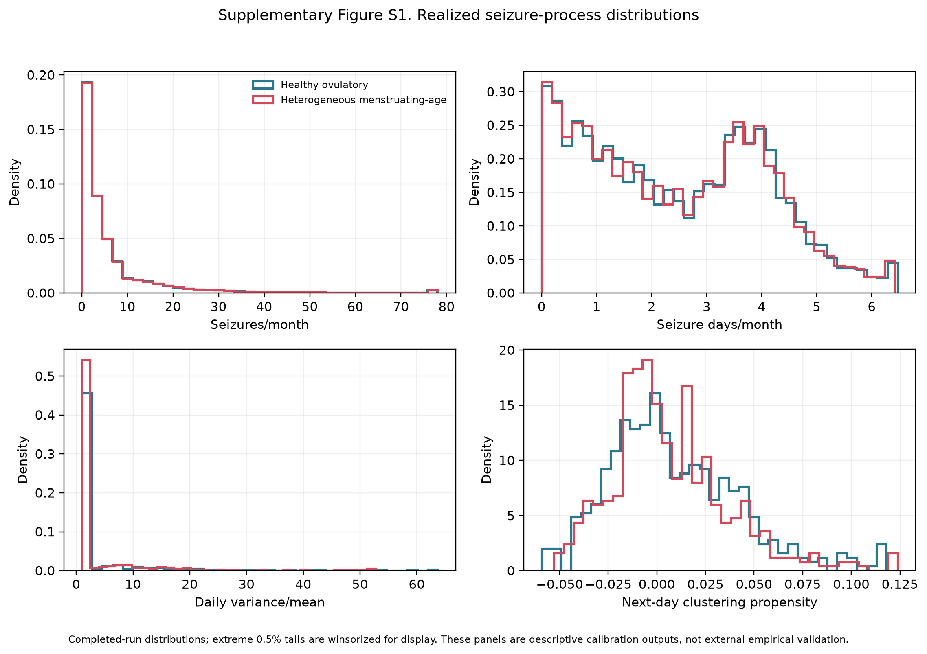

Supplementary Figure S2. Realized seizure-rhythm distributions. Panels show generator-reported dominant period, audit-sample spectral period and amplitude, and latent monthly seizure burden.
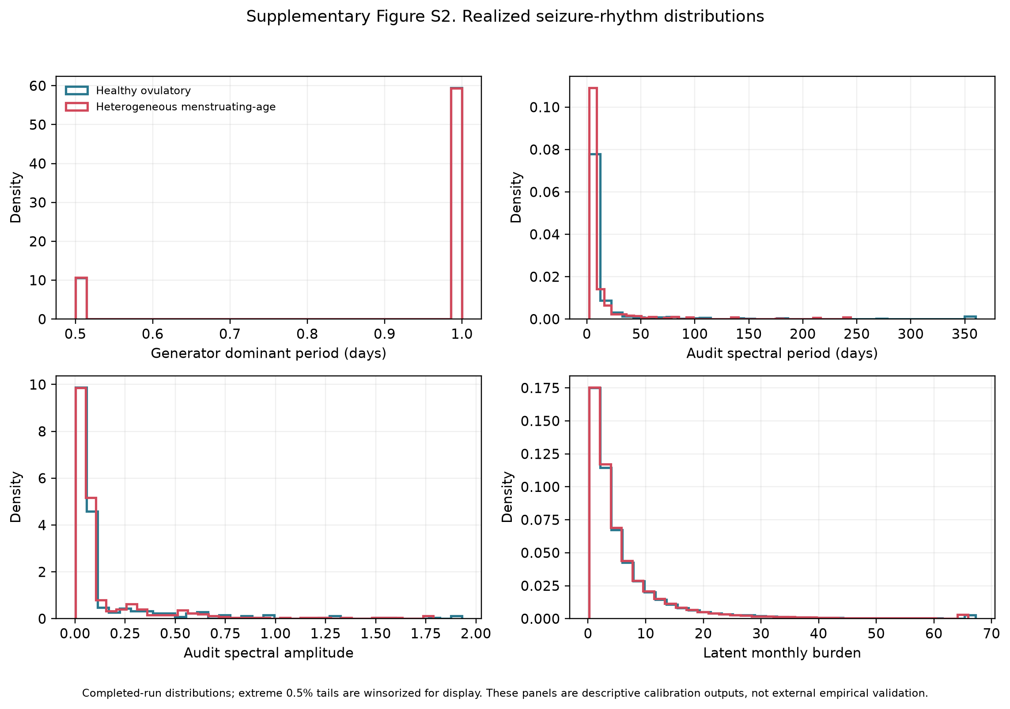

Supplementary Figure S3. Realized menstrual-cycle distributions. Panels show mean cycle length, within-person cycle-length SD, ovulatory fraction, and ILP fraction. ILP is displayed only for the heterogeneous audit sample because C3 is not applicable in the healthy cohort.
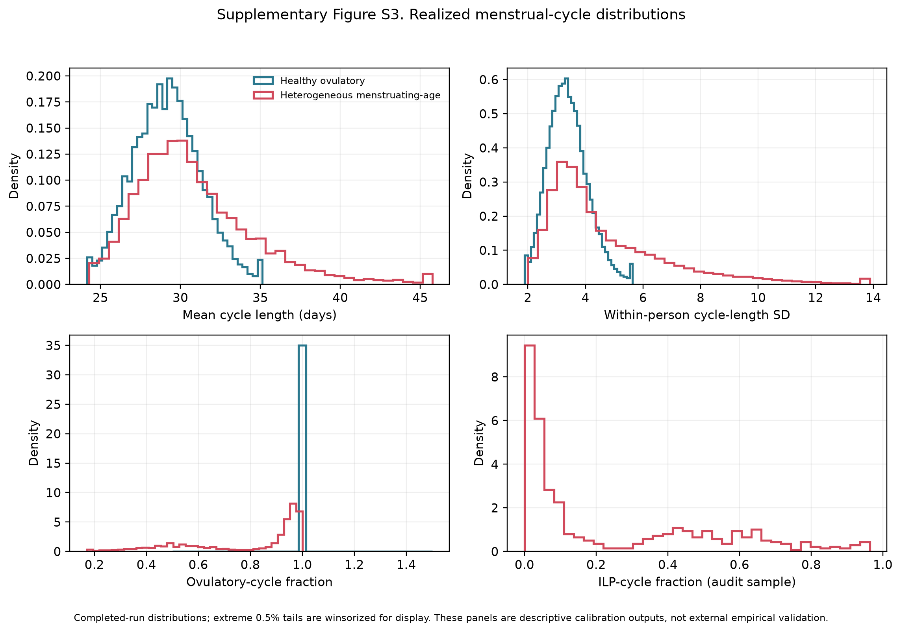

Supplementary Figure S4. Age and configured modifiers. Modifier frequencies are investigator-configured stress-test assumptions, not population estimates.
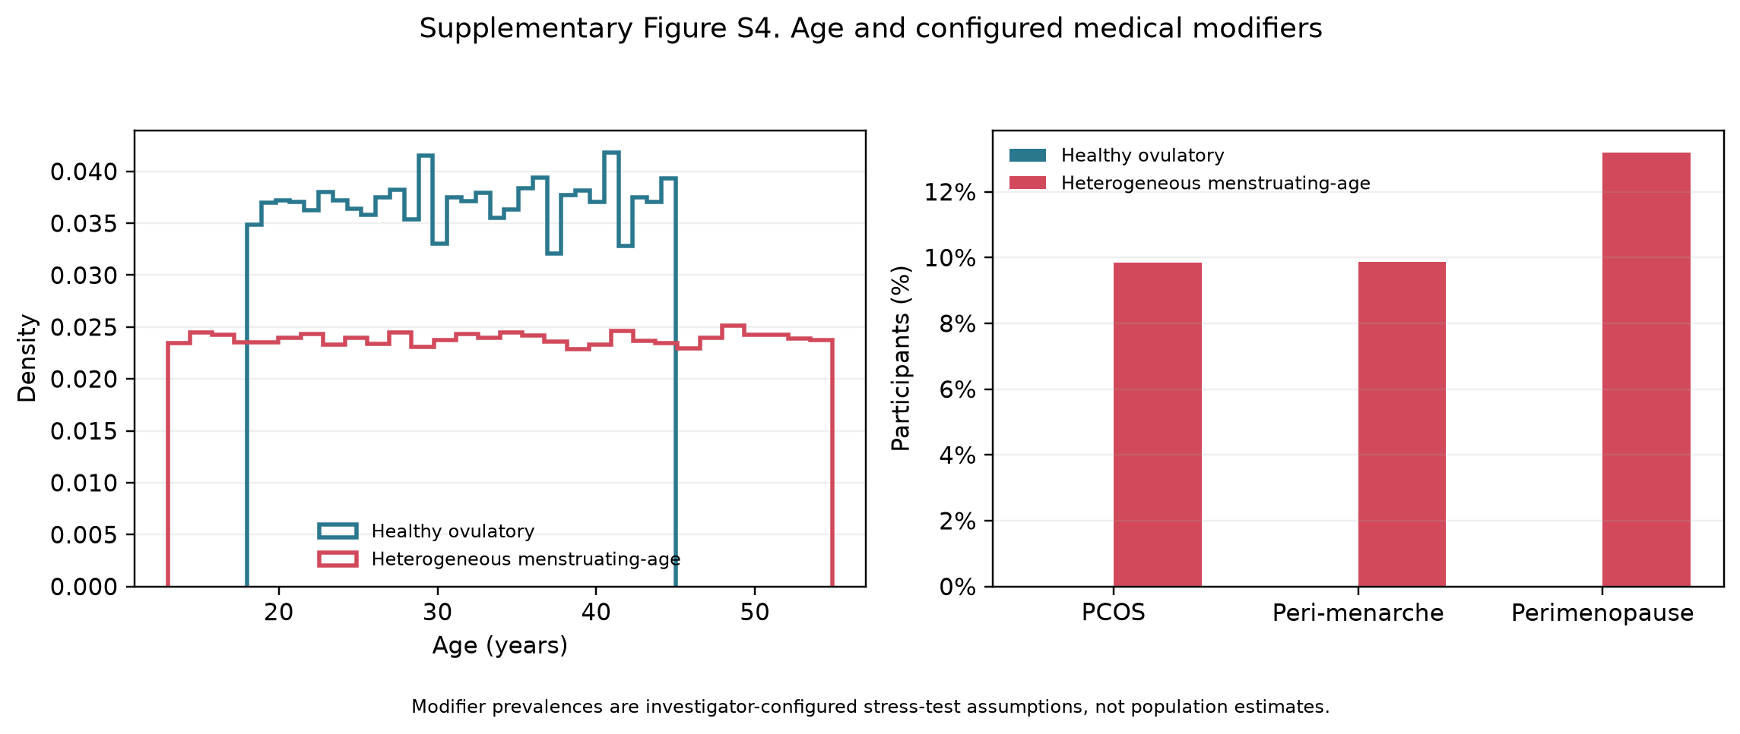

Supplementary Figure S5. Associations with simulated apparent classification across within-cohort feature quintiles. The display is descriptive and not a clinical risk model.
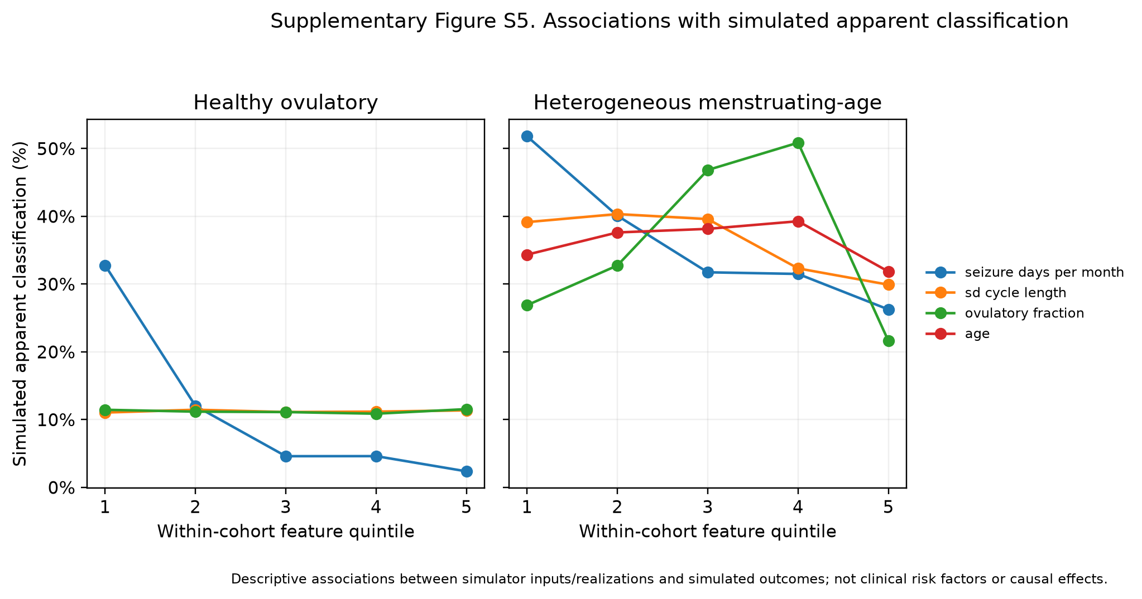

S12. Interpretation of simulator calibration
The figure set intentionally distinguishes completed-run distributions from external empirical validation. Where participant-level empirical microdata were unavailable, the figures show simulated distributions and the source table identifies the published summary targets. They should be described as distributional calibration outputs. External validation requires paired real seizure and menstrual diaries analyzed with aligned definitions, participant-level resampling, and complementary within-person shift and matched cross-person null designs.

References
1. Daniel Goldenholz. HORMONE-CYCLE [Internet]. GoldenholzLab; 2026. Available from: https://github.com/GoldenholzLab/catamenial-epilepsy-sim.git
2. Goldenholz DM, Westover MB. Flexible realistic simulation of seizure occurrence recapitulating statistical properties of seizure diaries. Epilepsia. 2023; 64(2):396–405.
3. Monks T, Currie CSM, Onggo BS, Robinson S, Kunc M, Taylor SJE. Strengthening the reporting of empirical simulation studies: introducing the STRESS guidelines. J Simul. 2019; 13(1):55–67.
4. Stricker R, Eberhart R, Chevailler M-C, Quinn FA, Bischof P, Stricker R. Establishment of detailed reference values for luteinizing hormone, follicle stimulating hormone, estradiol, and progesterone during different phases of the menstrual cycle on the Abbott ARCHITECT analyzer. Clin Chem Lab Med. 2006; 44(7):883–7.
5. Bull JR, Rowland SP, Scherwitzl EB, Scherwitzl R, Danielsson KG, Harper J. Real-world menstrual cycle characteristics of more than 600,000 menstrual cycles. NPJ Digit Med. 2019; 2:83.
6. Li H, Gibson EA, Jukic AMZ, Baird DD, Wilcox AJ, Curry CL, et al. Menstrual cycle length variation by demographic characteristics from the Apple Women’s Health Study. NPJ Digit Med. 2023; 6(1):100.
7. Herzog AG, Klein P, Ransil BJ. Three patterns of catamenial epilepsy. Epilepsia. 1997; 38(10):1082–8.

