Appendix S1
False Positive Catamenial Epilepsy Classification: A Simulation Study

S1. Reproducibility and provenance
The completed primary simulation run (100,000 participants; 50,000 per cohort; 36 months) used master seed 20260505. Its manifest records output hashes plus the exact analysis-code and configuration Secure Hash Algorithm 256-bit (SHA-256) fingerprints. Draft-v5 supplemental tables were derived from window_results.parquet, participant_summary.parquet, study_level_3month.parquet, and the deterministic 1% audit_daily_sample.parquet in that run directory. the HORMONE-CYCLE menstrual and hormone simulator, version 0.1.0, was used.(1) (2) (3)
The completed manifest stores the analysis-code fingerprint bb88a232804621881b1b9948997912156aca042d2044d41600fd8682a7587c1d and configuration fingerprint 754d14e80eee6c268d590d9893d9354f55cb8aa68da6b520bd0bae69e8eed9db, together with SHA-256 hashes for every primary output file. The supplemental manifest stores builder fingerprint 75b1fb3f708b33d2bb31c5856a94becb9785959b75c5fd6f78918ae6b34bbe44 and hashes for each derived artifact. These identifiers should accompany archived outputs.

S2. Simulator inputs, realized features, and sources
Both the CHOCOLATES seizure-diary simulator and the HORMONE-CYCLE menstrual and hormone simulator were designed to reproduce published statistical features within and across patient populations. CHOCOLATES encodes between-person seizure burden, overdispersion, clustering, rhythms, and interseizure constraints; HORMONE-CYCLE encodes between-person traits and within-person cycle-to-cycle realizations. The table distinguishes literature-calibrated targets, simulator-native behavior, investigator-configured stress assumptions, adapter-derived fields, and realized outputs. (2) (4–6)
Domain | Parameter | Cohort | Setting / sampling distribution | Level | Source / rationale | Realized target
Seizure | Monthly burden | Both | Simulator-native empirical distribution | Participant | Goldenholz & Westover 2023 | Realized seizures/month
Seizure | Overdispersion | Both | Simulator-native | Participant/day | Goldenholz & Westover 2023 | Audit daily variance/mean
Seizure | Clustering | Both | Simulator-native | Participant/day | Goldenholz & Westover 2023 | Audit next-day clustering proxy
Seizure | Multidien periods and amplitudes | Both | Simulator-native | Participant/day | Goldenholz & Westover 2023; Karoly et al. | Generator period and audit spectrum
Seizure | Interseizure constraints | Both | Simulator-native | Day | Goldenholz & Westover 2023 | Not separately stored
Menstrual | Age | Cohort-specific | {'healthy_ovulatory': {'age_range': [18.0, 45.0], 'force_ovulatory_cycles': True}, 'population': {'age_range': [13.0, 54.9], 'force_ovulatory_cycles': False}} | Participant | Investigator-configured study cohorts | Participant age
Menstrual | Cycle length and variability | Both | Literature-calibrated distributions | Participant/cycle | Li et al. 2023; Bull et al. 2019 | Mean and within-person standard deviation
Menstrual | Bleeding duration | Both | Literature-calibrated | Cycle | Bull et al. 2019 | Available in simulator validation suite
Menstrual | Ovulation and phase timing | Cohort-specific | Age/stage/modifier-dependent | Participant/cycle | Bull et al. 2019; simulator literature registry | Ovulatory fraction
Menstrual | Hormone trajectories | Both | Interpolated daily reference medians | Cycle/day | Stricker et al. 2006 | Simulator validation suite
Menstrual | Inadequate-luteal-phase rule | Population | Maximum progesterone on days 5–9 after ovulation < 5.0 ng/mL; nonovulatory/missing cycles flagged | Cycle | Investigator operationalization; threshold requires biological citation | Audit inadequate-luteal-phase fraction
Menstrual | Polycystic ovary syndrome | Population | 0.1 | Participant | Investigator-configured stress-test rate | Participant prevalence
Menstrual | Peri-menarche | Population | 0.6 | Participant conditional on age <20 | Investigator-configured stress-test rate | Participant prevalence
Menstrual | Perimenopause | Population | 0.55 | Participant conditional on age ≥45 | Investigator-configured stress-test rate | Participant prevalence
Menstrual | Dysmenorrhea | Population | 0.12 | Participant | Investigator-configured stress-test rate | Not retained in participant summary
Menstrual | Contraception/intrauterine-device settings | Both | Available but not sampled in completed run | Participant | Simulator literature registry | Not applicable to completed run
Observation | Diary duration | Both | 36 | Participant | Study design | 36 months
Observation | Missingness | Both | No diary missingness simulated | Day | Study-design simplification | Complete synthetic diaries
Null construction | Independent generators | Both | Separately seeded seizure and hormone generators aligned directly by calendar day | Participant | Study design | Direct alignment preserved
Null construction | Master seed | Both | 20260505 | Run | Reproducibility control | Manifested
Null construction | Phase modes | Both | strict_herzog, luteal_anchored_ovulatory | Analysis | Herzog criteria plus sensitivity | Both modes retained
Null construction | Cohort sizes | Cohort-specific | {'healthy_ovulatory': 50000, 'population': 50000} | Run | Monte Carlo design | 100,000 total

Note. The full machine-readable table additionally records code/config fields, sensitivity status, and the analysis-code and configuration Secure Hash Algorithm 256-bit fingerprints. Values labeled investigator-configured are stress-test assumptions. The completed output did not retain CHOCOLATES cluster status or generator amplitude fields; audit-sample proxies are reported instead.

S3. HORMONE-CYCLE: data-driven menstrual and hormone diary simulator
HORMONE-CYCLE is a new, custom, open-source simulator built for the present project. It generates reproducible daily menstrual-cycle, bleeding, ovulation, estradiol, and progesterone diaries from a compact set of patient inputs. The name HORMONE-CYCLE is the software title, not an abbreviation. The implementation is intended for simulation research and method evaluation; it is not a mechanistic model of the hypothalamic-pituitary-ovarian axis, a diagnostic device, or a clinical hormone calculator. (1)
The design is hierarchical: population evidence constrains age-specific distributions; each simulated person receives stable latent traits; each cycle receives a stochastic realization; and a daily renderer converts cycle timing into hormone and bleeding trajectories. Large app-based cohorts informed cycle length and irregularity, observed ovulatory-cycle data informed follicular and luteal timing, and phase-specific laboratory medians informed estradiol and progesterone anchors. (4–6) (7)

S3.1. Scope, inputs, and outputs
The public simulation call accepts age in years, diary length in days, a random seed, and optional medical or reproductive modifiers. The seed initializes an isolated pseudorandom stream, so identical inputs produce identical diaries without depending on global random state. Input validation rejects nonfinite ages, nonpositive diary lengths, and incompatible modifier combinations.
Each daily record contains the calendar-day index, cycle index, day within cycle, realized cycle length, estradiol in picograms per milliliter, progesterone in nanograms per milliliter, a binary ovulation indicator, and a binary bleeding indicator. Cycle summaries retain ovulatory status, ovulation day, follicular and luteal lengths, bleeding duration, and the patient profile used to render the cycle. Menstrual bleeding is treated as a modeled episode beginning on cycle day 1; the terminology is consistent with standard clinical definitions, while the simulator deliberately simplifies bleeding intensity to a daily indicator.
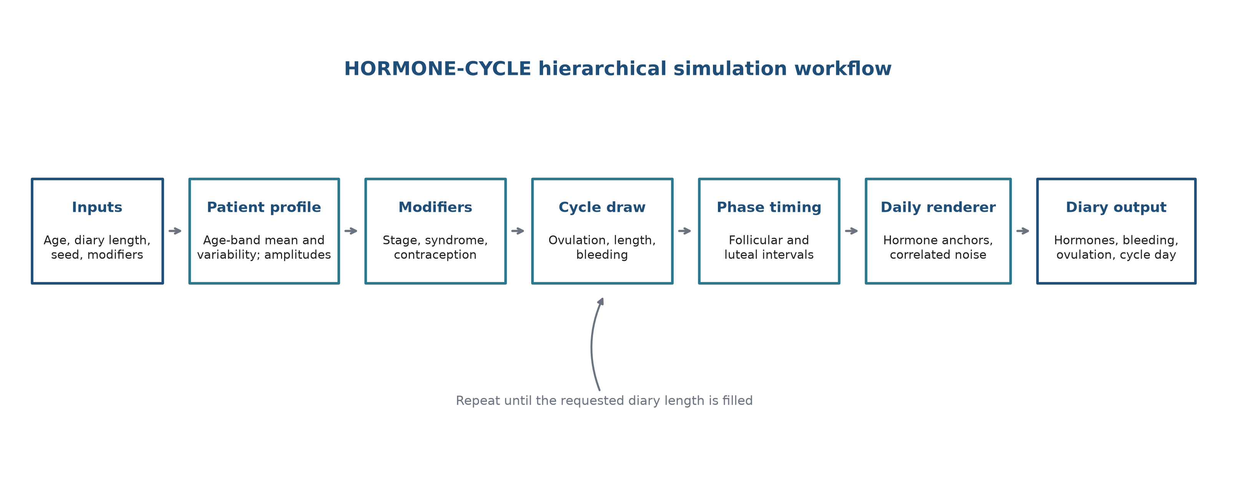
Appendix Figure A1. HORMONE-CYCLE workflow. Patient-level parameters are resolved once, cycle-level parameters are sampled repeatedly, and the daily renderer continues until the requested diary length is filled. All stages use the same seeded random stream.

S3.2. Patient-level parameter resolution
Age selects one of eight calibration bands. Each band supplies a target mean cycle length and a target probability that two adjacent cycles differ by at least 7 days. Under the working assumption that independent cycle-length deviations are Gaussian with within-person standard deviation σ, the adjacent-cycle difference has standard deviation √2σ. The implementation numerically inverts 2[1−Φ(7/(√2σ))] to obtain the σ that reproduces the published irregularity probability, where Φ is the standard normal cumulative distribution function. This inversion converts an observable population summary into a latent simulation parameter; it is not presented as a biological law.
A person's mean cycle length is then sampled around the age-band target with an age-dependent between-person standard deviation. Stable person-level estradiol and progesterone amplitude multipliers are lognormally distributed with coefficients of variation 0.18 and 0.22, respectively. The baseline day-to-day hormone-noise scale is 0.06. Baseline bleeding duration is sampled around 4.7 days with a standard deviation of 1.0 day. These dispersion terms were tuned to create realistic within- and between-person heterogeneity while retaining the published central targets.
Appendix Table A1. Core patient- and cycle-level targets. The ovulation probabilities are investigator-selected calibration constants constrained by age and reproductive-stage evidence; they are not direct prevalence estimates from a single study.
Parameter or age band | Mean or target | Irregularity or dispersion | Baseline ovulation probability | Evidence role
Age <20 years | 30.3 days | 31.2% | 0.62 | Li et al.; calibrated
Age 20–24 years | 30.0 days | 20.4% | 0.90 | Li et al.; calibrated
Age 25–29 years | 29.1 days | 16.4% | 0.97 | Li et al.; calibrated
Age 30–34 years | 28.8 days | 14.7% | 0.97 | Li et al.; calibrated
Age 35–39 years | 28.8 days | 15.9% | 0.97 | Li et al.; calibrated
Age 40–44 years | 28.4 days | 20.2% | 0.95 | Li et al.; calibrated
Age 45–49 years | 28.2 days | 27.2% | 0.88 | Li et al.; calibrated
Age ≥50 years | 30.8 days | 55.4% | 0.70 | Li et al.; calibrated
Ovulatory luteal interval | 12.4 days | Standard deviation 1.7 days | Not applicable | Bull et al.
Bleeding duration | 4.7 days | Standard deviation 1.0 day | Not applicable | Bull et al.

S3.3. Cycle generation algorithm
For each cycle, ovulation is first drawn from a Bernoulli distribution using the resolved patient probability. Cycle length is sampled from a truncated Gaussian distribution centered on the patient's mean, with a minimum of 18 days and a maximum of 120 days. Anovulatory cycles receive wider dispersion and reproductive-stage-specific shifts because their timing is less constrained. In an ovulatory cycle, luteal length is sampled from a truncated Gaussian distribution with mean 12.4 days, standard deviation 1.7 days, and minimum 9 days; the remaining length is assigned to the follicular interval. This concentrates most cycle-length variability in the follicular interval, consistent with observed cycle structure.
Bleeding duration is independently sampled from the resolved patient distribution and clipped to the cycle. Person-level traits are multiplied by additional cycle-level estradiol and progesterone amplitude factors with coefficients of variation 0.08 and 0.10. The simulator continues drawing complete cycles and truncates only the final rendered output to the requested diary length; no cycle is circularly shifted and no diary segment is wrapped from one end to the other.

S3.4. Daily hormone and bleeding renderer
Ovulatory hormone trajectories are constructed from seven reference subphases: early follicular, mid-follicular, preovulatory, ovulation, early luteal, midluteal, and late luteal. The renderer maps those anchors onto the realized follicular and luteal intervals and joins them with a smoothstep interpolation, which has zero slope at each endpoint and avoids artificial day-to-day discontinuities. Anovulatory cycles use separate blunted estradiol and progesterone anchors rather than an ovulatory peak.
Appendix Table A2. Reference hormone anchors used for ovulatory cycles. Estradiol is reported in picograms per milliliter and progesterone in nanograms per milliliter.
Menstrual subphase | Estradiol target | Progesterone target
Early follicular | 42.9 | 0.44
Mid-follicular | 88.1 | 0.56
Preovulatory | 234.0 | 1.31
Ovulation | 141.0 | 1.43
Early luteal | 132.0 | 3.95
Midluteal | 117.0 | 11.02
Late luteal | 111.0 | 6.75
Serial day-to-day variation is added with a first-order autoregressive process having coefficient 0.65; progesterone noise is multiplied by 0.9. The coefficient is an investigator-selected continuity parameter, not a published physiological constant. Final values are floored at 5 picograms per milliliter for estradiol and 0.05 nanograms per milliliter for progesterone and rounded to two decimals. Bleeding is marked from cycle day 1 through the realized bleeding duration, and ovulation is marked only on the sampled ovulation day. (4)

S3.5. Reproductive-stage and medical-factor modifiers
Modifiers operate on the resolved profile before cycles are rendered. Their purpose is to reproduce the direction and approximate magnitude of well-described phenotypes, not to encode causal physiology or estimate clinical prevalence. Polycystic ovary syndrome produces longer and more variable cycles and less frequent ovulation, with age-dependent cycle length effects. (8,9)
Early postmenarche profiles receive longer, more irregular, and more often anovulatory cycles, whereas perimenopause increases irregularity and reduces ovulation. (10–12)
Cyclic and continuous combined oral contraceptive profiles suppress endogenous-equivalent ovulation and use fixed 28-day regimen cycles. A levonorgestrel-releasing intrauterine device reduces bleeding and permits ovulation in most cycles; a copper intrauterine device preserves ovulation while increasing bleeding duration. (13–17)
Primary dysmenorrhea is represented as a modest bleeding-duration shift without a large steroid-hormone perturbation. (18)
Appendix Table A3. Implemented modifier values. Multipliers and offsets are transparent calibration parameters selected to place simulated summaries within prespecified evidence-constrained ranges.
Modifier | Cycle-length effect | Cycle variability | Ovulation effect | Bleeding and hormone effects
Polycystic ovary syndrome | Mean cycle ×1.30 if age <25; ×1.22 at 25–34; ×1.15 at ≥35 | Variability ×1.55 | Ovulation ×0.48 | Bleeding +0.4 day; estradiol ×1.08; progesterone ×0.58; noise ×1.15
Early postmenarche | Mean cycle +2.5 days | Variability ×1.25 | Maximum 0.55 | Bleeding +0.5 day; estradiol ×0.92; progesterone ×0.72; noise ×1.15
Perimenopause | Stage-specific cycle shifts | Variability ×1.35 | Ovulation ×0.78 | Bleeding +0.6 day; progesterone ×0.82; noise ×1.25
Copper intrauterine device | No cycle-length shift | No added cycle variability | Preserved | Bleeding +1.2 days; bleeding standard deviation +0.25 day
Levonorgestrel-releasing intrauterine device | No cycle-length shift | No added cycle variability | Maximum 0.82 | Bleeding −2.2 days with 0.8-day floor; amenorrhea probability 0.17
Cyclic combined oral contraceptive | Fixed 28 days | None | Suppressed | Approximately 4 days of scheduled withdrawal bleeding; suppressed hormone curves
Continuous combined oral contraceptive | Fixed 28 days | None | Suppressed | Amenorrhea probability 0.55 with modeled breakthrough bleeding
Primary dysmenorrhea | No cycle-length shift | No added cycle variability | Preserved | Bleeding +0.5 day; bleeding standard deviation +0.15 day

S3.6. Adapter used in the present study
The present study used two cohorts. The healthy ovulatory cohort sampled ages 18–45 years and forced every rendered cycle to be ovulatory. The heterogeneous cohort sampled ages 13–54.9 years and applied investigator-configured stress-test probabilities: polycystic ovary syndrome 0.10, early-postmenarche modifier 0.60 conditional on age under 20 years, perimenopause modifier 0.55 conditional on age at least 45 years, and dysmenorrhea 0.12. These probabilities define the simulation experiment and must not be interpreted as population prevalence estimates.
The adapter adds menstrual-onset, ovulatory-status, ovulation-day, reproductive-stage, and inadequate-luteal-phase fields. For an ovulatory cycle, inadequate luteal phase is designated when the maximum progesterone value from days 5–9 after ovulation is below 5 nanograms per milliliter; if that interval is unavailable, all available postovulation days are considered. Nonovulatory cycles and cycles lacking a usable ovulation day or progesterone field are designated inadequate. The seizure and hormone diaries are joined by the same calendar-day index. No circular shift, phase randomization, or wraparound is applied.

S3.7. Calibration and validation design
The current implementation was rerun for this appendix with 10,000 simulated participants, 365 days per participant, and seed 7. Baseline checks compare age-stratified mean cycle length and adjacent-cycle irregularity, mean follicular and luteal intervals, mean bleeding duration, and seven estradiol plus seven progesterone subphase summaries with prespecified target ranges. The source cohorts are large enough that their confidence intervals can be narrower than a reasonable tolerance for a simulator reconstructed from published summaries; therefore, the pass ranges are equivalence windows around target values rather than claims that the simulator reproduces the source-study confidence interval.
Modifier scenarios are assessed separately against directional or bounded expectations: longer and more irregular cycles with polycystic ovary syndrome; ovulation suppression under combined oral contraceptives; reduced bleeding with a levonorgestrel-releasing intrauterine device; preserved ovulation and increased bleeding with a copper intrauterine device; increased irregularity with perimenopause; longer and less frequently ovulatory cycles early after menarche; and preserved ovulation with a modest bleeding shift in dysmenorrhea.
These checks are best described as internal distributional calibration and face-validity checks because the same literature summaries informed parameter choice and evaluation ranges. They do not constitute independent external validation against unseen person-level hormone and bleeding diaries.
Appendix Table A4. Complete baseline calibration results from the current 10,000-participant run. All 33 prespecified metrics passed. Hormone concentrations use picograms per milliliter for estradiol and nanograms per milliliter for progesterone; duration metrics use days.
Metric | Simulated | Target | Pass range | Result | Primary source
Mean cycle length, age <20 | 30.57 | 30.30 | 29.65 to 30.95 | Pass | Li et al.
Adjacent cycles differing by ≥7 days, age <20 | 30.7% | 31.2% | 26.9% to 35.5% | Pass | Li et al.
Mean cycle length, age 20–24 | 30.01 | 30.00 | 29.50 to 30.50 | Pass | Li et al.
Adjacent cycles differing by ≥7 days, age 20–24 | 19.5% | 20.4% | 16.4% to 24.4% | Pass | Li et al.
Mean cycle length, age 25–29 | 28.98 | 29.10 | 28.60 to 29.60 | Pass | Li et al.
Adjacent cycles differing by ≥7 days, age 25–29 | 16.2% | 16.4% | 12.4% to 20.4% | Pass | Li et al.
Mean cycle length, age 30–34 | 28.78 | 28.80 | 28.30 to 29.30 | Pass | Li et al.
Adjacent cycles differing by ≥7 days, age 30–34 | 14.6% | 14.7% | 10.7% to 18.7% | Pass | Li et al.
Mean cycle length, age 35–39 | 28.68 | 28.80 | 28.30 to 29.30 | Pass | Li et al.
Adjacent cycles differing by ≥7 days, age 35–39 | 16.0% | 15.9% | 11.9% to 19.9% | Pass | Li et al.
Mean cycle length, age 40–44 | 28.52 | 28.40 | 27.90 to 28.90 | Pass | Li et al.
Adjacent cycles differing by ≥7 days, age 40–44 | 19.9% | 20.2% | 16.2% to 24.2% | Pass | Li et al.
Mean cycle length, age 45–49 | 28.40 | 28.20 | 27.60 to 28.80 | Pass | Li et al.
Adjacent cycles differing by ≥7 days, age 45–49 | 26.1% | 27.2% | 23.2% to 31.2% | Pass | Li et al.
Mean cycle length, age ≥50 | 32.21 | 30.80 | 29.25 to 32.35 | Pass | Li et al.
Adjacent cycles differing by ≥7 days, age ≥50 | 52.5% | 55.4% | 44.6% to 66.1% | Pass | Li et al.
Mean follicular interval | 16.81 | 16.90 | 15.90 to 17.90 | Pass | Bull et al.
Mean luteal interval | 12.41 | 12.40 | 11.70 to 13.10 | Pass | Bull et al.
Mean bleeding duration | 4.70 | 4.70 | 4.00 to 5.40 | Pass | Bull et al.
Estradiol, early follicular | 45.17 | 42.90 | 32.17 to 53.62 | Pass | Stricker et al.
Progesterone, early follicular | 0.45 | 0.44 | 0.29 to 0.59 | Pass | Stricker et al.
Estradiol, mid follicular | 81.81 | 88.10 | 66.07 to 110.12 | Pass | Stricker et al.
Progesterone, mid follicular | 0.57 | 0.56 | 0.36 to 0.76 | Pass | Stricker et al.
Estradiol, pre ovulatory | 185.60 | 234.00 | 175.50 to 292.50 | Pass | Stricker et al.
Progesterone, pre ovulatory | 1.10 | 1.31 | 0.85 to 1.77 | Pass | Stricker et al.
Estradiol, ovulation | 130.87 | 141.00 | 105.75 to 176.25 | Pass | Stricker et al.
Progesterone, ovulation | 1.44 | 1.43 | 0.93 to 1.93 | Pass | Stricker et al.
Estradiol, early luteal | 124.86 | 132.00 | 99.00 to 165.00 | Pass | Stricker et al.
Progesterone, early luteal | 3.53 | 3.95 | 2.57 to 5.33 | Pass | Stricker et al.
Estradiol, mid luteal | 111.18 | 117.00 | 87.75 to 146.25 | Pass | Stricker et al.
Progesterone, mid luteal | 9.36 | 11.02 | 7.16 to 14.88 | Pass | Stricker et al.
Estradiol, late luteal | 103.11 | 111.00 | 83.25 to 138.75 | Pass | Stricker et al.
Progesterone, late luteal | 6.99 | 6.75 | 4.39 to 9.11 | Pass | Stricker et al.
Appendix Table A5. Modifier-scenario summaries from the current validation run. Irregularity is the proportion of adjacent cycles differing by at least 7 days. Amenorrhea is reported only where the profile permits it.
Scenario | Mean cycle (days) | Ovulatory cycles | Mean bleeding (days) | Irregularity | Amenorrhea | Prespecified checks
Baseline reference | 29.43 | 90.5% | 4.69 | 24.5% | 0.0% | Reference
Polycystic ovary syndrome | 36.11 | 42.6% | 5.10 | 47.2% | 0.0% | 3/3 passed
Cyclic combined oral contraceptive | 28.00 | 0.0% | 4.00 | 0.0% | 0.0% | 2/2 passed
Continuous combined oral contraceptive | 28.00 | 0.0% | 0.96 | 0.0% | 55.4% | 3/3 passed
Levonorgestrel-releasing intrauterine device | 29.63 | 80.0% | 2.08 | 24.8% | 17.4% | 2/2 passed
Copper intrauterine device | 29.46 | 90.9% | 5.88 | 24.5% | 0.0% | 2/2 passed
Perimenopause | 30.26 | 52.4% | 5.92 | 40.4% | 0.0% | 2/2 passed
Early postmenarche | 32.86 | 54.9% | 5.82 | 37.2% | 0.0% | 3/3 passed
Primary dysmenorrhea | 29.27 | 90.9% | 5.21 | 24.9% | 0.0% | 2/2 passed
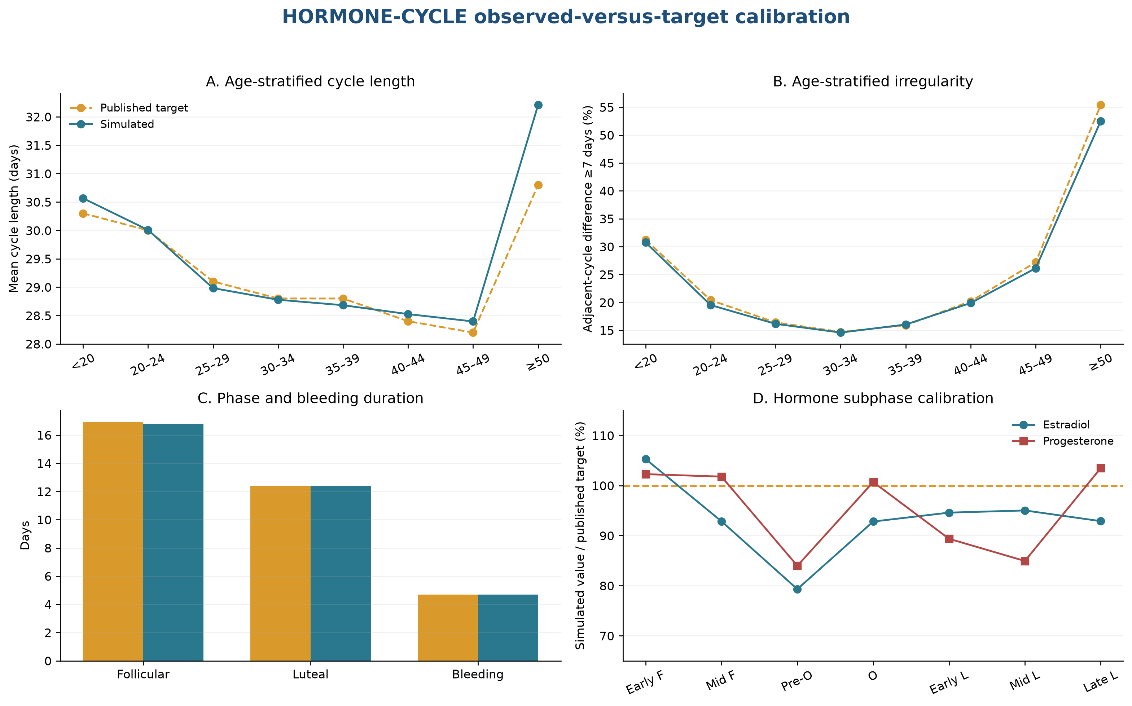
Appendix Figure A2. Observed-versus-target calibration in the current run. Panels A and B show age-stratified cycle length and irregularity; panel C shows mean follicular, luteal, and bleeding durations; panel D expresses simulated hormone values as a percentage of each published subphase target. Early F and mid F denote early and mid-follicular phases; pre-O and O denote preovulatory and ovulation phases; early L, mid L, and late L denote luteal phases.

S3.8. Reproducibility, intended uses, and limitations
The simulator is deterministic for fixed inputs and seed, implemented in pure Python, and distributed with unit tests, a command-line interface, and a machine-readable validation report. Reproducible research records should preserve the repository commit, configuration, seed, requested diary length, age and modifier inputs, and validation-report hash.
Appropriate uses include simulation studies, power and operating-characteristic analyses, testing algorithms that consume menstrual or hormone diaries, and generating controlled synthetic examples. The simulator should not be used to forecast an individual's hormones, infer ovulation from clinical data, estimate treatment effects, or substitute for measured endocrine data.
Important limitations are deliberate simplifications. The model does not simulate pregnancy, postpartum physiology, exogenous-hormone dose changes, medication adherence, secular trends, missing diary entries, bleeding intensity, laboratory-assay error, or feedback dynamics of the endocrine axis. Medical modifiers are coarse profile transformations and may overlap in real patients in ways not represented here. The published targets come from cohorts with their own selection, measurement, and cycle-tracking limitations. Finally, passing the internal calibration suite establishes consistency with selected summaries, not transportability to every population.

S4. Assumption-by-assumption review
This section uses type C1 for the perimenstrual pattern, type C2 for the periovulatory pattern, and type C3 for the inadequate-luteal-phase pattern. Inadequate luteal phase (ILP) and negative binomial (NB) are defined here for the assumption table.
Assumption | Rationale | Limitation / implication
Independent generators | Defines the false-positive estimand; no participant-level seizure–hormone coupling was introduced. | Does not model true catamenial effects or false negatives.
Direct calendar-day alignment | Preserves the separately seeded seizure and hormone generator outputs without reordering. | Independence follows from separate random streams; no artificial wraparound boundary is introduced.
36-month diaries | Provides long follow-up and permits shorter nested window comparisons. | Longer-term medication changes and secular trends were not modeled.
Healthy ovulatory cohort | Provides a lower-heterogeneity reference in which C3 is not applicable. | Not intended to represent all menstruating people with epilepsy.
Heterogeneous cohort | Stress-tests irregularity, anovulation, and configured modifiers. | Modifier rates are assumptions, not population prevalence estimates.
Strict Herzog phases | Preserves historical comparability with the original criteria. | The ovulatory interval expands in longer cycles; the luteal-anchored mode tests a fixed interval.
Unlabeled days | Matches the historical phase partition and prevents implicit reassignment. | Reduces observed denominators and can make short windows indeterminate.
Exact thresholds 1.69/1.83/1.62 | Uses the published distributional inflection points instead of rounded twofold shorthand. | Threshold performance remains dependent on sparse numerator and comparator counts.
Zero-comparator handling | A positive numerator over zero comparator is represented as +infinity; 0/0 is undefined. | Makes the sparse-event vulnerability transparent rather than silently adding a continuity correction.
Inadequate-luteal-phase threshold <5 ng/mL | Operationalizes the ovulatory threshold used in the original Herzog phase study. | A single operational cutoff does not exhaust biological definitions of luteal adequacy.
Nonovulatory cycles designated inadequate luteal phase | Matches the implemented C3 adapter and the C3 concept of inadequate luteal-phase cycles. | Makes C3 mechanically sensitive to anovulation prevalence and should not be called an independent validation.
Minimum-data rule | Investigator-selected sensitivity to reduce classifications dominated by very sparse seizure counts. | The 4-month/6-cycle and 4-seizure-day cutoffs are pragmatic rather than biologically derived.
Negative-binomial type C1/type C2 calibration | Checks rejection behavior with a model family concordant with the CHOCOLATES count process. | Not an alternative clinical diagnostic method or independent simulator validation.
Exploratory negative-binomial type C3 | Provides a separately specified F versus O+L+M contrast in ILP cycles. | Uses only the saved 1% daily audit sample and stricter eligibility.
No missingness | Keeps the primary estimand focused on finite-window stochastic alignment. | Real diary missingness could affect phase and event denominators.
No medication/secular changes | Keeps the null stationary and interpretable. | Limits transportability to clinical diaries with treatment changes or disease evolution.

S5. Type C3 and inadequate-luteal-phase algorithm and applicability
Type C3 is the inadequate-luteal-phase catamenial pattern. In this section, inadequate luteal phase (ILP), average daily seizure frequency (ADSF), follicular (F), ovulatory (O), luteal (L), and menstrual (M) are used as local abbreviations.
The adapter operates at the cycle level. A nonovulatory cycle, a cycle without a valid ovulation day, or a cycle without a usable progesterone field receives the simulator-generated inadequate-luteal-phase indicator. For another ovulatory cycle, the adapter identifies days 5–9 after ovulation and uses the maximum simulated progesterone concentration in that interval. If the interval is absent, it falls back to all postovulation days. A value below 5.0 ng/mL is designated inadequate. C3 then compares ADSF(O+L+M) with ADSF(F) using only designated cycles. This is the implemented algorithm, and it supersedes the earlier draft sentence suggesting that ordinary nonovulatory cycles without an ILP indicator were excluded. (19)
C3 applicability is window-specific: a pooled window is applicable when it includes at least one designated cycle, but its ratio can still be undefined because labeled numerator/comparator days or events are insufficient. The cycle-reproducibility rule requires at least the prespecified number of complete ILP cycles. The exploratory C3 negative-binomial model requires at least four complete designated cycles and four seizure days in labeled designated-cycle data. C3 is not applicable in the healthy ovulatory cohort.

S6. Cumulative simulated Herzog seizure-frequency ratios
This section defines type C1 as ADSF(M)/ADSF(F+L), type C2 as ADSF(O)/ADSF(F+L), and type C3 as ADSF(O+L+M)/ADSF(F), where average daily seizure frequency (ADSF), follicular (F), ovulatory (O), luteal (L), and menstrual (M) are local abbreviations.
Supplementary Table S1. Cumulative distributions of simulated Herzog seizure-frequency ratios in strict three-complete-cycle windows under independence. Each panel has one row per participant-window. The first column is the Herzog ratio threshold. Positive infinity is defined and exceeds every finite threshold; undefined 0/0 or missing-phase ratios are excluded from the defined-ratio denominator. The ≥0 row therefore equals 100%. Only the study simulations are tabulated; the published trial data that motivated the layout are not reproduced or combined.

Panel A — C1 = ADSF(M)/ADSF(F+L)
Herzog ratio threshold (≥) | Healthy n | Healthy % | Heterogeneous n | Heterogeneous %
0 | 43,607 | 100.00 | 43,653 | 100.00
1 | 19,555 | 44.84 | 19,669 | 45.06
1.69 | 11,748 | 26.94 | 11,967 | 27.41
2 | 10,618 | 24.35 | 10,764 | 24.66
3 | 6,039 | 13.85 | 6,116 | 14.01
4 | 4,622 | 10.60 | 4,756 | 10.90
5 | 3,385 | 7.76 | 3,498 | 8.01
6 | 3,106 | 7.12 | 3,257 | 7.46
7 | 2,900 | 6.65 | 3,071 | 7.04
8 | 2,539 | 5.82 | 2,661 | 6.10
9 | 2,454 | 5.63 | 2,567 | 5.88
10 | 2,297 | 5.27 | 2,418 | 5.54

Note. Healthy attempted=50,000, defined=43,607, undefined=6,393; heterogeneous attempted=50,000, defined=43,653, undefined=6,347. Percentages use the defined-ratio denominator.

Panel B — C2 = ADSF(O)/ADSF(F+L)
Herzog ratio threshold (≥) | Healthy n | Healthy % | Heterogeneous n | Heterogeneous %
0 | 44,005 | 100.00 | 44,349 | 100.00
1 | 20,212 | 45.93 | 20,802 | 46.91
1.83 | 11,282 | 25.64 | 11,554 | 26.05
2 | 10,255 | 23.30 | 10,489 | 23.65
3 | 6,529 | 14.84 | 6,746 | 15.21
4 | 4,786 | 10.88 | 5,050 | 11.39
5 | 3,908 | 8.88 | 4,207 | 9.49
6 | 3,455 | 7.85 | 3,792 | 8.55
7 | 3,117 | 7.08 | 3,516 | 7.93
8 | 2,915 | 6.62 | 3,331 | 7.51
9 | 2,811 | 6.39 | 3,205 | 7.23
10 | 2,697 | 6.13 | 3,114 | 7.02

Note. Healthy attempted=50,000, defined=44,005, undefined=5,995; heterogeneous attempted=50,000, defined=44,349, undefined=5,651. Percentages use the defined-ratio denominator.

Panel C — C3 = ADSF(O+L+M)/ADSF(F)
Herzog ratio threshold (≥) | Heterogeneous n | Heterogeneous %
0 | 16,756 | 100.00
1 | 10,413 | 62.14
1.62 | 8,849 | 52.81
2 | 8,372 | 49.96
3 | 7,776 | 46.41
4 | 7,538 | 44.99
5 | 7,404 | 44.19
6 | 7,332 | 43.76
7 | 7,285 | 43.48
8 | 7,249 | 43.26
9 | 7,228 | 43.14
10 | 7,212 | 43.04

Note. Attempted=50,000; applicable=19,973; defined=16,756; undefined=3,217. The healthy cohort is not applicable and is not shown.

S7. Type C3 window-duration sensitivity
Type C3 denotes the inadequate-luteal-phase pattern. Confidence interval (CI) is defined here for the table; the table spells out the term in its header.
Supplementary Table S2. Windowed Herzog C3-only false-positive classifications in the heterogeneous cohort. The healthy ovulatory cohort is not applicable and is omitted.
Window | Applicable | Classifiable | Positive | Classifiable rate (95% Wilson confidence interval) | All-attempted rate
1 month | 16,475 | 7,719 | 4,506 | 58.4% (57.3%–59.5%) | 9.0%
3 months | 22,112 | 16,179 | 8,743 | 54.0% (53.3%–54.8%) | 17.5%
4 months | 24,026 | 18,589 | 9,751 | 52.5% (51.7%–53.2%) | 19.5%
6 months | 26,666 | 21,904 | 10,810 | 49.4% (48.7%–50.0%) | 21.6%
9 months | 29,721 | 25,210 | 11,693 | 46.4% (45.8%–47.0%) | 23.4%
12 months | 32,120 | 27,655 | 12,143 | 43.9% (43.3%–44.5%) | 24.3%
18 months | 35,897 | 31,473 | 13,060 | 41.5% (41.0%–42.0%) | 26.1%
24 months | 38,555 | 34,086 | 13,507 | 39.6% (39.1%–40.1%) | 27.0%
36 months | 43,297 | 38,879 | 14,252 | 36.7% (36.2%–37.1%) | 28.5%
3 complete cycles | 19,973 | 16,756 | 8,849 | 52.8% (52.1%–53.6%) | 17.7%
6 complete cycles | 25,364 | 22,026 | 10,610 | 48.2% (47.5%–48.8%) | 21.2%
12 complete cycles | 31,068 | 27,571 | 11,795 | 42.8% (42.2%–43.4%) | 23.6%
36-month full diary | 43,297 | 38,879 | 14,252 | 36.7% (36.2%–37.1%) | 28.5%

Note. Each window has 50,000 attempted heterogeneous-cohort participant-windows. Indeterminate reason counts are retained in tableS2_c3_window_sensitivity.csv.

S8. Investigator-selected minimum-data sensitivity
The minimum-data rule is a pragmatic investigator-selected sensitivity, not a Nyquist sampling requirement. The table varies the seizure-day minimum without selecting an optimal value and reports both classifiable and all-attempted rates. Calendar windows shorter than four months and cycle windows shorter than six cycles do not meet the duration component and are not included below.
Cohort | Window | Minimum seizure days | Classifiable | Classifiable rate | All-attempted rate
Healthy | 4 months | 2 | 43,188 | 38.0% | 32.8%
Healthy | 4 months | 3 | 40,269 | 36.6% | 29.5%
Healthy | 4 months | 4 | 37,627 | 35.8% | 26.9%
Healthy | 4 months | 6 | 32,717 | 34.7% | 22.7%
Healthy | 6 months | 2 | 45,261 | 33.2% | 30.1%
Healthy | 6 months | 3 | 43,129 | 32.1% | 27.7%
Healthy | 6 months | 4 | 41,140 | 31.4% | 25.9%
Healthy | 6 months | 6 | 37,514 | 30.3% | 22.7%
Healthy | 12 months | 2 | 47,522 | 24.9% | 23.6%
Healthy | 12 months | 3 | 46,362 | 24.0% | 22.3%
Healthy | 12 months | 4 | 45,268 | 23.4% | 21.2%
Healthy | 12 months | 6 | 43,128 | 22.5% | 19.4%
Healthy | 36 months | 2 | 49,193 | 11.1% | 10.9%
Healthy | 36-month full diary | 2 | 49,193 | 11.1% | 10.9%
Healthy | 36 months | 3 | 48,777 | 10.7% | 10.4%
Healthy | 36-month full diary | 3 | 48,777 | 10.7% | 10.4%
Healthy | 36 months | 4 | 48,359 | 10.4% | 10.0%
Healthy | 36-month full diary | 4 | 48,359 | 10.4% | 10.0%
Healthy | 36 months | 6 | 47,556 | 9.8% | 9.3%
Healthy | 36-month full diary | 6 | 47,556 | 9.8% | 9.3%
Heterogeneous | 4 months | 2 | 43,102 | 38.3% | 33.0%
Heterogeneous | 4 months | 3 | 40,158 | 37.1% | 29.8%
Heterogeneous | 4 months | 4 | 37,366 | 36.2% | 27.1%
Heterogeneous | 4 months | 6 | 32,624 | 35.1% | 22.9%
Heterogeneous | 6 months | 2 | 45,198 | 33.8% | 30.5%
Heterogeneous | 6 months | 3 | 43,147 | 32.7% | 28.2%
Heterogeneous | 6 months | 4 | 41,163 | 31.9% | 26.3%
Heterogeneous | 6 months | 6 | 37,492 | 30.6% | 22.9%
Heterogeneous | 12 months | 2 | 47,510 | 25.3% | 24.0%
Heterogeneous | 12 months | 3 | 46,394 | 24.5% | 22.8%
Heterogeneous | 12 months | 4 | 45,278 | 24.0% | 21.7%
Heterogeneous | 12 months | 6 | 43,131 | 23.1% | 19.9%
Heterogeneous | 36 months | 2 | 49,168 | 11.3% | 11.2%
Heterogeneous | 36-month full diary | 2 | 49,168 | 11.3% | 11.2%
Heterogeneous | 36 months | 3 | 48,763 | 11.0% | 10.7%
Heterogeneous | 36-month full diary | 3 | 48,763 | 11.0% | 10.7%
Heterogeneous | 36 months | 4 | 48,333 | 10.7% | 10.3%
Heterogeneous | 36-month full diary | 4 | 48,333 | 10.7% | 10.3%
Heterogeneous | 36 months | 6 | 47,503 | 10.1% | 9.6%
Heterogeneous | 36-month full diary | 6 | 47,503 | 10.1% | 9.6%

S9. Exploratory type C3 negative-binomial calibration check
Type C3 denotes the inadequate-luteal-phase pattern. In this section, inadequate luteal phase (ILP), average daily seizure frequency (ADSF), follicular (F), ovulatory (O), luteal (L), and menstrual (M) are local abbreviations; the negative-binomial model is otherwise written in full.
The specification was frozen before inspecting results (docs/c3_nb_calibration_spec.md). The estimand is the within-participant daily seizure-count rate ratio for O+L+M versus F days in complete simulator-designated ILP cycles. The log-link negative-binomial model uses participant-full-diary method-of-moments dispersion and cycle fixed effects; robust Poisson is a reported fallback. A positive result requires a one-sided P<.05 and rate ratio ≥1.62. This is a standalone exploratory family, so it is not Holm-combined with the primary C1/C2 family.
Attempted | Ratio type C3 applicable | Negative-binomial classifiable | Positive | Classifiable rate (95% Wilson confidence interval) | All-attempted rate
500 | 431 | 204 | 8 | 3.9% (2.0%–7.5%) | 1.6%

Reason counts: classifiable=204; fewer than required complete ilp cycles=271; seizure days below minimum=25. The narrower classifiable denominator reflects the model’s minimum four complete ILP cycles and four seizure days, not a discrepancy with pooled-ratio applicability.

S10. Mutually exclusive pattern decomposition
Type C1 denotes the perimenstrual pattern, type C2 the periovulatory pattern, and type C3 the inadequate-luteal-phase pattern.
Cohort / definition | None | Indeterminate | C1 only | C2 only | C1+C2 | C3 only | C3 with C1 and/or C2
Healthy / windowed Herzog | 87.9% | 0.8% | 5.9% | 3.4% | 2.1% | Not applicable | Not applicable
Healthy / minimum-data | 86.7% | 3.3% | 5.4% | 2.8% | 1.8% | Not applicable | Not applicable
Heterogeneous / windowed Herzog | 63.7% | 0.8% | 3.8% | 2.0% | 1.2% | 23.9% | 4.6%
Heterogeneous / minimum-data | 62.6% | 3.3% | 3.5% | 1.6% | 1.0% | 23.7% | 4.2%

Note. Supplementary Table S3. Mutually exclusive participant-window categories in 36-month strict-Herzog windows. Percentages use all attempted windows and sum to 100% within rounding after treating C3 as not applicable in the healthy cohort.

S11. Simulator-feature associations
The machine-readable comma-separated-values file reports 95% Wilson confidence intervals; no abbreviation is used below.
Supplementary Table S4 (machine-readable comma-separated-values file) reports stratified apparent-classification rates and 95% Wilson confidence intervals across prespecified quintiles of age, seizure burden, cycle length and variability, ovulatory fraction, and dominant seizure-cycle period, plus configured binary modifiers. These are descriptive associations between simulator inputs/realizations and simulated outcomes. They are not clinical patient risk factors, causal effects, or a patient-level prediction model. A clinical-facing calculator was not built.

S12. Realized distribution and association figures
Standard deviation and inadequate luteal phase are written in full in this section. Type C3 denotes the inadequate-luteal-phase pattern.
Supplementary Figure S1. Realized seizure-process distributions. Panels show seizures/month, seizure days/month, daily count variance/mean, and a next-day clustering propensity in the completed run or retained audit sample.
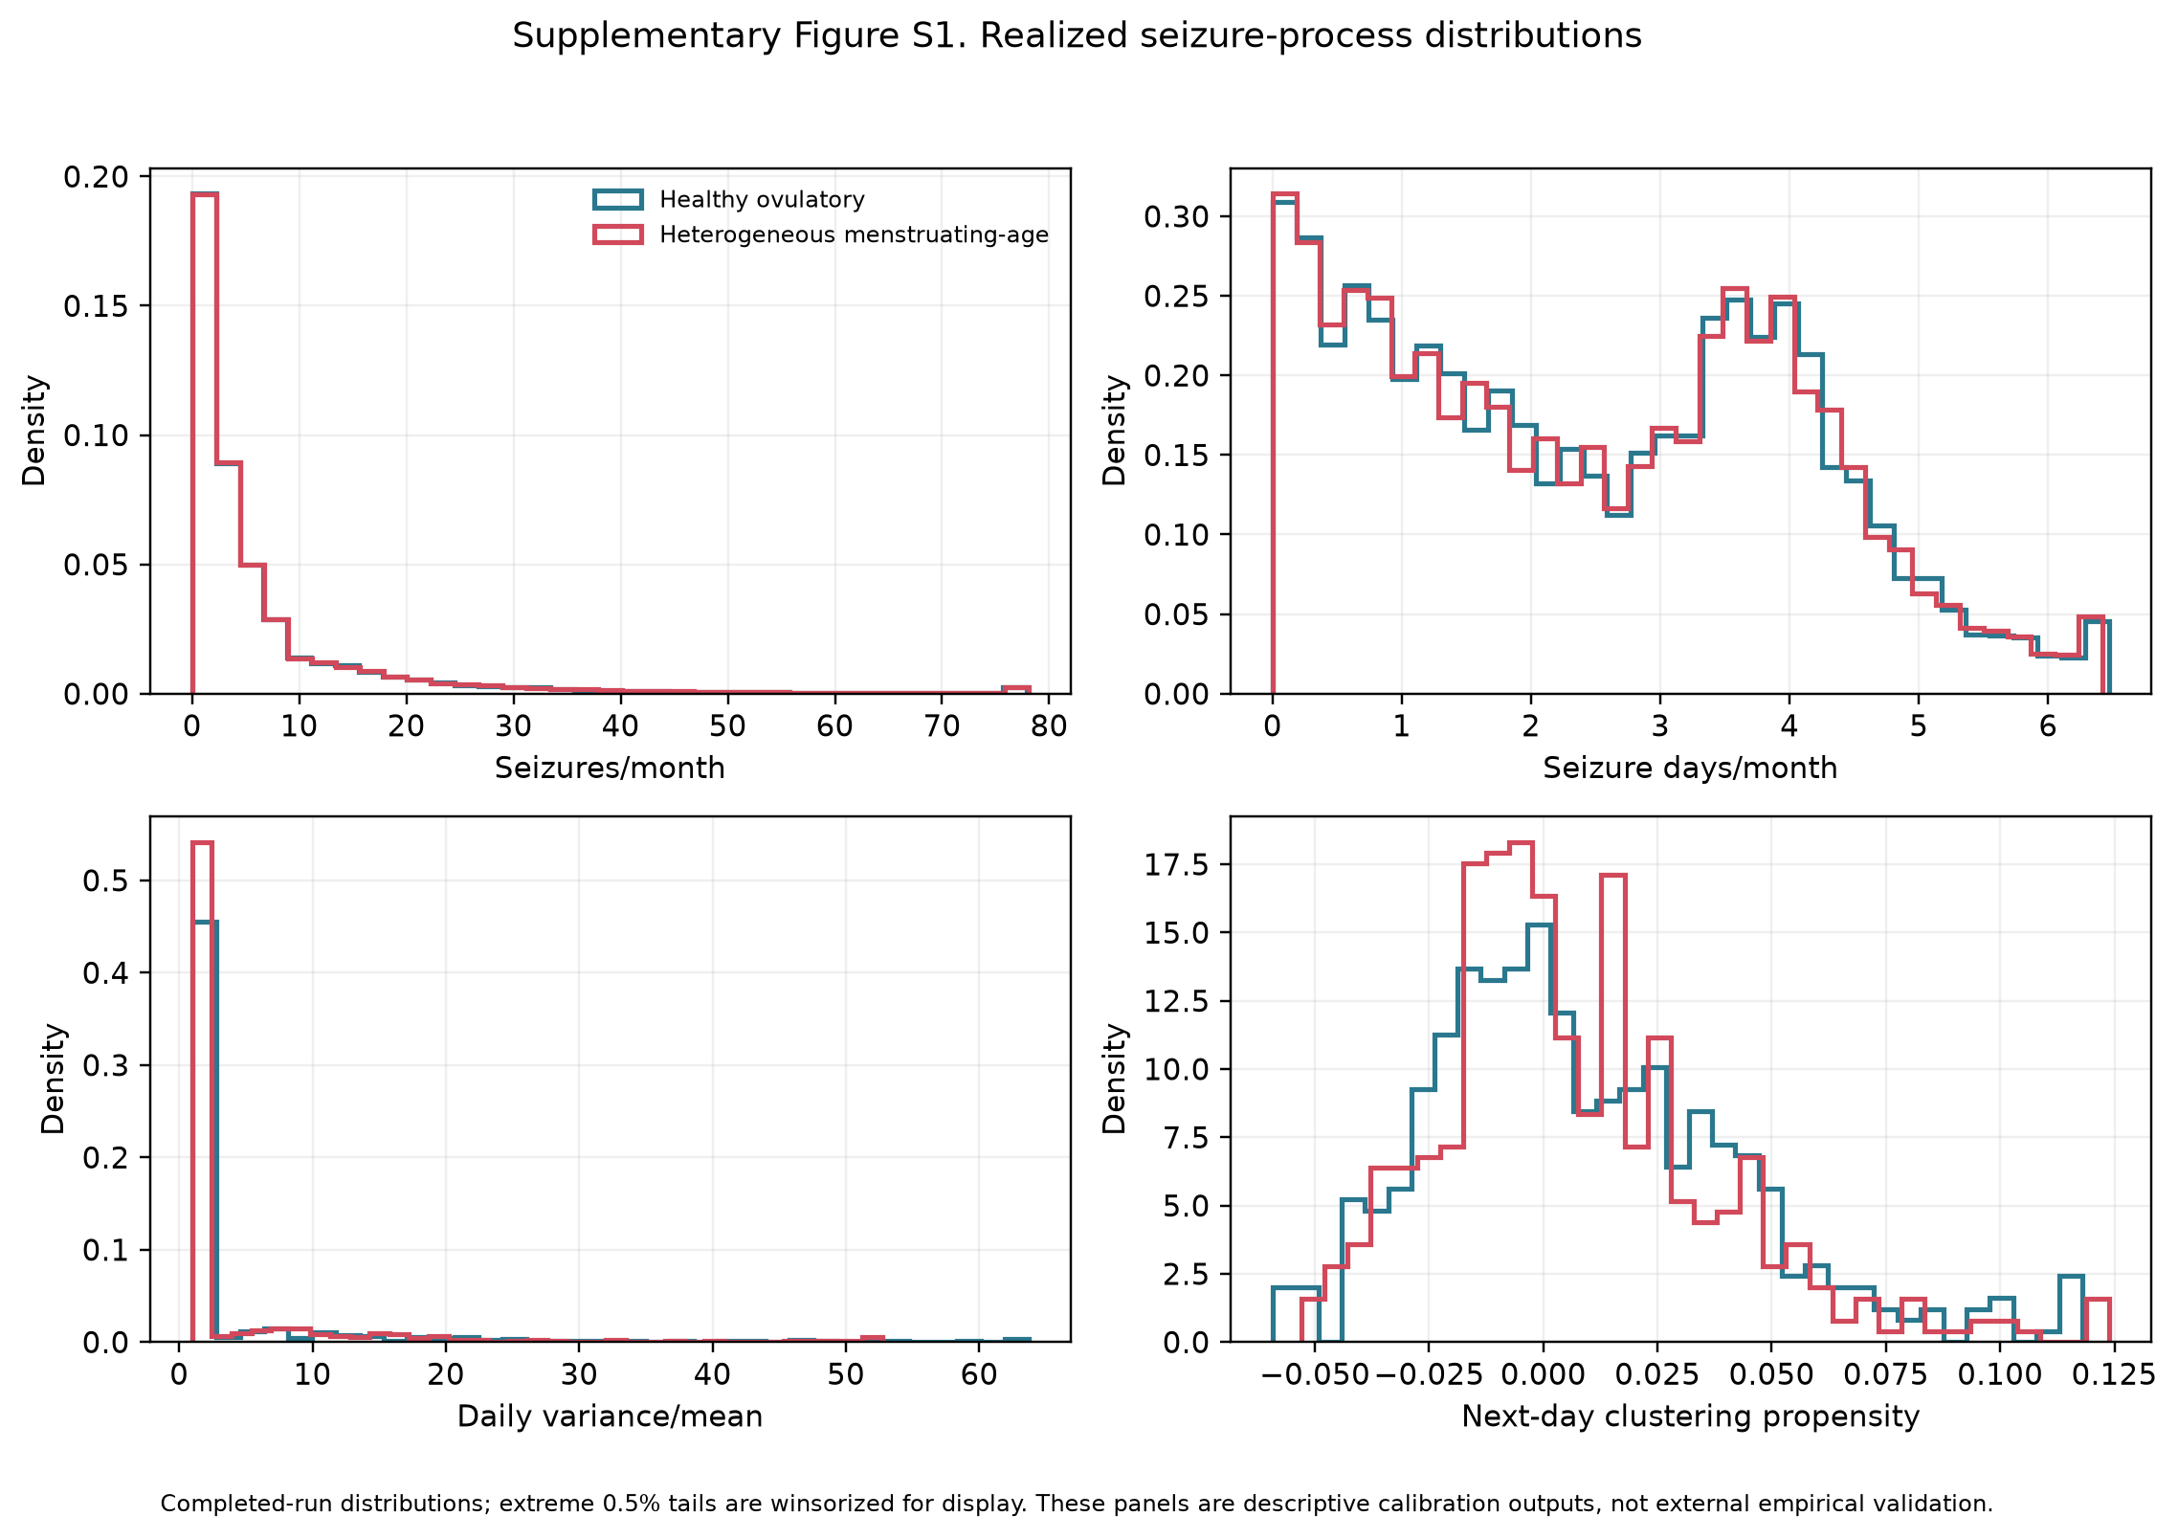
Supplementary Figure S2. Realized seizure-rhythm distributions. Panels show generator-reported dominant period, audit-sample spectral period and amplitude, and latent monthly seizure burden.
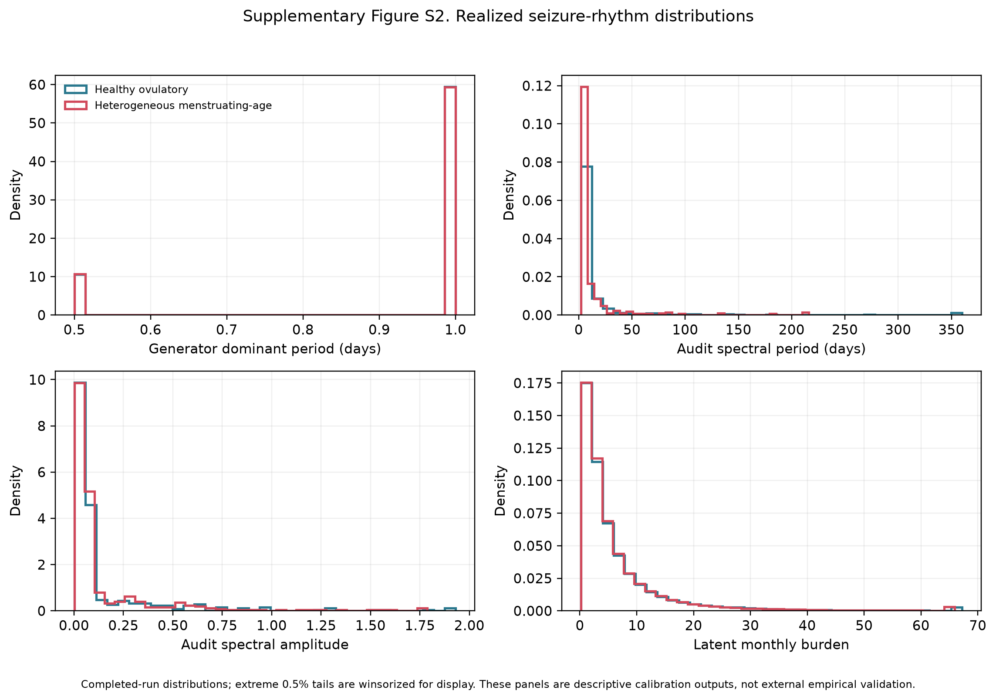

Supplementary Figure S3. Realized menstrual-cycle distributions. Panels show mean cycle length, within-person cycle-length standard deviation, ovulatory fraction, and inadequate-luteal-phase fraction. Inadequate luteal phase is displayed only for the heterogeneous audit sample because C3 is not applicable in the healthy cohort.
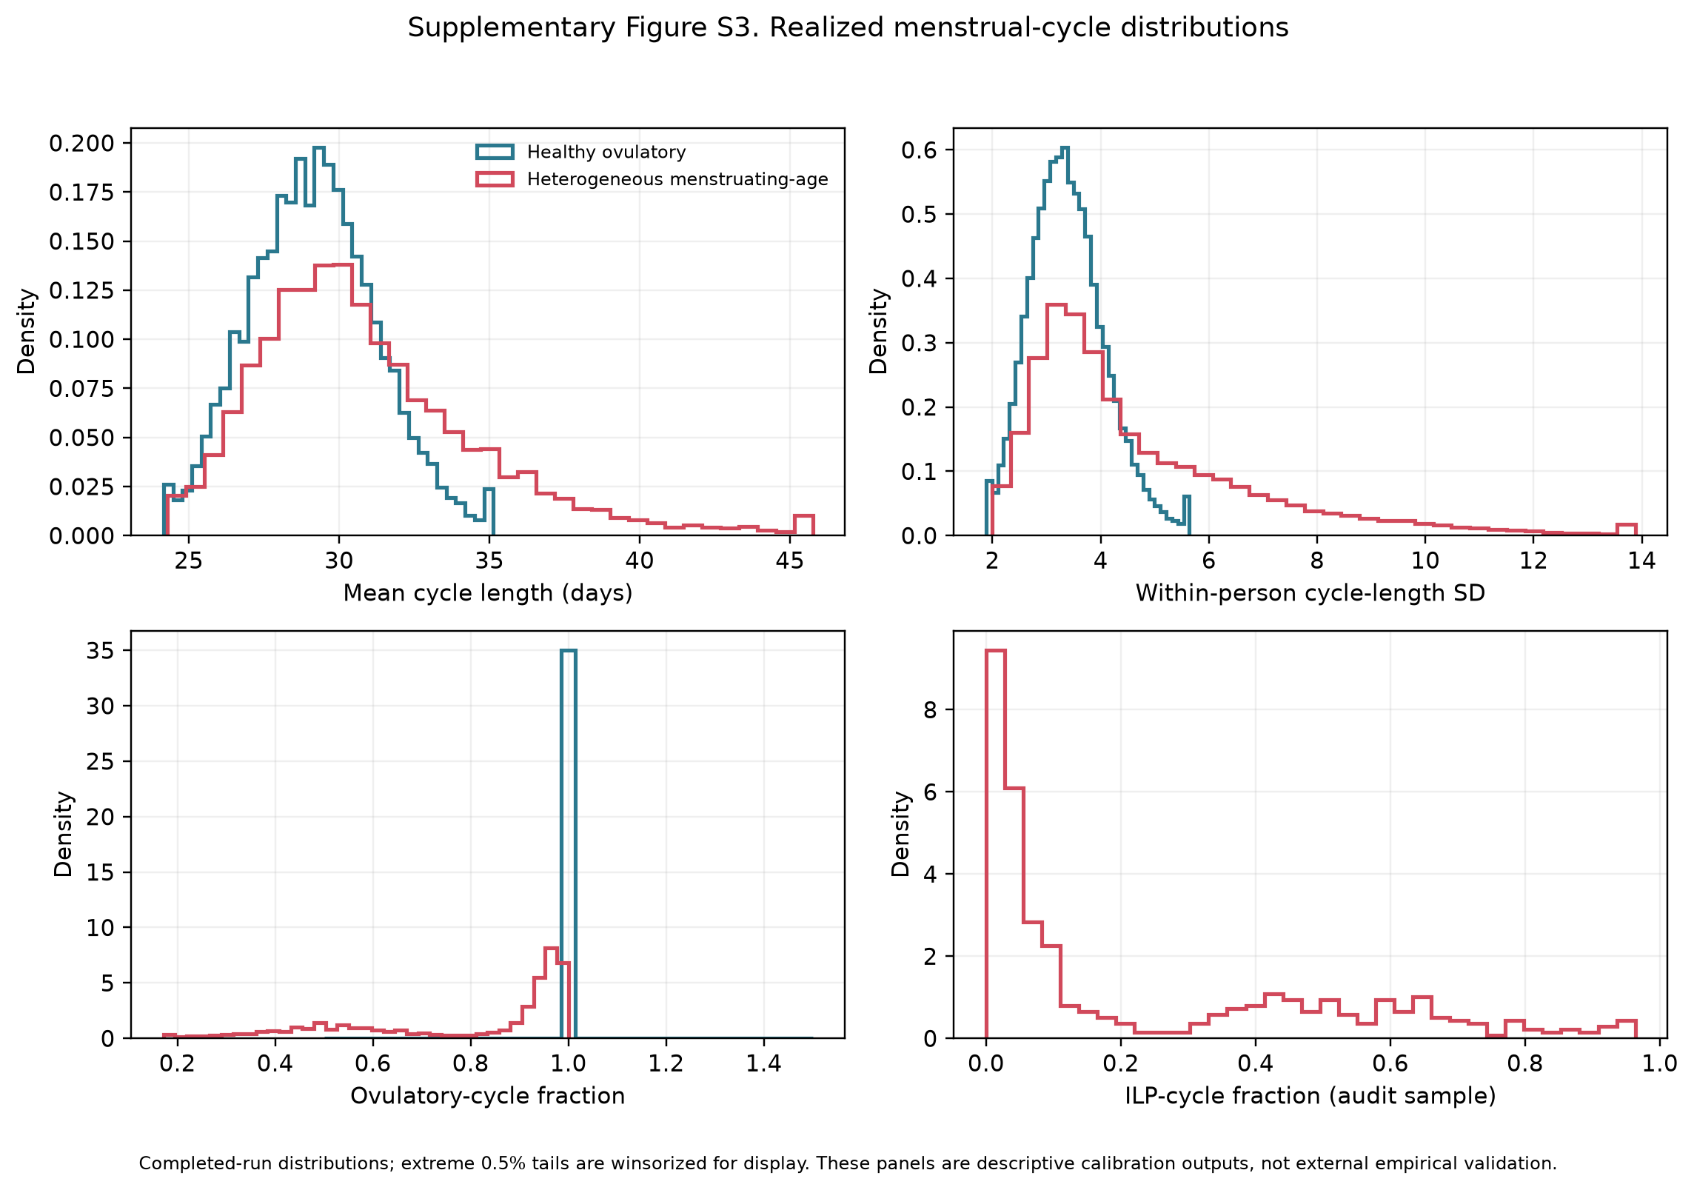

Supplementary Figure S4. Age and configured modifiers. Modifier frequencies are investigator-configured stress-test assumptions, not population estimates.
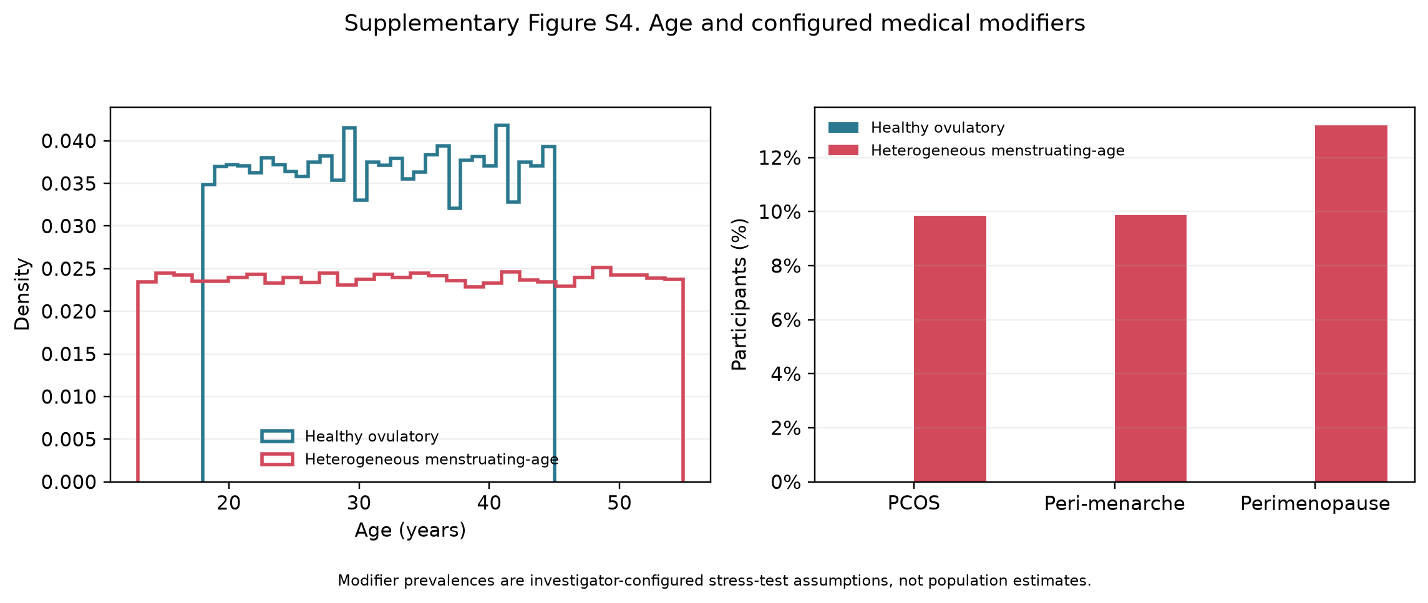

Supplementary Figure S5. Associations with simulated apparent classification across within-cohort feature quintiles. The display is descriptive and not a clinical risk model.
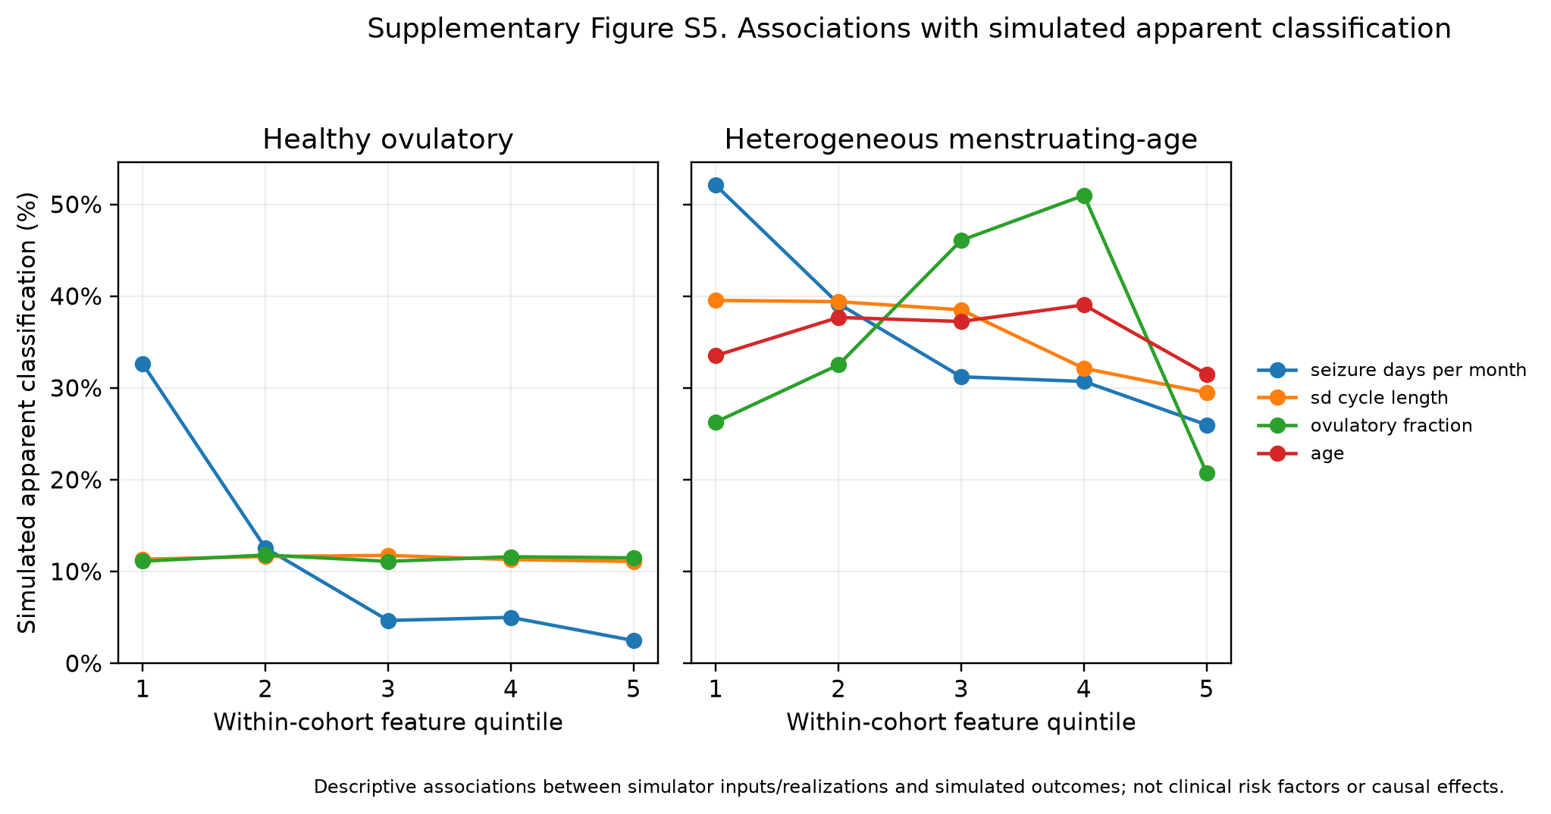

S13. Interpretation of simulator calibration
The figure set intentionally distinguishes completed-run distributions from external empirical validation. Where participant-level empirical microdata were unavailable, the figures show simulated distributions and the source table identifies the published summary targets. They should be described as distributional calibration outputs. External validation requires paired real seizure and menstrual diaries analyzed with aligned definitions, participant-level resampling, and complementary within-person shift and matched cross-person null designs.

References
1. Daniel Goldenholz. HORMONE-CYCLE [Python] [Python 3.11+]. GoldenholzLab; 2026. Available from: https://github.com/GoldenholzLab/catamenial-epilepsy-sim.git
2. Goldenholz DM, Westover MB. Flexible realistic simulation of seizure occurrence recapitulating statistical properties of seizure diaries. Epilepsia. 2023 Feb;64(2):396–405. doi:10.1111/epi.17471
3. Monks T, Currie CSM, Onggo BS, Robinson S, Kunc M, Taylor SJE. Strengthening the reporting of empirical simulation studies: introducing the STRESS guidelines. J Simul. 2019;13(1):55–67. doi:10.1080/17477778.2018.1442155
4. Stricker R, Eberhart R, Chevailler MC, Quinn FA, Bischof P, Stricker R. Establishment of detailed reference values for luteinizing hormone, follicle stimulating hormone, estradiol, and progesterone during different phases of the menstrual cycle on the Abbott ARCHITECT analyzer. Clin Chem Lab Med. 2006;44(7):883–7. PubMed PMID: 16776638. doi:10.1515/CCLM.2006.160
5. Bull JR, Rowland SP, Scherwitzl EB, Scherwitzl R, Danielsson KG, Harper J. Real-world menstrual cycle characteristics of more than 600,000 menstrual cycles. NPJ Digit Med. 2019;2:83. PubMed PMID: 31482137. doi:10.1038/s41746-019-0152-7
6. Li H, Gibson EA, Jukic AMZ, Baird DD, Wilcox AJ, Curry CL, et al. Menstrual cycle length variation by demographic characteristics from the Apple Women’s Health Study. NPJ Digit Med. 2023;6(1):100. PubMed PMID: 37248288. doi:10.1038/s41746-023-00848-1
7. Fraser IS, Critchley HOD, Broder M, Munro MG. The FIGO recommendations on terminologies and definitions for normal and abnormal uterine bleeding. Semin Reprod Med. 2011 Sep;29(5):383–90. doi:10.1055/s-0031-1287662 PubMed PMID: 22065325.
8. Mortimer R, Asokan G, Baird DD, Wilcox AJ, Abrams K, Curry CL, et al. Variability of menstrual cycles by age, polycystic ovary syndrome, and early-life cycle irregularity in the apple Women’s Health Study. Am J Obstet Gynecol. 2026 Apr;234(4):1042–69. doi:10.1016/j.ajog.2025.11.031 PubMed PMID: 41297783; PubMed Central PMCID: PMC12915291.
9. Jarrett BY, Vanden Brink H, Oldfield AL, Lujan ME. Ultrasound Characterization of Disordered Antral Follicle Development in Women with Polycystic Ovary Syndrome. J Clin Endocrinol Metab. 2020 Nov 1;105(11):e3847-3861. doi:10.1210/clinem/dgaa515 PubMed PMID: 32785651; PubMed Central PMCID: PMC7473602.
10. World Health Organization multicenter study on menstrual and ovulatory patterns in adolescent girls. II. Longitudinal study of menstrual patterns in the early postmenarcheal period, duration of bleeding episodes and menstrual cycles. World Health Organization Task Force on Adolescent Reproductive Health. J Adolesc Health Care. 1986 Jul;7(4):236–44. PubMed PMID: 3721946.
11. Zhang K, Pollack S, Ghods A, Dicken C, Isaac B, Adel G, et al. Onset of ovulation after menarche in girls: a longitudinal study. J Clin Endocrinol Metab. 2008 Apr;93(4):1186–94. doi:10.1210/jc.2007-1846 PubMed PMID: 18252789; PubMed Central PMCID: PMC2291492.
12. Santoro N, Randolph JF. Reproductive hormones and the menopause transition. Obstet Gynecol Clin North Am. 2011 Sep;38(3):455–66. doi:10.1016/j.ogc.2011.05.004 PubMed PMID: 21961713; PubMed Central PMCID: PMC3197715.
13. Edelman A, Micks E, Gallo MF, Jensen JT, Grimes DA. Continuous or extended cycle vs. cyclic use of combined hormonal contraceptives for contraception. Cochrane Database Syst Rev. 2014 Jul 29;2014(7):CD004695. doi:10.1002/14651858.CD004695.pub3 PubMed PMID: 25072731; PubMed Central PMCID: PMC6837850.
14. Xiao B, Zeng T, Wu S, Sun H, Xiao N. Effect of levonorgestrel-releasing intrauterine device on hormonal profile and menstrual pattern after long-term use. Contraception. 1995 Jun;51(6):359–65. doi:10.1016/0010-7824(95)00102-g PubMed PMID: 7554977.
15. Barbosa I, Olsson SE, Odlind V, Goncalves T, Coutinho E. Ovarian function after seven years’ use of a levonorgestrel IUD. Adv Contracept. 1995 Jun;11(2):85–95. doi:10.1007/BF01987274 PubMed PMID: 7491859.
16. Faundes A, Segal SJ, Adejuwon CA, Brache V, Leon P, Alvarez-Sanchez F. The menstrual cycle in women using an intrauterine device. Fertil Steril. 1980 Nov;34(5):427–30. doi:10.1016/s0015-0282(16)45131-9 PubMed PMID: 7439408.
17. Malmqvist R, Petersohn L, Bengtsson LP. Menstrual bleeding with copper-covered intrauterine contraceptive devices. Contraception. 1974 Jun;9(6):627–33. doi:10.1016/0010-7824(74)90048-1 PubMed PMID: 4448089.
18. Dawood MY. Primary dysmenorrhea: advances in pathogenesis and management. Obstet Gynecol. 2006 Aug;108(2):428–41. doi:10.1097/01.AOG.0000230214.26638.0c PubMed PMID: 16880317.
19. Herzog AG, Klein P, Ransil BJ. Three patterns of catamenial epilepsy. Epilepsia. 1997;38(10):1082–8. PubMed PMID: 9579954. doi:10.1111/j.1528-1157.1997.tb01197.x

