Supplementary Appendix: Apparent Catamenial Epilepsy Classification Under Independence
This appendix provides additional methodological details, defined analysis choices, quality-control checks, sensitivity analyses, and supplementary results for the null simulation. It is intended as online supplementary material accompanying the main Neurology submission draft.

Table of Contents
- A1. Simulation design and reproducibility
- A2. Simulator descriptions and validation targets
- A3. Cohort definitions and diary generation
- A4. Phase labeling and catamenial epilepsy definitions
- A5. Observation windows and analyzability rules
- A6. Statistical analysis and edge-case handling
- A7. Supplementary results
- A8. Output provenance and assumptions

A1. Simulation design and reproducibility
The analysis used a deterministic master seed of 20260505. The full run simulated 100,000 synthetic participants, processed in chunks, with 50,000 in the healthy ovulatory cohort and 50,000 in the heterogeneous menstruating-age cohort. The 36-month diaries were generated independently for seizures and menstrual/hormone cycles, followed by a participant-specific random circular shift before merging.
Daily audit data were saved for a 1% random sample. Participant-level and window-level outputs were written as parquet and CSV files, and every output artifact was recorded in a machine-readable manifest with file size and SHA-256 checksum.
The term 'defined before the full simulation run' is used instead of 'prespecified' unless a dated protocol, locked commit, or preregistration is supplied. The manifest records the seed, config values, output checksums, and adapter assumptions.

A2. Simulator descriptions and validation targets
CHOCOLATES generated seizure-count diaries independently of menstrual-cycle state. The adapter records observed seizure burden and the simulator-reported dominant seizure-cycle period when available. Because multidien rhythms near monthly periods are a key potential mechanism for chance alignment, submitted versions should report the distribution of dominant_seizure_cycle_days and sensitivity analyses excluding or flattening 24-35-day seizure rhythms.
HORMONE-CYCLE generated menstrual/hormone diaries independently of seizure state. The adapter records age, cycle length, within-participant cycle-length SD, ovulatory fraction, progesterone and estradiol when available, and inadequate-luteal-phase flags based on a progesterone threshold of 5.0 ng/mL. Submitted versions should include package versions or commits for both simulators and a validation table comparing simulated diary metrics with empirical benchmarks.
Supplementary Table 1. Minimum simulator validation targets for submission.
Domain | Simulated metric to report | Reviewer-facing purpose
Seizure burden | Seizure days/month, seizures/month, interseizure interval dispersion, seizure-cluster metrics | Shows the null seizure diary is not an unrealistically sparse or overclustered artifact.
Seizure rhythms | Dominant multidien period distribution; proportion in 24-35-day band; sensitivity excluding that band | Separates finite-count ratio artifacts from monthly-ish seizure-rhythm alignment.
Menstrual cycles | Cycle-length distribution, within-participant cycle-length SD, luteal length, ovulatory fraction, anovulation frequency | Shows phase labeling and C3 eligibility are generated from plausible cycle structure.
Missing/irregular behavior | Unlabeled days, non-23-35-day cycles, ILP/anovulatory flags, medical-factor prevalence | Quantifies sources of indeterminate windows and C3 sensitivity.

A3. Cohort definitions and diary generation
The healthy ovulatory cohort targeted adult ovulatory cycling, age 18-45 years, with simulator medical modifiers disabled where exposed. The heterogeneous menstruating-age cohort targeted a broader menstruating-age range of 13.0-54.9 years and allowed anovulation and irregularity. Because the hormone simulator exposed medical-factor controls but not a natural prevalence sampler, PCOS, peri-menarche, perimenopause, and dysmenorrhea were sampled from config.yaml rates. This cohort is an assumption-driven heterogeneity stress test unless external prevalence calibration is added.
Supplementary Table 2. Cohort construction parameters.
Parameter | Healthy ovulatory | Heterogeneous menstruating-age
Target sample size | 50,000 | 50,000
Age range | 18.0-45.0 years | 13.0-54.9 years
Ovulatory-cycle handling | Ovulation probability set to 1.0 | Natural ovulatory/anovulatory behavior allowed
PCOS rate | Disabled | 10%
Peri-menarche rate | Disabled | 60% when age <20 years
Perimenopause rate | Disabled | 55% when age >=45 years
Dysmenorrhea rate | Disabled | 12%

A4. Phase labeling and catamenial epilepsy definitions
Herzog-style phases were assigned on the full diary before window subsetting. For a complete cycle of length L, day 1 was the onset of menstrual flow and backward day was defined as d-(L+1). Strict Herzog phase assignment used an ordered lookup: menstrual phase if days 1-3 or backward days -3 to -1; follicular phase if days 4-9; ovulatory phase if day >=10 and backward day <=-13; luteal phase if backward days -12 to -4. The ovulatory condition is the intersection of forward and backward criteria. Days not satisfying any rule were unlabeled. The luteal-anchored sensitivity preserved the same menstrual and luteal windows but fixed ovulatory phase to backward days -16 to -13 and labeled remaining nonmenstrual, nonovulatory, nonluteal days as follicular.
Supplementary Table 3. Implemented catamenial epilepsy definitions.
Definition | Primary rule | Main analyzability condition
Exact Herzog 2004 | Three-cycle legacy rule; any CE if at least 2 of 3 cycles show any C1, C2, or C3 pattern. | Only complete 3-cycle windows with strict 23-35 day cycles.
Windowed Herzog thresholds | C1 ADSF(M)/ADSF(F+L) >=1.69; C2 ADSF(O)/ADSF(F+L) >=1.83; C3 ADSF(O+L+M)/ADSF(F) >=1.62 among ILP-flagged days. | Required phases observed; undefined ratios marked indeterminate.
Minimum-data rule | Windowed Herzog thresholds after applying minimum duration and seizure-burden criteria. | At least 4 months or 6 complete cycles, plus at least 4 seizure days.
Cycle reproducibility | At least two-thirds of eligible cycles positive for the same pattern and pooled ratio passes threshold. | At least 6 complete cycles for primary rule; 12 cycles for sensitivity.
Negative-binomial regression | Daily GLM with M and O indicators; one-sided Holm-adjusted tests and C1/C2 rate-ratio thresholds. Stabilized and window-only dispersion versions reported. | Minimum-data rule passed; Poisson robust fallback recorded when needed.
Historical rules | Assumption-based operationalizations of Newmark-Penry, Duncan 1993, Herzog 1997 twofold, and Reddy 2007 any-phase rules. | Reported separately and flagged as assumption based.

C3 was evaluated only in the heterogeneous cohort when ilp_flag was true. Anovulatory cycles without ILP labeling were not automatically considered C3-positive or C3-applicable. Supplementary sensitivity rows report any CE excluding C3 and C1, C2, and C3 separately.

A5. Observation windows and analyzability rules
Calendar windows used one random valid start day per participant for 1, 3, 4, 6, 9, 12, 18, 24, and 36 months. Cycle windows used one random valid start among complete cycles for 3, 6, and 12 cycles. The full-window analysis used the entire 36-month diary. Windows were marked indeterminate, not negative, when required phases or denominator information were unavailable.
Exact Herzog 2004 is rule-defined only for complete 3-cycle windows with strict 23-35-day cycles. Other window settings are not evaluated for this rule; they should not be interpreted as negative evidence.

A6. Statistical analysis and edge-case handling
All ratio definitions used average daily seizure frequency rather than raw counts. If a comparator phase had observed days but zero seizures, a positive numerator produced an infinite ratio and counted positive; zero numerator and zero comparator produced an undefined ratio and an indeterminate result. Wilson 95% confidence intervals were used for simple proportions. Study-level Monte Carlo sampled 10,000 studies of 30, 50, and 100 participants per cohort for the 3-month window.
Negative-binomial regression used daily rows with an intercept, menstrual indicator, ovulatory indicator, and cycle fixed effects when at least four complete cycles were available. The offset was one observed day. The Holm family comprised the menstrual and ovulatory one-sided tests within participant. Positivity required adjusted P<0.05 and the corresponding threshold ratio. NB regression was evaluated for full-diary windows in this revision. The stabilized-dispersion analysis uses full-diary alpha; the full-window, window-only alpha analysis is a non-oracle sensitivity.
Monte Carlo binomial intervals quantify uncertainty under the fixed simulation model. They do not include uncertainty about simulator validity, medical-factor prevalence, seizure-rhythm periods, or menstrual-cycle parameterization. Participant-level summary rows, all-attempted rates, indeterminate reasons, and unstable-denominator flags were generated from window_results.parquet. Rows with fewer than 1,000 classifiable windows are flagged as unstable and not interpreted.

A7. Supplementary results
Supplementary Table 3. Window-length sensitivity for core definitions.
Cohort | Observation window | Definition | Classifiable windows | False-positive windows | False-positive rate | Indeterminate
healthy ovulatory | 1 month | Cycle reproducibility >=2/3, C1/C2 | 0 | 0 | NA | 100.0%
healthy ovulatory | 1 month | Exact Herzog 2004, any pattern | 0 | 0 | NA | 100.0%
healthy ovulatory | 1 month | Herzog C1/C2 plus >=4 seizure-day minimum | 0 | 0 | NA | 100.0%
healthy ovulatory | 1 month | Negative-binomial regression C1/C2 | 0 | 0 | NA | 100.0%
healthy ovulatory | 1 month | Windowed Herzog C1/C2 union | 38,234 | 18,249 | 47.7% | 23.5%
healthy ovulatory | 1 month | Windowed Herzog thresholds | 38,234 | 18,249 | 47.7% | 23.5%
healthy ovulatory | 3 months | Cycle reproducibility >=2/3, C1/C2 | 0 | 0 | NA | 100.0%
healthy ovulatory | 3 months | Exact Herzog 2004, any pattern | 0 | 0 | NA | 100.0%
healthy ovulatory | 3 months | Herzog C1/C2 plus >=4 seizure-day minimum | 0 | 0 | NA | 100.0%
healthy ovulatory | 3 months | Negative-binomial regression C1/C2 | 0 | 0 | NA | 100.0%
healthy ovulatory | 3 months | Windowed Herzog C1/C2 union | 45,280 | 18,696 | 41.3% | 9.4%
healthy ovulatory | 3 months | Windowed Herzog thresholds | 45,280 | 18,696 | 41.3% | 9.4%
healthy ovulatory | 4 months | Cycle reproducibility >=2/3, C1/C2 | 0 | 0 | NA | 100.0%
healthy ovulatory | 4 months | Exact Herzog 2004, any pattern | 0 | 0 | NA | 100.0%
healthy ovulatory | 4 months | Herzog C1/C2 plus >=4 seizure-day minimum | 37,641 | 13,501 | 35.9% | 24.7%
healthy ovulatory | 4 months | Negative-binomial regression C1/C2 | 0 | 0 | NA | 100.0%
healthy ovulatory | 4 months | Windowed Herzog C1/C2 union | 46,381 | 17,894 | 38.6% | 7.2%
healthy ovulatory | 4 months | Windowed Herzog thresholds | 46,381 | 17,894 | 38.6% | 7.2%
healthy ovulatory | 6 months | Cycle reproducibility >=2/3, C1/C2 | 6,706 | 704 | 10.5% | 86.6%
healthy ovulatory | 6 months | Exact Herzog 2004, any pattern | 0 | 0 | NA | 100.0%
healthy ovulatory | 6 months | Herzog C1/C2 plus >=4 seizure-day minimum | 41,136 | 12,985 | 31.6% | 17.7%
healthy ovulatory | 6 months | Negative-binomial regression C1/C2 | 0 | 0 | NA | 100.0%
healthy ovulatory | 6 months | Windowed Herzog C1/C2 union | 47,489 | 16,185 | 34.1% | 5.0%
healthy ovulatory | 6 months | Windowed Herzog thresholds | 47,489 | 16,185 | 34.1% | 5.0%
healthy ovulatory | 9 months | Cycle reproducibility >=2/3, C1/C2 | 19,087 | 666 | 3.5% | 61.8%
healthy ovulatory | 9 months | Exact Herzog 2004, any pattern | 0 | 0 | NA | 100.0%
healthy ovulatory | 9 months | Herzog C1/C2 plus >=4 seizure-day minimum | 43,868 | 11,929 | 27.2% | 12.3%
healthy ovulatory | 9 months | Negative-binomial regression C1/C2 | 0 | 0 | NA | 100.0%
healthy ovulatory | 9 months | Windowed Herzog C1/C2 union | 48,361 | 14,169 | 29.3% | 3.3%
healthy ovulatory | 9 months | Windowed Herzog thresholds | 48,361 | 14,169 | 29.3% | 3.3%
healthy ovulatory | 12 months | Cycle reproducibility >=2/3, C1/C2 | 16,143 | 255 | 1.6% | 67.7%
healthy ovulatory | 12 months | Exact Herzog 2004, any pattern | 0 | 0 | NA | 100.0%
healthy ovulatory | 12 months | Herzog C1/C2 plus >=4 seizure-day minimum | 45,228 | 10,677 | 23.6% | 9.5%
healthy ovulatory | 12 months | Negative-binomial regression C1/C2 | 0 | 0 | NA | 100.0%
healthy ovulatory | 12 months | Windowed Herzog C1/C2 union | 48,754 | 12,482 | 25.6% | 2.5%
healthy ovulatory | 12 months | Windowed Herzog thresholds | 48,754 | 12,482 | 25.6% | 2.5%
healthy ovulatory | 18 months | Cycle reproducibility >=2/3, C1/C2 | 12,120 | 42 | 0.3% | 75.8%
healthy ovulatory | 18 months | Exact Herzog 2004, any pattern | 0 | 0 | NA | 100.0%
healthy ovulatory | 18 months | Herzog C1/C2 plus >=4 seizure-day minimum | 46,767 | 8,587 | 18.4% | 6.5%
healthy ovulatory | 18 months | Negative-binomial regression C1/C2 | 0 | 0 | NA | 100.0%
healthy ovulatory | 18 months | Windowed Herzog C1/C2 union | 49,167 | 9,847 | 20.0% | 1.7%
healthy ovulatory | 18 months | Windowed Herzog thresholds | 49,167 | 9,847 | 20.0% | 1.7%
healthy ovulatory | 24 months | Cycle reproducibility >=2/3, C1/C2 | 9,485 | 6 | 0.1% | 81.0%
healthy ovulatory | 24 months | Exact Herzog 2004, any pattern | 0 | 0 | NA | 100.0%
healthy ovulatory | 24 months | Herzog C1/C2 plus >=4 seizure-day minimum | 47,550 | 6,965 | 14.6% | 4.9%
healthy ovulatory | 24 months | Negative-binomial regression C1/C2 | 0 | 0 | NA | 100.0%
healthy ovulatory | 24 months | Windowed Herzog C1/C2 union | 49,379 | 7,884 | 16.0% | 1.2%
healthy ovulatory | 24 months | Windowed Herzog thresholds | 49,379 | 7,884 | 16.0% | 1.2%
healthy ovulatory | 36 months | Cycle reproducibility >=2/3, C1/C2 | 6,132 | 1 | 0.0% | 87.7%
healthy ovulatory | 36 months | Exact Herzog 2004, any pattern | 0 | 0 | NA | 100.0%
healthy ovulatory | 36 months | Herzog C1/C2 plus >=4 seizure-day minimum | 48,359 | 4,940 | 10.2% | 3.3%
healthy ovulatory | 36 months | Negative-binomial regression C1/C2 | 0 | 0 | NA | 100.0%
healthy ovulatory | 36 months | Windowed Herzog C1/C2 union | 49,605 | 5,576 | 11.2% | 0.8%
healthy ovulatory | 36 months | Windowed Herzog thresholds | 49,605 | 5,576 | 11.2% | 0.8%
healthy ovulatory | 3 cycles | Cycle reproducibility >=2/3, C1/C2 | 0 | 0 | NA | 100.0%
healthy ovulatory | 3 cycles | Exact Herzog 2004, any pattern | 22,996 | 11,422 | 49.7% | 54.0%
healthy ovulatory | 3 cycles | Herzog C1/C2 plus >=4 seizure-day minimum | 19 | Suppressed | Not interpreted (<1,000) | 100.0%
healthy ovulatory | 3 cycles | Negative-binomial regression C1/C2 | 0 | 0 | NA | 100.0%
healthy ovulatory | 3 cycles | Windowed Herzog C1/C2 union | 45,048 | 18,481 | 41.0% | 9.9%
healthy ovulatory | 3 cycles | Windowed Herzog thresholds | 45,048 | 18,481 | 41.0% | 9.9%
healthy ovulatory | 6 cycles | Cycle reproducibility >=2/3, C1/C2 | 22,669 | 2,779 | 12.3% | 54.7%
healthy ovulatory | 6 cycles | Exact Herzog 2004, any pattern | 0 | 0 | NA | 100.0%
healthy ovulatory | 6 cycles | Herzog C1/C2 plus >=4 seizure-day minimum | 40,861 | 12,839 | 31.4% | 18.3%
healthy ovulatory | 6 cycles | Negative-binomial regression C1/C2 | 0 | 0 | NA | 100.0%
healthy ovulatory | 6 cycles | Windowed Herzog C1/C2 union | 47,474 | 16,217 | 34.2% | 5.1%
healthy ovulatory | 6 cycles | Windowed Herzog thresholds | 47,474 | 16,217 | 34.2% | 5.1%
healthy ovulatory | 12 cycles | Cycle reproducibility >=2/3, C1/C2 | 15,728 | 350 | 2.2% | 68.5%
healthy ovulatory | 12 cycles | Exact Herzog 2004, any pattern | 0 | 0 | NA | 100.0%
healthy ovulatory | 12 cycles | Herzog C1/C2 plus >=4 seizure-day minimum | 45,112 | 10,618 | 23.5% | 9.8%
healthy ovulatory | 12 cycles | Negative-binomial regression C1/C2 | 0 | 0 | NA | 100.0%
healthy ovulatory | 12 cycles | Windowed Herzog C1/C2 union | 48,690 | 12,446 | 25.6% | 2.6%
healthy ovulatory | 12 cycles | Windowed Herzog thresholds | 48,690 | 12,446 | 25.6% | 2.6%
healthy ovulatory | 36-month full diary | Cycle reproducibility >=2/3, C1/C2 | 6,132 | 1 | 0.0% | 87.7%
healthy ovulatory | 36-month full diary | Exact Herzog 2004, any pattern | 0 | 0 | NA | 100.0%
healthy ovulatory | 36-month full diary | Herzog C1/C2 plus >=4 seizure-day minimum | 48,359 | 4,940 | 10.2% | 3.3%
healthy ovulatory | 36-month full diary | Negative-binomial regression C1/C2 | 48,359 | 1,966 | 4.1% | 3.3%
healthy ovulatory | 36-month full diary | Windowed Herzog C1/C2 union | 49,605 | 5,576 | 11.2% | 0.8%
healthy ovulatory | 36-month full diary | Windowed Herzog thresholds | 49,605 | 5,576 | 11.2% | 0.8%
heterogeneous menstruating-age | 1 month | Cycle reproducibility >=2/3, C1/C2 | 0 | 0 | NA | 100.0%
heterogeneous menstruating-age | 1 month | Exact Herzog 2004, any pattern | 0 | 0 | NA | 100.0%
heterogeneous menstruating-age | 1 month | Herzog C1/C2 plus >=4 seizure-day minimum | 0 | 0 | NA | 100.0%
heterogeneous menstruating-age | 1 month | Negative-binomial regression C1/C2 | 0 | 0 | NA | 100.0%
heterogeneous menstruating-age | 1 month | Windowed Herzog C1/C2 union | 38,083 | 18,300 | 48.1% | 23.8%
heterogeneous menstruating-age | 1 month | Windowed Herzog thresholds | 38,083 | 19,748 | 51.9% | 23.8%
heterogeneous menstruating-age | 3 months | Cycle reproducibility >=2/3, C1/C2 | 0 | 0 | NA | 100.0%
heterogeneous menstruating-age | 3 months | Exact Herzog 2004, any pattern | 0 | 0 | NA | 100.0%
heterogeneous menstruating-age | 3 months | Herzog C1/C2 plus >=4 seizure-day minimum | 0 | 0 | NA | 100.0%
heterogeneous menstruating-age | 3 months | Negative-binomial regression C1/C2 | 0 | 0 | NA | 100.0%
heterogeneous menstruating-age | 3 months | Windowed Herzog C1/C2 union | 45,297 | 19,056 | 42.1% | 9.4%
heterogeneous menstruating-age | 3 months | Windowed Herzog thresholds | 45,297 | 23,184 | 51.2% | 9.4%
heterogeneous menstruating-age | 4 months | Cycle reproducibility >=2/3, C1/C2 | 0 | 0 | NA | 100.0%
heterogeneous menstruating-age | 4 months | Exact Herzog 2004, any pattern | 0 | 0 | NA | 100.0%
heterogeneous menstruating-age | 4 months | Herzog C1/C2 plus >=4 seizure-day minimum | 37,530 | 13,732 | 36.6% | 24.9%
heterogeneous menstruating-age | 4 months | Negative-binomial regression C1/C2 | 0 | 0 | NA | 100.0%
heterogeneous menstruating-age | 4 months | Windowed Herzog C1/C2 union | 46,369 | 18,279 | 39.4% | 7.3%
heterogeneous menstruating-age | 4 months | Windowed Herzog thresholds | 46,369 | 23,060 | 49.7% | 7.3%
heterogeneous menstruating-age | 6 months | Cycle reproducibility >=2/3, C1/C2 | 5,189 | 401 | 7.7% | 89.6%
heterogeneous menstruating-age | 6 months | Exact Herzog 2004, any pattern | 0 | 0 | NA | 100.0%
heterogeneous menstruating-age | 6 months | Herzog C1/C2 plus >=4 seizure-day minimum | 41,240 | 13,284 | 32.2% | 17.5%
heterogeneous menstruating-age | 6 months | Negative-binomial regression C1/C2 | 0 | 0 | NA | 100.0%
heterogeneous menstruating-age | 6 months | Windowed Herzog C1/C2 union | 47,490 | 16,567 | 34.9% | 5.0%
heterogeneous menstruating-age | 6 months | Windowed Herzog thresholds | 47,490 | 22,546 | 47.5% | 5.0%
heterogeneous menstruating-age | 9 months | Cycle reproducibility >=2/3, C1/C2 | 21,809 | 378 | 1.7% | 56.4%
heterogeneous menstruating-age | 9 months | Exact Herzog 2004, any pattern | 0 | 0 | NA | 100.0%
heterogeneous menstruating-age | 9 months | Herzog C1/C2 plus >=4 seizure-day minimum | 43,843 | 11,844 | 27.0% | 12.3%
heterogeneous menstruating-age | 9 months | Negative-binomial regression C1/C2 | 0 | 0 | NA | 100.0%
heterogeneous menstruating-age | 9 months | Windowed Herzog C1/C2 union | 48,315 | 14,234 | 29.5% | 3.4%
heterogeneous menstruating-age | 9 months | Windowed Herzog thresholds | 48,315 | 21,444 | 44.4% | 3.4%
heterogeneous menstruating-age | 12 months | Cycle reproducibility >=2/3, C1/C2 | 19,802 | 138 | 0.7% | 60.4%
heterogeneous menstruating-age | 12 months | Exact Herzog 2004, any pattern | 0 | 0 | NA | 100.0%
heterogeneous menstruating-age | 12 months | Herzog C1/C2 plus >=4 seizure-day minimum | 45,331 | 10,921 | 24.1% | 9.3%
heterogeneous menstruating-age | 12 months | Negative-binomial regression C1/C2 | 0 | 0 | NA | 100.0%
heterogeneous menstruating-age | 12 months | Windowed Herzog C1/C2 union | 48,713 | 12,713 | 26.1% | 2.6%
heterogeneous menstruating-age | 12 months | Windowed Herzog thresholds | 48,713 | 20,738 | 42.6% | 2.6%
heterogeneous menstruating-age | 18 months | Cycle reproducibility >=2/3, C1/C2 | 15,646 | 24 | 0.2% | 68.7%
heterogeneous menstruating-age | 18 months | Exact Herzog 2004, any pattern | 0 | 0 | NA | 100.0%
heterogeneous menstruating-age | 18 months | Herzog C1/C2 plus >=4 seizure-day minimum | 46,739 | 8,710 | 18.6% | 6.5%
heterogeneous menstruating-age | 18 months | Negative-binomial regression C1/C2 | 0 | 0 | NA | 100.0%
heterogeneous menstruating-age | 18 months | Windowed Herzog C1/C2 union | 49,143 | 9,955 | 20.3% | 1.7%
heterogeneous menstruating-age | 18 months | Windowed Herzog thresholds | 49,143 | 19,559 | 39.8% | 1.7%
heterogeneous menstruating-age | 24 months | Cycle reproducibility >=2/3, C1/C2 | 12,938 | 3 | 0.0% | 74.1%
heterogeneous menstruating-age | 24 months | Exact Herzog 2004, any pattern | 0 | 0 | NA | 100.0%
heterogeneous menstruating-age | 24 months | Herzog C1/C2 plus >=4 seizure-day minimum | 47,522 | 7,151 | 15.0% | 5.0%
heterogeneous menstruating-age | 24 months | Negative-binomial regression C1/C2 | 0 | 0 | NA | 100.0%
heterogeneous menstruating-age | 24 months | Windowed Herzog C1/C2 union | 49,343 | 8,112 | 16.4% | 1.3%
heterogeneous menstruating-age | 24 months | Windowed Herzog thresholds | 49,343 | 18,615 | 37.7% | 1.3%
heterogeneous menstruating-age | 36 months | Cycle reproducibility >=2/3, C1/C2 | 9,243 | 0 | 0.0% | 81.5%
heterogeneous menstruating-age | 36 months | Exact Herzog 2004, any pattern | 0 | 0 | NA | 100.0%
heterogeneous menstruating-age | 36 months | Herzog C1/C2 plus >=4 seizure-day minimum | 48,333 | 5,183 | 10.7% | 3.3%
heterogeneous menstruating-age | 36 months | Negative-binomial regression C1/C2 | 0 | 0 | NA | 100.0%
heterogeneous menstruating-age | 36 months | Windowed Herzog C1/C2 union | 49,587 | 5,837 | 11.8% | 0.8%
heterogeneous menstruating-age | 36 months | Windowed Herzog thresholds | 49,587 | 17,983 | 36.3% | 0.8%
heterogeneous menstruating-age | 3 cycles | Cycle reproducibility >=2/3, C1/C2 | 0 | 0 | NA | 100.0%
heterogeneous menstruating-age | 3 cycles | Exact Herzog 2004, any pattern | 16,757 | 8,576 | 51.2% | 66.5%
heterogeneous menstruating-age | 3 cycles | Herzog C1/C2 plus >=4 seizure-day minimum | 2,015 | 744 | 36.9% | 96.0%
heterogeneous menstruating-age | 3 cycles | Negative-binomial regression C1/C2 | 0 | 0 | NA | 100.0%
heterogeneous menstruating-age | 3 cycles | Windowed Herzog C1/C2 union | 45,266 | 18,451 | 40.8% | 9.5%
heterogeneous menstruating-age | 3 cycles | Windowed Herzog thresholds | 45,266 | 22,640 | 50.0% | 9.5%
heterogeneous menstruating-age | 6 cycles | Cycle reproducibility >=2/3, C1/C2 | 25,545 | 1,639 | 6.4% | 48.9%
heterogeneous menstruating-age | 6 cycles | Exact Herzog 2004, any pattern | 0 | 0 | NA | 100.0%
heterogeneous menstruating-age | 6 cycles | Herzog C1/C2 plus >=4 seizure-day minimum | 41,264 | 12,885 | 31.2% | 17.5%
heterogeneous menstruating-age | 6 cycles | Negative-binomial regression C1/C2 | 0 | 0 | NA | 100.0%
heterogeneous menstruating-age | 6 cycles | Windowed Herzog C1/C2 union | 47,560 | 16,143 | 33.9% | 4.9%
heterogeneous menstruating-age | 6 cycles | Windowed Herzog thresholds | 47,560 | 22,129 | 46.5% | 4.9%
heterogeneous menstruating-age | 12 cycles | Cycle reproducibility >=2/3, C1/C2 | 18,764 | 168 | 0.9% | 62.5%
heterogeneous menstruating-age | 12 cycles | Exact Herzog 2004, any pattern | 0 | 0 | NA | 100.0%
heterogeneous menstruating-age | 12 cycles | Herzog C1/C2 plus >=4 seizure-day minimum | 45,354 | 10,560 | 23.3% | 9.3%
heterogeneous menstruating-age | 12 cycles | Negative-binomial regression C1/C2 | 0 | 0 | NA | 100.0%
heterogeneous menstruating-age | 12 cycles | Windowed Herzog C1/C2 union | 48,699 | 12,291 | 25.2% | 2.6%
heterogeneous menstruating-age | 12 cycles | Windowed Herzog thresholds | 48,699 | 20,319 | 41.7% | 2.6%
heterogeneous menstruating-age | 36-month full diary | Cycle reproducibility >=2/3, C1/C2 | 9,243 | 0 | 0.0% | 81.5%
heterogeneous menstruating-age | 36-month full diary | Exact Herzog 2004, any pattern | 0 | 0 | NA | 100.0%
heterogeneous menstruating-age | 36-month full diary | Herzog C1/C2 plus >=4 seizure-day minimum | 48,333 | 5,183 | 10.7% | 3.3%
heterogeneous menstruating-age | 36-month full diary | Negative-binomial regression C1/C2 | 48,333 | 2,032 | 4.2% | 3.3%
heterogeneous menstruating-age | 36-month full diary | Windowed Herzog C1/C2 union | 49,587 | 5,837 | 11.8% | 0.8%
heterogeneous menstruating-age | 36-month full diary | Windowed Herzog thresholds | 49,587 | 17,983 | 36.3% | 0.8%

Rows with fewer than 1,000 classifiable windows are retained for transparency but their positive counts and rates are suppressed to avoid over-interpretation.
Supplementary Table 4. Phase-labeling sensitivity.
Cohort | Phase mode | Observation window | Definition | Classifiable / attempted | Positive among classifiable | Positive among all attempted | Indeterminate
healthy ovulatory | Luteal-anchored ovulatory | 3 months | Windowed Herzog C1/C2 union | 45,280 / 50,000 | 39.6% (39.1%-40.0%) | 35.9% | 9.4%
healthy ovulatory | Luteal-anchored ovulatory | 3 months | Windowed Herzog thresholds | 45,280 / 50,000 | 39.6% (39.1%-40.0%) | 35.9% | 9.4%
healthy ovulatory | Luteal-anchored ovulatory | 12 months | Windowed Herzog C1/C2 union | 48,754 / 50,000 | 26.0% (25.6%-26.4%) | 25.4% | 2.5%
healthy ovulatory | Luteal-anchored ovulatory | 12 months | Windowed Herzog thresholds | 48,754 / 50,000 | 26.0% (25.6%-26.4%) | 25.4% | 2.5%
healthy ovulatory | Luteal-anchored ovulatory | 36-month full diary | Windowed Herzog C1/C2 union | 49,605 / 50,000 | 12.2% (11.9%-12.5%) | 12.1% | 0.8%
healthy ovulatory | Luteal-anchored ovulatory | 36-month full diary | Windowed Herzog thresholds | 49,605 / 50,000 | 12.2% (11.9%-12.5%) | 12.1% | 0.8%
healthy ovulatory | Strict Herzog | 3 months | Windowed Herzog C1/C2 union | 45,280 / 50,000 | 41.3% (40.8%-41.7%) | 37.4% | 9.4%
healthy ovulatory | Strict Herzog | 3 months | Windowed Herzog thresholds | 45,280 / 50,000 | 41.3% (40.8%-41.7%) | 37.4% | 9.4%
healthy ovulatory | Strict Herzog | 12 months | Windowed Herzog C1/C2 union | 48,754 / 50,000 | 25.6% (25.2%-26.0%) | 25.0% | 2.5%
healthy ovulatory | Strict Herzog | 12 months | Windowed Herzog thresholds | 48,754 / 50,000 | 25.6% (25.2%-26.0%) | 25.0% | 2.5%
healthy ovulatory | Strict Herzog | 36-month full diary | Windowed Herzog C1/C2 union | 49,605 / 50,000 | 11.2% (11.0%-11.5%) | 11.2% | 0.8%
healthy ovulatory | Strict Herzog | 36-month full diary | Windowed Herzog thresholds | 49,605 / 50,000 | 11.2% (11.0%-11.5%) | 11.2% | 0.8%
heterogeneous menstruating-age | Luteal-anchored ovulatory | 3 months | Windowed Herzog C1/C2 union | 45,297 / 50,000 | 40.3% (39.9%-40.8%) | 36.5% | 9.4%
heterogeneous menstruating-age | Luteal-anchored ovulatory | 3 months | Windowed Herzog thresholds | 45,297 / 50,000 | 46.9% (46.4%-47.4%) | 42.5% | 9.4%
heterogeneous menstruating-age | Luteal-anchored ovulatory | 12 months | Windowed Herzog C1/C2 union | 48,713 / 50,000 | 26.9% (26.5%-27.3%) | 26.2% | 2.6%
heterogeneous menstruating-age | Luteal-anchored ovulatory | 12 months | Windowed Herzog thresholds | 48,713 / 50,000 | 38.1% (37.7%-38.6%) | 37.1% | 2.6%
heterogeneous menstruating-age | Luteal-anchored ovulatory | 36-month full diary | Windowed Herzog C1/C2 union | 49,587 / 50,000 | 12.8% (12.5%-13.1%) | 12.7% | 0.8%
heterogeneous menstruating-age | Luteal-anchored ovulatory | 36-month full diary | Windowed Herzog thresholds | 49,587 / 50,000 | 30.0% (29.6%-30.4%) | 29.8% | 0.8%
heterogeneous menstruating-age | Strict Herzog | 3 months | Windowed Herzog C1/C2 union | 45,297 / 50,000 | 42.1% (41.6%-42.5%) | 38.1% | 9.4%
heterogeneous menstruating-age | Strict Herzog | 3 months | Windowed Herzog thresholds | 45,297 / 50,000 | 51.2% (50.7%-51.6%) | 46.4% | 9.4%
heterogeneous menstruating-age | Strict Herzog | 12 months | Windowed Herzog C1/C2 union | 48,713 / 50,000 | 26.1% (25.7%-26.5%) | 25.4% | 2.6%
heterogeneous menstruating-age | Strict Herzog | 12 months | Windowed Herzog thresholds | 48,713 / 50,000 | 42.6% (42.1%-43.0%) | 41.5% | 2.6%
heterogeneous menstruating-age | Strict Herzog | 36-month full diary | Windowed Herzog C1/C2 union | 49,587 / 50,000 | 11.8% (11.5%-12.1%) | 11.7% | 0.8%
heterogeneous menstruating-age | Strict Herzog | 36-month full diary | Windowed Herzog thresholds | 49,587 / 50,000 | 36.3% (35.8%-36.7%) | 36.0% | 0.8%

Supplementary Table 5. C1/C2/C3 decomposition and C3-exclusion sensitivity.
Cohort | Definition | Classifiable windows | Positive windows | Apparent classification rate | Indeterminate
healthy ovulatory | Herzog plus >=4 seizure-day minimum | 48,359 | 4,940 | 10.2% (9.9%-10.5%) | 3.3%
healthy ovulatory | Herzog plus >=4 seizure-day minimum, excluding C3 | 48,359 | 4,940 | 10.2% (9.9%-10.5%) | 3.3%
healthy ovulatory | Windowed Herzog C1 only | 49,451 | 3,893 | 7.9% (7.6%-8.1%) | 1.1%
healthy ovulatory | Windowed Herzog C2 only | 49,495 | 2,753 | 5.6% (5.4%-5.8%) | 1.0%
healthy ovulatory | Windowed Herzog C3 only | 0 | 0 | NA (NA-NA) | 100.0%
healthy ovulatory | Windowed Herzog thresholds | 49,605 | 5,576 | 11.2% (11.0%-11.5%) | 0.8%
healthy ovulatory | Windowed Herzog thresholds, excluding C3 | 49,605 | 5,576 | 11.2% (11.0%-11.5%) | 0.8%
heterogeneous menstruating-age | Herzog plus >=4 seizure-day minimum | 48,333 | 17,206 | 35.6% (35.2%-36.0%) | 3.3%
heterogeneous menstruating-age | Herzog plus >=4 seizure-day minimum, excluding C3 | 48,333 | 5,183 | 10.7% (10.5%-11.0%) | 3.3%
heterogeneous menstruating-age | Windowed Herzog C1 only | 49,392 | 4,171 | 8.4% (8.2%-8.7%) | 1.2%
heterogeneous menstruating-age | Windowed Herzog C2 only | 49,482 | 2,788 | 5.6% (5.4%-5.8%) | 1.0%
heterogeneous menstruating-age | Windowed Herzog C3 only | 38,989 | 14,425 | 37.0% (36.5%-37.5%) | 22.0%
heterogeneous menstruating-age | Windowed Herzog thresholds | 49,587 | 17,983 | 36.3% (35.8%-36.7%) | 0.8%
heterogeneous menstruating-age | Windowed Herzog thresholds, excluding C3 | 49,587 | 5,837 | 11.8% (11.5%-12.1%) | 0.8%

Supplementary Table 6. Negative-binomial stabilized versus window-only dispersion sensitivity.
Cohort | Observation window | Regression comparator | Classifiable windows | Apparent classification rate | Indeterminate
healthy ovulatory | 36-month full diary | Negative-binomial regression C1/C2 | 48,359 | 4.1% (3.9%-4.2%) | 3.3%
healthy ovulatory | 36-month full diary | Negative-binomial regression C1/C2, window-only dispersion | 48,359 | 4.1% (3.9%-4.2%) | 3.3%
heterogeneous menstruating-age | 36-month full diary | Negative-binomial regression C1/C2 | 48,333 | 4.2% (4.0%-4.4%) | 3.3%
heterogeneous menstruating-age | 36-month full diary | Negative-binomial regression C1/C2, window-only dispersion | 48,333 | 4.2% (4.0%-4.4%) | 3.3%

Supplementary Table 7. Study-level Monte Carlo results.
Cohort | N per study | Definition | Denominator | Mean apparent prevalence | 2.5th-97.5th percentiles | P >=39.1% | P >=44.2%
healthy ovulatory | 30 | Windowed Herzog C1/C2 union | All participants | 37.5% | 20.0%-53.3% | 45.4% | 20.1%
healthy ovulatory | 30 | Windowed Herzog C1/C2 union | Classifiable participants only | 41.4% | 23.1%-60.0% | 59.9% | 38.4%
healthy ovulatory | 30 | Windowed Herzog thresholds | All participants | 37.5% | 20.0%-53.3% | 45.4% | 20.1%
healthy ovulatory | 30 | Windowed Herzog thresholds | Classifiable participants only | 41.4% | 23.1%-60.0% | 59.9% | 38.4%
healthy ovulatory | 50 | Windowed Herzog C1/C2 union | All participants | 37.3% | 24.0%-50.0% | 39.7% | 13.0%
healthy ovulatory | 50 | Windowed Herzog C1/C2 union | Classifiable participants only | 41.3% | 27.3%-56.1% | 62.4% | 34.3%
healthy ovulatory | 50 | Windowed Herzog thresholds | All participants | 37.3% | 24.0%-50.0% | 39.7% | 13.0%
healthy ovulatory | 50 | Windowed Herzog thresholds | Classifiable participants only | 41.3% | 27.3%-56.1% | 62.4% | 34.3%
healthy ovulatory | 100 | Windowed Herzog C1/C2 union | All participants | 37.5% | 28.0%-47.0% | 33.8% | 7.1%
healthy ovulatory | 100 | Windowed Herzog C1/C2 union | Classifiable participants only | 41.4% | 31.5%-51.6% | 67.0% | 29.1%
healthy ovulatory | 100 | Windowed Herzog thresholds | All participants | 37.5% | 28.0%-47.0% | 33.8% | 7.1%
healthy ovulatory | 100 | Windowed Herzog thresholds | Classifiable participants only | 41.4% | 31.5%-51.6% | 67.0% | 29.1%
heterogeneous menstruating-age | 30 | Windowed Herzog C1/C2 union | All participants | 38.2% | 20.0%-56.7% | 48.9% | 22.4%
heterogeneous menstruating-age | 30 | Windowed Herzog C1/C2 union | Classifiable participants only | 42.2% | 24.0%-60.7% | 63.5% | 42.3%
heterogeneous menstruating-age | 30 | Windowed Herzog thresholds | All participants | 46.3% | 30.0%-63.3% | 80.5% | 55.9%
heterogeneous menstruating-age | 30 | Windowed Herzog thresholds | Classifiable participants only | 51.0% | 32.1%-69.2% | 89.7% | 76.6%
heterogeneous menstruating-age | 50 | Windowed Herzog C1/C2 union | All participants | 38.1% | 26.0%-52.0% | 43.9% | 15.3%
heterogeneous menstruating-age | 50 | Windowed Herzog C1/C2 union | Classifiable participants only | 42.0% | 28.3%-56.5% | 65.6% | 38.0%
heterogeneous menstruating-age | 50 | Windowed Herzog thresholds | All participants | 46.1% | 32.0%-60.0% | 84.5% | 55.9%
heterogeneous menstruating-age | 50 | Windowed Herzog thresholds | Classifiable participants only | 50.9% | 36.2%-65.9% | 94.9% | 81.4%
heterogeneous menstruating-age | 100 | Windowed Herzog C1/C2 union | All participants | 38.0% | 29.0%-47.0% | 38.2% | 8.8%
heterogeneous menstruating-age | 100 | Windowed Herzog C1/C2 union | Classifiable participants only | 42.0% | 31.9%-52.1% | 71.5% | 33.1%
heterogeneous menstruating-age | 100 | Windowed Herzog thresholds | All participants | 46.0% | 36.0%-56.0% | 90.8% | 62.2%
heterogeneous menstruating-age | 100 | Windowed Herzog thresholds | Classifiable participants only | 50.9% | 40.4%-61.1% | 98.7% | 89.7%

Supplementary Table 8. Assumption-based historical definitions.
Cohort | Observation window | Definition | Classifiable windows | False-positive windows | False-positive rate | Indeterminate
healthy ovulatory | 3 months | Duncan 1993 ten-day rule | 45,280 | 3,163 | 7.0% (6.8%-7.2%) | 9.4%
healthy ovulatory | 3 months | Herzog 1997 twofold rule | 45,280 | 16,862 | 37.2% (36.8%-37.7%) | 9.4%
healthy ovulatory | 3 months | Newmark-Penry perimenstrual rule | 45,280 | 3,939 | 8.7% (8.4%-9.0%) | 9.4%
healthy ovulatory | 3 months | Newmark-Penry two-thirds sensitivity | 45,280 | 1,870 | 4.1% (4.0%-4.3%) | 9.4%
healthy ovulatory | 3 months | Reddy 2007 any-phase twofold rule | 45,280 | 34,681 | 76.6% (76.2%-77.0%) | 9.4%
healthy ovulatory | 36-month full diary | Duncan 1993 ten-day rule | 49,605 | 361 | 0.7% (0.7%-0.8%) | 0.8%
healthy ovulatory | 36-month full diary | Herzog 1997 twofold rule | 49,605 | 3,603 | 7.3% (7.0%-7.5%) | 0.8%
healthy ovulatory | 36-month full diary | Newmark-Penry perimenstrual rule | 49,605 | 427 | 0.9% (0.8%-0.9%) | 0.8%
healthy ovulatory | 36-month full diary | Newmark-Penry two-thirds sensitivity | 49,605 | 170 | 0.3% (0.3%-0.4%) | 0.8%
healthy ovulatory | 36-month full diary | Reddy 2007 any-phase twofold rule | 49,605 | 6,599 | 13.3% (13.0%-13.6%) | 0.8%
heterogeneous menstruating-age | 3 months | Duncan 1993 ten-day rule | 45,297 | 3,018 | 6.7% (6.4%-6.9%) | 9.4%
heterogeneous menstruating-age | 3 months | Herzog 1997 twofold rule | 45,297 | 21,417 | 47.3% (46.8%-47.7%) | 9.4%
heterogeneous menstruating-age | 3 months | Newmark-Penry perimenstrual rule | 45,297 | 3,696 | 8.2% (7.9%-8.4%) | 9.4%
heterogeneous menstruating-age | 3 months | Newmark-Penry two-thirds sensitivity | 45,297 | 1,733 | 3.8% (3.7%-4.0%) | 9.4%
heterogeneous menstruating-age | 3 months | Reddy 2007 any-phase twofold rule | 45,297 | 34,750 | 76.7% (76.3%-77.1%) | 9.4%
heterogeneous menstruating-age | 36-month full diary | Duncan 1993 ten-day rule | 49,587 | 311 | 0.6% (0.6%-0.7%) | 0.8%
heterogeneous menstruating-age | 36-month full diary | Herzog 1997 twofold rule | 49,587 | 14,914 | 30.1% (29.7%-30.5%) | 0.8%
heterogeneous menstruating-age | 36-month full diary | Newmark-Penry perimenstrual rule | 49,587 | 378 | 0.8% (0.7%-0.8%) | 0.8%
heterogeneous menstruating-age | 36-month full diary | Newmark-Penry two-thirds sensitivity | 49,587 | 175 | 0.4% (0.3%-0.4%) | 0.8%
heterogeneous menstruating-age | 36-month full diary | Reddy 2007 any-phase twofold rule | 49,587 | 6,854 | 13.8% (13.5%-14.1%) | 0.8%

Supplementary Figure 1. False-positive and indeterminate frontier.
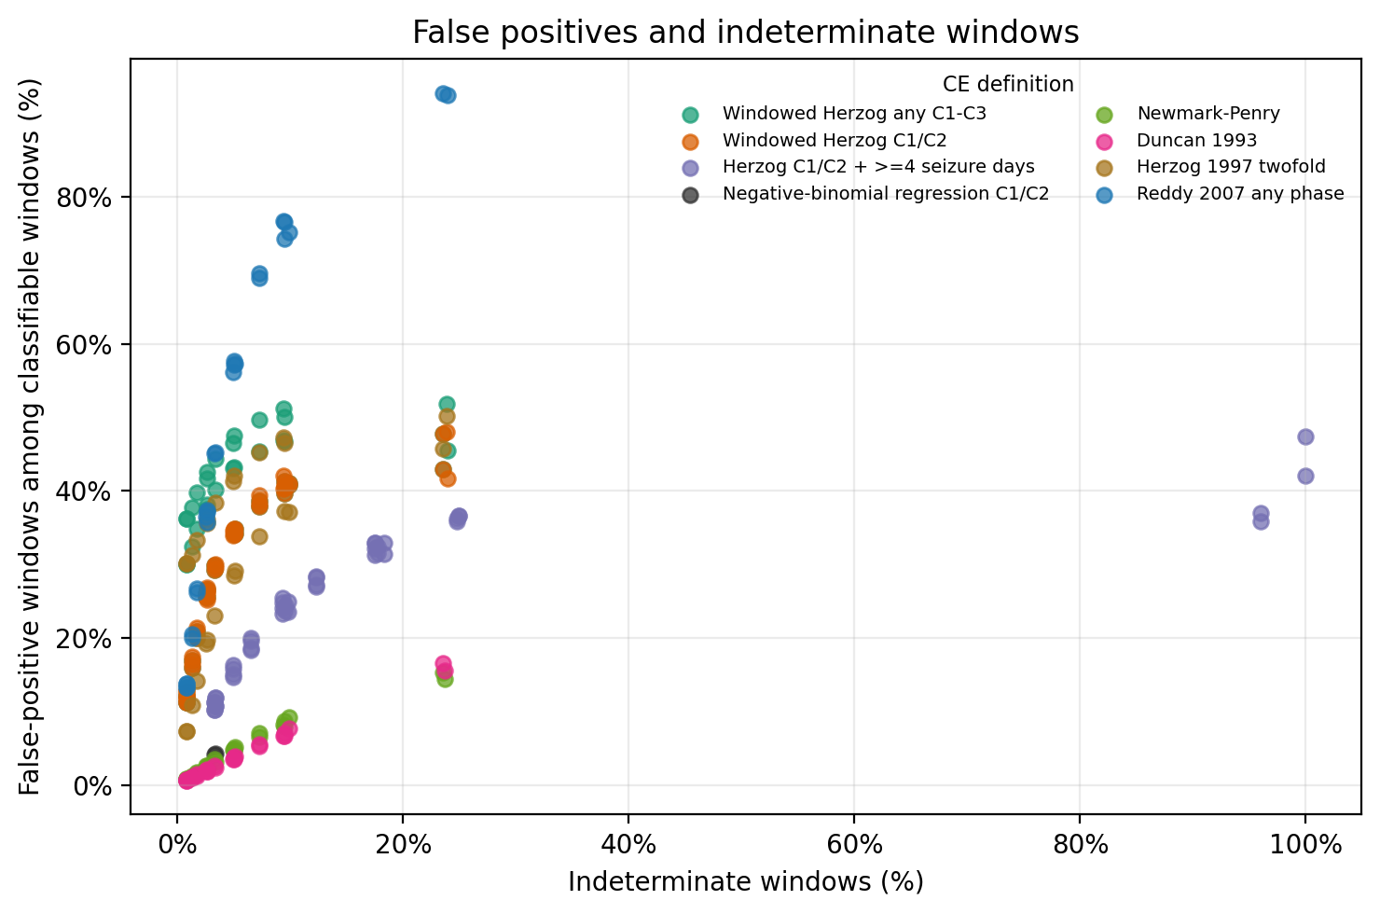
Supplementary Figure 2. Historical and core definitions in 3-month windows.
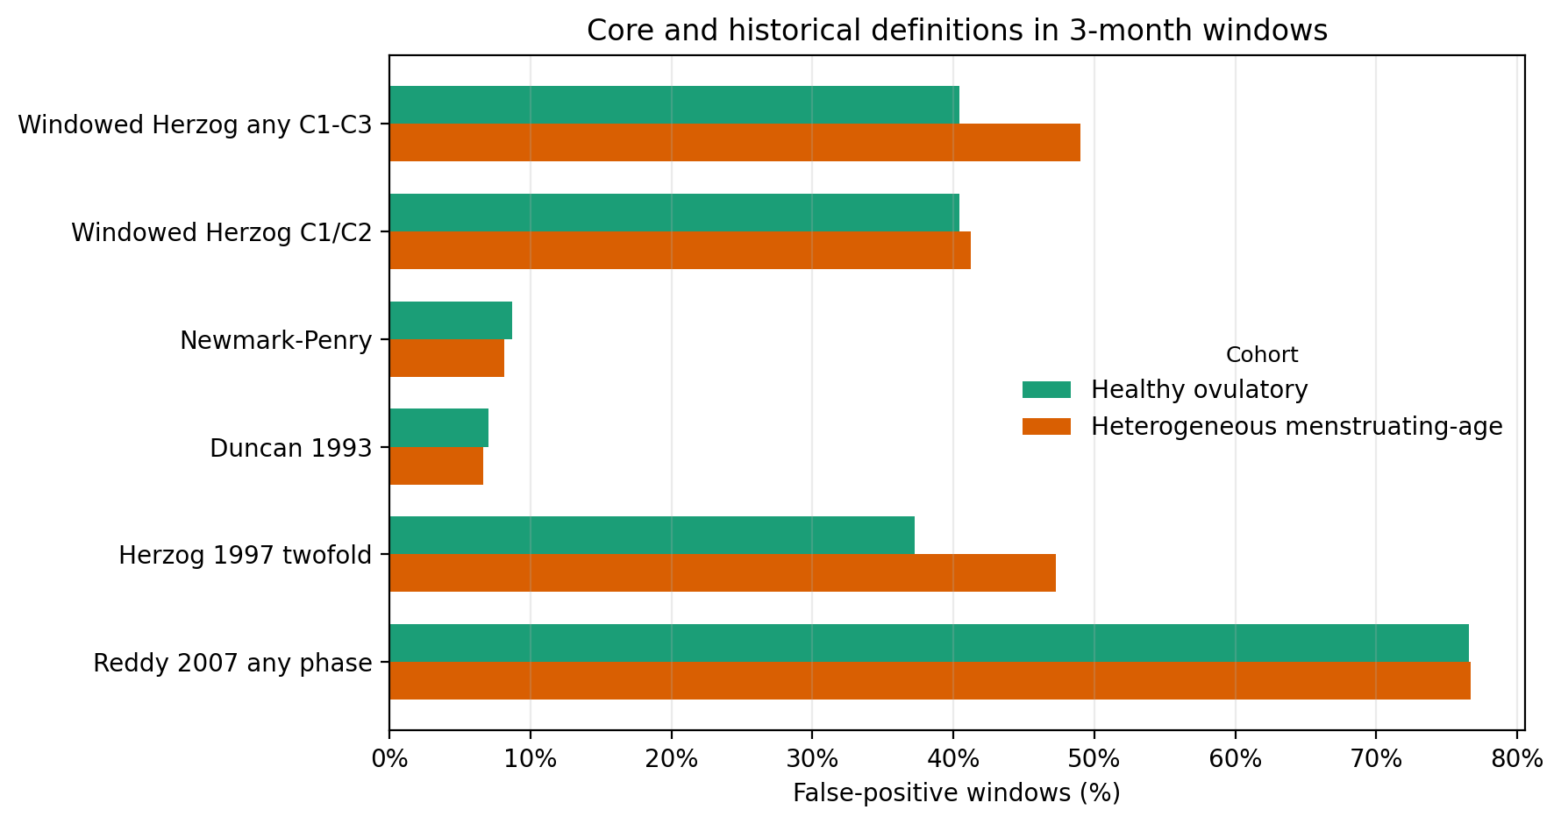
Supplementary Figure 3. Null seizure profile by menstrual cycle day.
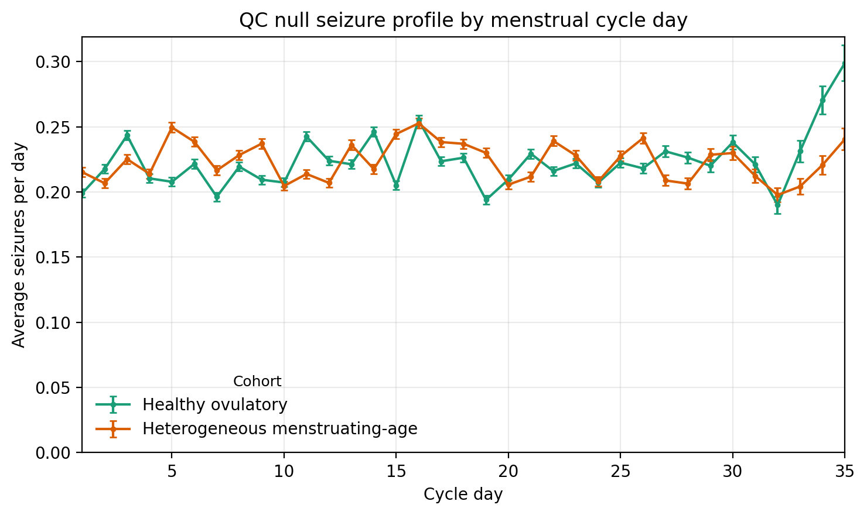

A8. Output provenance and assumptions
- Definition D uses a participant-full-diary method-of-moments negative-binomial alpha recorded in d_alpha; Poisson robust fallback is recorded in d_reason when statsmodels negative-binomial fitting fails. D_window_alpha re-estimates alpha from the analyzed window as a non-oracle sensitivity.
- Healthy ovulatory cohort used hormone_cycler build_patient_profile/render_cycle with ovulation_probability set to 1.0 because simulate_diary did not expose a public force-ovulation knob.
- Historical definitions H1-H4 are assumption-based operationalizations and are flagged in summary outputs.
- Study-level Monte Carlo samples each selected participant from a deterministic pool of precomputed random valid 3-month windows to avoid retaining all daily diaries in memory.
- The hormone simulator exposes medical-factor controls but no natural prevalence sampler; heterogeneous-cohort medical factors were sampled from config.yaml rates.
- True-coupling code paths are retained for future operating-characteristic analyses but are not reported as part of this null-only revision.

