Apparent Catamenial Epilepsy Classification Under a Null Simulation
Article type: Article
Running title: Null Catamenial Classification
Title character count: 67
Abstract word count: 245
Text word count: 2216
References: 18
Tables: 2
Figures: 3
Supplementary content: Yes; separate appendix document
Authors: (1) Daniel M. Goldenholz; (2) Sharon Chiang; (3) Wesley Kerr; (4) M. Brandon Westover, (5) Rachael Sumner.
Affiliations: 1 – Beth Israel Deaconess Medical Center
2 – UCSF
3 – University of Pittsburg
4 – Stanford
5 – University of Auckland

Corresponding author: Daniel M. Goldenholz.
Statistical analysis completed by: Daniel M. Goldenholz.
Author responsibility statement: Daniel M. Goldenholz takes responsibility for the simulation data, analyses, interpretation, and conduct of the research; had full access to all output data; and had responsibility for the decision to submit. All authors approved the submitted version.

CRediT contributorship: DMG, conceptualization, methodology, software, formal analysis, visualization, writing-original draft, writing-review and editing, funding acquisition; SC, methodology, clinical interpretation, writing-review and editing; WK, methodology, clinical interpretation, writing-review and editing; RS, conceptualization, methodology, clinical interpretation, writing-review and editing.

Abstract
Objective: To quantify how often catamenial epilepsy classification rules produce apparent catamenial epilepsy under a null model in which seizure diaries and menstrual-cycle diaries are generated independently. Methods: We simulated 100,000 synthetic participants for 36 months in healthy ovulatory and heterogeneous menstruating-age cohorts. CHOCOLATES generated seizure diaries and HORMONE-CYCLE generated independent menstrual/hormone diaries. A random circular shift was applied before merging. Herzog phases were labeled before window sampling. We evaluated exact Herzog 2004, windowed Herzog thresholds, minimum-data rules, cycle reproducibility rules, stabilized-dispersion and window-dispersion negative-binomial regression, and historical-rule operationalizations across defined calendar, cycle, and full-diary windows. Results: In 36-month windows, windowed Herzog thresholds classified 11.2% (Monte Carlo binomial 95% interval 11.0-11.5) of healthy ovulatory and 36.3% (35.8-36.7) of heterogeneous cohort participants as apparent catamenial epilepsy under independence. Stabilized-dispersion negative-binomial regression exhibited approximately nominal Type I error, 4.1% (3.9-4.2) and 4.2% (4.0-4.4), respectively. Exact Herzog 2004 applied to 3 complete cycles classified 50.3% and 51.6% of classifiable windows positive, with 53.8% and 66.7% not classifiable. In 10,000 null studies of 30 participants using 3-month windows, apparent prevalence exceeded 39.1% in 45.9% of healthy ovulatory and 79.9% of heterogeneous cohort studies. Conclusions: These findings quantify the potential for false-positive catamenial epilepsy classification under finite diary windows and independence between seizure and menstrual processes. Diagnostic studies should prespecify analyzability, comparator handling, ovulatory-status handling, and reproducibility requirements.
Classification of Evidence: Not applicable. This simulation study evaluates operating characteristics of classification rules under a synthetic null model and does not test a diagnostic intervention or therapeutic effect in human participants.
Search Terms: catamenial epilepsy; epilepsy; seizures; menstrual cycle; simulation study.

Introduction
Catamenial epilepsy describes seizure exacerbation in relation to the menstrual cycle. The clinical literature has long recognized perimenstrual, periovulatory, and inadequate luteal-phase patterns, but reported prevalence varies widely because studies use different phase definitions, thresholds, diary durations, and eligibility rules. Herzog and colleagues reported 39.1% catamenial epilepsy in women who charted seizures and menses for three complete cycles using a two-of-three-cycle rule, and later work from the NIH Progesterone Treatment Trial has been interpreted as supporting prevalence near 44% in selected trial participants.1,5
The diagnostic problem is not only biological. Seizures are temporally structured: clustering, circadian rhythms, and multidien rhythms have been documented in long-term diaries and intracranial recordings.9-11 If seizure rhythms are independent of menstrual cycles but contain multidien structure in overlapping period bands, finite diary windows can still contain chance alignments. Ratio definitions are especially vulnerable when seizure counts are sparse or comparator phases contain few events. This creates a specificity question with direct implications for clinical research: what apparent catamenial epilepsy prevalence should be expected when no menstrual coupling exists?
We conducted a reproducible null-simulation study to estimate apparent catamenial epilepsy classification across definitions and observation windows under independence. The analysis evaluates specificity-like behavior only. Positive-control true-coupling simulations were added as a sensitivity framework to calibrate future sensitivity analyses, but the primary inference is the null background rate.

Methods
Study design
This Monte Carlo null simulation was defined before the full simulation run. For each synthetic participant, seizure and menstrual/hormone diaries were generated independently for 36 months. A participant-specific random circular shift of the seizure diary was sampled uniformly over the diary length before merging to prevent hidden start-date alignment; cycle labels were preserved from the hormone diary and seizure counts were wrapped with the shifted seizure diary. All analyses were stratified by cohort; cohorts were never pooled.
Cohorts
The healthy ovulatory cohort included 50,000 synthetic participants, age 18-45 years, with ovulatory cycling enforced through the simulator. The heterogeneous menstruating-age cohort included 50,000 synthetic participants, age 13.0-54.9 years, allowing anovulation and cycle irregularity. Because the hormone-cycle simulator exposed medical-factor controls but not a natural prevalence sampler, PCOS, peri-menarche, perimenopause, and dysmenorrhea were sampled from data-driven population rates. This cohort should be interpreted as an assumption-driven heterogeneity stress test unless these rates are replaced with externally validated prevalence inputs.
Diary simulators
CHOCOLATES (Cyclic Heterogeneous Overdispersed Clustered Open-source L-relationship Adjustable Temporally limited E-diary Simulator) generated non-catamenial seizure diaries. CHOCOLATES uses a hierarchical gamma-Poisson/negative-binomial seizure-count generator in which participant-level seizure burden is sampled from a population distribution and daily risk is modified by empirically motivated multidien cycles, seizure clustering, the observed relationship between mean seizure rate and within-person variability, and limits on very short interseizure intervals. The simulator was developed to reproduce multiple statistical properties of seizure diaries and was validated by simulating 10,000 randomized antiseizure-medication trials and comparing 50% responder rates and median percent change with 23 historical trials.12 In the present null study, CHOCOLATES was useful because it generated realistic structured seizure diaries without menstrual-cycle coupling, allowing apparent catamenial classification to be interpreted as always incorrect by definition.
HORMONE-CYCLE generated independent menstrual/hormone diaries. It is a hierarchical simulator that samples patient-level latent traits and cycle-level realizations, then interpolates daily estradiol and progesterone trajectories from menstrual subphase reference medians. Its simulated features include cycle length, within-person cycle-length variability, bleeding days, ovulatory and anovulatory cycles, follicular and luteal phase lengths, ovulation day, luteal progesterone, inadequate-luteal-phase flags, and configured modifiers for PCOS, peri-menarche, perimenopause, dysmenorrhea, oral contraceptive use, hormonal IUD, and copper IUD. Baseline age-specific cycle length and adjacent-cycle irregularity targets were based on Apple Women's Health Study/Nurses' Health Study 3 data, phase-length and bleeding-duration targets on Natural Cycles data, and estradiol/progesterone trajectories on Stricker et al. menstrual subphase hormone reference values.13-15 Validation compared simulated age-band cycle length and irregularity with Li et al., aggregate follicular length, luteal length, and bleeding days with Bull et al., and subphase estradiol and progesterone medians with Stricker et al.; simulator validation targets, versioning, and reproducibility details are documented in the Appendix following STRESS reporting principles.13-16
Phase labeling and definitions
Herzog phases were assigned on the full diary before subsetting. In a complete cycle of length L, day 1 was menstrual-flow onset and backward day was d-(L+1). Labels were assigned in the following order: menstrual phase if forward day 1-3 or backward day -3 to -1; follicular phase if forward day 4-9; ovulatory phase if forward day >=10 and backward day <=-13; luteal phase if backward day -12 to -4; otherwise unlabeled. The ovulatory condition is an intersection, not a union. Windowed thresholds used C1 = ADSF(M)/ADSF(F+L) >=1.69, C2 = ADSF(O)/ADSF(F+L) >=1.83, and C3 = ADSF(O+L+M)/ADSF(F) >=1.62 among inadequate-luteal-phase days. C3 was evaluated only in the heterogeneous cohort when ilp_flag was present; anovulatory or nonclassifiable cycles without ilp_flag did not contribute to C3. C3-excluding and C1/C2/C3-only sensitivity endpoints were generated.
Exact Herzog 2004 was restricted to complete 3-cycle windows with all cycles lasting 23-35 days and required at least two of three cycles to show any positive pattern. Other calendar and longer cycle windows are reported as not evaluated for this rule rather than interpreted as negative. Minimum-data rules required at least 4 calendar months or 6 complete cycles and at least 4 seizure days. Reproducibility rules required at least two-thirds of eligible cycles to be positive for the same pattern and the corresponding pooled ratio to pass threshold.
Regression comparator
The primary regression comparator used a within-participant negative-binomial generalized linear model with daily seizure count as outcome, log link, intercept, menstrual-phase indicator, ovulatory-phase indicator, and cycle fixed effects when at least four complete cycles were available. The offset was one observed day for each daily row. One-sided Wald tests evaluated menstrual and ovulatory enrichment, Holm-adjusted across the two comparisons; positivity required both adjusted P<0.05 and the Herzog rate-ratio threshold for that phase. C3 was not evaluated by regression. The primary regression used full-diary method-of-moments dispersion as a stabilized-dispersion comparator, and a window-only dispersion sensitivity was added. If model fitting failed, a robust Poisson fallback was recorded.
Statistical analysis
The primary outcome was the person-window apparent catamenial epilepsy rate among classifiable windows under the null. We also report positivity among all attempted windows when indeterminate rates are material. Monte Carlo binomial 95% intervals quantify simulation uncertainty under the fixed model and do not incorporate uncertainty about simulator form, medical-factor rates, or period distributions. Study-level Monte Carlo independently sampled 10,000 studies of 30 participants without replacement from each cohort, selecting one precomputed random valid 3-month window per participant, and estimated probabilities that apparent prevalence exceeded 39.1% and 44.2%.
Positive-control sensitivity
A configurable true-coupling mode adds extra Poisson seizure events after null diary alignment on target phase days. The current positive-control setting targets menstrual-phase days with a 1.5-fold rate-ratio input. This is an auditable operating-characteristic sensitivity rather than a mechanistic hormone model.
Standard protocol approvals, registrations, and patient consents
This study used only synthetic participants and did not use human-subject data, identifiable patient information, images, or videos. Institutional review board approval and patient consent were not required.

Results
Simulation cohort and diary characteristics
The full run included 100,000 synthetic participants and 900,000 defined participant-window rows. Cohort summaries are shown in Table 1. The healthy ovulatory cohort had 100.0% ovulatory cycles by design. The heterogeneous cohort had 79.0% ovulatory cycles, greater cycle-length variability, and similar observed seizure burden.
Primary full-diary null rates
In 36-month windows, the windowed Herzog threshold definition classified 11.2% of healthy ovulatory participants and 36.3% of heterogeneous cohort participants as apparent catamenial epilepsy under independence (Table 2). Adding minimum-data rules changed the full-window estimates modestly because most full diaries were analyzable. Stabilized-dispersion negative-binomial regression exhibited approximately nominal Type I error at 4.1% and 4.2%, as expected for a calibrated test under the null. This calibration should not be interpreted as clinical usefulness; sensitivity and positive predictive value require true-coupling simulations.
C3 contribution
In the heterogeneous cohort, the high windowed full-diary null rate was driven largely by C3 logic. Full-window C3 positivity occurred in 37.0% of applicable heterogeneous-cohort windows, compared with C1 and C2 rates of 8.4% and 5.6%. C3-excluding endpoints and C1/C2/C3-only sensitivity rows are reported in the Appendix to separate inadequate-luteal-phase logic from perimenstrual and periovulatory classification.
Observation-window effects
Short diary windows were the most vulnerable to apparent catamenial classification. In random 3-month calendar windows, windowed Herzog thresholds yielded apparent classification rates of 41.3% in the healthy ovulatory cohort and 51.2% in the heterogeneous cohort. Minimum-data, reproducibility, and regression definitions were intentionally not classifiable for 3-month calendar windows when the required minimum structure was absent. Exact Herzog 2004 applied to 3 complete cycles yielded apparent classification rates of 50.3% and 51.6% among classifiable windows, while 53.8% and 66.7% of attempted 3-cycle windows were not classifiable.
Study-level Monte Carlo
In 10,000 simulated studies of 30 participants using 3-month windows and the windowed Herzog threshold rule, the mean apparent prevalence among all 30 participants was 37.5% in the healthy ovulatory cohort and 46.0% in the heterogeneous cohort. Apparent prevalence was at least 39.1% in 45.9% and 79.9% of null studies, respectively, and at least 44.2% in 19.7% and 54.5%.
Daily audit profile
The cycle-day audit plot is retained as an exploratory quality-control display rather than primary evidence. Because late cycle days have sparse denominators in irregular cycles, interpretation should emphasize phase-level and window-level endpoints rather than isolated day-level spikes.

Discussion
This null simulation shows that apparent catamenial epilepsy can arise frequently even when seizure and menstrual processes are generated independently. The magnitude depends strongly on the definition, window length, analyzability rules, and cohort menstrual-cycle assumptions. Ratio-only windowed definitions were vulnerable, particularly in short windows and in the heterogeneous cohort where inadequate-luteal-phase logic made C3 classification common. Regression and reproducibility requirements reduced null positives but did so partly by requiring longer diaries or by declining to classify insufficient windows.
The negative-binomial result should be interpreted as calibration, not superiority. A statistical test evaluated at alpha=0.05 should produce approximately 5% positives under a correctly specified null, and the stabilized-dispersion regression did so. Ratio rules are not nominal-alpha tests and therefore have no comparable Type I error guarantee. Whether regression, reproducibility rules, or ratio thresholds are useful for diagnosis depends on sensitivity, positive predictive value, burden, interpretability, and robustness under true coupling. The positive-control framework added here is intended to support that operating-characteristic assessment.
These results help interpret the broad range of prevalence estimates in the catamenial epilepsy literature without estimating true prevalence. Earlier work established biologically plausible and clinically important menstrual-cycle seizure patterns, including C1, C2, and C3 patterns.1-5 Treatment literature also suggests that robust perimenstrual exacerbation may identify subgroups of interest, even though randomized evidence for hormonal therapy remains limited and mixed.6,7 The present analysis instead quantifies a diagnostic background rate expected from chance alignment when seizure cycles and menstrual cycles coexist under independence.
The findings are consistent with modern seizure-cycle research. Multidien seizure rhythms and seizure forecasting studies have shown that seizure risk varies over days to weeks, and those rhythms can be detected in long-term electronic diaries and chronic recordings.9-11 A menstrual-cycle analysis that does not account for intrinsic seizure cyclicity can therefore mistake phase overlap for hormone coupling. This is most problematic when the observation window is short, because a few events can dominate average daily seizure-frequency ratios.
Several methodologic implications follow. First, catamenial epilepsy studies should report both positive rates and indeterminate rates, because stricter definitions may appear more conservative partly by declining to classify insufficient windows. Second, comparator phases with zero seizures require explicit rules; silently treating undefined ratios as negative can bias estimates. Third, benchmark comparisons should match the original study design. For Herzog 2004, the design-matched comparison is the exact 3-complete-cycle rule, whereas random 3-calendar-month windows are a design-sensitivity analysis. Fourth, C3 classification in heterogeneous or irregular-cycle populations requires careful ovulatory-status and luteal-phase ascertainment.
This study has limitations. The results are only as credible as the CHOCOLATES and HORMONE-CYCLE simulators, their parameter settings, and the adapter assumptions. The heterogeneous cohort medical-factor rates were configuration-sampled rather than drawn from a simulator-native prevalence sampler, and cycle-length variability is therefore a sensitivity driver rather than a settled population estimate. Monte Carlo binomial intervals do not include model-form uncertainty. The current positive-control coupling model is simple and perimenstrual; it does not represent full hormone dynamics, treatment effects, wavelet analyses, hidden Markov models, medication changes, or adjudicated seizure types.
In conclusion, under an independence model with structured seizure diaries and menstrual-cycle diaries, apparent catamenial epilepsy classification can be common and can reach historical benchmark prevalence values. This means that catamenial epilepsy was diagnosed in a population of patients who cannot have the condition. Future diagnostic and interventional studies should prespecify diary length, menstrual-phase labeling, analyzability thresholds, zero-denominator handling, ovulatory-status handling, and reproducibility criteria before interpreting apparent menstrual clustering as evidence of hormone-linked seizure exacerbation.

Acknowledgment
GPT 5.5 and Codex were instrumental in developing the software engine for HORMONE-CYCLE. CHOCOLATES was developed without AI assistance. Opus 4.7 and GPT 5.5 Pro were used for collaborative manuscript improvement, always with human oversight.

Study Funding
This work was supported by NIH K23NS124656, NIH R21NS142800, and American Board of Psychiatry and Neurology for DMG.
** SC funding. ** WK funding. ** RS funding. ** MBW funding.

Disclosure
DMG reports funding from NIH K23NS124656, NIH R21NS142800, and the American Board of Psychiatry and Neurology. SC, WK, RS, MBW report ***.

Data Availability
The simulation code, configuration, analysis outputs, and machine-readable manifest are available in the project repository https://github.com/GoldenholzLab/catamenial-epilepsy-sim.git.

References
1. Herzog AG, Harden CL, Liporace J, et al. Frequency of catamenial seizure exacerbation in women with localization-related epilepsy. Ann Neurol. 2004;56:431-434. doi:10.1002/ana.20214
2. Herzog AG, Klein P, Ransil BJ. Three patterns of catamenial epilepsy. Epilepsia. 1997;38:1082-1088. doi:10.1111/j.1528-1157.1997.tb01197.x
3. Herkes GK, Eadie MJ, Sharbrough F, Moyer T. Patterns of seizure occurrence in catamenial epilepsy. Epilepsy Res. 1993;15:47-52. doi:10.1016/0920-1211(93)90008-U
4. Herzog AG. Catamenial epilepsy: definition, prevalence, pathophysiology and treatment. Seizure. 2008;17:151-159. doi:10.1016/j.seizure.2007.11.014
5. Herzog AG. Catamenial epilepsy: update on prevalence, pathophysiology and treatment from the findings of the NIH Progesterone Treatment Trial. Seizure. 2015;28:18-25. doi:10.1016/j.seizure.2015.02.024
6. Maguire MJ, Nevitt SJ. Treatments for seizures in catamenial (menstrual-related) epilepsy. Cochrane Database Syst Rev. 2021;9:CD013225. doi:10.1002/14651858.CD013225.pub3
7. Herzog AG, Fowler KM, Smithson SD, et al. Progesterone vs placebo therapy for women with epilepsy: a randomized clinical trial. Neurology. 2012;78:1959-1966. doi:10.1212/WNL.0b013e318259e1f9
8. Reddy DS. The role of neurosteroids in the pathophysiology and treatment of catamenial epilepsy. Epilepsy Res. 2009;85:1-30. doi:10.1016/j.eplepsyres.2009.02.017
9. Baud MO, Kleen JK, Mirro EA, et al. Multi-day rhythms modulate seizure risk in epilepsy. Nat Commun. 2018;9:88. doi:10.1038/s41467-017-02577-y
10. Karoly PJ, Rao VR, Gregg NM, et al. Cycles in epilepsy. Nat Rev Neurol. 2021;17:267-284. doi:10.1038/s41582-021-00464-1
11. Karoly PJ, Cook MJ, Maturana MI, et al. Forecasting cycles of seizure likelihood. Epilepsia. 2020;61:776-786. doi:10.1111/epi.16485
12. Goldenholz DM, Westover MB. Flexible realistic simulation of seizure occurrence recapitulating statistical properties of seizure diaries. Epilepsia. 2023;64:396-405. doi:10.1111/epi.17471
13. Li K, Kresowik JD, Gore-Langton RE, et al. Characteristics of menstrual cycles with or without fertility awareness-based methods for ovulation estimation. JAMA Netw Open. 2024;7:e2414628. doi:10.1001/jamanetworkopen.2024.14628
14. Bull JR, Rowland SP, Scherwitzl EB, et al. Real-world menstrual cycle characteristics of more than 600,000 menstrual cycles. NPJ Digit Med. 2019;2:83. doi:10.1038/s41746-019-0152-7
15. Stricker R, Eberhart R, Chevailler MC, et al. Establishment of detailed reference values for luteinizing hormone, follicle stimulating hormone, estradiol, progesterone, prolactin and growth hormone during different phases of the menstrual cycle on the Abbott ARCHITECT analyzer. Clin Chem Lab Med. 2006;44:883-887. doi:10.1515/CCLM.2006.160
16. Monks T, Currie CS, Onggo BS, Robinson S, Kunc M, Taylor SJE. Strengthening the reporting of empirical simulation studies: introducing the STRESS guidelines. J Simul. 2019;13:55-67. doi:10.1080/17477778.2018.1442155
17. Newmark ME, Penry JK. Catamenial epilepsy: a review. Epilepsia. 1980;21:281-300. doi:10.1111/j.1528-1157.1980.tb04074.x
18. Duncan S, Read CL, Brodie MJ. How common is catamenial epilepsy? Epilepsia. 1993;34:827-831. doi:10.1111/j.1528-1157.1993.tb02100.x

Tables
Table 1. Simulated cohort characteristics.
Cohort | N | Mean age, y | Mean cycle length, d | Cycle-length SD, d | Ovulatory cycles | Seizure days/month | Seizures/month
healthy ovulatory | 50,000 | 31.5 (SD 7.8) | 29.15 | 3.39 | 100.0% | 2.46 | 6.83
heterogeneous menstruating-age | 50,000 | 34.0 (SD 12.1) | 30.92 | 4.74 | 79.0% | 2.45 | 6.80

Values are cohort-level means from the full 100,000-participant run. Cycle-length SD is the mean within-participant cycle-length SD.
Table 2. Key null false-positive results.
Cohort | Analysis setting | Definition | Classifiable denominator | Main result | Indeterminate | Benchmark probabilities
healthy ovulatory | 36-month full diary | Windowed Herzog thresholds | 49,605 / 50,000 | 11.2% (11.0%-11.5%) | 0.8% | Not applicable
healthy ovulatory | 36-month full diary | Windowed Herzog with minimum data | 48,359 / 50,000 | 10.2% (9.9%-10.5%) | 3.3% | Not applicable
healthy ovulatory | 36-month full diary | Negative-binomial regression, stabilized dispersion | 48,359 / 50,000 | 4.1% (3.9%-4.2%) | 3.3% | Not applicable
healthy ovulatory | 3 complete cycles | Exact Herzog 2004, any pattern | 23,101 / 50,000 | 50.3% (49.6%-50.9%) | 53.8% | Not applicable
healthy ovulatory | 10,000 n=30 studies; 3-month windows | Windowed Herzog thresholds | All 30 participants | Mean apparent prevalence 37.5% | Not applicable | 45.9%; 19.7%
heterogeneous menstruating-age | 36-month full diary | Windowed Herzog thresholds | 49,587 / 50,000 | 36.3% (35.8%-36.7%) | 0.8% | Not applicable
heterogeneous menstruating-age | 36-month full diary | Windowed Herzog with minimum data | 48,333 / 50,000 | 35.6% (35.2%-36.0%) | 3.3% | Not applicable
heterogeneous menstruating-age | 36-month full diary | Negative-binomial regression, stabilized dispersion | 48,333 / 50,000 | 4.2% (4.0%-4.4%) | 3.3% | Not applicable
heterogeneous menstruating-age | 3 complete cycles | Exact Herzog 2004, any pattern | 16,673 / 50,000 | 51.6% (50.8%-52.4%) | 66.7% | Not applicable
heterogeneous menstruating-age | 10,000 n=30 studies; 3-month windows | Windowed Herzog thresholds | All 30 participants | Mean apparent prevalence 46.0% | Not applicable | 79.9%; 54.5%

Main result is false-positive rate for participant windows unless the row is labeled as a study-level Monte Carlo result. Benchmark probabilities are P(apparent prevalence at least 39.1%) and P(apparent prevalence at least 44.2%).

Figure Legends
Figure 1. False-positive rates by observation window.
Bars show the percentage of classifiable participant windows classified as catamenial epilepsy under the null. Panels are separated by cohort; definitions are shown in the legend.
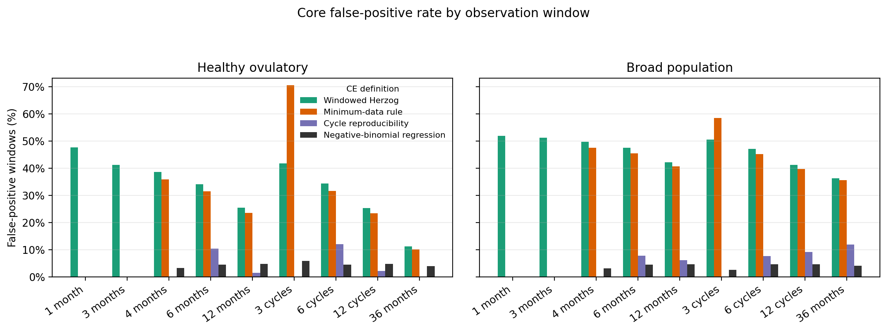
Figure 2. Apparent prevalence in null studies.
Distribution of apparent catamenial epilepsy prevalence in 10,000 simulated studies of 30 participants using random 3-month windows and the windowed Herzog threshold definition. Vertical lines show benchmark prevalence values of 39.1% and 44.2%.
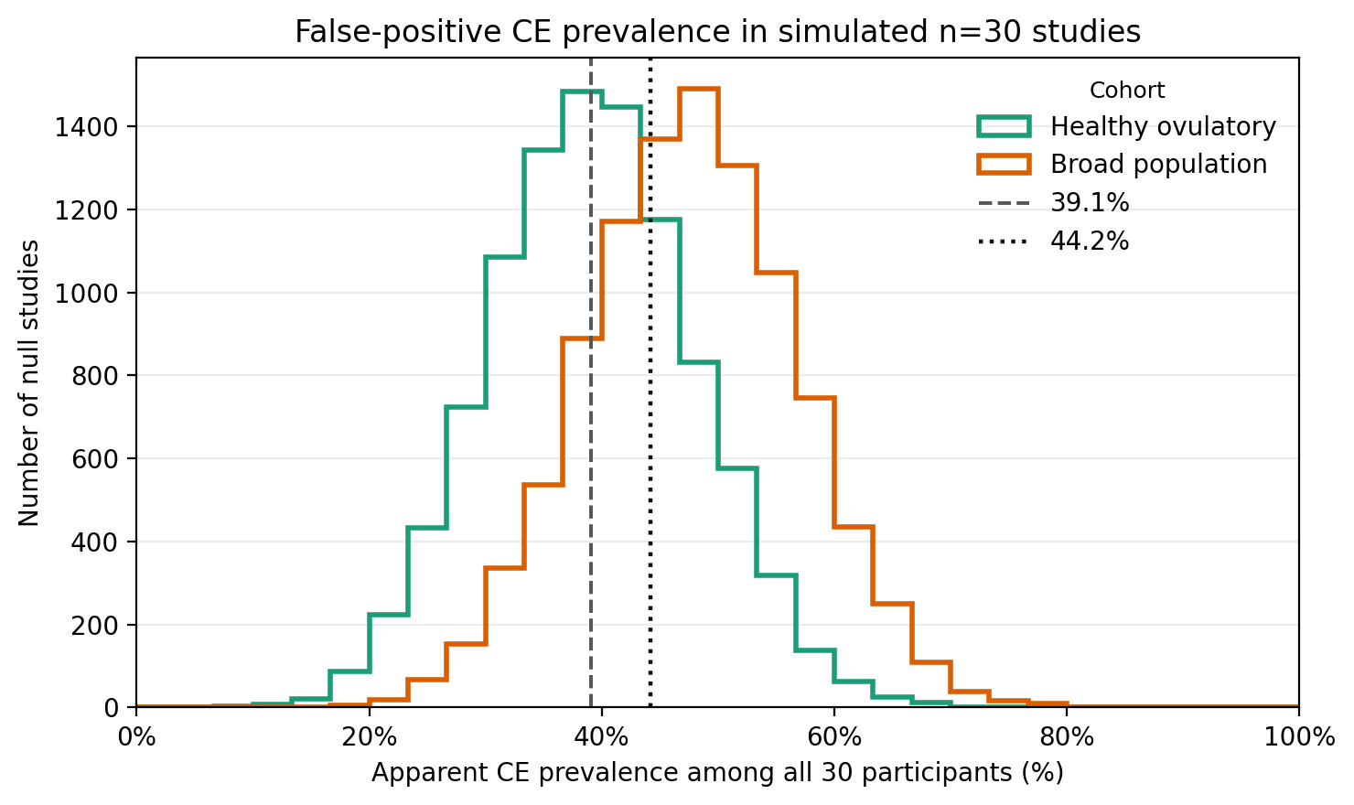
Figure 3. Null seizure profile by cycle day.
Average daily seizure frequency by menstrual cycle day in the 1% daily audit sample. The independent null simulation should not produce a coherent hormone-coupled seizure profile.
