DEPARTMENT OF COMPUTER ENGINEERING

AHMADU BELLO UNIVERSITY ZARIA KADUNA

MECHATRONICS (COEN 512)

ASSIGNMENT ON THE CONVERTION OF A HOUSE GATE INTO A MECHATRONICS SYSTEM

BY

MUHAMMAD IBRAHIM BABA

(U18CO2017)

# Converting a House Gate into a Mechatronics System

## **1.1 Background**

House gates are essential components in residential security systems. Traditionally, these gates operate mechanically, requiring manual intervention for opening and closing. However, with advancements in technology, there is an increasing demand to automate such systems for enhanced security, convenience, and efficiency. Converting a house gate into a mechatronics system involves integrating mechanical, electrical, and software components to create an intelligent and automated gate system.

## **1.2 Objective**

The objective of this report is to detail the process of converting a conventional mechanical house gate into a mechatronics system. This involves outlining the components required, the design process, the working principle, and the benefits of the converted system.

# **2. System Overview**

This section provides a comprehensive overview of the house gate system, comparing the traditional mechanical gate with the proposed mechatronics system. It outlines the key components and functionality of each system, highlighting the limitations of the conventional approach and the enhancements introduced through the integration of mechatronics technology. By understanding the existing system's framework and the advancements brought by automation, we can appreciate the transformation from a manual to a more intelligent and efficient operation.

## 2.1 Conventional House Gate

A traditional house gate operates on a simple mechanical principle where the user physically opens and closes the gate. The primary components of such a gate include:

1. Gate panels (usually made of metal or wood)
2. Hinges for movement
3. A locking mechanism
4. Manual operation, typically requiring physical effort to open or close

## **2.2 Mechatronics House Gate**

In a mechatronics system, the house gate is automated using a combination of mechanical, electrical, and control systems. The primary components involved in the conversion include:

1. Electric motor (for automated movement)
2. Sensors (for detecting presence and controlling gate movement)
3. Microcontroller (for processing inputs and controlling the system)
4. Remote control or smartphone app (for user interaction)
5. Safety mechanisms (such as obstacle detection and emergency stop)

# **3. Components and Design**

In this section, the critical components and design principles involved in converting a traditional house gate into a mechatronics system are highlighted. Each component, from the electric motor to the microcontroller, plays a vital role in automating the gate's operation. This section provides a detailed description of the key components, their functions, and how they are integrated into the overall system. Additionally, the design process is explored, highlighting the considerations and steps necessary to ensure that the mechatronics system operates seamlessly and efficiently.

## **3.1 Electric Motor**

An electric motor is central to the automation of the gate. It provides the necessary force to open and close the gate without manual intervention. A DC motor is typically used due to its reliability and ease of control. Figure 1 below is an electric motor which will act as the actuator in the system.

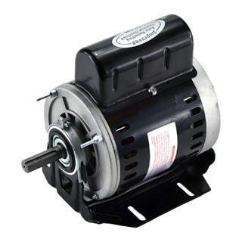

Figure 1: An Electric Motor

## **3.2 Sensors**

Sensors play a crucial role in the automation process. The following sensors can be integrated into the system:

1. **Proximity Sensors:** Detect the presence of objects or vehicles near the gate, Figure 2.
2. **Infrared Sensors:** Ensure that the gate does not close if there is an obstacle in its path, Figure 3.
3. **Position Sensors:** Monitor the position of the gate (open or closed), Figure 4.

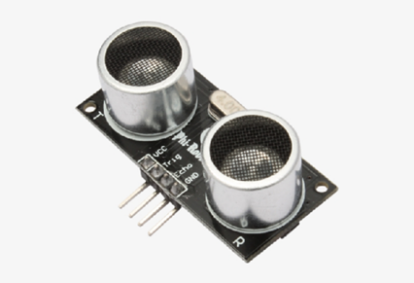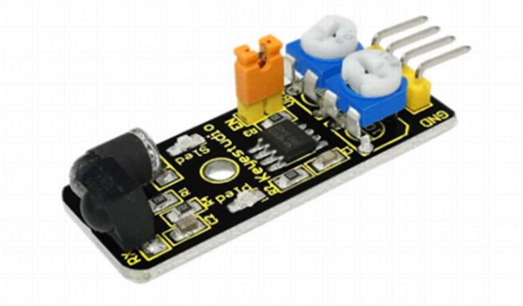

Figure 3: An Ultrasonic Proximity Sensor

Figure 2: Obstacle Avoidance Infrared Sensor

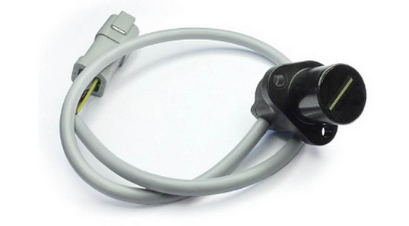

Figure 4: Absolute Position Sensor

## **3.3 Microcontroller**

A microcontroller serves as the brain of the mechatronics system. It processes input from the sensors and controls the motor's operation. Common microcontrollers include Arduino or ESP32, for this project Arduino (Figure 5) will be used which can be programmed to handle various tasks such as:

1. Opening and closing the gate
2. Interpreting signals from remote controls or smartphone apps
3. Managing safety protocols

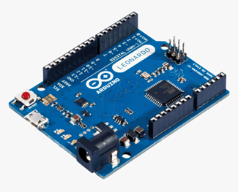

Figure 5: Arduino Microcontroller

## **3.4 Control Interface**

The control interface will be a remote control, a keypad, or a smartphone app. This will allow the user to operate the gate remotely. The system will be integrated with IoT (Internet of Things) technology to enable control via a smartphone app, providing greater convenience.

## **3.5 Safety Mechanisms**

To ensure the system operates safely, several safety mechanisms will be integrated:

**Emergency Stop Button**: Will allow the user to halt the gate's movement in case of an emergency.

**Obstacle Detection:** If an object or person is detected in the path of the closing gate, the system automatically stops or reverses the gate's movement.

# **4. Design Process**

This section outlines the step-by-step approach to converting a conventional house gate into a fully functional mechatronics system. The design process encompasses system integration, programming, testing, and installation. Each stage is crucial for ensuring that the components work harmoniously to achieve the desired automation and control. By carefully considering the mechanical and electronic elements, the design process transforms the traditional gate into an intelligent system that enhances security, convenience, and efficiency.

## **4.1 System Integration**

The first step in the conversion process is integrating the motor, sensors, and microcontroller with the existing mechanical structure of the gate. This involves mounting the motor and sensors in strategic locations and ensuring all components are securely attached.

## **4.2 Programming the Microcontroller**

The microcontroller needs to be programmed to handle various inputs and control outputs. The programming process includes:

1. Writing code to interpret sensor data
2. Setting up the motor control logic (e.g., when to start, stop, and reverse)
3. Implementing safety protocols
4. Configuring the control interface for remote operation

## **4.3 Testing and Calibration**

Once the system is assembled and programmed, it will undergo testing and calibration to ensure it operates correctly. This will involve:

1. Testing the motor's response to commands
2. Verifying that sensors accurately detect objects and control gate movement
3. Calibrating the system for smooth operation, ensuring the gate opens and closes without issues

## **4.4 Installation**

After successful testing, the system will be installed at the desired location. Installation involves wiring the components, connecting the control interface, and integrating the system with the existing gate structure.

# **5. Results and Benefits**

This section presents the outcomes of converting a traditional house gate into a mechatronics system, with focus on the tangible results and the advantages gained from the automation. The transformation will not only improve security and convenience but also introduce efficiencies that were previously unattainable with a manual gate. By evaluating the system's performance, this section highlights the significant benefits, such as enhanced safety, ease of use, and long-term cost savings, demonstrating the overall value of implementing a mechatronics solution.

## **5.1 Improved Security**

The automated gate system enhances security by providing controlled access to the property. The integration of sensors ensures that the gate operates only when it is safe to do so, reducing the risk of unauthorized entry.

## **5.2 Convenience**

The ability to operate the gate remotely adds convenience, especially for users who may have difficulty with manual operation. The system can be integrated with home automation systems for seamless operation.

## **5.3 Efficiency**

The automated gate system reduces the need for manual labor, making it more efficient. The system can be programmed to operate at specific times, reducing energy consumption.

# **6. Challenges and Considerations**

This section briefly addresses the potential challenges and important considerations, such as power supply, maintenance, and cost, that must be managed to ensure the successful implementation and operation of the mechatronics gate system.

## **6.1 Power Supply**

The system requires a reliable power supply to operate the motor and sensors. Backup power solutions, such as solar panels or batteries, may be considered to ensure uninterrupted operation during power outages.

## **6.2 Maintenance**

Regular maintenance is necessary to ensure the system remains functional. This includes checking the motor, sensors, and microcontroller for any faults and performing software updates as needed.

## **6.3 Cost**

The conversion of a traditional gate into a mechatronics system involves an initial investment in components and installation. However, the long-term benefits in terms of security and convenience often justify the cost.

# **7. Conclusion**

Converting a conventional house gate into a mechatronics system significantly enhances its functionality, security, and convenience. By integrating mechanical, electrical, and control systems, the automated gate provides a modern solution to residential access control. While there are challenges to consider, the benefits of such a system make it a worthwhile investment for homeowners seeking to improve their property's security and accessibility.

# **References**

1. Boldea, I., & Nasar, S. A. (2010). Electric drives. CRC Press.
2. El-Sharkawy, M. A. (2018). Smart home automation. Elsevier.
3. Dorf, R. C., & Bishop, R. H. (2016). Modern control systems (13th ed.). Pearson.
4. Ogata, K. (2020). Modern control engineering (5th ed.). Prentice Hall.
5. Kuo, B. C. (2002). Automatic control systems (8th ed.). John Wiley & Sons.
6. Kelly, G., & Van Zyl, G. (2014). Design and implementation of a low-cost automated gate control system. Journal of Engineering Design and Technology, 12(4), 620-637. https://doi.org/10.1108/JEDT-07-2013-0044
7. Piccoli, J. D., De Pellegrin, S. F., & Gama, V. (2020). A review of automation systems in buildings: Control approaches, energy management strategies, and emerging trends. Sustainable Cities and Society, 61, 102353. https://doi.org/10.1016/j.scs.2020.102353
8. Bolton, W. (2015). Mechatronics: Electronic control systems in mechanical and electrical engineering (6th ed.). Pearson.
9. HMT, I., & Ali, M. M. (2019). Automated gate system for home security using wireless sensor network and IoT. International Journal of Computer Applications, 178(31), 6-11. https://doi.org/10.5120/ijca2019919118
10. Kalpakjian, S., & Schmid, S. R. (2014). Manufacturing engineering and technology (7th ed.). Pearson.
11. Simplexity Product Development. (n.d.). Five tips for mechatronic system integration. Simplexity. https://www.simplexitypd.com/blog/five-tips-for-mechatronic-system-integration/
12. Keyestudio. (n.d.). Ks0051 keyestudio infrared obstacle avoidance sensor. Keyestudio Wiki. https://wiki.keyestudio.com/Ks0051_keyestudio_Infrared_Obstacle_Avoidance_Sensor