Jonathan Pilling

CS 3200

HW3 Writeup

Problem 2.

1. As NRHS values increase the amount of time computation takes increases. This makes sense because you’re working with bigger matrices.

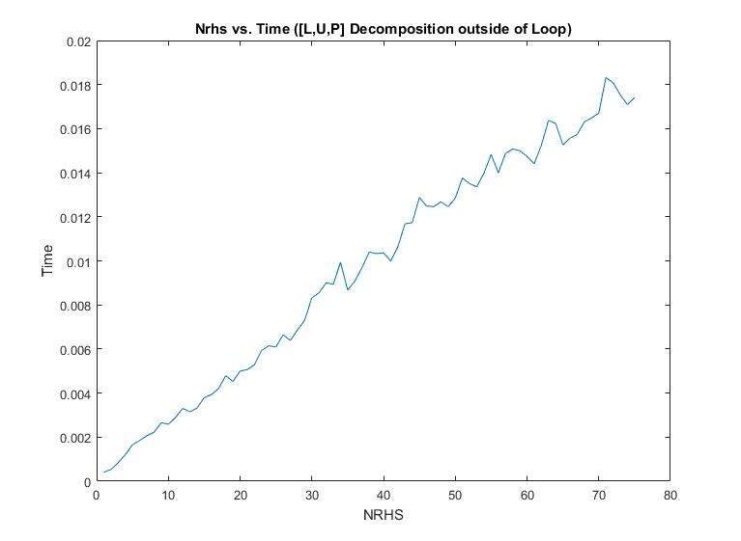

1. This graph follows a similar trend but takes a lot longer compared to the having the LUP decomposition outside of the loops. You can see to compute as the number of nrhs gets close to 75, it takes almost a full second to compute the solution matrix. This is different because you’re recomputing L, U, and P matrices every time.

