Heart Monitor

Embedded Systems Project Report – Spring 2020

# The purpose

The project’s purpose is to develop an application that displays and commands an ECG sensor. The application will be run on the PC with a serial connection to the ECG sensor.

# ECG

ECG or Electrocardiography represents the electric activity of the heart. It provides information about the structure of the heart and the condition of the cardiovascular system which proves useful to physician’s and doctor’s interpretation. The signal produced has a certain structure representing the stage of polarization and depolarization of the arteries and veins. To a trained doctor, many diseases can be seen clearly on an ECG signal including ischemia, arrhythmia, myocardial infarction and hypertrophy [1]. The cardiac rhythm is intriguing and one interesting application is developed by the US military which detects people based on their cardiac rhythm [2].

# Requirements

* Provide a easy to use UI including
  + Animated graph
  + Interfaces to other requirements
  + Warning pop ups
* Allow for the following commands:
  + Setting of the sampling rate
  + Collecting data (1 minute worth)
  + Reporting heart beat rate
* Allow the user to modify the serial connection including
  + The serial port
  + Baud rate

# Hardware

The following is a list of the proposed hardware needed to meet the requirements of the application.

* STM32F103C8T6

The following microcontroller provides some important features needed such as UART, ADC, Timers and GPIO pins. Little memory is needed as well as power.

* AD8232 (Sparkfun)

The following signal conditioning board provides the ECG signal from the pins available. It also eases the interfacing by allowing for an audio jack interface with electrode pads.

# Design

The following is the proposed design for the overall system. The main components are the software application, microcontroller and ECG sensor.

* Application

The application handles all the user interaction and display as well as communicate the commands to the microcontroller.

* Microcontroller

The microcontroller receives commands and responds to the application in a serial fashion. The on-board ADC interfaces with the ECG sensor.

* ECG Sensor

The sensor sends the data to microcontroller per its commands and control.

# Block Diagram

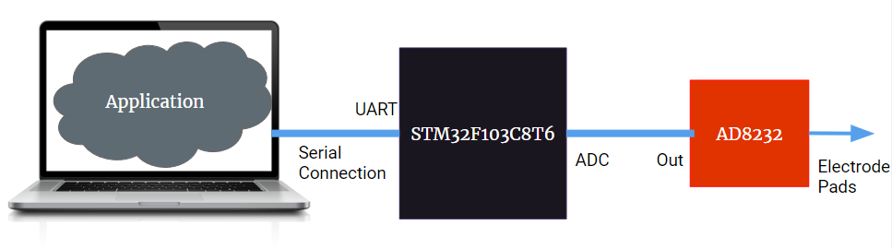

# Assumptions

* Expected to operate in room temperature
* Expected to use the PC USB to power the hardware
* The graph is sampled at 240bpm (maximum possible value)

# Implementation

# Given the available hardware, the following section includes the proposed implementation.

* Application

The language of development will be Python since it allows for rapid development. The libraries in aid would be PySerial, MatPlotLib and Tkinter.

* Microcontroller

The hardware section already indicates the intended hardware to be used (STM32F103). The application will be developed using C along with HAL APIs.

# Implementation: Application

The application is event triggered i.e. button triggered. It provides a UI discussed in a later section.

The application has a bunch of functions. The code is attached.

# Implementation: Microcontroller

The software architecture follows that of a Round Robin with Interrupts since the tasks are not expected to happen simultaneously.

The UART is interrupt based and only used to send and receive (no processing happens in the interrupt).

Task 1: Gather 1 minute worth of information from sensor

Timer 3 is used to control the ADC to read a sample with frequency of 4Hz (the maximum frequency considered at 240bpm which the maximum heart rate ever reached by a human). Timer 2 is used to accurately time 60 seconds for the data collection. The actual data collection happens in the interrupt.

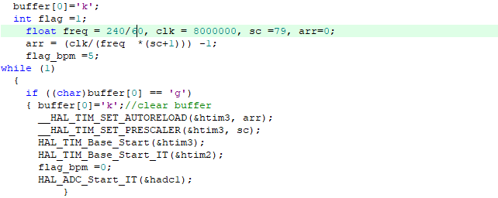

The interrupt reads the data from ADC and sends it on the UART using the following format ‘%d\n’.

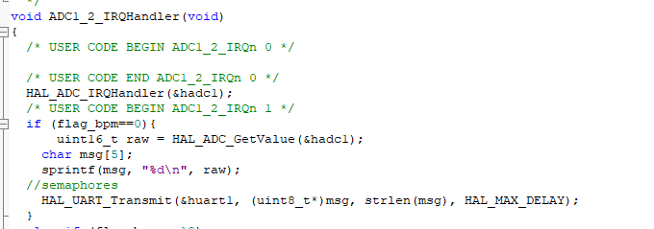

Timer 2 has a base of 1 minute. Once it triggers its interrupt, it disables the ADC and timer 3 to keep the UART lines clean.

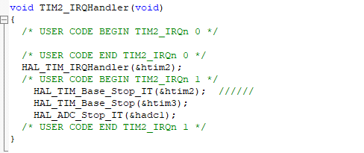

Task 2: Measure bpm

The main loop then checks if the UART request is to measure the bpm. Like task 1, the actual measurement happens in the ADC interrupt. Timer 3 is used to trigger the ADC with a time base of 1 microsecond.

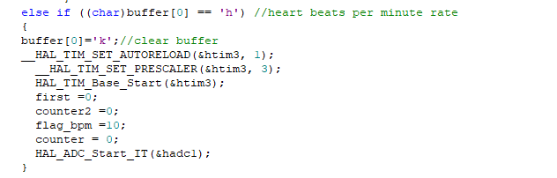

In the ADC interrupt, in a span of 2.5 seconds, the first peak is identified and then the second peak is identified. The difference is calculated in terms of microseconds. The frequency is 60*10^6/difference.

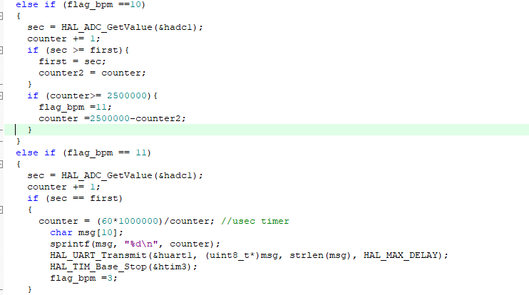

Task 3: change baud rate

If a baud rate change request is sent, the UART resets its baud rate value from predefined values.

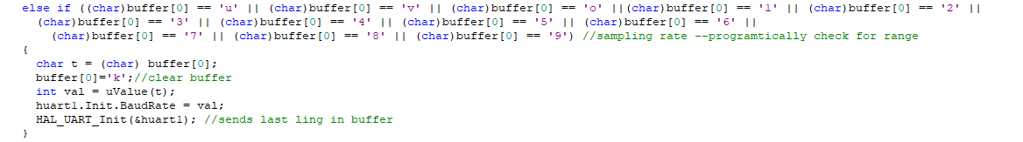

The function turns the request into the predefined baud rates. 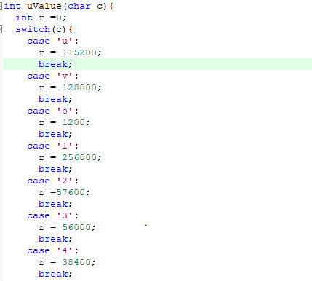

Task 4: change sampling rate

The application communicates the desired frequency; however, there is a range for acceptable frequencies. This task is done in the main loop. It replaces the frequency used in the calculation of the ARR and prescaler for timer 3 for the graphing.

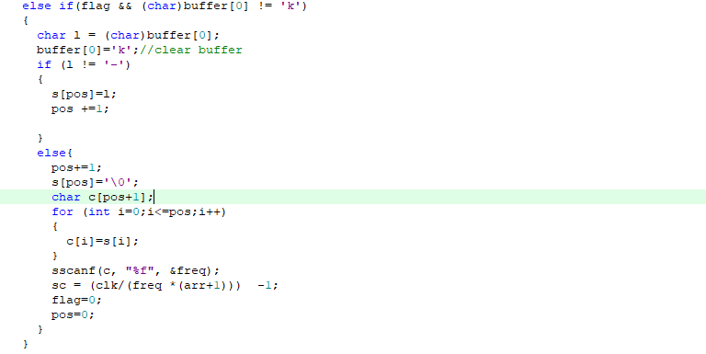

# Implementation: Hardware connection

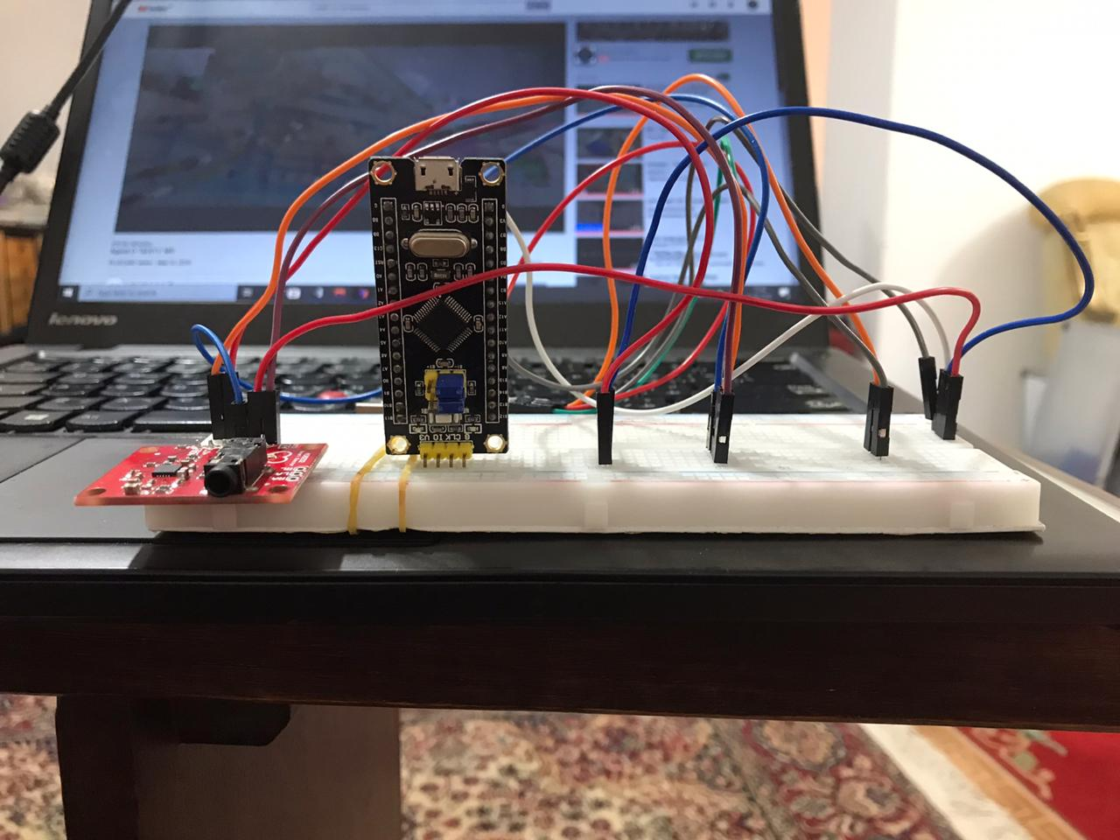

Figure 1: Hardware connection

# Implementation: UI

The layout is a combination of frames in a grid layout. The frames contain a grid layout.

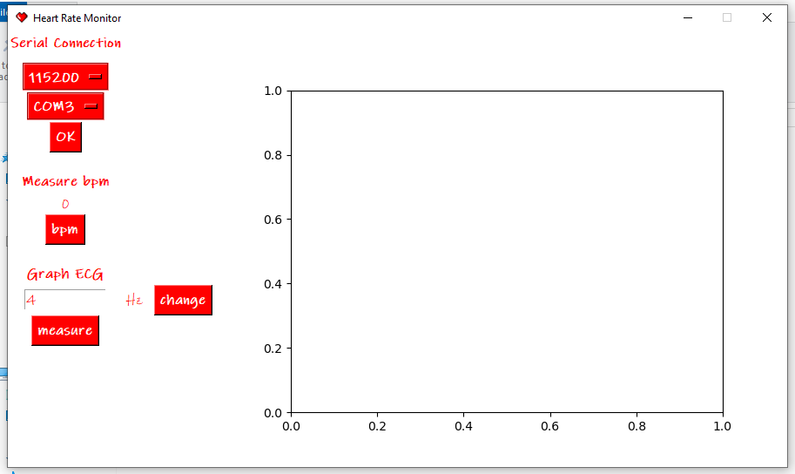

Figure 2: The UI

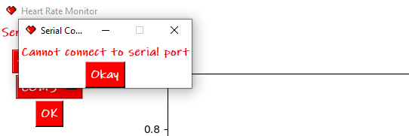

Figure 3: The warning pop up for serial connection

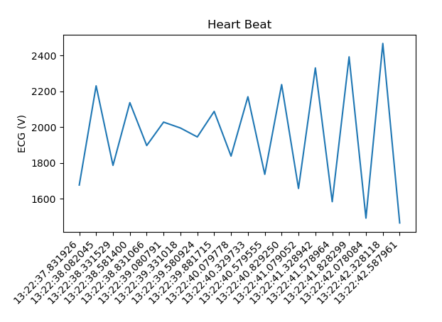

Figure 4: Real time Graph

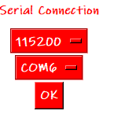

Figure 5: Serial Connection

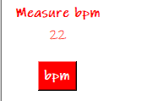

Figure 6: measuring bpm

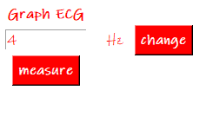

Figure 7: Graphing ECG

# Issues

The main issue was in the electrode pads; they lost stickiness. This resulted in a loss of accuracy and a lot of noise being picked up. Also, the circuit hardware is extremely sensitive which is not ideal for development.

# Further Development

This project could be the basic unit of many other projects. This includes integrating the monitor with machine learning techniques to different heart conditions. It could also evolve into a wireless wearable.

# Sources

[1] <https://www.msdmanuals.com/home/heart-and-blood-vessel-disorders/diagnosis-of-heart-and-blood-vessel-disorders/electrocardiography>

[2] <https://www.technologyreview.com/2019/06/27/238884/the-pentagon-has-a-laser-that-can-identify-people-from-a-distanceby-their-heartbeat/>