PROJECT REPORT
EDUNET FOUNDATION
SMART TRAVEL PLANNER
AGENT
AI-Powered Personalized Travel Planning System

Powered by
IBM watsonx.ai • LangFlow • ChromaDB • Scikit-Learn

GitHub: github.com/Goldi-Insights/Smart-Travel-Planner-Agent
Live Demo: smart-travel-planner-agent.onrender.com

1. Executive Summary
The Smart Travel Planner Agent is an advanced AI-powered travel planning platform designed to simplify and personalize the entire travel planning experience. Traditional travel planning involves visiting multiple websites, manually comparing costs, checking weather platforms, and reading scattered destination guides — a process that is both tedious and time-consuming.

This project eliminates that complexity by bringing together a suite of specialized AI agents, each responsible for a distinct aspect of travel planning. Together, they collaborate under a unified multi-agent architecture to deliver a seamless, intelligent, and fully personalized travel experience.

Key highlights of the system include:
- Multi-Agent AI Architecture powered by LangFlow for end-to-end workflow orchestration.
- Machine Learning-based travel cost estimation using a Random Forest Regressor model.
- Real-time weather intelligence via the OpenWeather API.
- Retrieval-Augmented Generation (RAG) using ChromaDB and LangChain for destination knowledge.
- Enterprise-grade itinerary generation using IBM watsonx.ai with Llama 3.3 70B Instruct.
- Responsive web interface built with HTML, CSS, and JavaScript on a Flask backend.

2. Introduction
Travel planning is a multi-dimensional process that requires gathering information from various sources — weather platforms, travel guides, hotel booking portals, tourism websites, and cost estimators. For most travelers, this results in information overload, inconsistent recommendations, and excessive time investment before even beginning the trip.

The Smart Travel Planner Agent was conceived as a solution to consolidate all these data points into a single intelligent platform. It leverages the latest advancements in Agentic AI, Machine Learning, Retrieval-Augmented Generation (RAG), and IBM watsonx.ai to build a truly smart travel assistant.

Instead of querying multiple sites, users simply provide their travel preferences — destination, duration, budget, number of travelers, and accommodation type — and the system handles everything else: recommending destinations, estimating costs, checking weather, retrieving destination guides, and producing a complete day-by-day itinerary.

3. Problem Statement
Despite the availability of numerous travel tools and applications, travelers continue to face significant challenges when planning their trips:

- Difficulty selecting suitable destinations — travelers often lack a personalized and data-driven recommendation engine tailored to their preferences.
- Absence of consolidated information — travel details are scattered across multiple platforms, requiring users to manually aggregate information.
- Uncertainty regarding travel costs — travelers struggle to accurately estimate the total expenses including transport, accommodation, and activities.
- Lack of personalized recommendations — generic travel guides do not account for individual preferences, travel style, or budget constraints.
- Time-consuming itinerary planning — creating a day-by-day travel plan manually is tedious and error-prone without expert knowledge.

The Smart Travel Planner Agent addresses all these pain points by unifying travel intelligence into a single, AI-powered system that adapts to each user's unique needs.

4. Project Objectives
The primary objectives of this project are:

- Develop a fully functional AI-powered travel planning system accessible via a web interface.
- Design a multi-agent architecture where specialized agents handle distinct planning tasks.
- Generate personalized, day-by-day travel itineraries using IBM watsonx.ai foundation models.
- Provide intelligent destination recommendations aligned with user preferences and budget.
- Estimate travel costs accurately using a trained Machine Learning regression model.
- Retrieve enriched destination knowledge using a Retrieval-Augmented Generation (RAG) pipeline.
- Integrate real-time weather forecasting to enable weather-aware travel planning.
- Visualize the multi-agent workflow using LangFlow for clarity and reproducibility.
- Deploy the application on a cloud platform (Render) for public accessibility.

5. Technology Stack
The project leverages a modern, production-grade technology stack spanning frontend development, backend APIs, AI/ML frameworks, vector databases, and cloud deployment.

Category | Technologies
Frontend | HTML, CSS, JavaScript
Backend | Flask, REST APIs
AI / LLM | IBM watsonx.ai, Llama 3.3 70B Instruct
Machine Learning | Random Forest Regressor, Scikit-Learn
RAG / Vector DB | ChromaDB, LangChain
External APIs | OpenWeather API
Workflow Orchestration | LangFlow
Deployment | Render
Version Control | GitHub

6. System Architecture
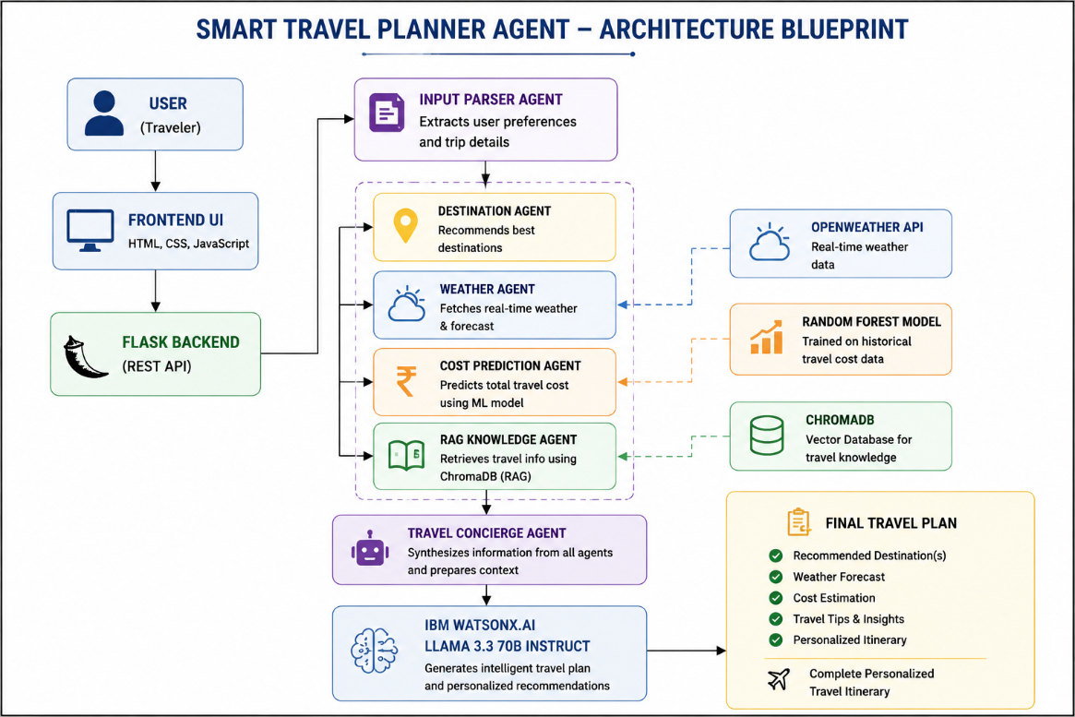
The Smart Travel Planner Agent is built on a layered multi-agent architecture. Each layer is independently responsible for a specific domain of the travel planning process, enabling modularity, scalability, and ease of maintenance.

6.1 Architectural Flow
The architecture follows a top-down pipeline:
- User Interface Layer — The user interacts with a responsive web frontend to submit travel preferences.
- Flask Backend Layer — Receives user requests, validates inputs, coordinates agent tasks, and compiles outputs.
- Agent Orchestration Layer — Multiple specialized AI agents execute in a coordinated sequence.
- AI & ML Processing Layer — Machine Learning models and IBM watsonx.ai perform cost prediction and itinerary generation.
- Data Retrieval Layer — ChromaDB handles semantic search over the RAG knowledge base.
- External Services Layer — OpenWeather API provides live meteorological data.
- Output Layer — A complete, personalized travel itinerary is returned to the user.

6.2 Architecture Pipeline
User → Frontend UI → Flask Backend → Input Parser Agent → Destination Agent → Weather Agent → Cost Prediction Agent → RAG Knowledge Agent → Travel Concierge Agent → IBM watsonx.ai (Llama 3.3) → Final Travel Plan

7. Multi-Agent Workflow
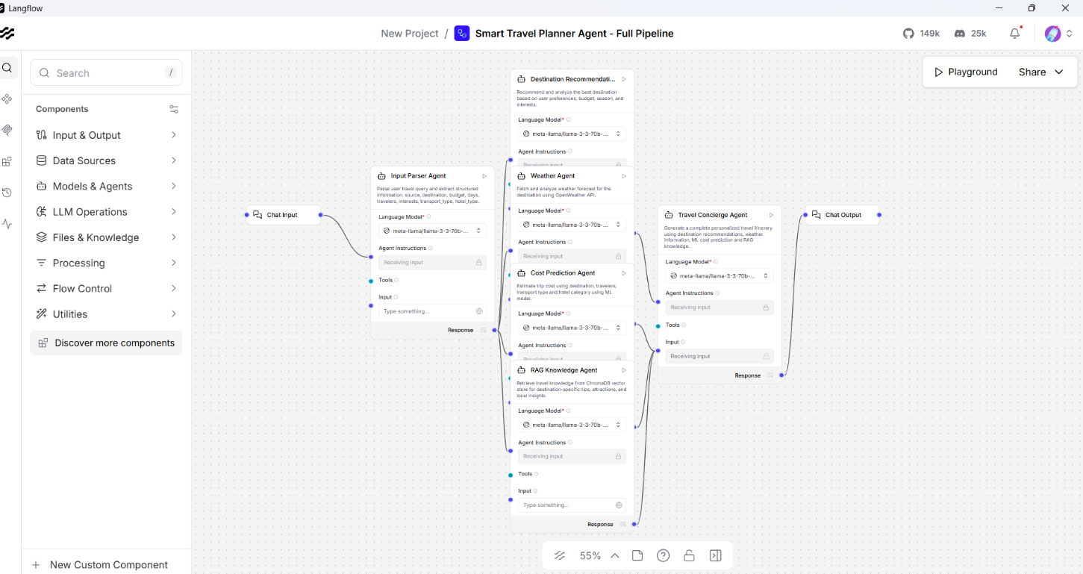
The heart of the Smart Travel Planner Agent lies in its multi-agent design. Each agent is a purpose-built module that specializes in one dimension of the travel planning process. Agents communicate through structured data passing, and the Travel Concierge Agent acts as the orchestrator that synthesizes all results.

Step | Agent | Responsibility
Step 1 | Input Parser Agent | Extracts and understands user travel preferences — destination, duration, budget, and accommodation type.
Step 2 | Destination Agent | Analyzes preferences and recommends the most suitable travel destinations tailored to the user's needs.
Step 3 | Weather Agent | Connects to the OpenWeather API to retrieve real-time weather conditions and forecasts for selected destinations.
Step 4 | Cost Prediction Agent | Uses a trained Machine Learning model (Random Forest Regressor) to estimate travel expenses based on key parameters.
Step 5 | RAG Knowledge Agent | Queries ChromaDB to retrieve relevant destination info, travel tips, and tourism insights using semantic search.
Step 6 | Travel Concierge Agent | Aggregates all outputs from the above agents into a unified structured prompt.
Step 7 | IBM watsonx.ai (Llama 3.3) | Generates a detailed, coherent, and personalized travel itinerary using the synthesized prompt.

This agentic design ensures that each component can be independently updated, tested, or replaced without affecting the rest of the system — a hallmark of scalable AI architecture.

8. Implementation Details

8.1 Frontend Development
The user interface was developed using HTML5, CSS3, and vanilla JavaScript to ensure broad browser compatibility and fast loading performance. The interface is fully responsive and adapts to various screen sizes, including desktop, tablet, and mobile devices.
Key UI components include:
- Home Dashboard — Provides a welcoming entry point and quick access to the travel planner.
- Trip Planning Form — A structured input form where users specify destination, dates, budget, number of travelers, transport preference, and hotel category.
- Itinerary Display Panel — Renders the AI-generated travel plan in a clean, readable format.
- Weather Widget — Shows real-time weather conditions for the chosen destination.

8.2 Backend Development
The backend is implemented using the Flask micro web framework, providing a lightweight yet powerful REST API server. The backend performs several critical functions:
- Receives and validates user input from the frontend.
- Parses travel preferences and dispatches tasks to respective agents.
- Coordinates agent outputs and assembles the final structured prompt.
- Interfaces with the IBM watsonx.ai API for itinerary generation.
- Returns the generated travel plan to the frontend in JSON format.

8.3 Machine Learning — Cost Prediction Model
A Random Forest Regressor model was trained using a custom travel cost dataset. The model takes five input features and predicts the estimated total travel expenditure:
- Destination — Encodes location-specific cost factors such as local price levels.
- Travel Duration — Number of days, which directly scales accommodation and daily expense costs.
- Number of Travelers — Scales base costs while accounting for group discounts.
- Transport Mode — Air, train, bus, or car, each with different cost profiles.
- Hotel Category — Budget, mid-range, or luxury, affecting accommodation pricing.

The Random Forest algorithm was selected for its robustness to overfitting, its ability to handle non-linear relationships between features, and its interpretability through feature importance analysis.

8.4 ChromaDB — RAG Knowledge Retrieval
A Retrieval-Augmented Generation (RAG) pipeline was built using ChromaDB as the vector database and LangChain as the orchestration framework. The RAG system works as follows:

- Destination guides, travel tips, cultural information, and tourism data are ingested and embedded into ChromaDB.
- When a user query is received, it is converted into a semantic embedding vector.
- ChromaDB performs a similarity search to retrieve the top-k most relevant documents.
- Retrieved knowledge is injected into the AI prompt sent to IBM watsonx.ai for richer context.

This approach significantly improves the factual accuracy and destination-specific relevance of generated itineraries.

8.5 IBM watsonx.ai Integration
The project integrates IBM watsonx.ai using the Llama 3.3 70B Instruct model — one of the most capable open-weight language models available today. The model is invoked via IBM's REST API with a carefully engineered prompt that includes:
- User travel preferences and trip parameters.
- Destination recommendations from the Destination Agent.
- Weather forecast summary from the Weather Agent.
- Estimated travel cost range from the ML Cost Prediction Agent.
- Destination knowledge retrieved from ChromaDB via the RAG pipeline.

The model synthesizes all this context into a coherent, day-by-day personalized travel itinerary complete with activity suggestions, dining recommendations, and practical travel tips.

9. Key Features
The Smart Travel Planner Agent is packed with powerful features that set it apart from conventional travel planning tools:

🤖 Personalized AI Planning | Generates custom itineraries based on user preferences, budget, and destination selection.
📍 Destination Recommendation | AI-powered destination matching tailored to traveler interests and travel style.
💰 ML Cost Prediction | Random Forest model accurately estimates travel costs for flights, hotels, and local transport.
🌦 Real-Time Weather | Live weather data via OpenWeather API to help travelers plan for climate conditions.
📚 RAG Knowledge Base | ChromaDB-powered retrieval fetches destination-specific travel guides and tourism insights.
🏗 Multi-Agent Architecture | Specialized AI agents work in parallel, each handling a distinct part of the planning workflow.
🧠 IBM watsonx.ai LLM | Enterprise-grade Llama 3.3 70B model generates fluent and contextually rich travel plans.
🔁 LangFlow Orchestration | Visual workflow builder used to design and visualize the multi-agent interaction pipeline.

10. Novelty and Uniqueness
What makes the Smart Travel Planner Agent stand out from existing travel planning tools is the combination of several cutting-edge AI technologies into a single, cohesive system:

- End-to-End Multi-Agent AI — Unlike single-model chatbots, this system uses a pipeline of specialized agents where each agent is an expert in one domain: destination discovery, weather intelligence, cost estimation, knowledge retrieval, and plan generation.
- ML-Powered Cost Estimation — Most travel tools rely on static price lists. This project uses a trained ML model that dynamically predicts travel costs based on the user's specific inputs.
- ChromaDB-Powered Semantic Knowledge — Rather than relying solely on the LLM's parametric knowledge, the system retrieves fresh, destination-specific information from a vector database at runtime, improving accuracy and reducing hallucination.
- Real-Time Weather Intelligence — Weather data is not just displayed — it actively informs the generated itinerary, ensuring that outdoor activities are not planned during forecasted bad weather.
- IBM watsonx.ai Enterprise LLM — The use of IBM's enterprise-grade AI foundation model with the Llama 3.3 70B Instruct architecture ensures high-quality, contextually rich, and fluent itinerary generation.
- LangFlow Workflow Visualization — The entire multi-agent pipeline is visually represented using LangFlow, making the system's logic transparent, explainable, and easily modifiable.

11. Deployment and Testing
The application was successfully deployed on the Render cloud platform, making it publicly accessible via a live URL. Render was chosen for its simplicity of deployment, automatic HTTPS provisioning, and free-tier support for web services.

11.1 Deployment Details
Platform: Render (Cloud Platform as a Service)
GitHub Repository: https://github.com/Goldi-Insights/Smart-Travel-Planner-Agent
Live Deployment URL: https://smart-travel-planner-agent.onrender.com

11.2 Testing Scenarios
The system was evaluated using multiple travel planning test scenarios, including:
- Budget domestic trip (e.g., 3 days, solo, bus transport, budget hotel).
- International family trip (e.g., 7 days, 4 travelers, air transport, mid-range hotel).
- Luxury vacation (e.g., 5 days, couple, flight, 5-star accommodation).
- Adventure travel (e.g., 10 days, group of 6, mixed transport).

Across all test cases, the system successfully generated personalized itineraries, accurate cost estimates, real-time weather data, and relevant destination knowledge within acceptable response times.

12. Challenges Faced
The development of this project involved navigating several technical and integration challenges:

- Multi-Agent Integration — Coordinating outputs between agents with different data formats and response times required careful schema design and error handling.
- ML and RAG Coordination — Ensuring that the ML cost predictions and the RAG-retrieved context were formatted consistently before being passed to the Concierge Agent was a significant engineering challenge.
- Deployment Configuration — Managing Python dependency conflicts, environment variables for API keys, and runtime configuration on Render required multiple iterations.
- Real-Time API Latency — Integrating the OpenWeather API and IBM watsonx.ai with acceptable response latency required asynchronous handling and response caching strategies.
- ChromaDB Embedding Quality — Selecting the right embedding model and chunk size for travel documents was critical to achieving high retrieval relevance.

13. Future Scope
The Smart Travel Planner Agent lays a strong foundation for numerous future enhancements:

- Hotel and Flight Booking Integration — Direct booking capabilities via APIs from providers like Booking.com, Skyscanner, or Amadeus.
- Mobile Application Development — A native iOS and Android app for on-the-go travel planning.
- Voice-Based Travel Assistant — Integration with voice interfaces (Alexa, Google Assistant) for hands-free travel planning.
- Multi-Language Support — Expanding the system to support regional languages, including Hindi, Spanish, French, and Mandarin.
- Advanced Recommendation Engine — Incorporating collaborative filtering and user history for increasingly personalized recommendations over time.
- Travel Expense Tracking — A real-time expense logger that tracks spending against the predicted budget during the trip.
- Social Travel Features — Allow users to share itineraries, collaborate on group trip planning, and discover community-curated routes.

14. Conclusion
The Smart Travel Planner Agent is a comprehensive demonstration of how modern AI technologies can be combined to solve real-world problems in creative and practical ways. By integrating Agentic AI, Machine Learning, Retrieval-Augmented Generation, real-time APIs, and enterprise-grade language models, the project delivers an intelligent travel assistant that is both technically sophisticated and genuinely useful.

The system successfully addresses the key pain points of traditional travel planning — scattered information, generic recommendations, inaccurate cost estimates, and tedious itinerary creation — replacing them with a unified, personalized, and AI-driven experience.

This project not only showcases technical competency across a broad range of AI and software engineering domains, but also demonstrates a vision for the future of intelligent travel assistance — where AI acts as a knowledgeable, adaptive, and always-available travel companion.

15. References
- IBM watsonx.ai Official Documentation — https://www.ibm.com/watsonx
- IBM SkillsBuild Learning Resources — https://skillsbuild.org
- LangFlow Documentation — https://docs.langflow.org
- ChromaDB Documentation — https://docs.trychroma.com
- OpenWeather API Documentation — https://openweathermap.org/api
- Scikit-Learn Documentation — https://scikit-learn.org/stable
- Flask Documentation — https://flask.palletsprojects.com
- LangChain Documentation — https://python.langchain.com

