IntelliCredit: FinTech Micro-Lending Risk and Alternative Credit Scoring Engine
Capstone Project, Business Analytics, Units 1, 2 and 3: Final Project Documentation
[Programme / Section] · Team [No.]

Darun R G (CB.SC.U4CSE23215)
Vimalharihar S K [Register No.]
Abhinav Juturu [Register No.]
Gowtham Reddy [Register No.]
Adithya [Register No.]

Guide: [Name, Designation]
Academic year 2026–27 · Submitted [date]
Repository: https://github.com/Goldmauler/intellicredit-review2

Declaration and Acknowledgement
We declare that this report and the accompanying code are our own work, carried out for the Business Analytics capstone. Sources of data, methods, software and prior studies are cited in the text and listed in the References. The use of generative-AI tools is disclosed in Section 8.3. [Signatures of all members.]
We thank [guide] for the Review 1 feedback that led us to collect and test real credit data, and the IMF, World Bank, Federal Reserve Bank of St. Louis and the US Consumer Financial Protection Bureau for open access to their data.

Abstract
Gig and platform workers in India, estimated at 7.7 million in 2020–21 and about 12 million by FY25 [16, 17], mostly have thin or no credit-bureau files, so lenders either exclude them or lend without evidence. IntelliCredit is an analytics engine that scores such borrowers from cash-flow behaviour, forecasts when portfolio defaults will rise, and explains every decision. Because individual credit records in India are confidential, borrower data (30,000 borrowers, 360,000 monthly transactions) were generated with documented, seeded logic, while all macroeconomic drivers were collected live from the FRED and World Bank APIs. In response to Review 1 feedback, five further real datasets (128,662 records from the IMF, World Bank, FRED and CFPB) were collected and used to re-test both advanced methods. A calibrated LightGBM model reaches a test AUC of 0.741. A SARIMAX model with lagged macro drivers forecasts the monthly portfolio default rate with a 12-month hold-out MAE of 0.0545 percentage points, ahead of six alternatives; on India's real bank NPL ratio a regime-aware SARIMAX attains 0.48 points against 2.04 for a naive forecast. Association rule mining yields 93 validated warning rules, and on 48,799 real loan applications 95% of mined denial rules hold in a state not used for mining. A Streamlit dashboard combines the three layers with macro-scenario approval, counterfactual paths to approval and conformal prediction intervals.

Executive Summary
Lenders to gig workers face two linked problems: they cannot tell which applicants will repay without a credit history, and they do not know when the economy will push defaults up. IntelliCredit addresses both.
- Who will repay. Cash-flow signals (income stability, utility bill punctuality, months on the platform, loan size relative to income) rank applicants with an AUC of 0.741, close to the 0.781 ceiling set by the data. The approval rule approves an applicant only when the predicted default probability is below the break-even level for the loan's rate and tenure.
- When risk rises. The monthly default rate is forecast from real Indian unemployment, GDP growth, inflation, interest-rate and exchange-rate data. Under a severe 2025 downturn expected credit loss rises from ₹1.59 crore to ₹4.32 crore, and the same rule automatically cuts approvals from 75% to 48%.
- Why an applicant is risky. 93 tested warning patterns, such as volatile and falling income with thin savings, flag 14% of applicants who account for 34% of defaults, including risky applicants inside the model's safest band.
- Evidence from real data. The forecasting and rule-mining methods were re-run on real Indian bank NPLs and on 48,799 real US loan applications and held up. The real data also showed where the simulation was wrong: COVID defaults in India were deferred by regulatory forbearance rather than spiking, and real lenders weight debt burden more heavily.
Recommended actions. Recommended actions: a two-tier decision (automatic approval only for low-risk applicants with fewer than three warning patterns), loan-size caps for new or declining-income workers, a monthly macro-adjustment of default probabilities, selective tightening on behaviour rather than on demographics in downturns, and provisioning at the baseline plus an adverse overlay of about ₹36 lakh.

Contents
Declaration and Acknowledgement 2
Abstract 2
Executive Summary 3
Contents 4
1. Introduction, Business Objectives and Literature Review 6
1.1 Context and scope 6
1.2 Related analytics work and research gap 7
2. Dataset Collection, Validation and Preparation 8
2.1 Provenance, coverage and challenges 8
2.2 Data quality, privacy and ethics 9
2.3 Transformations and usable dataset 9
3. Exploratory Data Analysis and Visualization (Unit 1) 10
4. Feature Engineering and Predictive Modelling (Unit 2) 11
5. Advanced Analytics (Unit 3): Two Selected Methods 13
5.1 Method 1 — Time-series forecasting of the portfolio default rate 13
5.2 Method 2 — Association rule mining of delinquency warning patterns 14
5.3 Re-testing both methods on real data (notebook 09) 15
6. Comparative Analysis and Business Impact 17
6.1 Comparison of the two Unit 3 methods 17
6.2 Comparison with existing studies 17
6.3 KPI-based business impact and scenarios 18
7. Interactive Application, Figure Index and Reproducibility 18
7.1 Dashboard 18
7.2 Figure index and reproduction map 19
7.3 Code and environment 19
8. End-to-End Validation, Traceability and Contributions 19
8.1 Completion and validity 19
8.2 Project tracking and individual work 20
8.3 AI use and originality declarations 20
9. Conclusion, Recommendations and Roadmap 21
References 21
Appendices 23

Abbreviations: AUC area under the ROC curve; ACI adaptive conformal inference; ARM association rule mining; BIC Bayesian information criterion; DPD days past due; DTI debt-to-income; ECL expected credit loss; EAD exposure at default; HMDA Home Mortgage Disclosure Act; LGD loss given default; MAE mean absolute error; MASE mean absolute scaled error; NPL non-performing loan; PD probability of default; PiT point-in-time; SARIMAX seasonal ARIMA with exogenous regressors; SHAP Shapley additive explanations; TTC through-the-cycle.

1. Introduction, Business Objectives and Literature Review

1.1 Context and scope
Digital lenders and microfinance institutions serve borrowers whom bureau scores cannot rank. About 1.4 billion adults worldwide were unbanked in 2021 [21], and India's gig workforce is growing quickly; the Economic Survey 2025-26 reports that about 40% of gig workers earn under ₹15,000 a month [17]. The stakeholders are the lender's underwriting team (approve or decline, loan size), its risk and finance teams (provisions and capital), and borrowers, who need fair and explained decisions. Scope: unsecured micro-loans of ₹5,000–₹3,00,000 over 3–24 months to individual gig workers; group lending, collections strategy and pricing optimisation are out of scope.
Table 1. Business questions and KPIs.
Analytical question | KPI (unit) | Baseline | Target / success criterion | Result
Who will default? | Test AUC | Logistic regression 0.728 | ≥ 0.73 and calibrated | 0.741, mean PD 7.9% vs observed 7.9%
How many bad loans does the policy let in? | Default rate of approved loans (%) | 7.87% (approve all) | < 6% in a neutral economy | 5.09% at 60.3% approval
When will portfolio defaults rise? | 12-month MAE (pp) | Naive 0.088 | Beat every benchmark | 0.0545 (MASE 0.079)
Which behaviour combinations signal default? | Share of rules valid on unseen borrowers | — | ≥ 80% keep lift ≥ 1.3 | 100% of 93 rules
Do the methods hold on real data? | India NPL MAE (pp); real rules valid out-of-state | Naive 2.04 | Beat naive; ≥ 80% valid | 0.48; 95% of 82 rules

Figure 1 summarises the end-to-end workflow: Unit 1 (cleaning, EDA) and Unit 2 (features, models) produce the PD; Unit 3 Method 1 produces the macro multiplier and loss scenarios, Method 2 the warning rules; all three feed the dashboard, and the real-data track re-tests both Unit 3 methods.
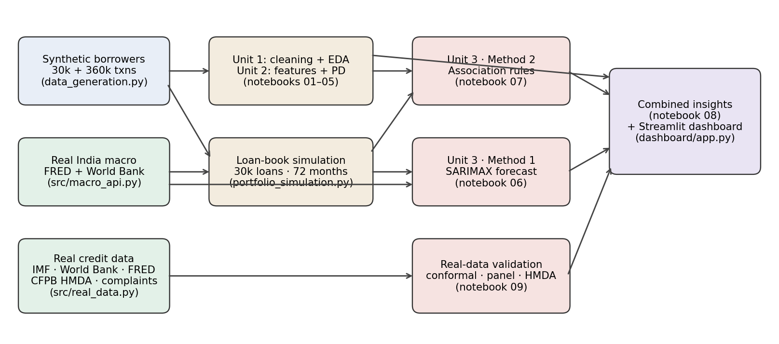
Figure 1. End-to-end workflow connecting Units 1–3, the real-data track and the dashboard. Source: authors' diagram (scripts/build_final_report.py).

1.2 Related analytics work and research gap
Berg et al. [1] show on about 250,000 German e-commerce purchases that a simple digital footprint predicts default as well as a bureau score (AUC 0.696 vs 0.683) and that the two combined reach 0.736. Óskarsdóttir et al. [2] add mobile-phone call records for 22,000 applicants and raise a random forest's AUC from 0.899 to 0.923. Agarwal et al. [3] report similar gains from mobile footprints at an Indian fintech. Lessmann et al. [4] benchmark 41 classifiers on credit data and find that ensembles such as random forests and gradient boosting rank above logistic regression. For portfolio-level risk, Beck, Jakubík and Piloiu [5] and Nkusu [6] link NPL ratios to GDP growth, unemployment, interest rates and exchange rates across countries. Association rules [7, 8] are widely used for basket analysis but rarely as validated, significance-tested credit warnings, where Webb [9] warns that large rule searches produce false discoveries.
The gap: (a) call-record scoring as in [2, 3] cannot be deployed in India, because RBI's Digital Lending Directions forbid lending apps from accessing contacts and call logs [15]; (b) studies rarely connect borrower-level scoring to a macro forecast that changes the approval rule month by month; (c) published rule-mining work seldom validates rules on unseen data; and (d) model-based forecast intervals assume the model is correct. IntelliCredit uses only consented cash-flow signals, links the PD to a macro forecast, validates every rule out-of-sample, and adds conformal intervals [10, 11] and actionable counterfactual explanations [12, 13].

2. Dataset Collection, Validation and Preparation

2.1 Provenance, coverage and challenges
Table 2. Data sources. No Kaggle, UCI or GitHub dataset is used. Provenance, endpoints and fetch times are logged in data/external/macro_sources.json and data/real/real_sources.json.
Dataset | Source and method | Records × variables | Period | Licence / use
Borrower profiles | Synthetic: data_generation.py (NumPy, Faker en_IN), seed 42 | 30,000 × 39 | snapshot | own work
Monthly transactions | Synthetic, same generator | 360,000 × 14 | 12 months | own work
India macro indicators | FRED API (CPI, call-money, 10Y G-sec, INR/USD); World Bank API (unemployment, GDP growth, lending rate) | 108 months × 7 + 2 event flags | 2017–2025 | public, cited
Loan book and performance | Simulation of the 30,000 borrowers driven by the real macro series (src/portfolio_simulation.py, seed 2026) | 30,000 loans; 250,191 loan-months | 2019–2024 | own work
India bank NPL ratio | IMF Financial Soundness Indicators SDMX API | 63 quarters × 2 | 2010-Q1 → 2026-Q2 | CC BY 4.0
NPL + macro panel | World Bank WDI API | 5,642 country-years × 10 | 2000–2025 | CC BY 4.0
US consumer credit | FRED (Federal Reserve delinquency and charge-off release) | 158 quarters × 6 | 1987–2026 | public domain
HMDA loan applications | CFPB HMDA Data Browser API (DE, RI, VT, 2023) | 48,799 × 31 | 2023 | US open data
Loan complaints | CFPB Consumer Complaint Database API | 15,000 × 10 | 2020–2023 | US open data

Target and dictionary. The target is loan_default_status (1 = 90+ days past due), with a 7.87% default rate. The level of observation is one borrower (Units 1–2, Method 2) or one month of the portfolio (Method 1). The data dictionary is in data/data_dictionary.txt and data/data_dictionary_review2.md; a 100-row sample is in data/sample_final_dataset.csv.
Collection challenges and fixes: World Bank series are annual, so they were interpolated to months and flagged; the lending rate stops in 2022 and the carried-forward months are excluded from history; the CFPB endpoints reject custom user-agent strings, so the library default is used; the CFPB search API pages with a search-after key, not an offset, and no longer returns narrative text, so text mining was not possible; three early IMF quarters are missing and were interpolated in logs. Every collector caches the raw response, so the pipeline also runs offline.
Synthetic generation logic: borrower attributes are drawn from documented distributions (for example log-normal income, beta-distributed utility punctuality) with correlations between income, volatility, savings and BNPL use; the default label is drawn from a logistic function of these signals, which fixes a theoretical AUC ceiling of 0.781 (the AUC of the true default probability). To guard against circular findings, every mechanism the synthetic data relies on was re-tested on real data in notebook 09 (Section 5.3). Two held and two did not (Table 8).

2.2 Data quality, privacy and ethics
Quality checks (notebooks 01, 06, 09): no duplicate borrowers; missing values handled by KNN imputation (numeric) and mode (categorical); IQR outlier review with winsorisation of the most skewed fields; class imbalance 7.87% handled with SMOTE on training folds only; 0 missing months and 0 missing values in the 72-month modelling window. In the real data, 33 HMDA rows are identical on the 31 kept fields (kept, as they are distinct applications), and 16.5% of panel cells are missing because many countries do not report NPLs every year.
Privacy and ethics: individual credit information in India may be shared only within the credit-information system (CICRA 2005 [14]), and personal data requires purpose-specific consent under the DPDP Act 2023 [19]. The synthetic borrowers are not real people; the real datasets are aggregates (IMF, World Bank, FRED) or records already de-identified by the publisher (HMDA has no names or exact ages). No personal data is stored. A deployment would require consent through the Account Aggregator framework, data minimisation, storage in India and no access to phone contacts or call logs [15]. Known biases: the synthetic population reflects our assumptions; HMDA covers US mortgages and three states; the IMF series is system-wide, not micro-loans.

2.3 Transformations and usable dataset
General cleaning (notebook 01) is separated from model-specific preprocessing. Ordinal encoding for location tier and education, one-hot encoding for platform, log transforms of skewed amounts, and 12-month aggregation of transactions into borrower features (for example income volatility = standard deviation ÷ mean). The borrower split is stratified 80/20 (24,000 / 6,000, seed 42); scalers, WoE bins, SMOTE and rule thresholds are fitted on training rows only. Time-series models use chronological splits only. Field mapping: Unit 1 uses all raw fields; Unit 2 uses 22 application features (src/underwriting_model.py); Method 1 uses the monthly default rate and seven macro series; Method 2 uses 19 binary flags derived from Unit 2 features.

3. Exploratory Data Analysis and Visualization (Unit 1)
Notebook 02 produced 38 charts and formal tests (chi-square for categorical fields, Mann–Whitney U for continuous ones). The findings below drove the feature and rule design.
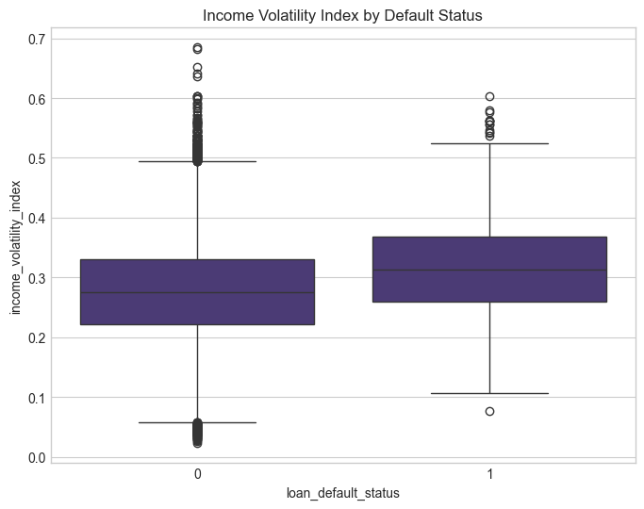
Figure 2. Income volatility index by default status: defaulters have visibly more volatile income. Source: notebooks/02_M2_exploratory_data_analysis.ipynb, Matplotlib/Seaborn.
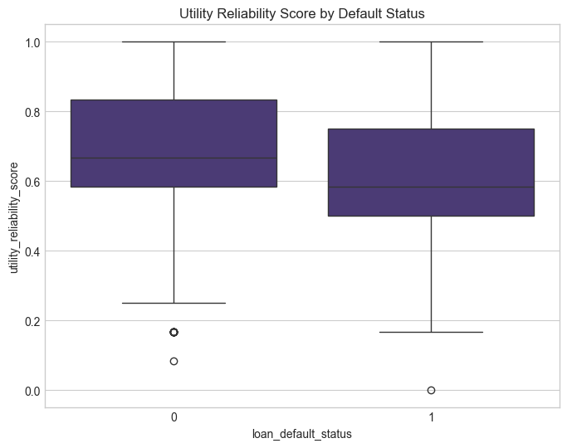
Figure 3. Utility reliability score by default status: on-time bill payment separates the classes. Source: notebooks/02_M2_exploratory_data_analysis.ipynb.
Income volatility, utility punctuality, savings buffer and gig tenure differ significantly between defaulters and non-defaulters; demographics (gender, location) differ little. This motivated volatility and reliability ratios as engineered features (Section 4) and the hypothesis that combinations of cash-flow stress signals, not single flags, mark the riskiest borrowers (tested in Method 2). Default rates by income quartile are flatter than by volatility, so low income alone is not treated as a risk flag in downturn policy.

4. Feature Engineering and Predictive Modelling (Unit 2)
Fourteen behavioural features were engineered (income volatility index, income trend slope, utility reliability, savings buffer ratio, debt-to-inflow ratio and others), then screened with VIF, mutual information, recursive feature elimination and Weight of Evidence / Information Value on training rows; PCA and t-SNE were used for exploration only. Five baselines and four tuned models plus voting and stacking ensembles were trained with 5-fold stratified cross-validation, with SMOTE inside each fold to avoid leakage.
Table 3. Model comparison on the same held-out test set (models/model_comparison.csv; threshold 0.5 for precision/recall).
Model (6,000 test borrowers) | AUC | Precision | Recall | F1
Logistic Regression | 0.728 | 0.149 | 0.642 | 0.242
Logistic Regression (Tuned) | 0.728 | 0.148 | 0.638 | 0.241
Random Forest (Tuned) | 0.713 | 0.136 | 0.663 | 0.226
XGBoost (Tuned) | 0.738 | 0.151 | 0.682 | 0.247
LightGBM (Tuned) | 0.735 | 0.162 | 0.614 | 0.256
Voting Classifier (Tuned) | 0.735 | 0.153 | 0.644 | 0.248
Stacking Classifier (Tuned) | 0.739 | 0.000 | 0.000 | 0.000
Calibrated LightGBM (dashboard model) | 0.741 | — | — | —

Leakage audit (README, Review 1 fixes): preprocessing, SMOTE and WoE were refitted inside training folds; post-outcome fields were removed; there is one row per borrower, so no entity overlap. The stacking ensemble has the highest AUC but its maximum score is 0.33, so it flags nobody at 0.5; this is why the decision rule uses an economic threshold rather than 0.5. The dashboard uses LightGBM trained without class weights so that its probabilities are calibrated (mean PD 7.9% vs observed 7.9% on test).
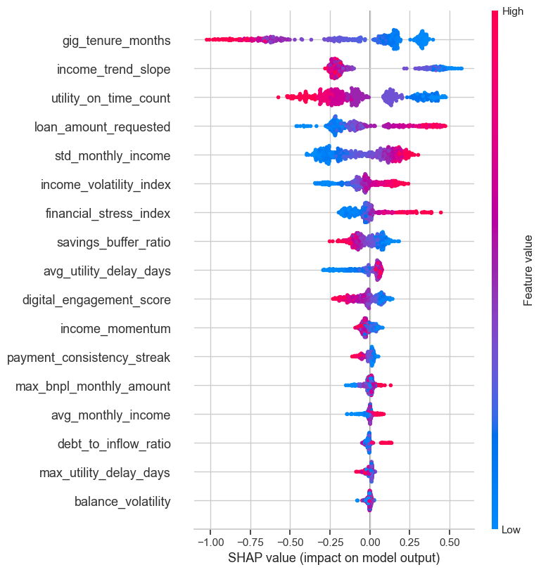
Figure 4. SHAP summary for the tuned gradient-boosting model: short gig tenure, falling income, late utility payments and large loans raise predicted risk. Source: notebooks/05_M5_evaluation_interpretation.ipynb, SHAP TreeExplainer [18].
Table 4. Subgroup performance of the dashboard model under the neutral break-even policy (models/subgroup_performance.csv).
Subgroup | n | Default rate | AUC | Approval rate | Default of approved
gender: Female | 2429 | 7.7% | 0.725 | 59.8% | 5.2%
gender: Male | 3442 | 7.9% | 0.754 | 60.8% | 5.1%
gender: Other | 129 | 10.1% | 0.646 | 55.0% | 2.8%
location_type: Metro | 1847 | 9.1% | 0.724 | 57.0% | 5.9%
location_type: Rural | 539 | 6.1% | 0.763 | 70.5% | 4.2%
location_type: Semi-Urban | 867 | 5.5% | 0.766 | 62.3% | 3.7%
location_type: Tier-1 City | 1526 | 8.1% | 0.715 | 58.7% | 5.4%
location_type: Tier-2 City | 1221 | 8.0% | 0.765 | 61.4% | 5.1%

Female and male applicants are approved at 59.8% and 60.8% (ratio 0.98, above the four-fifths guideline) with the same default rate among approved loans; the AUC is lower for women (0.725 vs 0.754), so discrimination is less sharp for that group, and the 'Other' group (n = 129) is too small to judge. Rural applicants are approved more often because their default rate is lower in the data. Gender is not a model input. These checks are on synthetic data; the real-data fairness audit is in Section 5.3.

5. Advanced Analytics (Unit 3): Two Selected Methods

5.1 Method 1 — Time-series forecasting of the portfolio default rate
Business question: when will portfolio defaults rise, by how much, and what will it cost? Input: 72 monthly observations (2019-01 to 2024-12) of the default rate (new 90+ DPD loans ÷ active loans) from the macro-driven loan book, with seven real macro series. Time series is chosen because provisions and capital depend on the path of defaults over time, which a cross-sectional PD cannot give.
Preparation and implementation (notebooks/06_R2_M1_time_series_forecasting.ipynb, src/macro_api.py, src/portfolio_simulation.py): the target is modelled in logs because its variance grows with its level; drivers enter with a two-month lag because a loan reaches 90 DPD two instalments after its first miss; train 2019–2023 (60 months), test 2024 (12 months). STL gives trend strength 0.46 and seasonal strength 0.10. ADF (p = 0.082) and KPSS (p = 0.01) indicate non-stationary levels. Granger tests [20] (minimum p over lags 1–4) are significant for unemployment (0.0003), GDP growth (0.004), the call-money rate (0.010) and rupee depreciation (0.046), borderline for CPI (0.051). Seven forecasters were compared; the SARIMAX driver set was chosen by BIC on training data: SARIMAX(1,0,1)×(1,0,0)₁₂ with the five lagged drivers and two COVID dummies (BIC 37.0).
Table 5. Method 1 evaluation: 12-month hold-out (2024) and rolling-origin backtest (models/ts_model_comparison.csv, ts_backtest_summary.csv).
Model | MAE (pp) | RMSE (pp) | MAPE % | MASE | Backtest MAE (40 origins)
SARIMAX + macro | 0.0545 | 0.0677 | 16.4 | 0.079 | 0.124
Gradient boosting | 0.0650 | 0.0728 | 21.9 | 0.094 | —
Holt-Winters (ETS) | 0.0747 | 0.1021 | 23.9 | 0.108 | 0.208
Naive | 0.0881 | 0.1124 | 24.2 | 0.127 | —
SARIMA | 0.0881 | 0.1023 | 29.5 | 0.127 | 0.176
12-month moving average | 0.1158 | 0.1317 | 42.3 | 0.167 | —
Seasonal naive | 0.1236 | 0.1641 | 40.4 | 0.178 | 0.351

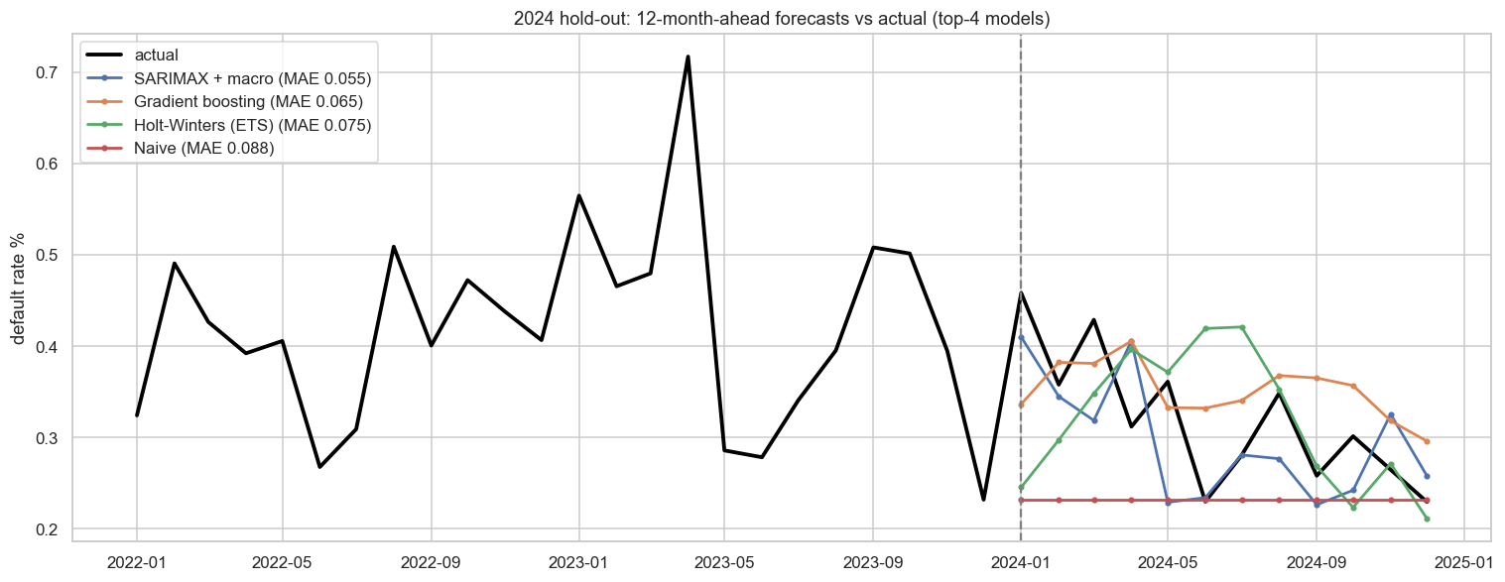
Figure 5. 2024 hold-out: 12-month-ahead forecasts against the actual default rate. Source: notebooks/06_R2_M1_time_series_forecasting.ipynb, statsmodels.
Interpretation: a 1-point rise in unemployment two months earlier raises the default rate by 20.8%, CPI inflation by 15.3%, the call-money rate by 10.4%; GDP growth lowers it by 1.9% per point; lockdown months multiply it by 5.65. Residuals pass Ljung–Box (p = 0.12 at lag 6, 0.28 at lag 12) and Jarque–Bera (p = 0.31). The 80% interval covered 11 of 12 test months. The 30+ DPD rate nowcasts defaults two months ahead (R² 0.76, 2024 MAE 0.038 pp). For 2025, expected credit loss is ₹158.9 lakh (baseline), ₹194.6 lakh (adverse) and ₹432.5 lakh (severe). Limitations: the forecast is conditional on the macro path; in the 2021 second-wave months of the backtest SARIMAX (MAE 0.381) was worse than ETS (0.276); bias is −0.023 pp, a slight under-forecast; annual World Bank series are interpolated.

5.2 Method 2 — Association rule mining of delinquency warning patterns
Business question: which combinations of behaviours occur together in borrowers who default far more often than chance? Input: the 24,000 training borrowers, each turned into a basket of 19 binary flags (average 5.22 per borrower) whose quantile thresholds were computed on training rows only; validation on the 6,000 test borrowers. Rules were chosen because underwriters need readable, multi-factor red flags that a single probability does not give.
Implementation (notebooks/07_R2_M2_association_rule_mining.ipynb, src/risk_rules.py): Apriori [7] and FP-Growth [8] at minimum support 0.5% found the same 2,852 frequent itemsets (Apriori was faster on these 20 dense items, about 0.6 s vs 1.0–1.1 s). From 21,684 rules, 242 have consequent {DEFAULT}; 170 pass lift ≥ 1.5, support ≥ 0.5% and a Bonferroni-corrected one-sided Fisher exact test; 93 remain after a productive-rule filter that requires each rule to beat all of its sub-rules by 5%.
Table 6. Top validated warning rules on unseen borrowers (base default rate 7.87%).
Rule ⇒ DEFAULT | Train lift | Test coverage | Test default rate | Test lift
Declining income + volatile income + low savings | 2.57 | 3.85% | 24.7% | 3.14
Volatile income + low savings + new gig worker | 2.47 | 3.75% | 24.4% | 3.11
Declining income + large loan vs income + low savings | 2.30 | 2.75% | 24.2% | 3.08
Declining income + low savings + new gig worker | 2.79 | 4.10% | 23.6% | 3.00

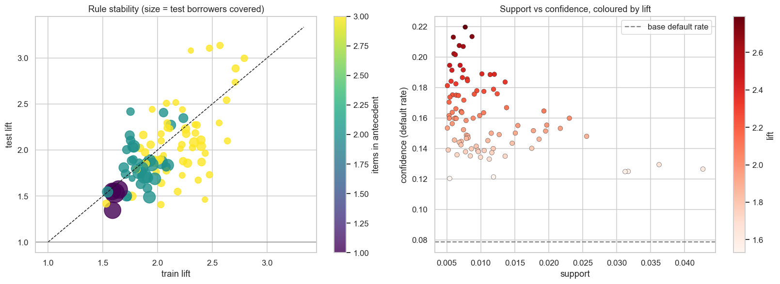
Figure 6. Train vs test lift of the 93 rules: all keep lift ≥ 1.3 on unseen borrowers (correlation 0.61, median lift 2.03 → 1.89). Source: notebooks/07_R2_M2_association_rule_mining.ipynb, mlxtend.
Interpretation: single flags are weak (best lift 1.65), but three-flag combinations of income instability and thin savings reach a test default rate near 25%. Applicants triggering three or more rules are 14% of test applicants and 34% of defaults. Under macro stress, income volatility adds 4.45 percentage points of extra default risk while low income adds none. Limitations: the default rate by rule count rises overall but not monotonically (17.4%, 13.8%, 11.3% for 3, 4 and 5 rules); the rule-count AUC is 0.645 when rules are ranked on training lift (0.657 when ranked on test lift).

5.3 Re-testing both methods on real data (notebook 09)
Table 7. Method 1 on India's real bank NPL ratio (IMF FSI), trained on 2010-Q1 to 2022-Q4.
Model (India NPL ratio, 14 unseen quarters) | MAE (pp) | MAPE % | MASE
SARIMAX (BIC choice) | 0.482 | 18.8 | 1.262
Holt damped trend (ETS) | 0.913 | 37.9 | 2.391
ARIMA(1, 1, 1) | 1.030 | 43.1 | 2.698
Naive (last value) | 2.036 | 85.7 | 5.332
Drift | 2.606 | 110.7 | 6.824

BIC selected a SARIMAX with three regulatory regime ramps (RBI Asset Quality Review recognition +8.0% per quarter, IBC clean-up −5.4% per quarter, COVID standstill). Macro drivers did not improve BIC once regimes were included: in India, recognition rules moved reported NPLs more than the business cycle did.
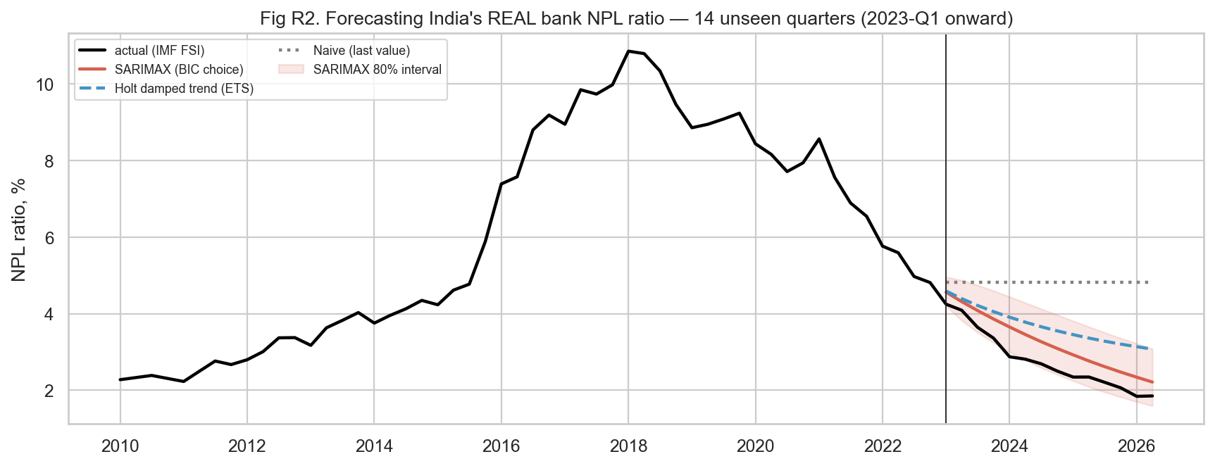
Figure 7. Forecasting India's real bank NPL ratio for 14 unseen quarters. Source: notebooks/09_R3_real_data_validation.ipynb; IMF FSI.
Conformal intervals: on 94 rolling one-step forecasts of real US consumer-loan delinquency, the adaptive conformal 80% band [11] covered 81% and the 90% band 90%, against 72% and 83% for the model's Gaussian bands.
Macro mechanism: a two-way fixed-effects panel of 140 countries (2,021 country-years, standard errors clustered by country) gives ΔNPL coefficients of +0.280 for the change in unemployment (p = 0.015), −0.111 for GDP growth (p = 0.048) and +0.080 for inflation (p = 0.002), the same signs as the simulation.
Method 2 on real loans: on 39,451 HMDA applications from Delaware and Rhode Island, Apriori produced 82 productive DENIED rules; 95% keep lift ≥ 1.3 on 9,348 Vermont applications never used for mining, and the rule-count score has AUC 0.707 there. Debt-to-income is the most cited real denial reason (43% of denials). After the risk flags, Black and Asian applicants still have about 1.7 times the odds of denial (p < 0.001); public HMDA has no credit scores, so this is a signal for review rather than proof of discrimination [22].
Table 8. Synthetic-vs-real fidelity scorecard.
Claim | Synthetic | Real | Verdict
Macro direction: unemployment ↑ ⇒ defaults ↑, GDP ↑ ⇒ defaults ↓ | yes (nb 06) | panel β: Δunemp +0.280, GDP -0.111 (140 countries) | CONFIRMED
Default level falls 2019 → 2024 as the economy recovers | 0.82% → 0.32% | 9.0% → 2.7% (corr 0.64) | CONFIRMED
COVID 2020 default spike | ×2.3 (2020 vs 2019) | ×0.89 — moratorium & standstill hid it | CONTRADICTED → add forbearance regime
Debt burden as a risk driver | loan-to-income flag lift 1.12 | DTI ≥ 50% flag lift 2.55 (HMDA denials) | UNDER-WEIGHTED → recalibrate generator
Multi-flag rules beat single flags & generalise out-of-sample | 93 rules, 100% hold on test | 82 rules, 95% hold in an unseen state | CONFIRMED

6. Comparative Analysis and Business Impact

6.1 Comparison of the two Unit 3 methods
Table 9. Method comparison. Their metrics are not comparable numerically and are not ranked against each other.
 | Method 1: time series | Method 2: association rules
Question | When and how much will portfolio defaults move? | Which behaviour combinations mark risky borrowers?
Input | 72 monthly rates + 7 real macro series | 24,000 borrowers × 19 binary flags
Output | 12-month forecast, scenarios in ₹, PD multiplier | 93 readable warning rules, rule-count score
Validation | Chronological hold-out, 40-origin backtest, residual tests, interval coverage | Unseen-borrower lift, Bonferroni tests, productive-rule filter
Strength | Links defaults to the economy; supports provisioning | Explains decisions; finds risk inside low-PD bands
Limitation | Conditional on macro path; few observations | Rules give reasons, not ranking (AUC 0.645–0.657)

Synthesis: the methods are complementary. Within PD band A, applicants with six or more rules default at 5.6% against 1.8% with none, so rules add information the PD lacks. The time-series multiplier makes the same break-even rule approve 75.1% of applicants in the baseline 2025 economy and 47.8% in a severe one, while the approved default rate falls from 6.10% to 3.98%. The macro-conditioned rules join the two: in downturns the dangerous flags are behavioural.

6.2 Comparison with existing studies
Our test AUC (0.738 tuned XGBoost; 0.741 calibrated LightGBM) is in the range reported by Berg et al. [1] (0.683–0.736) and below Óskarsdóttir et al. [2] (up to 0.923). Direct comparison is not valid: their labels are real repayments, ours are generated with a known ceiling of 0.781; their features include bureau scores or call records that Indian rules forbid for app lenders [15]. Our ranking of ensembles above logistic regression agrees with Lessmann et al. [4]. On the macro side, the signs we find on real data match the cross-country evidence of [5, 6]. Our distinct contributions are the link from a macro forecast to an approval rule, out-of-sample validated rules, and conformal intervals. Remaining gaps: no real micro-loan repayment labels and no live deployment. Full benchmark tables are in research/BENCHMARK_TABLE.md.

6.3 KPI-based business impact and scenarios
Table 10. Scenario impact. Approvals are measured on the 6,000 test applicants; credit losses are model forecasts.
Scenario (2025) | PD multiplier | Approval | Default of approved | Expected credit loss | vs baseline
Neutral economy | 1.00 | 60.3% | 5.09% | — | —
Baseline | 0.57 | 75.1% | 6.10% | ₹158.9 lakh | —
Adverse (unemployment +1.5 pp, GDP −3 pp) | 0.69 | 70.7% | 5.73% | ₹194.6 lakh | +₹35.6 lakh
Severe (COVID-style) | 1.53 | 47.8% | 3.98% | ₹432.5 lakh | +₹273.6 lakh

Assumptions: LGD 65%, cost of funds 9%, average exposure at default ₹111,589, book growth 1.38% per month. Measured outcomes (approval and default rates on the test set) are separated from forecasts (2025 losses). Sensitivity: the spread between baseline and severe losses (₹273.6 lakh) is the capital the lender should be able to absorb; the result depends on the macro path, the LGD assumption and the simulation's COVID response, which real Indian data suggest overstates short-run defaults when regulators grant forbearance. Priorities by impact and feasibility: (1) two-tier decision with rules, (2) monthly macro multiplier, (3) loan-size caps, (4) selective downturn tightening, (5) provisioning overlay.

7. Interactive Application, Figure Index and Reproducibility

7.1 Dashboard
Platform: Streamlit (dashboard/app.py), run locally with streamlit run dashboard/app.py; a standalone Plotly report is in reports/interactive_dashboard.html. Six tabs: Underwriter decision engine (live form, PD, point-in-time PD, break-even, TreeSHAP reasons, triggered rules, counterfactual path to approval), Dataset explorer (filters by band, location, platform, outcome and rules hit, with dynamic KPIs and charts), Portfolio outlook (scenario forecasts and ₹ losses), Warning rules (lift and coverage sliders), Real-data reality check (India NPL forecasts, conformal band, HMDA rule explorer, fidelity scorecard) and Model card. Computed live: features, PD, SHAP, decision, rules and recourse; precomputed: model, rules, scenario forecasts and notebook-09 results.
Tests: Streamlit AppTest renders every tab without exceptions, including the severe scenario with the high-risk preset, which exercises the recourse search. Known limitations: the recourse search uses a fixed grid (1,134 combinations); the dashboard is not deployed publicly. [Insert screenshots of the main state and a filtered state from reports/screenshots/.]

7.2 Figure index and reproduction map
Table 11. Figure index.
Figure | Caption | Reproduce with
1 | End-to-end workflow connecting Units 1–3, the real-data track and the dashboard. | authors' diagram (scripts/build_final_report.py)
2 | Income volatility index by default status: defaulters have visibly more volatile income. | notebooks/02_M2_exploratory_data_analysis.ipynb, Matplotlib/Seaborn
3 | Utility reliability score by default status: on-time bill payment separates the classes. | notebooks/02_M2_exploratory_data_analysis.ipynb
4 | SHAP summary for the tuned gradient-boosting model: short gig tenure, falling income, late utility payments and large loans raise predicted risk. | notebooks/05_M5_evaluation_interpretation.ipynb, SHAP TreeExplainer [18]
5 | 2024 hold-out: 12-month-ahead forecasts against the actual default rate. | notebooks/06_R2_M1_time_series_forecasting.ipynb, statsmodels
6 | Train vs test lift of the 93 rules: all keep lift ≥ 1.3 on unseen borrowers (correlation 0.61, median lift 2.03 → 1.89). | notebooks/07_R2_M2_association_rule_mining.ipynb, mlxtend
7 | Forecasting India's real bank NPL ratio for 14 unseen quarters. | notebooks/09_R3_real_data_validation.ipynb; IMF FSI

7.3 Code and environment
Repository: https://github.com/Goldmauler/intellicredit-review2 (README with project tree, requirements.txt, Python 3.12). Reproduce: python data_generation.py; python -m src.macro_api; python -m src.portfolio_simulation; python -m src.real_data; execute notebooks 01–09 in order; python -m src.underwriting_model; streamlit run dashboard/app.py; python scripts/build_final_report.py. Folders: data/ (raw, processed, external, portfolio, real), notebooks/, src/, models/, dashboard/, reports/, research/. No secrets are stored; all APIs used are keyless. Seeds: 42 (data, models), 2026 (loan book).

8. End-to-End Validation, Traceability and Contributions

8.1 Completion and validity
Table 12. Objective-to-evidence traceability matrix.
Objective | Evidence | Status
Score thin-file borrowers | notebooks 03–05; Table 3; AUC 0.741, calibrated | met
Forecast portfolio defaults | notebook 06; Table 5; MAE 0.0545 pp | met
Find validated warning patterns | notebook 07; Table 6; 93 rules, 100% valid | met
Combine into decisions | notebook 08; Table 10; dashboard | met
Respond to the 'use real data' feedback | notebook 09; Tables 7–8; 5 real datasets | met
Real micro-loan repayment labels | not legally obtainable | not met (future work)

Threats to validity: borrower labels are synthetic, so absolute performance is bounded by our generator; the macro mechanism was simulated and is only externally supported by the real panel; the real datasets are not micro-loans; the short monthly series limits model complexity. Reproducibility: all code is seeded and notebooks re-execute with identical model outputs (checked on 6 Nov 2026).

8.2 Project tracking and individual work
Board: GitHub issues on the team repository (19 tasks: 10 Review 1, 9 Review 2) with stages Backlog, To Do, In Progress, Review/Testing and Completed; task history is in reports/project_management_and_contributions.md. [Insert board screenshot.]
Table 13. Individual contributions (as recorded in the README; confirm before submission). Individual marks may vary with participation and explanation.
Member | Main contribution | Evidence
Darun R G | Data generator, Review 1 pipeline, dataset validation, project board | data_generation.py, notebooks 01–05, DATASET_VALIDATION_SUMMARY.md
Vimalharihar S K (Goldmauler) | Method 1 and Method 2, macro APIs, real-data track, recourse | notebooks 06, 07, 09; src/macro_api.py, real_data.py, recourse.py
Abhinav Juturu | EDA, loan-book simulation, Method 1 data preparation | notebook 02, src/portfolio_simulation.py
Gowtham Reddy | Cleaning, Streamlit dashboard | notebook 01, dashboard/app.py
Adithya | Evaluation, combined insights, report and slides | notebooks 05, 08, reports/

8.3 AI use and originality declarations
[To be completed and signed by the team.] Generative-AI tools were used: Claude (Anthropic), for drafting code for the real-data collectors, notebook 09, the recourse module, the dashboard tab and this report draft, for checking documents against notebook outputs, and for collecting and verifying literature. All generated code was executed and its outputs were checked against the saved results; numbers in this report were read from those outputs. [List any other tools and the parts each member wrote or verified.] Turnitin similarity: [__ %] (limit 15%).

9. Conclusion, Recommendations and Roadmap
All five objectives in Table 1 that could be met legally were met (Table 12). The engine ranks thin-file borrowers close to the data's ceiling, forecasts portfolio defaults better than six alternatives, produces rules that hold on unseen borrowers, and both advanced methods carried over to real data.
Table 14. Prioritised recommendations.
Recommendation | Expected KPI effect | Owner | Feasibility
Two-tier decision: auto-approve bands A–B with < 3 rules | Catches 34% of defaults in 14% of applicants for review | Credit policy | High
Monthly macro multiplier from the forecast | Approval adjusts 75% → 48% between baseline and severe | Risk analytics | High
Loan-to-income cap for tenure < 6 months or falling income | Fewer early defaults among new workers | Product | High
Tighten on behaviour, not demographics, in downturns | Protects inclusion of low-income applicants | Credit policy | Medium
Provision baseline ECL + adverse overlay (~₹36 lakh) | Capital ready for a moderate downturn | Finance | High
Track regulatory regimes in any India NPL forecast | India NPL MAE 0.48 vs 0.91 pp without regimes | Risk analytics | High

Roadmap. Immediate: merge the real-data track and present it. Medium term: add a forbearance regime to the loan-book simulation and raise the weight of debt burden in the generator; report conformal intervals on the portfolio forecast. Longer term: a consented gig-worker survey pilot to compare income volatility and BNPL use with the generator, and testing the rules and model on a partner lender's repayment data. Success checks: rule lift stays ≥ 1.3 on new data and PD calibration error stays below one percentage point.

References
[1] Tobias Berg, Valentin Burg, Ana Gombović, and Manju Puri. 2020. On the Rise of FinTechs: Credit Scoring Using Digital Footprints. The Review of Financial Studies 33, 7, 2845–2897. https://doi.org/10.1093/rfs/hhz099
[2] María Óskarsdóttir, Cristián Bravo, Carlos Sarraute, Jan Vanthienen, and Bart Baesens. 2019. The value of big data for credit scoring: Enhancing financial inclusion using mobile phone data and social network analytics. Applied Soft Computing 74, 26–39. https://doi.org/10.1016/j.asoc.2018.10.004
[3] Sumit Agarwal, Shashwat Alok, Pulak Ghosh, and Sudip Gupta. 2020. Financial Inclusion and Alternate Credit Scoring for the Millennials: Role of Big Data and Machine Learning in Fintech. Working paper.
[4] Stefan Lessmann, Bart Baesens, Hsin-Vonn Seow, and Lyn C. Thomas. 2015. Benchmarking state-of-the-art classification algorithms for credit scoring: An update of research. European Journal of Operational Research 247, 1, 124–136. https://doi.org/10.1016/j.ejor.2015.05.030
[5] Roland Beck, Petr Jakubík, and Anamaria Piloiu. 2015. Key Determinants of Non-performing Loans: New Evidence from a Global Sample. Open Economies Review 26, 3, 525–550. https://doi.org/10.1007/s11079-015-9358-8
[6] Mwanza Nkusu. 2011. Nonperforming Loans and Macrofinancial Vulnerabilities in Advanced Economies. IMF Working Paper WP/11/161.
[7] Rakesh Agrawal and Ramakrishnan Srikant. 1994. Fast Algorithms for Mining Association Rules in Large Databases. In Proceedings of the 20th International Conference on Very Large Data Bases (VLDB '94), 487–499.
[8] Jiawei Han, Jian Pei, and Yiwen Yin. 2000. Mining frequent patterns without candidate generation. In Proceedings of the 2000 ACM SIGMOD International Conference on Management of Data, 1–12. https://doi.org/10.1145/342009.335372
[9] Geoffrey I. Webb. 2007. Discovering Significant Patterns. Machine Learning 68, 1, 1–33. https://doi.org/10.1007/s10994-007-5006-x
[10] Anastasios N. Angelopoulos and Stephen Bates. 2021. A Gentle Introduction to Conformal Prediction and Distribution-Free Uncertainty Quantification. arXiv:2107.07511.
[11] Isaac Gibbs and Emmanuel Candès. 2021. Adaptive Conformal Inference Under Distribution Shift. In Advances in Neural Information Processing Systems 34 (NeurIPS 2021).
[12] Sandra Wachter, Brent Mittelstadt, and Chris Russell. 2018. Counterfactual Explanations without Opening the Black Box: Automated Decisions and the GDPR. Harvard Journal of Law & Technology 31, 2.
[13] Berk Ustun, Alexander Spangher, and Yang Liu. 2019. Actionable Recourse in Linear Classification. In Proceedings of the Conference on Fairness, Accountability, and Transparency (FAT* '19), 10–19. https://doi.org/10.1145/3287560.3287566
[14] Government of India. 2005. The Credit Information Companies (Regulation) Act, 2005 (Act No. 30 of 2005).
[15] Reserve Bank of India. 2025. Reserve Bank of India (Digital Lending) Directions, 2025. RBI/2025-26/36.
[16] NITI Aayog. 2022. India's Booming Gig and Platform Economy: Perspectives and Recommendations on the Future of Work. New Delhi.
[17] Ministry of Finance, Government of India. 2026. Economic Survey 2025-26.
[18] Scott M. Lundberg and Su-In Lee. 2017. A Unified Approach to Interpreting Model Predictions. In Advances in Neural Information Processing Systems 30 (NIPS 2017), 4765–4774.
[19] Government of India. 2023. The Digital Personal Data Protection Act, 2023 (Act No. 22 of 2023).
[20] C. W. J. Granger. 1969. Investigating Causal Relations by Econometric Models and Cross-spectral Methods. Econometrica 37, 3, 424–438. https://doi.org/10.2307/1912791
[21] World Bank. 2022. The Global Findex Database 2021. Washington, DC.
[22] Robert Bartlett, Adair Morse, Richard Stanton, and Nancy Wallace. 2022. Consumer-lending discrimination in the FinTech Era. Journal of Financial Economics 143, 1, 30–56. https://doi.org/10.1016/j.jfineco.2021.05.047
[23] International Monetary Fund. 2026. Financial Soundness Indicators (FSIC), India, series AQ12_CFSI_PT. https://api.imf.org/external/sdmx/2.1/data/IMF.STA,FSIC/IND..
[24] World Bank. 2026. World Development Indicators API, series FB.AST.NPER.ZS, NY.GDP.MKTP.KD.ZG, SL.UEM.TOTL.ZS, FP.CPI.TOTL.ZG, FR.INR.LEND. https://api.worldbank.org/v2/
[25] Federal Reserve Bank of St. Louis. 2026. FRED: series CPALTT01INM659N, IRSTCI01INM156N, INDIRLTLT01STM, EXINUS, DRCLACBS, UNRATE, FEDFUNDS. https://fred.stlouisfed.org
[26] Consumer Financial Protection Bureau. 2026. HMDA Data Browser API, 2023 data for DE, RI and VT. https://ffiec.cfpb.gov/data-browser/
[27] Consumer Financial Protection Bureau. 2026. Consumer Complaint Database API. https://www.consumerfinance.gov/data-research/consumer-complaints/
[28] Skipper Seabold and Josef Perktold. 2010. statsmodels: Econometric and Statistical Modeling with Python. In Proceedings of the 9th Python in Science Conference.
[29] Sebastian Raschka. 2018. MLxtend: Providing machine learning and data science utilities and extensions to Python's scientific computing stack. Journal of Open Source Software 3, 24, 638.

Appendices
Appendix A: data dictionaries (data/data_dictionary.txt, data/data_dictionary_review2.md), generation settings (data_generation.py, seed 42) and provenance logs (data/external/macro_sources.json, data/real/real_sources.json).
Appendix B: additional figures and tuning tables (notebooks 02–07; reports/figures/).
Appendix C: installation and dashboard guide (README, How to Run).
Appendix D: board evidence, contribution records, AI declaration and similarity report [to be attached].

