Project Management System

This service is able to create, update and delete projects, users and tasks, assign users to projects and tasks.

From the start service has 2 users in database: [goldtoolc@gmail.com](mailto:goldtoolc@gmail.com) (admin access level) and [vladislav@gmail.com (developer](mailto:vladislav@gmail.com%20(developer) access level). To log in as any of them you should click “log in” on initial page page and use a password “admin”, then press button “log in”.

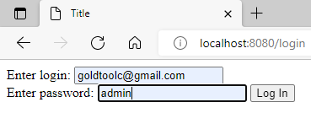

After that you will be redirected on home page

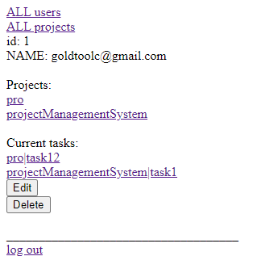

If you are not admin, when you try to see all users list, all project list, or any task or project you are not assigned to you will be redirected on the error page

Otherwise you will be redirected to this page

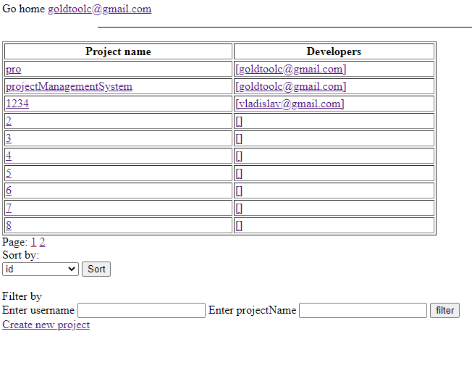

If you click on a cell of the table, you will be redirected to the project page

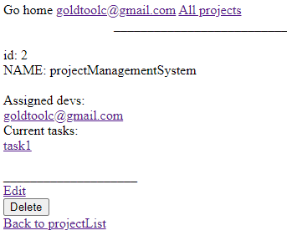

On the edit page you can assign developer to this project, rename it, or add new task. Same interface applies to tasks and users, except there is no all task list page.

