Epileptic Seizure Detection
- EEG Signal Visualization
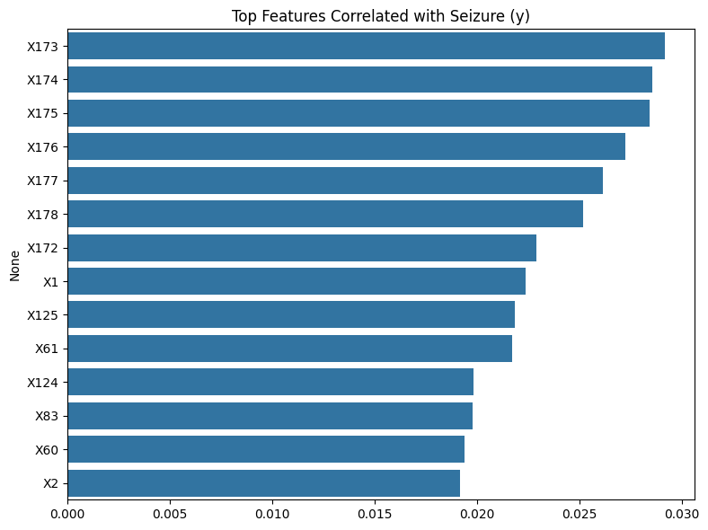

- PCA Explained Variance
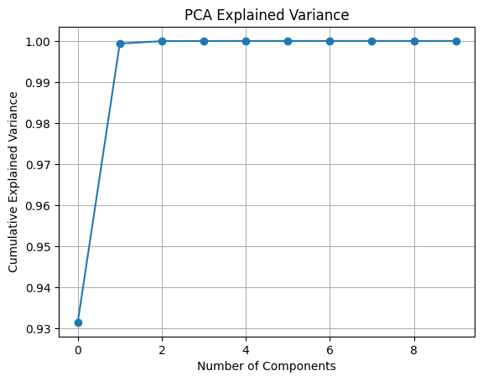

- T-sne visualization of EEG Features
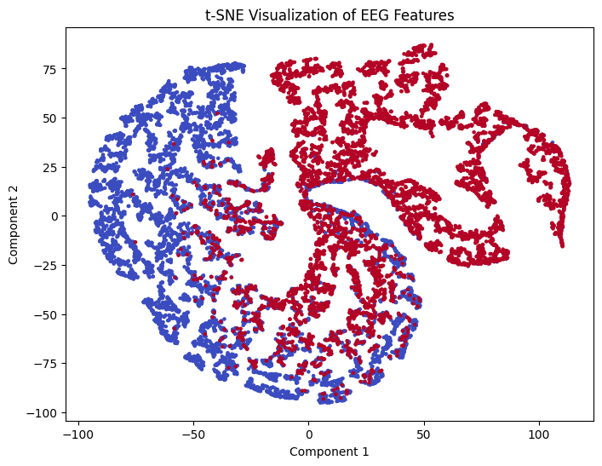

- K-Means Clustering on t-SNE Reduced EEG Data

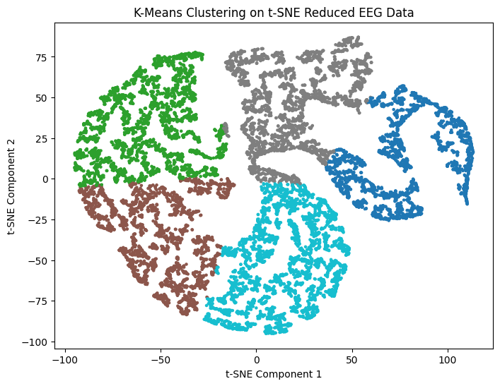

- All frequency graph
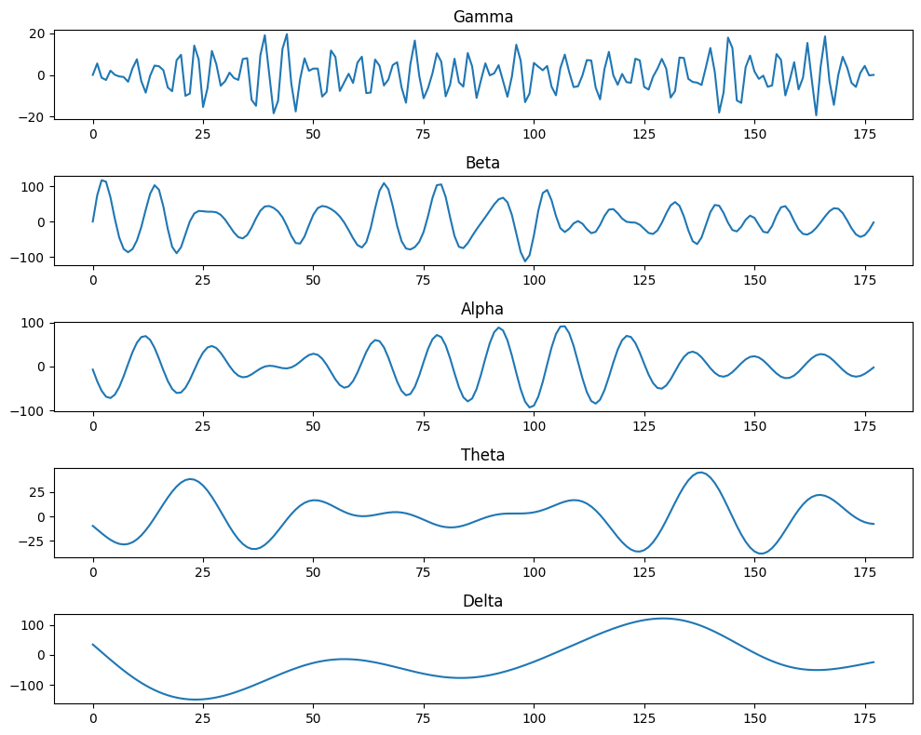

- DWT Signal Decomposition

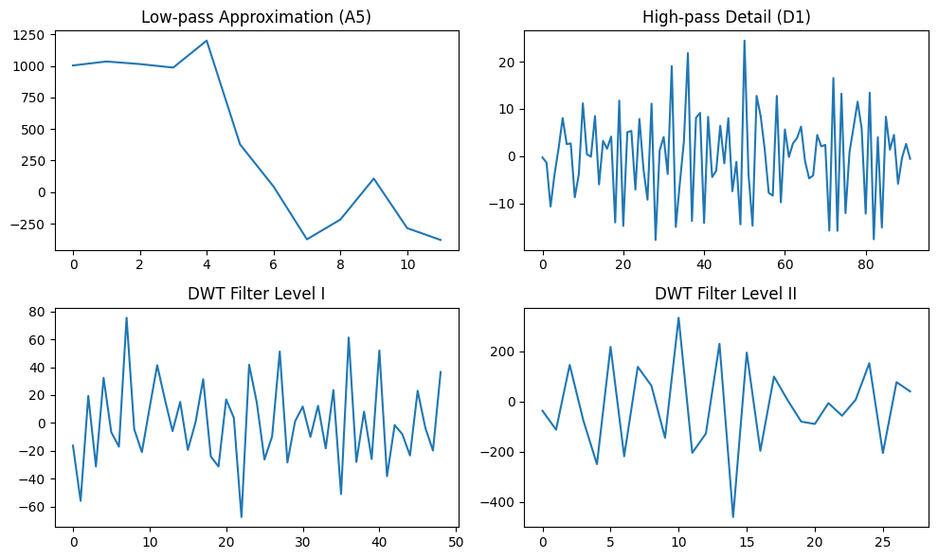

- Maximum Frequencies of EEG bands
