SOFTWARE REQUIREMENTS SPECIFICATION
for
GIVIN — Gujarat Integrated Video Intelligence Network
A Statewide, Vendor-Neutral CCTV Integration, AI Video Analytics,
Watchlist Correlation and GIS-Driven Intelligence Platform
Prepared for: Gujarat Police Innovation Hackathon 2026
Document Type: Software Requirements Specification (SRS)
Standard Reference: IEEE 830 / ISO/IEC/IEEE 29148 structure
Version: 1.0
Date: September 2026

Document Control

Revision History
Version | Date | Author | Description of Change
0.1 | 05-Sep-2026 | Solution Team | Initial draft based on problem-statement analysis
0.5 | 07-Sep-2026 | Solution Team | Added architecture, data model, NFRs
1.0 | 09-Sep-2026 | Solution Team | Finalized SRS for hackathon submission

Approval
Role | Name | Signature / Status
Project Lead | To be assigned | Pending
Technical Architect | To be assigned | Pending
QA Lead | To be assigned | Pending

Table of Contents
Document Control 2
Revision History 2
Approval 2
Table of Contents 3
List of Figures 7
1. Introduction 8
1.1 Purpose 8
1.2 Scope 8
1.3 Product Perspective 9
1.4 Definitions, Acronyms and Abbreviations 9
1.5 References 10
1.6 Overview of the Remainder of this Document 10
2. Overall Description 11
2.1 Product Perspective 11
2.2 Product Functions — Summary 11
2.3 User Classes and Characteristics 11
2.4 Operating Environment 12
2.5 Design and Implementation Constraints 12
2.6 Assumptions and Dependencies 13
3. External Interface Requirements 14
3.1 User Interfaces 14
3.2 Hardware Interfaces 14
3.3 Software Interfaces 14
3.4 Communications Interfaces 15
4. System Features (Functional Requirements) 16
4.1 Module: Camera Registry & GIS (Model 1 Foundation) 16
4.2 Module: Heterogeneous Feed Integration (Model 3 Interoperability Layer) 16
4.3 Module: Unified Command Center Viewing (Model 2) 17
4.4 Module: AI Video Analytics (Vehicle Detection, Tracking, ANPR) 17
4.5 Module: Cross-Camera Vehicle Correlation & History 18
4.6 Module: Watchlist Management & Real-Time Alerting 18
4.7 Module: Investigation, Evidence & Reporting 18
4.8 Module: Administration, Security & Audit 19
5. System Architecture 20
5.1 Architectural Style 20
5.2 System Context Diagram 20
5.3 High-Level Solution Architecture 20
5.4 Deployment / Physical Architecture 21
5.5 Scalability Hierarchy 22
5.6 Architectural Decisions and Rationale 22
6. Use Case Model 24
6.1 Use Case Diagram 24
6.2 Use Case Descriptions 25
UC-1: Onboard Camera 25
UC-2: Monitor Live Feed 25
UC-3: Run ANPR / Vehicle Detection 25
UC-4: Search Vehicle History 25
UC-5: Manage Watchlist 26
UC-6: Receive and Act on Alert 26
UC-7: View GIS Route / Camera Map 26
UC-8: Manage Users / Roles 26
UC-9: Monitor Camera Health 27
UC-10: Export Evidence / Report 27
UC-11: View Audit Log 27
6.3 Sequence Diagram — ANPR Detection to Alert 27
7. Non-Functional Requirements 30
7.1 Performance Requirements 30
7.2 Scalability Requirements 30
7.3 Reliability & Availability Requirements 30
7.4 Security Requirements 30
7.5 Usability Requirements 31
7.6 Maintainability & Extensibility Requirements 31
7.7 Interoperability Requirements 31
7.8 Cost-Effectiveness Requirements 31
8. Data Flow Diagrams 33
8.1 Level 0 — Context-Level Data Flow Diagram 33
8.2 Level 1 — Decomposed Data Flow Diagram 33
8.3 Data Store Descriptions 33
9. Data Model & Database Design 35
9.1 Entity Relationship Diagram 35
9.2 Entity Dictionary 35
departments 35
cameras 35
camera_connectors 36
camera_health 36
vehicle_detections 36
anpr_detections 36
vehicle_sightings 37
watchlists / watchlist_matches / alerts 37
users / roles / permissions / audit_logs 37
9.3 Alert Lifecycle State Diagram 38
10. Technology Stack 39
11. Security Architecture 40
11.1 Access Control 40
11.2 Data Protection 40
11.3 Network Security 40
11.4 Auditability 40
11.5 Resilience 40
11.6 Privacy & Responsible Use Considerations 40
12. Scalability Plan — Toward ~80,000 Cameras 42
12.1 Design Principles 42
12.2 Capacity Planning Guidance 42
13. Storage & Network/Bandwidth Strategy 43
13.1 Storage Tiering 43
13.2 Network & Bandwidth Strategy 43
14. Disaster Recovery & Reliability 44
15. Test Plan & Acceptance Criteria 45
15.1 Official Technical Evaluation / Test Scenario 45
15.2 Demonstration Script (Own-Feed, 2–3 Minutes) 45
15.3 Test Levels 46
15.4 Evaluation Framework Mapping 46
16. Development Roadmap 47
17. Appendices 48
Appendix A — Recommended Repository Structure 48
Appendix B — Submission Checklist 48
Appendix C — Department Onboarding Data Requirements 48
Appendix D — Explicit Anti-Patterns (What Not to Do) 49
Appendix E — One-Line Pitch 49
Appendix F — Source Notes 49

List of Figures
Figure 5.1: System Context Diagram
Figure 5.2: High-Level Solution Architecture (GIVIN)
Figure 5.3: Deployment / Physical Architecture
Figure 5.4: Scalability Hierarchy for ~80,000 Cameras
Figure 6.1: Use Case Diagram
Figure 6.2: Sequence Diagram — ANPR Detection to Alert
Figure 8.1: Data Flow Diagram — Level 0 (Context)
Figure 8.2: Data Flow Diagram — Level 1
Figure 9.1: Entity Relationship Diagram
Figure 9.2: Alert Lifecycle State Diagram

1. Introduction

1.1 Purpose
This Software Requirements Specification (SRS) document describes the functional and non-functional requirements for GIVIN — the Gujarat Integrated Video Intelligence Network — a proposed solution developed in response to the Gujarat Police Innovation Hackathon 2026 problem statement on statewide CCTV integration and AI-based video analytics. The purpose of this document is to provide a complete, unambiguous and verifiable specification of the system to be built, sufficient to guide design, implementation, testing and evaluation of the hackathon solution and its subsequent scale-up toward a statewide deployment covering approximately 80,000 cameras.
This SRS is intended for use by the development team, solution architects, UI/UX designers, QA engineers, hackathon evaluators, and any government stakeholders reviewing the technical feasibility of the proposed platform. It translates the problem statement and the recommended hybrid architecture into concrete, testable requirements structured according to the IEEE 830 / ISO/IEC/IEEE 29148 conventions.

1.2 Scope
The product described in this document is named GIVIN (Gujarat Integrated Video Intelligence Network). GIVIN is a vendor-neutral, modular video intelligence platform that integrates heterogeneous CCTV infrastructure operated by 26 Government departments in Gujarat — including the Home Department, Food & Civil Supplies Department, Regional Transport Office (RTO), and others — into a single command-center experience without requiring departments to replace their existing VMS/NVR infrastructure.
In scope for the hackathon proof-of-concept (PoC) and this SRS:
- Central CCTV asset registry with GIS mapping of camera locations, status and coverage.
- Protocol/vendor-neutral connector framework supporting RTSP, ONVIF, vendor APIs/SDKs.
- Unified live-viewing command-center interface with multi-camera grids/video walls.
- AI-based vehicle detection, multi-object tracking and Automatic Number Plate Recognition (ANPR).
- Cross-camera vehicle correlation and searchable movement-history/timeline reconstruction.
- Watchlist management and real-time alert generation with severity, status and audit workflow.
- GIS-based visualization of events and reconstructed vehicle routes.
- Camera health and system monitoring dashboards.
- Role-based access control, audit logging and evidence-handling controls.
- A documented architecture and roadmap for scaling to approximately 80,000 cameras statewide.
Out of scope for the current PoC (but architecturally anticipated for future phases):
- Full production integration with VAHAN, SARTHI, eGujCop/CCTNS, AFIS and NAFIS (interfaces are designed as extensible connectors; live production integration is a future phase subject to data-sharing approvals).
- Statewide onboarding of all ~80,000 cameras (the PoC targets the ~50 cameras made available via the official Resources page plus own-feed demonstration cameras).
- Facial recognition against AFIS/NAFIS at production scale (architecturally supported as a bonus module, not mandatory for the PoC).
- Replacement of any department's existing VMS or storage infrastructure.

1.3 Product Perspective
GIVIN is a new, independent system that is designed to interoperate with — rather than replace — existing departmental CCTV, VMS and NVR infrastructure. It sits as an overlay/federation layer, as illustrated in the system context diagram (Figure 5.1) and the architecture diagram (Figure 5.2). GIVIN is intended to eventually interface with external government systems including VAHAN (vehicle registration), SARTHI (driving licenses), eGujCop/CCTNS (crime and criminal tracking), AFIS and NAFIS (fingerprint identification systems), through well-defined, auditable API connectors.

1.4 Definitions, Acronyms and Abbreviations
Term | Definition
ANPR | Automatic Number Plate Recognition — detection and OCR of vehicle registration plates.
VMS | Video Management System — software used by a department to manage/record camera feeds.
NVR | Network Video Recorder — hardware/software device that records IP camera streams.
ONVIF | Open Network Video Interface Forum — an industry standard protocol for IP camera interoperability.
RTSP | Real Time Streaming Protocol — used to control and stream live video.
GIS | Geographic Information System — used for map-based visualization of cameras and events.
PoC | Proof of Concept — the hackathon-stage working demonstration of the platform.
HLD | High-Level Design document.
RBAC | Role-Based Access Control.
SLA | Service Level Agreement.
RPO / RTO | Recovery Point Objective / Recovery Time Objective — disaster recovery metrics.
GIVIN | Gujarat Integrated Video Intelligence Network — the proposed solution name used throughout this SRS.
VAHAN | National vehicle registration database maintained by MoRTH.
SARTHI | National driving license database maintained by MoRTH.
eGujCop / CCTNS | Gujarat Police crime and criminal tracking network system.
AFIS / NAFIS | (National) Automated Fingerprint Identification System.

1.5 References
- Gujarat Police Innovation Hackathon 2026 — Official Problem Statement (source material supplied for this analysis).
- IEEE Std 830-1998 — IEEE Recommended Practice for Software Requirements Specifications.
- ISO/IEC/IEEE 29148:2018 — Systems and software engineering — Life cycle processes — Requirements engineering.
- ONVIF Core Specification, RTSP RFC 2326, relevant vendor SDK documentation.
- Internal document: "Gujarat CCTV Hackathon 2026 — Complete Analysis and Solution" (user-supplied problem analysis and recommended hybrid architecture, used as the primary basis for this SRS).

1.6 Overview of the Remainder of this Document
Section 2 describes the overall product perspective, functions, user classes, operating environment, constraints and assumptions. Section 3 lists external interface requirements. Section 4 defines system features as detailed functional requirements grouped by module. Section 5 presents system architecture and design diagrams. Section 6 covers use cases and interaction/sequence diagrams. Section 7 defines non-functional requirements (performance, security, reliability, usability, scalability). Section 8 presents data flow diagrams. Section 9 details the data model and database design. Section 10 covers the technology stack. Section 11 addresses security architecture in depth. Section 12 addresses the 80,000-camera scalability plan. Section 13 covers storage and network/bandwidth strategy. Section 14 covers disaster recovery. Section 15 defines the test plan and acceptance criteria mapped to the official evaluation framework. Section 16 presents the development roadmap. Section 17 lists appendices including the database schema reference, API summary and traceability matrix.

2. Overall Description

2.1 Product Perspective
GIVIN is conceived as a Hybrid Architecture combining three of the four reference integration models described in the official problem statement, plus selectively introduced capabilities from the fourth model:
- Model 1 (Centralised CCTV Registry & GIS Mapping) — used as the authoritative foundation for camera metadata, ownership, GIS location and health status.
- Model 3 (VMS Federation & Middleware) — used as the interoperability layer so that departments retain their existing VMS/NVR infrastructure while GIVIN integrates via adapters, APIs and SDKs.
- Model 2 (Unified Viewing & Metadata Analytics) — used as the operational command-center layer for live viewing, ANPR, event tagging and searchable vehicle-movement records.
- Selected Model 4 (Central VMS & AI Platform) concepts — introduced only where centrally justified: tiered hot/warm/cold evidence storage, centralized watchlist matching, statewide alerting, and readiness for VAHAN/SARTHI/eGujCop/AFIS/NAFIS integration — without forcing all raw video into one central store.
This hybrid approach directly satisfies the official challenge's explicit permission for hybrid or fully customized architectures, and avoids the operational and bandwidth risks of assuming continuous full-resolution video transport from ~80,000 cameras to a single data center.

2.2 Product Functions — Summary
At a high level, GIVIN performs the following functions (each elaborated as detailed functional requirements in Section 4):
- Camera onboarding, metadata registry management and GIS visualization.
- Heterogeneous feed integration via protocol/vendor adapters without displacing departmental VMS.
- Live multi-camera viewing, video walls, and camera health monitoring.
- AI vehicle detection, multi-object tracking, and ANPR with confidence scoring.
- Cross-camera correlation to reconstruct a vehicle's movement timeline and route.
- Watchlist management and automated, confidence-gated alert generation.
- Case/investigation workflow: alert acknowledgment, investigation status, evidence export.
- Role-based access control and comprehensive audit logging of sensitive actions.
- Administrative functions: user/role management, connector configuration, system monitoring.

2.3 User Classes and Characteristics
User Class | Description | Technical Expertise
System Administrator | Configures departments, onboards cameras, manages users/roles, monitors overall system health. | High
Control Room Operator | Monitors live feeds, video walls, and receives/responds to real-time alerts. | Low–Medium
Investigation Officer | Searches vehicle history, reviews reconstructed routes, exports evidence for case files. | Medium
Department Coordinator | Provides/maintains camera inventory and connectivity details for their department; monitors department-specific camera health. | Medium
Auditor / Oversight Role | Read-only access to audit logs and sensitive-action history for compliance review. | Medium
Hackathon Evaluator (special) | Reviews solution presentation, tests the platform on own-feed and government-feed test cases per the evaluation framework. | High

2.4 Operating Environment
- Server-side: containerized microservices (Docker) orchestrated via Kubernetes for the scale deployment; Docker Compose acceptable for the PoC.
- Client-side: modern evergreen web browsers (Chrome, Edge, Firefox) on desktop workstations in control rooms; responsive layout for tablets where applicable.
- Camera-side: analog cameras via existing NVR/encoder bridges; IP cameras via RTSP/ONVIF; selected vendor VMS via published SDK/API.
- Network: mix of high-bandwidth government WAN/MPLS links, regional broadband and intermittent/low-bandwidth rural links, addressed through edge processing (Section 12–13).
- GPU inference nodes (regional and/or central) with NVIDIA CUDA-compatible hardware for real-time AI inference.

2.5 Design and Implementation Constraints
- Must not require replacement of any department's existing VMS, NVR or storage infrastructure.
- Must operate over heterogeneous, geographically dispersed infrastructure spanning approximately 1,000 km across Gujarat.
- Must support analog and IP cameras, multiple vendors, multiple storage models (cloud/local) and variable retention policies (7 days, 15 days, or longer).
- Must be demonstrably interoperable, scalable, secure, cost-effective and modular per the official evaluation criteria.
- The PoC must connect to the official Resources-page test feed of approximately 50 cameras and to at least two own-feed demonstration sources; concept-only/mocked demonstrations are explicitly disqualifying per the problem statement.
- All watchlist data used in the PoC must be representative/synthetic as permitted by the challenge, not real sensitive intelligence.
- Development technology choices are constrained to open-source or cost-effective commercially licensed components to satisfy the cost-effectiveness evaluation criterion.

2.6 Assumptions and Dependencies
- The official Resources page will provide credentials/URLs to approximately 50 government-operated test cameras with variety in vendor, protocol and storage model.
- Network connectivity to test cameras will be sufficiently stable to demonstrate live/recorded feed integration.
- Production integration with VAHAN, SARTHI, eGujCop/CCTNS, AFIS and NAFIS depends on future data-sharing agreements and API access not available during the hackathon; GIVIN's connector framework is built to accommodate them without redesign.
- GPU-enabled compute (cloud or on-premises) will be available for AI inference during development, testing and demonstration.
- A representative/synthetic watchlist dataset will be used for demonstration purposes, per challenge guidance.

3. External Interface Requirements

3.1 User Interfaces
- Command Center Dashboard — landing screen showing camera map, active alerts summary, and system health widgets.
- Live View / Video Wall — configurable N x N grid of live camera feeds with PTZ controls where supported.
- GIS Map View — interactive map (MapLibre/Leaflet) with layered camera, department, health, event and route overlays.
- Vehicle Search Console — search-by-registration-number interface returning a chronological sighting timeline and route map.
- Watchlist Management Console — CRUD interface for watchlist entries with risk level and reason.
- Alerts Console — real-time alert feed with filter, acknowledge, investigate, resolve and false-positive actions.
- Camera Registry / Onboarding Console — bulk import (CSV/API), manual entry, and connector configuration screens.
- Reports & Audit Console — exportable reports and read-only audit log viewer for authorized roles.
Wireframe-level UI screens are out of scope for this SRS but shall be delivered separately as high-fidelity mockups referencing the functional requirements in Section 4.

3.2 Hardware Interfaces
- IP Cameras/NVRs — Ethernet/Wi-Fi connectivity, RTSP/ONVIF-compliant streaming interfaces.
- Analog Cameras — via existing encoder/NVR bridge devices producing an IP-accessible stream.
- GPU Inference Servers — NVIDIA CUDA-compatible GPUs at regional edge clusters and/or central data center.
- Storage Hardware — object storage (S3-compatible/Ceph) and block storage for databases; tiered hot/warm/cold hardware or cloud-tier equivalents.

3.3 Software Interfaces
Interface | Purpose | Protocol / Format
Camera / NVR / VMS Connectors | Pull or subscribe to live/recorded feeds without displacing the departmental VMS. | RTSP, ONVIF, vendor REST/SDK, HTTP(S)
Stream Gateway | Relay/transcode video to browser-compatible formats. | WebRTC, HLS
Event Bus | Publish/subscribe compact detection and alert events between microservices. | Kafka (scale) / Redis Streams (PoC)
AI Inference Service API | Internal API between stream gateway and detection/ANPR services. | gRPC / REST + JSON
GIS Service | Store and query spatial camera/event data. | PostgreSQL + PostGIS, GeoJSON
Search Service | Full-text/plate/event search at scale. | OpenSearch/Elasticsearch REST API
External Government Databases (future) | Verify/enrich vehicle, license, criminal and biometric data. | VAHAN, SARTHI, eGujCop/CCTNS, AFIS, NAFIS APIs (future integration)
Notification Channel | Push real-time alerts to the Command Center UI. | WebSocket

3.4 Communications Interfaces
- All external and inter-service API traffic shall use TLS 1.2 or higher.
- Live-view streaming to browser clients shall use WebRTC where feasible, with HLS fallback for constrained networks.
- Real-time alert delivery to the Command Center UI shall use a persistent WebSocket connection with automatic reconnection.
- Regional-to-central metadata transport shall use the Kafka event bus (or Redis Streams for the PoC), designed to tolerate transient WAN interruption via local buffering.

4. System Features (Functional Requirements)
Each feature below is stated as a functional requirement with a unique identifier (FR-x.y), description, and acceptance criteria, grouped by module. Priority follows the hackathon problem statement: Mandatory (M), Very High (VH), or Bonus (B).

4.1 Module: Camera Registry & GIS (Model 1 Foundation)
ID | Requirement | Priority
FR-1.1 | The system shall allow bulk import of camera inventory via CSV/API, manual entry via UI form, and API-based onboarding. | M
FR-1.2 | The system shall assign each camera a stable, platform-generated logical Camera ID independent of any vendor-specific identifier. | M
FR-1.3 | The system shall capture, at minimum: department/owner, coordinates (lat/lng), camera type, make/model, resolution, VMS/NVR vendor, supported protocol, stream endpoint reference, storage location/capacity, retention period, and AMC/support status. | M
FR-1.4 | The system shall render all onboarded cameras on a GIS map with layers selectable by department, camera type, operational status and coverage. | M
FR-1.5 | The system shall track and display camera health: online/offline state, last-seen timestamp, stream latency and connector status. | M
FR-1.6 | The system shall provide coverage/gap analysis identifying geographic zones with insufficient camera density or aging infrastructure. | VH
FR-1.7 | The system shall support role-based search, filter, export (CSV/PDF) of the camera registry, with a full metadata audit trail of changes. | M

4.2 Module: Heterogeneous Feed Integration (Model 3 Interoperability Layer)
ID | Requirement | Priority
FR-2.1 | The system shall provide a pluggable connector/adapter framework supporting RTSP, ONVIF, and vendor-specific REST APIs/SDKs, allowing new vendors to be added without core redesign. | M
FR-2.2 | The system shall validate connectivity and credentials for each camera/VMS connection through a secure connector prior to activation. | M
FR-2.3 | The system shall relay and, only where necessary, transcode live video via a Stream Gateway to browser-compatible formats (WebRTC/HLS), avoiding unnecessary transcoding overhead. | M
FR-2.4 | The system shall support ingestion of both live and previously recorded feeds from departmental VMS/NVR systems where access is permitted. | M
FR-2.5 | The system shall not require replacement, reconfiguration, or downtime of the source department's existing VMS/NVR to complete onboarding. | M
FR-2.6 | The system shall isolate each connector so that a failure or compromise of one vendor integration does not affect other connectors or core services. | VH

4.3 Module: Unified Command Center Viewing (Model 2)
ID | Requirement | Priority
FR-3.1 | The system shall provide a configurable multi-camera grid / video wall (e.g., 1x1, 2x2, 3x3, 4x4) for simultaneous live viewing. | M
FR-3.2 | The system shall allow operators to switch between live and recorded playback for any onboarded, permitted camera. | M
FR-3.3 | The system shall provide camera-wise indexing and event tagging for later retrieval. | M
FR-3.4 | The system shall display real-time camera health indicators within the live-view interface. | M

4.4 Module: AI Video Analytics (Vehicle Detection, Tracking, ANPR)
ID | Requirement | Priority
FR-4.1 | The system shall detect vehicles in each processed video frame and classify them by vehicle bounding box/class. | M
FR-4.2 | The system shall assign and maintain a track ID per vehicle across consecutive frames within a single camera's field of view using multi-object tracking (e.g., ByteTrack/BoT-SORT). | M
FR-4.3 | The system shall detect the license plate region within a tracked vehicle crop and apply OCR to extract plate text. | M
FR-4.4 | The system shall normalize OCR output (character confusion correction) using a controlled, auditable rule set, and shall never treat raw OCR text as ground truth. | M
FR-4.5 | The system shall attach a confidence score to every detection and ANPR result, and shall apply configurable confidence thresholds before downstream actions (matching/alerting). | M
FR-4.6 | The system shall publish a compact event — plate text, confidence, timestamp, camera ID, GPS coordinates, direction and an evidence reference (image/clip URI) — to the event bus for every qualifying detection. | M
FR-4.7 | The system should support optional multi-frame voting to increase ANPR reliability before an event is finalized. | VH
FR-4.8 | The system may detect additional vehicle attributes (color, type, make/model) where reliably inferable. | B
FR-4.9 | The system may support intrusion detection, wrong-way movement detection and other configurable event rules. | B

4.5 Module: Cross-Camera Vehicle Correlation & History
ID | Requirement | Priority
FR-5.1 | The system shall allow an authorized user to search by vehicle registration number and retrieve all recorded sightings across the camera network. | M
FR-5.2 | The system shall order all sightings for a given vehicle chronologically and display camera ID, location, timestamp and confidence for each. | M
FR-5.3 | The system shall reconstruct and visualize the vehicle's route on the GIS map using timestamp ordering and camera coordinates. | M
FR-5.4 | The system should incorporate road-network routing and travel-time plausibility checks to flag impossible or suspicious transitions between sightings (e.g., two distant cameras within an infeasible time window). | VH
FR-5.5 | The system shall allow the user to open the underlying evidence (image/clip) for any individual sighting from the timeline view. | M

4.6 Module: Watchlist Management & Real-Time Alerting
ID | Requirement | Priority
FR-6.1 | The system shall allow authorized users to create, update, deactivate and review watchlist entries with entity type, identifying value (vehicle number / person reference), risk level, reason, and status. | M
FR-6.2 | The system shall automatically match normalized detection events against active watchlist entries in near real time. | M
FR-6.3 | The system shall generate an alert only after configured confidence and data-quality thresholds are met, referencing the source event, camera, timestamp, location, matched entity and confidence. | M
FR-6.4 | The system shall support alert lifecycle states: NEW, ACKNOWLEDGED, INVESTIGATING, RESOLVED and FALSE_POSITIVE, with the identity of the acting user recorded at every transition. | M
FR-6.5 | The system shall push new alerts to authorized operators' Command Center UI in real time via WebSocket, with configurable severity-based prioritization. | M
FR-6.6 | The system shall never expose raw sensitive watchlist data to roles not authorized to view it; all sensitive fields shall be access-controlled. | M

4.7 Module: Investigation, Evidence & Reporting
ID | Requirement | Priority
FR-7.1 | The system shall allow authorized users to export a report of a selected alert or vehicle history, including evidence references, timestamps and locations. | M
FR-7.2 | The system shall log every access to evidence (image/clip) with user identity, timestamp and purpose/context where provided. | M
FR-7.3 | The system may support a lightweight case/investigation workflow allowing multiple alerts to be grouped under a single case reference. | B

4.8 Module: Administration, Security & Audit
ID | Requirement | Priority
FR-8.1 | The system shall provide role-based access control (RBAC) with at minimum the roles: Administrator, Operator, Investigator, Department Coordinator and Auditor. | M
FR-8.2 | The system shall maintain an immutable audit log of all sensitive actions including searches, exports, watchlist changes and alert-status transitions. | M
FR-8.3 | The system shall allow administrators to manage users, roles and department associations. | M
FR-8.4 | The system shall provide a system/camera health monitoring dashboard including connector status, stream latency, and worker/service health. | M
FR-8.5 | The system shall store all camera credentials and API keys in a credential vault; credentials shall never be hard-coded or exposed in logs or client-side code. | M

5. System Architecture

5.1 Architectural Style
GIVIN is designed as a distributed, event-driven microservices architecture with three physical tiers: (1) Site/Department Connectors close to camera sources, (2) Regional Edge Clusters performing video decode and AI inference near the data source, and (3) a Central Platform providing registry, correlation, watchlist, alerting, GIS and investigation services. This tiered approach is the key architectural decision that makes the ~80,000-camera target credible without assuming continuous full-resolution video transport to one data center.

5.2 System Context Diagram
Figure 5.1 shows GIVIN's boundary and its principal external actors and systems: heterogeneous CCTV sources (departmental and, where permitted, private), external government verification databases, and the human user roles that interact with the platform.
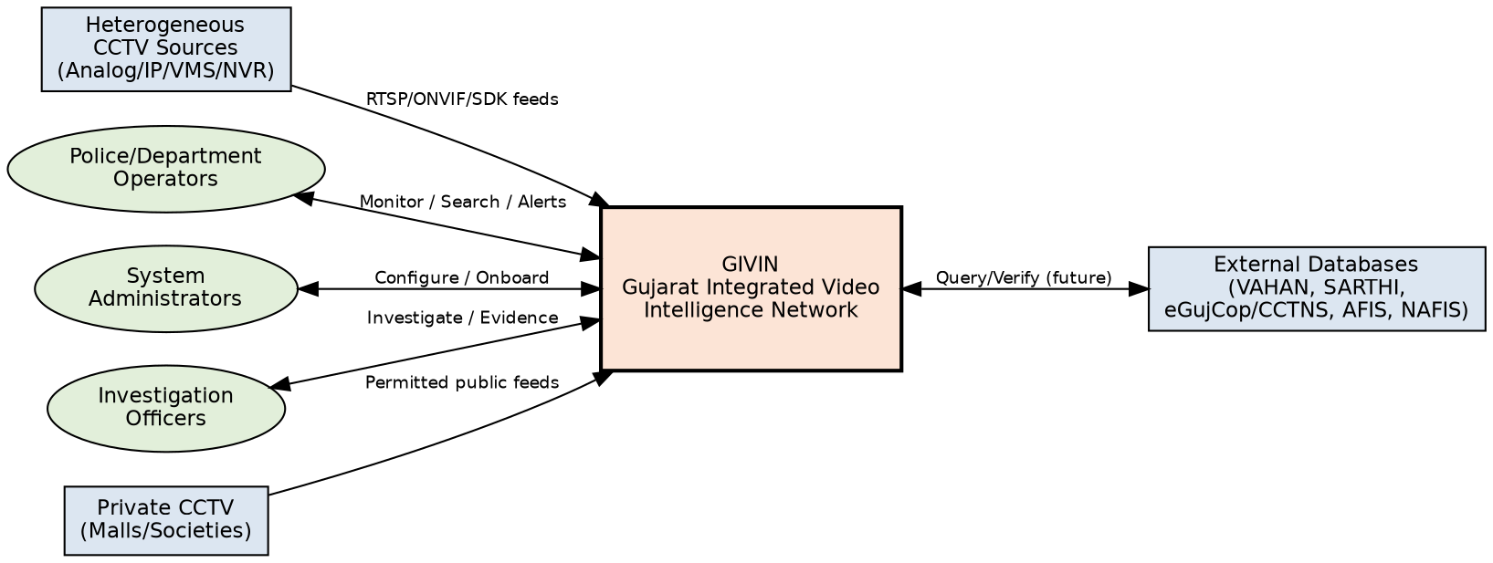
Figure 5.1: System Context Diagram

5.3 High-Level Solution Architecture
Figure 5.2 presents the recommended hybrid architecture. Camera feeds pass through regional/site connectors into a Stream Gateway, then split into a Video/AI path (detection, tracking, ANPR) and a Metadata path (event bus). Metadata converges in an Event Correlation Engine, which feeds the Watchlist Engine and GIS/History service, driving the Alert Engine, all surfaced through the Command Center UI.
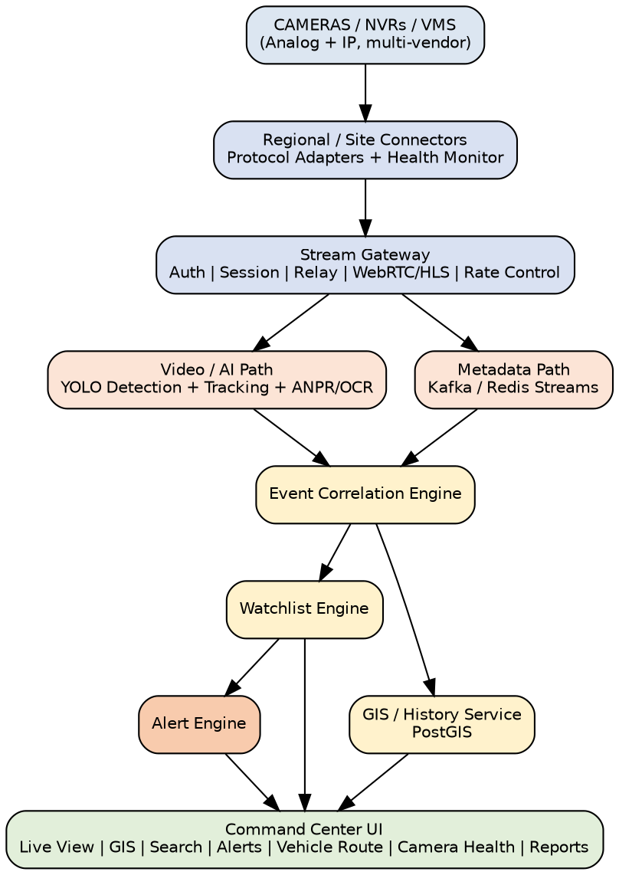
Figure 5.2: High-Level Solution Architecture (GIVIN)

5.4 Deployment / Physical Architecture
Figure 5.3 maps the logical architecture onto physical/cloud infrastructure across three layers: the Site/Department layer (cameras and lightweight connector containers), the Regional Edge layer (GPU inference nodes, local buffering, regional stream gateways), and the Central Platform (Kubernetes-orchestrated microservices, Kafka, PostgreSQL/PostGIS, OpenSearch, Redis, object storage, and observability stack).
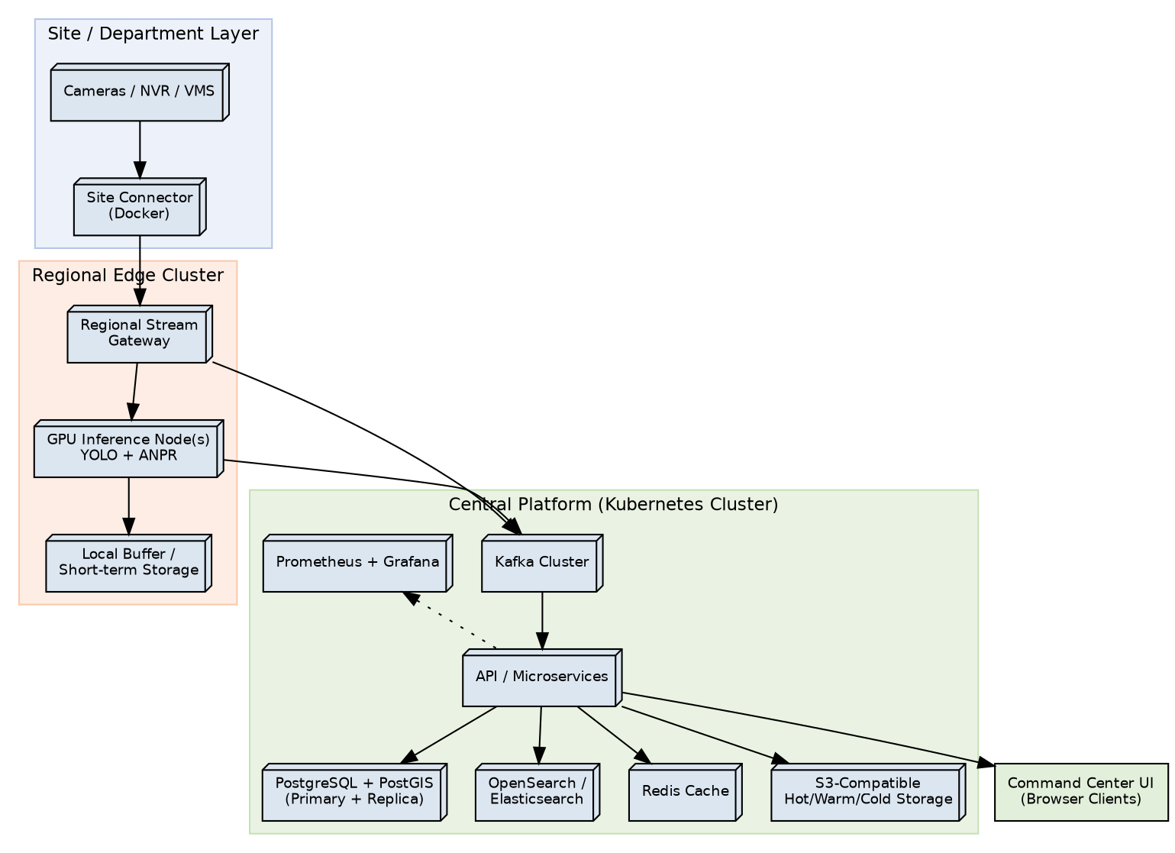
Figure 5.3: Deployment / Physical Architecture

5.5 Scalability Hierarchy
Figure 5.4 summarizes the scaling hierarchy used to reach the statewide target of approximately 80,000 cameras: individual site/department connectors feed multiple regional edge clusters, which forward only compact metadata/events (not raw full-resolution streams) to the central platform by default. Full details are provided in Section 12.
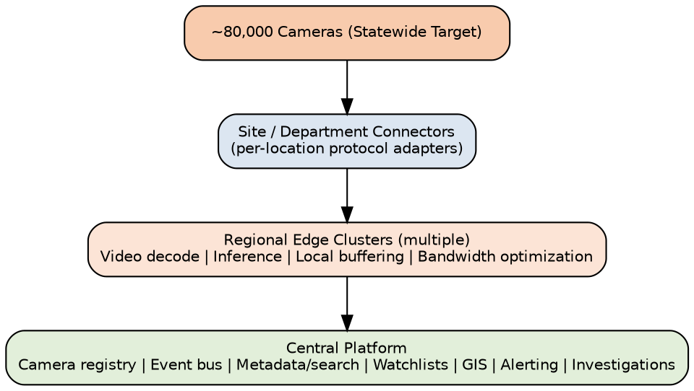
Figure 5.4: Scalability Hierarchy for ~80,000 Cameras

5.6 Architectural Decisions and Rationale
Decision | Rationale
Hybrid Model 1+2+3 (+selective Model 4) | Satisfies interoperability and cost-effectiveness requirements without forcing full centralized video ingestion; matches the problem statement's explicit permission for hybrid/custom architectures.
Edge/regional AI inference | Reduces WAN bandwidth demand, lowers latency for real-time alerts, and makes the ~80,000-camera target technically feasible.
Event-driven microservices with Kafka/Redis Streams | Enables independent scaling of detection, ANPR, correlation and alerting services; new analytics modules can subscribe to the event bus without modifying producers.
Vendor-neutral connector/adapter framework | Allows onboarding of new camera vendors, VMS platforms and protocols without core redesign, directly satisfying the interoperability and future-readiness evaluation criteria.
Logical Camera ID independent of vendor ID | Prevents vendor lock-in and allows a camera's identity to remain stable even if underlying hardware/VMS changes.
Metadata-first, video-on-demand transport | Sends compact events centrally by default and requests high-resolution video only when needed, conserving bandwidth across ~1,000 km of dispersed sites.
Tiered hot/warm/cold storage | Balances rapid investigative access to recent evidence against the cost of long-term retention at statewide scale.

6. Use Case Model

6.1 Use Case Diagram
Figure 6.1 shows the primary actors and use cases supported by GIVIN. The four actor roles — Administrator, Control Room Operator, Investigation Officer and Department Coordinator — interact with eleven core use cases spanning onboarding, monitoring, analytics, investigation and administration.
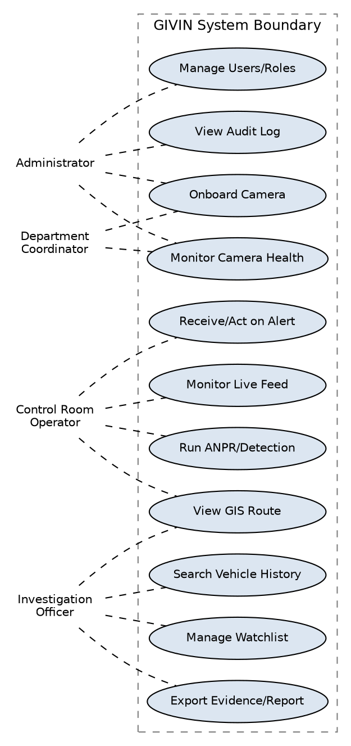
Figure 6.1: Use Case Diagram

6.2 Use Case Descriptions

UC-1: Onboard Camera
Field | Description
Primary Actor | Administrator / Department Coordinator
Preconditions | User is authenticated with onboarding permission.
Main Flow | 1) User selects bulk-import, manual entry, or API onboarding. 2) User enters/uploads camera metadata (department, coordinates, protocol, credentials, storage). 3) System validates connectivity via the appropriate connector. 4) System assigns a logical Camera ID and adds the camera to the registry and GIS map.
Postconditions | Camera appears in registry with status; connector begins health monitoring.

UC-2: Monitor Live Feed
Field | Description
Primary Actor | Control Room Operator
Preconditions | At least one camera is onboarded and online.
Main Flow | 1) Operator opens Live View. 2) Operator selects camera(s) for a grid layout. 3) System streams live video via the Stream Gateway. 4) Operator may switch to recorded playback.
Postconditions | Operator views live/recorded feed(s) with health indicators visible.

UC-3: Run ANPR / Vehicle Detection
Field | Description
Primary Actor | System (automated), monitored by Operator
Preconditions | Camera stream is active and connected to the AI pipeline.
Main Flow | 1) System detects vehicles in frames. 2) System tracks each vehicle across frames. 3) System detects and OCRs the plate. 4) System normalizes text and applies confidence thresholds. 5) System publishes a compact event to the event bus.
Postconditions | Event is available for correlation, search and watchlist matching.

UC-4: Search Vehicle History
Field | Description
Primary Actor | Investigation Officer
Preconditions | User is authenticated with search permission; vehicle has at least one recorded sighting.
Main Flow | 1) User enters a registration number. 2) System queries the sightings store. 3) System returns a chronological timeline with camera, location, timestamp and confidence. 4) System renders the reconstructed route on GIS. 5) User opens evidence for any sighting.
Postconditions | Search and any evidence access are recorded in the audit log.

UC-5: Manage Watchlist
Field | Description
Primary Actor | Investigation Officer / Administrator
Preconditions | User is authenticated with watchlist-management permission.
Main Flow | 1) User creates/updates/deactivates a watchlist entry with entity type, value, risk level and reason. 2) System validates and stores the entry. 3) System begins matching future events against the active entry.
Postconditions | Watchlist entry is active/inactive as specified; change is audit-logged.

UC-6: Receive and Act on Alert
Field | Description
Primary Actor | Control Room Operator / Investigation Officer
Preconditions | A watchlist match has been generated by the system.
Main Flow | 1) System pushes the alert via WebSocket. 2) Operator reviews severity, location, evidence. 3) Operator acknowledges the alert. 4) Investigator transitions the alert through INVESTIGATING to RESOLVED or FALSE_POSITIVE.
Postconditions | Alert status and all transitions are recorded with the acting user's identity.

UC-7: View GIS Route / Camera Map
Field | Description
Primary Actor | Any authenticated user (per role)
Preconditions | GIS layers are populated with camera and/or event data.
Main Flow | 1) User opens the GIS map. 2) User selects layer(s): cameras, department, health, events, vehicle routes. 3) System renders the selected layer(s) with interactive markers.
Postconditions | User can drill down into camera detail or event/evidence detail from the map.

UC-8: Manage Users / Roles
Field | Description
Primary Actor | Administrator
Preconditions | User is authenticated with administrative permission.
Main Flow | 1) Administrator creates/updates a user account. 2) Administrator assigns role(s) and department association. 3) System enforces RBAC on subsequent user actions.
Postconditions | User account reflects updated role/permissions; change is audit-logged.

UC-9: Monitor Camera Health
Field | Description
Primary Actor | Administrator / Department Coordinator
Preconditions | Cameras are onboarded and connectors are active.
Main Flow | 1) User opens the camera health dashboard. 2) System displays online/offline status, last-seen time, latency and connector status per camera. 3) User filters by department or region to identify at-risk cameras.
Postconditions | Health status is current as of the last successful health check.

UC-10: Export Evidence / Report
Field | Description
Primary Actor | Investigation Officer
Preconditions | User has access to the alert or vehicle history being exported.
Main Flow | 1) User selects an alert or vehicle history record. 2) User requests export. 3) System compiles a report including evidence references, timestamps and locations. 4) System logs the export action.
Postconditions | Report is available for download; export is recorded in the audit log.

UC-11: View Audit Log
Field | Description
Primary Actor | Auditor / Administrator
Preconditions | User is authenticated with audit-log-view permission.
Main Flow | 1) User opens the audit console. 2) User filters by user, action type, date range. 3) System displays matching, immutable audit records.
Postconditions | No data is modified; view itself may optionally be logged.

6.3 Sequence Diagram — ANPR Detection to Alert
Figure 6.2 illustrates the primary end-to-end interaction from a camera stream through detection, tracking, ANPR, event publication, correlation, watchlist matching and alert delivery to the Command Center UI. This sequence underlies functional requirements FR-4.1 through FR-6.5 and is the core demonstration flow required by the official test case.
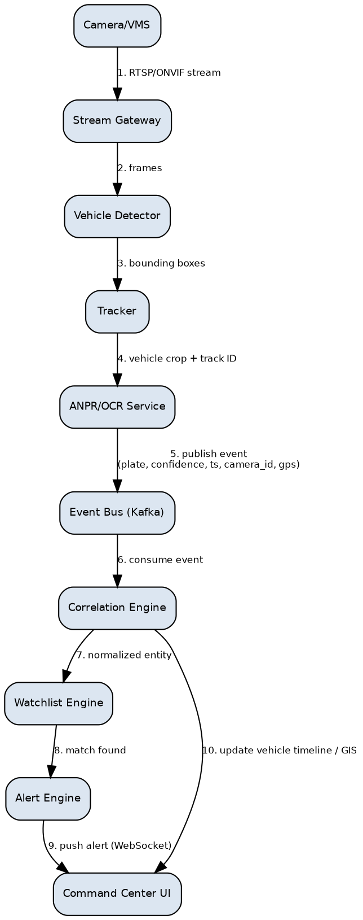
Figure 6.2: Sequence Diagram — ANPR Detection to Alert

7. Non-Functional Requirements

7.1 Performance Requirements
ID | Requirement | Target
NFR-P1 | End-to-end latency from vehicle detection to alert delivery at the Command Center UI. | ≤ 5 seconds (PoC), ≤ 8 seconds (statewide, WAN-dependent)
NFR-P2 | ANPR pipeline throughput per regional GPU inference node. | ≥ 15 camera streams per node at 5–10 fps analytic sampling
NFR-P3 | Vehicle history search response time for a given registration number. | ≤ 2 seconds for up to 12 months of indexed sightings
NFR-P4 | Live-view stream startup latency in the Command Center UI. | ≤ 3 seconds
NFR-P5 | GIS map render time for a fully layered statewide camera view. | ≤ 4 seconds for up to 5,000 visible markers (clustered)
NFR-P6 | Concurrent Command Center UI sessions supported centrally. | ≥ 500 concurrent operators (statewide target)

7.2 Scalability Requirements
- The architecture shall support horizontal scaling of stateless API, detection and correlation services independent of database scaling (see Section 12).
- The system shall support incremental onboarding from the PoC scale (~50 cameras) to the target scale (~80,000 cameras) without core architectural redesign.
- Kafka topics and relational/search data stores shall support partitioning by region and/or time window.

7.3 Reliability & Availability Requirements
ID | Requirement | Target
NFR-R1 | Availability of core central platform services (registry, alerting, GIS, search). | ≥ 99.5% monthly (PoC/early phase); ≥ 99.9% for statewide production
NFR-R2 | Recovery Point Objective (RPO) for camera registry, watchlists, alert history and audit logs. | ≤ 15 minutes
NFR-R3 | Recovery Time Objective (RTO) for core central services after a regional outage. | ≤ 60 minutes
NFR-R4 | Regional edge clusters shall continue local detection and buffering during a temporary WAN outage to the central platform. | No loss of locally buffered evidence for outages ≤ 24 hours

7.4 Security Requirements
- All API and inter-service traffic shall be encrypted in transit (TLS 1.2+).
- Sensitive metadata and evidence shall be encrypted at rest where policy requires.
- Role-based access control shall be enforced on every sensitive action (search, export, watchlist change, alert transition).
- Camera credentials and API keys shall be stored only in a credential vault; never hard-coded or logged in plaintext.
- All sensitive actions shall generate an immutable audit record.
- Network segmentation shall separate camera/connector, AI inference, data, and management networks.
- See Section 11 for the complete security architecture.

7.5 Usability Requirements
- The Command Center UI shall be operable by control room staff with basic computer literacy after no more than 2 hours of training.
- Critical actions (alert acknowledgment, evidence export) shall be reachable within 3 clicks from the alert notification.
- The UI shall provide clear visual differentiation of alert severity (e.g., color coding) and camera health status.

7.6 Maintainability & Extensibility Requirements
- New camera vendors/VMS platforms shall be onboarded by adding a connector module without modifying core services.
- New AI analytics modules shall subscribe to the existing event bus without requiring changes to upstream producers.
- The system shall expose versioned, documented REST/gRPC APIs for internal and future external integration.

7.7 Interoperability Requirements
- The system shall support standard protocols (RTSP, ONVIF) as first-class integration methods in addition to vendor-specific SDKs.
- The system's data model shall represent camera and event metadata in a vendor-neutral canonical schema (Section 9).
- Connector interfaces shall be designed to accommodate future integration with VAHAN, SARTHI, eGujCop/CCTNS, AFIS and NAFIS without core schema changes.

7.8 Cost-Effectiveness Requirements
- The reference technology stack (Section 10) shall prioritize open-source components to minimize licensing cost at statewide scale.
- The storage strategy (Section 13) shall avoid unnecessary central storage of full-resolution video to control storage cost growth as camera count increases.

8. Data Flow Diagrams

8.1 Level 0 — Context-Level Data Flow Diagram
Figure 8.1 presents the Level 0 DFD, showing GIVIN's central process and its principal data stores and external entities: camera sources, operators, investigators, and four core data stores — Camera Registry, Event/ANPR Store, Watchlist Store, and Audit Log.
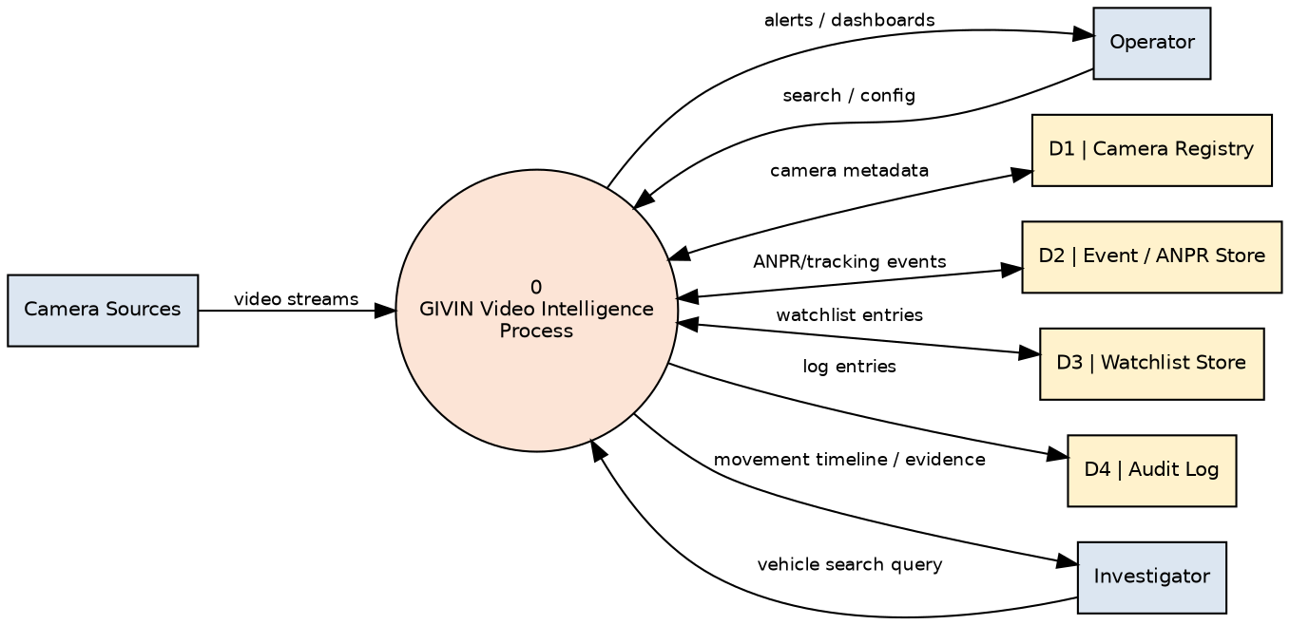
Figure 8.1: Data Flow Diagram — Level 0 (Context)

8.2 Level 1 — Decomposed Data Flow Diagram
Figure 8.2 decomposes the central process into seven sub-processes reflecting the ANPR-to-alert pipeline: Stream Ingestion, Vehicle Detection & Tracking, ANPR/OCR, Event Correlation, Watchlist Matching, Alert Generation, and GIS Route Reconstruction, each reading from and writing to dedicated data stores.
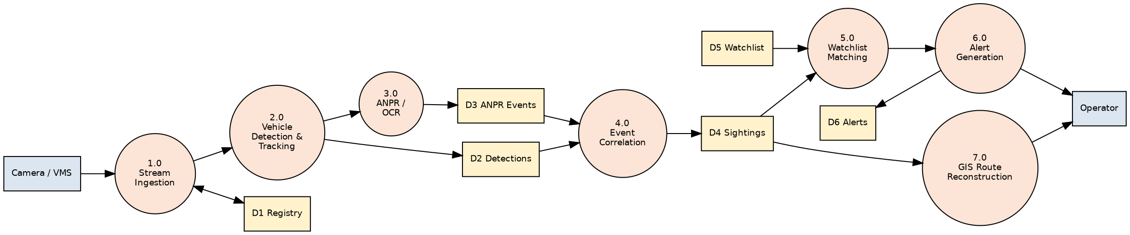
Figure 8.2: Data Flow Diagram — Level 1

8.3 Data Store Descriptions
Data Store | Contents | Primary Owner Process
D1 — Camera Registry | Camera metadata, department ownership, GIS coordinates, connector configuration. | Stream Ingestion / Onboarding
D2 — Vehicle Detections | Raw detection/track records: bounding boxes, track IDs, timestamps. | Vehicle Detection & Tracking
D3 — ANPR Events | Normalized plate text, confidence, evidence URI, camera ID, GPS, direction. | ANPR / OCR
D4 — Vehicle Sightings | Correlated, deduplicated per-vehicle sighting records used for search/history. | Event Correlation
D5 — Watchlist | Active/inactive watchlist entries with risk level and reason. | Watchlist Matching (read)
D6 — Alerts | Generated alerts with severity, status, and lifecycle history. | Alert Generation

9. Data Model & Database Design

9.1 Entity Relationship Diagram
Figure 9.1 presents the core relational schema underlying GIVIN. PostgreSQL with the PostGIS extension is the system of record for camera geolocation and spatial event queries; OpenSearch/Elasticsearch is used as a secondary, denormalized index for high-speed plate/event search at scale.
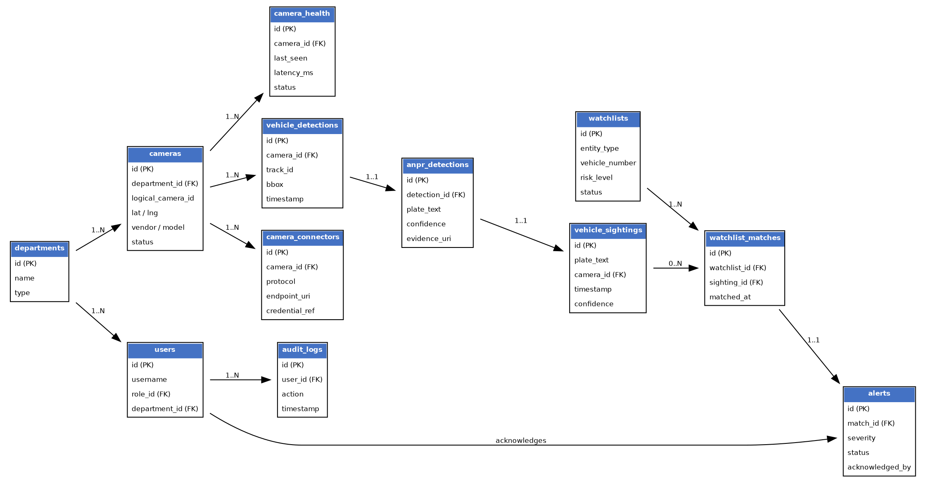
Figure 9.1: Entity Relationship Diagram

9.2 Entity Dictionary

departments
Field | Type | Notes
id | UUID (PK) | Primary key
name | VARCHAR | e.g., Home Department, Food & Civil Supplies, RTO
type | VARCHAR | Department category/classification

cameras
Field | Type | Notes
id | UUID (PK) | Primary key
department_id | UUID (FK) | References departments.id
logical_camera_id | VARCHAR | Platform-generated, vendor-independent identifier
lat / lng | GEOGRAPHY(Point) | PostGIS spatial column
vendor / model | VARCHAR | Camera make and model
protocol | VARCHAR | RTSP / ONVIF / vendor-API
status | VARCHAR | ACTIVE / INACTIVE / MAINTENANCE

camera_connectors
Field | Type | Notes
id | UUID (PK) | Primary key
camera_id | UUID (FK) | References cameras.id
protocol | VARCHAR | Connector protocol type
endpoint_uri | VARCHAR | Stream/API endpoint (not publicly exposed)
credential_ref | VARCHAR | Pointer to secret in credential vault, never the raw credential

camera_health
Field | Type | Notes
id | UUID (PK) | Primary key
camera_id | UUID (FK) | References cameras.id
last_seen | TIMESTAMPTZ | Last successful health check
latency_ms | INTEGER | Stream latency measurement
status | VARCHAR | ONLINE / OFFLINE / DEGRADED

vehicle_detections
Field | Type | Notes
id | UUID (PK) | Primary key
camera_id | UUID (FK) | References cameras.id
track_id | VARCHAR | Per-camera tracker-assigned ID
bbox | JSONB | Bounding box coordinates
timestamp | TIMESTAMPTZ | Detection time

anpr_detections
Field | Type | Notes
id | UUID (PK) | Primary key
detection_id | UUID (FK) | References vehicle_detections.id
plate_text | VARCHAR | Normalized plate text
confidence | NUMERIC | 0.0 – 1.0
evidence_uri | VARCHAR | Reference to stored image/clip

vehicle_sightings
Field | Type | Notes
id | UUID (PK) | Primary key
plate_text | VARCHAR | Normalized, searchable plate value
camera_id | UUID (FK) | References cameras.id
timestamp | TIMESTAMPTZ | Sighting time
confidence | NUMERIC | Aggregated confidence for this sighting

watchlists / watchlist_matches / alerts
Field | Type | Notes
watchlists.id | UUID (PK) | Primary key
watchlists.entity_type | VARCHAR | VEHICLE / PERSON
watchlists.vehicle_number | VARCHAR | Nullable if entity_type = PERSON
watchlists.risk_level | VARCHAR | LOW / MEDIUM / HIGH / CRITICAL
watchlists.status | VARCHAR | ACTIVE / INACTIVE
watchlist_matches.watchlist_id | UUID (FK) | References watchlists.id
watchlist_matches.sighting_id | UUID (FK) | References vehicle_sightings.id
alerts.match_id | UUID (FK) | References watchlist_matches.id
alerts.severity | VARCHAR | LOW / MEDIUM / HIGH / CRITICAL
alerts.status | VARCHAR | NEW / ACKNOWLEDGED / INVESTIGATING / RESOLVED / FALSE_POSITIVE

users / roles / permissions / audit_logs
Field | Type | Notes
users.id | UUID (PK) | Primary key
users.role_id | UUID (FK) | References roles.id
users.department_id | UUID (FK) | References departments.id, nullable
audit_logs.user_id | UUID (FK) | References users.id
audit_logs.action | VARCHAR | e.g., SEARCH, EXPORT, WATCHLIST_UPDATE, ALERT_TRANSITION
audit_logs.timestamp | TIMESTAMPTZ | Action time

9.3 Alert Lifecycle State Diagram
Figure 9.2 shows the permitted alert-status transitions enforced by the Alert Generation and Investigation modules (FR-6.4).
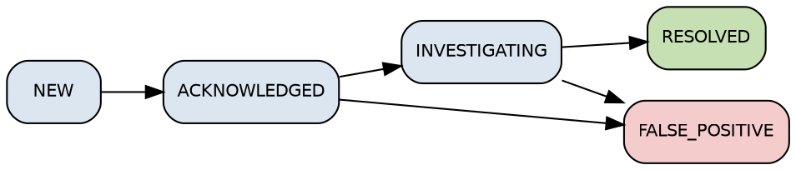
Figure 9.2: Alert Lifecycle State Diagram

10. Technology Stack
Layer | Recommended Choice | Rationale
Frontend | Next.js/React, Tailwind CSS, WebSocket client, MapLibre or Leaflet | Rich interactive dashboards, real-time updates, mature GIS libraries
API / Orchestration | FastAPI (Python) for AI-heavy services; Node.js for gateway/orchestration | Python ecosystem for AI integration; Node.js for high-concurrency I/O
Database (system of record) | PostgreSQL + PostGIS | ACID guarantees; native spatial querying for GIS
Cache | Redis | Low-latency session, connector-state and rate-limiting cache
Event Bus | Kafka (statewide scale); Redis Streams (PoC) | Durable, partitioned, high-throughput event streaming
Video Streaming | RTSP, FFmpeg, WebRTC/HLS | Standard, broadly compatible ingestion and relay
AI / Computer Vision | YOLO family (PyTorch), OpenCV, ByteTrack/BoT-SORT, PaddleOCR (or comparable OCR) | State-of-the-art open-source detection/tracking/OCR performance
Search | OpenSearch / Elasticsearch | Fast plate/event search across large historical datasets
Deployment | Docker (PoC); Kubernetes (statewide scale) | Portable containerization; horizontal scaling and self-healing at scale
GPU Compute | NVIDIA CUDA-compatible GPU nodes (regional + central) | Real-time inference throughput for detection/ANPR
Object Storage | S3-compatible / Ceph | Cost-effective tiered evidence storage
Observability | Prometheus + Grafana + centralized logging | Operational visibility across a distributed, multi-region deployment
All primary components are open-source, satisfying the cost-effectiveness evaluation criterion, while remaining production-proven at scale in comparable video-analytics deployments.

11. Security Architecture

11.1 Access Control
- Department- and role-based access control (RBAC) enforced at the API gateway and service layer, not only in the UI.
- Least-privilege service accounts for every microservice and worker.
- Multi-factor authentication recommended for Administrator and Investigator roles in production.

11.2 Data Protection
- TLS 1.2+ for all APIs and, where supported by the source system, for feed exchange.
- Encryption at rest for sensitive metadata and evidence where policy requires.
- Credential vaulting for camera passwords and API keys; credentials are never hard-coded, logged, or exposed to the client.

11.3 Network Security
- Network segmentation separating camera/connector, AI inference, data, and management planes.
- Connector isolation so that a compromised vendor integration cannot laterally expose the wider platform.
- Ingress restricted to authenticated, authorized clients; camera stream URLs are never publicly exposed.

11.4 Auditability
- Immutable, append-only audit logs for sensitive searches, exports, watchlist changes and alert-status transitions.
- Evidence access is always authorized and logged, including viewer identity, timestamp and (where provided) case/purpose reference.

11.5 Resilience
- High availability and disaster recovery for critical metadata and alerting services (see Section 14).
- Regional failover for edge clusters supporting continuity of local detection during partial outages.

11.6 Privacy & Responsible Use Considerations
- Watchlist matching is confidence-gated to reduce false positives that could otherwise trigger unwarranted scrutiny.
- Access to sensitive personal data (plate history, evidence) is role-restricted and fully audited.
- The PoC uses only representative/synthetic watchlist data, consistent with hackathon guidance.

12. Scalability Plan — Toward ~80,000 Cameras
The scalable design deliberately avoids the assumption that every camera continuously streams full-resolution video to a single central data center. Instead, GIVIN uses a three-tier hierarchy: Site/Department Connectors, Regional Edge Clusters, and the Central Platform (see Figure 5.4).

12.1 Design Principles
- Process video as close to the source as practical; avoid unnecessary long-haul transport of raw video.
- Send compact metadata/events centrally by default; request high-resolution video only when an investigation requires it.
- Use adaptive bitrate and selective stream profiles (sub-stream for routine monitoring, main stream on demand).
- Scale stateless API and analytics workers horizontally, independent of stateful data stores.
- Partition Kafka topics and databases by region and/or time window to bound query and ingestion load.
- Apply hot/warm/cold storage tiers to control long-term storage cost growth.
- Use health checks, load balancing and automated restart/recovery across all tiers.
- Keep the registry and connector model vendor-neutral so new camera vendors can be added without redesign as the estate grows.

12.2 Capacity Planning Guidance
Parameter | PoC Scale | Statewide Target Scale
Cameras onboarded | ~50 (official test set) + own-feed demo cameras | ~80,000
Regional edge clusters | 1 (or simulated) | Multiple, aligned to department/geographic regions
GPU inference nodes | 1–2 | Scaled per regional cluster based on stream count and analytic sampling rate
Kafka partitioning | Single topic set, minimal partitioning | Partitioned by region and/or time window
Central DB sizing | Single PostgreSQL instance | Primary + read replicas; partitioned tables for high-volume event data

13. Storage & Network/Bandwidth Strategy

13.1 Storage Tiering
- Hot tier: recent evidence and high-value event clips for rapid investigation access.
- Warm tier: less frequently accessed evidence on lower-cost storage.
- Cold tier: long-term archive where retention policy requires it.
- Searchable metadata is stored separately from large video/image objects to keep search performant and cost-efficient.
- Lifecycle policies automatically migrate data between tiers based on age and access patterns.
- Full-resolution video is not centrally stored for every stream unless operationally justified for that camera/department.

13.2 Network & Bandwidth Strategy
- Edge/regional analytics is preferred for continuous detection workloads to minimize WAN traffic.
- Event metadata and short evidence clips are transmitted centrally rather than full continuous streams wherever possible.
- Sub-streams are used for routine monitoring; main (high-resolution) streams are pulled on demand.
- Gateways buffer locally during intermittent connectivity to prevent event/evidence loss.
- Alert and metadata traffic is prioritized over non-critical bulk video traffic (QoS).
- Bitrate, packet loss, latency and connector health are continuously measured and surfaced on the health dashboard.

14. Disaster Recovery & Reliability
- Critical metadata and configuration (camera registry, watchlists, alert history, audit logs) are replicated across availability zones/regions.
- Regular backups are taken of the camera registry, watchlists, alert history and audit logs, with the RPO/RTO targets defined in Section 7.3.
- Regional failover is designed for critical central services (registry, alerting, search).
- Automated health checks trigger worker restart/recovery without manual intervention for transient failures.
- Local buffering at regional edge clusters ensures a temporary WAN failure does not automatically destroy freshly captured evidence.
- RPO/RTO targets, backup schedules and failover runbooks shall be finalized in the accompanying High-Level Design (HLD) document prior to production rollout.

15. Test Plan & Acceptance Criteria

15.1 Official Technical Evaluation / Test Scenario
The official evaluation provides access to approximately 50 geographically distributed government cameras via the Resources page after registration, spanning multiple departments, technologies, formats, VMS platforms and storage mechanisms. GIVIN's PoC shall satisfy the following acceptance steps, each traced to the functional requirements in Section 4:
Step | Acceptance Criterion | Traced Requirement(s)
1 | Onboard approximately 50 cameras across the provided test set. | FR-1.1, FR-1.2, FR-1.3, FR-2.1, FR-2.2
2 | Integrate live or recorded feeds from onboarded cameras. | FR-2.3, FR-2.4, FR-3.1, FR-3.2
3 | Demonstrate centralized monitoring across heterogeneous sources. | FR-1.4, FR-3.1, FR-3.4
4 | Run AI-powered video analytics (detection, tracking, ANPR). | FR-4.1–FR-4.6
5 | Accept a designated vehicle registration number as search input. | FR-5.1
6 | Identify the vehicle across different camera locations and times. | FR-5.1, FR-5.2
7 | Generate a timestamped, location-wise movement history. | FR-5.2, FR-5.3
8 | Cross-reference live detections against a representative watchlist. | FR-6.1, FR-6.2
9 | Generate automated real-time alerts for matches. | FR-6.3, FR-6.5
10 | Visualize the route and searchable events on GIS. | FR-5.3, FR-7.1, FR-1.4

15.2 Demonstration Script (Own-Feed, 2–3 Minutes)
The following sequence is recommended to align the live demonstration with the evaluation framework in Section 15.4:
- Open the command-center dashboard.
- Show the camera registry and GIS map.
- Connect at least two heterogeneous own-feed sources.
- Show a vehicle entering a camera's field of view.
- Display the detection and ANPR result with confidence score.
- Show a watchlist match and the resulting alert.
- Search the same registration number.
- Display all historical sightings in a timeline.
- Display the reconstructed route on GIS.
- Open the evidence for a selected sighting.
- Show camera health and system monitoring.
- Close with the scalable architecture diagram for the 80,000-camera target.

15.3 Test Levels
Test Level | Focus | Example Cases
Unit Testing | Individual service/module correctness. | ANPR normalization rules, watchlist matching logic, connector validation.
Integration Testing | Cross-service data flow via the event bus. | Detection event -> correlation -> watchlist match -> alert delivery.
System Testing | End-to-end scenario against the official test case. | Full 50-camera onboarding and vehicle-search scenario (Section 15.1).
Performance Testing | Load and latency under target concurrency. | Simulated multi-camera load against NFR-P1–P6 (Section 7.1).
Security Testing | Access control, credential handling, audit completeness. | RBAC bypass attempts, credential exposure checks, audit-log completeness.
User Acceptance Testing | Usability for control-room and investigation roles. | Time-to-acknowledge-alert, time-to-locate-vehicle-history.

15.4 Evaluation Framework Mapping
Evaluation Area (Official) | How GIVIN Addresses It
Successful Test Case | PoC onboards and operates on the government-provided feed with viewing and required analytics (Section 15.1).
Solution Presentation | Problem understanding, model justification and solution overview are captured in Sections 1–2 and 5–6.
Solution Architecture | Technical soundness, feasibility, security and interoperability documented in Sections 5, 7, 11, 12.
Working Platform & Demonstration | Section 15.2 defines a concrete own-feed and government-feed demonstration script backed by working services, not mockups.
Video Analytics Output | Section 4.4 defines detection, tracking and ANPR requirements with explicit confidence handling.
Scalability & PoC Readiness | Section 12 documents the ~80,000-camera scaling architecture and capacity plan.
Submission Completeness | Section 17 provides a submission checklist and traceability appendix.

16. Development Roadmap
Phase | Focus | Key Deliverables
Phase 1 — Foundation | Core registry and access control. | Camera registry, authentication, roles, PostgreSQL/PostGIS, GIS dashboard.
Phase 2 — Integration | Heterogeneous feed connectivity. | RTSP/ONVIF connector, stream gateway, camera health, feed onboarding.
Phase 3 — AI | Core analytics pipeline. | Vehicle detection, tracking, ANPR/OCR, confidence handling, evidence capture.
Phase 4 — Intelligence | Correlation and watchlist. | Watchlist engine, event schema, correlation engine, vehicle search, route reconstruction.
Phase 5 — Operations | Real-time alerting workflow. | Real-time alerts, WebSocket delivery, alert lifecycle workflow, reports, audit logs.
Phase 6 — Scale | Statewide scalability engineering. | Kafka, regional workers, load testing, storage tiers, bandwidth strategy, Kubernetes design.
Phase 7 — Submission | Hackathon readiness. | Own-feed demo, government-feed test, HLD, presentation deck, output report, final QA.

17. Appendices

Appendix A — Recommended Repository Structure
gujarat-cctv-intelligence/
├── frontend/ (dashboard, gis, live-view, alerts, vehicle-search)
├── services/ (api, camera-registry, connector-service, stream-gateway,
│ ai-service, anpr-service, tracking-service, watchlist-service,
│ correlation-service, alert-service)
├── workers/ (inference-worker, event-worker, report-worker)
├── db/ (migrations, seed)
├── infrastructure/ (docker, kubernetes, monitoring)
├── tests/
├── docs/ (HLD.md, API.md, SECURITY.md, SCALABILITY.md)
└── README.md

Appendix B — Submission Checklist
- Solution Presentation (PPT/PDF): model justification, overview, objectives, innovations.
- High-level architecture and end-to-end workflow.
- AI video analytics approach; watchlist correlation and alert methodology.
- Technology/framework/tool stack.
- Scalability, interoperability, security and deployment approach.
- Operational benefits and policing/public-safety impact.
- Technical Proposal / HLD, including integration approach for heterogeneous cameras/NVRs/VMS.
- Live-stream ingestion/processing architecture; watchlist and AI analytics architecture; alert workflow.
- 80,000-camera scalability strategy and departmental information requirements.
- 2–3 minute own-feed screen-recorded demonstration.
- Government-feed demonstration and output report.
- Submission links: unlisted YouTube, Google Drive/OneDrive, hosted platform credentials, GitHub/GitLab as applicable.

Appendix C — Department Onboarding Data Requirements
- Department and owning authority; camera inventory with stable identifiers.
- Latitude/longitude and site details; camera make/model/type/resolution.
- VMS/NVR vendor and version; supported protocols/API/SDK.
- Stream URLs or integration endpoints and secure credential handoff process.
- Storage location, capacity and retention period.
- Network type, bandwidth and connectivity constraints; existing analytics capabilities.
- AMC/support status; permitted sharing scope and operational/security restrictions.

Appendix D — Explicit Anti-Patterns (What Not to Do)
- Do not build only a static CCTV dashboard without functioning analytics.
- Do not let the UI be the main achievement while the backend is mocked.
- Do not depend on a single camera vendor or VMS format.
- Do not claim 80,000-camera capability without a concrete scaling architecture.
- Do not send every full-resolution stream to a single central server in the statewide design.
- Do not treat ANPR OCR output as perfectly accurate; always retain confidence and evidence.
- Do not hard-code credentials or expose camera URLs publicly.
- Do not pursue advanced analytics at the expense of a reliable mandatory ANPR + tracking flow.
- Do not substitute animations/mockups for a functional backend — concept-only demonstrations are explicitly disqualifying.

Appendix E — One-Line Pitch
"A vendor-neutral statewide video intelligence layer that connects Gujarat's heterogeneous CCTV ecosystem, turns video into searchable AI events, correlates vehicles across cameras, matches authorized watchlists, and delivers real-time, GIS-driven intelligence without requiring replacement of existing departmental systems."

Appendix F — Source Notes
The problem-statement facts, terminology, reference integration models, official test scenario, submission requirements, scalability expectations and evaluation framework referenced throughout this SRS are based on the supplied Gujarat CCTV Hackathon 2026 problem-statement material. The GIVIN architecture name, detailed component design, database schema, technology selections, non-functional requirement targets, implementation roadmap and this SRS document structure are solution recommendations prepared for the hackathon response and are not represented as official Government of Gujarat specifications.

