Experiment #1

Due date: Nov.9th  2020

1.

// Fig. 2.3: fig02_03.cpp

// Printing a line of text with multiple statements.

#include <iostream> // allows program to output data to the scren

// function main begins program execution

int main()

{

std::cout << "Welcome";

std::cout << "to C++!\n";

}//end function main

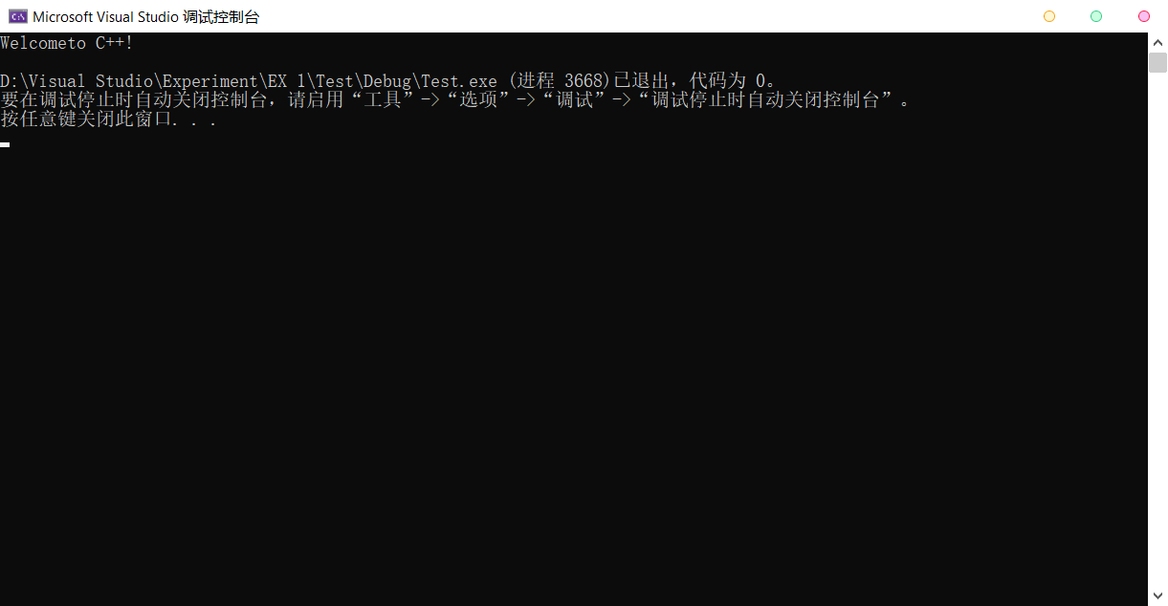

2.

#include <iostream>

using namespace std;

int main()

{

cout << "Input three different integers:";

int a = 0, b = 0, c = 0;

cin >> a >> b >> c;

int sum = a + b + c;

int average = (a + b + c) / 3;

int product = a * b * c;

cout << "Sum is " << sum << endl\

<< "Average is " << average << endl\

<< "Prduct is " << product << endl;

int smallest = a;

if (b < smallest)

{

smallest = b;

}

if (c < smallest)

{

smallest = c;

}

cout << "Smallest is " << smallest << endl;

int largest = a;

if (b > largest)

{

largest = b;

}

if (c > largest)

{

largest = c;

}

cout << "Largest is " << largest << endl;

return 0;

}

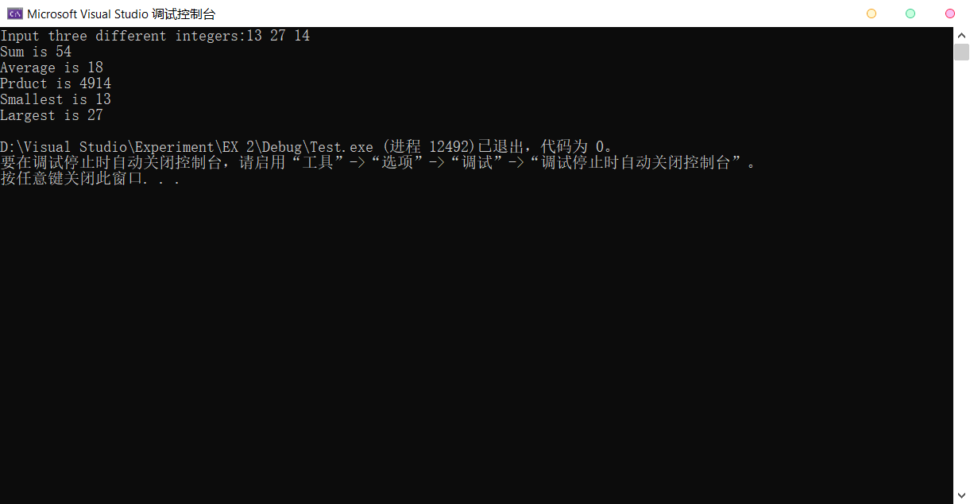 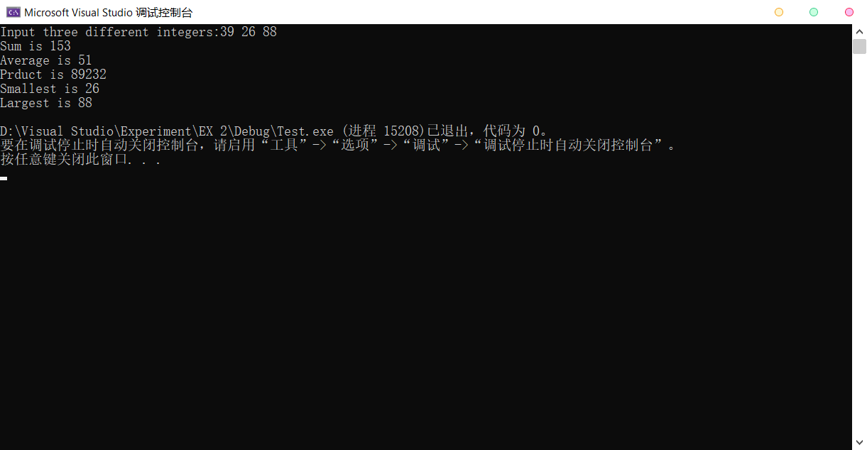

3.

#include <iostream>

using namespace std;

int main()

{

int num1, num2;

cout << "Enter two integers: ";

cin >> num1 >> num2;

if (num1 % num2)

{

cout << num1 << " is not a multiple of " << num2;

}

else

{

cout << num1 << " is a multiple of " << num2;

}

return 0;

}

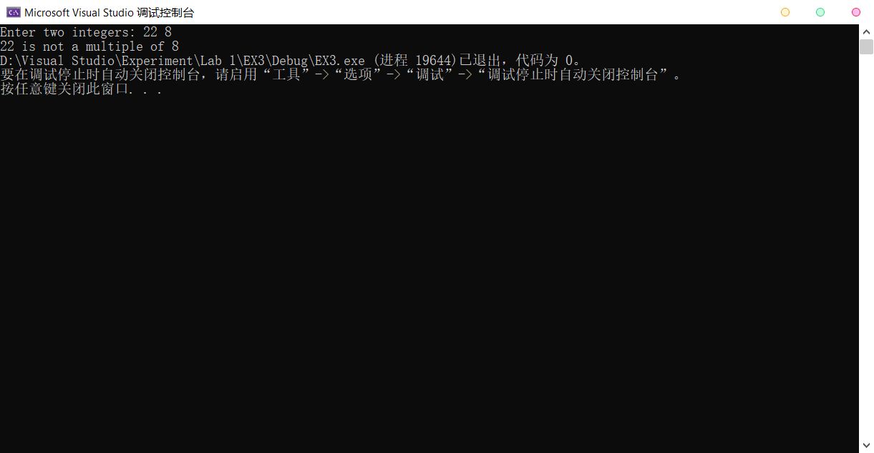

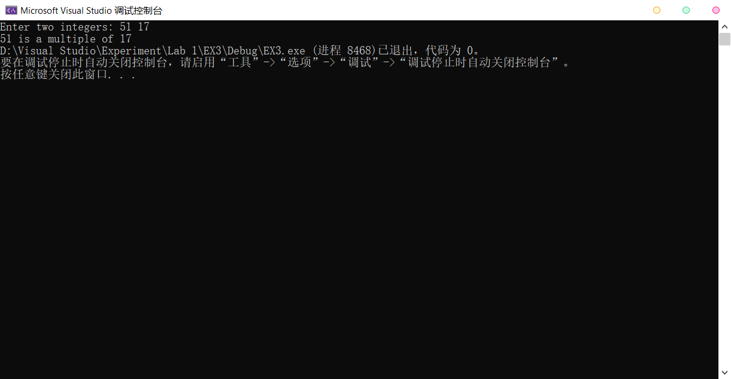

4.

#include <iostream>

using namespace std;

int main()

{

int n, g, s, b, q, w;

cout << "Enter a five-digit number: ";

cin >> n;

w = n / 10000;

q = n / 1000 - w * 10;

b = n / 100 - w * 100 - q * 10;

s = n / 10 - w * 1000 - q * 100 - b * 10;

g = n % 10;

cout << w << " " << q << " " << b << " " << s << " " << g;

return 0;

}