Experiment #2

1.

#include<iostream>

#include<string>

using namespace std;

class GradeBook {

public:

GradeBook() {

setCourseName("Default");

setInstructorName("Default");

}

void setCourseName(string input) {

C_Name = input;

}

string getCourseName() {

return C_Name;

}

void setInstructorName(string input) {

I_Name = input;

}

string getInstructorName() {

return I_Name;

}

void displayMessage() {

cout << "Welcome to the grade book for\n" << getCourseName() << "!\n" << "This course is presented by: " << getInstructorName() << ".\n";

}

void changeInstructorName(string input) {

I_Name = input;

cout << "Changing instructor name to " << I_Name << ".\n";

displayMessage();

}

private:

string C_Name, I_Name;

};

int main(){

GradeBook gb1;

gb1.setCourseName("CS101 Introduction to C++ Programming");

gb1.setInstructorName("Sam Smith");

gb1.displayMessage();

gb1.changeInstructorName("Judy Jones");

system("pause");

return 0;

} 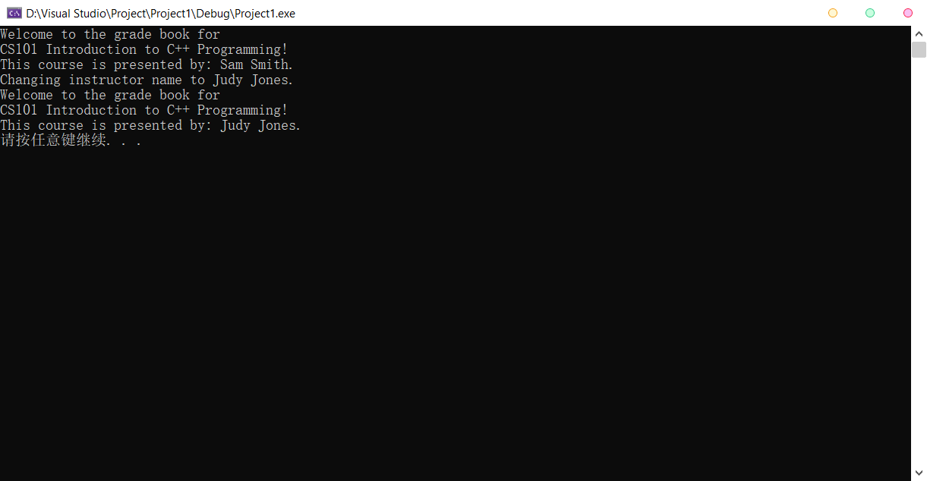

2.

#include<iostream>

#include<string>

using namespace std;

class Employee {

public:

Employee() {

name = "Default";

num = 0;

salary = 0;

increase = 0;

}

void setNumber(int input) {

num = input;

}

int getNumber() {

return num;

}

void setName(string input) {

name = input;

}

string getName() {

return name;

}

void setSalary(int input) {

if (input < 0)

cout << "You can't give an employee less than 0!" << endl;

else

salary = input;

}

int getSalary() {

return salary;

}

void displayMessage() {

cout << "Employee " << getNumber() << ": " << getName() << "; Yearly Salary: " << getSalary() << ".\n";

}

void setIncrease(double input) {

increase = input;

salary *= (1 + input);

displayMessage();

}

private:

string name;

int num, salary;

double increase;

};

int main(){

double increase = 0.1;

Employee employee1, employee2;

employee1.setNumber(1);

employee1.setName("Bob Jones");

employee1.setSalary(34500);

employee2.setNumber(2);

employee2.setName("Susan Baker");

employee2.setSalary(37800);

employee1.displayMessage();

employee2.displayMessage();

cout<< "Increasing employee salaries by " << increase * 100 << "%.\n";

employee1.setIncrease(increase);

employee2.setIncrease(increase);

system("pause");

return 0;

}

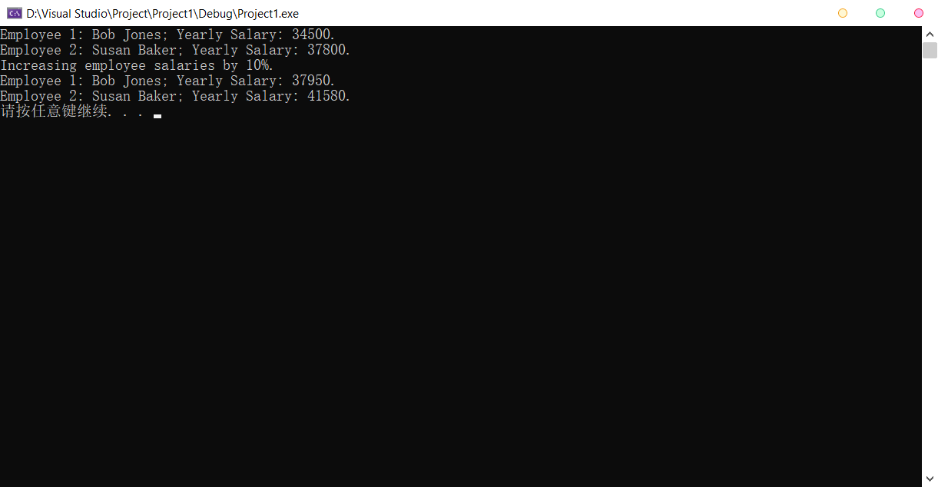

3.

#include<iostream>

#include<string>

using namespace std;

class Date {

public:

Date() {

year = 0;

month = 0;

day = 0;

}

void setDate(int m, int d, int y) {

day = d;

year = y;

if (m < 1 || m > 12)

month = 1;

else

month = m;

}

int getYear() {

return year;

}

int getMonth() {

return month;

}

int getDay() {

return day;

}

void displayDate() {

cout << "The date is " << getMonth() << '/' << getDay() << '/' << getYear() << endl;

}

private:

int year, month, day;

};

int main() {

Date test;

int y = 0, m = 0, d = 0;

cout << "Please set the date." << endl;

cin >> m >> d >> y;

test.setDate(m, d, y);

test.displayDate();

system("pause");

return 0;

}

