Experiment #3

Due date: Nov.23rd  2020

1.

#include <iostream>

using namespace std;

int main() {

int counter = 1, num = 0, max = 0;

cout << "Please enter 10 numbers one by one." << endl;

while (counter <= 10) {

cin >> num;

if (num > max) {

max = num;

}

counter++;

}

cout << "The largest of the 10 numbers is " << max << '.' << endl;

return 0;

}

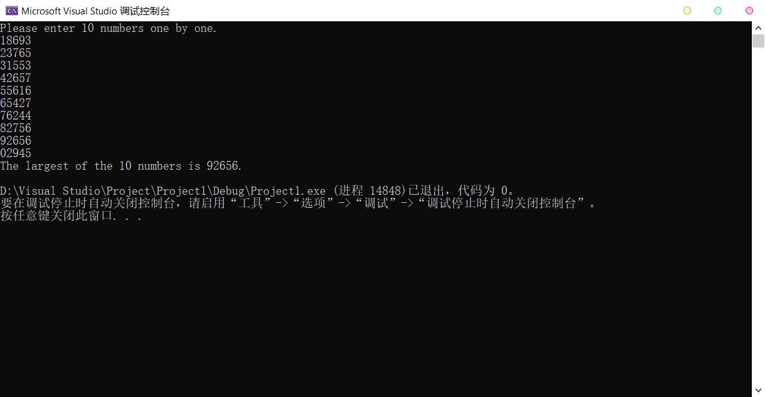

2.

#include <iostream>

using namespace std;

int main() {

int num = 0, d1, d2, d3, d4, d5;

cout << "Please enter five-digit integers." << endl;

while (cin >> num) {

if (num < 10000 || num > 99999) {

cout << "It is not a five-digit integer!" << endl;

}

else {

d5 = num / 10000;

d4 = num / 1000 - 10 \* d5;

d3 = num / 100 - 100 \* d5 - 10 \* d4;

d2 = num / 10 - 1000 \* d5 - 100 \* d4 - 10 \* d3;

d1 = num % 10;

if (d1 == d5 && d2 == d4) {

cout << "It is a palindrome!" << endl;

}

else {

cout << "It is not a palindrome!" << endl;

}

}

}

return 0;

}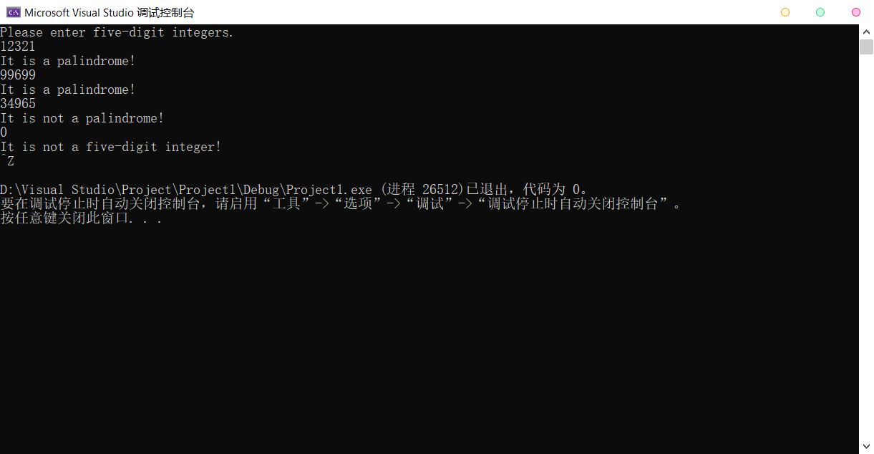

3.

#include <iostream>

using namespace std;

int main() {

int bin = 0, dec = 0, a = 1, b = 0;

cout << "Input a binary number containing only 0s and 1s." << endl;

cin >> bin;

while (b >= 0) {

dec += bin % 2 \* a;

bin /= 10;

a \*= 2;

b = bin - 1;

}

cout << "The decimal equivalent of this binary number is " << dec << endl;

return 0;

}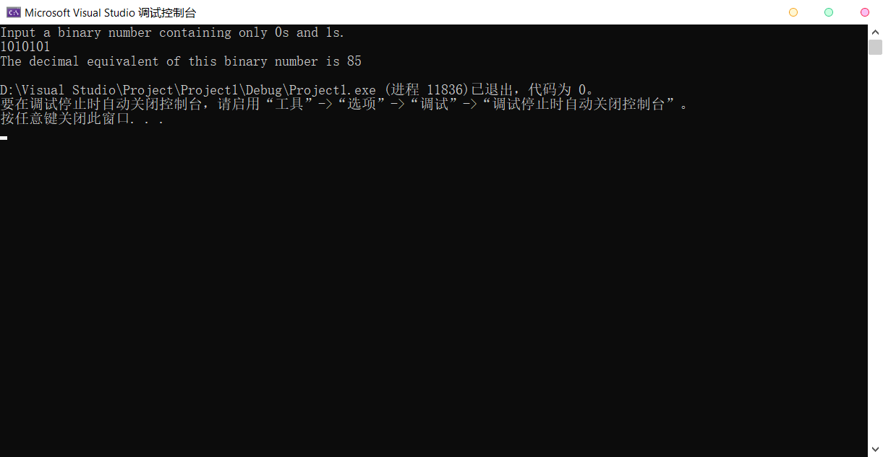

4.

(a)

#include <iostream>

using namespace std;

int main() {

int n, result = 1;

cout << "Input a nonnegative integer 'n'." << endl;

cin >> n;

while (n > 0) {

result \*= n;

n--;

}

cout << "n! = " << result << endl;

return 0;

}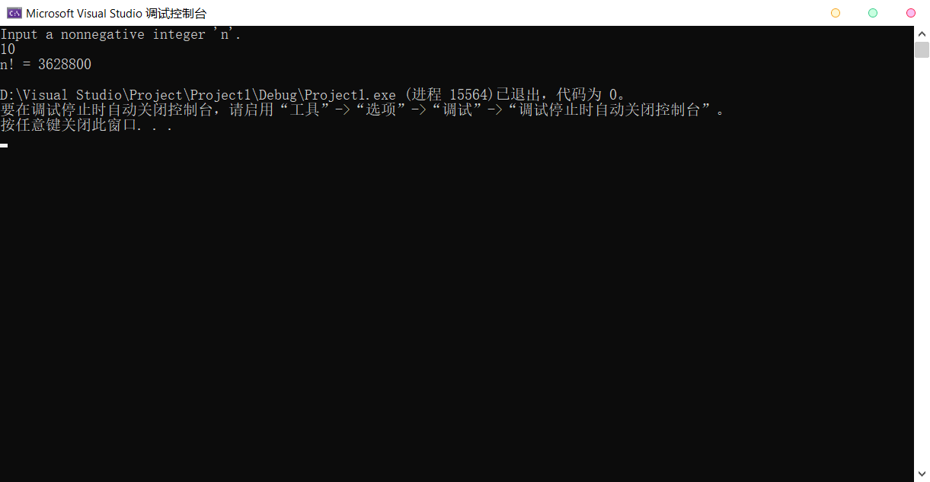

(b)

#include <iostream>

using namespace std;

int fac(int n) {

int result = 1;

while (n > 0) {

result \*= n;

n--;

}

return result;

}

int main() {

int ac, x = 1;

double e = 1.0;

cout << "Enter your desired accuracy( > 0) of e." << endl;

cin >> ac;

while (x <= ac) {

e += double(1) / fac(x);

x++;

}

cout << "Under this accuracy, e = " << e << endl;

return 0;

}

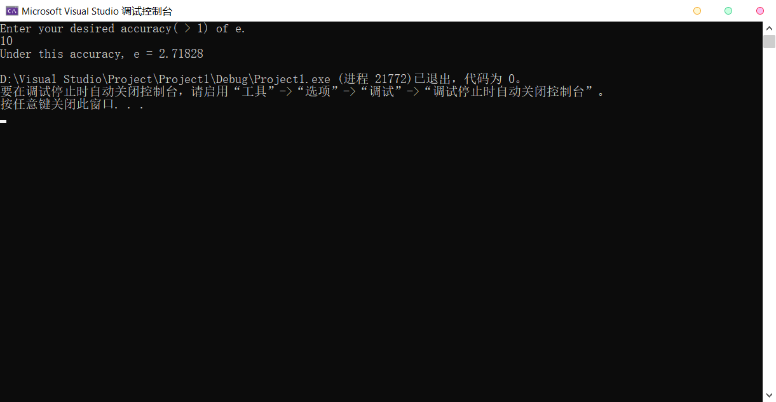

(c)

#include <iostream>

using namespace std;

int fac(int n) {

int result = 1;

while (n > 0) {

result \*= n;

n--;

}

return result;

}

int pow(int n,int m) {

//n是底数，m是指数

int result = 1;

for (int i = 0; i < m; i++) {

result \*= n;

}

return result;

}

int main() {

int ac, x, n = 1;

double e = 1.0;

cout << "Enter the index 'x' of e." << endl;

cin >> x;

cout << "Enter your desired accuracy( > 0) of e^x." << endl;

cin >> ac;

while (n <= ac) {

e += double(pow(x,n)) / fac(n);

n++;

}

cout << "Under this accuracy, e = " << e << endl;

return 0;

}

