Experiment #4

1.

#include <iostream>

using namespace std;

int main() {

cout << "Enter integers (9999 to end):" << endl;

int num = 0, sum = 0, i =-1, a = 0;

for (; a != 9999;) {

cin >> num;

a = num;

sum += num;

i++;

}

if (i != 0) {

cout << "The average is: " << double(sum - 9999) / i << endl;

}

else {

cout << "No values were entered." << endl;

}

return 0;

}

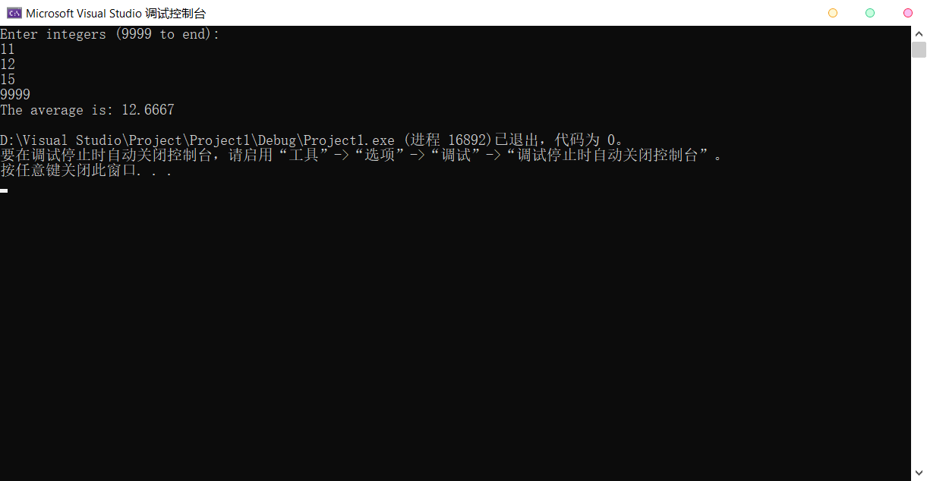

2.

#include<iostream>

#include<iomanip>

#include<cmath>

using namespace std;

int main() {

int counter = 0;

cout << "Side 1\tSide 2\tSide 3\n";

for (int a = 1; a <= 500; a++) {

for (int b = a; b <= 500; b++) {

int m = pow(a, 2) + pow(b, 2);

for (int c = 2; (c <= sqrt(m)) && (c <= 500); c++) {

if ((m == pow(c, 2)) && (a + b > c)) {

cout << a << '\t' << b << '\t' << c << endl;

counter++;

}

}

}

}

cout << "A total of " << counter << " triples were found." << endl;

system("pause");

return 0;

}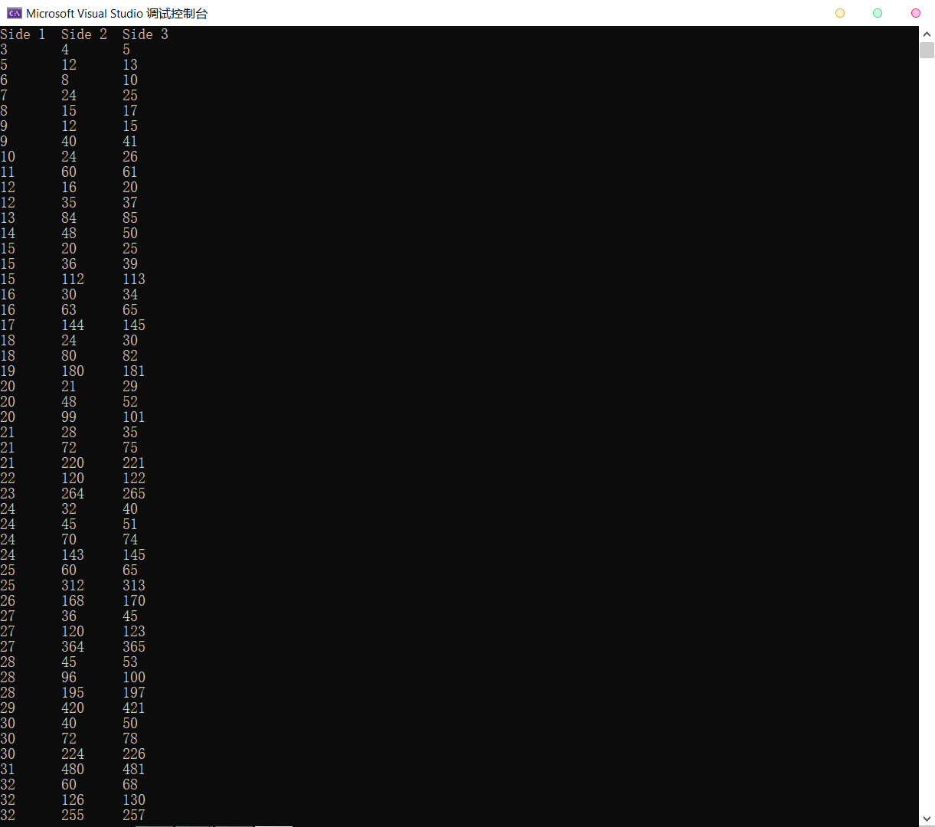 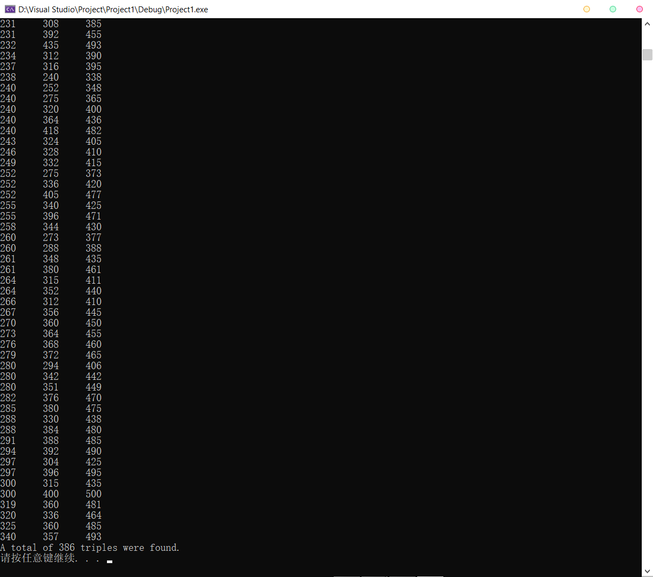

3.

a)

#include <iostream>

using namespace std;

int main() {

int k = 0;

for (; (k % 2 == 0) || (k < 1);) {

cout << "Input the number of lines(positive odd number).\n";

cin >> k;

cout << endl;

}

for (int i = 1; i <= k; i++) {

if (i <= (k + 1) / 2) {

for (int j = 1; j <= k / 2 + 2 - i; j++)

cout << ' ';

for (int j = 1; j <= 2 \* i - 1; j++)

cout << '\*';

}

else {

for (int j = 1; j <= i - k / 2; j++)

cout << ' ';

for (int j = 1; j <= 2 \* (k + 1 - i) - 1; j++)

cout << '\*';

}

cout << endl;

}

system("pause");

return 0;

}

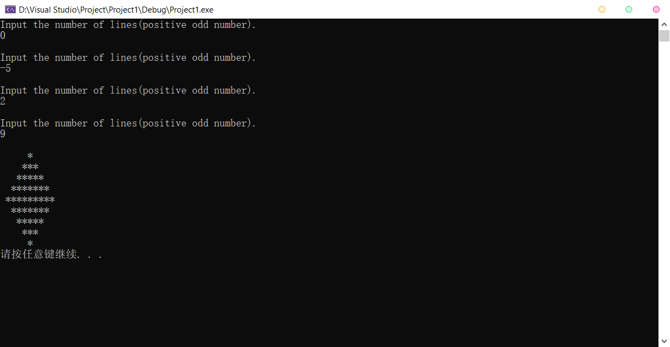

b)

#include <iostream>

using namespace std;

int main() {

int k = 0;

for (; (k % 2 == 1) || (k < 2) || (k > 18);) {

cout << "Input the number of lines(positive even number between 1 and 19).\n";

cin >> k;

cout << endl;

}

for (int i = 1; i <= k; i++) {

if (i <= (k + 1) / 2) {

for (int j = 1; j <= k / 2 + 2 - i; j++)

cout << ' ';

for (int j = 1; j <= 2 \* i - 1; j++)

cout << '\*';

}

else {

for (int j = 1; j <= i - k / 2 + 1; j++)

cout << ' ';

for (int j = 1; j <= 2 \* (k + 1 - i) - 1; j++)

cout << '\*';

}

cout << endl;

}

system("pause");

return 0;

}

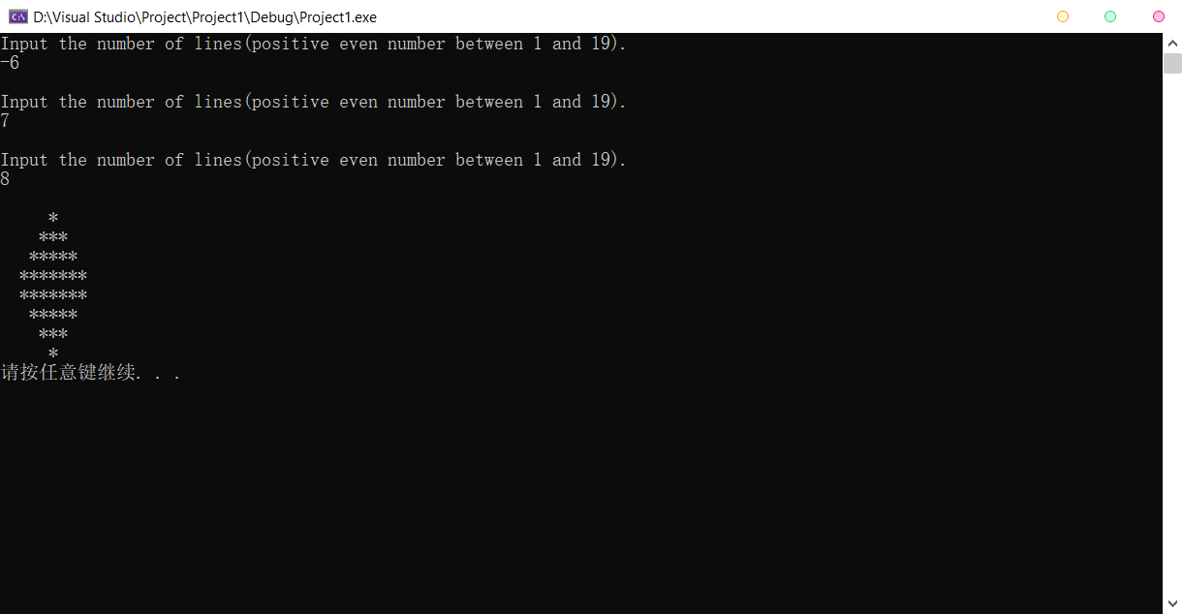

4.

#include<iostream>

using namespace std;

int main() {

string day[12], gift[12];

for (int i = 1; i <= 12; i++) {

switch (i) {

case 1:

day[i - 1] = "first";

break;

case 2:

day[i - 1] = "second";

break;

case 3:

day[i - 1] = "third";

break;

case 4:

day[i - 1] = "fourth";

break;

case 5:

day[i - 1] = "fifth";

break;

case 6:

day[i - 1] = "sixth";

break;

case 7:

day[i - 1] = "seventh";

break;

case 8:

day[i - 1] = "eighth";

break;

case 9:

day[i - 1] = "ninth";

break;

case 10:

day[i - 1] = "tenth";

break;

case 11:

day[i - 1] = "eleventh";

break;

case 12:

day[i - 1] = "twelfth";

break;

}

switch (i) {

case 12:

gift[i - 1] = "Twelve drummers drumming, \n";

case 11:

gift[i - 1] += "Eleven pipers piping, \n";

case 10:

gift[i - 1] += "Ten lords a-leaping, \n";

case 9:

gift[i - 1] += "Nine ladies dancing, \n";

case 8:

gift[i - 1] += "Eight maids a-milking, \n";

case 7:

gift[i - 1] += "Seven swans a-swimming, \n";

case 6:

gift[i - 1] += "Six geese a-laying, \n";

case 5:

gift[i - 1] += "Five golden rings, \n";

case 4:

gift[i - 1] += "Four calling birds, \n";

case 3:

gift[i - 1] += "Three French hens, \n";

case 2:

gift[i - 1] += "Two turtle doves, \n";

case 1:

if (i != 1 && i != 12) {

gift[i - 1] += "And a partridge in a pear tree.";

}

if (i == 1) {

gift[i - 1] = "A partridge in a pear tree.";

}

if (i == 12) {

gift[i - 1] += "And a partridge in a pear tree!";

}

}

cout << "On the " << day[i - 1] << " of Christmas, my true love sent to me:\n" << gift[i - 1] << endl << endl;

}

system("pause");

return 0;

}