Experiment #5

1.

#include<iostream>

using namespace std;

void fillCharacter(int side, char character) {

for (int i = 0; i < side; i++) {

for (int j = 0; j < side; j++) {

cout << character;

}

cout << endl;

}

cout << endl;

}

int main() {

int s = 0;

char c = 0;

for (; (c < 33) || (c > 126) || (s < 0);) {

cout << "side = ";

cin >> s;

cout << "fillCharacter = ";

cin >> c;

cout << endl;

}

fillCharacter(s, c);

system("pause");

return 0;

}

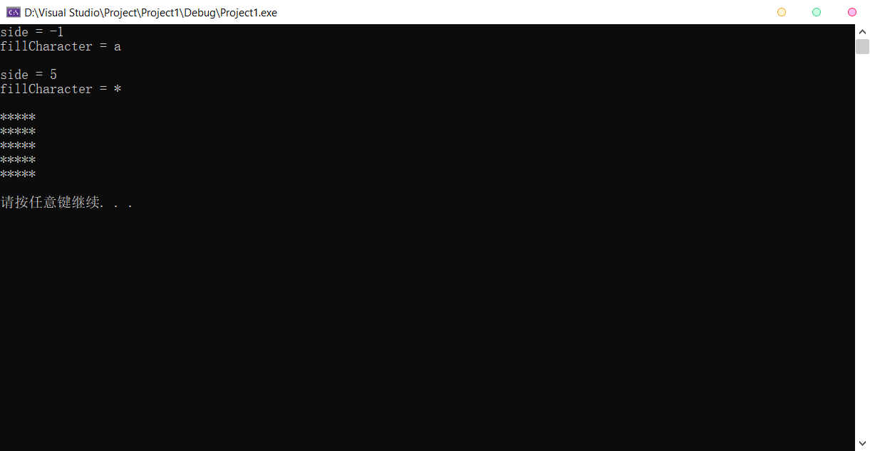

2.

#include<iostream>

using namespace std;

bool PerfectNumber(int num) {

int sum = 0;

for (int fct = 1; fct < num; fct++) {

if (num % fct == 0) {

sum += fct;

}

}

if (sum == num)

return true;

else

return false;

}

int main() {

cout << "Perfect integers between 1 and 1000:" << endl;

for (int i = 2; i < 1000; i++) {

if (PerfectNumber(i) ==true) {

cout << i << " = 1";

for (int f = 2; f < i; f++) {

if (i % f == 0) {

cout << " + " << f;

}

}

cout << endl;

}

}

cout << endl << endl;

system("pause");

return 0;

}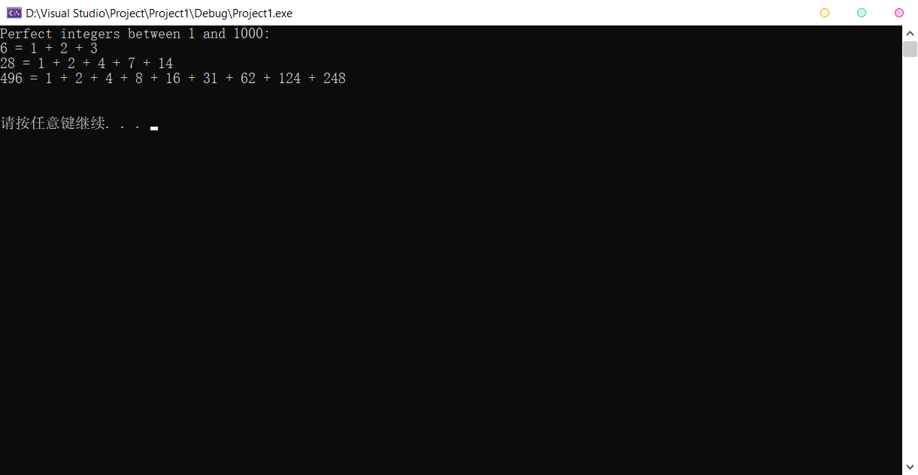

3.

#include<iostream>

#include<cmath>

#include<iomanip>

using namespace std;

bool PrimeNumber(int num) {

int judge = 0;

for (int i = 1; i <= sqrt(num); i++) {

if (num % i == 0) {

judge += 1;

}

}

if (judge == 1)

return true;

else

return false;

}

int main() {

cout << "The prime numbers from 1 to 10000 are:\n";

int c = 0;

for (int n = 2; n <= 10000; n++) {

if (PrimeNumber(n) == true) {

cout << setw(6) << n;

c++;

if (c % 10 == 0)

cout << endl;

}

}

cout << "\nTotal of " << c << " prime numbers between 1 and 10000.\n";

system("pause");

return 0;

}

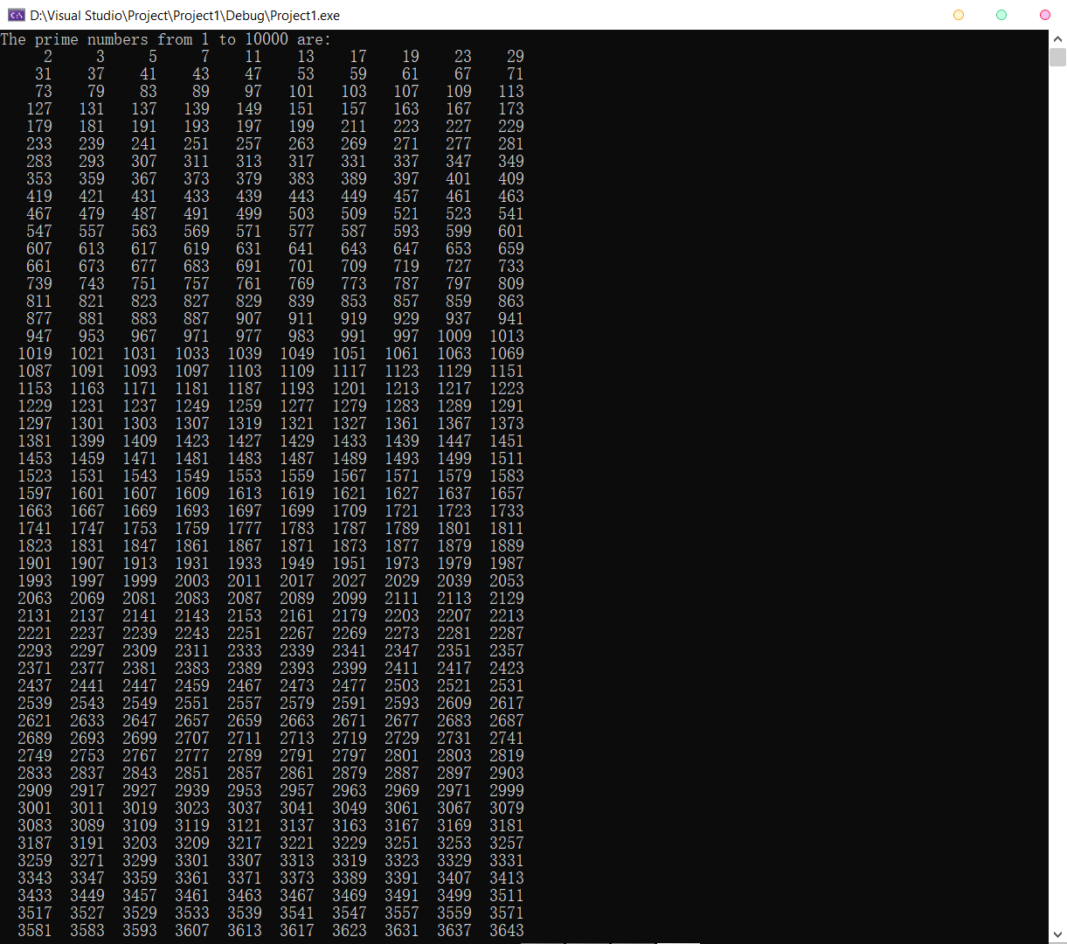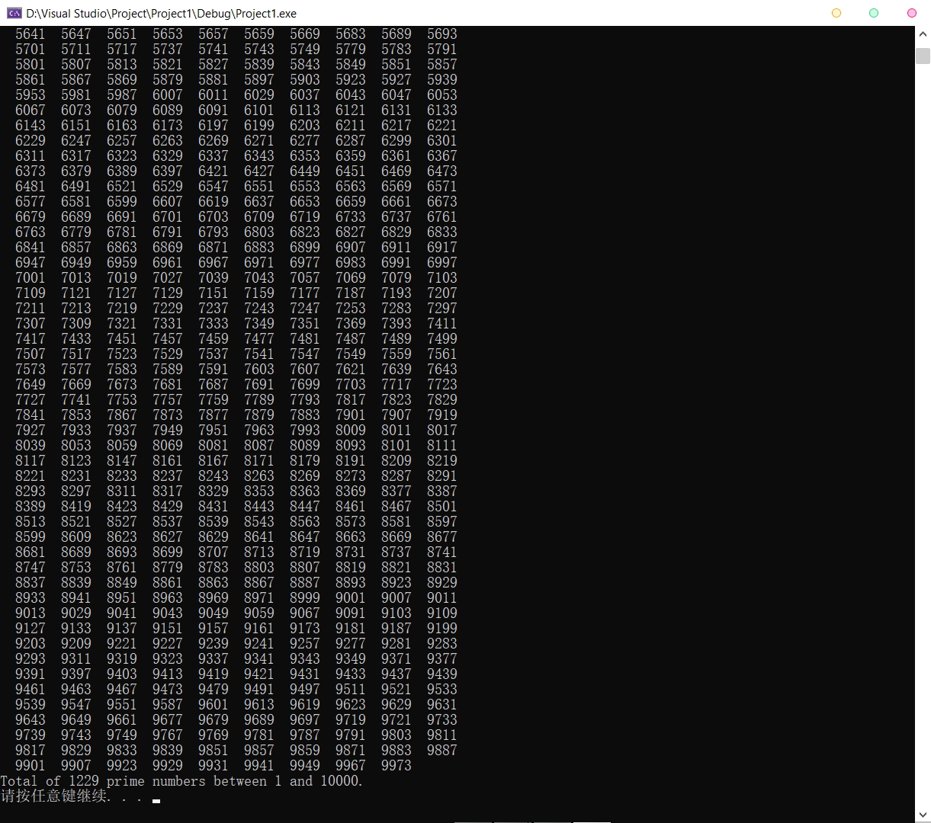

4.

#include<iostream>

#include<ctime>

using namespace std;

bool CoinTossing() {

return (rand() % 2);

}

double Percentage(int times) {

int h = 0;

for (int i = 0; i < times; i++) {

if (CoinTossing() == 1)

h += 1;

}

return (double(h) / times);

}

int main() {

srand(time(0));

int t[5] = { 10,100,1000,10000,100000 };

for (int i = 0; i < 5; i++) {

cout << "The percentage of " << t[i] << " times is " << Percentage(t[i]) << ".\n";

}

system("pause");

return 0;

}

