Experiment #7

1.

#include<iostream>

using namespace std;

int main() {

int num[20] = { 0 };

cout << "Enter 20 integers between 10 and 100.\n";

for (int i = 0; i < 20; i++) {

cin >> num[i];

if (num[i] < 10 || num[i]>100) {

cout << "Invalid number.\n";

num[i] = 0;

i--;

}

for (int j = 0; j < i; j++) {

if (num[j] == num[i]) {

cout << "Duplicate number.\n";

num[i] = 0;

i--;

}

}

}

cout << "\nThe nonduplicate values are:\n";

for (int i = 0; i < 20; i++) {

cout << num[i] << ' ';

}

cout << endl;

system("pause");

return 0;

}

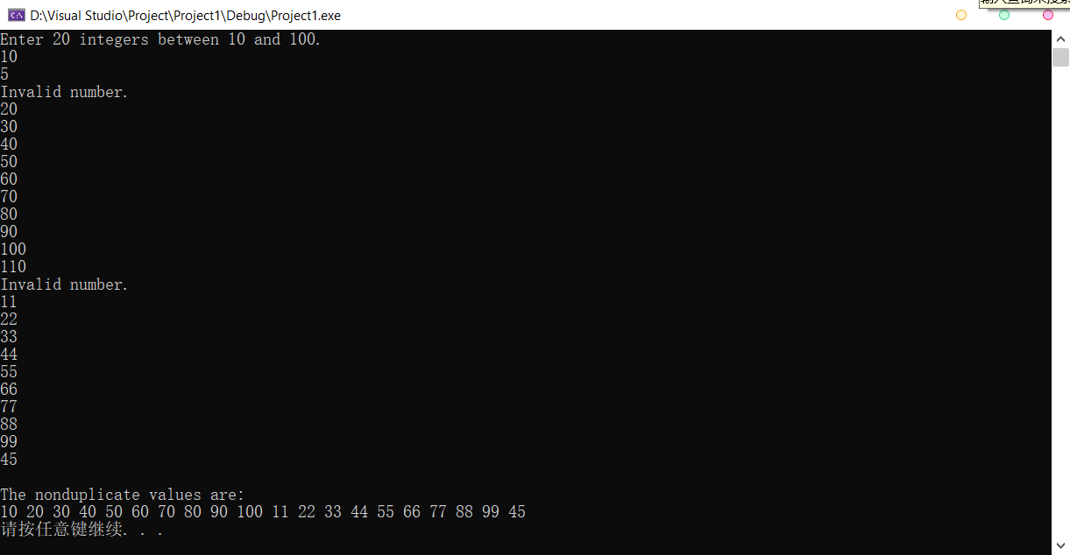

2.

#include<iostream>

#include<ctime>

#include<iomanip>

using namespace std;

int Dice() {

return (rand() % 6 + 1);

}

int main() {

int t[4] = { 3600,36000,360000,3600000 }, d1 = 0, d2 = 0, c[11] = { 0 }, s[11] = { 2,3,4,5,6,7,8,9,10,11,12 };

string p[11] = { "2.778%","5.556%","8.333%","11.111%","13.889%","16.667","13.889%", "11.111%","8.333%","5.556%","2.778%" };

srand(time(0));

for (int a = 0; a < 4; a++) {

for (int i = 0; i < t[a]; i++) {

c[Dice() + Dice() - 2]++;

}

cout << "Roll the two dice " << t[a] << " times:\n\tSum\tTotal\tExpected\tActual\n";

for (int j = 0; j < 11; j++) {

cout << setw(11) << s[j] << setw(10) << c[j] << setw(11) << p[j] << setw(13) << double(c[j]) / t[a] \* 100 << "%\n";

c[j] = 0;

}

cout << "\n\n";

}

system("pause");

return 0;

}

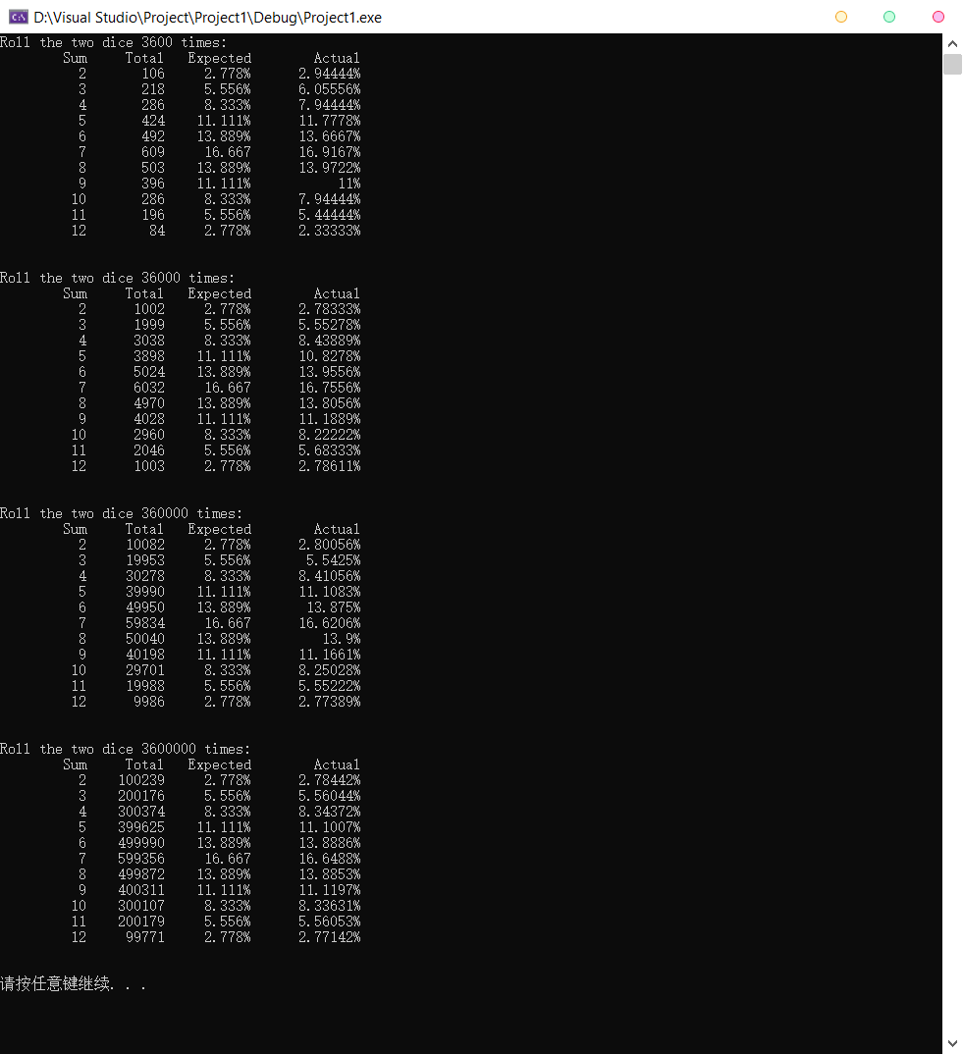

3.

#include<iostream>

#include<array>

#include<iomanip>

using namespace std;

int main()

{

const int arraySize = 10;

array<int, arraySize> a = { 2, 6, 4, 8, 10, 12, 89, 68, 45, 37 };

int hold = 0;

cout << "Data items in original order\n";

for (int i = 0; i < arraySize; i++)

cout << setw(4) << a[i];

for (int m = arraySize - 1; m > 0; m--) {

for (int j = 0; j < m; j++) {

if (a[j] > a[j + 1]) {

hold = a[j];

a[j] = a[j + 1];

a[j + 1] = hold;

}

}

}

cout << "\nData items in ascending order\n";

for (int k = 0; k < arraySize; k++) {

cout << setw(4) << a[k];

}

cout << endl;

system("pause");

return 0;

}

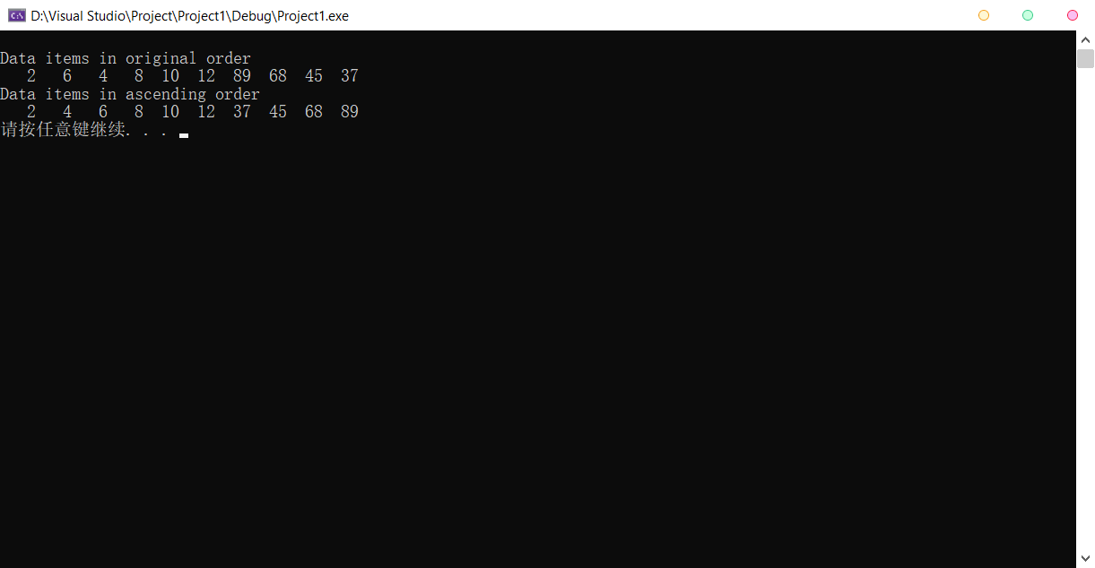

4.

#include<iostream>

using namespace std;

int main() {

const int ul = 1000;

int num[ul] = { 0 }, counter = 0;

for (int i = 0; i < ul; i++)

num[i] = 1;

for (int i = 2; i < ul; i++) {

if (num[i] == 1) {

cout << i << '\t';

counter++;

for (int j = i; j < ul; j += i)

num[j] = 0;

if (counter % 10 == 0)

cout << endl;

}

}

cout << endl;

system("pause");

return 0;

}

