Homework assignment #8

Due date: June.15th  2021

1.

//main.cpp

#include <iostream>

#include<string>

using namespace std;

#define noe numberOfElements

template<class T>

class Array {

public:

Array(int n) {

noe = n;

p = new T[noe];

}

void write() {

cout << "Enter " << noe << " values:\n";

for (int i = 0; i < noe; i++)

cin >> p[i];

}

void print() {

cout << "The values are:\n";

for (int i = 0; i < noe; i++)

cout << p[i] << " ";

cout << endl << endl;

}

private:

T* p;

int noe;

};

int main() {

Array<int>a(5);

a.write();

a.print();

Array<string>b(7);

b.write();

b.print();

system("pause");

return 0;

}

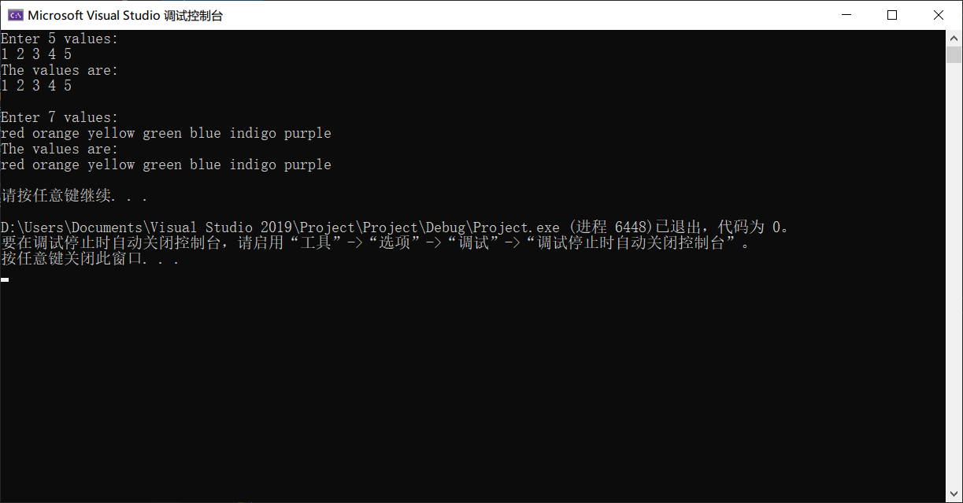

2.

//main.cpp

#include <iostream>

#include<string>

using namespace std;

template<class T>

bool isEqualTo(T a, T b){

if (a == b)

return 1;

else

return 0;

}

int main(){

int a_i = 1;

int b_i = 1;

bool judge_i = isEqualTo(a_i, b_i);

if (judge_i)

cout << "a == b\n";

else cout << "a != b\n";

char a_c = 'c';

char b_c = 'c';

bool judge_c = isEqualTo(a_c, b_c);

if (judge_c)

cout << "a == b\n";

else cout << "a != b\n";

string a_s = "equal";

string b_s = "Equal";

bool judge_s = isEqualTo(a_s, b_s);

if (judge_s)

cout << "a == b\n";

else cout << "a != b\n";

system("pause");

return 0;

}

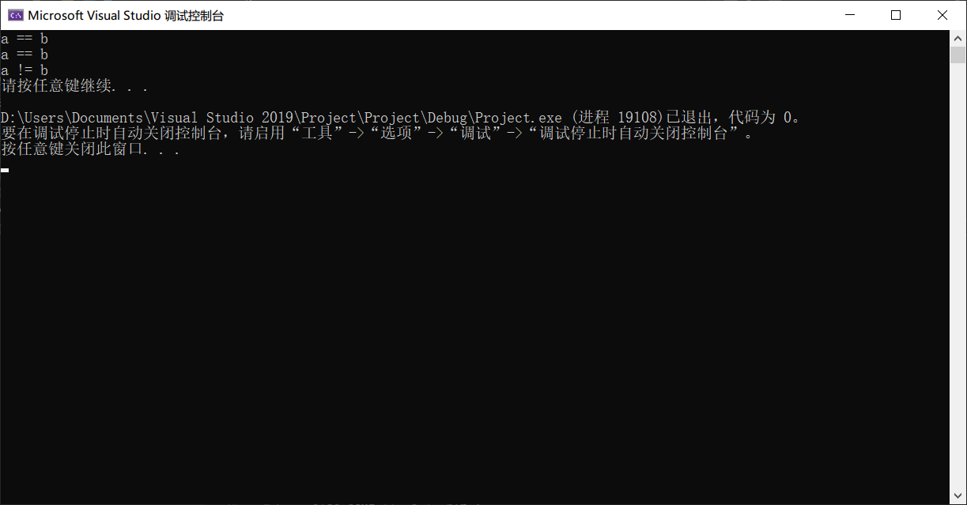

//main.cpp

#include <iostream>

#include<string>

using namespace std;

class Person {

public:

Person(string n, int a)

:name(n), age(a) {}

bool operator==(Person p) {

if (this->name == p.name && this->age == p.age)

return 1;

else

return 0;

}

string name;

int age;

};

template<class T>

bool isEqualTo(T a, T b) {

if (a.name == b.name && a.age == b.age)

return 1;

else

return 0;

}

int main() {

Person p1("LGW", 19);

Person p2("LGW", 19);

bool judge = isEqualTo(p1, p2);

if (judge)

cout << "p1 == p2\n";

else cout << "p1 != p2\n";

system("pause");

return 0;

}

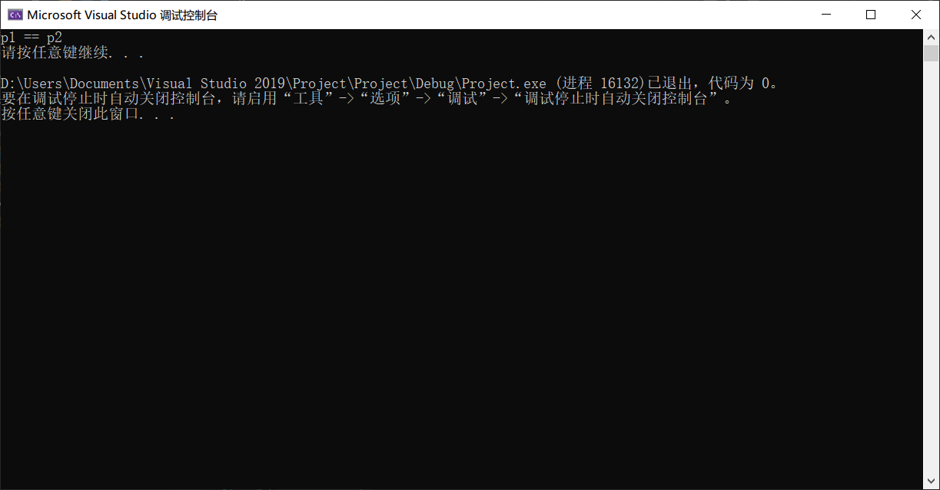

3.

//main.cpp

#include <iostream>

using namespace std;

template <class T>

class Vector {

public:

T* start;

int size;

Vector(int a = 10) {

size = a;

start = new T[size];

}

~Vector() {

delete[]start;

}

friend ostream& operator<<(ostream& out, const Vector& a) {

for (int i = 0; i < a.size; i++)

out << a.start[i] << " ";

return out;

}

friend istream& operator >>(istream& in, Vector& a) {

for (int i = 0; i < a.size; i++)

in >> a.start[i];

return in;

}

};

int main() {

Vector<int> ints(5);

cout << "Enter some integers:\n";

cin >> ints;

cout << endl;

cout << ints;

cout << endl;

Vector<char> chars(5);

cout << "Enter some characters:\n";

cin >> chars;

cout << endl;

cout << chars;

cout << endl;

system("pause");

return 0;

}

