MethylDetector: Statistical Foundations and Implementation Architecture

Summary
MethylDetector compares two extended centroids (group-level methylation summaries with Beta parameters per cytosine) to detect statistically significant DMPs, filter them by discriminatory power, and select a minimal subset of biologically meaningful sites capable of classifying the groups.
This document summarizes the statistical underpinnings (tests, effect sizes, multiple testing) and the implementation architecture (modules, data contracts, GPU acceleration), and provides a short Methods section suitable for a Methods/Appendix in a manuscript.

Pipeline Overview
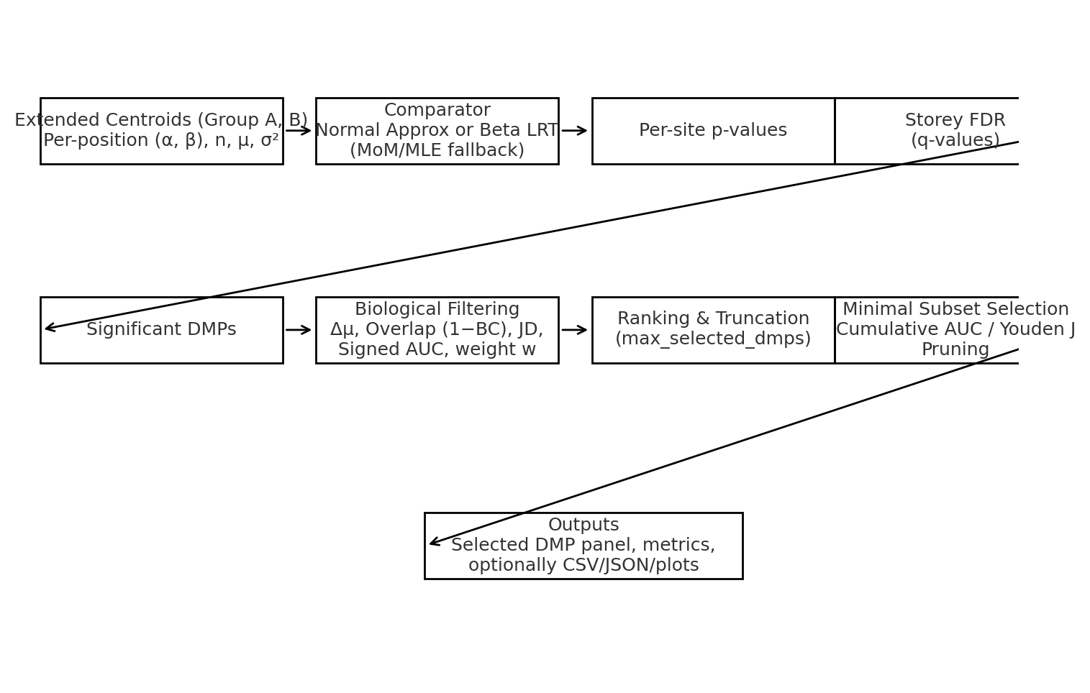

Statistical Foundations
1. Data Model & Sufficient Statistics
• Each group centroid provides per-position Beta parameters (α, β), along with counts n and derived mean μ = α/(α+β) and variance σ² = αβ / [ (α+β)² (α+β+1) ].
• These are sufficient to model methylation uncertainty at each site as a Beta distribution.
2. Per-site Hypothesis Testing
H0: The two group-level distributions are equal at a position.
Two complementary branches are used per site:
• Normal Approximation: difference of means with pooled SE (valid for sufficiently large effective shapes and n), yielding a z-statistic and two-sided p-value.
• Beta Likelihood-Ratio Test (LRT): fit (α1,β1) and (α2,β2) for groups and (α0,β0) under the null (pooled). The LRT statistic Λ = 2[ℓ(α1,β1)+ℓ(α2,β2)−ℓ(α0,β0)] is compared to χ² with df=2.
• Robustness: When MLE is unstable, method-of-moments (MoM) parameters and safe floors on α,β avoid numerical pathologies.
3. Multiple Testing
• Storey’s q-values control FDR at scale. A single FDR pass is applied to site-level p-values; π0 can be estimated over a λ-grid and q-values are made monotone in rank.
4. Effect Sizes & Discrimination Metrics
• Mean difference: Δμ = |μ1 − μ2| (direction tracked to define hypo/hyper).
• Overlap via Bhattacharyya coefficient (closed form for Beta): BC = exp( betaln((α1+α2)/2, (β1+β2)/2) − ½[betaln(α1,β1)+betaln(α2,β2)] ). Overlap := 1 − BC.
• Jeffreys divergence: J = KL(p||q) + KL(q||p), robustly capturing distributional shifts.
• Signed AUC from LLR moments: d = |m1 − m2| / sqrt(s1² + s2²), AUC ≈ Φ(d); signed_auc = sign(direction)·(2·AUC−1).
5. Minimal Subset Selection (Analytic)
• DMPs are sorted by a configurable rank (default: Δμ / overlap with ε-guard; alternative: J · |signed_auc|^γ).
• Cumulative LLR moments across top-k yield an analytic AUC(k) via Φ(d(k)); optionally compute Youden J(k) for thresholded operating points.
• Stop at target AUC or J; then prune redundant sites while preserving the target. Directional flipping enforces monotone accumulation.
6. GPU Acceleration & Batching
• CuPy-backed vectorization for core metrics (BC, LLR moments) and selection loops.
• Batch sizing is chosen to amortize PCIe and kernel launches; auto-tuning by available memory is recommended.

Implementation Architecture
See Appendix for auto-extracted classes and functions.

Methods
Methods (Concise)
1) Inputs: Two extended centroids providing per-position (α, β), n, and derived μ, σ² for each cytosine position passing coverage QC.
2) Statistical DMP Detection: For each site, run Normal Approx or Beta LRT, producing p-values; apply Storey’s FDR to obtain q-values. Significant DMPs are retained (e.g., q ≤ 0.05).
3) Biological Filtering & Ranking: Compute Δμ, overlap (1−BC), Jeffreys divergence, and signed AUC. Rank by a configurable formula (default: Δμ / overlap with ε-guard).
4) Minimal Subset Selection: Use cumulative LLR moments to derive AUC(k) (and optionally Youden J(k)); pick the smallest k achieving target (e.g., AUC ≥ 0.95). Apply backward pruning to remove redundancies while maintaining target performance.
5) Outputs: Selected DMP panel with statistics (Δμ, overlap, J, signed AUC, direction), final operating metrics (AUC/Youden), and optional CSV/JSON artifacts.

Numerics & Stability
Numerics & Stability
• Floors: enforce α,β ≥ 1e−6 at construction; clip probabilities away from {0,1} where logs appear.
• Consistency: apply FDR exactly once. Assert AUC ∈ [0,1] prior to signing and export.
• Root-finding for Youden: bracket with conservative bounds; if no sign change, fall back to coarse grid search and pick the best J.

Limitations & Future Work
Limitations & Future Work
• Beta LRT quality depends on robust parameterization under low coverage; MoM fallback helps but can be conservative.
• Consider auto-tuning GPU batch size by querying device memory; add CPU↔GPU parity tests and Monte Carlo validation for AUC(LLR) approximations.
• Unify the notion of “overlap” across modules (recommend 1−BC for speed and closed form on Beta); keep JS for reporting.

Equations
- μ = α / (α + β)
- σ² = αβ / [ (α + β)² (α + β + 1) ]
- Λ = 2[ ℓ(α₁,β₁) + ℓ(α₂,β₂) − ℓ(α₀,β₀) ] ~ χ²(df = 2)
- J(p, q) = KL(p || q) + KL(q || p)
- BC = exp( betaln((α₁+α₂)/2, (β₁+β₂)/2) − ½[ betaln(α₁,β₁) + betaln(α₂,β₂) ] ), Overlap = 1 − BC
- AUC ≈ Φ( |m₁ − m₂| / sqrt(s₁² + s₂²) ), signed_auc = sign(direction) · (2·AUC − 1)

Appendix: Extracted Symbols
File | Classes | Functions
centroid_comparer.py | SmartLRTResult, ComparisonData, FDRAnalyzer, SmartCentroidComparator | register_global_cleanup_handlers, are_global_cleanup_handlers_registered, main
dmp_filter.py | DMPFilterResult, DMPData, DMPFilter | —
dmp_selector.py | — | compute_llr_moments, select_min_subset_analytic
methyldetector.py | DMPFilterResult, DMPData, MethylDetector | —

