**TIMED BOMB MANUAL**

**v1.0**

**DEVICE DESCRIPTION**

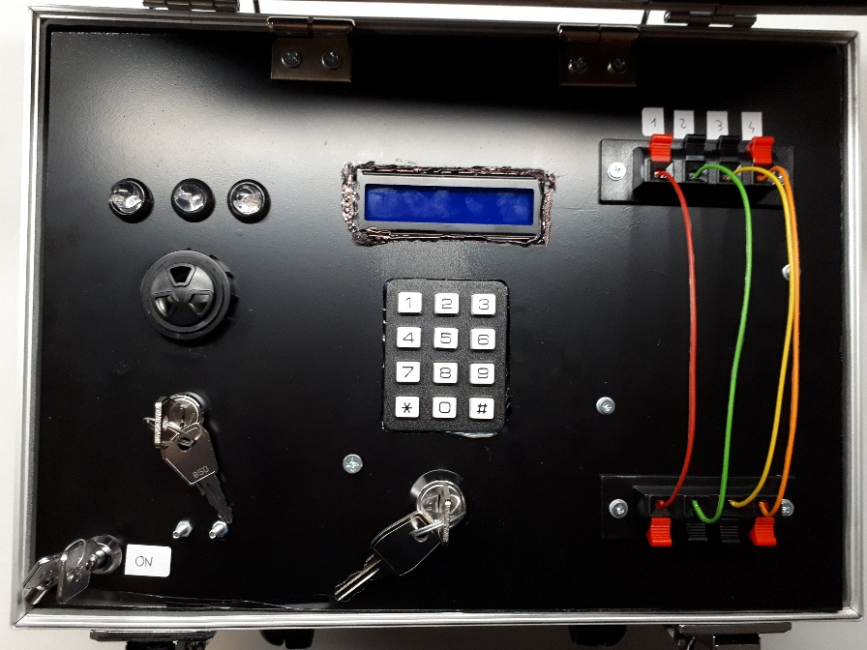

1. LCD DISPLAY WITH BLUE BACKLIGHT
2. 3x4 KEYS KEYBOARD FOR SETTINGS AND DEACTIVATION CODE
3. DEACTIVATION WIRES
4. DEACTIVATION KEY
5. BUZZER
6. SIGNALING LEDS
7. SWITCH KEY TO TURN ON/OFF THE SYSTEM
8. KEYS TO ACCESS TO THE BATTERY COMPARTMENT

**TURNING ON THE SYSTEM**

TO TURN ON THE SYSTEM, SIMPLY TURN THE SWITCH KEY (7) TO THE “ON” POSITION. WHEN THE SYSTEM STARTS, THE SIGNALING LEDS WILL TURN ON IN SEQUENCE (GREEN, YELLOW, RED, FROM LEFT TO RIGHT) FOLLOWED BY TWO QUICK ‘BEEPS’ OF THE BUZZER. THE LCD WILL PRESENTS THIS SCREEN:

Timed Bomb

v1.0

AFTER THE STARTUP SCREEN THE NEXT SCREEN WILL LET YOU SET THE COUNTDOWN GAME TIMER:

Set Time

HH:MM:SS

WHERE ***HH*** ARE THE HOURS, ***MM*** ARE THE MINUTES AND ***SS*** ARE THE SECONDS. TO SET THE TIMER, SIMPLY PUSH THE CORRESPONDING NUMBERS ON THE KEYBOARD. TO CHANGE AN ALREADY INSERTED NUMBER, SIMPLY PRESS THE ***HASHTAG*** ***#*** KEY TO MOVE THE CURSOR TO THE DESIRED POSITION AND THEN CHANGE THE NUMBER WITH THE APPROPRIATE ONE. THE MAXIMUM GAME TIME THAT CAN BE SET IS:

**99:59:59**

EXAMPLE

COUNTDOWN TIMER SET TO 25 MINUTES:

Set Time

00:25:00 *->

ONLY AFTER HAVING INSERTED ALL THE NUMBERS OF THE COUNTDOWN GAME TIMER IT WILL BE POSSIBLE TO PROCEED TO THE NEXT SCREEN BY PRESSING THE ***ASTERISK \**** KEY ON THE KEYBOARD(ALREADY MENTIONED ON THE SCREEN WITH THE **\*->** SYMBOL).

ON THE NEXT SCREEN IT WILL BE POSSIBLE TO INSERT THE DEACTIVATION WIRE THAT, IF DISCONNECTED FROM THE BOMB DURING THE GAME, WILL SUCCESSFULLY DEACTIVATE IT:

Set Wire

N. _

THE NUMBER MUST BE INCLUDED BETWEEN ***1*** AND ***4***. BY PRESSING, INSTEAD, THENUMBER ***0*** A ‘***No Wire’*** TEXT WILL BE WRITED ON THE SCREEN INDICATING THAT NONE OF THE FOUR WIRES CAN DEACTIVATE THE BOMB BUT IF ONE OF THEM WILL BE TOUCHED DURING THE GAME, THE BOMB WIL EXPLODES.

AFTER THAT IT WILL BE POSSIBLE TO ADVANCE TO THE NEXT SCREEN BY PRESSING THE ***ASTERISK \**** KEY.

THE LAST SETTING IS THE DEACTIVATION CODE:

Set Code

_ _ _ _

THE CODE MUST BE OF FOUR DIGITS. IN CASE OF ERROR IT WILL BE POSSIBLE TO CHANGE THE INSERTED NUMBERS BY PRESSING THE ***HASHTAG #*** KEY TO MOVE THE CURSOR TO THE DESIRED POSITION. AFTER THE CODE HAVE BEEN SET IT WILL BE POSSIBLE TO PROCEED TO THE NEXT PHASE BY PRESSING THE ***ASTERISK \**** KEY.

IN CASE THAT THE DEACTIVATION KEY HAS BEEN LEFT ON THE “DEACTIVATION” POSITION AND/OR IF ONE OR MORE DEACTIVATION WIRES HAVE BEEN LEFT DISCONNECTED, A WARNING WILL BE PRESENT ON THE SCREEN INDICATING TO FIX THE CORRESPONDING PROBLEM BEFORE PROCEED TO THE NEXT STEP:

EXAMPLE

DEACTIVATION WIRE N.2 LEFT DISCONNECTED

Check Wire 2

IF NO ERRORS WILL BE PRESENT ANYMORE A SUMMARY SCREEN WILL BE PRESENT WITH THESE INFORMATIONS:

**GAME TIME-DEACTIVATION WIRE-DEACTIVATION CODE**

EXAMPLE

00:25:00-F2-1234

*Start #Reset

BY PRESSING THE ***ASTERISK \**** KEY THE TIMER WILL START THE COUNTDOWN AND THE GAME BEGIN OTHERWISE, BY PRESSING THE ***HASHTAG #*** KEY IT WILL BE POSSIBLE TO RETURN TO THE FIRST SETTING SCREEN LOSING ALL THE INFORMATION INSERTED.

**DURING THE GAME**

THE GAMING SCREEN WILL PRESENT A COUNTDOWN TIMER AND FOUR BLANK SPACES WHERE TO INSERT THE DEACTIVATION CODE:

00:24:45

_ _ _ _

DURING THE GAME LEDS WILL BLINK:

GREEN LED: REMAINING TIME ABOVE 2/3 OF THE TOTAL TIME

YELLOW LED: REMAINING TIME BETWEEN 2/3 AND 1/3 OF THE TOTAL TIME

RED LED: REMAINING TIME BELOW 1/3 OF THE TOTAL TIME

DURING THE GAME IT WILL BE POSSIBLE TO INSERT THE FOUR DIGITS DEACTIVATION CODE BY SIMPLY PRESSING THE NUMBERS ON THE KEYBOARD AND BY CONFIRMING THE CODE WITH THE ***ASTERISK \**** KEY. IN CASE OF ERROR ON INSERTING THE DEACTIVATION CODE AND BEFORE CONFIRMING IT, IT WILL BE POSSIBLE THE MOVE BACK THE CURSOR BY PRESSING THE ***HASHTAG #*** KEY.

IT WILL BE ALREADY POSSIBLE TO DEACTIVATE THE BOMB BY DISCONNECTING THE CORRECT DEACTIVATION WIRE (IF SET) OR BY TURNING TO THE “DEACTIVATION” POSITION THE DEACTIVATION KEY.

IF A DEACTIVATION WIRE HAS BEEN SET, ONLY THAT WIRE WILL DEACTIVATE THE BOMB. THE OTHER REMAINING WIRES, RANDOMLY, IF DISCONNECTED WILL: HALF THE COUNTDOWN TIMER OR LET THE BOMB EXPLODES.

**END GAME**

WHEN THE BOMB WILL EXPLODES, THE RED LED WILL REMAINS ON AND A SIREN WILL BE ACTIVATED FOR ABOUT 8 SECONDS AND AFTER THAT IT WILL BE POSSIBLE TO RETURN TO THE STARTING SET SCREEN BY PRESSING THE ***ASTERISK \**** KEY. OTHERWISE, IF THE BOMB WILL BE DEACTIVATED, THE GREEN LED WILL REMAINS ON AND AFTER 8 SECONDS IT WILL BE POSSIBLE TO RETURN TO THE STARTING SCREEN BY PRESSING THE  ***ASTERISK \**** KEY.