Temperature sensor programming using ESP 32

Name: Golla Saravanan
Department: ECE
College: Easwari Engineering College
Date: 15/08/2025

Abstract
This project demonstrates a simple IoT-based approach for real-time environmental data logging using an ESP32 microcontroller and a DHT11 temperature and humidity sensor. The data is wirelessly transmitted and stored in a Google Spreadsheet via Google Apps Script, providing global access and visualization. The system offers an efficient, scalable, and low-cost solution for remote monitoring applications.

Introduction
With the evolution of the Internet of Things (IoT), remote sensing and cloud-based data logging have become integral to environmental monitoring, smart homes, and automation. This project focuses on creating a wireless, real-time temperature and humidity monitoring system using the ESP32 microcontroller and DHT11 sensor, with seamless data logging and visualization through Google Sheets. The system ensures that sensor data can be accessed from anywhere in the world.

Objectives
- To measure temperature and humidity using a DHT11 sensor.
- To utilize the ESP32 microcontroller for data acquisition and Wi-Fi communication.
- To store sensor readings in a Google Spreadsheet via HTTP requests and Google Apps Script.
- To enable real-time, remote monitoring of environmental conditions.

Hardware and Software Overview
Hardware:
- ESP32 Dev Kit v1: Wi-Fi & Bluetooth enabled microcontroller for data processing and transmission.
- DHT11 Sensor module: Digital temperature and humidity sensor.
- Jumper wires & breadboard.
Software:
- Arduino IDE: For ESP32 code development and uploading.
- DHT sensor library: For simplified sensor interfacing.
- Google Sheets: For online data storage and visualization.
- Google Apps Script: For handling POST requests and updating the spreadsheet.

Theory / Working Principle
The DHT11 sensor detects the ambient temperature and relative humidity, outputting digital signals interpretable by microcontrollers like the ESP32. The ESP32 reads these sensor outputs at set intervals, then connects to a Wi-Fi network and sends the measurements as HTTP GET requests to a web app created using Google Apps Script. The script extracts the values and logs them with a timestamp into Google Sheets. This cloud-based solution enables the user to access, analyze, or share the environmental data from any location with internet access.

System Architecture / Block Diagram

DHT11 Sensor → ESP32 → Wi-Fi → Google Apps Script Web App → Google Sheets

Implementation
Hardware Setup
The DHT11 sensor’s VCC, DATA, and GND pins are connected to the 3.3V, GPIO4, and GND pins of the ESP32, respectively.

Software Setup
Google Spreadsheet and Apps Script:

Create a Google Spreadsheet, set up Apps Script with a doGet handler to accept data, and deploy it as a public web app.

ESP32 Programming:

Configure Wi-Fi credentials and Apps Script URL in the Arduino sketch.

Read sensor values and send as HTTP GET requests.

Module used: DHT11 Temperature and humidity sensor module

Pins:
VCC 3.3V
GND GND
DATA GPIO 4

Output=Serial monitor

Program
#include "DHT.h"
#define DHTPIN 4
#define DHTTYPE DHT11
DHT dht(DHTPIN, DHTTYPE);
void setup()
{
Serial.begin(115200);
dht.begin();
}
void loop()
{
delay(2000);
float humidity = dht.readHumidity();
float temperature = dht.readTemperature();
float temperatureF = dht.readTemperature(true); // in Fahrenheit
if (isnan(humidity) || isnan(temperature) || isnan(temperatureF))
{
Serial.println("Failed to read from DHT sensor!");
return;
}
Serial.print("Humidity: ");
Serial.print(humidity);
Serial.print(" %\t");
Serial.print("Temperature: ");
Serial.print(temperature);
Serial.print(" °C ");
Serial.print(temperatureF);
Serial.println(" °F");
}

Following inferences were found
1. when the delay is reduced to 1 second (delay(1000);), there are the same old readings appearing and there is no change in them.
2. Temperature is almost accurate by about (+-0.5*C)
3.Time between two readings is best if kept at 2 seconds

Pictorial representation of the sensor

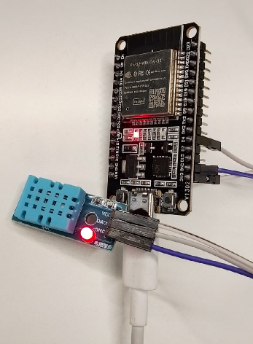

Test case (AC Hall temp set=23)
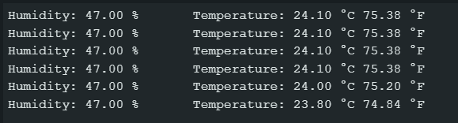

Test case (Outside AC hall approx. =28)
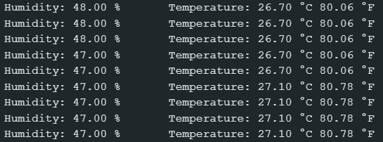

Output=Google Spreadsheet

Program
A-Google spreadsheets
Extensions App script

function doGet(e)
{
try
{
var ss = SpreadsheetApp.getActiveSpreadsheet();
var sheet = ss.getActiveSheet();
// Read query parameters
var temp = e.parameter.temp; // Celsius
var hum = e.parameter.hum; // H
if (temp === undefined || hum === undefined)
{
return ContentService.createTextOutput("Missing params").setMimeType(ContentService.MimeType.TEXT);
}
// Server-side timestamp
var now = new Date();
// Format as date and time strings with seconds
var dateStr = Utilities.formatDate(now, Session.getScriptTimeZone(), "yyyy-MM-dd");
var timeStr = Utilities.formatDate(now, Session.getScriptTimeZone(), "HH:mm:ss");
sheet.appendRow([dateStr, timeStr, Number(temp), Number(hum)]);
var out = ContentService.createTextOutput("OK").setMimeType(ContentService.MimeType.TEXT);
out.setHeaders({ "Access-Control-Allow-Origin": "*" });
return out;
}
catch (err)
{
return ContentService.createTextOutput("ERR: " + err).setMimeType(ContentService.MimeType.TEXT);
}
}

BArduino IDE
#include <WiFi.h>
#include <HTTPClient.h>
#include "DHT.h"
#define DHTPIN 4
#define DHTTYPE DHT11
const char* WIFI_SSID = "sarva's";
const char* WIFI_PASSWORD = "123123123";
const char* WEB_APP_URL = "https://script.google.com/macros/s/AKfycbyL-cVksa2RApuLA9sLKSr_Yu_KiWXfmY2V1bsFO6C5oJ-WVf1mHEGVbrUmgAdMsOmAVw/exec";
DHT dht(DHTPIN, DHTTYPE);
void connectWiFi() {
WiFi.mode(WIFI_STA);
WiFi.begin(WIFI_SSID, WIFI_PASSWORD);
Serial.print("Connecting to WiFi");
int retries = 0;
while (WiFi.status() != WL_CONNECTED && retries < 60) {
delay(500);
Serial.print(".");
retries++;
}
Serial.println();
if (WiFi.status() == WL_CONNECTED) {
Serial.print("Connected. IP: ");
Serial.println(WiFi.localIP());
} else {
Serial.println("WiFi connect failed.");
}
}
void setup() {
Serial.begin(115200);
dht.begin();
connectWiFi();
}
unsigned long lastPost = 0;
const unsigned long readPeriodMs = 10000; // ≥ 2000 ms for DHT11
void loop() {
unsigned long now = millis();
if (now - lastPost >= readPeriodMs) {
lastPost = now;
float hum = dht.readHumidity();
float temp = dht.readTemperature(); // Celsius
if (isnan(hum) || isnan(temp)) {
Serial.println("DHT read failed");
return;
}
if (WiFi.status() != WL_CONNECTED) {
Serial.println("WiFi not connected, retrying...");
connectWiFi();
if (WiFi.status() != WL_CONNECTED) return;
}
// Only temp and hum
String url = String(WEB_APP_URL) + "?temp=" + String(temp, 2) + "&hum=" + String(hum, 2);
HTTPClient http;
http.begin(url);
int httpCode = http.GET();
if (httpCode > 0) {
Serial.printf("HTTP %d: %s\n", httpCode, http.getString().c_str());
} else {
Serial.printf("HTTP error: %s\n", http.errorToString(httpCode).c_str());
}
http.end();
}
}

Output
Testcase-1 (Approx temp=31)
`

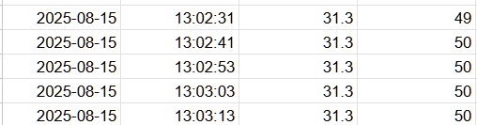

Test case II-(AC Tempset=24)
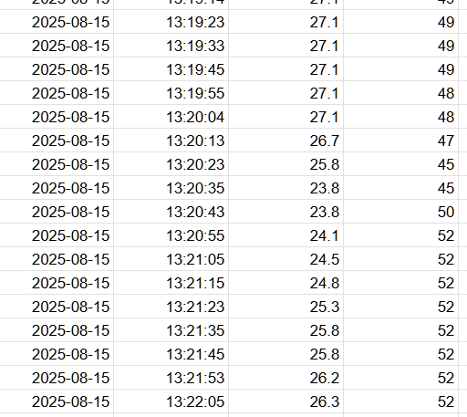

Results
Serial Monitor Output: Shows real-time readings and HTTP status.

Google Sheet Screenshot: (Add your project’s sheet, showing Date, Time, Temperature, Humidity columns being updated live.)

The system reliably logs data with timestamp precision.

Advantages, Limitations, and Applications
Advantages:

Real-time monitoring from anywhere.

Data easily shareable and graphable.

Low-cost and scalable.

Limitations:

Google Apps Script daily quota limits (fine for low-frequency use).

DHT11 sensor’s moderate accuracy and slow refresh (<1Hz).

Dependent on stable Wi-Fi and cloud services.

Applications:

Home or laboratory environment monitoring.

Agriculture data logging.

Remote weather stations and IoT education.

Conclusion
This project successfully demonstrates a cloud-connected environmental monitoring system using ESP32 and DHT11. Data is logged in real-time to Google Sheets, enabling global remote access through any web-connected device. The approach is modular, low-cost, and suitable for basic IoT applications.

