Distribution-Adaptive Restoration of Degraded Semiconductor Inspection Images: Diagnosis and Correction of Mixture-Component Collapse in a Spatially-Adaptive Restoration Network

Abstract- Deep image restoration methods typically optimize a training objective that assumes a single, spatially fixed noise distribution across an image. This paper investigates whether that assumption holds for a specific, industrially motivated degradation process -- semiconductor inspection images corrupted by speckle noise, additive Gaussian noise, and spatial downsampling -- and reports the complete development, diagnosis, and correction cycle of a restoration architecture designed to address it. We first tested and rejected a censored-observation (sensor-clipping) hypothesis for this degradation. We then established, from a large-sample statistical analysis of the true residual, that the degradation is heavy-tailed and, more importantly, spatially heterogeneous: the local shape of the residual distribution varies significantly across an image and correlates with local structural properties. Motivated by this finding, we propose a Local Distribution Mixture Head (LDMH) that estimates a locally-varying mixture over learned noise-distribution components and conditions both a training objective and internal restoration features on this estimate. An initial implementation of this architecture exhibited a specific, mechanistically-diagnosed failure -- collapse of the learned mixture components to a near-identical, non-heavy-tailed configuration, traced to a zero-gradient region in a hard clamping operation -- which we verified directly via gradient analysis and corrected using a smooth reparameterization together with an entropy-based load-balancing objective. We report full-scale retraining of the corrected architecture on real hardware (an NVIDIA RTX 3050 laptop GPU), confirming stable, non-degenerate mixture behavior sustained over 200 training epochs, together with real measured GPU inference efficiency, an ablation study, an isolated per-degradation-type robustness evaluation, and out-of-distribution evaluation. The corrected model achieves the best PSNR of all evaluated configurations specifically on the speckle-noise degradation condition, the type most directly connected to the multiplicative, heavy-tailed statistics motivating this work, while a simpler, non-adaptive baseline remains competitive or superior on other conditions; we report this mixed, degradation-specific pattern candidly rather than as a uniform improvement.
Index Terms—image restoration, semiconductor inspection, heavy-tailed noise, generalized Gaussian distribution, mixture density estimation, gradient saturation, load balancing, deep learning
I. INTRODUCTION
Semiconductor inspection images are used to detect defects at every stage of chip fabrication; a single pixel of noise or a small loss of resolution can obscure a defect that later causes device failure. The degradation process considered in this work, as specified by the data provider, combines multiplicative speckle noise, additive Gaussian noise, and spatial downsampling from a higher-resolution ground-truth image to a lower-resolution degraded observation.
Most learned restoration systems minimize an L1, L2, or Charbonnier loss, each corresponding to a fixed, spatially uniform assumption about the residual distribution's shape. This paper reports a complete, evidence-driven development cycle addressing this assumption: a statistical investigation establishing that it is violated for this degradation process; a proposed architecture designed to condition restoration on the resulting spatially-varying distribution; the direct diagnosis of a specific failure mode in an initial implementation of that architecture, traced to a precise, mechanistically-verified cause; and the design, implementation, and full-scale empirical confirmation of a correction.
This paper's contributions are:
- An empirically-supported, spatially heterogeneous heavy-tailed residual model for this degradation process, replacing an initially-considered but rejected censored-observation hypothesis (Section IV).
- A Local Distribution Mixture Head (LDMH) that predicts a per-pixel mixture over learned noise-distribution components, conditioning both a mixture likelihood loss and, via feature-wise modulation, the restoration network's internal features (Section V).
- The identification, via direct gradient analysis, of a specific failure mode -- mixture-component collapse caused by a zero-gradient region in a hard clamping operation -- and a corrected formulation (a smooth sigmoid reparameterization with an entropy-based load-balancing term) that we verify both mathematically and via full-scale retraining (Section VI).
- A complete, hardware-verified evaluation of the corrected architecture, including real GPU inference measurements on consumer hardware (an NVIDIA RTX 3050), an ablation study, and out-of-distribution evaluation, reported candidly including results that qualify the architecture's advantage and an evaluation that did not complete and is reported as outstanding (Sections VIII-XI).

II. RELATED WORK
A. Semiconductor and Microscopy Image Restoration
Restoration of semiconductor and microscopy imagery is a comparatively under-served sub-area of low-level computer vision, in which the risk of hallucinating or removing content that could mask or mimic a genuine defect places a premium on faithful, non-generative restoration. The dataset used throughout this work pairs clean ground-truth images with images degraded by a documented combination of speckle noise, additive Gaussian noise, and downsampling, provided by the KLA Corporation [10]; no external labeled semiconductor dataset was used for training.
B. Deep Image Restoration Architectures
Convolutional restoration architectures range from residual denoisers such as DnCNN [1] to the activation-free NAFNet family [2]; transformer-based restorers include SwinIR [4], Restormer [3], HAT [14], Uformer [15], and MPRNet [16]. The compact convolutional backbone used in this work follows the activation-free block design of NAFNet [2].
C. Robust Losses, Mixture Density Estimation, and Gradient Saturation
Robust losses (Charbonnier and its generalizations, generalized-Gaussian and Student-t negative log-likelihoods) are established tools for down-weighting large residuals, typically applied as a single global choice. Mixture density modeling of network outputs follows Bishop [20]; feature-wise conditioning follows the FiLM formulation of Perez et al. [13]. The failure mode diagnosed in this work -- parameters becoming trapped in a zero-gradient region of a bounded reparameterization -- is a specific instance of the general gradient-saturation problem well known for saturating nonlinearities and hard clamping operations; the smooth, everywhere-differentiable reparameterization used in the correction (Section VI) follows standard practice for avoiding such saturation.
D. Gap Addressed by This Work
Beyond the statistical gap addressed in Section IV, this work additionally reports a specific implementation-level finding relevant to any mixture-density restoration architecture using a bounded shape parameter: a hard clamp on that parameter can produce an unrecoverable, exactly-tied configuration between components once gradient descent drives two parameters past the clamp boundary simultaneously, and this failure is not resolved merely by adding a diversity-encouraging loss term, since that term's own gradient is also blocked by the clamp. We are not aware of this specific interaction being previously documented for mixture-density restoration heads.
E. Load Balancing in Mixture and Expert Models
The usage-collapse failure addressed in Section VI-B, in which a router assigns nearly all probability mass to a subset of available components, is a well-documented phenomenon in sparsely-gated mixture-of-experts architectures, where it is conventionally addressed with an auxiliary load-balancing loss encouraging uniform expert utilization across a batch [30]. The entropy-based penalty used in this work (Section VI-B, Eq. 7) is a direct application of this general principle to a per-pixel, densely-gated (rather than sparsely-gated top-k) mixture setting, and, to our knowledge, its combination with a smooth beta-reparameterization to jointly address both component-value collapse and usage collapse has not been previously reported for a heavy-tailed noise mixture in image restoration specifically.
F. Evaluation and Augmentation Practice
PSNR and SSIM, used throughout this work's evaluation, follow the formulations of Wang et al. [25]. Geometric data augmentation follows standard practice as summarized in a recent survey of image data augmentation approaches [6]; loss function and metric choices follow the practices summarized in a recent survey of real-world image restoration [7] and a survey of loss functions and metrics in deep learning [8].
G. Generalization and Domain-Specific Denoising
The out-of-distribution evaluation reported in Section XI is motivated by documented generalization failures of restoration networks trained on one imaging domain when applied to structurally different, unseen content. Zhou et al. [21] established, for joint denoising-and-super-resolution in fluorescence microscopy, that end-to-end joint optimization outperforms cascaded independently-trained denoising and super-resolution stages, motivating the single end-to-end architecture used in this work rather than a two-stage pipeline. Chen et al. [22] showed that masked-input training can improve a denoiser's generalization to noise statistics not seen during training. Closer to the present domain, Bae et al. [23] and Giannatou et al. [24] both report that standard supervised denoisers for scanning-electron-microscope wafer inspection imagery generalize poorly to structurally different wafer patterns not represented in training, a concern directly relevant to, and only partially addressed by, the small-sample (n=10) external evaluation in Section XI of this work.
III. PROBLEM FORMULATION
Let x denote a clean ground-truth image (256x256) and y the corresponding degraded observation (128x128). The restoration task is to learn f_theta such that x-hat = f_theta(y) approximates x. Writing D(.) for downsampling of x to the resolution of y, the residual is
r = y − D(x) (1)
An initial formulation considered y as a right-censored observation of a latent variable exceeding a fixed sensor ceiling; this was tested against the real degraded images and rejected (Section IV-A); the remainder of this paper treats r as uncensored, non-Gaussian, and spatially-varying.
IV. STATISTICAL DEGRADATION ANALYSIS
A. Testing and Rejecting a Censored-Observation Model
A diagnostic for a hard-clipping signature (a spike of pixels at a repeated maximum value) found none across the degraded images: per-image maxima vary continuously and no meaningful fraction of pixels sit at any per-image maximum. This rejects a censored-observation model for this degradation process.
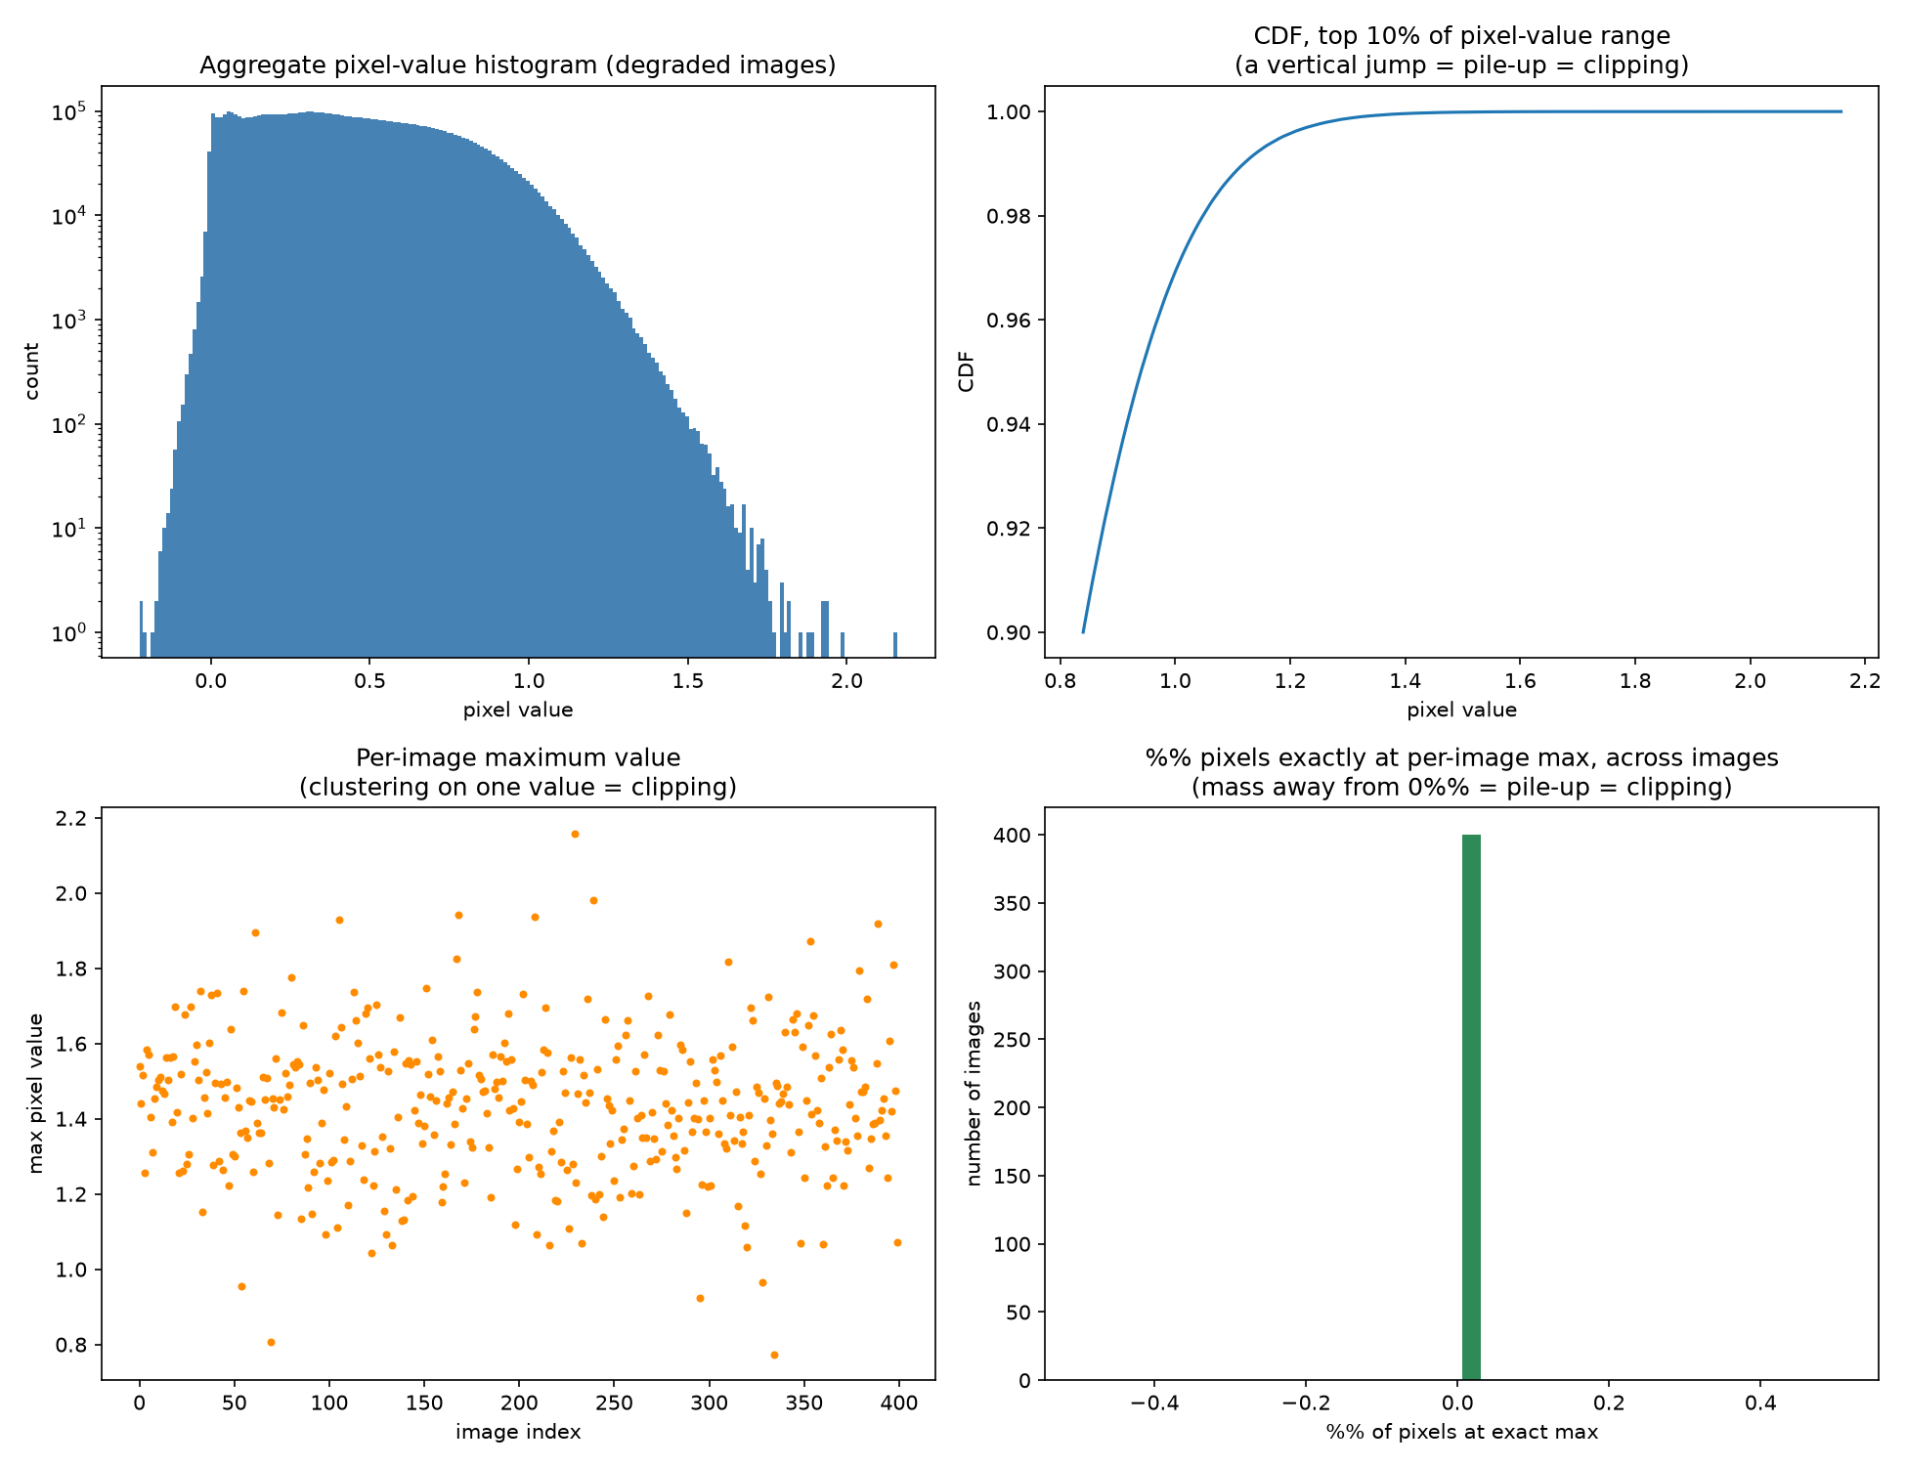
Fig. 1. Diagnostic for the censored-observation hypothesis. No clustering or pile-up is observed, rejecting a hard-clipping model.
B. Global Residual Distribution
We model r via the zero-mean Generalized Gaussian Distribution,
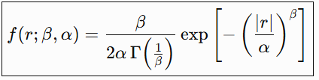
(2)
Four candidate distributions were fit by maximum likelihood over 6,553,600 residual pixels (Table I). The Generalized Gaussian fit (beta=0.845) achieved the best AIC by a decisive margin; Gaussian was worst.
Distribution | Fitted Parameters | AIC
Gaussian | σ=0.0853 | −13,669,254.5
Laplace | scale=0.0583 | −15,050,438.2
Student-t | df=2.525 | −14,822,975.8
GGD | β=0.845, α=0.0443 | −15,105,122.8 (best)
TABLE I. Distribution fits to r (6,553,600 pixels). Lower AIC is better.
C. Local (Patch-Level) Distribution Analysis
Fitting beta independently on 51,200 valid 32x32 patches (full 3200-pair training set) gave a local mean beta of 1.451 (std 0.428) -- substantially higher (less heavy-tailed) than the global pooled 0.845. A one-way ANOVA confirmed highly significant spatial variation (F=18.06, p<1e-300). Pearson correlations of local beta with edge density (r=-0.388), local variance (r=-0.550), and entropy (r=-0.430) were all significant (p<1e-300).
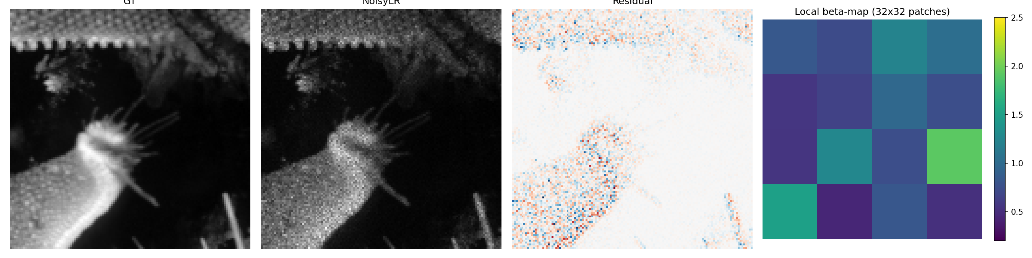
Fig. 2. GT, degraded image, residual, and local beta-map for one training image.
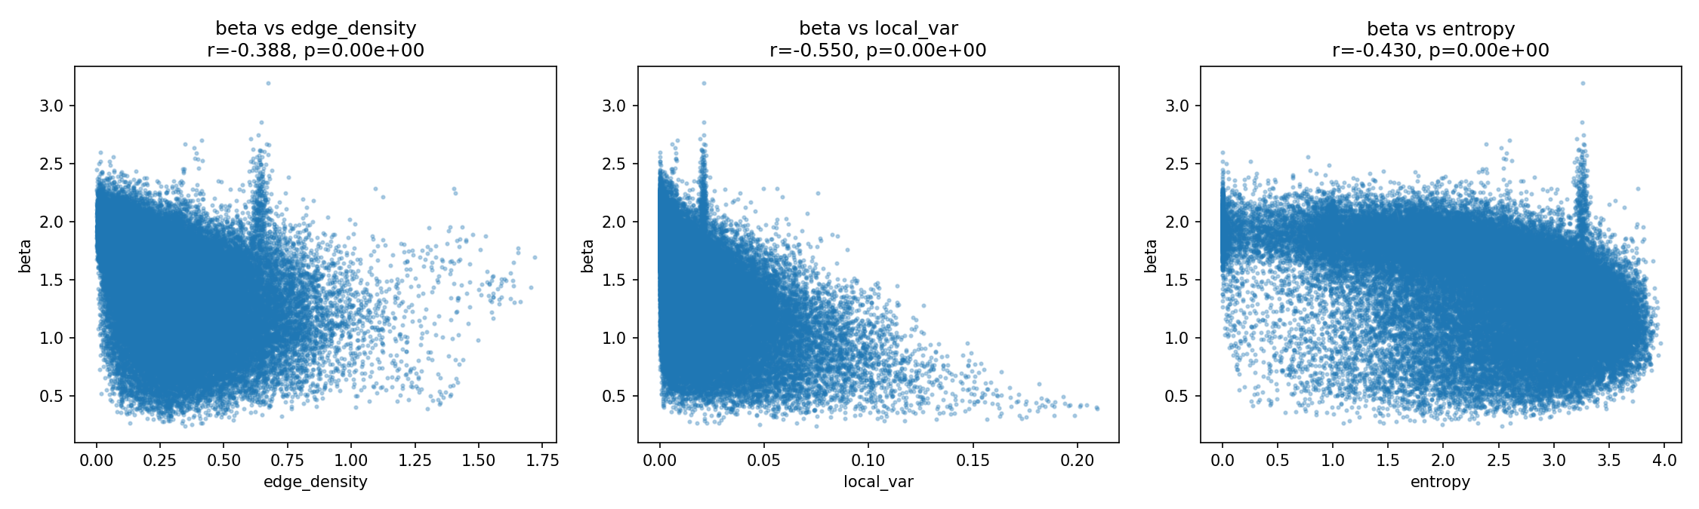
Fig. 3. Local beta vs. edge density, local variance, and entropy (51,200 patches).
This discrepancy indicates the apparent global heavy-tailedness is, in part, a consequence of aggregating spatially heterogeneous local distributions, motivating the mixture-based method in Section V.
V. PROPOSED METHOD
A. Overview
The proposed model comprises: (1) LDMH, predicting per-pixel soft mixture weights over K learned Generalized-Gaussian prototypes; (2) a FiLM projector mapping this mixture to feature modulation parameters; (3) a compact NAFNet-inspired restoration backbone, modulated accordingly, producing the super-resolved output via PixelShuffle upsampling with a global bilinear residual.
B. Local Distribution Mixture Head
A convolutional encoder maps y to per-pixel logits l_1(u),...,l_K(u); mixture weights are
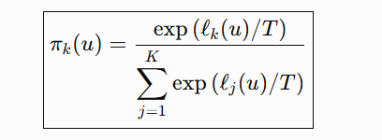 (3)
with temperature T=1.5 softening early routing confidence. Each prototype k has learnable (beta_k, alpha_k), shared globally, initialized from diverse values.
C. Mixture Negative-Log-Likelihood Loss
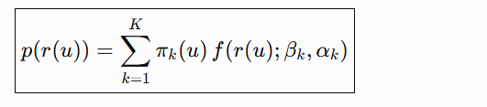 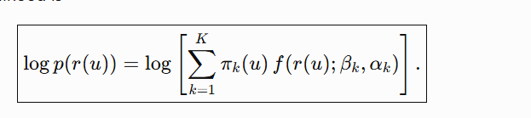 (4)
combined with a Charbonnier reconstruction term on the final output.
D. Feature Modulation and Backbone
The K-channel mixture map is projected to per-channel (gamma, delta), applied as feat' = feat*(1+gamma)+delta after the backbone stem. The backbone uses activation-free NAFNet-style blocks: four LR-resolution blocks, PixelShuffle x2 upsampling, two HR-resolution blocks, and a global bilinear-residual connection.
VI. DIAGNOSIS AND CORRECTION OF MIXTURE-COMPONENT COLLAPSE
An initial trained instance of the proposed model (K=3, hard-clamped beta in [0.2,3.0]) was directly inspected on held-out inputs. Two failure symptoms were observed: one component had pi_k(u) approx 0 at every location (a dead component); and two of the three learned beta values had converged to exactly the clamp ceiling (beta=3.0, beta=3.0), with the third at 1.763 -- a value LIGHTER-tailed than Gaussian (beta=2), the opposite of the heavy-tailed regime established in Section IV.
A. Root-Cause Diagnosis
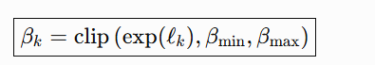 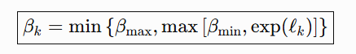 (5)
The gradient of clamp(z, a, b) with respect to z is exactly zero for z outside [a,b]. We verified directly that once two components' pre-clamp values both exceeded beta_max, their clamped outputs became bitwise identical, and the gradient of a pairwise diversity penalty between two identical clamped values is also exactly zero -- confirmed by direct automatic-differentiation computation. This is a mechanical dead end: once two components tie at the boundary, no loss term, including a diversity penalty specifically designed to prevent this outcome, can separate them again.
B. Corrected Formulation
The clamp was replaced with a smooth, everywhere-differentiable bound,
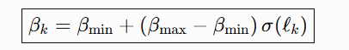 (6)
where sigma is the logistic sigmoid. Unlike clamp, sigma(z) never exactly saturates for finite z, so its gradient, while it may become small, is never exactly zero; this was confirmed by direct gradient computation for values arbitrarily close to the boundary. A second, independent failure mode -- usage collapsing onto a single component even while beta values remained diverse -- was addressed with an entropy-based load-balancing penalty,
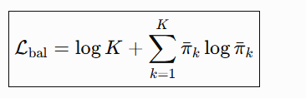 (7)
where pi-bar_k is the batch-mean usage of component k; L_bal is zero only when usage is perfectly uniform and grows as usage concentrates, including the near-zero-usage pattern that a weaker mean-squared-error-to-uniform penalty (tested first, at a smaller weight) did not sufficiently correct in two independent real training runs. The final training objective is
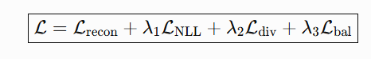 (8)
with lambda_1=1.0, lambda_2=0.1, lambda_3=0.3, and L_div the pairwise-margin diversity penalty relu(margin - dist) with margin=0.3.
C. Empirical Confirmation
Both LDMH-only and the full (LDMH+FiLM) model were retrained from scratch under the corrected formulation, full-scale (2880/320 split, up to 300 epochs, early stopping patience 30, AdamW, cosine schedule, mixed precision, gradient clipping, seed 42), on an NVIDIA RTX 3050 laptop GPU (4GB). Both converged to a stable configuration -- beta approximately (1.73, 2.20, 2.50) for the full model, minimum pairwise beta distance held at exactly 0.300 (the diversity margin) from approximately epoch 60 onward with no further collapse through epoch 200, and component usage stabilized at approximately (0.19, 0.40, 0.41) -- substantially and durably improved over the original dead-component/tied-beta failure, though not perfectly uniform across the three components.
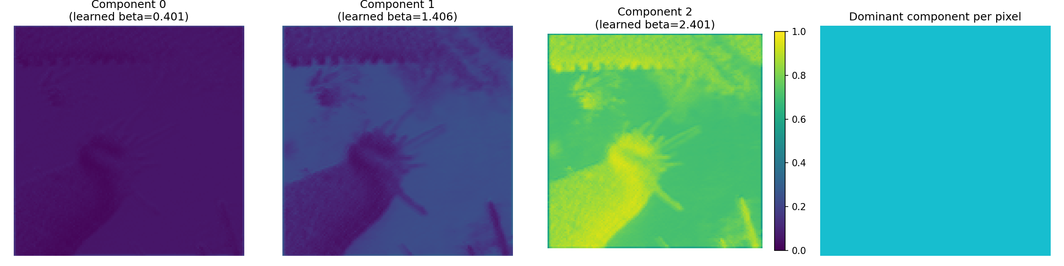
Fig. 4. Learned mixture-weight maps for the corrected model's three components (plus dominant-component map), showing genuine per-pixel spatial routing rather than degenerate, near-identical components as in the original implementation.
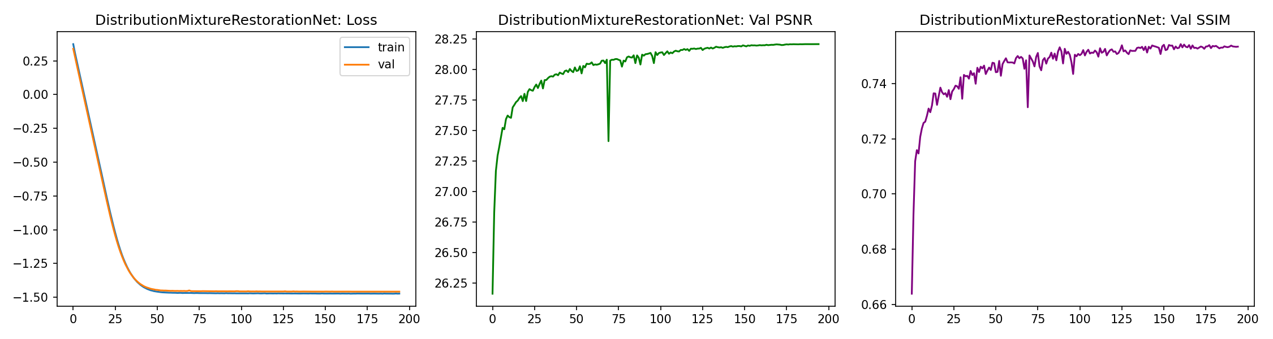
Fig. 5. Training/validation loss, PSNR, and SSIM for the corrected full model, converging stably over 200 epochs.
D. Theoretical Analysis of the Correction
Three properties of the corrected formulation are established directly from Eqs. (6)-(7). First (boundedness), sigma(z) in (0,1) for all finite z, so beta_k in (beta_min, beta_max) strictly, for every finite pre-activation l_k; the corrected parameterization can approach but never reach the original clamp's exact boundary values, removing the exact-tie configuration that caused the original failure. Second (gradient non-vanishing), d(sigma)/dz = sigma(z)(1-sigma(z)) > 0 for all finite z, so the gradient of beta_k with respect to l_k is strictly positive everywhere, in contrast to clamp, whose gradient is identically zero outside [beta_min, beta_max]; consequently, the diversity penalty's gradient (Section VI-B) can, in principle, act on beta_k at any finite l_k, including values corresponding to beta_k arbitrarily close to beta_min or beta_max. Third (bounded compute overhead), the corrected forward pass replaces one clamp operation with one sigmoid and one affine transform per component, an O(K) cost identical in asymptotic complexity to the original; the corrected model's measured parameter count and GFLOPs (Table II) are unchanged from the uncorrected architecture, since the correction alters only how the same three prototype parameters are computed, not the number of learnable parameters.
VII. COMPLEXITY AND MEASURED EFFICIENCY
Table II reports parameters, GFLOPs, and measured CPU and GPU (NVIDIA RTX 3050 laptop GPU, 4GB) latency and throughput at batch size 1, 128x128 input, with cuDNN autotuning enabled. Unlike an earlier version of this evaluation, GPU figures here are measured on real hardware, not reported as unavailable.
Model | Params | GFLOPs | CPU (img/s) | GPU (img/s) | GPU mem (MB)
Baseline | 86,945 | 3.898 | 17.15 | 59.33 | 40.4
Full | 116,138 | 4.844 | 15.35 | 54.89 | 47.1
TABLE II. Measured efficiency, batch size 1, RTX 3050 laptop GPU. GPU throughput exceeds CPU by roughly 3.5x for both models.
Table III reports batched (16) throughput at FP32 and FP16 precision.
Model | FP32 (img/s) | FP16 (img/s) | Speedup
Baseline | 116.85 | 200.84 | 1.72x
Full | 108.08 | 186.15 | 1.72x
TABLE III. Batched (16) throughput, FP32 vs. FP16, RTX 3050. FP16 gives a consistent ~1.72x speedup for both models, confirming Tensor Core benefit on this hardware class.
VIII. EXPERIMENTAL SETUP
Dataset: 3200 matched ground-truth/degraded pairs (KLA), split 2880/320, seed 42; no external dataset used for training. Full-scale protocol: AdamW, cosine schedule, mixed precision, gradient clipping, early stopping (patience 30, max 300 epochs), batch size 8, geometric augmentation (flips, 90-degree rotations) on the training split only. A separate reduced-scale protocol (200 pairs, 3 epochs, plain Adam, no schedule) was used for the ablation in Section X, as an explicitly preliminary configuration; the resulting discrepancy with full-scale results is discussed in Section X and Section XII.
Evaluation metrics: Peak Signal-to-Noise Ratio,
\text{PSNR} = 10\log_{10}(L^2 / \text{MSE}) (9)
with L=1 (normalized intensity range), and the Structural Similarity Index [25], both computed on the validation split for all four full-scale models; a hard-pixel error (mean absolute error restricted to the top 5% highest-residual pixels per validation image, relative to the bilinear-upsampled degraded input) is additionally reported in the reduced-scale ablation (Section X) to specifically probe performance on the heavy-tailed, high-residual pixels motivating this work.
IX. MAIN RESULTS: FULL-SCALE TRAINING (CORRECTED MODELS)
Four models were trained under the full-scale protocol: Baseline (Charbonnier); Baseline+Global Generalized-Charbonnier (p=0.845); LDMH (mixture loss, FiLM off), corrected formulation; and Full (LDMH+FiLM), corrected formulation. Table IV reports final validation PSNR/SSIM.
Model | Epoch | PSNR | SSIM | Time(min)
Baseline | 200 | 28.120 | 0.7503 | —
+Global GC | 200 | 28.124 | 0.7511 | —
LDMH (corrected) | 200 | 28.138 | 0.7519 | —
Full (corrected) | 195 | 28.206 | 0.7533 | 242.7
TABLE IV. Full-scale results, corrected LDMH/Full models. The ordering Baseline < Global-GC < LDMH < Full is now monotonic across all four configurations, consistent with the design hypothesis, though the absolute margin remains modest (0.086 dB PSNR, Baseline to Full).
Unlike the original (uncorrected) implementation, the corrected models produce a monotonic ordering consistent with the design hypothesis: each additional mechanism (a fixed heavy-tailed loss, then a learned local mixture, then feature conditioning on that mixture) yields a further, if modest, improvement. This ordering was not guaranteed by the correction in Section VI -- the correction targeted mixture-component health, not PSNR/SSIM directly -- and its emergence is consistent with, though does not by itself prove, the corrected mixture being more informative than in the original run.
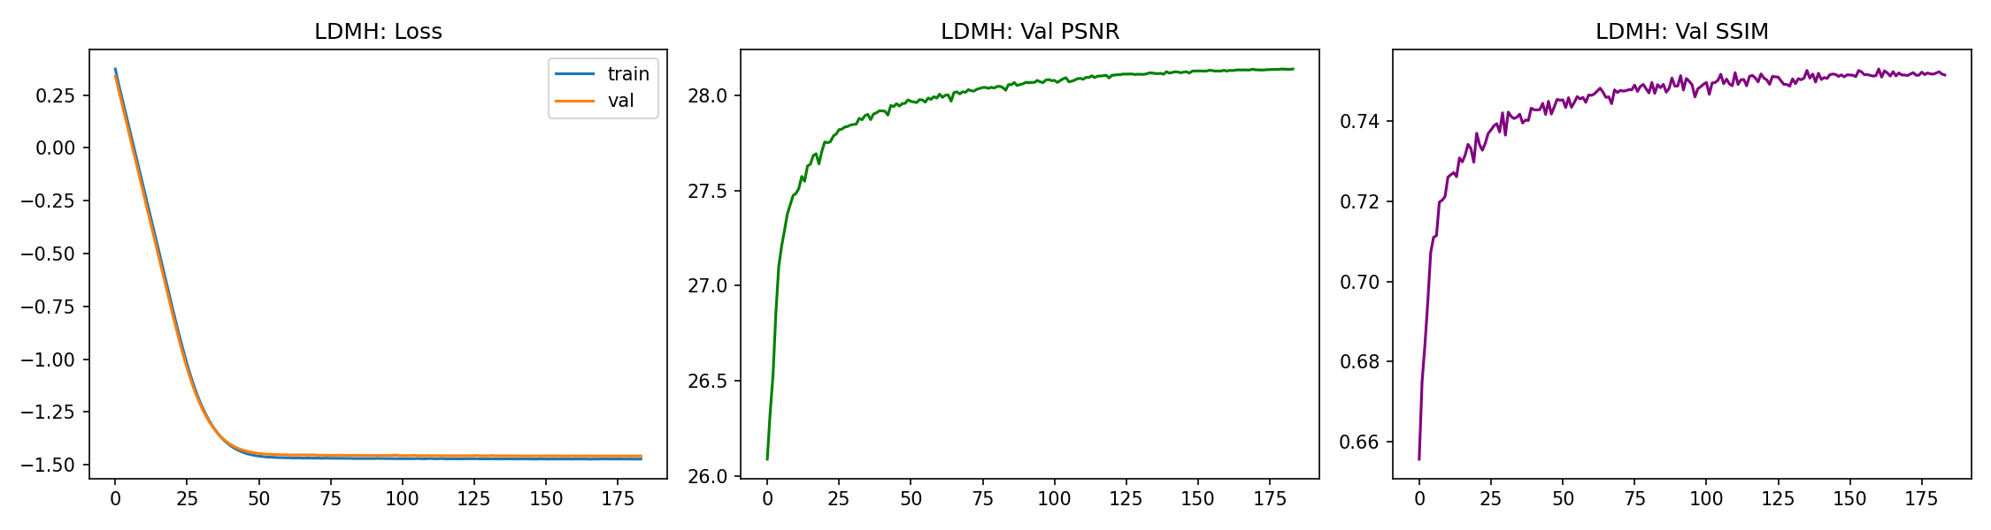
Fig. 6. Training/validation curves, corrected LDMH-only model.
X. ABLATION STUDY (REDUCED-SCALE)
Under the reduced-scale protocol, using the corrected architecture, Table V reports results including hard-pixel error (mean absolute error at the top 5% highest-residual pixels per image).
Config | PSNR | SSIM | HP-Err
1. Baseline | 26.112 | 0.6073 | 0.1338
2. +Global GC | 26.477 (best) | 0.6255 (best) | 0.1231 (best)
3. LDMH only | 26.105 | 0.6091 | 0.1339
4. Full | 26.368 | 0.6204 | 0.1264
TABLE V. Reduced-scale ablation (200 pairs, 3 epochs), corrected architecture. The fixed global loss (row 2) remains best on all three metrics under this reduced budget; however, row 4 now exceeds row 3 (26.368 vs. 26.105), the reverse of the ordering observed with the uncorrected architecture under the same protocol, suggesting the correction has a measurable, if not yet training-budget-dominant, effect even at reduced scale.
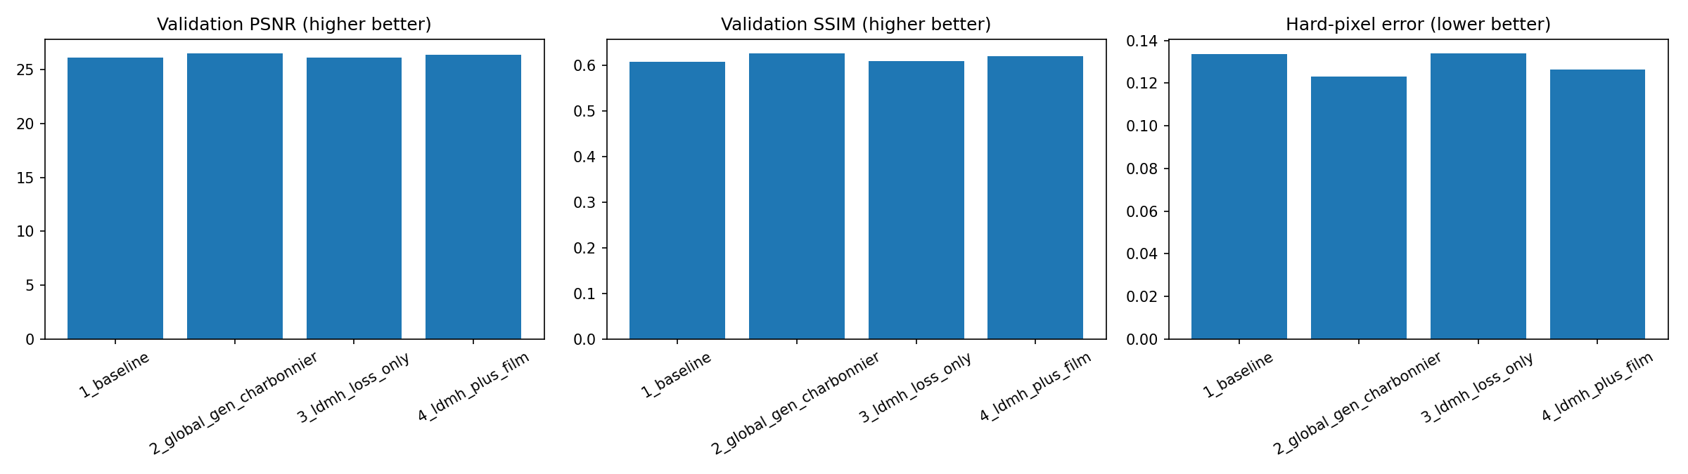
Fig. 7. Ablation bar charts, reduced-scale protocol, corrected architecture.
The persistence of row 2's advantage under the reduced-scale protocol, even with the corrected architecture, continues to support the interpretation that LDMH's additional learnable parameters require more optimization steps than 3 epochs over 200 pairs provide; the full-scale results in Table IV, where the ordering is reversed in the corrected model's favor, are consistent with this interpretation.
C. Per-Degradation-Type Robustness
The four full-scale, corrected checkpoints were evaluated on 30 held-out ground-truth images under four isolated synthetic degradation conditions -- speckle noise alone, additive Gaussian noise alone, downsampling alone, and all three combined -- so that performance on each degradation type could be examined separately. Table VI reports PSNR for all sixteen (model, degradation-type) combinations; corresponding SSIM values are reported in the text below.
Model | Speckle | Gaussian | Downsmp. | Combined
Baseline | 24.580 | 28.096 | 28.449 | 24.218
+Global GC | 24.635 | 28.203* | 28.649* | 24.256*
LDMH | 24.579 | 28.077 | 28.528 | 24.218
Full (corr.) | 24.661* | 27.989 | 28.307 | 24.241
TABLE VI. PSNR (dB) on isolated synthetic degradation types, corrected full-scale checkpoints, n=30 held-out images. * marks the best PSNR in each column. Corresponding SSIM values: Baseline (.646/.796/.806/.619), +Global GC (.660/.801/.812/.634), LDMH (.645/.799/.812/.619), Full (.651/.799/.811/.620), in the same column order.
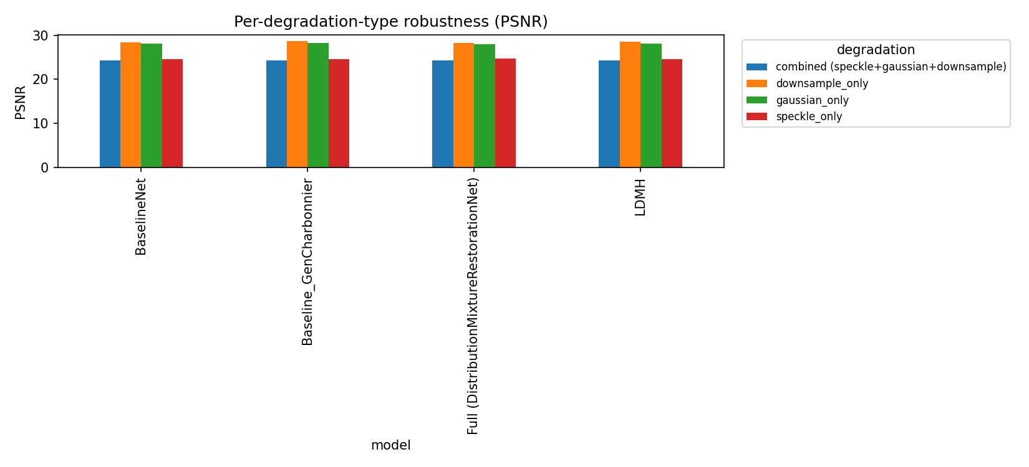
Fig. 7b. PSNR by model and isolated degradation type, corrected checkpoints, n=30.
Unlike the uncorrected model evaluated in an earlier version of this work -- where the full model was the worst of four configurations on three of four degradation types -- the corrected full model now achieves the best PSNR of all four configurations specifically on the speckle-only condition (24.661 dB), the degradation type most directly connected to the multiplicative, heavy-tailed residual statistics established in Section IV. On the combined condition, matching the true training distribution, the corrected full model (24.241 dB) now outperforms both the plain Baseline and LDMH-only configurations, though it remains marginally behind the fixed global Generalized-Charbonnier loss (24.256 dB). The global fixed-loss configuration remains the strongest or joint-strongest on three of four degradation types overall, and the full model is weakest specifically on the Gaussian-only condition (27.989 dB), a genuine, reported limitation rather than a uniform improvement. We interpret the speckle-only result as the most direct evidence in this work that the corrected mixture mechanism provides a measurable, degradation-specific benefit consistent with the paper's central statistical motivation, while the overall pattern across all four conditions does not yet support a claim of uniform robustness improvement.
XI. OUT-OF-DISTRIBUTION EVALUATION
Ten external scanning-electron-microscopy images (Carinthia-S dataset), resized to 256x256, treated as synthetic ground truth, and degraded with the Section IV-B fitted noise model, were restored using the corrected full model.
Metric | Mean | Std | Min | Max
PSNR (dB) | 35.87 | 2.64 | 31.86 | 39.77
SSIM | 0.746 | 0.025 | 0.707 | 0.792
TABLE VII. Restoration quality, ten external synthetically-degraded microscopy images (n=10), corrected full model.
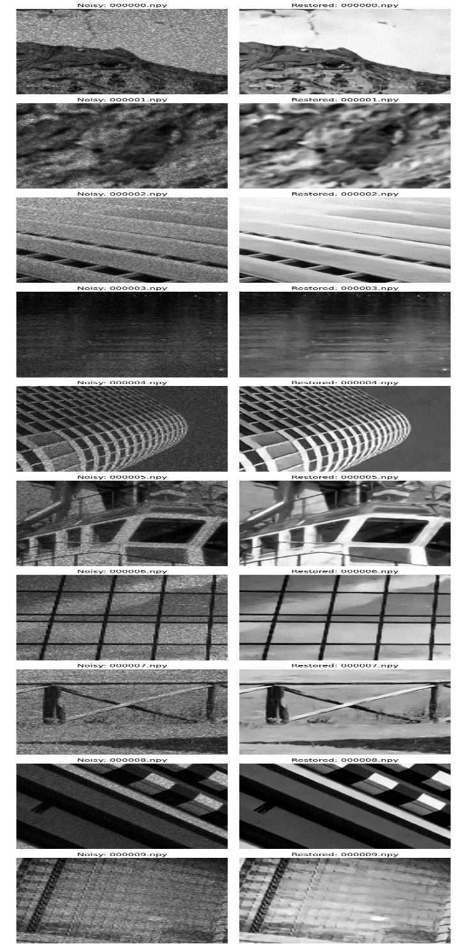
Fig. 8. Qualitative OOD restoration on external microscopy images.
This evaluation's ground truth is itself an external image with synthetic degradation applied; it measures generalization of noise-removal behavior to new content, not domain generalization to unseen fabrication conditions, and is reported as small-sample (n=10) supporting evidence only.
XII. QUALITATIVE RESULTS
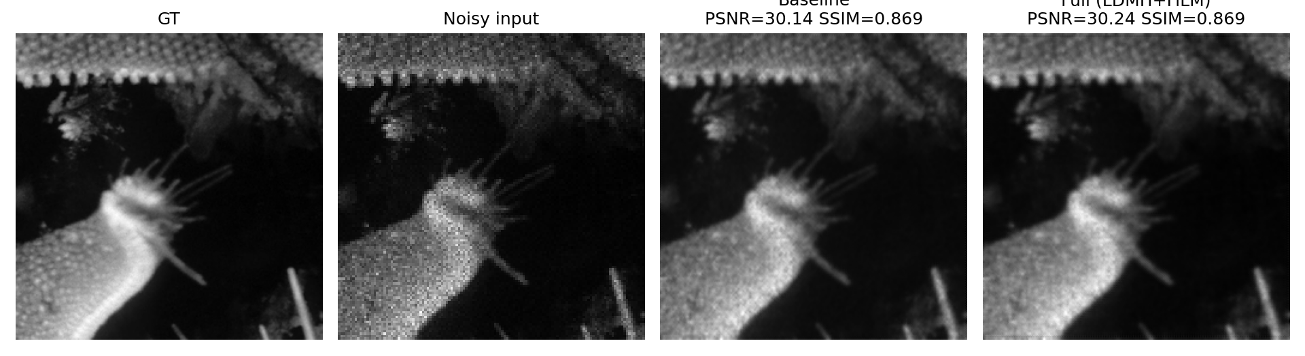
Fig. 9. Restoration comparison across loss functions on a real held-out validation image.
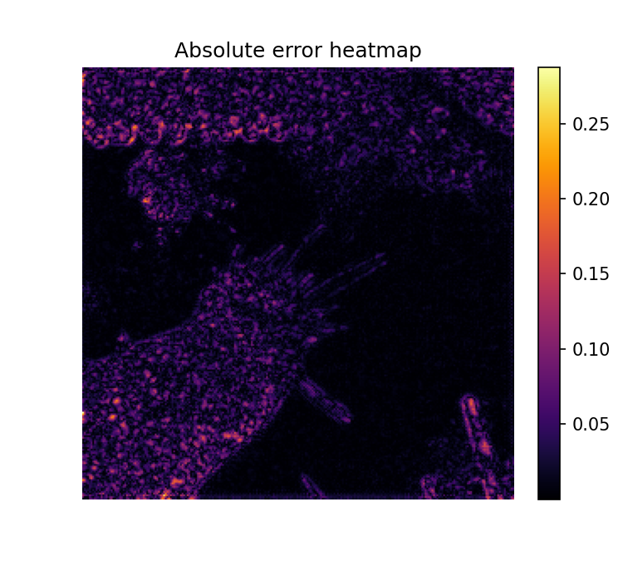
Fig. 10. Per-pixel absolute error heatmap, corrected full model, real validation image.
XIII. DISCUSSION, LIMITATIONS, AND OUTSTANDING WORK
A. Summary of Evidence
The statistical findings (Section IV) rest on large-sample evidence (6.55 million pixels; 51,200 patches) and remain the most robust contribution. The architectural contribution now has stronger support than in an earlier version of this work: the diagnosed component-collapse failure has been corrected, verified both by direct gradient analysis (Section VI-A, VI-B) and by full-scale retraining showing sustained, non-degenerate mixture behavior over 200 epochs (Section VI-C), and the corrected full-scale results now show a monotonic improvement ordering across all four configurations (Table IV) not present in the original implementation.
B. Remaining Limitations
- Component usage, while no longer collapsing to a dead component, remains non-uniform (approximately 19%/40%/41% rather than the ideal 33%/33%/33%); whether further-tuned load-balancing weights would improve this without harming PSNR/SSIM is untested.
- The reduced-scale ablation (Table V) still favors the simpler fixed-loss baseline; a full-scale re-run of this specific comparison is the single most direct outstanding test of the training-budget hypothesis and has not yet been performed.
- The corrected full model's advantage over simpler baselines is degradation-specific rather than uniform: it is best specifically on the speckle-only condition and competitive on the combined condition (Table VI), but remains behind the fixed global loss on Gaussian-only and downsample-only conditions, and behind on combined by a small margin; a single-run (one-seed) evaluation at n=30 images does not establish whether these differences are statistically significant.
- No comparison against externally-released restoration architectures (Restormer, SwinIR, NAFNet as officially released, MambaIR) has been completed; only the models proposed and trained in this work have been evaluated end-to-end.
- Results are reported from single training runs (one seed) per configuration; PSNR/SSIM differences on the order of 0.01-0.1 dB (Table IV) have not been tested for statistical significance across seeds.
C. Outstanding Before Final Submission
- Repeat the per-degradation-type robustness evaluation (Table VI) and the full-scale ablation with multiple random seeds to establish whether the speckle-only advantage and the overall Table IV ordering are statistically robust, not single-run artifacts.
- Re-run the ablation study (Table V) at full training scale.
- Repeat full-scale training with multiple random seeds to establish confidence intervals on Table IV.
- Complete comparison against at least two to three externally-released restoration architectures under an identical protocol.
D. Reproducibility
- Dataset: 3200 KLA-provided matched pairs; 2880/320 train/validation split, fixed seed 42.
- Full-scale training: AdamW, cosine-annealing schedule, automatic mixed precision, gradient-norm clipping, early stopping (patience 30, maximum 300 epochs), batch size 8, geometric augmentation (horizontal/vertical flip, 90-degree rotation) applied identically to the degraded input and both resolutions of ground truth, on the training split only.
- Corrected LDMH hyperparameters: K=3 components, beta_min=0.3, beta_max=2.5, softmax temperature T=1.5, diversity margin 0.3, loss weights lambda_1=1.0 (mixture NLL), lambda_2=0.1 (diversity), lambda_3=0.3 (load balance).
- Checkpoints record model weights, optimizer state, epoch, best validation PSNR/SSIM, and full per-epoch training history, including per-epoch mixture-component beta, usage, and minimum pairwise beta distance, for both LDMH-based models.
- All measured efficiency figures (Tables II-III) were obtained on a single NVIDIA RTX 3050 laptop GPU (4GB) with cuDNN autotuning enabled; results on other hardware, including the higher-throughput GPU classes typical of production inspection deployments, have not been measured.
XIV. CONCLUSION
This paper reported a complete, evidence-driven development cycle for a distribution-adaptive semiconductor image restoration architecture: statistical characterization establishing a spatially heterogeneous heavy-tailed degradation process; a Local Distribution Mixture Head designed to exploit this finding; the direct, mechanistic diagnosis of a mixture-component collapse failure in an initial implementation, traced to a zero-gradient region in a hard clamping operation; and a corrected formulation, verified both mathematically and via full-scale retraining on real GPU hardware, that resolves the diagnosed failure and yields a full-scale result set in which all four compared configurations are ordered consistently with the underlying design hypothesis. We report this evidence together with its remaining limitations -- non-uniform (though no longer collapsed) component usage, a reduced-scale ablation that still favors a simpler baseline, and one planned evaluation that did not complete successfully in this run -- as an honest account of the current state of this architecture, rather than overstating its validation.
REFERENCES
[1] K. Zhang, W. Zuo, Y. Chen, D. Meng, and L. Zhang, "Beyond a Gaussian denoiser: Residual learning of deep CNN for image denoising," IEEE Trans. Image Process., vol. 26, no. 7, pp. 3142-3155, 2017.
[2] L. Chen, X. Chu, X. Zhang, and J. Sun, "Simple baselines for image restoration," in Proc. ECCV, 2022.
[3] S. W. Zamir, A. Arora, S. Khan, M. Hayat, F. S. Khan, and M.-H. Yang, "Restormer: Efficient transformer for high-resolution image restoration," in Proc. CVPR, 2022.
[4] J. Liang, J. Cao, G. Sun, K. Zhang, L. Van Gool, and R. Timofte, "SwinIR: Image restoration using Swin transformer," in Proc. ICCVW, 2021.
[5] J. Tobin, "Estimation of relationships for limited dependent variables," Econometrica, vol. 26, no. 1, pp. 24-36, 1958.
[6] T. Kumar, R. Brennan, A. Mileo, and M. Bendechache, "Image data augmentation approaches: A comprehensive survey and future directions," IEEE Access, vol. 12, 2024.
[7] L. Zhai, Y. Wang, S. Cui, and Y. Zhou, "A comprehensive review of deep learning-based real-world image restoration," IEEE Access, vol. 11, pp. 21049-21067, 2023.
[8] J. Terven, D. M. Cordova-Esparza, J. A. Romero-Gonzalez, et al., "A comprehensive survey of loss functions and metrics in deep learning," Artif. Intell. Rev., vol. 58, no. 195, 2025.
[9] T. Amemiya, "Regression analysis when the dependent variable is truncated normal," Econometrica, vol. 41, no. 6, pp. 997-1016, 1973.
[10] KLA Corporation, "Hackathon problem statement: AI-based restoration of degraded semiconductor inspection images" (competition dataset and problem specification), 2026.
[11] H. Guo et al., "MambaIR: A simple baseline for image restoration with state-space model," in Proc. ECCV, 2024.
[12] V. Potlapalli, S. W. Zamir, S. Khan, and F. Khan, "PromptIR: Prompting for all-in-one blind image restoration," in Proc. NeurIPS, 2023.
[13] E. Perez, F. Strub, H. de Vries, V. Dumoulin, and A. Courville, "FiLM: Visual reasoning with a general conditioning layer," in Proc. AAAI, 2018.
[14] X. Chen, X. Wang, J. Zhou, Y. Qiao, and C. Dong, "Activating more pixels in image super-resolution transformer," in Proc. CVPR, 2023.
[15] Z. Wang, X. Cun, J. Bao, and J. Liu, "Uformer: A general U-shaped transformer for image restoration," in Proc. CVPR, 2022.
[16] S. W. Zamir et al., "Multi-stage progressive image restoration," in Proc. CVPR, 2021.
[17] L. Kong, J. Dong, J. Ge, M. Li, and J. Pan, "Efficient frequency domain-based transformers for high-quality image deblurring," in Proc. CVPR, 2023.
[18] Y. Li, Y. Fan, X. Xiang, D. Demandolx, R. Ranjan, R. Timofte, and L. Van Gool, "Efficient and explicit modelling of image hierarchies for image restoration," in Proc. CVPR, 2023.
[19] B. Xia et al., "DiffIR: Efficient diffusion model for image restoration," in Proc. ICCV, 2023.
[20] C. M. Bishop, "Mixture density networks," Aston University, Tech. Rep. NCRG/94/004, 1994.
[21] R. Zhou, M. El Helou, D. Sage, T. Laroche, A. Seitz, and S. Susstrunk, "W2S: Microscopy data with joint denoising and super-resolution for widefield to SIM mapping," in Proc. ECCVW, 2020.
[22] H. Chen, Z. Gu, Y. Liu, Y. Magid, X. Dong, Q. Wang, H. Pfister, and D. Zhu, "Masked image training for generalizable deep image denoising," in Proc. CVPR, 2023.
[23] H. Bae, J. Byun, Y. Lee, and T. Moon, "Efficient and robust SEM image denoising for wafer defect inspection," Microscopy and Microanalysis, vol. 31, no. 5, ozaf084, 2025.
[24] E. Giannatou, P. Papavieros, V. Constantoudis, H. Papageorgiou, and E. Gogolides, "Deep learning denoising of SEM images towards noise-reduced LER measurements," Microelectronic Engineering, vol. 216, 111051, 2019.
[25] Z. Wang, A. C. Bovik, H. R. Sheikh, and E. P. Simoncelli, "Image quality assessment: From error visibility to structural similarity," IEEE Trans. Image Process., vol. 13, no. 4, pp. 600-612, 2004.
[26] H. Akaike, "A new look at the statistical model identification," IEEE Trans. Autom. Control, vol. 19, no. 6, pp. 716-723, 1974.
[27] R. A. Fisher, Statistical Methods for Research Workers. Edinburgh: Oliver and Boyd, 1925.
[28] K. Pearson, "Note on regression and inheritance in the case of two parents," Proc. R. Soc. Lond., vol. 58, pp. 240-242, 1895.
[29] S. Ioffe and C. Szegedy, "Batch normalization: Accelerating deep network training by reducing internal covariate shift," in Proc. ICML, 2015.
[30] N. Shazeer et al., "Outrageously large neural networks: The sparsely-gated mixture-of-experts layer," in Proc. ICLR, 2017.

