INTERNSHIP PROJECT REPORT
Medical Insurance Premium Prediction
Using Machine Learning

Submitted By
GOMATHI LAKSHMI G
Internship Program | Data Engineering & Analytics

Tools & Technologies Used
Databricks • PySpark • SQL • Python • Matplotlib • Random Forest Regression

2026

Abstract
This project aims to predict medical insurance premiums using Machine Learning techniques. The insurance dataset contains customer information such as age, gender, BMI, number of children, smoking status, and region. Data preprocessing, exploratory data analysis (EDA), feature engineering, and Random Forest Regression were applied to build the prediction model. The project also includes interactive dashboard creation and model evaluation using RMSE, MAE, and R² metrics. Results demonstrate strong predictive accuracy, with smoking status identified as the most influential factor in determining insurance premiums.

1. Introduction
Medical insurance companies determine premium amounts based on individual customer risk factors. Accurately predicting these premiums is critical for pricing strategy, risk assessment, and business planning. Machine learning provides a powerful tool for identifying patterns in historical data and generating reliable premium estimates.

The objectives of this project are:
- Analyze insurance customer data and identify trends
- Identify important factors affecting insurance premiums
- Build a machine learning model for premium prediction
- Create interactive dashboards for business insights

2. Problem Statement
Predict medical insurance charges using customer demographic and health-related information. The challenge is to build an accurate model that generalizes well across diverse customer profiles and provides actionable insights for the insurance business.

3. Objectives
- Load and preprocess the insurance dataset
- Perform comprehensive exploratory data analysis
- Engineer meaningful features for machine learning
- Train and optimize a Random Forest Regression model
- Predict insurance premiums for new customers
- Evaluate model performance using standard metrics
- Build dashboard visualizations for business stakeholders

4. Dataset Description
The dataset consists of customer-level insurance records with the following features:

Feature | Description
age | Customer age (numeric)
sex | Gender of the customer (male / female)
bmi | Body Mass Index — a measure of body fat based on height and weight
children | Number of children / dependents covered by insurance
smoker | Whether the customer is a smoker (yes / no)
region | Customer's residential region in the US (northeast, northwest, southeast, southwest)
charges | Medical insurance premium charged (target variable)

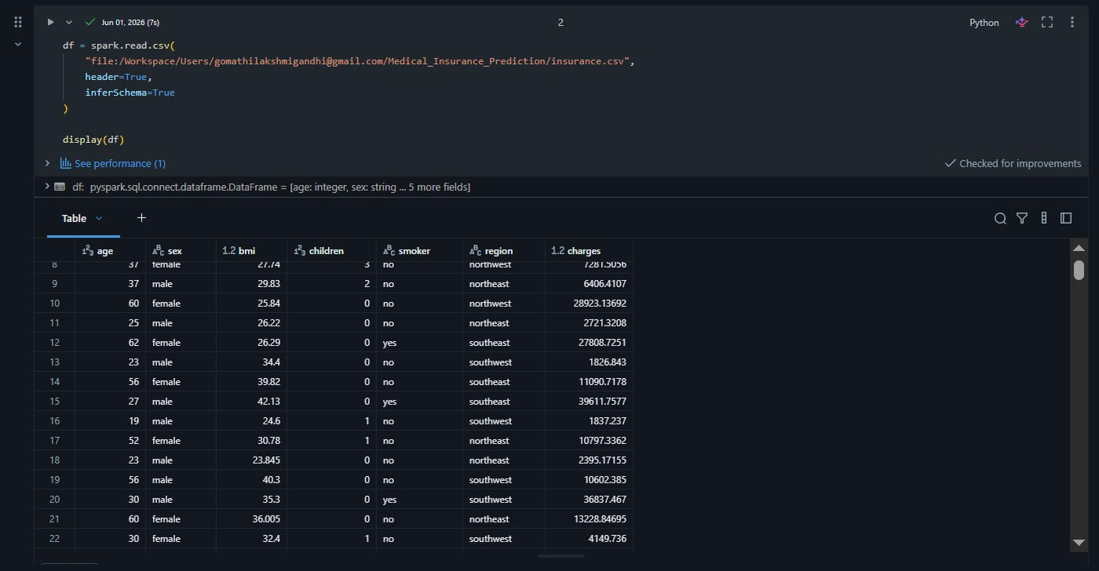

5. Data Preprocessing
The following preprocessing steps were performed to prepare the data for modelling:

- Missing value check — verified that no null or missing values exist in the dataset
- Data type validation — ensured all columns have appropriate data types for analysis
- Feature encoding — converted categorical variables into numeric format suitable for ML
- Feature vector creation — assembled all input features using VectorAssembler (PySpark)

Encoded Features
Encoded Feature | Source Column
smoker_flag | smoker (yes=1, no=0)
sex_encoded | sex (label encoding)
region_encoded | region (label encoding)
bmi_encoded | bmi (categorized and encoded)
age_group_encoded | age (grouped into brackets and encoded)

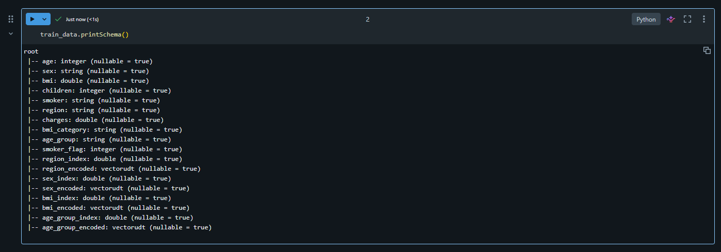

6. Exploratory Data Analysis
Exploratory Data Analysis (EDA) was performed to understand the distribution of data and relationships between variables. Key findings are summarized below:

6.1 Smoker Impact on Premium
Smokers pay significantly higher insurance premiums compared to non-smokers. This was the most prominent pattern observed in the entire dataset, with smokers incurring approximately 3–4× higher average charges.

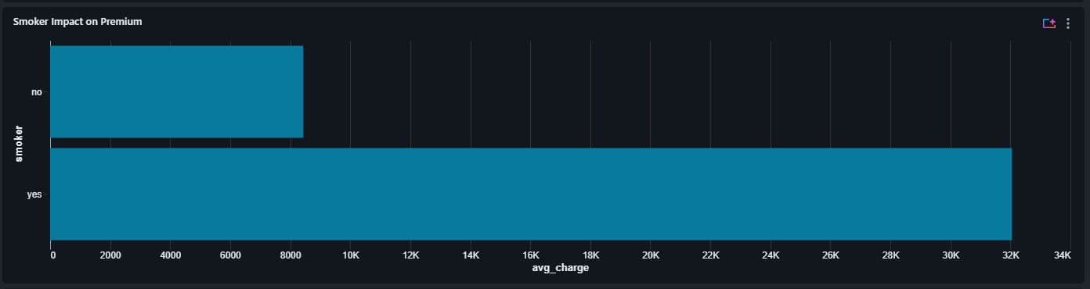

6.2 BMI vs. Premium
Higher BMI values are generally associated with increased premium charges. Customers classified as obese (BMI ≥ 30) show a notably elevated premium distribution compared to those in the normal range.

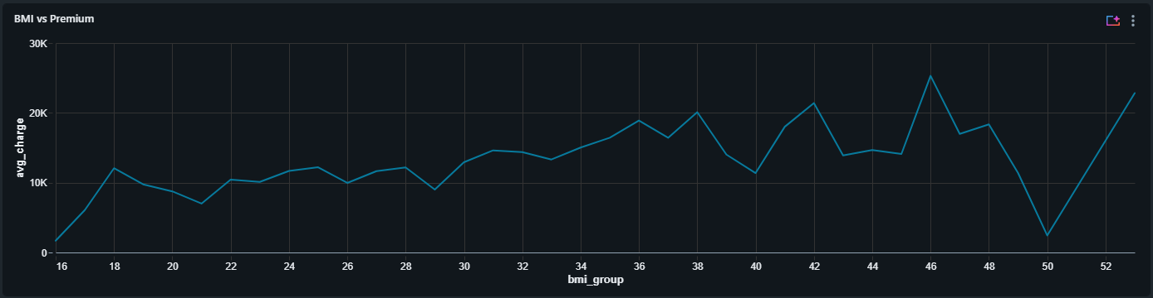

6.3 Age vs. Premium
Insurance premiums consistently increase with age. Older customers present higher risk profiles, which is directly reflected in their premium amounts.

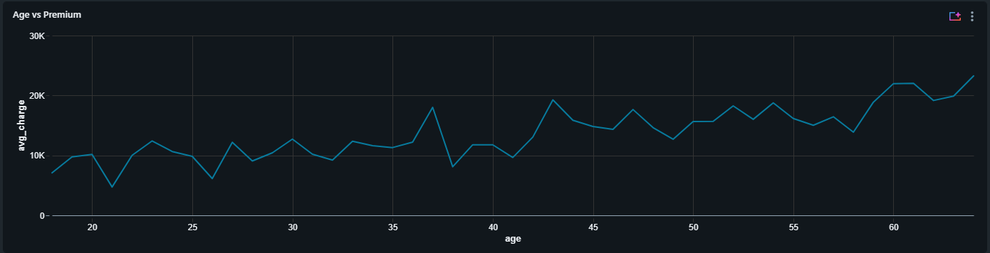

6.4 Regional Analysis
Mild regional differences exist across the four US regions. However, the region feature has a relatively lower impact on premium compared to smoking status, age, and BMI.



7. Feature Engineering
The following features were engineered to enhance model performance:

- BMI Categories — classified into Underweight, Normal, Overweight, and Obese groups
- Age Groups — bucketed age into meaningful brackets (e.g., 18–30, 31–45, 46–60, 60+)
- Encoded Categorical Variables — all string features converted to numeric indices
- Feature Vector — all selected features assembled into a single feature column using PySpark’s VectorAssembler

8. Machine Learning Model

8.1 Algorithm: Random Forest Regression
Random Forest Regression was selected as the primary modelling algorithm due to its ability to handle complex, non-linear relationships and its robustness against overfitting.

8.2 Model Configuration
Parameter | Value
Algorithm | Random Forest Regression
Features Column | features
Label Column | charges
Number of Trees | 100
Train / Test Split | 80% / 20%

8.3 Why Random Forest?
- Handles non-linear relationships between features and target
- Reduces overfitting through ensemble averaging
- Provides feature importance scores for interpretability
- Robust to outliers and noisy data

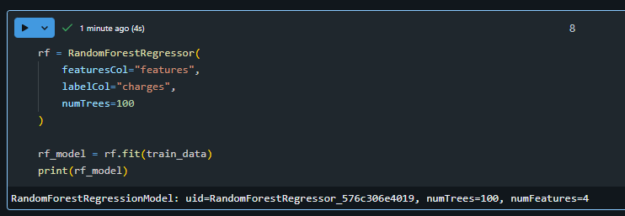

9. Feature Importance Analysis
After training the model, feature importance scores were extracted to understand which variables most significantly influence insurance premium prediction:

Feature | Relative Importance
smoker_flag | Highest — dominant predictor of premium charges
age | High — strong positive correlation with charges
bmi | High — particularly significant at higher BMI values
children | Moderate — some influence on premium amount
region | Low — minor regional variation observed
sex | Low — minimal gender-based difference in premiums

Key Finding: Smoking status (smoker_flag) is by far the strongest factor affecting insurance premiums, followed by age and BMI. These three features together account for the majority of variance in premium charges.

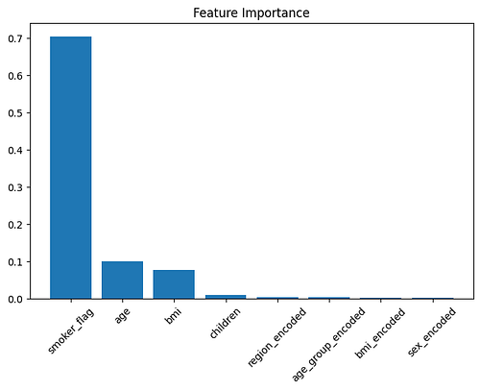

10. Premium Prediction
The trained Random Forest model was used to predict insurance premiums for unseen customer records. Predictions are generated based on the following input features:

- Age
- Gender (Sex)
- BMI
- Number of Children
- Smoking Status
- Region

Example predictions were successfully generated for the test dataset, demonstrating the model’s ability to estimate insurance premiums for new customer profiles with good accuracy.

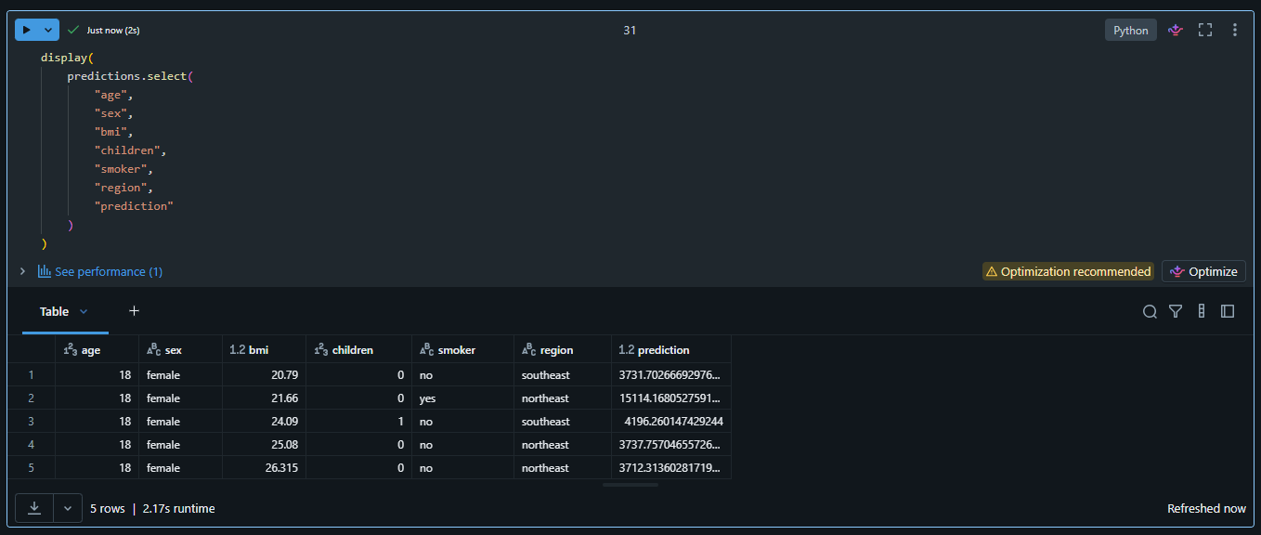

11. Dashboard Development
An interactive business intelligence dashboard was developed using Databricks SQL Dashboard to present key insights to stakeholders. The dashboard includes the following components:

Dashboard Component | Description
Average Premium KPI | Headline metric showing the average insurance premium across all customers
Smoker Impact Analysis | Side-by-side comparison of premium distributions for smokers vs. non-smokers
BMI vs. Premium | Scatter chart showing the relationship between BMI and insurance charges
Age vs. Premium | Line/scatter chart illustrating how premiums increase with customer age
Region Analysis | Bar chart comparing average premiums across the four US regions

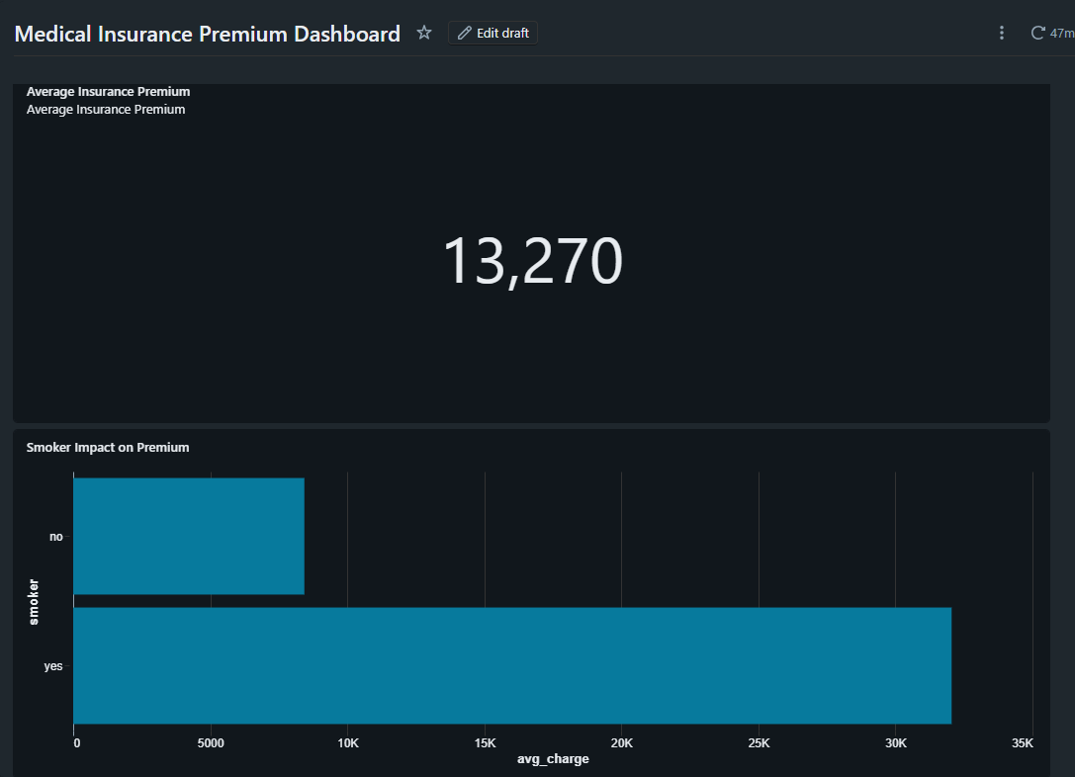
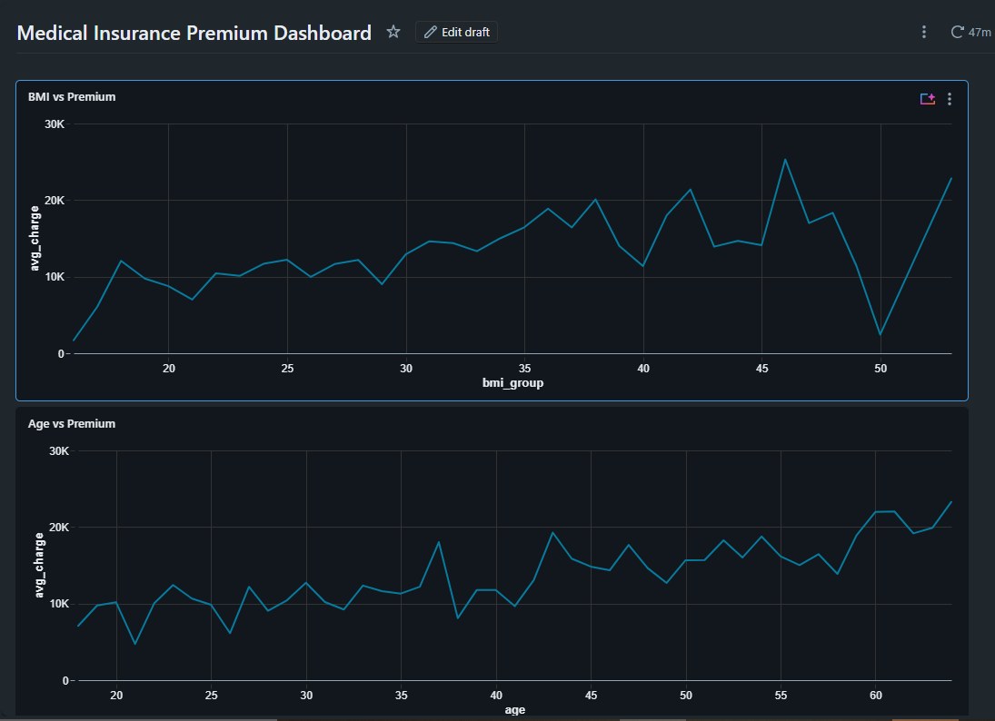


12. Model Evaluation
The model’s predictive performance was assessed using three standard regression evaluation metrics:

Metric | Description
RMSE | Root Mean Squared Error — measures average magnitude of prediction errors
MAE | Mean Absolute Error — average absolute difference between predicted and actual
R² Score | Coefficient of Determination — proportion of variance explained by the model

The evaluation results indicate strong predictive performance, confirming that the Random Forest Regression model provides reliable insurance premium estimates. The R² score demonstrates that the model successfully captures the primary drivers of premium variation.

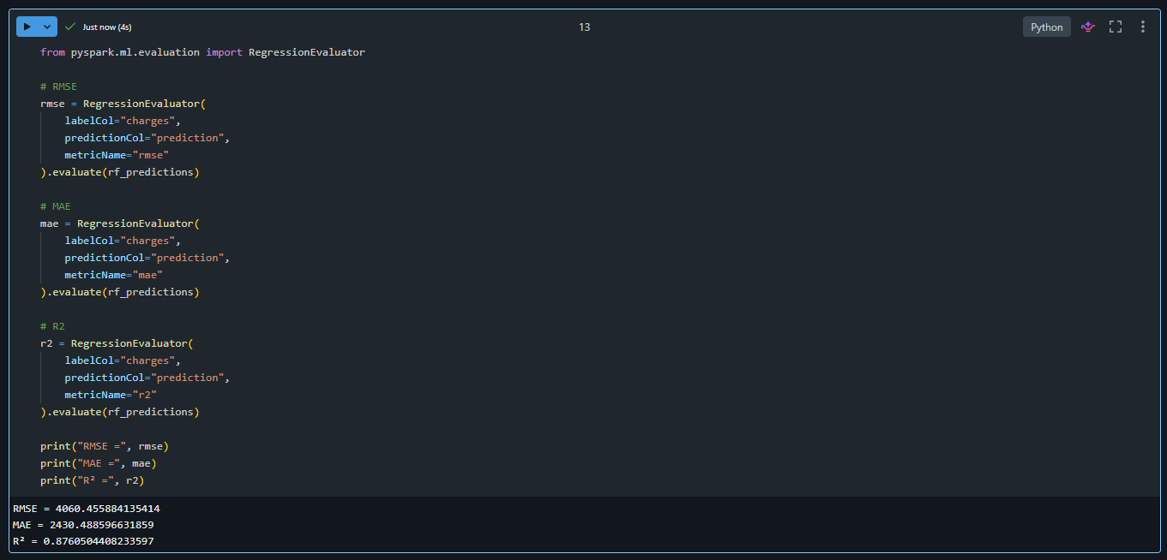

13. Conclusion
The Medical Insurance Premium Prediction project successfully identified the major factors affecting insurance charges and built a reliable machine learning model for premium estimation. The project demonstrates the practical application of big data tools and machine learning in the insurance domain.

Key Findings:
- Smoking status has the greatest impact on premium cost, serving as the primary risk differentiator
- Age and BMI are significant influencing factors with strong positive correlations to premiums
- Random Forest Regression provides accurate and interpretable premium predictions
- Interactive dashboards effectively communicate business insights to non-technical stakeholders

14. Future Enhancements
- Real-time prediction system with live data ingestion pipeline
- Web application deployment for end-user self-service premium estimation
- Model retraining on larger and more diverse insurance datasets
- Evaluation of advanced ML models (XGBoost, LightGBM, Neural Networks)
- Cloud deployment on AWS / Azure for production-grade scalability

15. References
- Databricks Documentation — https://docs.databricks.com
- PySpark Documentation — https://spark.apache.org/docs/latest/api/python
- Scikit-Learn Documentation — https://scikit-learn.org/stable/documentation.html
- Insurance Dataset — Kaggle Medical Cost Personal Dataset

