Source file Structure:
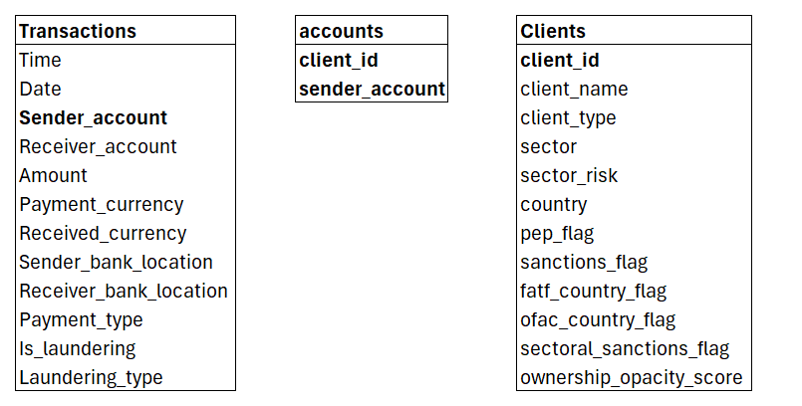

Source data:
ADLS: databricksamlstoracc
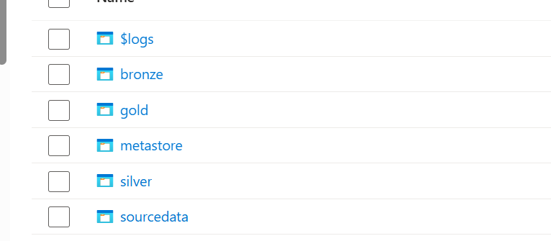
Data Ingestion:
BronzeDataLoad.ipynb (Autoloader loads into Delta tables in bronze schema)
schemaLocation:
abfss://sourcedata@databricksamlstoracc.dfs.core.windows.net/checkpoint/<filetype>/
checkpointLocation: To process only new files abfss://bronze@databricksamlstoracc.dfs.core.windows.net/checkpoint/<filetype>/
Unity Catalog snapshot of bronze schema:
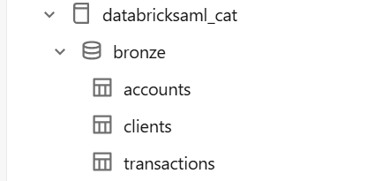

Silver Layer data Load:
- SilverTransactionsDataLoad
  - Amount field was not loaded in bronze table, and has to be retrieved from _rescued_data column
  - Date and Time are separate fields, will be combined together to create TransactionDate field.
  - Sender_account and Receiver_account are string fields, will be converted to BIGINT in line with Accounts table.

Streaming table is created under databricksaml_cat.silver.transactions
checkpointLocation:
abfss://silver@databricksamlstoracc.dfs.core.windows.net/transactions/checkpoint/
OutputMode: append

- SilverClientsDataLoad
  - Check if any fields are present in _rescued_data and retrieve the value.
Streaming table is created under databricksaml_cat.silver.clients
checkpointLocation:
abfss://silver@databricksamlstoracc.dfs.core.windows.net/clients/checkpoint/
OutputMode: append

- SilverAccountsDataLoad
  - Check if any fields are present in _rescued_data and retrieve the value.
Streaming table is created under databricksaml_cat.silver.accounts
checkpointLocation:
abfss://silver@databricksamlstoracc.dfs.core.windows.net/accounts/checkpoint/
OutputMode: append
Gold Layer data load:
Created aggregated tables and views to identify the PEP risks, high volume transaction risks and Sanctioned client names fuzzy matches.
- HighVolTrans: Aggregates the amount and number of transactions on daily basis for each client. Generates a flag is_HighVolTrans which is used to dashboard reporting.
- PEPCustomerAlert: For Politically exposed clients, checks the transaction volume with their risk flag.
- CustSanctionAlert: Compares the client names against the sanctioned client names using Levenshtein Distance alogrithm. Stores the clients where the distance is <3.

Dashboard:
Using the gold layer tables, the dashboard is generated with the below metrics.
- Number of transactions per day
- Top 10 customers with high transaction amounts
- Client name, Sanctioned name and their distance calculated
- Number of Fuzzy clients for Sanctioned clients
- High volume of transactions from PEP clients
- Number of PEP clients within High risk sectors

Job:
End to end orchestration is maintained in job using relevant dependencies.
