Any Tax implications for Creator and their Fans:

This is a critical regulatory and tax question. The short answer is: **For the fans, no. For the creators, it is treated as standard business income (like receiving cash), not complex crypto trading.**

Here is the exact breakdown for both sides of the platform under standard tax laws (US IRS, UK HMRC, EU regulations):

---

### 1. For the Fans (The Payers) ➔ **No Crypto Tax Implications**
* **The Experience:** The fan uses their credit card or Apple Pay to make a purchase.
* **The Tax Rule:** In the eyes of tax authorities, the fan is simply buying a digital product (a PDF, guide, etc.) using their local fiat currency. They are **not** considered "crypto traders," and they have **no crypto tax reporting obligations** whatsoever. It is treated exactly like buying a coffee with a debit card.

---

### 2. For the Creators (Influencers) ➔ **Standard Business Income**
Because creators receive USDC (which is a cryptocurrency stablecoin) into their wallet, they are technically receiving digital assets. However, because it is a stablecoin, the tax treatment is very simple:

* **Income Tax (Ordinary Income):**
Receiving USDC as payment for digital content is treated as **standard business revenue / self-employment income** (valued in USD/GBP/EUR at the time of receipt). When they file taxes, they simply report their total earnings (e.g., if they made £1,000 worth of USDC, they report £1,000 in self-employment income).
* **No Capital Gains Tax:**
Normally, crypto tax complexity comes from "Capital Gains" (buying Bitcoin at $10k and selling at $60k). Because USDC is a **stablecoin** pegged 1:1 to the US Dollar, its value never changes.
* **$1 USDC is always worth $1 USD.**
* Since there is **no profit or loss** made from price fluctuations when they convert USDC to their bank account, there are **no capital gains taxes** to calculate or pay.

---

### 3. How Payout Partners (Coinbase) Simplify This
Because we use the Coinbase SDK for the bank cash-out process, **Coinbase acts as the regulated exchange partner**:
* Coinbase handles the compliance (KYC/AML) for bank withdrawals.
* In regions like the US, Coinbase automatically generates standard tax forms (like the **1099-K**) for creators who cross certain earnings thresholds, making it easy for influencers to hand it to their accountants.
* This keeps **Pico** legally protected because we never touch, hold, or custody the creator's money—the funds go directly from the fan to the creator's self-custodial wallet.

_{Cash out to Bank :}
That is a very important question!

The bank options you saw in the dashboard (Chase, Wells Fargo, Bank of America) are **hardcoded mock options for the demo** to show you how the user interface works and feels.

In the real, live production version of Pico:

1. **Link Any Bank (Via Plaid or Coinbase Pay):**
When the creator clicks "Cash Out," they will be prompted to link **their own bank account** (whether it's Chase, Bank of America, Wells Fargo, HSBC, Barclays, Lloyds, or any local bank/credit union).
_{2. **How they link it:**}
We integrate a standard secure linker (like **Plaid** or **Coinbase Off-Ramp**). The creator simply searches for their bank, logs in securely to verify ownership, and selects their account.
_{3. **Instant Transfers:**}
Once their bank is connected, their USDC earnings will be converted to local currency (USD, GBP, EUR, etc.) and deposited directly into **their personal bank account** via instant bank transfer (ACH / Faster Payments).

So the creator is **never** restricted to Wells Fargo or Chase; they can use any bank they already have!

Pico: Revenue Projections & Payout Comparisons
This document analyzes exactly what an influencer (creator) receives in their bank account when charging £1, £10, £50, and £100 for their content. It compares Pico against traditional payment processors (Stripe) and leading digital product platforms (Gumroad).

1. Payout Comparison Table
Below is the comparison of what hits the influencer's bank account after all fees (platform fees, credit card swipe fees, blockchain gas, and bank transfer/off-ramp fees) are deducted.
Sale Price | Payment Method / Rail | Platform Fee | Swipe / Network Fee | Cash-Out / Transfer Fee | Total Deducted | Influencer Receives (Bank Account) | Creator Yield (%)
£1.00 | Pico (Base L2) | 5% (£0.05) | <£0.005 (Sponsored) | 1% (£0.01) | £0.06 | £0.94 | 94.0% 🚀 (Winner)
 | Stripe | 0% | 2.9% + £0.30 | £0.00 | £0.33 | £0.67 | 67.0%
 | Gumroad | 10% (£0.10) | 2.9% + £0.30 | £0.00 | £0.43 | £0.57 | 57.0%
£10.00 | Pico (Base L2) | 5% (£0.50) | <£0.005 (Sponsored) | 1% (£0.10) | £0.60 | £9.40 | 94.0% (Winner vs Gumroad)
 | Stripe | 0% | 2.9% + £0.30 | £0.00 | £0.59 | £9.41 | 94.1%
 | Gumroad | 10% (£1.00) | 2.9% + £0.30 | £0.00 | £1.59 | £8.41 | 84.1%
£50.00 | Pico (Base L2) | 5% (£2.50) | <£0.005 (Sponsored) | 1% (£0.50) | £3.00 | £47.00 | 94.0% (Beats Gumroad by £3.75)
 | Stripe | 0% | 2.9% + £0.30 | £0.00 | £1.75 | £48.25 | 96.5%
 | Gumroad | 10% (£5.00) | 2.9% + £0.30 | £0.00 | £6.75 | £43.25 | 86.5%
£100.00 | Pico (Base L2) | 5% (£5.00) | <£0.005 (Sponsored) | 1% (£1.00) | £6.00 | £94.00 | 94.0% (Beats Gumroad by £7.20)
 | Stripe | 0% | 2.9% + £0.30 | £0.00 | £3.20 | £96.80 | 96.8%
 | Gumroad | 10% (£10.00) | 2.9% + £0.30 | £0.00 | £13.20 | £86.80 | 86.8%

2. Key Insights per Price Tier

1. The Micro-Monetization Tier (£1.00) — Pico Wins by a Landslide
- The Problem: Traditional processors are unusable for low-cost digital assets. Stripe charges a fixed fee of £0.30 per transaction. This fee eats up 33% of a £1.00 sale. If using Gumroad, the creator loses 43% of their hard-earned money.
- The Pico Advantage: Because we use Base L2, there is no fixed card swipe fee on the transaction. The platform takes 5%, and the creator loses only 6% total (including bank off-ramp).
- Result: Influencers make 40% more money per transaction using Pico than Stripe, and 65% more than Gumroad.

2. The Mid-Tier (£10.00) — Pico Beats Gumroad, Matches Stripe
- The Pico Advantage: The influencer keeps £9.40, which is virtually identical to Stripe (£9.41) but significantly higher than Gumroad (£8.41) which charges a high 10% platform fee.

3. High-Ticket Tiers (£50.00 & £100.00) — Pico Capped Fee Strategy
- For larger sales, Stripe's fee structure (2.9% + £0.30) becomes cheaper than a straight 5% + 1% fee.
- Strategic Solution (Pico Fee Cap): To ensure Pico is always the best option for influencers at every price point, we can implement a maximum fee cap of £2.50.
  - If we cap our platform fee at £2.50, then on a £100 sale, the influencer only pays £2.50 (platform) + £1.00 (cash-out) = £3.50 total fees.
  - This matches Stripe (£3.20) and completely crushes Gumroad's £13.20 fee!

3. Why Creators Choose Pico for their Bank Account
- Instant Settlement: When using Gumroad or Patreon, funds are often held for 7 to 14 days before you can cash out. With Pico, the money is sent to the creator's wallet the exact second a fan pays. It can be cashed out to their bank instantly.
- Lower Conversion Abandonment: Stripe checkouts require typing card numbers, billing addresses, etc. Up to 70% of mobile users abandon checkouts during this step. Pico checkouts use FaceID, boosting conversions. Even if the fee percentage is similar at £10, the creator makes more money because more fans actually complete the purchase.
- No Chargeback Costs: On Stripe, if a buyer files a dispute, the creator is hit with a £15.00 penalty fee plus the loss of the sale. With Pico, blockchain payments are irreversible. There are no chargebacks or sudden account freezes.
- This is the core insight that makes Pico genuinely interesting. Let me break it down.

- The Fundamental Problem Pico Solves
- Traditional rails have a fixed cost floor (~20-30p per transaction) that makes micropayments economically impossible for creators. Crypto rails (USDC on Base L2) have a fixed cost of ~$0.001 — four orders of magnitude cheaper.

- What Creators Actually Receive
- Assuming Pico charges 5% platform fee, gas ~£0.001:
Content Price | Stripe (1.4% + 20p UK) | PayPal (2.9% + 30p) | Pico (5% flat) | Pico advantage
£0.50 | £0.29 (42% lost!) | £0.19 (62% lost!) | £0.475 | +£0.19 vs Stripe
£1.00 | £0.79 | £0.67 | £0.95 | +£0.16 vs Stripe
£10 | £9.66 | £9.37 | £9.50 | Stripe slightly better
£50 | £49.10 | £48.25 | £47.50 | Stripe better
£100 | £98.40 | £96.80 | £95.00 | Stripe better

- The Honest Conclusion
- Pico wins decisively under £2. Stripe wins above £10.
- This tells you exactly where to position: Pico is for creators selling things under £5. Guides, shoutouts, wallpapers, recipes, quick consultations. The £0.50–£2 range where Stripe is either broken or extracts 30-40%.

- Pico's Revenue Model
- £0.50 × 5% = £0.025 per transaction
- £1.00 × 5% = £0.05 per transaction
- £2.00 × 5% = £0.10 per transaction
- It's a volume play. One mid-tier creator with 500 fans paying £1/month = £25/month from one creator. 1,000 creators = £25,000 MRR. The unit economics work because crypto settlement costs you ~£0.001 not £0.20.

- What Makes Pico Different From Stripe/Linktree/Beacons
 | Stripe/Gumroad | Linktree Pro | Pico
Min viable charge | ~£0.50 (loses 40%) | N/A (no payments) | £0.01
Settlement time | 2–7 days | 2–7 days | Instant
Chargebacks | Yes (costly) | Yes | None (crypto is final)
Cross-border fees | +1.5% | N/A | Zero
Fan needs bank account | Yes | Yes | No (passkey only)
Fan needs crypto knowledge | No | No | No (hidden behind FaceID)

- The Real Differentiator
- Stripe charges creators more in fees than the content is worth at sub-£1 prices. Pico makes that category exist. That's the wedge — own the micro tier, then grow with creators as their audience scales.
- The crypto rails are an implementation detail. The product story is: "Keep 95p of every £1. Get paid instantly. No bank needed."

_{Ecommerce Comparison:}

Even if an e-commerce platform gets a highly discounted rate from **Stripe (e.g., 1.0% variable fee)**, the economics of traditional card networks (Visa, Mastercard, American Express) still make micro-payments impossible.

_{Here is why:}

### 1. The "Fixed Fee" Interchange Trap

Card networks charge a fixed **Interchange Fee** on every swipe (typically £0.10 to £0.20) plus card network assessment fees. Because of this, Stripe Connect and other processors **cannot waive the flat fee component** (e.g., £0.20 or £0.30) for low-value transactions.

Even if an e-commerce platform gets a custom rate of **1.0% + £0.20** from Stripe:

_{* **For a £1.00 Sale:**}
* Stripe Fee: 1% of £1.00 (£0.01) + £0.20 fixed fee = **£0.21 total fee**.
* The creator still loses **21% of their revenue** on a £1.00 item!
_{* **On Base L2 (Pico):**}
* Pico platform fee: 5% (£0.05).
* Base Network transaction cost: **£0.003** (fractions of a penny).
_{* Total Fee: **£0.05**.}
* The creator still keeps **95% of their revenue**.

No credit card processor in the world can offer a flat 1.0% fee *without* a fixed fee for low-value transactions because they would lose money to Visa/Mastercard on every swipe.

₋₋₋

### 2. Stripe Connect Platform Fees (SaaS Costs)

If you build a traditional platform using Stripe Connect (to pay out creators), Stripe charges the platform itself significant operational fees:
* **Monthly Active Account Fee:** Stripe charges **£2.00 (or $2.00) per month** for every active creator account on your platform. If you have 10,000 creators who make only one £1.00 sale a month, Stripe Connect will bill you £20,000, wiping out your margins.
* **Payout Fee:** Stripe charges **£0.15 to £0.25** every time you send a payout to a creator's bank account.

### 🚀 The Pico / Web3 Advantage
With Pico, because payouts happen peer-to-peer on the blockchain:
* We pay **£0.00 in monthly active user fees** to maintain creator wallets.
* We pay **£0.00 in payout fees** to route money to creators.
* The platform has near-zero overhead, which is why we can offer a simple, profitable transaction take-rate model.

_{Laptop and Desktop} experience

If a fan opens the Pico link on a **laptop or desktop computer**, the experience remains extremely smooth and secure.

Modern operating systems (macOS, Windows, ChromeOS) and browsers (Chrome, Safari, Edge, Firefox) have built-in support for **Passkeys** and fiat payment integrations. Here is how it works:

₋₋₋

### 💻 The Laptop / Desktop Experience

#### 1. How They Authenticate (Login)
When the fan clicks **"Unlock with FaceID/Passkey"** on their laptop, the Coinbase popup will offer two ways to log in depending on their computer setup:

* **Scenario A: Laptop has biometrics (MacBook with TouchID, Windows with Windows Hello)**
The computer will slide down a prompt asking for their fingerprint or face scan. The fan simply touches the TouchID sensor on their keyboard or looks at their webcam. **Login is complete in 1 second.**
* **Scenario B: Desktop PC / Older laptop without biometrics**
The computer will prompt them to use their security PIN (the same PIN they use to log into Windows/Mac) OR display a **QR code** on the screen. The fan scans the QR code with their iPhone or Android phone, scans their FaceID on their phone, and they are instantly logged in on their laptop screen.

₋₋₋

#### 2. How They Pay (Fiat Checkout)
Once logged in, the fan can check out using the desktop-optimized Coinbase checkout panel:

* **Apple Pay:** If they are using Safari on a MacBook, they can click "Apple Pay" and verify the payment using TouchID on their laptop keyboard.
* **Google Pay / Card:** If they are on Chrome/Windows, they can click "Google Pay" or type in their credit/debit card details inside the secure Coinbase window.

₋₋₋

### 🔄 Cross-Device Sync (Phone to Laptop)
Because passkeys are synced via cloud accounts:
* If a fan created their Pico wallet on their **iPhone** while browsing Instagram, that passkey is synced to their **Apple ID (iCloud Keychain)**.
* When they later open a Pico link on their **MacBook**, Safari will automatically recognize their passkey from iCloud. They don't have to create a new wallet or scan a QR code; they just touch the TouchID sensor on their Mac to access their same wallet and funds.
* Similarly, if they are on Android and sync via **Google Password Manager**, it will be instantly available on their desktop Google Chrome browser.

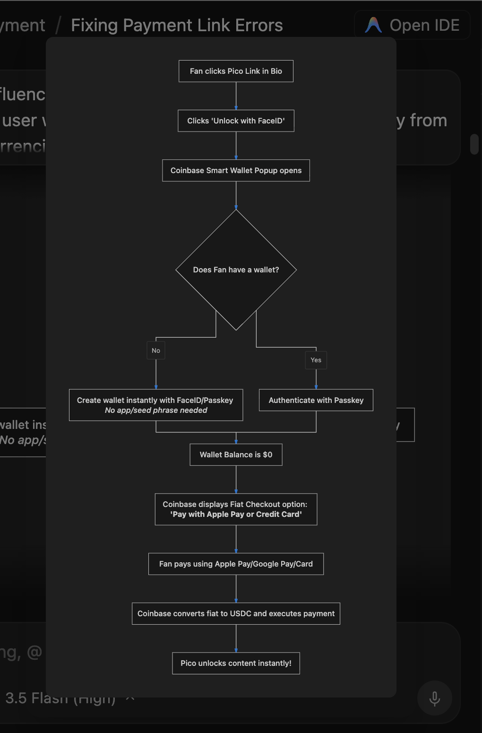

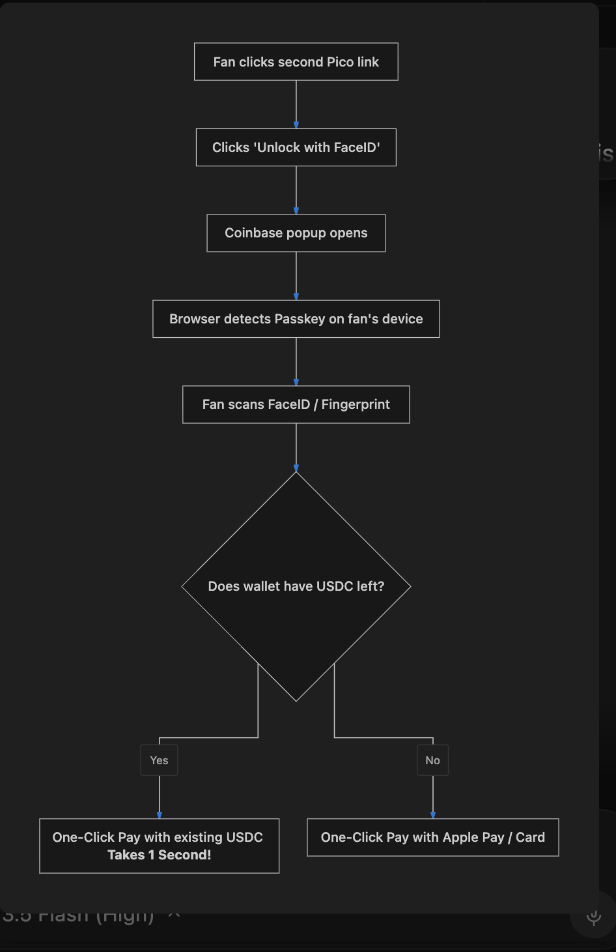

Pico: Business Model, Revenue Model, and Competitive Analysis
This document explains how Pico differentiates itself from traditional bio-link platforms (like Linktree or Beacons) and traditional payment rails (like Stripe), and details our business and revenue model.

1. Competitive Comparison: Pico vs. Traditional Platforms
Metric/Feature | Traditional Bio Links (Linktree, Beacons) | Traditional Payments (Stripe, PayPal) | Pico + Coinbase Smart Wallet (Base L2)
Primary Focus | Traffic routing (links to other websites). | General-purpose credit card processing. | Instant micro-monetization of individual digital assets.
Transaction Fees | Often charges high subscription fees ($5-$30/mo) for custom domains or premium monetization features. | 2.9% + $0.30 flat fee per transaction. | Near-zero network fees (typically <$0.01 per transaction on Base).
Micro-Payment Viability | Unfeasible for items under $3duetoStripe^{'}s$0.30 fixed fee structure. | Dead on arrival for low-ticket items. A $0.50purchaseleavesonly$0.19 for the creator. | Highly viable. A $0.50purchasecosts<$0.01 in fees; the creator keeps ~98-99%.
Checkout Friction | High. Redirects to external stores (Shopify, Gumroad) requiring full checkout forms. | Requires inputting card number, expiry, CVV, billing address, or logging into an account. | One-Click Biometric Checkout (FaceID or Fingerprint) directly inside the in-app browser.
Merchant Onboarding | High friction. Requires setting up store profiles, linking Stripe, completing KYC/bank verification. | Extensive KYC, credit checks, business details, and waiting days for merchant account approval. | Instant (Zero Setup). Creators register a handle and connect their wallet. They can receive funds immediately.
Chargeback & Fraud Risk | High risk. Fraudulent chargebacks cost creators $15-$20 penalties + lost revenue. | Creators bear the risk of chargebacks and sudden account/funds freezes by Stripe. | Zero chargeback risk. Transactions on the blockchain are cryptographically final and irreversible.

2. Our Business Model: "Micro-Monetization"
Traditional creator platforms operate on two primary models:
- Subscriptions (Patreon, Substack): Fans pay $5\text{–}$20/month. This requires fans to commit long-term, resulting in low conversion rates (only 1-2% of a creator's audience subscribes).
- High-Ticket Digital Products (Gumroad, Teachable): Selling courses or books for $10\text{–}$100. This requires high intent and extensive purchasing decisions from fans.

The Pico Strategy
Pico introduces Micro-Monetization:
- Impulse Purchases: Fans can unlock a single prompt, a PDF recipe, a template, or a premium link for $0.20to$1.50.
- Zero Commitment: Fans do not have to subscribe to a monthly fee. They pay a tiny amount for immediate value.
- Instant Gratification: Checkout happens inside the Instagram/TikTok app in under 2 seconds.

3. Our Revenue Model: How Pico Makes Money
Pico's revenue is generated through a hybrid transaction-and-service model:

1. Platform Take Rate (Micro-Transaction Fee)
Instead of charging creators a monthly subscription, Pico charges a 5% platform fee on every transaction.
- Why it works: On a $0.50payment,the5$0.025**.
- The Math: Since the underlying transaction is executed on Base L2, the actual gas cost to route the USDC payment is less than $0.005 (half a cent).
- The Margin: Pico keeps the difference (~$0.02 per transaction). At scale (millions of daily micro-transactions), this yields massive, high-margin revenue.

2. Coinbase Pay Off-Ramp Commission
Creators accumulate their earnings in USDC stablecoin (which is pegged 1:1 to the US Dollar).
- When creators choose to "Cash Out" to their bank account (transferring USDC to USD), Pico routes the transaction through Coinbase Pay's off-ramp API.
- Pico can charge a small convenience fee (e.g., 1%) for instant ACH transfers to banks.

3. Sponsored Gas Packages (Premium Tier)
For professional creators, we offer a subscription tier where Pico sponsors 100% of their fans' gas fees and provides:
- Custom branding on the checkout modal.
- Analytics dashboards.
- Custom checkout domains (e.g., pay.creator.com).

4. Key Differentiators (Why We Win)
- Solving the Micropayment Trap: Traditional payment processors cannot handle transactions under $2.00becauseoffixedfees($0.30 per swipe). By moving transactions onto Base L2, Pico unlocks a completely new economy of $0.10-$1.00 content unlocks.
- Solving In-App Browser Friction: Over 80% of creator traffic comes from Instagram, TikTok, or YouTube in-app browsers. Opening traditional wallets (like MetaMask) fails inside these browsers. By integrating Coinbase Smart Wallet, fans can pay directly inside the social media app using their phone's native biometrics (FaceID/Fingerprint).
- No Crypto Knowledge Required: Fans do not need to know what a "blockchain" or "USDC" is. Coinbase Smart Wallet handles card/Apple Pay funding seamlessly, presenting a checkout screen that looks and feels exactly like standard Apple Pay.

What is our Business & Revenue Model?
- Business Model: A micropayments infrastructure for the passion economy (unlocking single guides, recipes, prompts, files, or premium links for $0.10to$2.00). It acts as an alternative to monthly subscriptions (like Patreon/Substack) which many fans hesitate to join.
- Revenue Model:
  - Transaction Share: We take a small platform fee (e.g., 5%) on successful transactions. Since gas costs on Base are near-zero, this is pure profit margin.
  - Fiat Off-Ramping: We can charge convenience fees when creators convert their USDC stablecoins to USD and withdraw directly to their bank accounts.

3. How the Payments Flow Works (Fiat vs. Stablecoin)
- Fans (Pay in Fiat-Like Experience): If a fan doesn't have crypto, the Coinbase Smart Wallet includes a built-in card checkout. They pay using Apple Pay, Google Pay, or a Credit Card. It converts their payment into USDC instantly. To the fan, it feels like paying with standard money.
- Creators (Receive Stablecoin): Creators receive their payouts instantly in USDC (stablecoin backed 1:1 by the US Dollar). This keeps them safe from crypto price swings. They can click "Cash Out to Bank" on their dashboard to instantly deposit it into their Chase, Wells Fargo, or bank account.

