**COIMBATORE INSTITUTE OF TECHNOLOGY, COIMBATORE – 641 014**

**(Government Aided Autonomous Institution affiliated to Anna University)**

**COIMBATORE-641014**

**DEPARTMENT OF ELECTRONICS AND COMMUNICATION**

**ENGINEERING**

**B.E, VI SEMESTER**

**ACADEMIC YEAR 2019-2020**

**15EC67-ANALOG AND DIGITAL COMMUNICATION LABORATORY**



**DIGITAL COMMUNICATION SYSTEM DESIGN USING 32-ary PSK MODULATION**

**A PROJECT REPORT**

***Submitted by***

|  |  |
| --- | --- |
| GOMATHI R | 1704071 |

Under the guidance of

**Dr.I.S.Akila**

Assistant Professor

Department of Electronics and Communication Engineering

**AIM:**

To build and analyze a Digital communication system employing 32-ary PSK modulation scheme for a Bird signal.

**SOFTWARE USED:**

Software: LabVIEW 2017

Toolkit : NI Modulation Toolkit

**PROJECT DESCRIPTION:**

The proposed Digital Communication System involves the transmission and reception of a bird’s sound. A peacock sound is converted into bit streams for the purpose of modulation in which the bits are mapped to symbols. The bits streams are encoded using convolutional encoder. Convolutional coding is a widely used channel coding method in which the output code bits are determined by logic operations on the present bit in a stream and a small number of previous bits. The encoded bits are then modulated using 32-ary PSK (Phase Shift Keying) modulation scheme. This uses 32 symbols and 11.25° shifts of constant amplitude carrier signal. This arrangement results in the transmission of 5 bits per symbol. The benefit of M-ary PSK is that the constant carrier amplitude means that more efficient non-linear power amplification can be used. The modulated signal is then transmitted over AWGN (Additive White Gaussian Noise) channel. This is the most commonly used channel model in which the only impairment to communication is a linear addition of white band or white noise with a uniform spectral density and a Gaussian distribution of constant amplitude. It has zero mean and adds it to the complex baseband modulated waveform from the modulator block. It gives a signal plus noise waveform with Eb/No. It is followed by Eb/No measurement. Eb/No is defined as the ratio of energy per bit (Eb) to the Spectral Noise Density (No). It is the measure of Signal to Noise ratio for a digital communication system. It is measured at the input to the receiver and is used as the basic measure of how strong the signal is. The signal is then demodulated at the receiver side. It is then decoded using convolutional decoder. The decoded signal is used to calculate BER (Bit Error Rate). BER defines the number of bits that are in error out of the total number of transferrable bits during an observation period. From the signal at the receiver side, SINAD (Signal-to-Noise And Distortion) and THD (Total Harmonic Distortion) are calculated by signal distortion vi for the SNR (Signal to Noise Ratio) measurement. SINAD is the combination of SNR and THD. The SNR characterizes the ratio of fundamental signal to the noise spectrum. The noise spectrum includes all non-fundamental spectral components in the Nyquist frequency range (Sampling frequency / 2) without the DC component, the fundamental itself and the harmonics. The THD characterizes the ratio of the sum of harmonics to the fundamental signal. From the calculated SNR and BER, graph is drawn for various values of Eb/No and the performance of the system is evaluated. Root Raised cosine filter is used in this system. In this filter low frequency produces a frequency response with unity gain and complete at higher frequencies.

**SYSTEM MODEL:**

Bird’s sound

AWGN channel

Modulation

Convolutional encoding

Bit streams

Eb/No measurement

Demodulation

Convolutional decoding

BER and SNR measurements

**THEORETICAL SOLUTIONS:**

The M-ary PSK provides higher data rate and enhanced bandwidth efficiency. Arithmetically M-PSK signal can be represented as,

Si (t) = A cos (2πfct+2π/M*i), i=1, 2, 3

where A is the signal amplitude, M is the number of possible phases of the carrier and fc is the carrier frequency. The probability of error involves comparing the received phase at the receiver (in the presence of noise) to the actual phases. The probability of error is,

Pe ≈ Q $\sqrt{\frac{2Eb}{No}}$ for M=2

Pe ≈ 2Q $\left\{\left.\sqrt{\frac{2Eb}{No}\log_{2}{M\sin^{2}\left(\frac{π}{M}\right)}} \right\}\right.$ for M > 2

The accuracy of transmitted digital signal is measured by BER which is given by,

BER = $\frac{The no.of error bits}{The total no.of bits}$

The SNR is defined as the ratio of signal power to the noise power and is given by,

SNR (dB) = 10 $\log_{10}{\frac{Average signal power}{Noise signal power}}$

In terms of Eb/No­, SNR is given by,

SNR (dB) = 10 $\log_{10}\left(\frac{Eb}{No}\right)$

For Eb/No = 30.896 dB, SNR = 10 $\log_{10}\left(31\right)$ ≈ 15 dB

**FLOWCHART:**

Convert the bird’s sound into stream of bits

Encode the bit streams using MT Convolutional Encode.vi

Modulate the bit streams using MT Modulate PSK.vi

(32-ary PSK)

Transmit the modulated bit stream over AWGN channel

Calculate Eb/No (dB) using MT Calculate EbN0.vi

Demodulate the received bits using MT Demodulate PSK.vi

Decode the bit stream using MT Convolutional Decode.vi

Calculate BER using MT Calculate BER.vi

Calculate SNR using SubVI SNR.vi from the values of SINAD and THD calculated from the Distortion Measurement

Plot and observe SNR vs. BER graph for various values of Eb/No

**SIMULATED RESULTS:**

1) The block diagram of the proposed digital communication system is shown below,

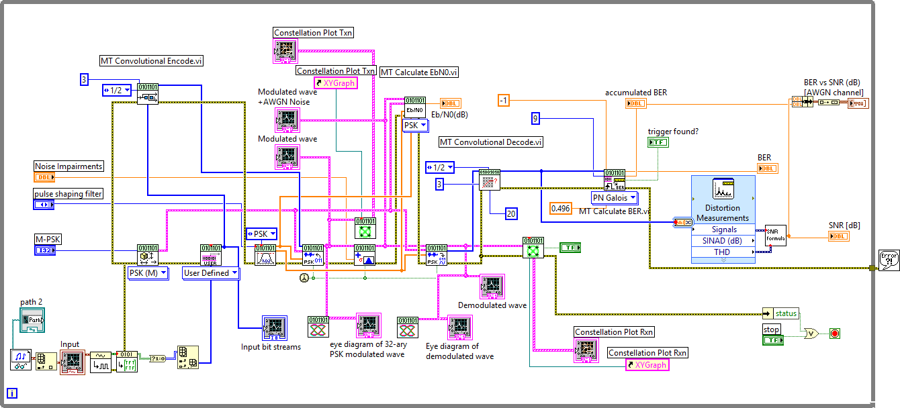

Figure 1. Block diagram of Digital communication system employing 32-ary PSK

2) The waveform of input Peacock signal, PSK, Filter and Noise impairments are shown below,

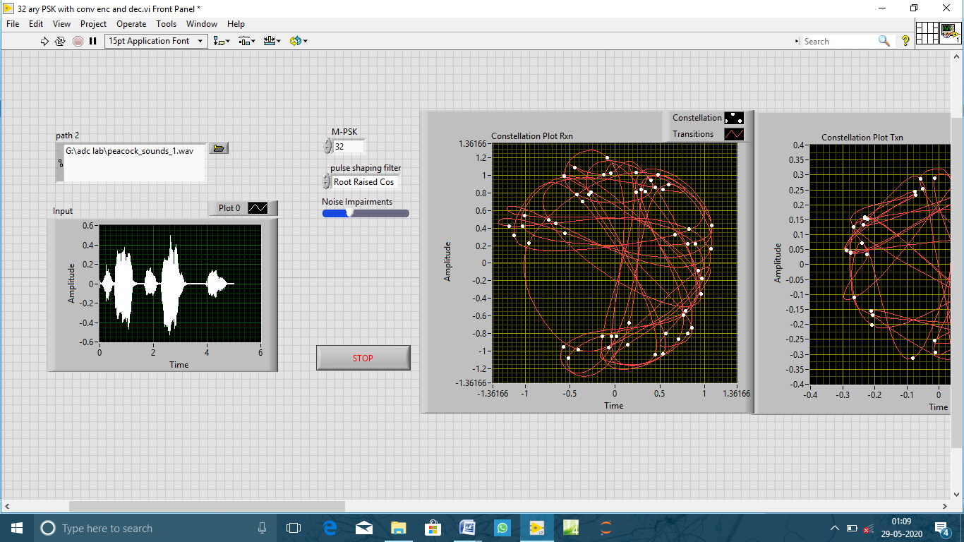

Figure 2. Waveform of Input signal

3) The input bit stream, modulated signal, noise added modulated signal and demodulated signal are shown below,

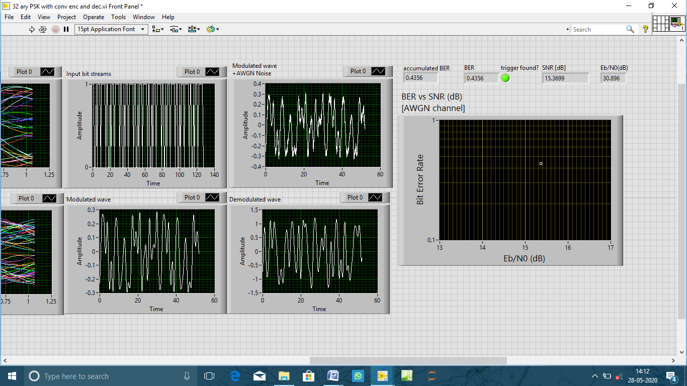

Figure 3. Input bit streams, Modulated wave, Noise added Modulated wave and demodulated wave

4) Constellation graph for transmission and reception are shown below,

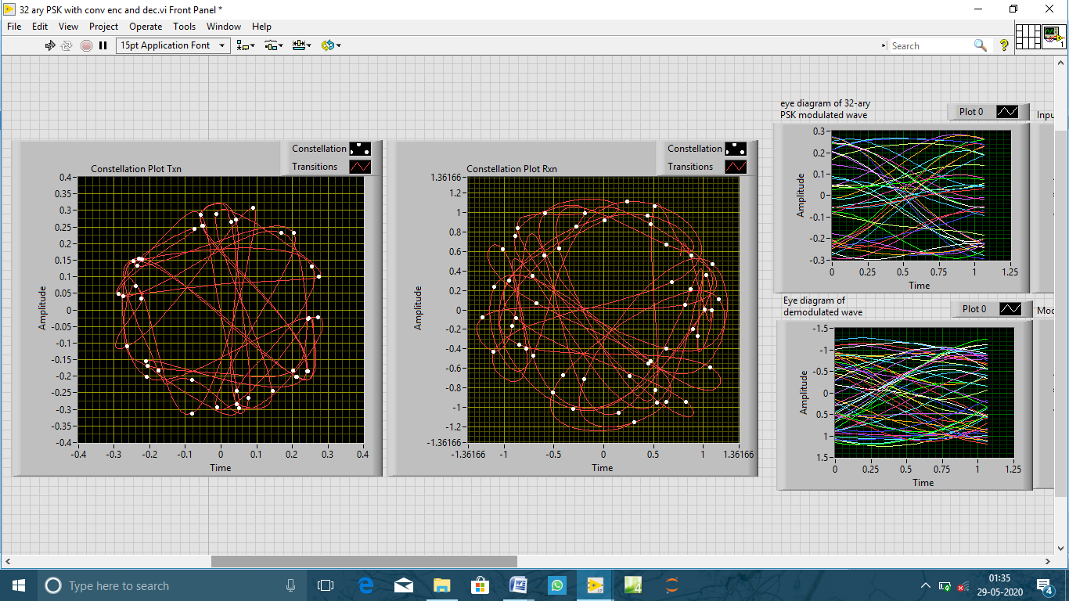

Figure 4. Constellation plot for transmission and reception

5) Eye diagrams of modulated and demodulated wave are shown below,



Figure 5. Eye diagram of modulated wave and demodulated wave

6) BER vs. SNR graph for Eb/No = 30.896 dB is shown below,



Figure 6. BER vs. SNR graph

**INFERENCE:**

* The communication system designed based on M-PSK technique provide high data rate and SNR.
* M-PSK modulation has improved bandwidth efficiency for lower order PSK.
* Data errors can be minimized by using coding techniques which in turn improves the Signal to Noise ratio.
* Transmitted power increases for higher values of M.
* Signal Recovery is more complex as M increases.
* High level PSK modulations are more sensitive to phase differences.
* Higher order PSK modulations exhibit higher error rates; in exchange however they deliver a data rate
* Higher order PSK modulations decreases bandwidth efficiency

**CONCLUSION:**

The Digital Communication system employing 32-ary PSK modulation is implemented in LabVIEW. Suitable filter, encoding and decoding techniques are used and the performance of the system is analyzed over AWGN channel. The performance of other order PSK modulation are also analyzed by changing the parameters in the Front panel of the LabVIEW. From the simulations, it is clear that lower order PSK modulations are more efficient than higher order PSK techniques.

**REFERENCES:**

1. Simon Haykin, “*Digital Communication*” Edition, 2006.
2. Md. Emdadul Haque, Md. Golam Rashed, M. Hasnat Kabir, “A comprehensive study and performance comparison of M-ary modulation schemes for an efficient wireless mobile communication system*,” International Journal of Computer Science, Engineering and Applications (IJCSEA)*, Vol.1, No.3, June 2011.
3. M. Bystrom and J. W. Modestino, "Combined source channel coding schemes for video transmission over an additive white Gaussian noise channel," in *IEEE Journal on Selected Areas in Communications*, vol. 18, no. 6, pp. 880-890, June 2000.
4. Svilen Dimitrov, Balazs Matuz, Gianluigi Liva, Ricardo Barrios, Ramon MataCalvo and Dirk Giggenbach, “Digital Modulation and Coding for Satellite optical feeder links,” in the proceedings of *IEEE conference on Advanced Satellite Multimedia Systems,* pp.150-157, 2014.
5. Kanmani B, “Digital Communication Using LabVIEW”, in *IEEE International Conference in MOOC Innovation and Technology in Education (MITE),* 20-22 Dec. 2013, pp. 405-410, 2013.
6. Shujiao Ji., Ming Zhu, “The Simulation Design of Communication System Based on LabVIEW”, *IEEE 2nd* *International Conference on Measurement, Information and* *Control,* pp. 661-664, 16-18 Aug. 2013.
7. Kalani Nilesh, Anant Dipti, “Performance Analysis of Linear Modulation Techniques with Different Channel Coding in LabVIEW”, *IEEE International conference on* *Circuits, Controls and Communications (CCUBE), CCUBE*, 27-28 Dec.2013, pp 1-5.
8. R. Prameela Devi, Humaira Nishat, “Performance Evaluation of Digital Modulation Schemes-BPSK, QPSK & QAM”, *International Journal of Engineering and Techniques (IJET),* vol. 3 Issue 2, pp. 71-74, March 2017.