Milestone 3: Block Semantic Operators and Adaptive Block Sizing
Kalypso on vLLM · NVIDIA L40S · Qwen2.5-7B-Instruct · code and data: PR #20
Overview. Kalypso runs semantic operators (filter, join, map) with one LLM request per row. We added block versions of all three, which put k rows into one request. We measured when that helps, alone and in pipelines. From the measurements we built a cost model and an algorithm that picks the block size for every stage of a pipeline. We then tested it against static batching and per-tuple execution on 23 experiments it was not built from. Result: 1.12x faster than per-tuple, 3.9% from the best arm measured; static k = 4 / 16 / 32 gave 0.85x / 0.71x / 0.52x.

1. Block Semantic Operators
All three block operators share one interface, so Kalypso's stage scheduler runs them the same way. A query turns them on with block_size > 1 (sem_filter, sem_map) or pair_block_size (join); otherwise the ordinary per-row operator runs.
Member | What it does
supports_blocks = True | The Stage hands the operator one block (a list of rows) per task
block_size, max_block_tokens | Rows per request (k); optionally also close a block when its prompt would exceed this many tokens
run_block(ctxs, priority) | Builds the prompt, calls the LLM, parses, repairs rows the answer missed, returns the rows
evaluate_block(...) | One block request plus parsing; one result per row, or None if unusable
estimate_tokens(ctxs) | Peak tokens of one block (prompt + output cap, or the largest one-row repair); the scheduler reserves this much KV cache per task

 | 1.1 Block Filter | 1.2 Block Join | 1.3 Block Map
Class | BlockSemFilter | CartesianProduct → BlockSemJoin (a BlockSemFilter subclass) | BlockSemMap (a SemMap subclass)
Prompt | Instruction once; rows numbered 1..k, one per line | Same, each item is “Left item: … / Right item: …” | Instruction once; rows as JSON [{id, context}]
Answer format | k lines “<n>: YES|NO” | Same as filter | JSON {items: [{id, output}]}
Parsing | Tolerant line parser (YES/NO/TRUE/FALSE); each id once, in range | Same as filter | Strict JSON; an id must be in 1..k with one string output
Bad or missing answer | One-row fallback call, run sequentially | Same as filter | Ordinary one-row SemMap path, with its retry
Output budget | 16 + 6·k tokens | 16 + 6·k tokens | 32 + each row's SemMap budget
Result | true / false / undecided; passing rows continue | Pairs keep idx and right_idx | Each row stored as if mapped alone; answer-length estimator updated
Key parameters | block_size, max_tokens_per_row, single_max_tokens, negate | pair_block_size, max_tokens_per_pair | block_size, max_tokens_overhead; pin not allowed

2. Architecture Diagram
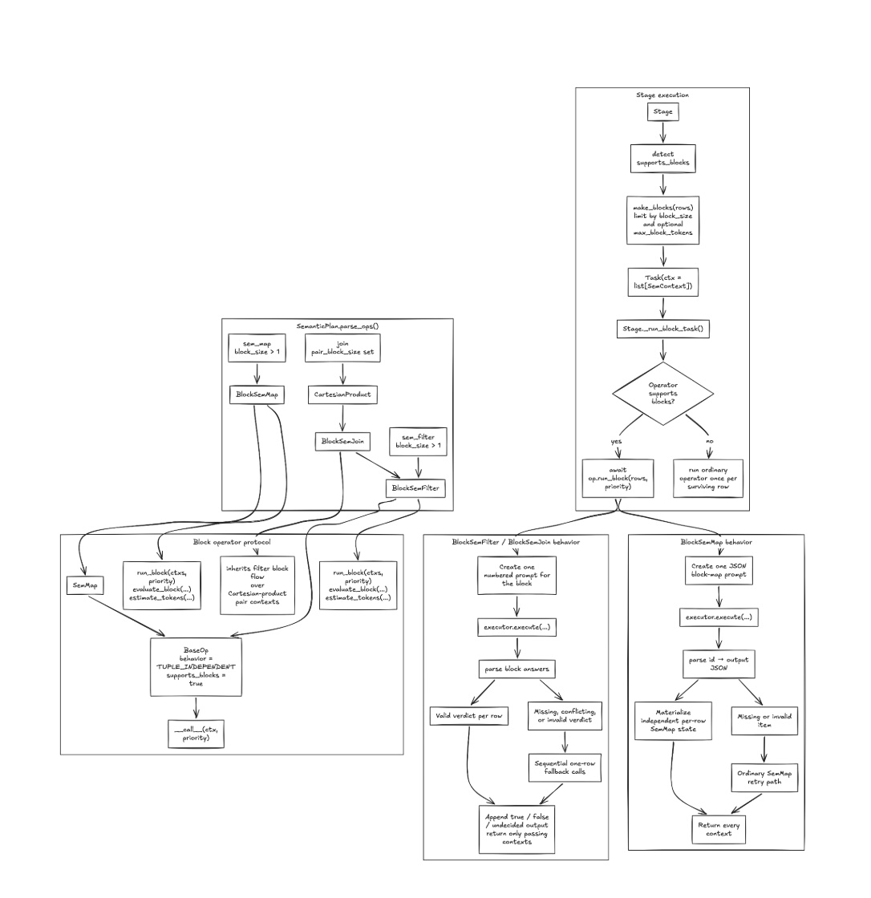
Figure 1. Planner, stage scheduler and block operators.
The planner (SemanticPlan.parse_ops) replaces operators that have a block size with their block versions; a block join becomes CartesianProduct followed by BlockSemJoin. The Stage detects supports_blocks, groups rows with make_blocks (by block_size and max_block_tokens) and runs each block as one task through run_block. Filters and joins parse one verdict per row and fall back to one-row calls; maps parse JSON and repair bad items with SemMap.

3. Hardware, Datasets and Execution Modes
Hardware / serving | Setting | Why it matters for batching
GPU | 1× NVIDIA L40S 48 GB (Modal), fresh server per experiment | Sets prefill (reading) and decode (writing) speed
Server, model | vLLM 0.29.0 + Kalypso, Qwen2.5-7B-Instruct (bf16), temperature 0 | vLLM already batches separate requests; answers repeat exactly
Limits | max_num_seqs 256, max_num_batched_tokens 2048, max_model_len 32768 | ≤ 256 requests at once (more run in waves); context caps block size
Prefix cache | On, reset before every trial | Repeated prompt text is reused, so per-tuple is already cheap

Dataset | Rows | Labels | Workloads built from it
SemBench movie reviews | ~31 tokens (short) | Sentiment | Filter “clearly positive?” (100–1865 rows, 7–92% true); join “opposite / same sentiment?” (16×16–64×64 pairs); map “main reason in one sentence” (100–500); pipelines filter→join, filter→map, map→filter, join→filter
ContractNLI (NDAs) | ~1500 tokens (long); also cut to ~125–940 | Entailment, with evidence spans | Filter “does the contract entail the hypothesis?” (200–400 rows); join contract × hypothesis (24×8, 40×8); filter, join and map on contracts cut to a set length

Mode | Meaning
Per-tuple (kalypso_per_tuple) | Ordinary Kalypso, one request per row or pair (baseline)
Static block (kalypso_block:k) | Same block size k in every stage
Per-stage block (kalypso_pipe:k1,k2) | Its own block size per stage
Direct vLLM (vllm_direct) | Per-row requests without Kalypso; an accuracy control only

Measurement. Each arm: 1 warm-up and 3 timed repeats, median latency, arms interleaved. Speedup = per-tuple latency ÷ arm latency. Accuracy = F1 change vs per-tuple (maps: ROUGE-1 against per-tuple output).

4. Analysis: Batching Alone and in Pipelines
vLLM already batches separate requests and caches repeated prompt text, so a block only saves what each request repeats: instructions, answer format and extra waves. In exchange, one request writes k answers one after another, and the wave waits for it. Blocking therefore helps only when the per-request overhead is a large part of each request.

4.1 Each operator alone
Workload | k = 2 | k = 4 | k = 6–8 | k ≥ 16 | Accuracy change
Filter, short rows, 100 rows | – | 1.22x | 0.93–1.03x | – | F1 +0.06 to +0.09
Filter, short rows, 1000–1865 rows | – | 2.08–2.15x | 2.15–2.30x | 1.56–2.03x | F1 +0.10 to +0.11
Join, short rows, 32×32 – 64×64 | 1.46–1.48x | 1.44–1.49x | 1.42–1.45x | 1.07–1.35x | F1 −0.07 to +0.07
Map, short rows, 500 | 1.14x | 0.92x | 0.68–0.77x | 0.37x | ROUGE-1 0.32–0.37
Filter, long rows (~1500 tok) | 0.99–1.02x | 0.94x | 0.84x | 0.68x | F1 −0.08 to −0.19
Join, long rows (~1600 tok) | 0.30x | 0.21x | 0.16x | – | F1 −0.13 to 0

Row length isolated: the same contracts cut to set lengths and run as each operator (best block k ≥ 2 vs per-tuple; below 1 = per-tuple faster):
Tokens per row | ~31 | ~140 | ~260 | ~500 | ~940 | ~1500
Filter | 2.16x | 1.33x | 1.15x | 1.07x | 1.00x | 1.02x
Join | 1.50x | 0.97x | 0.70x | 0.50x | 0.37x | 0.30x
Map | 1.14x | 1.03x | 0.80x | 0.88x | 0.80x | –

4.2 Pipelines
Finding | Evidence
Blocks stay full: a stage holds rows until it has k | 100% fill in all 9 pipeline runs checked
A filter's block size changes the next stage's work | A blocked filter passed 1.2–4x more rows to the join (recall 0.79 vs 0.63 per-tuple)
The best size in a pipeline differs from each stage's best alone | Filter → join: filter per-tuple + join k 2 was fastest (1.45x), though the filter alone is fastest blocked
Blocking a neighbour makes a per-tuple map cut off and redo answers | 12–56% of map rows rerun
Join → filter: small blocks in both stages | Join 2, filter 2–3: 1.21–1.40x
Stages on one GPU add up | Pipeline ≈ 0.98 × sum of stage times

4.3 Patterns
- Filters: block short rows (k 3–8); the gain fades with length and is gone by ~1000 tokens.
- Joins: block only when both sides are short (k 2–4); with a long row a block repeats it in every pair, while per-tuple reads it once from the cache.
- Maps and long rows: do not block. Large blocks (k ≥ 16) never pay.
- Pipelines: choose all stages together; the best k depends on measured speeds, lengths and pass rates, so it needs a fitted model.

5. Cost Model and Algorithm
No fixed size works (k = 4 ranged from 0.21x to 2.15x), so the algorithm predicts the latency of every block-size choice with a model fitted to our runs and picks the fastest. It was fitted on 45 runs (173 single-operator arms, 75 pipeline arms) by least squares.

5.1 Model
Stage latency, operator op, n items of t tokens, block size k:
L(op,n,t,k) = g[op] + α·P + (β + τ[op])·W·D + γ·C·D + δ·C·(p/1000)²
C = n if k = 1 else ⌈n/k⌉ requests
W = ⌈C / 256⌉ waves (256 = max_num_seqs)
k = 1: D = d_pt[op] p = t + q_pt[op] P = n·(t − t_L + a_pt[op]) + L·t_L
k > 1: D = d0[op] + d1[op]·k p = q[op] + k·(t + e[op])
P = n·(t + e[op]) + C·o[op] − c_L[op]·max(0, C − L)·t_L
(t_L, L: tokens and count of a join's left rows; P = prompt tokens not served by the cache)
Pipeline of stages j = 1..m, N input rows, R right rows per join, selectivity s_j:
n_1 = N
items_j = n_j·R if op_j is a join, else n_j
L_j = L(op_j, items_j, t_j, k_j) + reruns_j
n_{j+1} = items_j·(r_j(k_j)·s_j + f_j(k_j)·(1 − s_j)) for a filter or join
= n_j for a map
L_pipeline(k_1..k_m) = λ·Σ_j L_j

Constant | Value (L40S, Qwen2.5-7B) | Constant | Value
g filter / join / map | −0.057 / −0.048 / 0.286 s | α (prefill) | 0.79 s per 10k tokens
β (decode step) | 24.8 ms | τ map (longest answer) | 11.0 ms
γ (busy batch) | 0.10 ms per token | δ (attention) | 1.77 ms per (1k tokens)²
d0 + d1·k filter / join / map | −2.6+4.46k / −2.6+4.57k / 63+14.7k | q_pt filter / join / map | 133 / 157 / 128
r, f short filter (k=1 → k≥2) | recall 0.63 → 0.79, fpr 0.013 → 0.03 | λ | 0.98
r, f long filter (k=1 → k≥2) | recall 0.70 → 0.45, fpr 0.35 → 0.2 | map reruns ρ | 0.12–0.56 of map rows

5.2 Algorithm (paste-ready)
ALGORITHM ChooseBlockSizes(pipeline P = (op_1..op_m), N, tokens per row t, right rows R,
selectivities s_j, fitted constants Θ)
Output: block size k_j per stage (k_j = 1 means no batching)
1. Bounds. For each stage j:
K_j = {1, ..., min(k_ctx_j, k_meas_j, n_j)}
k_ctx_j = largest k whose block prompt + answer fits max_model_len
k_meas_j = largest k measured for (op_j, short ≤ 512 < long tokens per row)
2. Predict. For every k = (k_1..k_m) in K_1 × ... × K_m, compute L_pipeline(k) (model above),
passing on the rows each filter or join keeps at its block size.
3. Pick. L* = min L_pipeline(k); T = { k : L_pipeline(k) ≤ 1.02·L* }
return the k in T with the smallest Σ_j k_j (ties: lower L_pipeline)
4. Optional accuracy guard: before step 2, cap K_j at the largest k whose measured F1 stayed
within 0.02 of per-tuple (maps: ROUGE-1 ≥ 0.8).

Example. Filter → join, 100 × 32 rows, 68% true: per-tuple filter passes ≈ 43 rows (0.63·0.68 + 0.013·0.32), a blocked one ≈ 54, which gives the join ~350 more pairs. The model picks filter 1, join 2 (10.9 s predicted); measured 10.4 s, 1.45x, the fastest arm.
Prediction error | Mean | Max
Single operators (fitted / one workload left out) | 4.3% / 4.8% | 36% / 61%
Pipelines (fitted) | 13.2% | 87%
23 held-out experiments, the arm the algorithm picked | 6.5% | 25%

6. Experiments and Ablation Results
Design | What we did
Held out | The algorithm chose block sizes before each run; choices were frozen; none of these runs is in the fit
Rounds | 1 (5): filter 1500 rows, join 48×48, filter→join, filter→map, map→filter. 2 (4): join→filter at four selectivities. 3 (14): long-row filter and join; filter, join and map at ~125–940 tokens per row
Compared | Per-tuple; static k = 4, 16, 32; best size per operator (fastest size for each operator alone); algorithm; algorithm + accuracy guard; oracle = fastest arm measured
Metrics | Speedup vs per-tuple (geometric mean); regret = slower than the oracle; F1 change

6.1 Ablations: block size, row length, pipelines
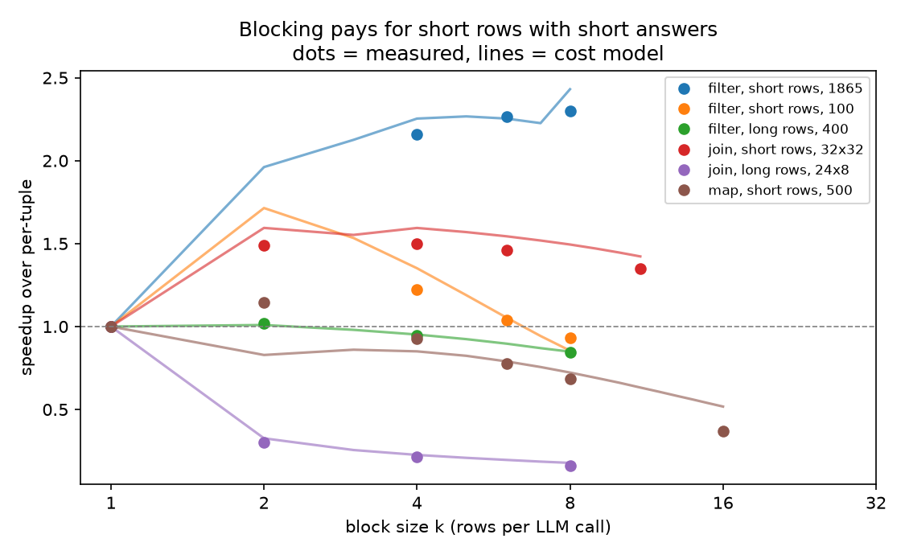 | 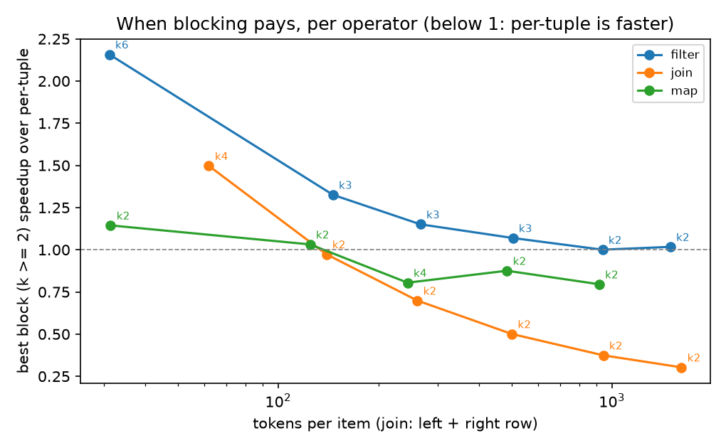
Speedup vs block size (dots measured, lines = model) | Best block vs per-tuple by row length

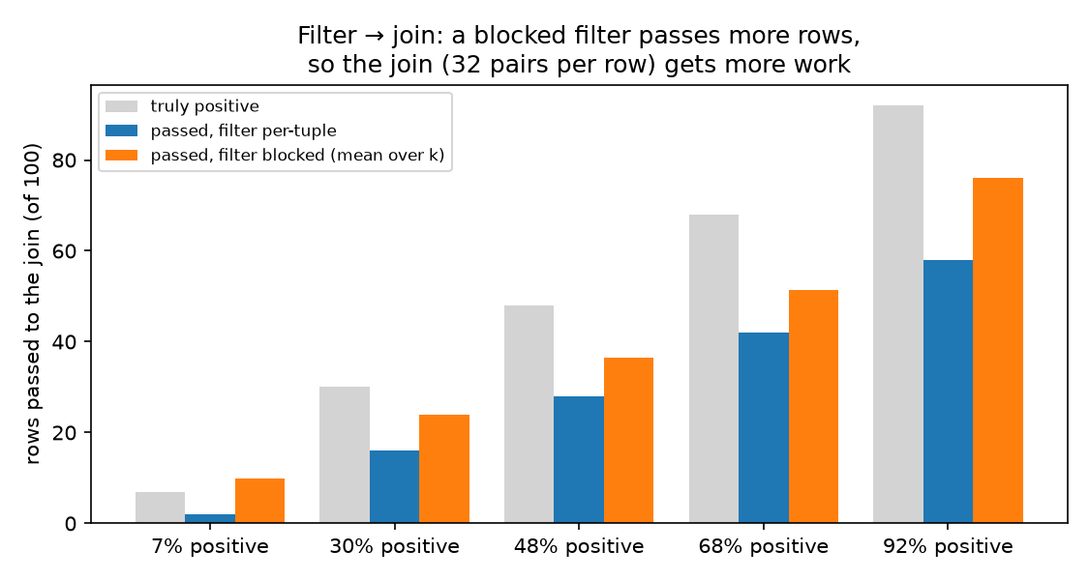 | 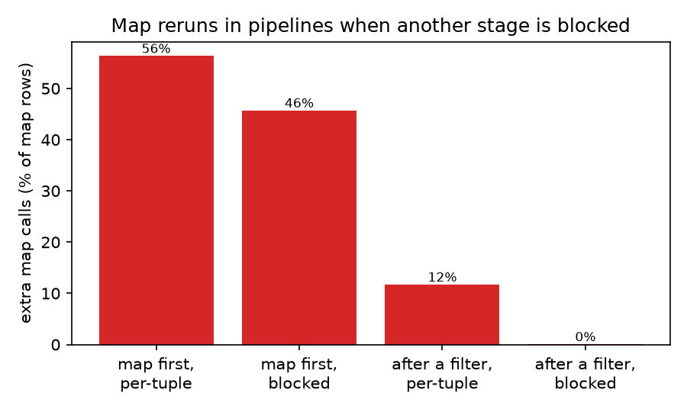
Rows a filter passes to the join | Map rows redone when a neighbour is blocked

6.2 Algorithm vs static batching and per-tuple
Strategy | Round 1 | Round 2 | Round 3 | All 23 | Mean regret | Worst regret
Per-tuple | 1.00x | 1.00x | 1.00x | 1.00x | 19% | 126%
Static k = 4 | 1.08x | 1.25x | 0.69x | 0.85x | 54% | 380%
Static k = 16 | 0.69x | 0.89x | 0.65x | 0.71x | 96% | 438%
Static k = 32 | 0.47x | 0.62x | 0.51x | 0.52x | 193% | 858%
Best size per operator | 1.31x | 1.25x | 0.90x | 1.03x | 17% | 182%
Algorithm | 1.38x | 1.17x | 1.03x | 1.12x | 3.9% | 24%
Algorithm + accuracy guard | 1.17x | 1.07x | 1.03x | 1.07x | 10% | 54%
Oracle (best measured) | 1.45x | 1.31x | 1.04x | 1.16x | 0% | 0%

Experiment | Algorithm picked | Speedup | Fastest measured | Regret
Filter, 1500 short rows | k 6 | 2.23x | k 7, 2.26x | 1%
Join, 48 × 48 | k 2 | 1.52x | k 3, 1.54x | 1%
Filter → join, 75% | filter 1, join 2 | 1.45x | same | 0%
Filter → map / map → filter | per-tuple | 1.00x | 1.05x / 1.24x | 5% / 24%
Join → filter (4) | join ≈ 10, filter 2 | 1.09–1.22x | join 2, filter 2–3: 1.21–1.40x | 7–16%
Long-row filter and join | per-tuple | 1.00x | same | 0%
Filter, ~140–940 tokens | k 2 | 1.27x → 1.00x | k 3 (k 2 at 940) | 0–4%
Join and map, ~125–940 tokens | per-tuple (join 140: k 2) | 0.97–1.00x | per-tuple (map 125: k 2) | 0–3%

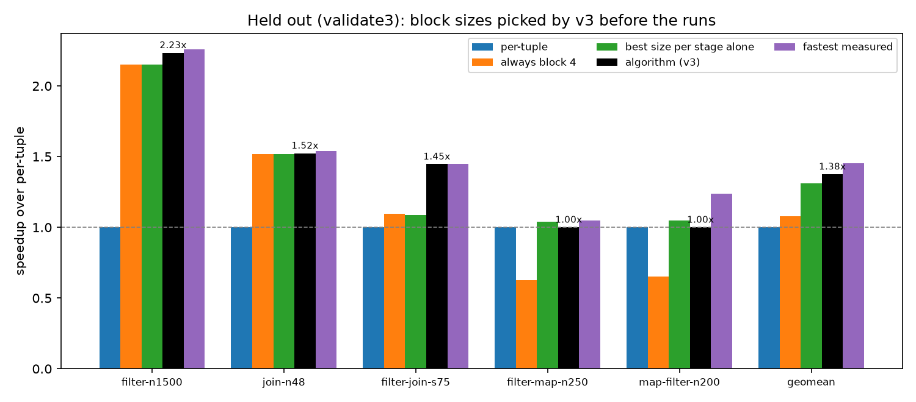
Round 1: speedup per strategy and experiment
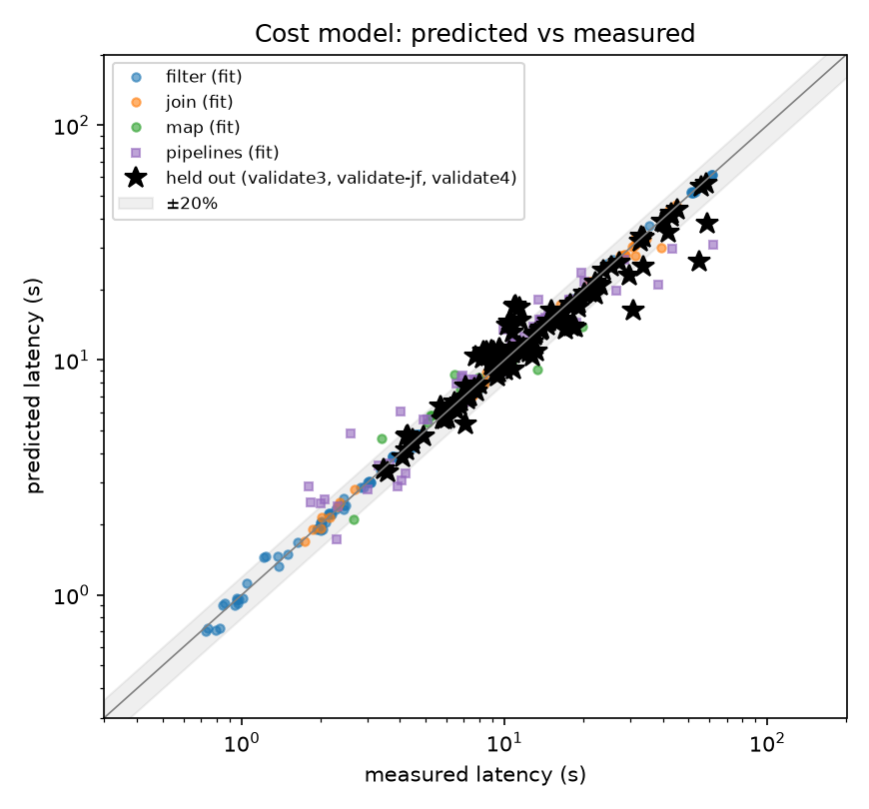
Predicted vs measured latency (stars: held out)

6.3 Conclusions and limits
- Beats static batching and per-tuple: 1.12x overall; no static size is safe (k = 4 was 2.15x on one filter and 0.21x on a long-row join).
- Never far from the best: worst case 24% from the oracle, against 380–860% for static sizes.
- Beats best size per operator (1.12x vs 1.03x): that rule ignores row length and stage interaction; it chose correctly not to block long rows, joins and maps.
- Misses: map → filter (per-tuple predicted 5.3 s, measured 7.1 s) and join → filter (it assumed per-tuple join recall 0.69; with the same-sentiment question it was ~0.05).
- Limits: one GPU and model (refit for others); latency first, so blocking can lower F1 (use the guard); true selectivity was given, a deployed version must estimate it.

