Batching Semantic Operators in Kalypso
When does it pay, and how big should the blocks be? L40S GPU · vLLM 0.29.0 · Qwen2.5-7B-Instruct · full details in STUDY.md (PR #20)
Summary. A semantic operator (filter, join or map) can send one row per LLM call (per-tuple), or put k rows into one call (a block of size k). We measured both, built a cost model from the measurements, and used it to choose the block size for each stage of a pipeline. We then tested it on 15 experiments it had not seen.
Question | Short answer
Q1. When does batching help, alone and in pipelines? | Short rows with short answers (filter, join): up to 2.2x faster, best k = 2–8. The gain fades as rows get longer and is gone by ~1000 tokens. Maps and large blocks (k ≥ 16) are slower. In a pipeline, a filter's block size changes how many rows the next stage gets.
Q2. Algorithm: block or not, and what size? | A fitted latency cost model predicts every block-size combination for the pipeline and picks the fastest. k = 1 means “don't block”.
Q3. Experiments vs static batching and per-tuple | 15 held-out experiments: algorithm 1.19x vs per-tuple, 5.7% from the best measured arm. Static k = 4 / 16 / 32: 1.00x / 0.80x / 0.58x.

Q1. Batching for each operator, alone and in pipelines

Hardware
Item | Setting | Why it matters for batching
GPU | 1× NVIDIA L40S, 48 GB (on Modal), one container per experiment | Sets how fast prompts are read and answers are written
Server | vLLM 0.29.0, OpenAI-compatible server, default bf16 weights | vLLM already runs separate requests together on the GPU
Batch limits | max_num_seqs 256, max_num_batched_tokens 2048, max_model_len 32768 | Up to 256 calls run at once; more calls run in waves
Prefix cache | On; reset before every trial | Separate calls reuse shared prompt text, so per-tuple is already cheap
Model | Qwen2.5-7B-Instruct, temperature 0 | Same answers on every repeat
Measurement | 1 warm-up + 3 repeats, median time; arms interleaved A, B, A, B | Slow drift affects all arms equally

Workloads
Workload | Operator | Rows | Tokens per row | Correct answers from
Movie reviews: “Is the review clearly positive?” (7–92% true) | filter | 100–1865 | ~31 | SemBench sentiment labels
Review pairs: “Opposite sentiment?” (10–90% match) | join | 16×16 – 64×64 | ~31 per side | SemBench labels
Reviews: “Main reason, in one sentence” | map | 100–500 | ~31 | No labels: compared with per-tuple output (ROUGE-1)
Contracts: “Does the contract entail the hypothesis?” | filter | 300–400 | ~1500 | ContractNLI labels
Contracts cut to a set length (the window keeps the evidence) | filter | 400 | 146 / 267 / 505 / 937 | ContractNLI labels
Contract × clause | join | 24×8, 40×8 | ~1600 + 15 | ContractNLI labels
Pipelines: filter→join, filter→map, map→filter, join→filter | 2 stages | 50–1000 | ~31 | Labels of the whole query

Each operator alone
vLLM already batches separate requests and caches repeated prompt text. So a block only saves the work every call repeats (instructions, answer format, extra waves). In exchange, one call has to write k answers one after another.
Case | Does blocking help? | Evidence (speed vs per-tuple)
Short rows, short answers (filter, join), many rows | Yes, k 2–8 | Filter 1500 rows: 2.2x at k 6–7. Join 48×48: 1.5x at k 2–3
Few rows (50–100) | Barely | 1.0–1.1x; starting the operator dominates
Medium rows (146–505 tokens) | A little, k 2–3 | 1.33x at 146, 1.15x at 267, 1.07x at 505
Long rows (937–1500 tokens) | No | ≤ 1.02x; reading the row dominates
Long answers (map) | No | 0.37–0.9x; one call writes all k answers
Long-row join | No, much slower | 0.21–0.30x; every pair in a block repeats the contract
Large blocks (k ≥ 16) | No | 0.47–0.69x, and accuracy drops

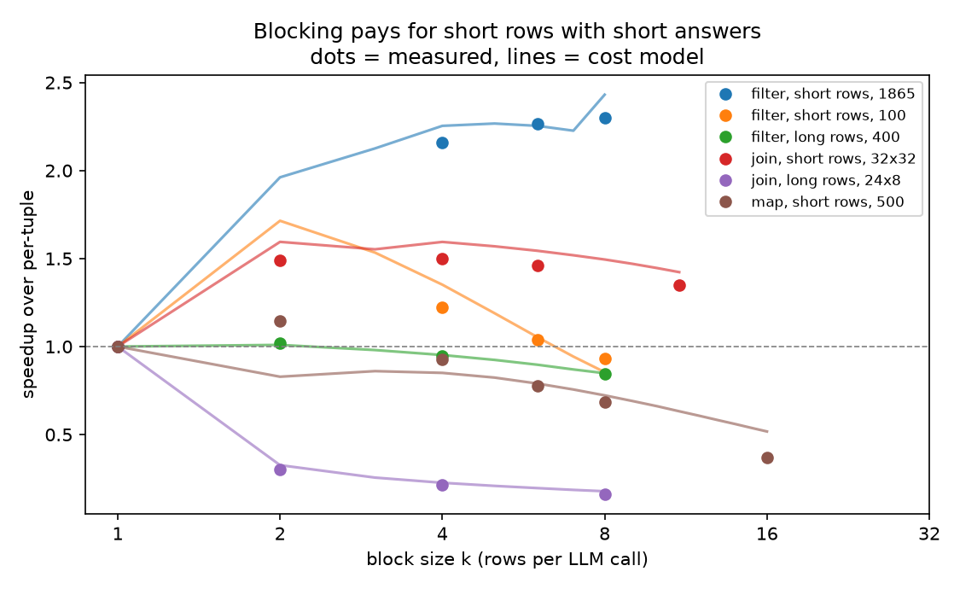 | 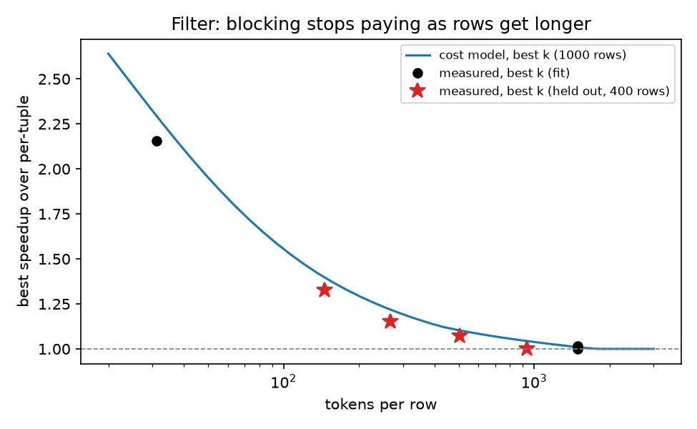
Speed vs block size (dots measured, lines = cost model) | Best filter speed vs row length (stars = held-out sweep)

Tokens per row | 31 | 146 | 267 | 505 | 937 | ~1500
Best speedup measured | 2.26x | 1.33x | 1.15x | 1.07x | 1.00x | 1.00x
Best block size | 7 | 3 | 3 | 3 | 2 | 1
F1 change from blocking | +0.11 | −0.12 | −0.11 | −0.18 | −0.25 | −0.1 to −0.2

F1 change = F1 with blocking minus F1 per-tuple. Negative means blocking lost accuracy.

Operators in pipelines
Finding | Evidence
Blocks stay full. Rows are held until a block has k of them; only the last block can be short | 100% block fill in every pipeline run
A filter's block size changes the next stage's work | A blocked filter passed 1.2–4x more rows to the join than per-tuple (table below)
Block the expensive stage, not the cheap one before it | Filter per-tuple + join k=2 was fastest (1.45x)
Join→filter: small blocks in both stages win | Join 2, filter 2–3: 1.21–1.40x
Blocking one stage can make a per-tuple map cut off answers and redo them | 12–56% of map rows rerun
Stages share one GPU, so their times add up | Pipeline ≈ 0.98 × sum of stage times
A join's accuracy depends on how its question is worded | “Same sentiment?”: per-tuple join found 0–8% of true pairs, blocks 23–49%

Filter → join (100 rows) | s10 | s25 | s50 | s75 | s90
Truly positive | 7 | 30 | 48 | 68 | 92
Passed, filter per-tuple | 2 | 16 | 28 | 42 | 58
Passed, filter blocked | 8 | 23 | 36 | 50 | 78

Rules: (1) choose all stages' block sizes together, not one stage at a time; (2) keep blocks full; (3) don't block maps or long rows; (4) proposed fixes: group block-join pairs by left row, and fix the map's answer-length estimate.

Q2. Algorithm: whether to batch, and what block size
No single block size works everywhere (k = 4 ranged from 0.21x to 2.15x). The best size depends on things that have to be measured: GPU speed, prompt and answer lengths, and how many rows each filter passes. So we fit a cost model on 45 measured runs (173 single-operator arms, 75 pipeline arms) and use it to choose.

Cost model: time of one stage
Time = start cost + reading prompts + writing answers + batch slowdown + long-prompt cost
Part | What it counts | Fitted value (L40S)
Start cost | Fixed cost to start the operator | map 0.29 s; filter, join ≈ 0
Reading prompts | Prompt tokens not already in the cache | 0.79 s per 10k tokens
Writing answers | Waves of up to 256 calls × answer length | 24.8 ms per token step (+11 ms for maps)
Batch slowdown | More running calls make each token slower | 0.1 ms per token
Long-prompt cost | Attention grows with the square of prompt length | 1.77 ms per call per (1k tokens)²

Input to the model | Per-tuple (k = 1) | Block of k
Number of calls | N | N / k (rounded up)
Answer length (tokens) | fixed per operator | filter −2.6 + 4.5k, join −2.6 + 4.6k, map 63 + 14.7k
Rows passed to the next stage | rows × (recall·s + false-pos rate·(1 − s)) | same, with recall and false-pos rate measured at that k

The algorithm
Step | What it does
1 | For each stage, list block sizes from 1 up to the largest that fits the context window and was measured for that operator and row length
2 | Try every combination of block sizes across the stages (k = 1 means no blocking)
3 | Predict each stage's time, passing on the number of rows each filter or join keeps
4 | Pick the combination with the lowest total time
5 | If several are within 2% of the best (about the model's error), take the smallest blocks
6 | Optional accuracy guard: skip block sizes where F1 dropped more than 0.02

Example. Filter → join, 100 × 32 rows, 68% pass. The model predicts filter per-tuple + join k = 2 is fastest (10.9 s). Measured: 10.4 s, 1.45x, the fastest arm. Blocking the filter would pass more rows and make the join slower.
How accurate the model is | Mean error | Max error
Single operators (fitted) | 4.3% | 36%
Single operators, one workload left out | 4.8% | 61%
Pipelines (fitted) | 13.2% | 87%
15 held-out experiments, the arm it picked | 6.3% | 25%

Q3. Experiments: algorithm vs static batching and per-tuple
Design choice | What we did
Held out | The model chose block sizes before each run. Choices were saved and never changed. None of these runs were used to fit the model
Experiments (15) | Round 1: filter 1500 rows, join 48×48, filter→join, filter→map, map→filter. Round 2: join→filter at 4 selectivities. Round 3: long-row filter and join; filters at 146 / 267 / 505 / 937 tokens per row
Compared | Per-tuple; static k = 4, 16, 32 (same k for every stage); best size per operator from single-operator runs; the algorithm; the algorithm with accuracy guard
Oracle | The fastest arm measured in that experiment (we also ran a grid of sizes around the pick)
Metrics | Speedup vs per-tuple (geometric mean); regret = how much slower than the oracle; F1 change. Same GPU and settings as Q1

Strategy | Round 1 | Round 2 (join→filter) | Round 3 (long rows, lengths) | All 15 | Mean regret | Worst regret
Per-tuple | 1.00x | 1.00x | 1.00x | 1.00x | 29% | 126%
Static k = 4 | 1.08x | 1.25x | 0.82x | 1.00x | 40% | 380%
Static k = 16 | 0.69x | 0.89x | 0.86x | 0.80x | 82% | 438%
Static k = 32 | 0.47x | 0.62x | 0.73x | 0.58x | 184% | 858%
Best size per operator | 1.31x | 1.25x | 1.08x | 1.20x | 5.5% | 33%
Algorithm | 1.38x | 1.17x | 1.07x | 1.19x | 5.7% | 24%
Algorithm + accuracy guard | 1.17x | 1.07x | 1.07x | 1.10x | 15% | 54%
Oracle (best measured) | 1.45x | 1.31x | 1.09x | 1.26x | 0% | 0%

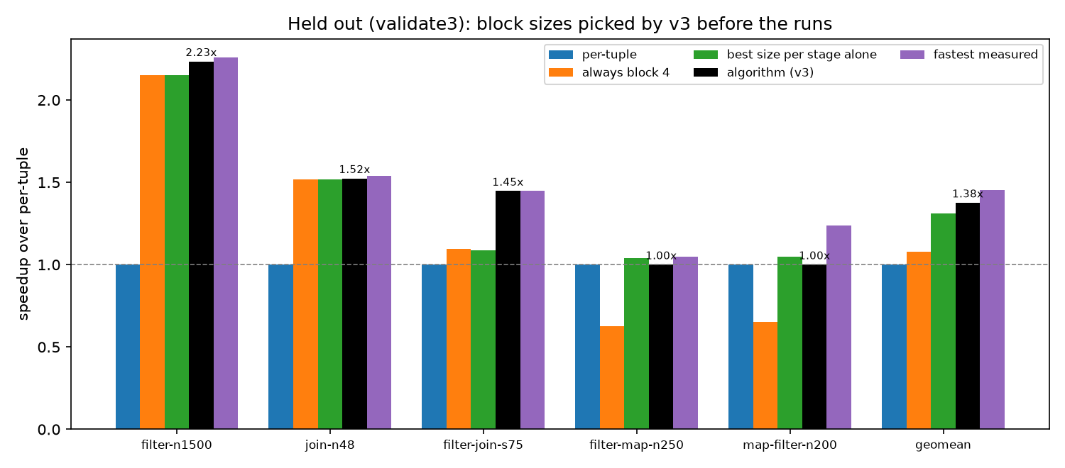
Round 1: speedup of each strategy per experiment
Experiment | Algorithm picked | Its speedup | Fastest measured | Regret
Filter, 1500 short rows | k 6 | 2.23x | k 7, 2.26x | 1%
Join, 48×48 | k 2 | 1.52x | k 3, 1.54x | 1%
Filter → join, 75% | filter 1, join 2 | 1.45x | same | 0%
Filter → map, 250 rows | per-tuple | 1.00x | filter 2, map 1: 1.05x | 5%
Map → filter, 200 rows | per-tuple | 1.00x | map 1, filter 2: 1.24x | 24%
Join → filter (4 runs) | join ≈10, filter 2 | 1.09–1.22x | join 2, filter 2–3: 1.21–1.40x | 7–16%
Long-row filter, 300 rows | per-tuple | 1.00x | same | 0%
Long-row join, 40×8 | per-tuple | 1.00x | same (k 4: 0.21x) | 0%
Rows of 146 / 267 tokens | k 2 | 1.27x / 1.12x | k 3: 1.33x / 1.15x | 4% / 2%
Rows of 505 / 937 tokens | k 2 | 1.05x / 1.00x | k 3 / k 2 | 2% / 0%

What the experiments show
- Beats static batching and per-tuple. 1.19x overall. No static size was good everywhere: k = 4 was 2.15x on one filter and 0.21x on the long-row join.
- Never far from the best. Worst case 24% slower than the best measured arm. Static sizes were up to 380–860% slower.
- Ties with “best size per operator” overall (1.19x vs 1.20x). It wins when the stages interact (round 1, 1.38x vs 1.31x) and loses on join→filter.
- Correct on long rows. It chose not to block, which was the fastest choice.
Where it missed | Why
Map → filter (24% regret) | Predicted 5.3 s for per-tuple, measured 7.1 s. Repeats varied by ~1 s
Join → filter (7–16% regret) | It assumed the per-tuple join finds 69% of matches (learned from other joins). With this question it found ~5%, so the model planned with the wrong row counts

Limits
- One GPU and one model. Other hardware needs a refit on a small sweep; the model's form stays the same.
- Speed comes first. Blocking often lowers F1 (−0.1 to −0.25 on joins and contract filters); use the accuracy guard when that matters.
- The model was given each workload's true selectivity. A real run would estimate it as rows go by (proposed, not built).

