Hibernate Tutorial



This hibernate tutorial provides in-depth concepts of Hibernate Framework with simplified examples. It was started in 2001 by Gavin King as an alternative to EJB2 style entity bean.

Hibernate Framework

Hibernate is a Java framework that simplifies the development of Java application to interact with the database. It is an open source, lightweight, ORM (Object Relational Mapping) tool. Hibernate implements the specifications of JPA (Java Persistence API) for data persistence.

ORM Tool

An ORM tool simplifies the data creation, data manipulation and data access. It is a programming technique that maps the object to the data stored in the database.

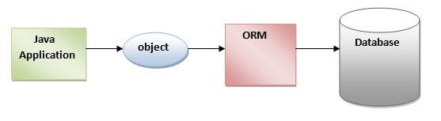

The ORM tool internally uses the JDBC API to interact with the database.

What is JPA?

Java Persistence API (JPA) is a Java specification that provides certain functionality and standard to ORM tools. The **javax.persistence** package contains the JPA classes and interfaces.

Advantages of Hibernate Framework

Following are the advantages of hibernate framework:

1) Open Source and Lightweight

Hibernate framework is open source under the LGPL license and lightweight.

2) Fast Performance

The performance of hibernate framework is fast because cache is internally used in hibernate framework. There are two types of cache in hibernate framework first level cache and second level cache. First level cache is enabled by default.

3) Database Independent Query

HQL (Hibernate Query Language) is the object-oriented version of SQL. It generates the database independent queries. So you don't need to write database specific queries. Before Hibernate, if database is changed for the project, we need to change the SQL query as well that leads to the maintenance problem.

4) Automatic Table Creation

Hibernate framework provides the facility to create the tables of the database automatically. So there is no need to create tables in the database manually.

5) Simplifies Complex Join

Fetching data from multiple tables is easy in hibernate framework.

6) Provides Query Statistics and Database Status

Hibernate supports Query cache and provide statistics about query and database status.

# Hibernate Architecture

The Hibernate architecture includes many objects such as persistent object, session factory, transaction factory, connection factory, session, transaction etc.

The Hibernate architecture is categorized in four layers.

* Java application layer
* Hibernate framework layer
* Backhand api layer
* Database layer

Let's see the diagram of hibernate architecture:

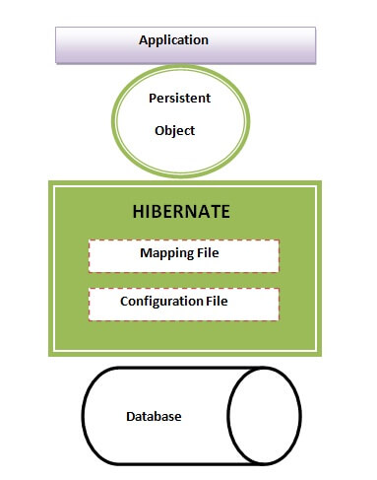

## Elements of Hibernate Architecture

|  |
| --- |
| For creating the first hibernate application, we must know the elements of Hibernate architecture. They are as follows: |

#### **SessionFactory**

The SessionFactory is a factory of session and client of ConnectionProvider. It holds second level cache (optional) of data. The org.hibernate.SessionFactory interface provides factory method to get the object of Session.

#### **Session**

The session object provides an interface between the application and data stored in the database. It is a short-lived object and wraps the JDBC connection. It is factory of Transaction, Query and Criteria. It holds a first-level cache (mandatory) of data. The org.hibernate.Session interface provides methods to insert, update and delete the object. It also provides factory methods for Transaction, Query and Criteria.

#### **Transaction**

The transaction object specifies the atomic unit of work. It is optional. The org.hibernate.Transaction interface provides methods for transaction management.