CPE 233: Peripheral assignment 3, Keypad Driver

Prof. Bridget Benson

Marina Dushenko, Luis Gomez

# BBD

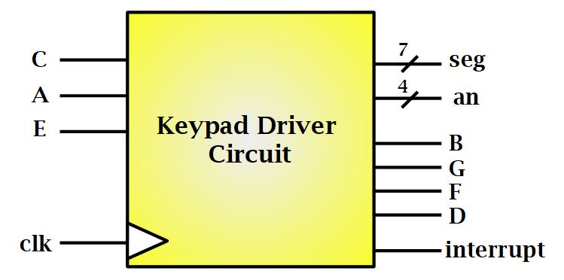

# Behavior

The **Keypad Driver** is a sequential circuit whose inputs are 1-bit signals from a ‘key-press’ on the keypad circuit, and whose output consists of a four 1-bit signals driving the keypad-columns, 11-bits driving a seven-segment display, and 1-bit 60ns interrupt pulse.

The Keypad Driver allows a user to interact with an external keypad circuit, reading from a 3 X 4 matrix of push-buttons. The user’s button-press is registered and displayed on a seven-segment display for the duration of the key-press; releasing the button will clear the display digit.

# Structural

The structural design of the Keypad Driver is found below:

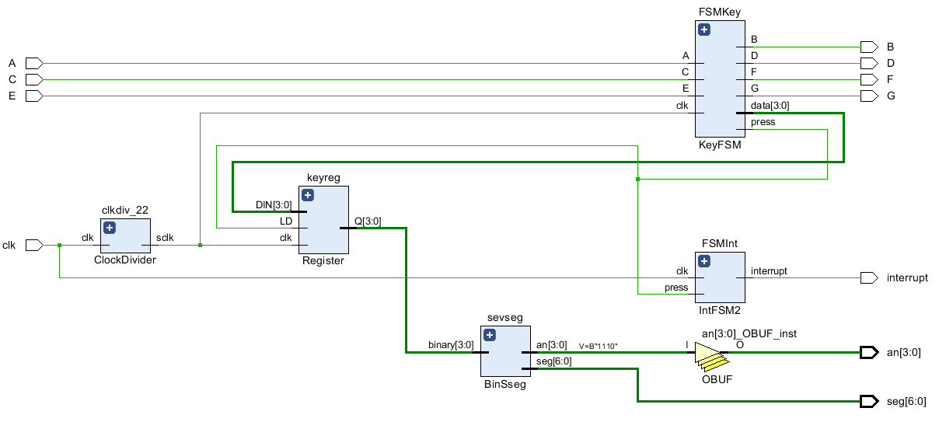

# Specifications

|  |  |
| --- | --- |
| **Operating Speed**: 22Hz w/ Button Signal Debounced | **Supports 3 X 4 Keypads** |
| **Input Clock**: 100Mhz | **Output:** 3.3 V 60ns Interrupt pulse |
| **Output Characters:** 0-9, ‘A’, ‘b’ to a Seven-Segment Display | **Input** |

The Key-Pad driver consists of various modules:

* **Key-Press FSM:** Finite state machine which drives high signal through a keypad column each cycle (22 hz). Four states are State B, State G, State F, State D. During each state, the FSM reads in C, A , E inputs and drives the corresponding key-value to the 4-bit Register.
* **Interrupt FSM:** Finite state machine which drives the 60ns Interrupt signal. The FSM has seven states 0-7, during each state the FSM checks if a debounced-button press has been input. When a debounced button-press is detected, the FSM drives the Interrupt signal high for that cycle (10ns). Over the span of 6 additional states, the cumulative period of the interrupt signal amounts to 60ns.
* **Seven-Segment Display Driver:** Converts a 4-bit binary input into a Seven-Segment Display Digit.
* **Clock-Divider:** Generates the 22 hz ‘slow’ clock
* **4-bit Register:** 4-bit register with a LD input

# 

# Verification

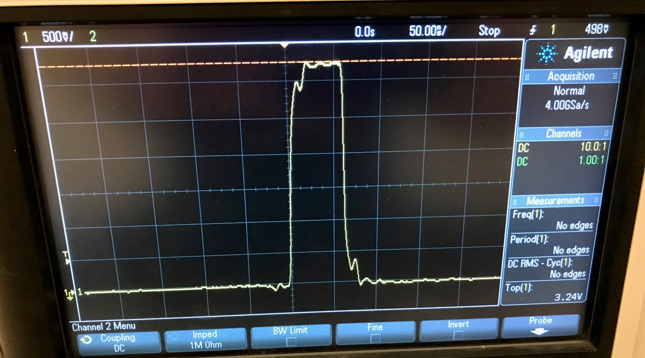

***Interrupt Signal as seen by the Oscilloscope***

# Example Assembly Code

.EQU KEYPAD_PORT = 0x82

.CSEG

.ORG 0x1

; Code Demonstrating use of the Key Pad Driver

; 8-bit counter with LD

SEI

start: MOV R0, 0x00

count: ADD R0, 0x01

CMP R0, 0xFF

BRNE count

BRN start

.CSEG

.ORG 0x3FF

ISR: IN R0, KEYPAD_PORT

RETIE

# System Verilog Source Code

# Key-Press FSM (3pgs)

`timescale 1ns / 1ps

module KeyFSM(input clk, C, A, E,

output logic B, G, F, D, press,

output logic [3:0] data

);

typedef enum {STATE_B, STATE_G, STATE_F, STATE_D} STATE;

STATE NS, PS = STATE_B;

always_ff @ (posedge clk)

begin

PS <= NS;

end

always_comb

begin

case(PS)

STATE_B:

begin

if(C == 1)

begin

data = 1;

press = 1;

end

else if(A == 1)

begin

data = 2;

press = 1;

end

else if(E == 1)

begin

data = 3;

press = 1;

end

else

begin

data = 13;

press = 0;

end

begin

B = 1; G =0; F = 0; D = 0;

NS = STATE_G;

end

end

STATE_G:

begin

if(C == 1)

begin

data = 4;

press = 1;

end

else if(A == 1)

begin

data = 5;

press = 1;

end

else if(E == 1)

begin

data = 6;

press = 1;

end

else

begin

data = 12;

press = 0;

end

begin

B = 0; G = 1; F = 0; D = 0;

NS = STATE_F;

end

end

STATE_F:

begin

if(C == 1)

begin

data = 7;

press = 1;

end

else if(A == 1)

begin

data = 8;

press = 1;

end

else if(E == 1)

begin

data = 9;

press = 1;

end

else

begin

data = 14;

press = 0;

end

begin

B = 0; G = 0; F = 1; D = 0;

NS = STATE_D;

end

end

STATE_D:

begin

if(C == 1)

begin

data = 10;

press = 1;

end

else if(A == 1)

begin

data = 0;

press = 1;

end

else if(E == 1)

begin

data = 11;

press = 1;

end

else

begin

data = 15;

press = 0;

end

begin

B = 0; G = 0; F = 0; D = 1;

NS = STATE_B;

end

end

default: NS = STATE_B;

endcase

end

endmodule

# Interrupt FSM (2pgs)

`timescale 1ns / 1ps

module IntFSM2(

input clk, press,

output logic interrupt

);

typedef enum {ST0, ST1, ST2, ST3, ST4, ST5, ST6, ST7} STATE;

STATE NS, PS = ST0;

always_ff @ (posedge clk)

begin

PS <= NS;

end

always_comb

begin

interrupt = 0 ;

case(PS)

ST0:

begin

if (press == 0)

begin

interrupt = 0;

NS = ST0;

end

else

NS = ST1;

end

ST1:

begin

if(press == 1)

interrupt = 1;

NS = ST2;

end

ST2:

begin

if(press == 1)

interrupt = 1;

NS = ST3;

end

ST3:

begin

if(press == 1)

interrupt = 1;

NS = ST4;

end

ST4:

begin

if(press == 1)

interrupt = 1;

NS = ST5;

end

ST5:

begin

if(press == 1)

interrupt = 1;

NS = ST6;

end

ST6:

begin

if(press == 1)

interrupt = 1;

NS = ST7;

end

ST7:

begin

if(press == 1)

begin

interrupt = 0;

NS = ST7;

end

else

NS = ST0;

end

default: NS = ST0;

endcase

end

endmodule

# 4-bit Register

module Register(input clk, LD,

input [3:0] DIN,

output logic [3:0] Q

);

always_ff @ (posedge clk)

begin

case(LD)

1: Q <= DIN;

0: Q <= Q;

endcase

end

endmodule

# Clock Divider

module ClockDivider(

input clk,

output logic sclk);

localparam MAX_COUNT = 2272727;

logic [26:0] count = 0;

always_ff @ (posedge clk)

begin

count <= count + 1;

if (count == MAX_COUNT)

begin

count <= 0;

sclk <= ~sclk;

end

end

endmodule

# Seven Segment Display Driver

module BinSseg(

input [3:0] binary,

output logic [6:0] seg,

output [3:0] an

);

//always block for converting binary into 7 segment format

always_comb

begin

case (binary) //case statement

0 : seg = 7'b1000000;

1 : seg = 7'b1111001;

2 : seg = 7'b0100100;

3 : seg = 7'b0110000;

4 : seg = 7'b0011001;

5 : seg = 7'b0010010;

6 : seg = 7'b0000010;

7 : seg = 7'b1111000;

8 : seg = 7'b0000000;

9 : seg = 7'b0010000;

10: seg = 7'b0001000;

11: seg = 7'b0000011;

12: seg = 7'b1000110;

13: seg = 7'b0100001;

14: seg = 7'b0000110;

15: seg = 7'b1111111; // Shuts off output

//15: seg = 7'b0001110;

//switch off 7 segment character when the bcd digit is not a decimal number.

default : seg = 7'b1111111;

endcase

end

assign an = 4'b1110;

endmodule