CPE 233: Software assignment 7

Prof. Bridget Benson

Luis Gomez, Marina Dushenko

# Behavior

In this assignment, we wrote two Assembly programs using the RAT simulator.

**Program 1**: A Rat Assembly implementation of a Stack Data Structure (Last In First Out behavior). This program continuously reads 8-bit inputs from port 0x9A, adding each value to the ‘Top’ of the stack (Memory location) until 0xFF is read. When 0xFF is input, the program begins to ‘Pop’ and output values (port 0x42) opposite in order to which they were input.

**Program 2:** A Rat Assembly implementation of a Queue Data Structure (First In First Out behavior). This program continuously reads 8-bit inputs from port 0x9A, adding each value to the ‘Front’ of the Queue (Memory location) until 0xFF is read. When 0xFF is input, the program begins to ‘Deque’ and output values (port 0x42) in order by which they were input.

# Flowchart

**Program 1**

# 

**Program 2**

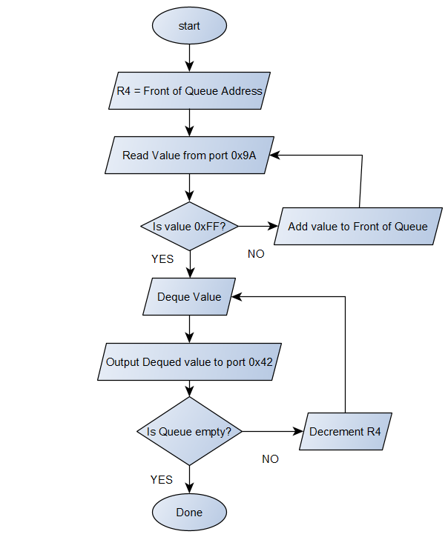

# Verification

**Program 1 Verification**

|  |  |  |  |  |  |  |  |  |  |  |
| --- | --- | --- | --- | --- | --- | --- | --- | --- | --- | --- |
|  |  |  | **Memory** |  |  |  |  |  |  |  |
| **Input (hex)** | **Output** | **R3 (stack size)** | **0xF8** | **0xF9** | **0xFA** | **0xFB** | **0xFC** | **0xFD** | **0xFE** | **0xFF** |
| **01** | -- | **01** | 000 | 000 | 000 | 000 | 000 | 000 | 000 | **001** |
| **02** | -- | **02** | 000 | 000 | 000 | 000 | 000 | 000 | **002** | **001** |
| **03** | -- | **03** | 000 | 000 | 000 | 000 | 000 | **003** | **002** | **001** |
| **04** | -- | **04** | 000 | 000 | 000 | 000 | **004** | **003** | **002** | **001** |
| **05** | -- | **05** | 000 | 000 | 000 | **005** | **004** | **003** | **002** | **001** |
| **06** | -- | **06** | 000 | 000 | **006** | **005** | **004** | **003** | **002** | **001** |
| **07** | -- | **07** | 000 | **007** | **006** | **005** | **004** | **003** | **002** | **001** |
| **08** | -- | **08** | **008** | **007** | **006** | **005** | **004** | **003** | **002** | **001** |
| **FF** | **08** | **07** | 000 | **007** | **006** | **005** | **004** | **003** | **002** | **001** |
| -- | **07** | **06** | 000 | 000 | **006** | **005** | **004** | **003** | **002** | **001** |
| -- | **06** | **05** | 000 | 000 | 000 | **005** | **004** | **003** | **002** | **001** |
| -- | **05** | **04** | 000 | 000 | 000 | 000 | **004** | **003** | **002** | **001** |
| -- | **04** | **03** | 000 | 000 | 000 | 000 | 000 | **003** | **002** | **001** |
| -- | **03** | **02** | 000 | 000 | 000 | 000 | 000 | 000 | **002** | **001** |
| -- | **02** | **01** | 000 | 000 | 000 | 000 | 000 | 000 | 000 | **001** |
| -- | **01** | **00** | 000 | 000 | 000 | 000 | 000 | 000 | 000 | 000 |

**Program 2 Verification**

|  |  |  |  |  |  |  |  |  |  |  |  |
| --- | --- | --- | --- | --- | --- | --- | --- | --- | --- | --- | --- |
|  |  |  |  | **Memory** |  |  |  |  |  |  |  |
| **Input (hex)** | **Output** | **R3**  **(Queue size)** | **R4**  **(Front of Queue)** | **0xF8** | **0xF9** | **0xFA** | **0xFB** | **0xFC** | **0xFD** | **0xFE** | **0xFF** |
| **01** | -- | **01** | 0xFF | 000 | 000 | 000 | 000 | 000 | 000 | 000 | **001** |
| **02** | -- | **02** | 0xFF | 000 | 000 | 000 | 000 | 000 | 000 | **002** | **001** |
| **03** | -- | **03** | 0xFF | 000 | 000 | 000 | 000 | 000 | **003** | **002** | **001** |
| **04** | -- | **04** | 0xFF | 000 | 000 | 000 | 000 | **004** | **003** | **002** | **001** |
| **05** | -- | **05** | 0xFF | 000 | 000 | 000 | **005** | **004** | **003** | **002** | **001** |
| **06** | -- | **06** | 0xFF | 000 | 000 | **006** | **005** | **004** | **003** | **002** | **001** |
| **07** | -- | **07** | 0xFF | 000 | **007** | **006** | **005** | **004** | **003** | **002** | **001** |
| **08** | -- | **08** | 0xFF | **008** | **007** | **006** | **005** | **004** | **003** | **002** | **001** |
| **FF** | **01** | **07** | 0xFE | **008** | **007** | **006** | **005** | **004** | **003** | **002** | 000 |
| -- | **02** | **06** | 0xFD | **008** | **007** | **006** | **006** | **004** | **003** | 000 | 000 |
| -- | **03** | **05** | 0xFC | **008** | **007** | **006** | **006** | **004** | 000 | 000 | 000 |
| -- | **04** | **04** | 0xFB | **008** | **007** | **006** | **006** | 000 | 000 | 000 | 000 |
| -- | **05** | **03** | 0xFA | **008** | **007** | **006** | 000 | 000 | 000 | 000 | 000 |
| -- | **06** | **02** | 0xF9 | **008** | **007** | 000 | 000 | 000 | 000 | 000 | 000 |
| -- | **07** | **01** | 0xF8 | **008** | 000 | 000 | 000 | 000 | 000 | 000 | 000 |
| -- | **08** | **00** | 0xF7 | 000 | 000 | 000 | 000 | 000 | 000 | 000 | 000 |

# Source Code

PROGRAM 1: Stack Implementation

.EQU IN_PORT = 0x9A

.EQU OUT_PORT = 0x42

.CSEG

.ORG 0x01

;-------------------

; registers used:

; R1- Input

; R2- Ouput

; R3- stack size counter

;-------------------

start: IN R1,IN_PORT ;READ: read value from port 0x9A

CMP R1,0xFF ;Is value 0xFF?

BREQ popped

PUSH R1 ;If not, push value to stack, return to READ

ADD R3,0x01 ; increment stack size

BRN start

popped: POP R2 ;Popped: pop stack

OUT R2,OUT_PORT ;output popped value

SUB R3, 0x01 ;decrement stack size

CMP R3, 0x00

BRNE popped ;is stack empty? return to Popped

PROGRAM 2: Queue Implementation

.EQU IN_PORT = 0x9A

.EQU OUT_PORT = 0x42

.CSEG

.ORG 0x01

;-------------------------

; Registers Used:

; R1- input

; R2- output

; R3- Queue size counter

; R4- Front of Queue address

;-------------------------

MOV R4, 0xFF ; Front of Queue address

queue: IN R1, IN_PORT

CMP R1, 0xFF ; Check if value read is 0xFF

BREQ deque

PUSH R1 ; Push to stack

ADD R3,0x01 ; increment stack size

BRN queue

deque: LD R2,(R4) ; deque from front

OUT R2,OUT_PORT

SUB R4,0x01 ; shift queue address

SUB R3,0x01 ; decrement stack size

CMP R3,0x00 ; is stack empty?

BRNE deque