CPE 233: Software assignment 7

Prof. Bridget Benson

Luis Gomez, Marina Dushenko

# Behavior

In this assignment, we wrote two Assembly programs and subroutines using the RAT simulator.

**Program 1**: A Rat Assembly 8-bit BCD converter. The program reads an 8-bit value from port 0x9A and utilizes the DIV_10 subroutine twice, finally outputting the BCD equivalent of the 8-bit values via ports 0x41, 0x42, and 0x43.

# Flowchart

**Program 1**

# 

# Verification

**Program 1 Verification**

|  |  |  |  |  |  |  |  |
| --- | --- | --- | --- | --- | --- | --- | --- |
|  |  |  | **Registers** |  |  | **Output** |  |
|  | **In_Port 0x9A** | **R0 (Input)** | **R1 (Quotient)** | **R2 (Remainder)** | **0x41** | **0x42** | **0x43** |
| **start** | 0xFF | - | - | - | - | - | - |
| **1st Call** | - | 0xFF | 0x19 | 0x05 | - | - | - |
| **2nd Call** | - | 0x19 | 0x02 | 0x05 | - | - | 0x05 |
| **end** | - | 0x19 | 0x02 | 0x05 | **0x02** | **0x05** | **0x05** |
|  |  |  |  |  |  |  |  |
| **start** | 0x68 | - | - | - | - | - | - |
| **1st Call** | - | 0x68 | 0x0A | 0x04 | - | - | - |
| **2nd Call** | - | 0x0A | 0x01 | 0x00 | - | - | 0x04 |
| **end** | - | 0x0A | 0x01 | 0x00 | **0x01** | **0x00** | **0x04** |
|  |  |  |  |  |  |  |  |
| **start** | 0x09 | - | - | - | - | - | - |
| **1st Call** | - | 0x09 | 0x00 | 0x09 | - | - | - |
| **2nd Call** | - | 0x00 | 0x00 | 0x00 | - | - | 0x09 |
| **end** | - | 0x00 | 0x00 | 0x00 | **0x00** | **0x00** | **0x09** |

# Source Code

PROGRAM 1: 8b BCD converter

; Efficient 8bit to BCD converter

.EQU IN_PORT = 0x9A

.EQU OUT_PORT_1 = 0x43

.EQU OUT_PORT_10 = 0x42

.EQU OUT_PORT_100 = 0x41

.CSEG

.ORG 0x01

; Registers Used

; R0- Input

; R1- Subroutine Quotient

; R2- Subroutine Remainder

main: IN R0, IN_PORT

CALL DIV_10

MOV R0, R1

OUT R2, OUT_PORT_1

CALL DIV_10

OUT R2, OUT_PORT_10

OUT R1, OUT_PORT_100

END: BRN END

; Subroutine DIV_10

; Description:

; Subroutine divides input value by 10

;

; Parameter Registers:

; R0- Input

; R1- Quotient

; R2- Remainder

DIV_10: MOV R1, 0x00 ; Quotient/Counter

MOV R2, R0 ; Remainder

DIFF: CMP R2, 0x0A ; Remainder < 10?

BRCS END_SUB ; if True, branch

ADD R1, 0x01 ; Else, increment Quotient/Counter

SUB R2, 0x0A ; Remainder - 10

BRN DIFF

END_SUB:RET

# Behavior

**Program 2:** A Rat Assembly 16-bit multiplier. The program reads operands A & B from port 0x9A, and uses the ADD_EIGHT_BIT subroutine to compute the product. The subroutine adds the carry from each iteration to a Register storing the ‘Top’ 4-bits of the product. The program then outputs the ‘Top’ and ‘Bottom’ parts of the 16-bit product to ports 0x41 and 0x42 respectively.

# Flowchart

**Program 2**

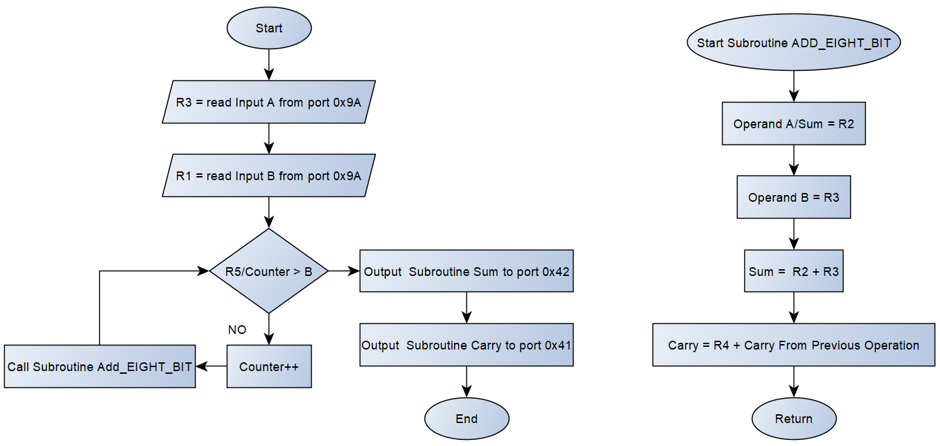

# Verification

**Program 2 Verification**

Below we have provided four test trials of the 16b multiplier program. In some cases, the iterations can span many loops, which would be very impractical to tabulate.

|  |  |  |  |  |
| --- | --- | --- | --- | --- |
| **Trial #** | **Input A (R3)** | **Input B (R1)** | **Top (R4)** | **Bot (R2)** |
| 1 | 0x00 | 0xFF | 0x00 | 0x00 |
| 2 | 0xFF | 0x00 | 0x00 | 0x00 |
| 3 | 0x55 | 0x1 | 0x00 | 0xFF |
| 4 | 0x04 | 0x40 | 0x01 | 0x00 |

PROGRAM 2: 16b Multiplier

.EQU IN_PORT = 0x9A

.EQU OUT_PORT_TOP = 0x41

.EQU OUT_PORT_BOT = 0x42

.CSEG

.ORG 0x01

; Efficient Program that computes 16b product of

; 8 bit values, A * B

;

; Registers Used

; R1- Input B

; R2- Output Bot / Subroutine Operand A & Sum

; R3- Input A / Subroutine Operand B

; R4- Output Top / Subroutine Carry

; R5- Counter

MOV R2, 0x00 ; Initialize Registers

MOV R4, 0x00

MOV R5, 0x00

IN R3, IN_PORT ; Input A

IN R1, IN_PORT ; Input B

CMP R3, 0x00

BREQ OUTPUT

MULT: CMP R5, R1 ; counter > B?

BREQ OUTPUT

ADD R5, 0x01 ; counter++

CALL ADD_EIGHT_BIT

BRN MULT

OUTPUT: OUT R2, OUT_PORT_BOT

OUT R4, OUT_PORT_TOP

END: BRN END

; Subroutine ADD_EIGHT_BIT

; Description:

; Subroutine adds two 8b registers and

; stores the carry.

;

; R2- Operand A & Sum

; R3- Operand B

; R4- Carry

ADD_EIGHT_BIT:

ADD R2,R3 ; Sum = A + B

ADDC R4, 0x00 ; Store Carry

END_SUB: RET