CPE 233: Software assignment 8

Prof. Bridget Benson

Luis Gomez, Isai Bolaños

# Behavior

In this assignment, we wrote two Assembly programs and subroutines using the RAT simulator.

**Program 1**: A Rat Assembly Interrupt driven program. The interrupt driven program turns LEDS on and off. The Interrupt toggles LED output on and off, additionally the switch input is EXOR w/ the current LED output.

Input: 8-bit switch input from SWITCH_PORT.

Output: 8-bit led output from LED_PORT

# Flowchart

**Program 1**

# 

# Verification

**Program 1 Verification**

|  |  |  |
| --- | --- | --- |
| **Switch Input** | **Interrupt** | **LED output** |
| - | 0 | 00000000 |
| 10101010 | 1 | 10101010 |
| - | 0 | 10101010 |
| 10101011 | 1 | 00000000 |
| - | 0 | 00000000 |
| 00000000 | 1 | 00000001 |
| - | 0 | 00000001 |
| 11110001 | 1 | 00000000 |
| - | 0 | 00000000 |
| 00001111 | 1 | 00001111 |
| - | 0 | 00001111 |

# Source Code

PROGRAM 1: 8b BCD converter

; This is an interrupt driven program that turns LEDS on and off

; Interrupt toggles LED output on and off, additionally the

; switch input is EXOR w/ the current LED output

; Input: 8-bit switch input from SWITCH_PORT

; Output: 8-bit led output from LED_PORT

.EQU LED_PORT = 0x42

.EQU SWITCH_PORT = 0x9A

.CSEG

.ORG 0x01

; Registers Used

; R0 = LED TOGGLE

; R1 = LED states

; R2 = SWITCH states

; R3 = Output

MOV R0, 0x00

MOV R1, 0x00

MOV R3, 0x00

SEI

loop: OUT R3, LED_PORT ; Output LEDS

BRN loop

ISR: IN R2, SWITCH_PORT

EXOR R0, 0x01 ; Toggle LEDs

EXOR R1, R2 ; EXOR switches, LEDs

CMP R0, 0x00 ; Are LEDs Enabled?

BRNE tog_on

MOV R3, R0 ; Output = Zero

BRN exit

tog_on: MOV R3, R1 ; Output = LED states

exit: RETIE

.ORG 0x3FF

BRN ISR

# Behavior

**Program 2:** A Rat Assembly Interrupt driven program. The interrupt driven program turns LEDS on and off. The Interrupt toggles LED output on and off, additionally the switch input is EXOR w/ the current LED output. When the switch inputs are identical during two consecutive interrupt cycles the program toggles all LEDS off until a 1 is read from the 0-bit at BUTTON_PORT. When the button is pressed, the LED outputs the states before the system locked up.

Input: 8-bit switch input from SWITCH_PORT.

Input: 8-bit button input from BUTTON_PORT.

Output: 8-bit led output from LED_PORT

# Flowchart

**Program 2**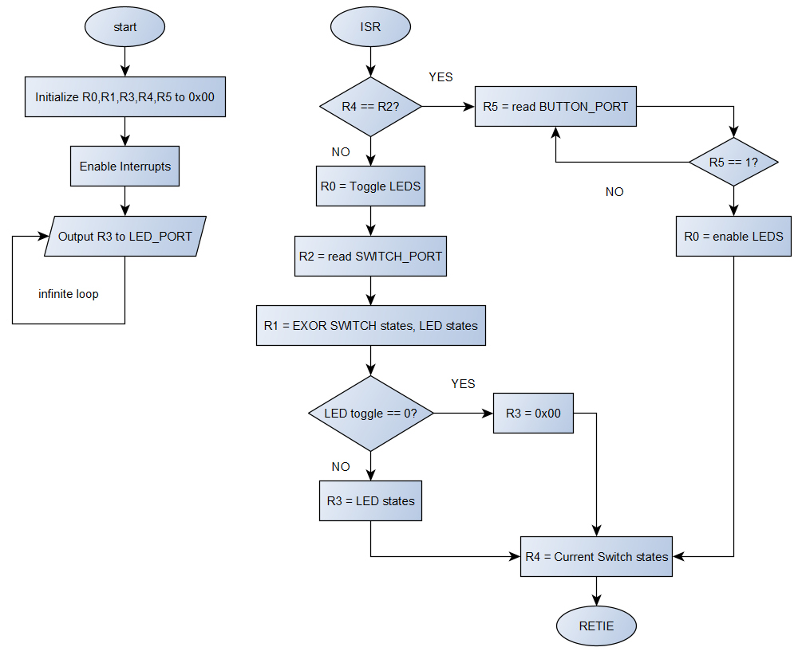

# Verification

**Program 2 Verification**

|  |  |  |  |
| --- | --- | --- | --- |
| **Switch Input** | **Button Input** | **Interrupt** | **LED output** |
| - | - | 0 | 00000000 |
| 10101010 | - | 1 | 10101010 |
| - | - | 0 | 10101010 |
| 10101010 | - | 1 | 10101010 |
| - | 0 | - | 10101010 |
| - | 1 | - | 10101010 |
| - | - | 0 | 10101010 |
| 10101011 | - | 1 | 00000000 |
| - | - | 0 | 00000000 |
| 10101011 | - | 1 | 00000000 |
| - | 1 | - | 00000000 |

PROGRAM 2: 16b Multiplier

; This is an interrupt driven program that turns LEDS on and off

; Interrupt toggles LED output on and off, additionally the

; switch input is EXOR w/ the current LED output

; Input: 8-bit switch input from SWITCH_PORT

; Output: 8-bit led output from LED_PORT

.EQU LED_PORT = 0x42

.EQU SWITCH_PORT = 0x9A

.EQU BUTTON_PORT = 0x9B

.CSEG

.ORG 0x01

; Registers Used

; R0 = LED TOGGLE

; R1 = LED states

; R2 = SWITCH states

; R3 = Output

; R4 = BUTTON TOGGLE

; R5 = Button state

MOV R0, 0x00

MOV R1, 0x00

MOV R2, 0x00

MOV R3, 0x00

MOV R4, 0x00

SEI

loop: OUT R3, LED_PORT ; Output LEDs

BRN loop

;--------------------------------

ISR: IN R2, SWITCH_PORT

CMP R4, R2 ; Does current Switch input match previous?

BREQ button

EXOR R0, 0x01 ; Toggle LED output

EXOR R1, R2 ; EXOR switches, leds

CMP R0, 0x00

BRNE tog_on

MOV R3, R0 ; LED toggle == OFF, output is 0x00

BRN exit

tog_on: MOV R3, R1 ; LED toggle == ON, output is LED states

BRN exit

button: IN R5, BUTTON_PORT ; Read button input until toggled

CMP R5, 0x01

BRNE button

MOV R0, 0x01 ; Enable LEDS

exit: MOV R4, R2 ; Previous Switch state = Current Switch State

RETIE

;--------------------------------

.ORG 0x3FF

BRN ISR