CPE 233: Peripheral assignment 1

Prof. Bridget Benson

Luis Gomez, Jared Rocha

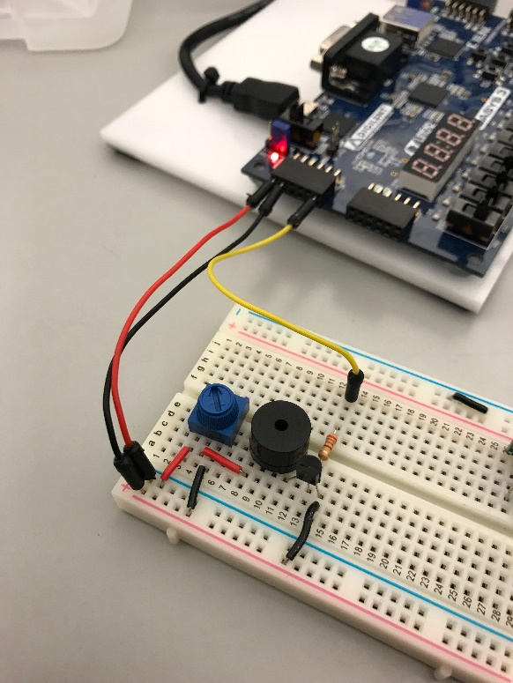

# BBD

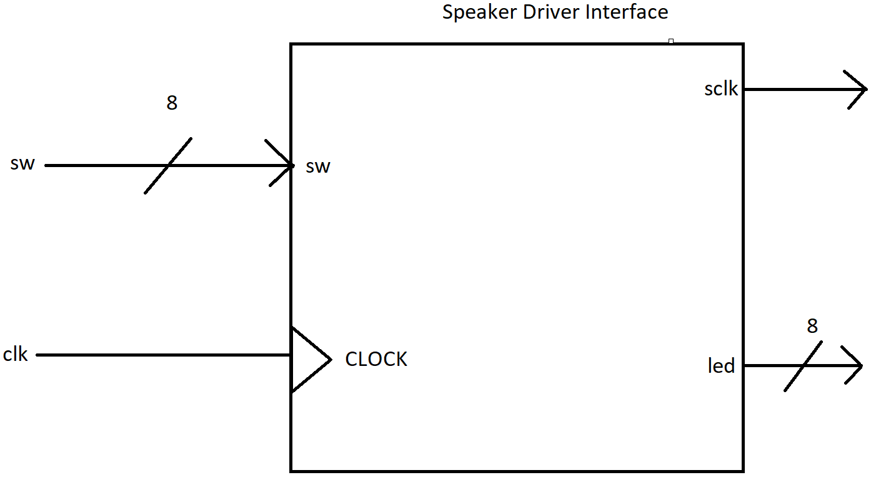

# Behavior

The Speaker Driver Interface is a System Verilog module which utilizes an input clock signal and an 8-bit switch input, to output an 8-bit LED buffer and a clock signal of variable frequency (50% duty cycle). Currently, the module is programed to provide 35 musical notes ranging from Octaves 6 -8.

# Structural

The structural design of the Speaker Driver Interface is found below. We would like to make note of the large MUX seen in the design. The large size of the MUX accounts for the 35 notes currently programmed in the module.

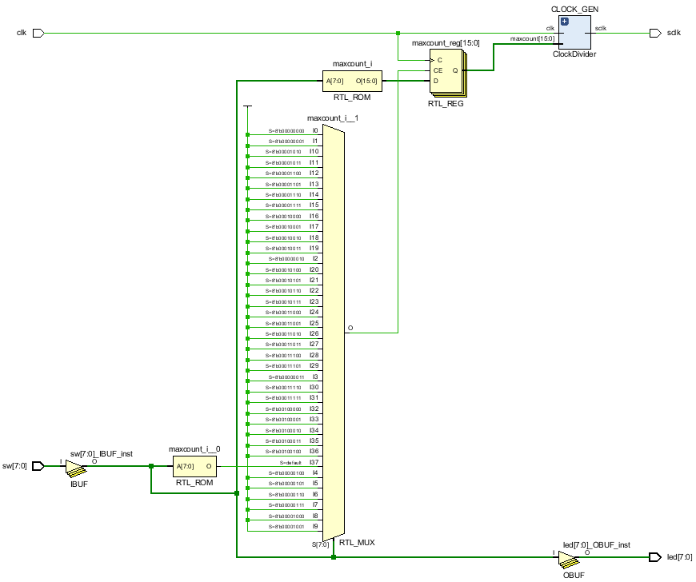

# Specifications

|  |  |
| --- | --- |
| **Operating Speed**: 100Mhz | **8 convenient LEDS** to indicate enabled switches |
| **Input Clock**: 100Mhz | **Volume Contro**l via a 10kohm potentiometer |
| Generates Output Frequencies with **less than .02 % error!** | **Input Voltage:** 3.3 V |

The **Speaker Driver Interface** is a System Verilog module which utilizes an input clock signal and an 8-bit switch input, to output an 8-bit LED buffer and a clock signal of variable frequency (50% duty cycle). Currently, the module is programed to provide 35 musical notes ranging from Octaves 6 -8; however, our input width can support up to 255 different inputs so many more notes can be programmed by the user. The module is equipped with a separate clock divider module that produces a varying clock signal (**sclock**) with a frequency dependent on the desired note. The clock divider receives a 15-bit input (**maxcount**) which is computed according to the following formula:

$$maxcount= \frac{100Mhz}{2*frequency}$$

The resulting clock signal is then output to an external speaker/amplifier circuit to produce audible sound. For convenience, the module illuminates the 8 LEDS corresponding to toggled input switches on the Basys 3 FPGA. Furthermore, the circuit allows for volume control via a 10kohm potentiometer. The circuit diagram is found below:

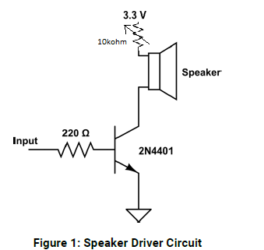

# Verification

|  |  |  |  |  |  |  |
| --- | --- | --- | --- | --- | --- | --- |
| **Input Value** | **Note** | **Octave** | **Frequency (Hz)** | **maxcount** | **Verification (Hz)** | **% error** |
| 0 | none | none | 0 | 0 | 0.0 | 0.00000% |
| 1 | C | 6 | 1046.502 | 47778 | 1046.6 | 0.00936% |
| 2 | C #, Db | 6 | 1108.731 | 45097 | 1108.7 | 0.00280% |
| 3 | D | 6 | 1174.659 | 42566 | 1174.7 | 0.00349% |
| 4 | D#, Eb | 6 | 1244.508 | 40177 | 1244.5 | 0.00064% |
| 5 | E | 6 | 1318.51 | 37922 | 1318.6 | 0.00683% |
| 6 | F | 6 | 1396.913 | 35793 | 1397.0 | 0.00623% |
| 7 | F#, Gb | 6 | 1479.978 | 33784 | 1480.0 | 0.00149% |
| 8 | G | 6 | 1567.982 | 31888 | 1568.0 | 0.00115% |
| 9 | G#, Ab | 6 | 1661.219 | 30098 | 1661.4 | 0.01090% |
| 10 | A | 6 | 1760 | 28409 | 1760.1 | 0.00568% |
| 11 | A#, Bb | 6 | 1864.655 | 26815 | 1864.6 | 0.00295% |
| 12 | B | 6 | 1975.533 | 25310 | 1975.5 | 0.00167% |
| 13 | C | 7 | 2093.004 | 23889 | 2093.1 | 0.00459% |
| 14 | C #, Db | 7 | 2217.462 | 22548 | 2217.5 | 0.00171% |
| 15 | D | 7 | 2349.318 | 21283 | 2349.4 | 0.00349% |
| 16 | D#, Eb | 7 | 2489.016 | 20088 | 2489.0 | 0.00064% |
| 17 | E | 7 | 2637.02 | 18961 | 2637.0 | 0.00076% |
| 18 | F | 7 | 2793.826 | 17897 | 2793.9 | 0.00265% |
| 19 | F#, Gb | 7 | 2959.956 | 16892 | 2960.0 | 0.00149% |
| 20 | G | 7 | 3135.964 | 15944 | 3136.0 | 0.00115% |
| 21 | G#, Ab | 7 | 3322.438 | 15049 | 3322.4 | 0.00114% |
| 22 | A | 7 | 3520 | 14205 | 3520.1 | 0.00284% |
| 23 | A#, Bb | 7 | 3729.31 | 13407 | 3729.5 | 0.00509% |
| 24 | B | 7 | 3951.066 | 12655 | 3951.1 | 0.00086% |
| 25 | C | 8 | 4186.008 | 11945 | 4186.2 | 0.00459% |
| 26 | C #, Db | 8 | 4434.924 | 11274 | 4435.0 | 0.00171% |
| 27 | D | 8 | 4698.636 | 10641 | 4698.7 | 0.00136% |
| 28 | D#, Eb | 8 | 4978.032 | 10044 | 4978.1 | 0.00137% |
| 29 | E | 8 | 5274.04 | 9480 | 5274.3 | 0.00493% |
| 30 | F | 8 | 5587.652 | 8948 | 5587.8 | 0.00265% |
| 31 | F#, Gb | 8 | 5919.912 | 8446 | 5920.0 | 0.00149% |
| 32 | G | 8 | 6271.928 | 7972 | 6272.0 | 0.00115% |
| 33 | G#, Ab | 8 | 6644.876 | 7525 | 6645.4 | 0.00789% |
| 34 | A | 8 | 7040 | 7102 | 7040.3 | 0.00426% |
| 35 | A#, Bb | 8 | 7458.62 | 6704 | 7459.6 | 0.01314% |
| 36 | B | 8 | 7902.132 | 6327 | 7902.9 | 0.00972% |

**Example Verification, C in 3 octaves. Note the frequency in the Red Box**

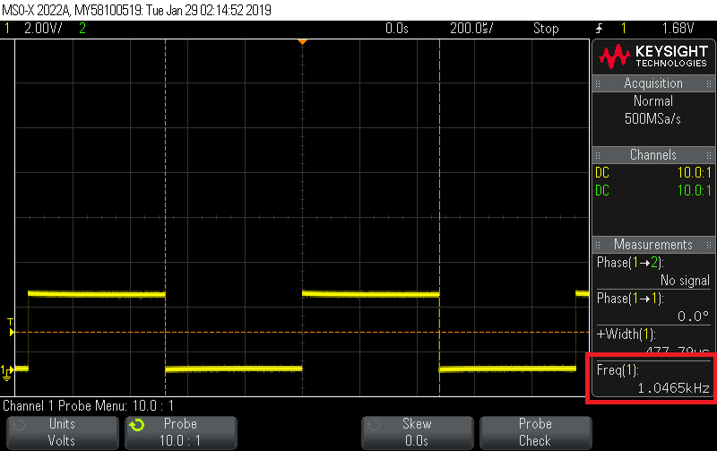

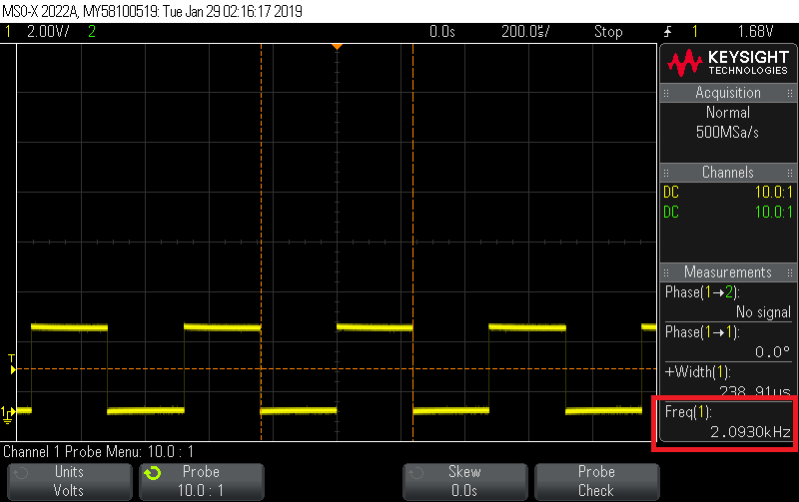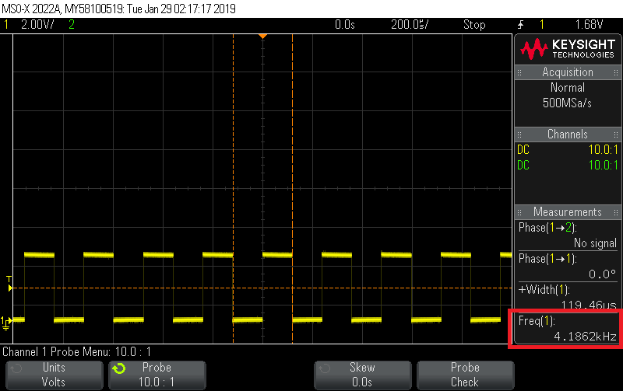

# System Verilog Source Code

**SPEAKER DRIVER INTERFACE (4 pgs.)**

`timescale 1ns / 1ps

//////////////////////////////////////////////////////////////////

// Engineer: Luis Gomez

//

// Create Date: 01/26/2019 10:50:59 PM

// Module Name: speaker_driver_interface

// Description:

// Interface for a Speaker Driver. Provides 8-bit input via

// switches on the Basys3 board

// Outputs a 50% duty cycle square wave of variable frequency,

// according do desired Note & Octave

// Dependencies: clock_div.sv

////////////////////////////////////////////////////////////////

module speaker_driver_interface(

input clk,

input [7:0] sw,

output [7:0] led,

output sclk // square_wave

);

assign sw = led; // enables leds for switches

logic [15:0] maxcount = 0;

ClockDivider CLOCK_GEN (.*);

parameter

C = 47778, C_sharp = 45097,

D = 42566, D_sharp = 40177,

E = 37922,

F = 35793, F_sharp = 33784,

G = 31888, G_sharp = 30098,

A = 28409, A_sharp = 26815,

B = 25310;

always_ff @(posedge clk)

begin

case (sw)

0: begin

maxcount <= 0;

end

/**********6th OCTAVE*****************/

1: begin // C

maxcount <= C;

end

2: begin // C#, D flat

maxcount <= C_sharp;

end

3: begin // D

maxcount <= D;

end

4: begin // D#, E flat

maxcount <= D_sharp;

end

5: begin // E

maxcount <= E;

end

6: begin // F

maxcount <= F;

end

7: begin // F#, G flat

maxcount <= F_sharp;

end

8: begin // G

maxcount <= G;

end

9: begin // G#,A flat

maxcount <= G_sharp;

end

10: begin // A

maxcount <= A;

end

11: begin // A#, B flat

maxcount <= A_sharp;

end

12: begin // B

maxcount <= B;

end

/**********7th OCTAVE*****************/

13: begin // C

maxcount <= C/2;

end

14: begin // C#, D flat

maxcount <= C_sharp/2;

end

15: begin // D

maxcount <= D/2;

end

16: begin // D#, E flat

maxcount <= D_sharp/2;

end

17: begin // E

maxcount <= E/2;

end

18: begin // F

maxcount <= F/2;

end

19: begin // F#, G flat

maxcount <= F_sharp/2;

end

20: begin // G

maxcount <= G/2;

end

21: begin // G#,A flat

maxcount <= G_sharp/2;

end

22: begin // A

maxcount <= A/2;

end

23: begin // A#, B flat

maxcount <= A_sharp/2;

end

24: begin // B

maxcount <= B/2;

end

/**********8th OCTAVE*****************/

25: begin // C

maxcount <= C/4;

end

26: begin // C#, D flat

maxcount <= C_sharp/4;

end

27: begin // D

maxcount <= D/4;

end

28: begin // D#, E flat

maxcount <= D_sharp/4;

end

29: begin // E

maxcount <= E/4;

end

30: begin // F

maxcount <= F/4;

end

31: begin // F#, G flat

maxcount <= F_sharp/4;

end

32: begin // G

maxcount <= G/4;

end

33: begin // G#,A flat

maxcount <= G_sharp/4;

end

34: begin // A

maxcount <= A/4;

end

35: begin // A#, B flat

maxcount <= A_sharp/4;

end

36: begin // B

maxcount <= B/4;

end

default: begin

maxcount = 0;

end

endcase

end

endmodule

**CLOCK DIVIDER**

`timescale 1ns / 1ps

//////////////////////////////////////////////////////////////////////////////////

// Engineer: Bridget Benson

//

// Create Date: 10/01/2018 10:22:13 AM

// Description: Generic Clock Divider. Divides the input clock by MAXCOUNT*2

//

//////////////////////////////////////////////////////////////////////////////////

module ClockDivider (

input clk,

input [15:0] maxcount,

output logic sclk = 0

);

logic [15:0] count = 0;

always_ff @ (posedge clk)

begin

if (maxcount == 0) // LOW CLOCK, I added this to account for 0 input and default cases

sclk = 0;

else

count = count + 1;

if (count == maxcount)

begin

count = 0;

sclk = ~sclk;

end

end

endmodule

# RAT Assembly Example Use Code

;-----------------------------------------------------------------

; Peripheral_one

; by Luis Gomez, Jared Roscha

; date : 1/28/19

;

; Drunken Sailor: A, A, A, A, A, A, A, D, F, A

; Beats: .25, .125, .125, .25, .125, .125, .25, .25, .25. 25

; "What shall we do with the Drunken Sailor..."

;-----------------------------------------------------------------

.EQU SPEAKER_OUT = 0x03 ; speaker port on fpga

.CSEG

.ORG 0x01

OUT 0x0A, SPEAKER_OUT ; A, 1/4 note

;DELAY FUNCTION .25 sec

OUT 0x0A, SPEAKER_OUT ; A, 1/8 note

;DELAY FUNCTION .125 sec

OUT 0x0A, SPEAKER_OUT ; A, 1/8 note

;DELAY FUNCTION .125 sec

OUT 0x0A, SPEAKER_OUT ; A, 1/4 note

;DELAY FUNCTION .25 sec

OUT 0x0A, SPEAKER_OUT ; A, 1/8 note

;DELAY FUNCTION .125 sec

OUT 0x0A, SPEAKER_OUT ; A, 1/8 note

;DELAY FUNCTION .125 sec

OUT 0x0A, SPEAKER_OUT ; A, 1/4 note

;DELAY FUNCTION .25 sec

OUT 0x03, SPEAKER_OUT ; D, 1/4 note

;DELAY FUNCTION .25 sec

OUT 0x06, SPEAKER_OUT ; F, 1/4 note

;DELAY FUNCTION .25 sec

OUT 0x0A, SPEAKER_OUT ; A, 1/4 note

;DELAY FUNCTION .25 sec