CPE 233: Peripheral assignment 2, DAC

Prof. Bridget Benson

Luis Gomez, Matt Bailey

# BBD

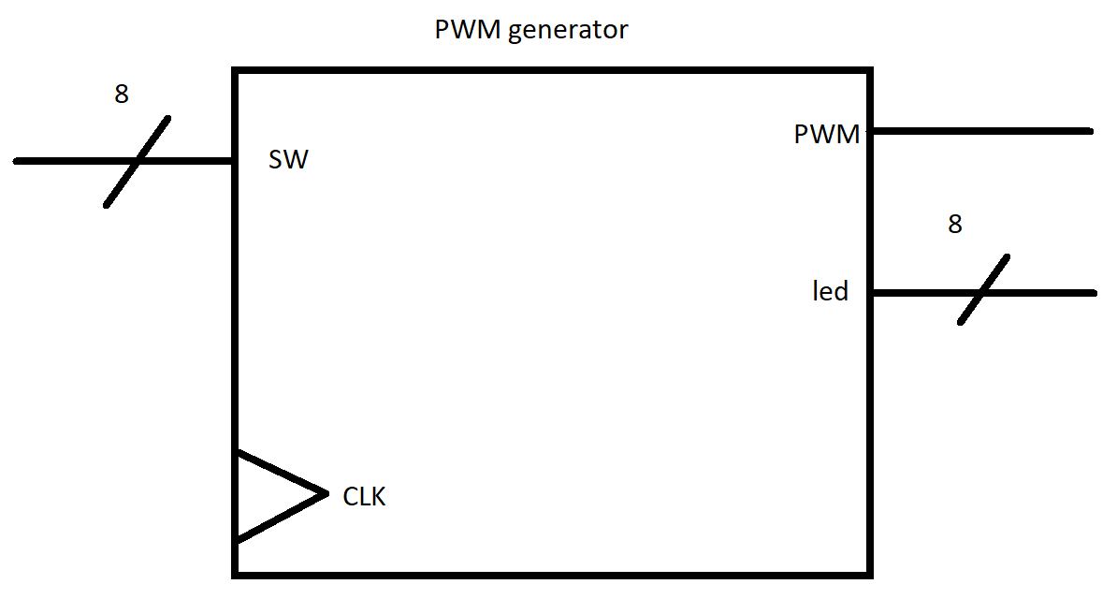

# Behavior

The DAC or Digital to Analog Converter is comprised of an external circuit connected to a PWM generator (loaded on the Basys 3 FPGA). Most of this report describes the design of the PWM generator, which can be described as having the following: 8-bit switch input (SW), 8-bit LED output (led), and a 1-bit PWM output signal. The PWM generator operates at ~ 392.157 kHz, and can produce duty cycles ranging from 0-100%, with 255 uniquely possibly duty cycles.

# Structural

The structural design of the PWM generator for the DAC is found below.

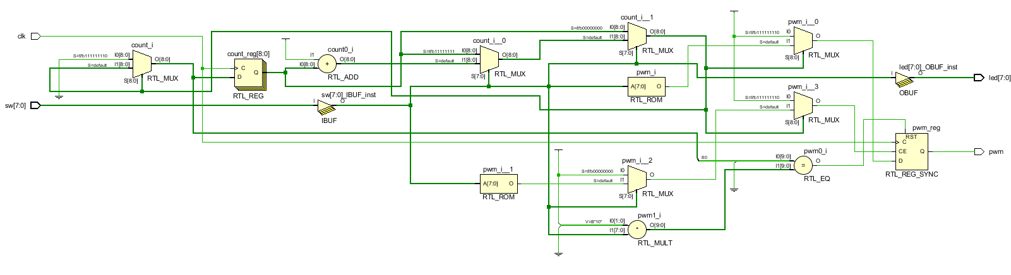

# Specifications

|  |  |
| --- | --- |
| **Operating Speed**: 100Mhz | **8 convenient LEDS** to indicate enabled switches |
| **Input Clock**: 100Mhz | **Output Voltage:** [0 - 3.3 ] V |
| Generates Output Voltages and Duty Cycles with **less than 5% error** | **Input** |

The **Digital to Analog Converter (DAC)** is a System Verilog module which utilizes an input clock signal and an 8-bit switch input which creates a variable 8-input. This 8-bit value can be used to specify the analog voltage to output. Using 8-bits allows us to have 256 different analog voltages including 0V, to be output with a resolution of:

$\frac{3.3V}{255 }=0.013V$

The **Pulse Width Modulation (PWM) generator** is a System Verilog module which utilizes an input clock signal and our 8-bit switch input to vary the width of the high or low of a square wave without changing the frequency of the pulses. This changes the signals duty cycle, or the percent of the time it is low v. high. For example if we have a 0% duty cycle it will always be low, where a 100% duty cycle will be always high. Once again with our 8-bit input we are allowed 256 different cycles, with a 100 MHz internal clock for the Basys 3 Board we can calculate out frequency.

$\frac{100Mhz}{255}=392.157 kHz$

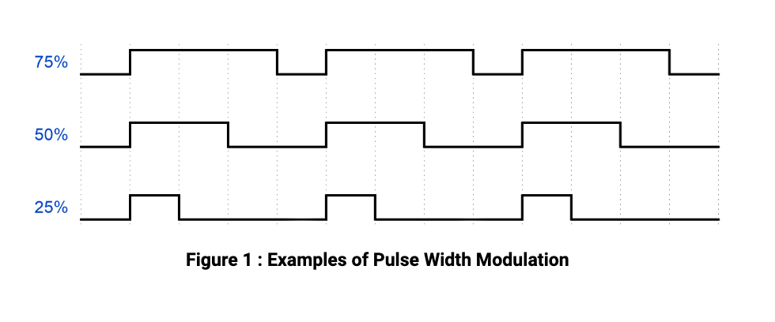

Our **Low Pass Filter**  take the square wave output from our PWM generator will cause the capacitor to charge and discharge on the high and low cycles. We built the low pass filter with a 1.6kΩ and a capacitor of 100nF assembled in ther configuration show in Figure 2. The output of the low pass filter will be a steady voltage rating based upon the duty cycle of the square wave being input.

# 

# Verification

|  |  |  |  |  |  |  |
| --- | --- | --- | --- | --- | --- | --- |
|  | **Expected** |  | **Measured** |  | **% error** |  |
| **Input (sw)** | **∆V out** | **Duty Cycle %** | **∆V out** | **Duty Cycle %** | **∆V out** | **Duty Cycle %** |
| **1** | 0.013 | 0.3921568627 | 0.0134 | 0.41 | 3.076923077 | 4.55 |
| **13** | 0.169 | 5.098039216 | 0.1689 | 5.11 | 0.05917159763 | 0.2346153846 |
| **31** | 0.403 | 12.15686275 | 0.401 | 12.17 | 0.4962779156 | 0.1080645161 |
| **127** | 1.651 | 49.80392157 | 1.645 | 49.81 | 0.3634161114 | 0.01220472441 |
| **128** | 1.664 | 50.19607843 | 1.658 | 50.21 | 0.3605769231 | 0.027734375 |
| **200** | 2.6 | 78.43137255 | 2.593 | 78.44 | 0.2692307692 | 0.011 |
| 254 | 3.302 | 99.60784314 | 3.294 | 99.60 | 0.2422774076 | 0.007874015748 |

***Example verification, Input 13***

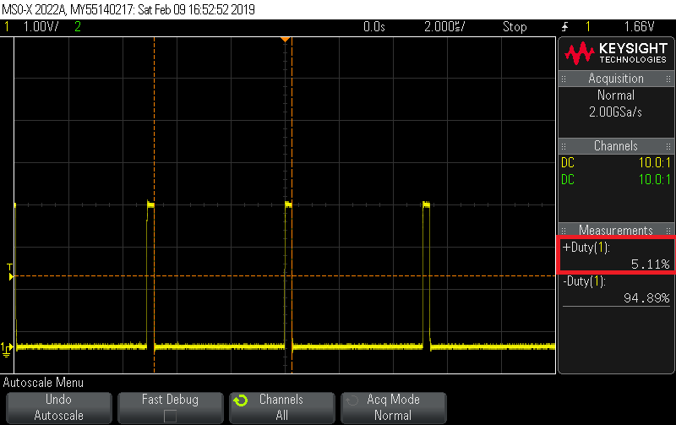

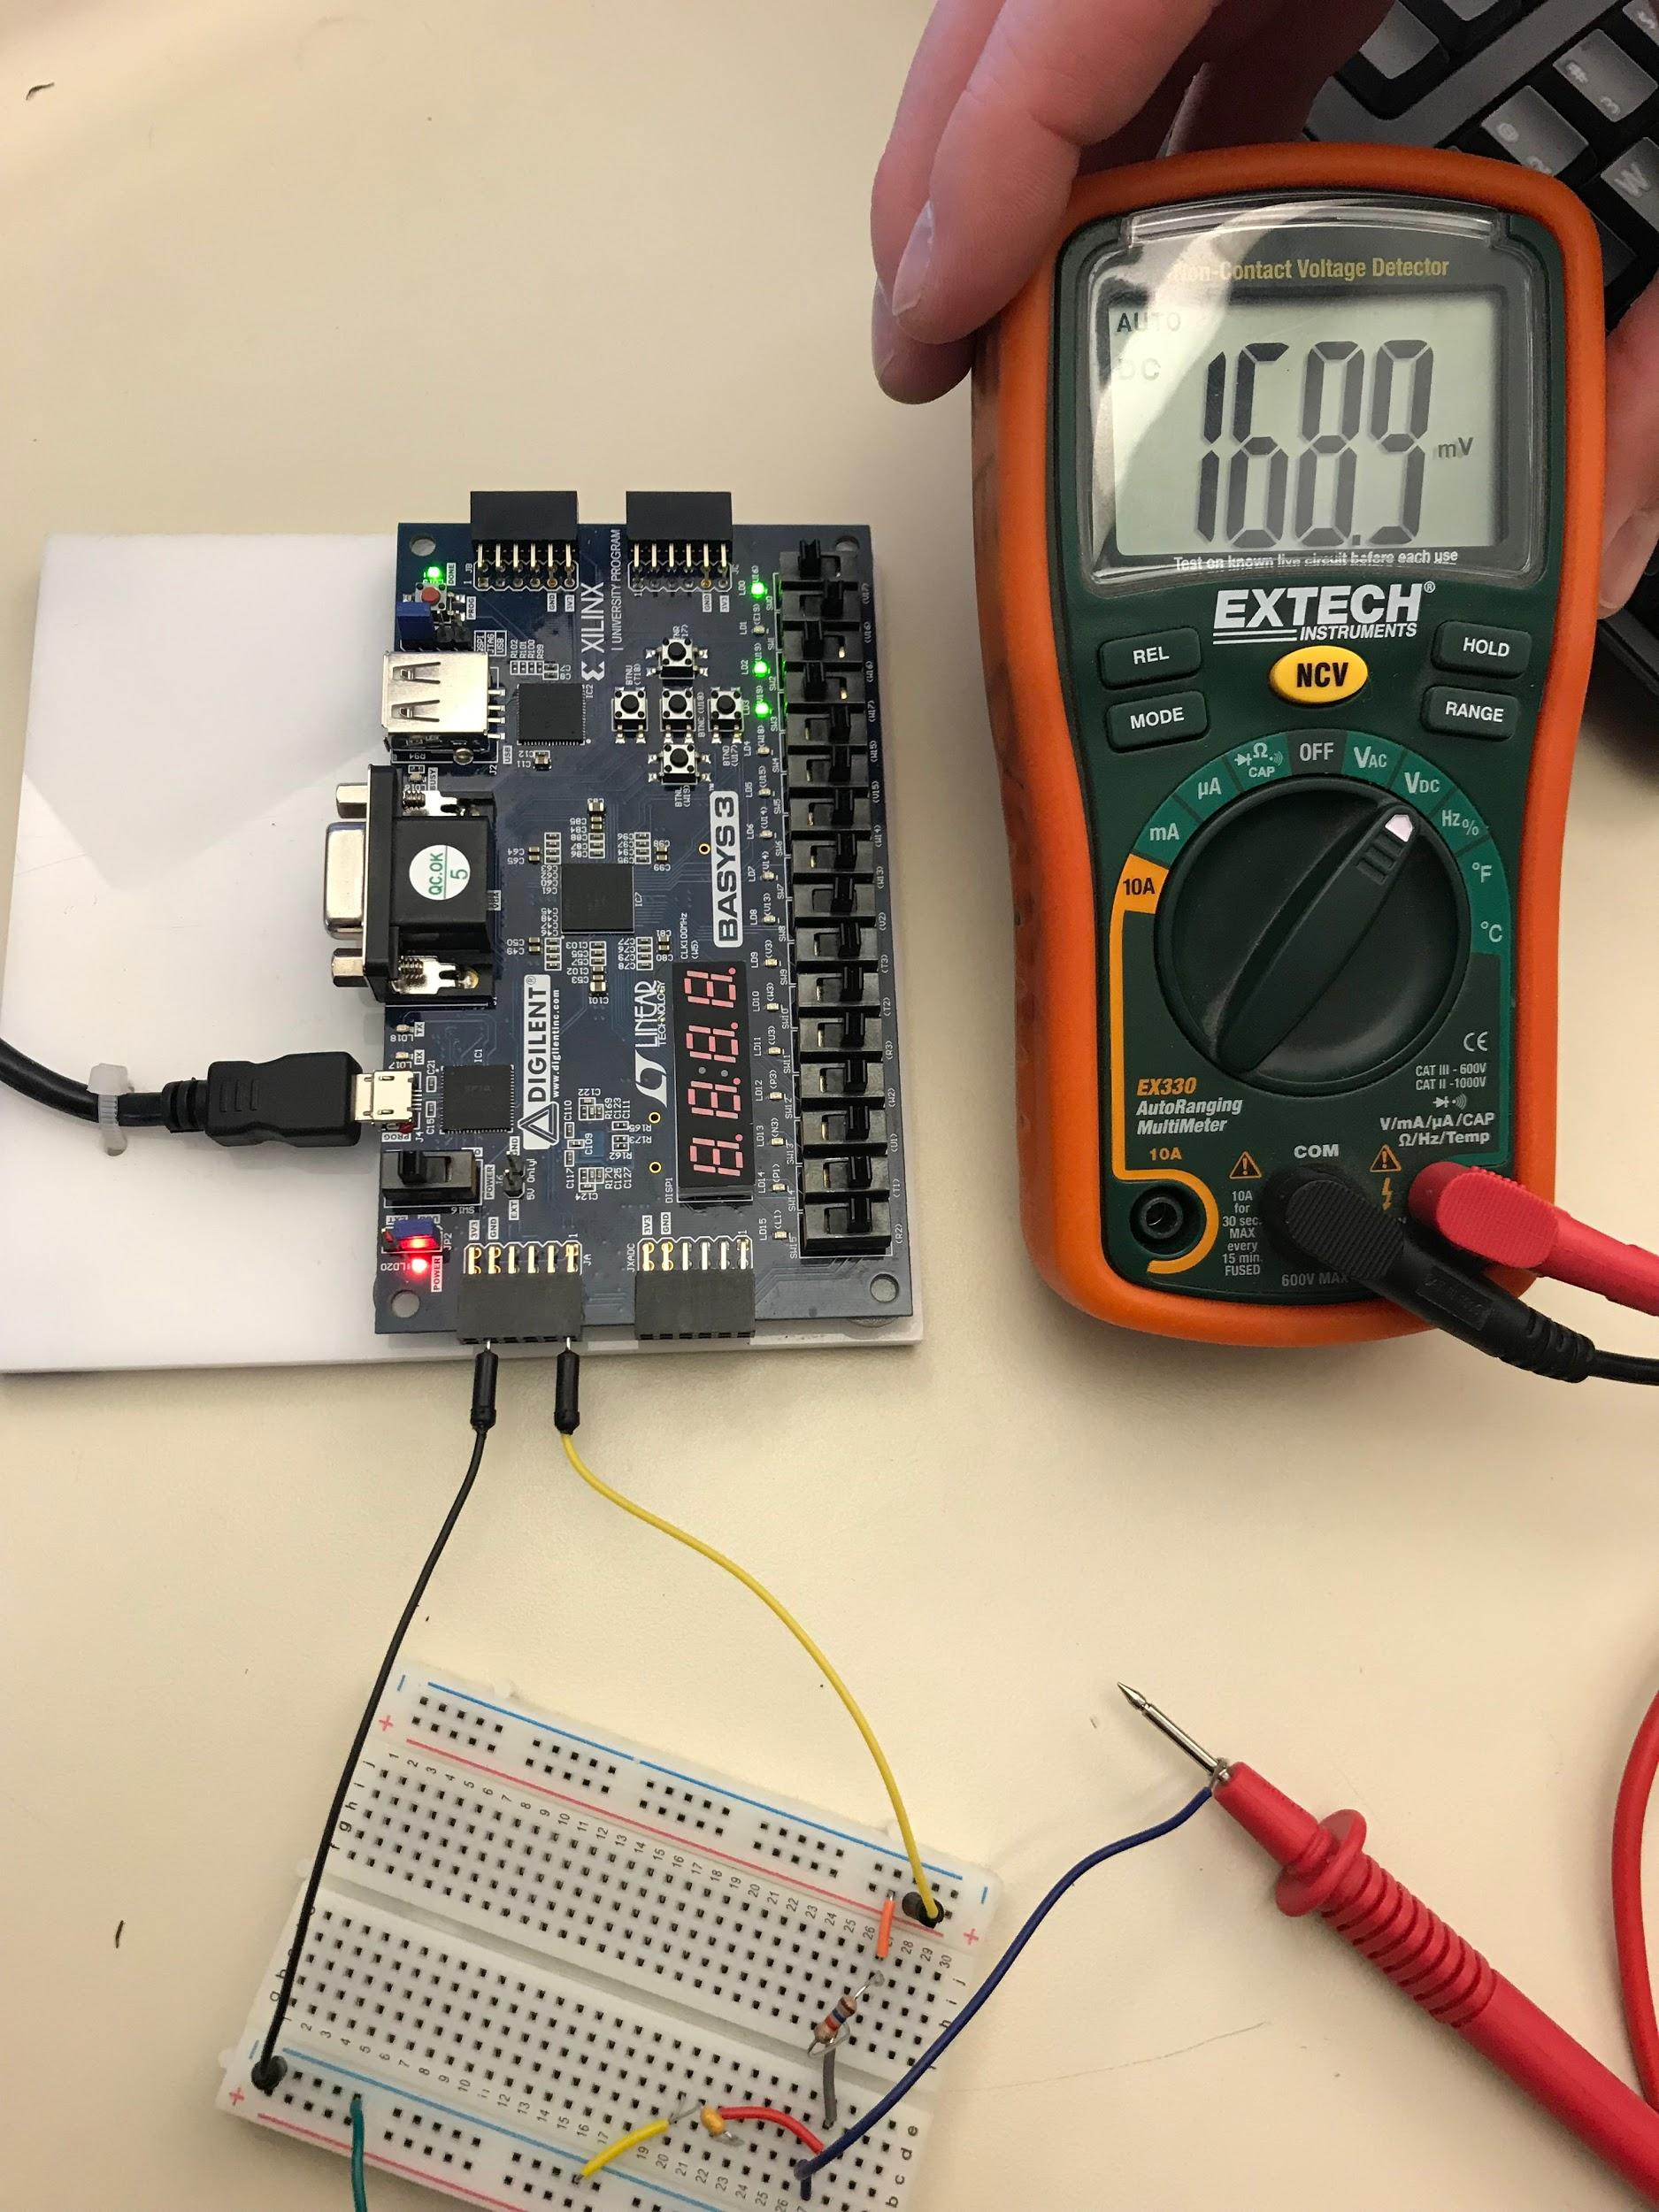

# System Verilog Source Code

# RAT Assembly Example Use Code