CPE 233, RAT assignment 1

Luis Gomez, Brandon Flores

**Part 1:**

|  |  |  |  |  |  |  |
| --- | --- | --- | --- | --- | --- | --- |
| ProgROM Address | Instruction | Destination Register | C Flag | Z Flag | | OUT (port_id) |
| 0x40 | MOV R10, 0x05 | R10 = 0x05 | x | x | x | |
| 0x41 | MOV R11, 0x64 | R11 = 0x64 | x | x | x | |
| 0x42 | ADD R10, R11 | R10 = 0x69 | 0 | 0 | x | |
| 0x43 | ADD R10, 0x14 | R10 = 0x7D | 0 | 0 | x | |
| 0x44 | MOV R20, R10 | R20 = 0x7D | x | x | x | |
| 0x45 | OUT R20, LED_PORT | x | x | x | 0x7d | |
| 0x46 | BRN main_loop | x | x | x | x | |

**Part 2:**

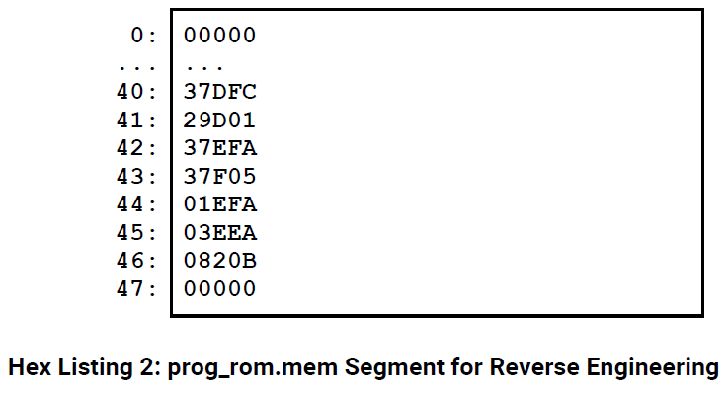

|  |  |  |  |
| --- | --- | --- | --- |
| ProgROM Address | Machine Code | **Hex Listing** | Assembly Instruction |
| 0x40 | 1 1011 11101 1111 1100 | **37DFC** | MOV R29, 0xFC |
| 0x41 | 1 0100 11101 0000 0001 | **29D01** | ADD R29, 0x01 |
| 0x42 | 1 1011 11110 1111 1010 | **37EFA** | MOV R30, 0xFA |
| 0x43 | 1 1011 11111 0000 0101 | **37F05** | MOV R31, 0x05 |
| 0x44 | 0 0000 11110 11111 0 10 | **01EFA** | EXOR R30, R31 |
| 0x45 | 0 0001 11110 11101 0 10 | **03EEA** | SUB R30, R29 |
| 0x46 | 0 0100 00 0100 0001 0 11 | **0820B** | BRNE 0x41 |
| 0x47 | 0 0000 00000 00000 0 00 | **00000** | AND R00, R00 |

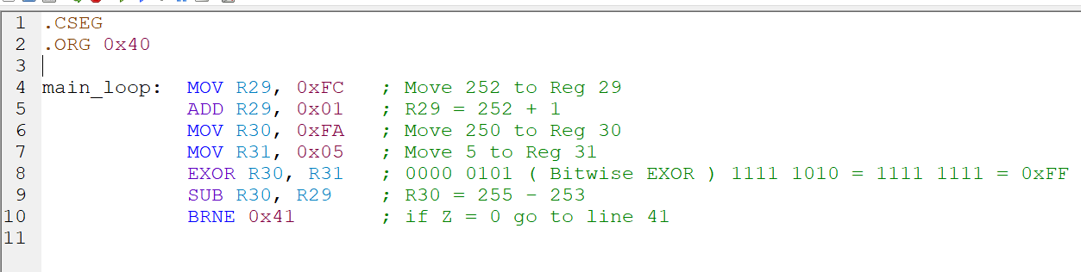

|  |  |  |  |  |  |
| --- | --- | --- | --- | --- | --- |
| ProgROM Address | Assembly Instruction | Destination Register | C Flag | Z Flag | OUT(port_id) |
| 0x40 | MOV R29, 0xFC | R29 = 0xFC | x | x | x |
| 0x41 | ADD R29, 0x01 | R29 = 0xFD | 0 | 0 | x |
| 0x42 | MOV R30, 0xFA | R30 = 0xFA | x | x | x |
| 0x43 | MOV R31, 0x05 | R31 = 0x05 | x | x | x |
| 0x44 | EXOR R30, R31 | R30 = 0xFF | x | 0 | x |
| 0x45 | SUB R30, R29 | R30=0x02 | 0 | 0 | x |
| 0x46 | BRNE 0x41 | x | x | x | x |