CPE 233: RAT assignment 5, MCU

Prof. Bridget Benson

Stan Carpenco, Luis Gomez

# BBD

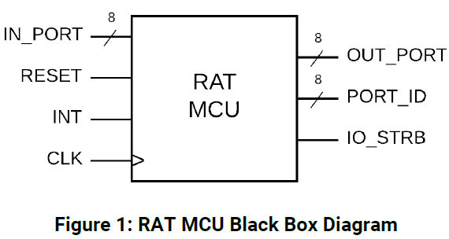

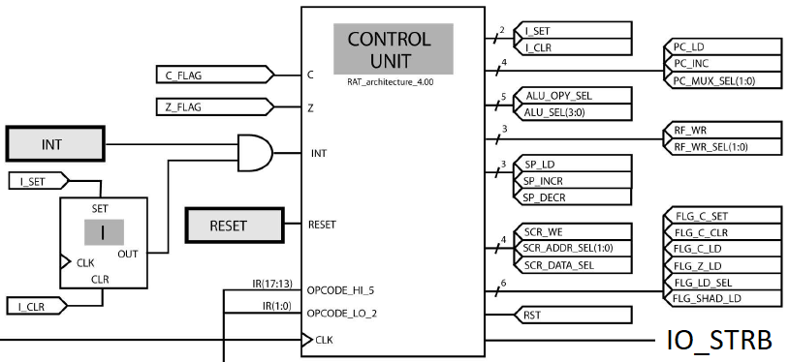

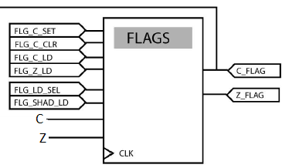

# Behavior

In this assignment, we built the Micro-Controller (MCU), Control-Unit (CU), and Flags modules in System Verilog. The MCU was assembled using the CU, Flags, PC, Prog Rom, Reg File, SCR, and ALU modules from previous Rat assignments.

**Micro-Controller (MCU)**: The MCU is a sequential circuit that serves as an interface between the many modules of the RAT computer and the outside world, via the RAT Assembly language. Between the many modules are a variety of combinatorial circuits, namely Muxes, which use incoming flag signals from the CU to control inputs to various modules.

**Control-Unit (CU)**: The CU is an FSM whose behavior is determined by its state (INIT, FETCH, or EXEC) and the input values generated by the binary op-codes of Assembly instructions. Using the 5 MSBs and 2 LSBs of an instruction, the CU toggles a host of output Flag signals. These output flag signals ripple through the RAT computer modules, directing these modules to execute the instructions set out by the op-codes.

**Flags:** The Flags module is a sequential circuit whose inputs are a series of flags from the CU and ALU modules. The Flags module is comprised of four registers: C, SHAD C, Z, and SHAD Z. The inputs to the Flags module control the 4 registers and ultimately determine the outputs C_FLAG and Z_FLAG.

# Structural Design

***MCU***

# 

***CU***

# 

***Flags***

Note, that our flags structural design does not include the four registers. This resulted from the System Verilog code we created for the Registers. Our Register code defines Muxes of variable size such that Vivado cannot generate an elaborated design, presumably because the code describes a module of indefinite size. (**See Source, pg 11)**.

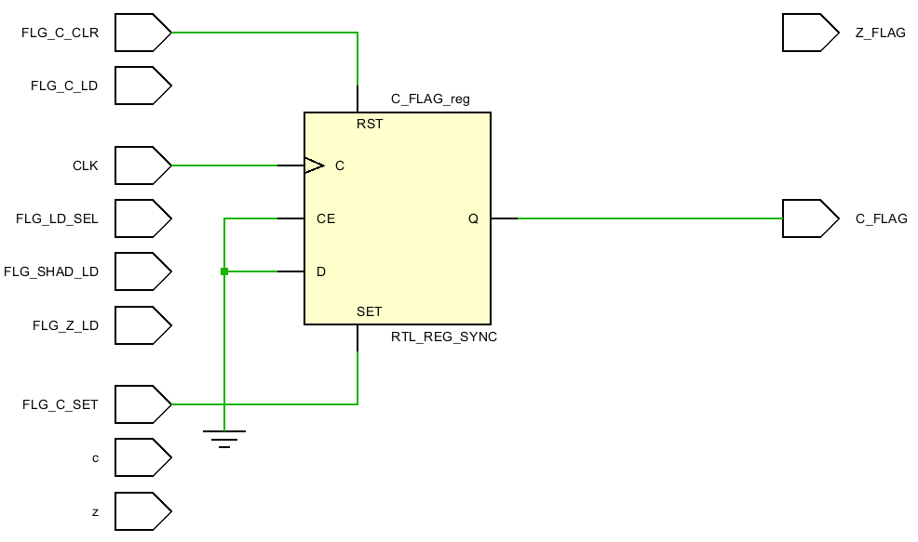

# Verification

To verify the behavior of the MCU, we simulated the following assembly code via a System Verilog test bench. The test bench System Verilog code can be found on the last few pages of the report, under Source (**pg 12**).

.EQU SWITCH_PORT = 0x20 ; port for switch input

.EQU LED_PORT = 0x40 ; port for LED output

.CSEG

.ORG 0x10

main: IN R10, SWITCH_PORT

MOV R11, 0xFF

EXOR R10, R11

OUT R10, LED_PORT

BRN main

The entire waveform can be found on the following page. For clarity, we colored input signals a light blue and output signals, orange. The internal clock signal is yellow and the present state of the MCU is labeled in pink.

*Waveform Upper Half*

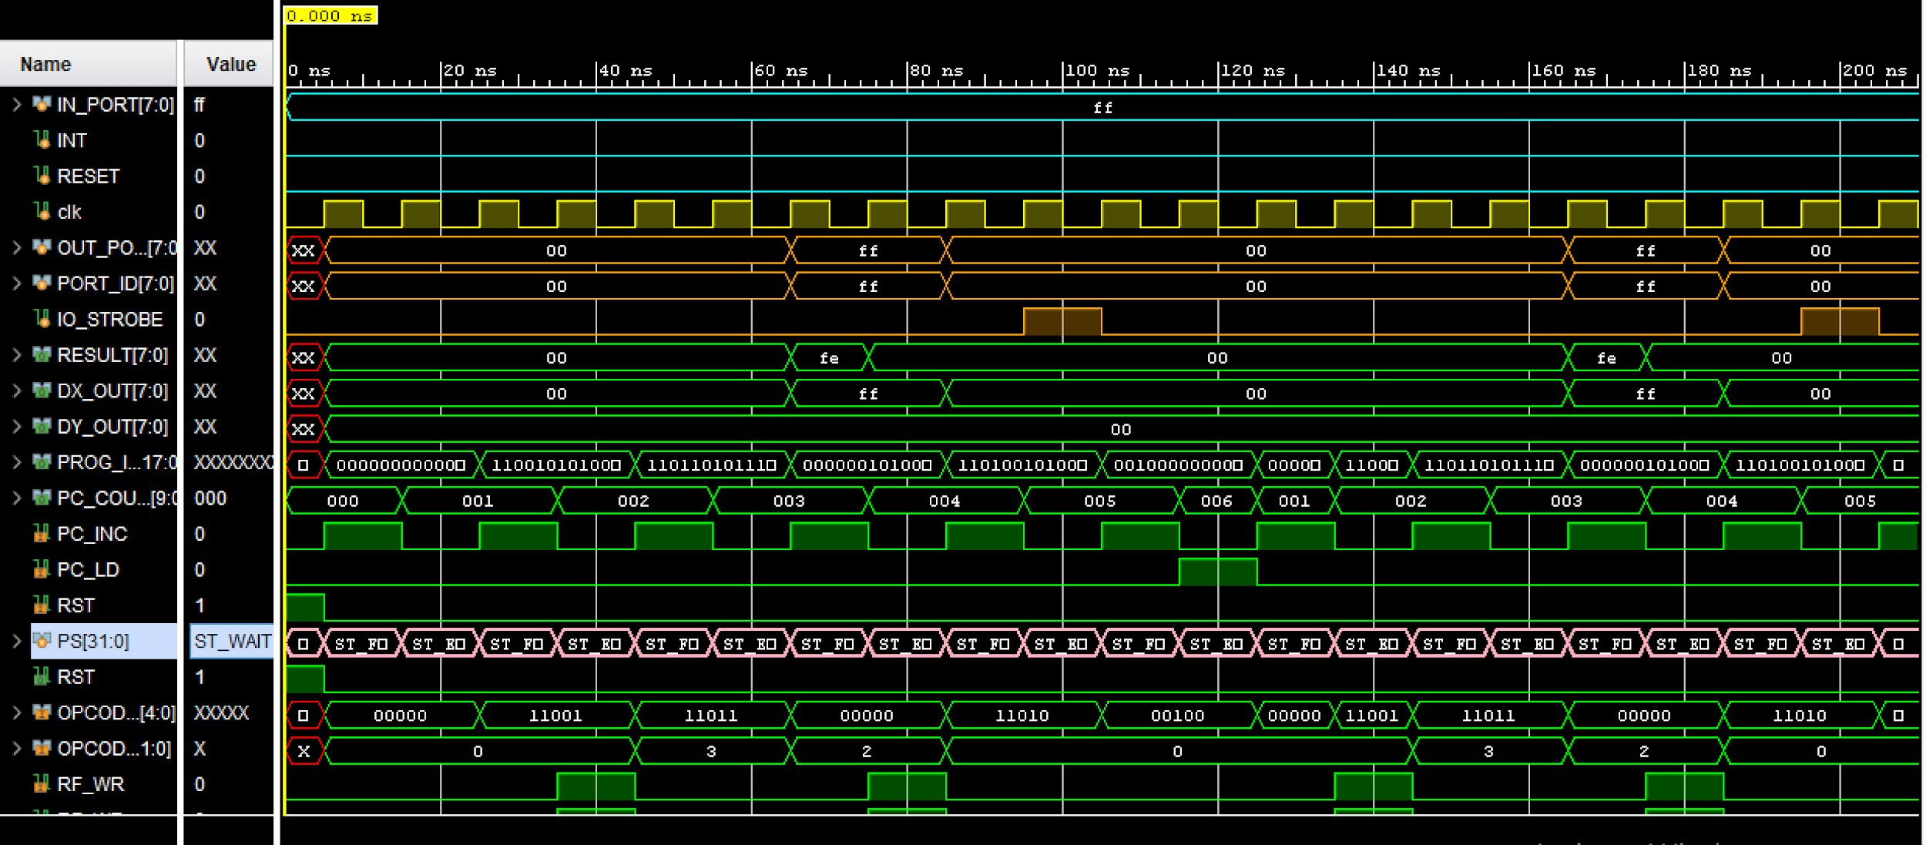

*Waveform Lower Half*

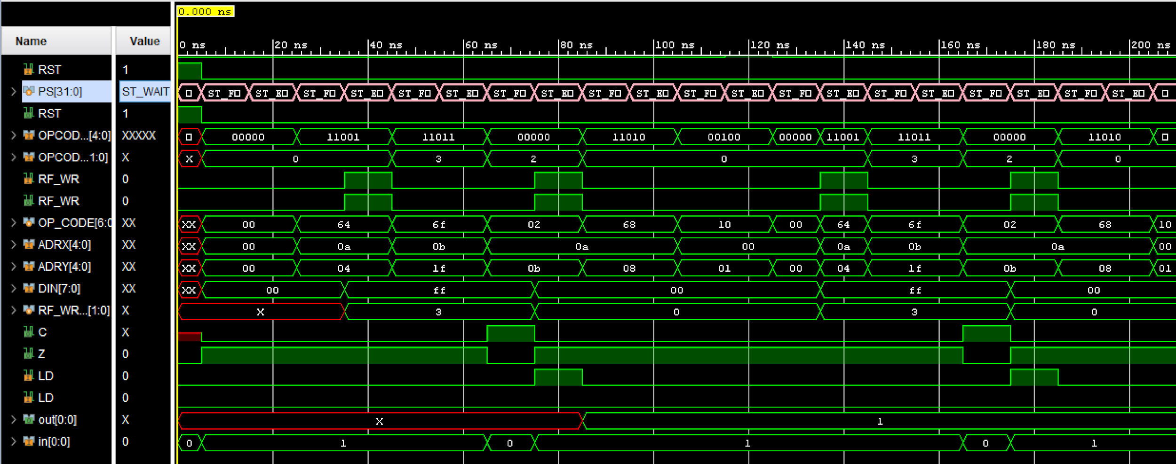

# Source Code

***MCU (2 pages)***

`timescale 1ns / 1ps

module RAT_MCU(

input clk,

input INT,

input RESET,

input [7:0] IN_PORT,

output logic [7:0] OUT_PORT,

output logic [7:0] PORT_ID,

output logic IO_STROBE

);

logic [9:0] tFromPc;

logic [17:0] tRom2Reg;

logic [7:0] tIN, t2ALU, t2ALUMUX, tRESULT, t8,

tFROMMUX, t11;

logic [9:0] t6, t10;

logic c, z;

logic I_SEL, I_CLR, PC_LD, PC_INC, ALU_OPY_SEL,

tRF_WR, SP_LD, SP_INCR, SP_DECR;

logic SCR_WE, SCR_DATA_SEL, FLG_C_SET, FLG_C_CLR,

FLG_C_LD, FLG_Z_LD, FLG_LD_SEL;

logic FLG_SHAD_LD, RST;

logic [1:0] PC_MUX_SEL, RF_WR_SEL, SCR_ADDR_SEL;

logic [3:0] ALU_SEL; logic C_FLAG, Z_FLAG;

PC PC( .clk(clk), .FROM_IMMED(tRom2Reg[12:3]),

.FROM_STACK(t6), .PC_MUX_SEL(PC_MUX_SEL),

.PC_LD(PC_LD), .PC_INC(PC_INC), .RST(RST),

.PC_COUNT(tFromPc));

ProgRom ProgRom ( .PROG_CLK(clk), .PROG_ADDR(tFromPc),

.PROG_IR(tRom2Reg));

PC_REGISTER PC_REG (.clk(clk), .DIN(tIN), .RF_WR(tRF_WR),

.ADRX( tRom2Reg[12:8]), .ADRY(tRom2Reg[7:3]),

.DX_OUT(t2ALU), .DY_OUT(t2ALUMUX));

ALU ALU(.CIN(C_FLAG), .SEL(ALU_SEL),

.A(t2ALU), .B(tFROMMUX),

.RESULT(tRESULT), .C(c), .Z(z));

ControlUnit PC_FSM (.clk(clk), .C(C_FLAG), .Z(Z_FLAG),

.RESET(RESET), .OPCODE_HI_5(tRom2Reg[17:13]),

.OPCODE_LOW_2(tRom2Reg[1:0]), .I_SET(I_SEL),

.I_CLR(I_CLR), .PC_LD(PC_LD), .PC_INC(PC_INC),

.ALU_OPY_SEL(ALU_OPY_SEL), .RF_WR(tRF_WR),

.SP_LD(SP_LD), .SP_INCR(SP_INCR), .SP_DECR(SP_DECR),

.SCR_WE(SCR_WE), .SCR_DATA_SEL(SCR_DATA_SEL),

.FLG_C_SET(FLG_C_SET), .FLG_C_CLR(FLG_C_CLR),

.FLG_C_LD(FLG_C_LD), .FLG_Z_LD(FLG_Z_LD),

.FLG_LD_SEL(FLG_LD_SEL), .FLG_SHAD_LD(FLG_SHAD_LD),

.RST(RST), .IO_STROBE(IO_STROBE),

.PC_MUX_SEL(PC_MUX_SEL), .RF_WR_SEL(RF_WR_SEL),

.SCR_ADDR_SEL(SCR_ADDR_SEL),.ALU_SEL(ALU_SEL) );

//Lacking INT assign PORT_ID = t2[7:0];

Reg4Flags zflag ( .clk(clk), .in(z), .SET(0),

.LD(FLG_Z_LD), .CLR(0), .out(Z_FLAG));

Reg4Flags cflag ( .clk(clk), .in(c), .SET(FLG_C_SET),

.LD(FLG_C_LD), .CLR(FLG_C_CLR), .out(C_FLAG));

//Muxes

mux2bits #8 REG_FILE_MUX (.zero(tRESULT), .one(t6[7:0]), .two(t8),

.three(IN_PORT), .sel(RF_WR_SEL), .muxout(tIN));

mux2bits #8 ALU_MUX ( .zero(t2ALU), .one(t2ALUMUX[7:0]),

.sel({1'b0, ALU_OPY_SEL}), .muxout(tFROMMUX));

mux2bits #10 SCR_DATA_IN_MUX ( .zero(t2ALU), .one(tFromPc),

.sel(SCR_DATA_SEL), .muxout(t10));

mux2bits #8 SCR_ADDR_MUX ( .zero(t2ALUMUX), .one(tRom2Reg[7:0]),

.two(t8), .three(-t8), .sel(SCR_ADDR_SEL),

.muxout(t11));

assign PORT_ID = t2ALU[7:0];

assign OUT_PORT = t2ALU;

endmodule

***CU (3 pages)***

`timescale 1ns / 1ps

module ControlUnit(

input C, Z , INT, RESET, clk,

input [4:0] OPCODE_HI_5,

input [1:0] OPCODE_LOW_2,

output logic OI_STRB, RST,

output logic I_SET, I_CLR,

output logic PC_LD, PC_INC,

output logic [1:0] PC_MUX_SEL,

output logic ALU_OPY_SEL,

output logic [3:0] ALU_SEL,

output logic RF_WR,

output logic [1:0] RF_WR_SEL,

output logic SP_LD, SP_INCR, SP_DECR,

output logic SCR_WE, SCR_DATA_SEL,

output logic [1:0] SCR_ADDR_SEL,

output logic FLG_C_SET, FLG_C_CLR, FLG_C_LD, FLG_Z_SET, FLG_Z_CLR, FLG_Z_LD, FLG_LD_SEL, FLG_SHAD_LD,

output logic IO_STROBE,

output logic [7:0] OUT_PORT, POT_ID

);

logic [6:0] OP_CODE;

assign OP_CODE = {OPCODE_HI_5 , OPCODE_LOW_2};

typedef enum { ST_WAIT, ST_FETCH, ST_EXEC} STATE;

STATE NS; STATE PS= ST_WAIT;

always_ff @ ( posedge clk)

begin

if(RESET==1)

PS <= ST_WAIT;

else

PS <= NS;

end

always_comb

begin

I_SET = 0;

I_CLR = 0;

PC_LD = 0;

PC_INC = 0;

PC_MUX_SEL = 0;

ALU_OPY_SEL = 0;

RF_WR = 0;

SP_LD = 0;

SP_INCR = 0;

SP_DECR = 0;

SCR_WE = 0;

ALU_SEL=0;

FLG_C_SET = 0;

FLG_C_CLR = 0;

FLG_C_LD = 0;

FLG_Z_LD = 0;

FLG_LD_SEL = 0;

FLG_SHAD_LD = 0;

IO_STROBE=0;

RST = 0;

case (PS)

ST_WAIT:

begin

RST = 1;

NS= ST_FETCH;

end

ST_FETCH:

begin

PC_INC=1;

NS= ST_EXEC;

end

ST_EXEC:

begin

case (OP_CODE)

//In

7'b1100100, 7'b1100101, 7'b1100110, 7'b1100111:

begin

RF_WR =1; RF_WR_SEL = 3 ;

end

// Mov Reg-Imed

7'b0001001:

// 7'b1101100, 7'b1101101, 7'b1101110, 7'b1101111:

begin

RF_WR=1; ALU_SEL= 4'b1110; RF_WR_SEL=0; //ALU_OPY_SEL=1;

end

//Exor

7'b0000010:

begin

ALU_SEL= 4'B0111; RF_WR=1; FLG_Z_LD = 1; FLG_C_CLR=1; RF_WR_SEL=0;

end

// OUT

7'b1101000, 7'b1101001, 7'b1101010, 7'b1101011:

begin

IO_STROBE=1; //RF_WR=1;

end

//BRN

7'B0010000:

begin

PC_LD=1; PC_MUX_SEL=0;

end

//default: RST = 1; //never gets here

endcase

NS = ST_FETCH;

end

//default: NS = ST_WAIT;

endcase

end

endmodule

***Flags & Registers***

module FLAGS(

input CLK,

input FLG_C_SET,c,z,

input FLG_C_CLR,

input FLG_C_LD,

input FLG_Z_LD,

input FLG_LD_SEL,

input FLG_SHAD_LD,

output logic C_FLAG,

output logic Z_FLAG

);

always_ff@ (posedge CLK)

begin

if (FLG_C_CLR == 1)

C_FLAG <= 0 ;

else if (FLG_C_SET == 1)

C_FLAG <= 1;

else if (FLG_C_LD == 1)

C_FLAG = C_FLAG;

end

endmodule

module Reg4Flags #(parameter WIDTH = 1)(

input clk,

input [WIDTH - 1 : 0] in,

input SET, LD, CLR,

output logic [WIDTH - 1 : 0] out );

always_ff @ (posedge clk)

begin

if (CLR) out = 0;

else if (LD) out = in;

else if (SET) out = 1;

end

endmodule

***Testbench***

`timescale 1ns / 1ps

module RAT_MCU_tb(

);

logic [7:0] IN_PORT;

logic INT;

logic RESET;

logic clk;

logic [7:0] OUT_PORT;

logic [7:0] PORT_ID;

logic IO_STROBE;

RAT_MCU RAT_MCU_INST (.*);

always

begin

clk = 0; #5;

clk = 1; #5;

end

initial

begin

INT= 0;

RESET = 0; IN_PORT = 8'hFF;

#120;

end

endmodule