CPE 233: Software assignment 3

Prof. Bridget Benson

Luis Gomez, Jared Rocha

# Behavior

In this assignment, we wrote two Assembly programs using the RAT simulator.

**Program 1**: A multiplier program that reads a single 8-bit value (port 0x9A), and outputs the product of A x B (port 0x42); where A is composed of the 4 most significant bits and B by the 4 least significant bits. Value B is generated by applying a mask to the 8-bit input to isolate the needed bits. Value A is generated by right-shifting the 8-bit value four times, clearing the carry with each iteration. When A & B are isolated, we check for zero and if not zero, we computer the product by adding A to a running total B times. The resulting product it output.

**Program 2:** A ½ second delay generator. This program reads a single 8-bit value (port 0x9A), generates a ½ second delay, and then outputs the value (port 0x42). The ½ second delay is generated through 3 sets of nested loops, details of which can be found in the verification section and in source code header.

# Flowchart

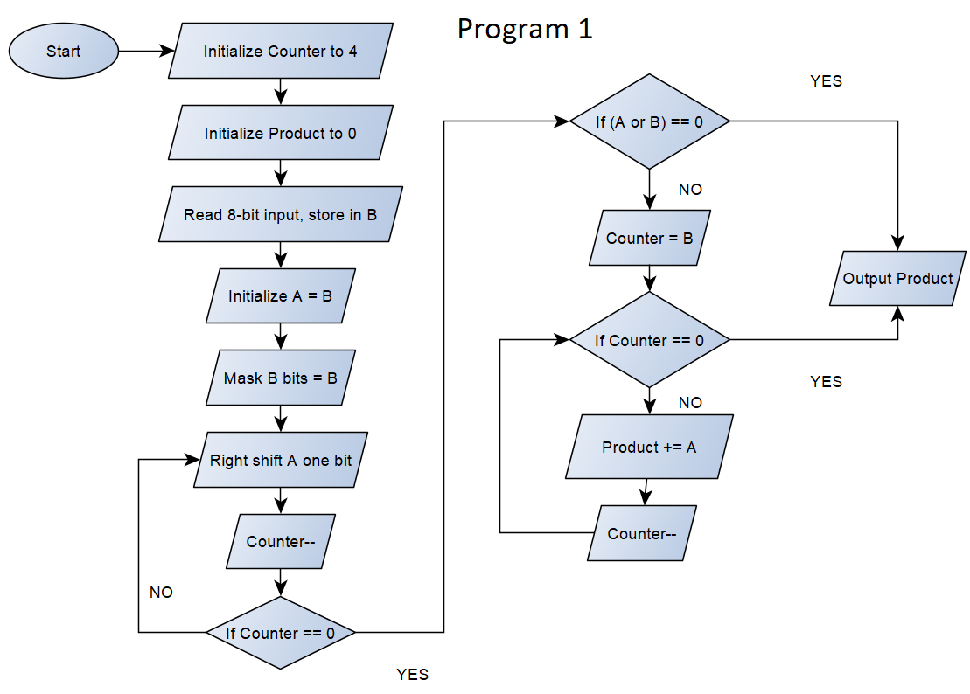

# 

# Verification

**Program 1 Verification**

|  |  |  |  |  |
| --- | --- | --- | --- | --- |
| **Input** | **A** | **B** | **Expected Output** | **Output** |
| 0x0A | 0 | A | 0 x 10 = 0 | 0x00 |
| 0xF0 | F | 0 | 15 x 0 = 0 | 0x00 |
| 0xFF | F | F | 15 x 15 = 225 | 0xE1 |
| 0x44 | 4 | 4 | 4 x 4 = 16 | 0x10 |
| 0xC1 | C | 1 | 12 x 1 = 12 | 0x0C |

**Program 2 Verification**

Let T = 40 ns, such that:

$T*(2+\left[1+255\left(255*\left(94*2\right)+255*3\right)+255*3\right]+\left[1+255\left(154*2\right)+255*3\right]+\left[1+75*2\right])$ = .5 s

# Source Code

PROGRAM 1: Multiplier

; Registers Used:

; R0- counter variable

; R2- input value, lower half of input (multiplier B)

; R3- upper half of input, (multiplicand A)

; R4- product (A * B)

;

; This program multiplies A * B, via iterations of addition

.EQU IN_PORT = 0x9A

.EQU OUT_PORT = 0x42

.EQU SIZE = 4

.CSEG

.ORG 0x01

; SET-UP

start: MOV R0, SIZE ; initialize counter

MOV R4, 0x00 ; initialize product

IN R2, IN_PORT ; Read input value

MOV R3, R2

upper: CLC ; ISOLATE A LOOP

LSR R3

SUB R0, 1 ; counter--

BRNE upper ; END LOOP if R0 == 0

CMP R4, R3 ; if A == 0, output 0

BREQ end

AND R2, 0x0F ; ISOLATE B

CMP R4, R2 ; if B == 0, output 0

BREQ end

MOV R0, R2 ; initialize multiplication counter

mult: ADD R4, R3 ; MULT LOOP

SUB R0, 1 ; counter--

BRNE mult ; END LOOP if R0 == 0

end: OUT R4, OUT_PORT

PROGRAM 2: ½ Second delay

; Program which reads in a value, and generates a delay of .5 seconds, then outputs value

;

; Given that each instruction ~ 40 ns, RAT MCU ~ 25MHZ. Let T = 40ns, such that:

;

; T*{2+

; [1+ 255(255*(94*2)+255* 3)+255*3] (loop1(loop2(loop3)))

; [1+ 255(154*2)+255* 3] (loop4(loop5))

; [1+ 75(2)]} (loop6)

; = .5 secs

;

; Registers Used:

; R0- input value

; R1- count 1, count 4, count 6

; R2- count 2, count 5

; R3- count 3

.EQU IN_PORT = 0x9A

.EQU OUT_PORT = 0x42

.EQU COUNT = 0xFF

.EQU COUNT_3 = 0x5E ; 94

.EQU COUNT_5 = 0x9A ; 154

.EQU COUNT_6 = 0x4B ; 74

.CSEG

.ORG 0x01

IN R0, IN_PORT ; Start, read input

MOV R1, COUNT ; DELAY STARTS

loop1: MOV R2, COUNT ; START LOOP 1

loop2: MOV R3, COUNT_3 ; START LOOP 2

loop3: SUB R3, 1 ; START LOOP 3, count3--

BRNE loop3 ; END LOOP 3

SUB R2, 1 ; count2--

BRNE loop2 ; END LOOP 2

SUB R1, 1 ; count1--

BRNE loop1 ; END LOOP 1

MOV R1, COUNT

loop4: MOV R2, COUNT_5 ; START LOOP 4

loop5: SUB R2, 1 ; START LOOP 5, count5--

BRNE loop5 ; END LOOP 5

SUB R1, 1 ; count4--

BRNE loop4 ; END LOOP 4

MOV R1, COUNT_6

loop6: SUB R1, 1 ; START LOOP ^, count6--

BRNE loop6 ; END LOOP 6

MOV R1, COUNT

MOV R1, COUNT ; DELAY ENDS

OUT R0, OUT_PORT ; end, output