Reg File (Assume that the value of 0x08 was already written to address 19)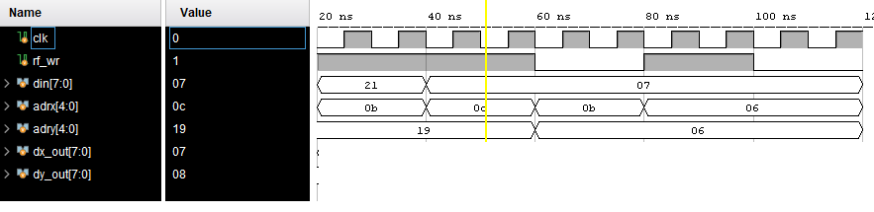

Flag  
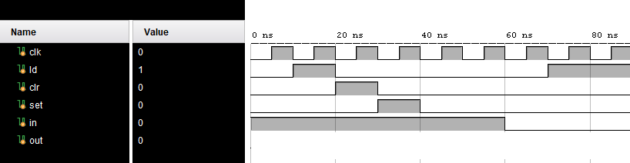

PC AND MUX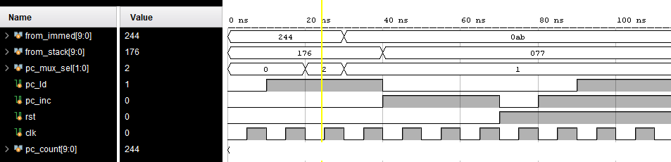

Scratch RAM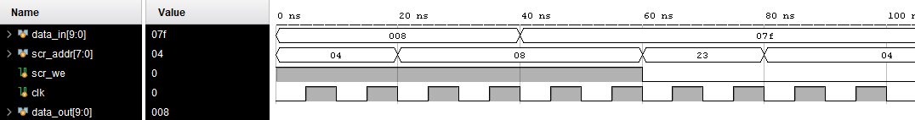

ALU

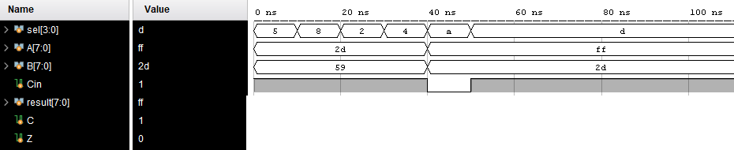

Stack Pointer

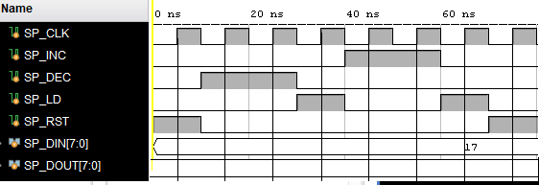

CPU

.CSEG

.ORG 0x02

IN R13, 0x64

label: ADDC R13, R13

AND R13, 0x32

BRN label

