1.Reg File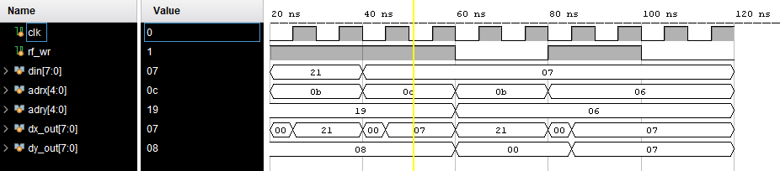

2. Flag

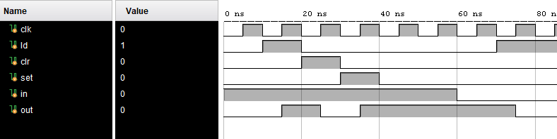

3. PC and MUX

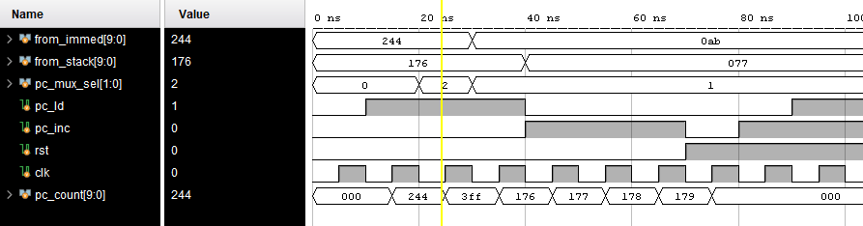

4. Scratch RAM

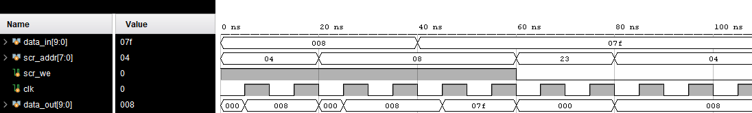

5. ALU

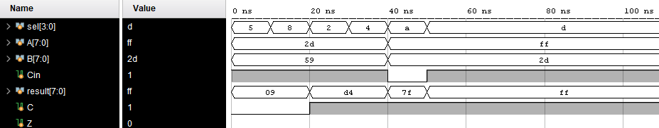

Stack Pointer

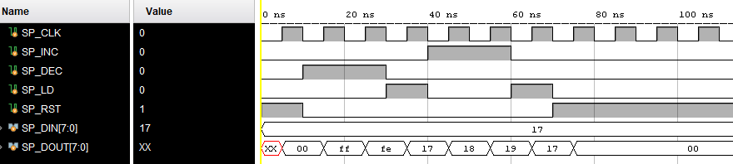

CPU

