|  |
| --- |
| **OHIO LOTTERY** |
| [ABDALLAH HOLOZADAH]  [MIGUEL GOMES]  **[ELBERT WASHINGTON**] |

**PROPOSAL**

Lottery is one of the popular gambling around United states. Every American has spent some money in order to try his/her luck to win one of the biggest prizes ever announced in USA. Ohioan people usually play lottery from some time to time and they are trying their luck in hope to win their American dream.

This project is analyzing the lottery tickets average sales in Cuyahoga County for 2013 along with the average income salary per zip code for the same year. The project is divided into multiple task stages and the results will be shown on a webpage as an HTML file. The tasks are as following:

1. Creating MySQL database. Import the collected Lottery sales Excel data to the database.
2. Using API RESTFUL to retrieve the income salary per zip code and export it to the Database
3. Add a new column of the income salary to the first database by joining census data with lottery sales
4. Use Leaflet.js to create a full map of Cuyahoga County and visualize a heat map of the average lottery sales and income salary per zip codes.
5. Create an HTML file that filtrates the zip code as a menu and returns the information of the collected data from the database and plot it onto HTML as a table format.
6. Create interactive map that will read specific business information

GitHub Link - https://github.com/Gomesm450/Project-3

Figure 2 Average Lottery sales per zip

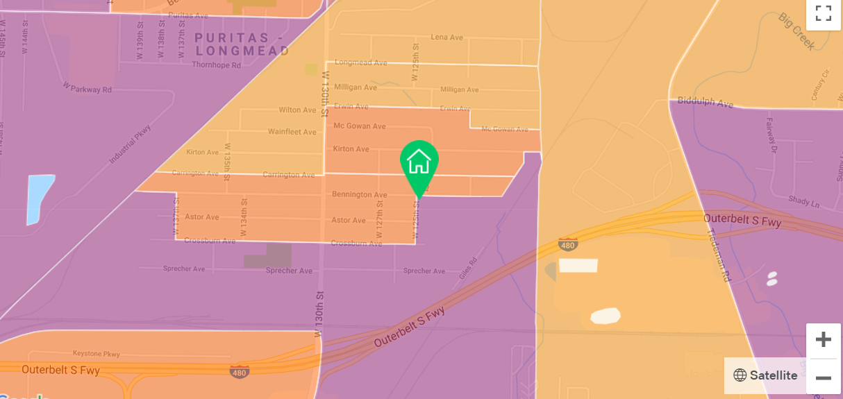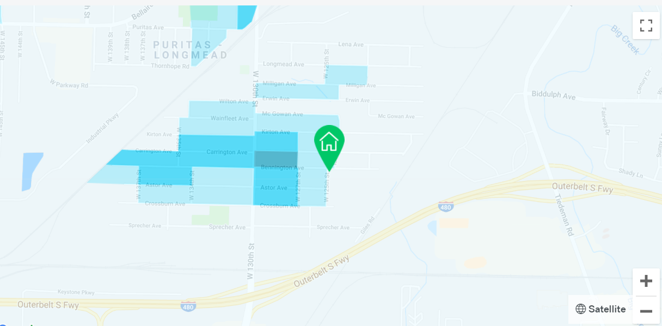

Figure 1 Average Income Salary per zip code

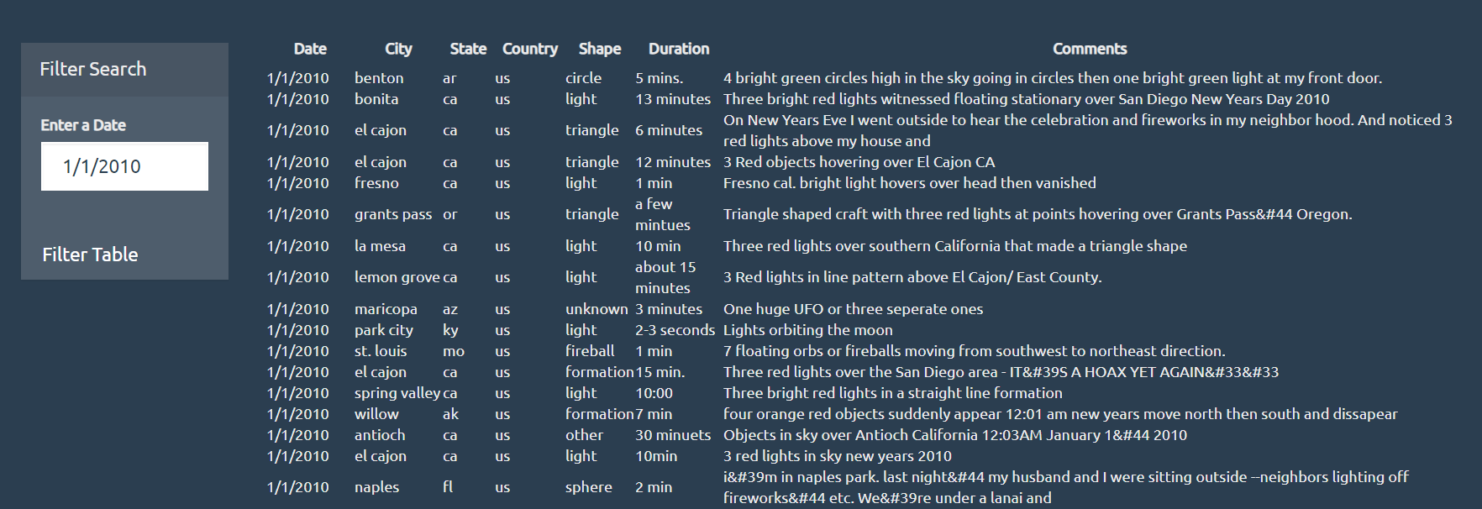

Figure 3 Summary table of Ohio Lottery 1