April 18, 2026
sleepneed
Joseph Gomez, Carlos Cardona, Bircan sahin
IronCore System Requirements Document
DRAFT
Table of Contents
Introduction 1
Description Model 1
Class Diagram 1
Use Case Diagram 1
Use Case Scenarios 1
System Sequence Charts 1

Introduction
The purpose of this System Requirements Document is to define the technical, functional, and operational specifications for the IronCore Fitness application. It serves as the foundational blueprint for the development, testing, and maintenance teams to ensure the final product successfully delivers an accessible, highly personalized AI coaching and gamification platform. This document outlines the complete scope of the system, detailing the specific inputs collected from users, the core processing logic of the AI and points engine, the expected outputs delivered via the user interface, and the strict performance and security standards required to maintain a seamless, secure, and tamper-proof $15/month subscription ecosystem.

Description Model
System Requirements Description Model
The IronCore Fitness system requires a cohesive flow of data between user actions, hardware sensors, and cloud-based AI to deliver its dynamic coaching and rewards platform. The system requirements are expanded across the following five categories:
- Input Requirements: The system must capture explicit user data during the initial AI profiling and bi-weekly progress check-ins, including height, weight, dietary restrictions, fatigue levels, and visual progress. It must seamlessly capture hardware inputs, specifically using the device camera as a UPC scanner to read physical food barcodes (e.g., a cereal box) and GPS/WiFi location data to verify physical gym attendance. Additionally, it must ingest passive biometric data (heart rate, active minutes) via integrations with Apple Health and Google Fit, alongside standard payment details for subscription billing.
- Process Requirements: The system's core processing relies on an AI engine that must instantly calculate baseline workout and macro-nutrient profiles from initial inputs, and dynamically recalibrate these plans based on cyclical progress check-ins. The system must process camera feeds to query a comprehensive food database for exact nutritional facts based on scanned barcodes. Furthermore, the backend must execute strict validation logic to award points—cross-referencing logged workouts with biometric and location data to prevent points manipulation—while the frontend UI engine must enforce a strict black-and-white rendering process that explicitly prevents darkening overlays or blurs on Unsplash photography.
- Output Requirements: The primary system outputs include dynamically generated, personalized daily workout routines, class schedules, and high-level meal plans delivered directly to the user's interface. The system must output visual data analytics using Recharts to display weight trends, consistency streaks, and macro adherence over time. Additionally, the system must output localized human coach recommendations upon user request and render a real-time gamification marketplace displaying accumulated point balances and available physical rewards (apparel, supplements).
- Performance Requirements: The application must deliver a highly responsive user experience, with the UPC barcode scanner recognizing and returning database queries in under 2 seconds to ensure frictionless meal logging. The AI generation and routine recalibration must process via Supabase Edge Functions efficiently, returning updated plans without noticeable loading delays.
- Security Requirements: The system must strictly secure all user health and billing data using Supabase Authentication and encrypted key-value storage. All subscription payments for the $15/month tier must be tokenized and processed through a secure, PCI-compliant gateway (e.g., Stripe), ensuring the system never stores raw credit card information. Finally, robust anti-fraud security measures must be implemented within the points ledger—hard-capping daily point accruals and strictly authenticating GPS and wearable data streams—to ensure the gamification system cannot be manipulated for financial gain.

Class Diagram
Create a class diagram. The Class Diagram should contain all of the system objects, their attributes, and any known methods. This diagram may be included as a separate file – it does not need to be inserted into this Word document.

Use Case Diagram

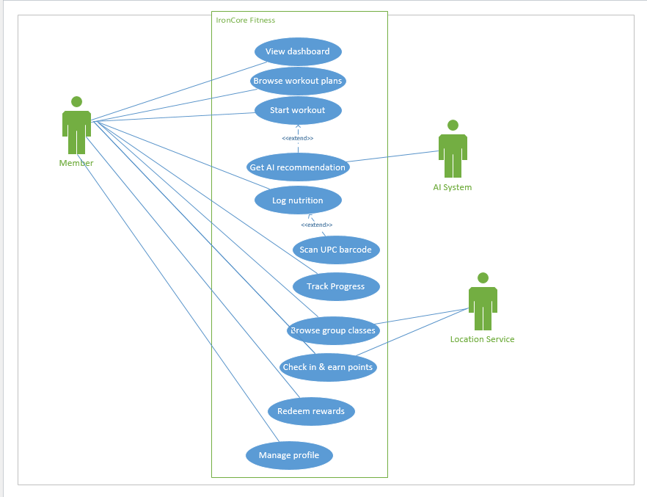Use Case Scenarios
Refer to submission

System Sequence Charts
For each Use Case Scenario, provide a sequence diagram. Use your class diagram, use case diagram and scenarios to create the corresponding System Sequence Diagram.

