Министерство образования Республики Беларусь
Учреждение образования
«Брестский государственный технический университет»
Кафедра ИИТ

Лабораторная работа №4
По дисциплине: «Криптографические методы защиты информации»
Тема: «Эллиптические кривые»

Выполнил:
студент 3 курса
группы ИИ-23
Романюк А. П.

Проверил:
Хацкевич А. С.

Брест 2024
Цель работы: разработать программу для упражнений на эллиптических кривых.
Вариант 9
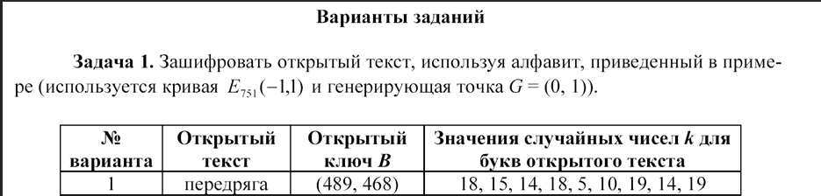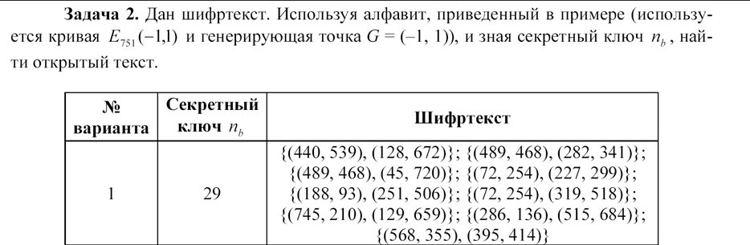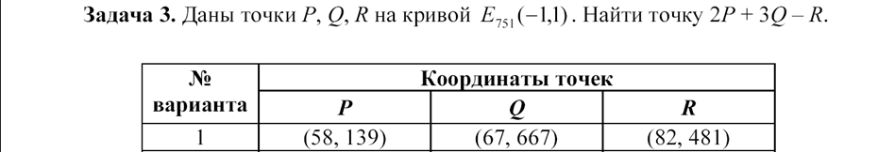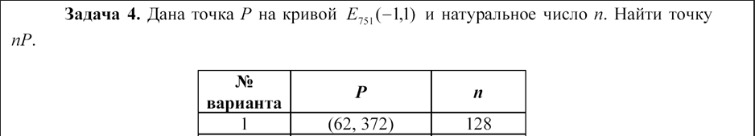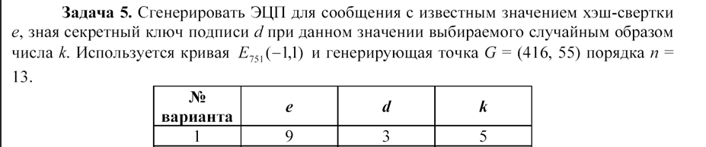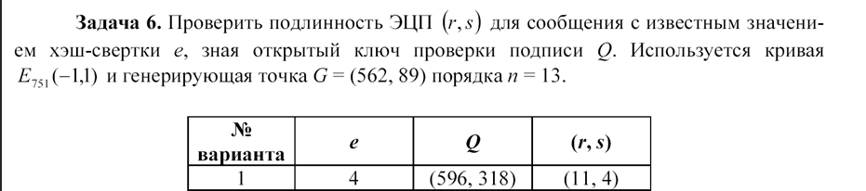
Реализация:
#include <iostream>
#include <vector>
#include <map>
#include <cmath>
#include <random>
#include <windows.h>
#include <locale>
#include <string>
using namespace std;

class ElipticCurves {
int p = 751;
int a = -1;
int b = 1;
pair<int, int> G = { 0,1 };
pair<int, int> Gq23 = { -1,1 };
pair<int, int> G5 = { 416,55 };
int n = 13;
pair<int, int> G6 = { 562,89 };
pair<int, int> GTest = { 384,475 };

map<int, pair<int, int>> alphabet = {
{' ', {33, 355}},
{'!', {33, 396}},
……………………
};
public:
int positiveMod(int a, int m) {
return (a % m + m) % m;
}

int extendEucled(int a, int b, int &x, int &y) {
if (a == 0) {
x = 0;
y = 1;
return b;
}
int x1, y1;
int gcd = extendEucled(positiveMod(b,a), a, x1, y1);
x = y1 - (b / a) * x1;
y = x1;
return gcd;
}

int gcd(int a, int m) {
if (a == 0) {
return 0;
}
int gcd, x, y;
gcd = extendEucled(a, m, x, y);
if (gcd != 1) {
cout << "Error gcd\n";
return 0;
}
return positiveMod(x, m);
}

pair<int, int> doubleAdditing(pair<int, int> P, pair<int, int> Q) {
if (P.first == -1) return Q;//maybe error
if (Q.first == -1) return P;
int x1 = P.first, y1 = P.second;
int x2 = Q.first, y2 = Q.second;

int lm;
if (P != Q) {
int denom1 = positiveMod((y2 - y1), p);
int denom2 = positiveMod((x2 - x1), p);
denom2 = gcd(denom2, p);
lm = positiveMod((denom1 * denom2), p);
}
else {
int denom1 = positiveMod((3 * x1 * x1 + a), p);
int denom2 = positiveMod((2 * y1), p);
denom2 = gcd(denom2, p);
lm = positiveMod((denom1 * denom2), p);
}

int x3 = positiveMod((lm * lm - x1 - x2), p);
int y3 = positiveMod((lm * (x1 - x3) - y1), p);
return { x3,y3 };
}

int bit_length(unsigned int a) {
return a > 0 ? static_cast<int>(std::log2(a)) + 1 : 0;
}

pair<int, int> multiplyPoint(int k, pair<int, int> P) {
pair<int, int> Q = {-1,-1};
for (int i = 0; i < bit_length(k); i++) {
if ((k >> i) & 1) {
Q = doubleAdditing(P, Q);
}
P = doubleAdditing(P, P);
}
return Q;
}

pair<pair<int, int>, pair<int, int>> encryptChar(int k, pair<int, int> Pb, char _char) {
pair<int, int> C1 = multiplyPoint(k, G);
pair<int, int> C2 = multiplyPoint(k, Pb);
C2 = doubleAdditing(C2, alphabet[_char]);
return { C1,C2 };
}

void encryptText(vector<int> k, pair<int,int> Pb, string plaintext) {
vector<pair<pair<int, int>, pair<int, int>>> answer;
for (int i = 0; i < plaintext.size(); i++) {
answer.push_back(encryptChar(k[i], Pb, plaintext[i]));
cout <<"x: (" << answer[i].first.first << "," << answer[i].first.second << ")k * G, y: (" << answer[i].second.first << "," << answer[i].second.second << ")\n";
}
cout << "\n";
}

pair<int, int> reverseSign(pair<int, int> C) {
int x = C.first;
int y = -1 * C.second;
return {x,y};
}

int findKeyByValue(const std::pair<int, int>& value) {
for (const auto& pair : alphabet) {
if (pair.second == value) {
return pair.first;
}
}
return '\0';
}

wchar_t decryptChar(pair<pair<int, int>, pair<int, int>> C, int nb) {
pair<int, int> C_ = multiplyPoint(nb, C.first);
pair<int, int> C_m = reverseSign(C_);
pair<int, int> C_a = doubleAdditing(C.second, C_m);
int char_ = findKeyByValue(C_a);
if (!char_) {
wcout << L"Error char index\n";
return 0;
}
return static_cast<wchar_t>(char_);
}

wstring decryptText(int nb, vector<pair<pair<int, int>, pair<int, int>>> ciphertext) {
wstring decryptedText = L"";
for (auto C : ciphertext) {
wchar_t char_ = decryptChar(C, nb);
if (!char_) {
wcout << L"error find char";
return L"";
}
decryptedText += char_;
}
wcout << decryptedText;
return decryptedText;
}

pair<int, int> signatureGenerate(int k, int e, int d) {
pair<int, int> kG = multiplyPoint(k, G5);
int r = positiveMod(kG.first, n);
int z = gcd(k, n);
int s = positiveMod(z * (e + d * r), n);
cout << "r: " << r << " s: " << s << endl;
return { r,s };
}
bool signatureVerification(int e, pair<int, int> rs, pair<int, int> Q) {
if (1 <= rs.first <= n - 1 && 1 <= rs.second <= n - 1) {
int v = gcd(rs.second, n);
int u1 = positiveMod(e * v, n);
int u2 = positiveMod(rs.first * 3, n);
pair<int, int> u1G = multiplyPoint(u1, G6);
pair<int, int> u2Q = multiplyPoint(u2, Q);
pair<int, int> X = doubleAdditing(u1G, u2Q);
int X_ = positiveMod(X.first, n);
if (rs.first == X_) {
cout << "r: " << rs.first << " x: " << X_ << endl;
return 1;
}
else {
cout << "r: " << rs.first << " x: " << X_ << endl;
return 0;
}
}
else {
cout << "error sign ver";
return -1;
}
}
};
class Task1 {
public:
string plaintext;
pair<int, int> Pb;
vector<int> k;

Task1(string plaintext, pair<int, int> Pb, vector<int> k) {
this->plaintext = plaintext;
this->Pb = Pb;
this->k = k;
}

void activate(ElipticCurves obj) {
obj.encryptText(k, Pb, plaintext);
}
};
class Task2 {
int nb;
vector<pair<pair<int, int>, pair<int, int>>> ciphertext;
public:
Task2(int nb, vector<pair<pair<int, int>, pair<int, int>>> ciphertext) {
this->nb = nb;
this->ciphertext = ciphertext;
}
void activate(ElipticCurves obj) {
obj.decryptText(nb,ciphertext);
}
};
class Task3 {
public:
pair<int,int> P;
pair<int, int> Q;
pair<int, int> R;
int kP = 2;
int kQ = 3;
Task3(pair<int, int> P, pair<int, int> Q, pair<int, int> R) {
this->P = P;
this->Q = Q;
this->R = R;
}

void activate(ElipticCurves obj) {
pair<int, int> p2 = obj.multiplyPoint(kP, P);
pair<int, int> q3 = obj.multiplyPoint(kQ, Q);
pair<int, int> r_ = obj.reverseSign(R);
pair<int, int> p2q3 = obj.doubleAdditing(p2, q3);
pair<int, int> C = obj.doubleAdditing(p2q3, r_);
cout << "x: " << C.first << " y: " << C.second << endl;
}
};

class Task4 {
public:
pair<int, int> P;
int k;
Task4(pair<int, int> P, int k) {
this->P = P;
this->k = k;
}

void activate(ElipticCurves obj) {
pair<int, int> C = obj.multiplyPoint(k, P);
cout << "x: " << C.first << " y: " << C.second << endl;
}
};
class Task5 {
int e;
int d;
int k;
public:
Task5(int e, int d, int k) {
this->e = e;
this->d = d;
this->k = k;
}
void activate(ElipticCurves obj) {
obj.signatureGenerate(k, e, d);
}
};
class Task6 {
int e;
pair<int, int> Q;
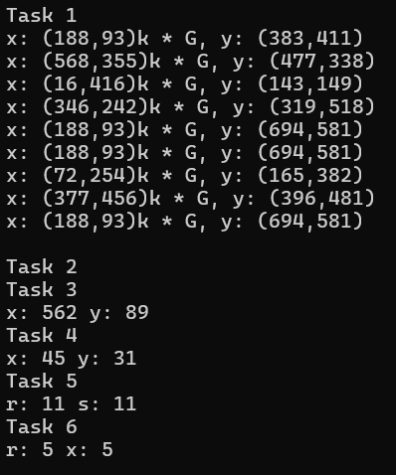
pair<int, int> rs;
public:
Task6(int e,pair<int, int> Q,pair<int, int> rs) {
this->e = e;
this->Q = Q;
this->rs = rs;
}
void activate(ElipticCurves obj) {
obj.signatureVerification(e, rs, Q);
}
};
int main() {
ElipticCurves obj;
cout << "Task 1\n";
Task1 task1("Renessans", { 725,195 }, vector<int>{2, 19, 4, 8, 2, 2, 16, 10, 2});
task1.activate(obj);
cout << "Task 2\n";
vector<pair<pair<int, int>, pair<int, int>>> data = {
{{188, 93}, {623, 166}},
{{725, 195}, {513, 414}},
{{346, 242}, {461, 4}},
{{489, 468}, {739, 574}},
{{725, 195}, {663, 476}},
{{745, 210}, {724, 522}},
{{725, 195}, {663, 476}},
{{618, 206}, {438, 40}},
{{286, 136}, {546, 670}},
{{179, 275}, {73, 72}}
};
Task2 task2(32, data);
task2.activate(obj);
cout << "Task 3\n";
Task3 task3({ 59,386 }, { 61,129 }, { 100,364 });
task3.activate(obj);
cout << "Task 4\n";
Task4 task4({ 45,720 },111);
task4.activate(obj);
cout << "Task 5\n";
Task5 task5(11,5,6);
task5.activate(obj);
cout << "Task 6\n";
Task6 task6(7, {384,475}, { 5,5 });
task6.activate(obj);
}
Вывод: разработал программу для упражнений на эллиптических кривых.

