Министерство образования Республики Беларусь
Учреждение образования
«Брестский Государственный технический университет»
Кафедра ИИТ

Лабораторная работа №2
По дисциплине «Модели решения задач в интеллектуальных системах»
Тема: «SLP. Прогнозирование»

Выполнил:
Студент 3 курса
Группы ИИ-23
Романюк А. П.
Проверил:
Туз И. С.

Брест 2024
Цель: Обучить сеть с использованием константного и адаптивного шага обучения, online-learning и batch-learning. Результаты для каждого варианта сети занести в таблицу(
test error, количество эпох, время обучения и тд)

Ход работы
Вариант 9

import matplotlib.pyplot as plt
import numpy as np
import pandas as pd
import time
class NN:
def __init__(self, alpha=0.01, neurons=5):
self.alpha = alpha
self.neurons = neurons
self.W = np.random.rand(neurons)
self.T = np.zeros(1)
self.errors = []
def create_dataset(self, y):
return np.array([y[i - self.neurons : i] for i in range(self.neurons, len(y))])
def adaptive_alpha(self, x):
return 1/(1+sum(x**2))
def a(self,X,E,xk):
a = 0
for x, e in zip(X,E):
sum = 0
for i in range(len(x)):
sum+=xk[i]*x[i]
a+=(self.predict(x)-e)*(1+sum)
return a
def adaptive_batch_alpha(self, X, E):
sum_a = 0
sum_b = 0
for x, e in zip(X,E):
sum_a+=(self.predict(x)-e)*self.a(X,E,x)
sum_b+=(self.a(X,E,x))**2
return sum_a/sum_b
def MSE(self, x, e):
return (1 / 2) * ((self.predict(x) - e) ** 2)
def predict(self, x):
return self.W @ x - self.T
def train(self, X, E):
for x, e in zip(X[: 31 - self.neurons], E[self.neurons : 31]):
y = self.predict(x)
self.W += -self.alpha * (y - e) * x
self.T += self.alpha * (y - e)
def adapt_train(self, X, E):
for x, e in zip(X[: 31 - self.neurons], E[self.neurons: 31]):
y = self.predict(x)
self.W += -self.adaptive_alpha(x) * (y - e) * x
self.T += self.adaptive_alpha(x) * (y - e)
def batch_train(self, X, E, batch_size):
num_batches = len(X[: 31 - self.neurons]) // batch_size + (
1 if len(X[: 31 - self.neurons]) % batch_size != 0 else 0)
for batch_index in range(num_batches):
start = batch_index * batch_size
end = min((batch_index + 1) * batch_size, len(X[: 31 - self.neurons]))
W_update = np.zeros_like(self.W)
T_update = np.zeros(1)
for x, e in zip(X[start:end], E[start+self.neurons:end+self.neurons]):
y = self.predict(x)
W_update += (y - e) * x
T_update += (y - e)
self.W += -self.alpha * W_update
self.T += self.alpha * T_update
def adapt_batch_train(self, X, E, batch_size):
num_batches = len(X[: 31 - self.neurons]) // batch_size + (
1 if len(X[: 31 - self.neurons]) % batch_size != 0 else 0)
for batch_index in range(num_batches):
start = batch_index * batch_size
end = min((batch_index + 1) * batch_size, len(X[: 31 - self.neurons]))
W_update = np.zeros_like(self.W)
T_update = np.zeros(1)
for x, e in zip(X[start:end], E[start+self.neurons:end+self.neurons]):
y = self.predict(x)
W_update += (y - e) * x
T_update += (y - e)
self.W += -self.adaptive_batch_alpha(X[start:end], E[start+self.neurons:end+self.neurons]) * W_update
self.T += self.adaptive_batch_alpha(X[start:end], E[start+self.neurons:end+self.neurons]) * T_update
def test(self, epoch: int, X, E):
values = []
error = np.mean([self.MSE(x, e) for x, e in zip(X[31 - self.neurons :], E[31:])])
for x, e in zip(X[0 : len(E) - self.neurons], E[self.neurons : len(E)]):
values.append(self.predict(x))
print(f"Epoch: {epoch}: e={error}")
return values
def set_MSE(self, X, E):
self.errors.append(np.mean([self.MSE(x, e) for x, e in zip(X[31 - self.neurons :], E[31:])]))
def collect_results(model_name, model, epochs, start_time):
results = {
"Model": model_name,
"Test Error": model.errors[-1], # Last error value
"Epochs": epochs,
"Training Time (s)": time.time() - start_time # Time in seconds
}
return results
# Create an empty list to store results
results_table = []
if __name__ == "__main__":
# best alpha=0.2 neurons=5
neurons = 5
lin_model = NN(alpha=0.05, neurons=neurons)
lin_model_adapt = NN(alpha=0.05, neurons=neurons)
batch_model = NN(alpha=0.05, neurons=neurons)
batch_model_adapt = NN(alpha=0.05, neurons=neurons)
arrange = np.arange(0, 5, 0.1)
func = lambda a, b, d, x: a * np.sin(b * x) + d
y = func(1, 8, 0.3, np.arange(0, 5, 0.1))
x = lin_model.create_dataset(y)
# Linear model
print("\nLinear model\n")
start_time = time.time()
last_epoch = -1
for epoch in range(1, 100):
lin_model.train(x, y)
lin_model.set_MSE(x, y)
lin_model.test(epoch, x, y)
if lin_model.errors[-1] <= 1e-5:
last_epoch = epoch
break
if last_epoch == -1:
last_epoch = 99
print("Training results")
lin_values = lin_model.test(last_epoch, x, y)
# Collect results for the linear model
results_table.append(collect_results("Linear Model", lin_model, last_epoch, start_time))
# Linear model adaptive
print("\nLinear model adapt\n")
start_time = time.time()
last_epoch = -1
for epoch in range(1, 100):
lin_model_adapt.adapt_train(x, y)
lin_model_adapt.set_MSE(x, y)
lin_model_adapt.test(epoch, x, y)
if lin_model_adapt.errors[-1] <= 1e-5:
last_epoch = epoch
break
if last_epoch == -1:
last_epoch = 99
print("Training results")
lin_values_adapt = lin_model_adapt.test(last_epoch, x, y)
# Collect results for the linear model adaptive
results_table.append(collect_results("Linear Model Adaptive", lin_model_adapt, last_epoch, start_time))
# Batch model
print("\nBatch model\n")
start_time = time.time()
last_epoch = -1
for epoch in range(1, 100):
batch_model.batch_train(x, y, 10)
batch_model.set_MSE(x, y)
batch_model.test(epoch, x, y)
if batch_model.errors[-1] <= 1e-5:
last_epoch = epoch
break
if last_epoch == -1:
last_epoch = 99
print("Training results")
batch_values = batch_model.test(last_epoch, x, y)
# Collect results for the batch model
results_table.append(collect_results("Batch Model", batch_model, last_epoch, start_time))
# Batch model adaptive
print("\nBatch model adapt\n")
start_time = time.time()
last_epoch = -1
for epoch in range(1, 100):
batch_model_adapt.adapt_batch_train(x, y, 10)
batch_model_adapt.set_MSE(x, y)
batch_model_adapt.test(epoch, x, y)
if batch_model_adapt.errors[-1] <= 1e-5:
last_epoch = epoch
break
if last_epoch == -1:
last_epoch = 99
print("Training results")
batch_values_adapt = batch_model_adapt.test(last_epoch, x, y)
# Collect results for the batch model adaptive
results_table.append(collect_results("Batch Model Adaptive", batch_model_adapt, last_epoch, start_time))
# Convert results to a pandas DataFrame
df = pd.DataFrame(results_table)
# Print the table
print("\nTraining Results Table:")
print(df)
# Optionally, save the table to a CSV file
df.to_csv("training_results.csv", index=False)
plt.plot(range(1, len(lin_model.errors) + 1), lin_model.errors, label="Lin Model")
plt.plot(range(1, len(lin_model_adapt.errors) + 1), lin_model_adapt.errors, label="Lin Model Adapt")
plt.plot(range(1, len(batch_model.errors) + 1), batch_model.errors, label="Batch Model")
plt.plot(range(1, len(batch_model_adapt.errors) + 1), batch_model_adapt.errors, label="Batch Model Adapt")
plt.xlabel("Epoch")
plt.ylabel("Error")
plt.legend() # Optional, to add labels for each line
plt.savefig("NN.png")
plt.clf()
plt.plot(np.arange(0, 5, 0.1), func(1, 8, 0.3, np.arange(0, 5, 0.1)), label="Original Function")
plt.plot(np.arange(neurons / 10, 5, 0.1), lin_values, label="Prediction (Linear)")
plt.plot(np.arange(neurons / 10, 5, 0.1), lin_values_adapt, label="Prediction (Linear, Adaptive)")
plt.plot(np.arange(neurons / 10, 5, 0.1), batch_values, label="Prediction (Batch)")
plt.plot(np.arange(neurons / 10, 5, 0.1), batch_values_adapt, label="Prediction (Batch, Adaptive)")
plt.xlabel("X (Input Value)")
plt.ylabel("Y (Output Value)")
plt.title("Comparison of Original Function and Neural Network Predictions")
plt.legend(loc="upper center")
plt.savefig("graph.png")

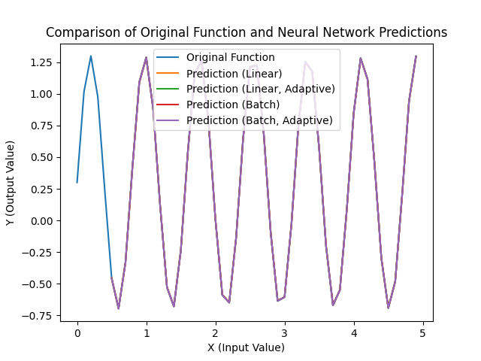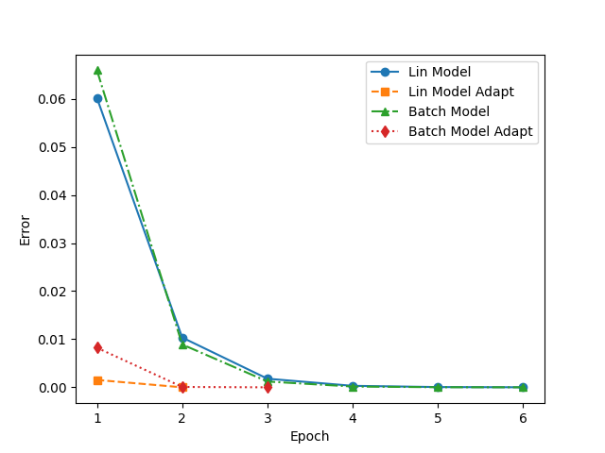
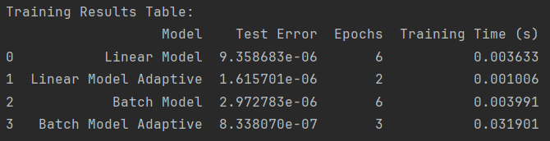
Вывод: в ходе лабораторной работы я научился реализовывать однослойную нейронную сеть.

