Министерство образования Республики Беларусь
Учреждение образования
«Брестский Государственный технический университет»
Кафедра ИИТ

Лабораторная работа №5
По дисциплине «Модели решения задач в интеллектуальных системах»
Тема: «MLP. Прогнозирование»

Выполнил:
Студент 3 курса
Группы ИИ-23
Романюк А. П.
Проверил:
Туз И. С.

Брест 2024
Цель: Изучить обучение и функционирование MLP при решении задач прогнозирования.

Написать нейронную сеть(multilayer perceptron c одним скрытым слоем) для
решения задачи прогнозирования функции:
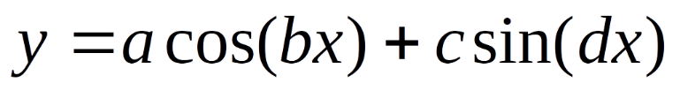
Обучить сеть с использованием константного и адаптивного шага обучения, online-
learning и batch-learning. Результаты для каждого варианта сети занести в таблицу(
test error, количество эпох, время обучения и тд).
В обучении использовать алгоритм обратного распространения ошибки и batch_size > 1
Вариант: 9
Ход работы

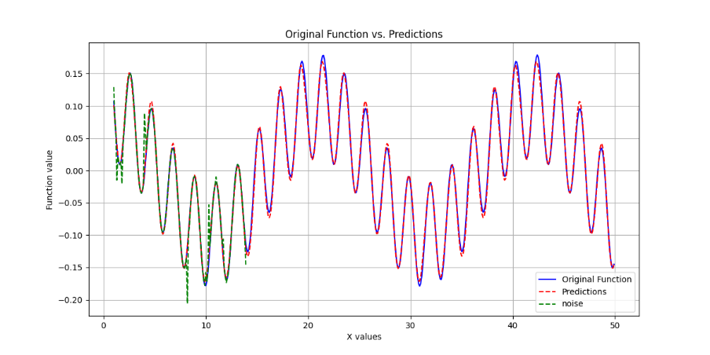
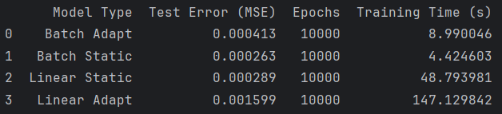
import numpy as np
import matplotlib.pyplot as plt
import pandas as pd
import time
class MLP:
def __init__(self, input_size, hide_size, output_size, alpha):
self.input_size = input_size
self.output_size = output_size
self.hide_size = hide_size
self.Wh = np.random.uniform(size=(input_size, hide_size))
self.Wo = np.random.uniform(size=(hide_size, output_size))
self.Th = np.random.uniform(size=(1, hide_size))
self.To = np.random.uniform(size=(1, output_size))
self.alpha = alpha
def tanh(self, x):
return np.tanh(x)
def tanh_derivative(self, x):
return 1 - np.tanh(x) ** 2
def create_dataset(self, noise_percentage=0.1):
func = lambda a, b, c, d, x: a * np.cos(b * x) + c * np.sin(d * x)
x = np.arange(0, 15, 0.1)
y = func(0.1, 0.3, 0.08, 3, x)
y = np.array([y[i - self.input_size: i] for i in range(self.input_size, len(y))])
e = np.array([y[i + self.input_size][0] for i in range(len(y) - self.input_size)])
# Calculate the number of noisy points based on the noise_percentage
num_noisy_points = int(len(e) * (noise_percentage))
noisy_indices = np.random.choice(len(e), num_noisy_points, replace=False)
# Apply noise to the selected indices of e
noise = np.random.uniform(-0.1, 0.1, size=num_noisy_points) # Adjust the range of noise
e[noisy_indices] += noise # Add noise to the selected indices
return y[:len(y) - self.input_size], e, x[:len(y) - self.input_size]
def train(self, x, e, batch_size,mode="ba"):
if mode == "ba":
num_samples = x.shape[0]
for start in range(0, num_samples, batch_size):
end = start + batch_size
x_batch = x[start:min(end, num_samples)]
e_batch = e[start:min(end, num_samples)].reshape(-1, self.output_size)
yi = np.dot(x_batch, self.Wh) + self.Th
# Calculate the hidden layer output
yh = self.tanh(np.dot(x_batch, self.Wh) + self.Th)
# Output layer calculation
yo = np.dot(yh, self.Wo) + self.To
error = e_batch - yo
deltao = error * self.tanh_derivative(yo)
self.learning_rate_output = np.sum(error**2*self.tanh_derivative(yo)) / \
(1 + np.sum(yh**2) * np.sum(error**2*self.tanh_derivative(yo)**2))
hidden_error = deltao.dot(self.Wo.T)
self.learning_rate_hidden = np.sum(hidden_error**2*self.tanh_derivative(yh)) / \
(1 + (np.sum(yi**2)) * np.sum(hidden_error**2*self.tanh_derivative(yh)**2))
self.learning_rate_hidden = self.alpha
deltah = hidden_error * self.tanh_derivative(yh)
self.Wo += yh.T.dot(deltao) * self.learning_rate_output / x_batch.shape[0]
self.To += np.sum(deltao, axis=0, keepdims=True) * self.learning_rate_output / x_batch.shape[0]
self.Wh += x_batch.T.dot(deltah) * self.learning_rate_hidden / x_batch.shape[0]
self.Th += np.sum(deltah, axis=0, keepdims=True) * self.learning_rate_hidden / x_batch.shape[0]
elif mode == "b":
num_samples = x.shape[0]
for start in range(0, num_samples, batch_size):
end = start + batch_size
x_batch = x[start:min(end, num_samples)]
e_batch = e[start:min(end, num_samples)].reshape(-1, self.output_size)
yh = self.tanh(np.dot(x_batch, self.Wh) + self.Th)
# Output layer calculation
yo = np.dot(yh, self.Wo) + self.To
error = e_batch - yo
deltao = error * self.tanh_derivative(yo)
hidden_error = deltao.dot(self.Wo.T)
deltah = hidden_error * self.tanh_derivative(yh)
self.Wo += yh.T.dot(deltao) * self.alpha / x_batch.shape[0]
self.To += np.sum(deltao, axis=0, keepdims=True) * self.alpha / x_batch.shape[0]
self.Wh += x_batch.T.dot(deltah) * self.alpha / x_batch.shape[0]
self.Th += np.sum(deltah, axis=0, keepdims=True) * self.alpha / x_batch.shape[0]
def test(self, x):
yh = self.tanh(np.dot(x, self.Wh) + self.Th)
yo = np.dot(yh, self.Wo) + self.To
return yo.flatten()
def mean_squared_error(self, true_values, predictions):
return np.mean((true_values - predictions) ** 2)
def draw_test_on_interval(self, start, end,e, step=0.1):
x_new = np.arange(start, end, step)
func = lambda a, b, c, d, x: a * np.cos(b * x) + c * np.sin(d * x)
y_new = func(0.1, 0.3, 0.08, 3, x_new)
y_input = np.array([y_new[i - self.input_size: i] for i in range(self.input_size, len(y_new))])
predictions = self.test(y_input)
x_new_cropped = x_new[self.input_size:]
print(e[:10])
print(y_new[self.input_size:20])
plt.figure(figsize=(12, 6))
plt.plot(x_new_cropped, y_new[self.input_size:], label='Original Function', color='blue')
plt.plot(x_new_cropped, predictions, label='Predictions', color='red', linestyle='dashed')
plt.plot(x_new_cropped[:len(e)], e, label='noise', color='green', linestyle='dashed')
plt.xlabel('X values')
plt.ylabel('Function value')
plt.title('Original Function vs. Predictions')
plt.legend()
plt.grid()
plt.show()
def run_model(mode, input_size=10, hide_size=4, output_size=1, alpha=0.2, batch_size=10, epochs=10000):
model = MLP(input_size=input_size, hide_size=hide_size, output_size=output_size, alpha=alpha)
y, e, x_values = model.create_dataset()
start_time = time.time()
for epoch in range(epochs):
model.train(y, e, batch_size, mode=mode)
if (epoch + 1) % 100 == 0:
predictions = model.test(y)
mse = model.mean_squared_error(e, predictions)
print(f'Epoch {epoch + 1}, Mean Squared Error: {mse}')
training_time = time.time() - start_time
predictions = model.test(y)
mse = model.mean_squared_error(e, predictions)
model.draw_test_on_interval(0,50,e)
return mse, training_time, epochs
def show_results_table(results):
df = pd.DataFrame(results, columns=['Model Type', 'Test Error (MSE)', 'Epochs', 'Training Time (s)'])
print(df)
# Run and collect results for different models
results = []
mse, training_time, epochs = run_model(mode="ba")
results.append(["Batch Adapt", mse, epochs, training_time])
mse, training_time, epochs = run_model(mode="b", batch_size=10)
results.append(["Batch Static", mse, epochs, training_time])
mse, training_time, epochs = run_model(mode="b", batch_size=1)
results.append(["Linear Static", mse, epochs, training_time])
mse, training_time, epochs = run_model(mode="ba", batch_size=1)
results.append(["Linear Adapt", mse, epochs, training_time])
# Show the table of results
show_results_table(results)
Вывод: в ходе лабораторной работы я научился реализовывать однослойную нейронную сеть.

