Министерство образования Республики Беларусь
Учреждение образования
«Брестский Государственный технический университет»
Кафедра ИИТ

Лабораторная работа №2
По дисциплине «Модели решения задач в интеллектуальных системах»
Тема: «Альтернативные методы обучения автоэнкодеров»

Выполнил:
Студент 3 курса
Группы ИИ-23
Романюк А. П.
Проверил:
Туз И. С.

Брест 2025

Цель работы: В рамках данной работы необходимо реализовать и обучить автоэнкодер. В качестве алгоритмов оптимизации использовать правило Ойя, кумулятивное дельта правило, SGD, Adam.
Ход работы
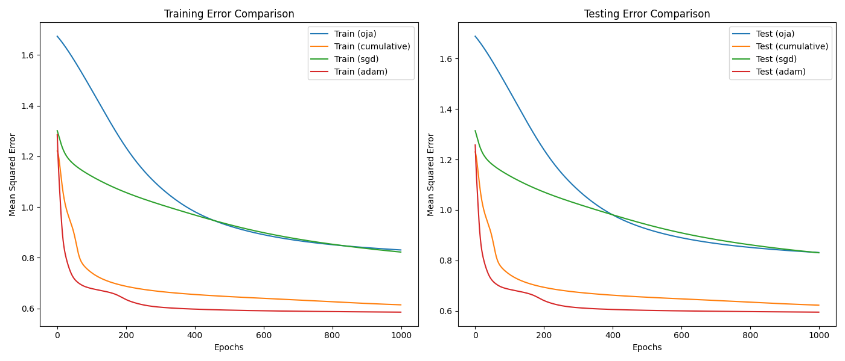

Autoencoder.py:
class Autoencoder:
def __init__(self, input_dim, encoding_dim, learning_rate, alpha=0.0, optimizer_type="cumulative"):
self.input_dim = input_dim
self.encoding_dim = encoding_dim
self.learning_rate = learning_rate
self.alpha = alpha
self.optimizer_type = optimizer_type
self.weights_input_encoding = np.random.randn(input_dim, encoding_dim)
self.weights_encoding_input = np.random.randn(encoding_dim, input_dim)
self.bias_encoding = np.random.randn(1, encoding_dim)
self.bias_input = np.random.randn(1, input_dim)
self.prev_delta_weights_input_encoding = np.zeros((input_dim, encoding_dim))
self.prev_delta_weights_encoding_input = np.zeros((encoding_dim, input_dim))
self.prev_delta_bias_encoding = np.zeros((1, encoding_dim))
self.prev_delta_bias_input = np.zeros((1, input_dim))
self.train_errors = []
self.test_errors = []
if optimizer_type == "adam":
self.model = nn.Sequential(
nn.Linear(input_dim, encoding_dim),
nn.Sigmoid(),
nn.Linear(encoding_dim, input_dim),
nn.Sigmoid()
)
self.criterion = nn.MSELoss()
self.optimizer = optim.Adam(self.model.parameters(), lr=learning_rate)
@staticmethod
def sigmoid(x):
return 1 / (1 + np.exp(-x))
@staticmethod
def sigmoid_derivative(x):
return x * (1 - x)
def encode(self, inputs):
self.encoding_layer_input = np.dot(inputs, self.weights_input_encoding) + self.bias_encoding
self.encoding_layer_output = self.sigmoid(self.encoding_layer_input)
def decode(self, encoding_output):
self.input_layer_input = np.dot(encoding_output, self.weights_encoding_input) + self.bias_input
self.input_layer_output = self.sigmoid(self.input_layer_input)
def backward_pass(self, inputs):
if self.optimizer_type == "adam":
inputs_tensor = torch.tensor(inputs, dtype=torch.float32)
outputs = self.model(inputs_tensor)
loss = self.criterion(outputs, inputs_tensor)
self.optimizer.zero_grad()
loss.backward()
self.optimizer.step()
self.train_errors.append(loss.item())
return
encoding_error = inputs - self.input_layer_output
encoding_delta = encoding_error * self.sigmoid_derivative(self.input_layer_output)
if self.optimizer_type == "oja":
self.weights_encoding_input += self.learning_rate * np.dot(self.encoding_layer_output.T, encoding_delta) / inputs.shape[0]
self.bias_input += self.learning_rate * np.mean(encoding_delta, axis=0, keepdims=True)
decoding_error = encoding_delta.dot(self.weights_encoding_input.T)
decoding_delta = decoding_error * self.sigmoid_derivative(self.encoding_layer_output)
for i in range(self.encoding_dim):
delta_w = self.learning_rate * (self.encoding_layer_output[:, i][:, np.newaxis] * (
inputs - self.encoding_layer_output[:, i][:, np.newaxis] * self.weights_input_encoding[:, i])).mean(axis=0)
self.weights_input_encoding[:, i] += delta_w
self.bias_encoding += self.learning_rate * np.mean(decoding_delta, axis=0, keepdims=True)
elif self.optimizer_type == "cumulative":
delta_weights_encoding_input = (
self.learning_rate * np.dot(self.encoding_layer_output.T, encoding_delta) / inputs.shape[0]
+ self.alpha * self.prev_delta_weights_encoding_input
)
delta_bias_input = (
self.learning_rate * np.mean(encoding_delta, axis=0, keepdims=True)
+ self.alpha * self.prev_delta_bias_input
)
self.weights_encoding_input += delta_weights_encoding_input
self.bias_input += delta_bias_input
decoding_error = encoding_delta.dot(self.weights_encoding_input.T)
decoding_delta = decoding_error * self.sigmoid_derivative(self.encoding_layer_output)
delta_weights_input_encoding = (
self.learning_rate * np.dot(inputs.T, decoding_delta) / inputs.shape[0]
+ self.alpha * self.prev_delta_weights_input_encoding
)
delta_bias_encoding = (
self.learning_rate * np.mean(decoding_delta, axis=0, keepdims=True)
+ self.alpha * self.prev_delta_bias_encoding
)
self.weights_input_encoding += delta_weights_input_encoding
self.bias_encoding += delta_bias_encoding
# Store current deltas for next iteration
self.prev_delta_weights_input_encoding = delta_weights_input_encoding
self.prev_delta_weights_encoding_input = delta_weights_encoding_input
self.prev_delta_bias_encoding = delta_bias_encoding
self.prev_delta_bias_input = delta_bias_input
elif self.optimizer_type == "sgd":
self.weights_encoding_input += self.learning_rate * np.dot(self.encoding_layer_output.T, encoding_delta) / inputs.shape[0]
self.bias_input += self.learning_rate * np.mean(encoding_delta, axis=0, keepdims=True)
decoding_error = encoding_delta.dot(self.weights_encoding_input.T)
decoding_delta = decoding_error * self.sigmoid_derivative(self.encoding_layer_output)
self.weights_input_encoding += self.learning_rate * np.dot(inputs.T, decoding_delta) / inputs.shape[0]
self.bias_encoding += self.learning_rate * np.mean(decoding_delta, axis=0, keepdims=True)
mse = np.mean((inputs - self.input_layer_output) ** 2)
self.train_errors.append(mse)
def train(self, train_data, test_data, epochs=10):
for epoch in range(epochs):
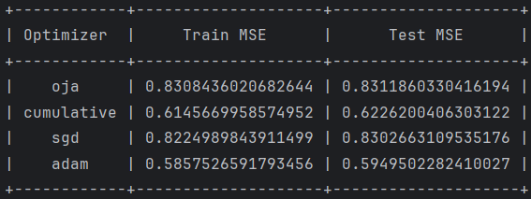
if self.optimizer_type == "adam":
self.backward_pass(train_data)
else:
self.encode(train_data)
self.decode(self.encoding_layer_output)
self.backward_pass(train_data)
if self.optimizer_type == "adam":
test_inputs_tensor = torch.tensor(test_data, dtype=torch.float32)
test_outputs = self.model(test_inputs_tensor)
test_loss = self.criterion(test_outputs, test_inputs_tensor)
self.test_errors.append(test_loss.item())
else:
self.encode(test_data)
self.decode(self.encoding_layer_output)
test_mse = np.mean((test_data - self.input_layer_output) ** 2)
self.test_errors.append(test_mse)
if (epoch + 1) % 100 == 0:
print(f"Epoch {epoch + 1}/{epochs}, Train MSE: {self.train_errors[-1]:.4f}, Test MSE: {self.test_errors[-1]:.4f}")

Вывод: в ходе лабораторной работы я научился реализовывать PCA и автоэнкодеры.

