SQL1

SQL2

SQL3

SQL4

SQL5

SQL6

SQL7

SQL8

SQL9

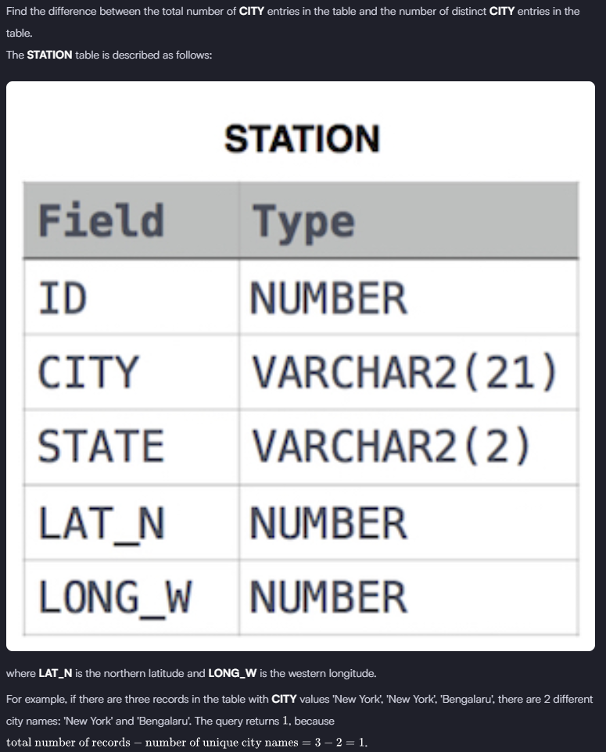

SQL10

