12 May 2018

Nick P. Gondek

Conservation Metrics Inc.

145 McAllister Way

Santa Cruz, CA 95060

(414) 581-4445

nick@conservationmetrics.com

RH: Gondek et al. • Subsampling for SECR

**Too much DNA? Subsampling strategies for Spatially Explicit Capture-Recapture Estimators**

NICK P. GONDEK,[1] *University of Minnesota, 2003 Upper Buford Cir, St Paul, MN 55108 USA*

DAVID L. GARSHELIS, *Minnesota Department of Natural Resources, 1201 E. Hwy 2, Grand Rapids, MN 55744, USA*

KAREN V. NOYCE, *Minnesota Department of Natural Resources, 1201 E. Hwy 2, Grand Rapids, MN 55744, USA*

JOHN F. FIEBERG,[2] *University of Minnesota, 2003 Upper Buford Cir, St Paul, MN 55108 USA*

**ABSTRACT** Genetic mark-recapture studies estimate animal abundance using non-invasive DNA identification methods to "capture" and subsequently "recapture" individuals that leave genetic material at trap sites. Due to the cost of genotypic analysis, researchers often choose to process only a subsample of this genetic material. We explored the effect of subsampling on spatially-explicit capture recapture (SECR) estimators using hair-snare data obtained from a 2012 genetic mark-recapture study of black bears (*Ursus americanus*), and by simulating capture histories from a known population. Similar to effects on non-spatial mark-recapture estimators, subsampling produced density estimates that were lower, on average, than the full data estimate when individuals left varying numbers of samples at a trap; however non-proportional subsampling (sampling at least one observation from each unique trapping site and sampling period combination) had much less of an effect on estimator performance than simple random sampling. Thus, non-proportional subsampling may be preferable to simple random sampling, despite the inherent violations of SECR assumptions that may result. The benefits of using non-proportional sampling will be greatest when individuals exhibit substantial heterogeneity in their capture propensities, leave multiple samples at a trap, and when available funding severely limits the amount of samples that can be processed.

**KEY WORDS** black bear, genetic mark-recapture, density estimation, Minnesota, subsampling, simulation, spatially-explicit, *Ursus americanus*

Wildlife managers routinely use mark-recapture studies to estimate animal abundance; especially in the case of endangered species and game animals, abundance and its associated temporal trends are of critical importance for making informed management decisions (Borchers *et al.* 2002; McCrea and Morgan 2014). Abundance estimates can be difficult to interpret, however, without some understanding of the effective area sampled; extrapolation to a regional scale by way of density is almost always desired, if not necessary (Borchers *et al.* 2002; Royle *et al.* 2013). As such, abundance estimates without associated reliable density estimates may be of limited use to managers.

Ad-hoc methods are sometimes used to estimate the effective area sampled in mark-recapture studies (e.g., by quantifying how far animals move); this area can then be used to rescale abundance estimates to obtain estimates of density (Wilson and Anderson 1985, White and Shenk 2001, Ivan et al. 2013ab). Spatially-explicit capture recapture methods (SECR), by contrast, link abundance estimators to their associated study area in a statistically rigorous way (Efford *et al.* 2005; Borchers 2012; Royle *et al.* 2013). SECR estimates of abundance scale directly with a given sampled area, potentially allowing for better standardization of estimates across space or time. SECR models also make better use of capture-recapture data by using the information in the spatial capture histories to model detection probabilities as a function of the distance between each animal's (latent) activity center (AC) and the trapping grid. As such, SECR provides a way to account for an important source of individual heterogeneity in capture probabilities that is unaccounted for in traditional (non-spatial) mark-recapture estimators (e.g., animals with home ranges near the edge of the trapping grid will be less likely to be captured than animals with activity centers near the center of the trapping grid).

SECR models are often fit to capture histories obtained using genetic data (e.g., from hair collected at a trap site), which provides a non-invasive and efficient means of detecting unique individuals (Boulanger *et al.* 2004; Petit and Valiere 2006; Gervasi *et al.* 2008; Buckworth and Territory 2012). Due to the costs of genotypic analysis, however, managers may only be able to process a subsample of genetic material left at trapping sites (Boulanger *et al.* 2004; Petit and Valiere 2006; Gervasi *et al.* 2008; Settlage *et al.* 2008).

Subsampling has been shown to be problematic for non-spatial mark-recapture estimators, especially when individuals exhibit a behavioral response to having been previously captured and this behavioral response is not consistent across individuals (Tredick *et al.* 2007; Ebert *et al.* 2010; Augustine *et al.* 2014). In this case, individuals that leave many DNA samples (e.g., clusters of hair) are likely to be identified in a subsample, whereas individuals that leave few samples are often excluded. In other words, samples of DNA selected in a subsample of data are likely to come from individuals that are repeatedly captured. As a result, subsampling tends to result in estimators of capture probability that are biased high and abundance estimators that are biased low; this effect is more pronounced as subsample size decreases (Augustine *et al.* 2014).

A fundamental difference between SECR and non-spatial capture-recapture models relates to how the estimators make use of multiple captures of the same individual during the same time period. Whereas non-spatial models collapse multiple captures at different traps (same time period) into a single capture event, these multiple captures would be used to inform individual movement characteristics in a SECR model (Borchers 2012; Royle et al. 2013). Thus, samples that are redundant in a non-spatial model (captures at $>1$ trap location in a single period) are of critical importance to SECR models. Importantly, managers often avoid taking multiple samples from a single trap under the assumption that they are likely to be from the same individual, and thus not informative and not worth the cost of genotypic analysis. This strategy is effective for use with non-spatial models; analyzing several samples from the same site often leads to diminishing returns in precision and accuracy (Dreher *et al.* 2009). Instead, preference is given to samples from novel site by session combinations (hereafter referred to as site-sessions), because they are more likely to represent new individuals. Yet, this approach tends to increase inclusion probabilities for samples left at infrequently visited sites and decrease inclusion probabilities for samples left at frequently visited sites. Because SECR models attempt to use information in the spatial capture histories to inform capture probabilities (by modeling movement about activity centers), we hypothesized that the effects of non-proportional subsampling would be problematic for SECR models (more so than for non-spatial capture-recapture models that reduce capture histories to a single binary response for each sampling period). A natural solution to this violation is to avoid preference for novel site-sessions (i.e., use simple random sampling), at the cost of identifying fewer unique individuals.

Others have shown that subsampling results in non-spatial mark-recapture estimators that are biased low, but the magnitude of the bias depended on the dataset and several assumptions such as erroneous genotyping rate and trap spacing (Tredick *et al.* 2007; Dreher *et al.* 2009; Augustine *et al.* 2014, Murphy *et al*. 2016). The effects of subsampling using different sampling methods has rarely been investigated in the context of SECR models (but see the Appendix A of Murphy *et. al.* 2016). Our objective was to use a northern Minnesota genetic mark-recapture dataset in tandem with simulated datasets with known individuals, to compare abundance and density estimates using (1) subsampling strategies commonly utilized by wildlife managers and researchers and (2) various subsampling rates reflective of different budgetary constraints. Using these results, we provide guidance for genetic mark-recapture estimates when budget constraints limit effective sample size.

**STUDY AREA**

**METHODS**

## Genetic mark-recapture data from Minnesota

We considered data from a 2012 genetic mark-recapture study of American black bears (*Ursus americanus*) in northern Minnesota (Garshelis and Noyce 2013). Using stationary hair-snare traps baited with suspended bacon and scent lures, we collected 1642 hair clusters (groups of hair samples obtained from adjacent barbs) from 121 sites over six, 10-day trapping sessions from May through July 2012. Of these 1642 clusters, 1113 were sent to a genetics laboratory for genotypic analysis, and 1019 hair samples from these clusters were successfully linked to individual bears.

Camera traps fitted to a subset of the trap locations indicated that bears occasionally visited the same trap several times in a single session, often using several different entry locations to approach the bait hung at the center of the trap. This individual variation is evidenced in the number of samples left at a given site-session by individual bears; in 46.7% of observations, bears left only a single cluster of hair at a given site-session (Garshelis and Noyce 2013). Conversely, in 25.8% of cases, bears left three or more clusters of hair (up to 11) at a given site-session (Fig. 1).

## Simulated Data

*Capture History Simulation. —* We developed a simulation model to create capture histories allowing for the possibility of among-individual capture heterogeneity, a behavioral response following initial capture at a trap, and the possibility that individuals might leave multiple samples at a site during a single trapping period (e.g., by entering and leaving hair snare traps at different locations or revisiting sites multiple times). To describe the different scenarios, we have compiled a list of terms and definitions used in model notation (Table 1; Fig. 2).

We simulated ‘activity centers’, (*Ai*; *i* = 1, 2, …, N), for *N* individuals using a simple sequential inhibition (SSI) process with an inhibition distance *ϕ* (Baddeley, 2017).

A ~ rSSI(N, ϕ) (1)

In a simple sequential inhibition process, points are generated at random in the window of interest, and if a new point is generated within *ϕ* distance of an existing point, that point is discarded and a new one is generated. In scenarios with stratified density, we simulated separate SSI processes in two spatial strata, with *Nα* of activity centers located exclusively in the left half of the trapping grid and the remaining individuals in the entirety of the trapping grid (Fig. 3A).

Further, we assigned a normally distributed ‘individual heterogeneity’ parameter, δi, to each individual, which characterized that individual’s heightened or depressed propensity for capture relative to the population:

δi ~ Normal(0, Δ) (2)

We determined the capture probability for individual *i*, at trap *k*,during trapping session *t, gi,k,t*, using:

$$\begin{aligned}g_{i,k, t}\left(Ψ_{i,k}, C_{i,k},b,δ_{i}, σ\right)=\frac{exp\left(g_{0}+C_{i,k,t}*b+δ_{i}\right)}{1+exp⁡(g_{0}+C_{i,k,t}*b+δ_{i})}e^{\frac{- {Ψ_{i,k}}^{2}}{2σ^{2}}},\#(3)\end{aligned}$$

where Ψi,k is the distance between the individual’s activity center and trap k, Ci,k ,t is 1 if the individual i was previously captured at trap k during any previous trapping period (and 0 otherwise), and δi measures the individual’s propensity for capture (Fig. 3B). In the context of a fitted SECR model using a half-normal detection function (see Model Fitting), g0 represents the probability of detecting an animal whose activity center is located exactly at the trap location and has not been previously captured at that trap (Ci,k ,t = 0) and has no additional propensity for capture (δi = 0), and σ represents the rate at which this probability decreases as an animal’s activity center moves further away from the trap. These parameters can be allowed to vary by sex, time, and they may be allowed to change following an initial capture event (i.e., a behavioral trap response, bk; Table 1)). Capture histories were then simulated as Bernouli random variables:

c­i,s,t ~Bernouli(gi,k,t) (4)

If captured, we simulated a number of samples left at the trap, Ii,k,t, using a Poisson distribution:

Ii,k,t ~ Poisson(λ­i ci,k,t) with log(λ­i) = γ+δi (5)

By including δi (above), we assume that bears that have a higher propensity for being captured are also more likely to leave more samples at a trap.

Investigated Scenarios — We simulated eight scenarios with different combinations of behavior, individual heterogeneity, sample redundancy, and uneven density of activity centers (Fig. 4). These scenarios allowed us to quantify impacts of subsampling on estimator performance across a range of realistic conditions.

## Subsampling

We chose to explore two alternative subsampling strategies: *simple random sampling* (SRS), and a subsampling method that gives preference to unique site-sessions, which we will refer to as *site-session preferred* (*SPR*). With simple random sampling, *n* samples were chosen at random from the set of hair clusters pooled across the different sites and trapping periods. Alternatively, with *SPR*, we tried to maximize the number of unique site-sessions represented in the subsample. Let *m* represent the number of unique site-sessions in the full dataset. If *m > n*, we randomly choose *n* unique site-sessions, with 1 sample randomly selected from each of these site-sessions (in the survey sampling literature, this would be referred to as a 2-stage cluster sample). When *n* > *m*, we randomly chose one sample at random from each unique site-session and then took a second simple random subsample of size *n – m* from the remaining clusters (from the pooled data) to give a total of *n* samples.

We subsampled the empirical (black bear) dataset and simulated data sets (from each of the 8 simulation scenarios) using both subsampling strategies, with subsample sizes of *n* = 250, *n* = 550, and *n* = 850. We fit SECR models to each subsampled dataset and the original (i.e., “full”) dataset.

In the context of this study, an observation (i.e. hair cluster) can be considered ‘redundant’ if it does not contribute a unique combination (individual x site x session) to the capture history of interest; i.e., a sample is redundant if there is another observation of the same individual at the particular site-session. To better understand the performance of the estimators under different types of subsampling, we calculated the percentage of each dataset that was not-redundant.

**Model Fitting**

A SECR model is unique from other mark-recapture models in that an animal’s capture probability at each trap depends on the distance between the trap and the animal’s activity center (AC) (Borchers et al. 2002; Royle et al. 2013). A variety of functions can be used to model how detection probabilities change as a function of distance between an animal's activity center and a trap location. A common and readily understood choice is a half-normal curve, which uses parameters *g0* and *σ* (Figure 3B).

For each simulated (and potentially subsampled) data set, we fitted two SECR models to the observed capture histories; a null model (*g0* ~ 1), and model where individuals’ likelihood of capture at a given trap changed after initial capture at that specific trap (*g0* ~ bk). For each empirical subsample, we fit two additional models; a model where likelihood of capture depended on the trapping period (*g0* ~ t), and one where capture probabilities varied by trapping period and depended on whether the animal had been previously caught at the trap (*g0* ~ bk + t). In each case, we assumed $σ$ was constant for all individuals.

We fit models using the R programming language (R Core Team 2015), package ‘secr’, and packages ‘foreach’ and ‘doParallel’ for optimization of model fitting and capture history simulation using parallel processing (Analytics and Weston 2014, 2015; Efford 2015). The main function for fitting models to subsampled data is secr.fit in package ‘secr’. This function requires a capture history and a trapping grid and returns a derived density estimate and estimated parameters describing the effect of time, trap-specific behaviorial responses, and any other individual-level covariates (e.g., sex) on capture probabilities (Royle *et al.* 2013).

## Simulation

Note the distinction between a capture history simulation, which refers to the construction of a capture history as described in *Capture History Simulation*, and a subsampling simulation, which refers to the subsampling and subsequent model fitting of an empirical or simulated capture history. We generated 220 capture histories for each of the eight unique simulated bear populations. We then subsampled each capture history (real and simulated) six times: using both SPR and SRS methods, with sample size equal to *n* = 250, *n* = 550, and *n* = 850. Whereas the 220 simulated capture histories from each scenario were subsampled only once for each *n* by subsampling type combination, the real capture history was subsampled 220 times for each *n* by subsampling type combination. We then fit two (simulation scenarios) or four (empirical data) SECR models as described in *Model Fitting*, and saved resultant model objects for comparison.

# RESULTS

**Empirical Datasets**

SECR models fitted to data subsampled using the SRS scheme resulted in lower density estimates, on average, than those estimated using the full data set or when using data subsampled using SPR (Fig. 5A). Differences between SRS and SPR estimators (and that of the full data set) were greatest when sample sizes were small (e.g., n = 250) and when *bk* was not included as a covariate in the half-normal detection function.

**Simulated Datasets**

Models tended to produce biased estimates (1) when an unmodelled behavioral effect was present, (2) when individuals exhibited heterogeneity in capture probabilities, and (3) when activity centers were not uniformly distributed (Fig. 4, Fig. 5). In scenarios where bears deposited multiple samples at a trap (t4, t5, t6 and t7; Fig. 4), SPR produced density estimates that were closer, on average, to the estimate obtained from the full dataset and estimates were also less variable than those obtained from SRS samples (Fig. 5B). Further, SRS subsampling resulted in higher proportions of redundant samples, on average, than SPR subsampling, particularly at lower sample sizes (Fig. 6). SPR and SRS performed similarly in simulations in which bears only deposited 1 sample at a trap (t1, t2, t3 and t8) (Appendix A).

# DISCUSSION

Our simulation results suggest that, despite violating SECR’s assumption that a given capture history is an accurate representation of occupancy and movement characteristics of the study population, non-random sampling (SPR) produced density estimates that were closer to the true density of the simulation and the density obtained when using the full, un-subsampled dataset than estimates produced using random sampling (SRS). Further, our results mirror those found in studies investigating the use of non-spatial mark-recapture estimators on capture histories with missing data (which is analogous to subsampling, as all data excluded is effectively missing), in that post-sampling capture probabilities (*gi,k,t*) were biased high and behavioral effects were biased low (*bk*) (Tredick et. al 2007, Augustine et. al 2014). This effect occurred when bears left multiple samples at the trap (t4-t7) and was most notable when individual heterogeneity and redundancy were both present (t5-t7). Overall, the benefits of using non-proportional sampling (SPR) were greatest when individuals exhibit substantial heterogeneity in their capture propensities, leave multiple samples at a trap, and when relatively few samples can be processed.

Bears in the empirical study investigated here exhibited substantial heterogeneity in the amount of samples deposited at a given site-session; in 47% of cases, bears left only a single sample at a given site-session, but some left as many as 11 (Fig. 1, Noyce and Garshelis 2013). Thus, subsampling empirical data using SRS was highly likely to select redundant data from bears that tended to leave several samples at a single site-session. Conversely, SPR performed well because much of the data it excluded from the full dataset was redundant (repeated individual by site by session combinations), and thus, increased the likelihood of including novel samples.

Both SECR and non-spatial mark-recapture estimators are biased when unmodeled heterogeneity in capture probabilities exists within the study population. Similarly, SECR estimators are biased when the implicit assumption of uniform distribution of activity centers is violated, but recent advancements allow for differential AC densities with respect to a resource selection function that recognizes differences in habitat suitability (Royle *et. al* 2013). Biases associated with low sample size may be mitigated by the use of a categorical spatial partial identity model (Categorical SPIM) which allows for the use of partially identified genetic samples, which are often excluded from analysis in the SECR framework due to the “shadow effect” - erroneously treating a novel individuals as recapture due to similarity in their genotype (Mills *et al.* 2000, Augustine *et al.* 2018).

**MANAGEMENT IMPLICATIONS**

Genetic mark-recapture studies frequently result in more DNA samples than researchers can afford to process. In these cases, it is best to choose samples to process using a strategy that maximizes the number of unique site-sessions in the processed dataset. We proposed to choose 1 sample from unique site-sessions, and then any additional samples using simple random sampling (i.e., a random selection from the remaining pooled data). This strategy resulted in density estimates that were less variable and more accurate than estimates obtained using simple random sampling, particularly when animals displayed individual heterogeneity in propensity for capture (Fig. 4, Fig. 5). The benefits of using this subsampling approach are expected to be greatest when subsample sizes are small and when individuals leave multiple DNA samples at a trap.

# ACKNOWLEDGEMENTS

# This project was funded in part by the Minnesota Department of Natural Resources (Game and Fish Fund) and Federal Wildlife Restoration (Pittman-Robertson) Program. JF received partial support from the Minnesota Agricultural Experimental Station and the McKnight Foundation.

# LITERATURE CITED

Analytics, R., and S. Weston. 2014. doParallel: Foreach parallel adaptor for the parallel package. <http://cran.r-project.org/package=doParallel>.

Analytics, R., and S. Weston. 2015. foreach: Provides Foreach Looping Construct for R. <http://cran.r-project.org/package=foreach>.

Augustine, B. C., C. A. Tredick, and S. J. Bonner. 2014. Accounting for behavioural response to capture when estimating population size from hair snare studies with missing data. Methods in Ecology and Evolution 5:1154–1161. Wiley Online Library.

Augustine, B. C., J. A. Royle, S. Murphy, B. Chandler, R. & J. Cox, J. & K. Marcella. (2018). Spatial Capture-Recapture for Categorically Marked Populations with An Application to Genetic Capture-Recapture. 10.1101/265678.

Baddeley, A. (2017). spatstat: Spatial Point Pattern Analysis, Model-Fitting, Simulation, Tests. <http://cran.r-project.org/package=spatstat>.

Borchers, D. L., S. T. Buckland, and W. Zucchini. 2002. Estimating animal abundance: closed populations. Springer-Verlag London.

Borchers, D. 2012. A non-technical overview of spatially explicit capture--recapture models. Journal of Ornithology 152:435–444. Springer.

Borchers, D. L., S. T. Buckland, and W. Zucchini. 2002. Estimating animal abundance: closed populations. Volume 13. Springer Science and Business Media.

Boulanger, J., S. Himmer, and C. Swan. 2004. Monitoring of grizzly bear population trends and demography using DNA mark-recapture methods in the Owikeno Lake area of British Columbia. Canadian Journal of Zoology 82:1267–1277. NRC Research Press.

Buckworth, R. C., and N. Territory. 2012. GENETAG: Genetic Mark-recapture for Real-time Harvest Rate Monitoring: Pilot Studies in Northern Australian Spanish Mackerel Fish. Fisheries Research and Development Corporation.

Dreher, B. P., G. J. M. Rosa, P. M. Lukacs, K. T. Scribner, and S. R. Winterstein. 2009. Subsampling Hair Samples Affects Accuracy and Precision of DNA-Based Population Estimates. The Journal of Wildlife Management 73:1184–1188. Wiley Online Library.

Ebert, C., F. Knauer, I. Storch, and U. Hohmann. 2010. Individual heterogeneity as a pitfall in population estimates based on non-invasive genetic sampling: a review and recommendations. Wildlife Biology 16:225–240. BioOne.

Efford, M. G. 2012. secr: Spatially explicit capture--recapture models. R package version 2.3. 2.

Efford, M. 2015. secr: Spatially explicit capture-recapture models. <http://cran.r-project.org/package=secr>.

Efford, M. G., B. Warburton, M. C. Coleman, and R. J. Barker. 2005. A field test of two methods for density estimation. Wildlife Society Bulletin 33:731–738. BioOne.

Garshelis, D. L., and K. V Noyce. 2013. Capture heterogeneity in hair-trapping of bears. Summary of Research Findings 71–85.

Gervasi, V., P. Ciucci, J. Boulanger, M. Posillico, C. Sulli, S. Focardi, E. Randi, and L. Boitani. 2008. A preliminary estimate of the Apennine brown bear population size based on hair-snag sampling and multiple data source mark-recapture Huggins models. Ursus 19:105–121. BioOne.

Ivan, J. S., G. C. White, and T. M. Shenk. 2013a. Using auxiliary telemetry information to estimate animal density from capture–recapture data. Ecology 94:809–816.

Ivan, J.S., White, G.C. and Shenk, T.M., 2013b. Using auxiliary telemetry information to estimate animal density from capture–recapture data. Ecology, 94(4), pp.809-816.

Laake, and J.L. 2013. {RMark}: An R Interface for Analysis of Capture-Recapture Data with {MARK}. Seattle, {WA}. <http://www.afsc.noaa.gov/Publications/ProcRpt/PR2013-01.pdf>.

McCrea, R. S., and B. J. T. Morgan. 2014. Analysis of Capture-Recapture Data. Chapman and Hall, CRC.

McCrea, R. S., and B. J. T. Morgan. 2014. Analysis of Capture-Recapture Data. Chapman and Hall, CRC.

McCrea, R. S., and B. J. T. Morgan. 2014. Analysis of capture-recapture data. CRC Press.

Mills, L. S., J. J. Citta, K. P. Lair, M. K. Schwartz, and D. A. Tallmon. 2000. Estimating animal abundance using noninvasive DNA sampling: promise and pitfalls. Ecological applications 10:283–294. Eco Soc America.

Murphy, S. M., J. J. Cox, B. C. Augustine, J. T. Hast, J. M. Guthrie, J. Wright, J. McDermott, S. C. Maehr, and J. H. Plaxico. 2016. Characterizing recolonization by a reintroduced bear population using genetic spatial capture–recapture. Journal of Wildlife Management 80:1390–1407.

Petit, E., and N. Valiere. 2006. Estimating population size with noninvasive capture-mark-recapture data. Conservation Biology 20:1062–1073. Wiley Online Library.

R Core Team. 2015. R: A Language and Environment for Statistical Computing. Vienna, Austria. <http://www.r-project.org/>.

Royle, J. A., R. B. Chandler, R. Sollmann, and B. Gardner. 2013. Spatial capture-recapture. Academic Press.

Settlage, K. E., F. T. MANEN, J. D. Clark, and T. L. King. 2008. Challenges of DNA-Based Mark-Recapture Studies of American Black Bears. The Journal of Wildlife Management 72:1035–1042. Wiley Online Library.

Team, R. C. 2014. R: A language and environment for statistical computing. R Foundation for Statistical Computing, Vienna, Austria. 2013. ISBN 3-900051-07-0.

Tredick, C. A., M. R. Vaughan, D. F. Stauffer, S. L. Simek, and T. Eason. 2007. Sub-sampling genetic data to estimate black bear population size: a case study. Ursus 18:179–188. BioOne.

Wilson, K. R., and D. R. Anderson. 1985. Evaluation of two density estimators of small mammal population size. Journal of Mammalogy 66:13–21.

White, G. C., and T. M. Shenk. 2001. Population estimation with radio-marked animals. Pages 329–350 in J. J. Millspaugh and J. M. Marzluff, editors. Radio tracking and animal populations. Academic Press, San Diego, California, USA.

Figure 1. Histogram displaying the number of samples deposited across unique site-sessions by individual black bears (Ursus americanus) in a 2014 genetic mark-recapture study in northern Minnesota.

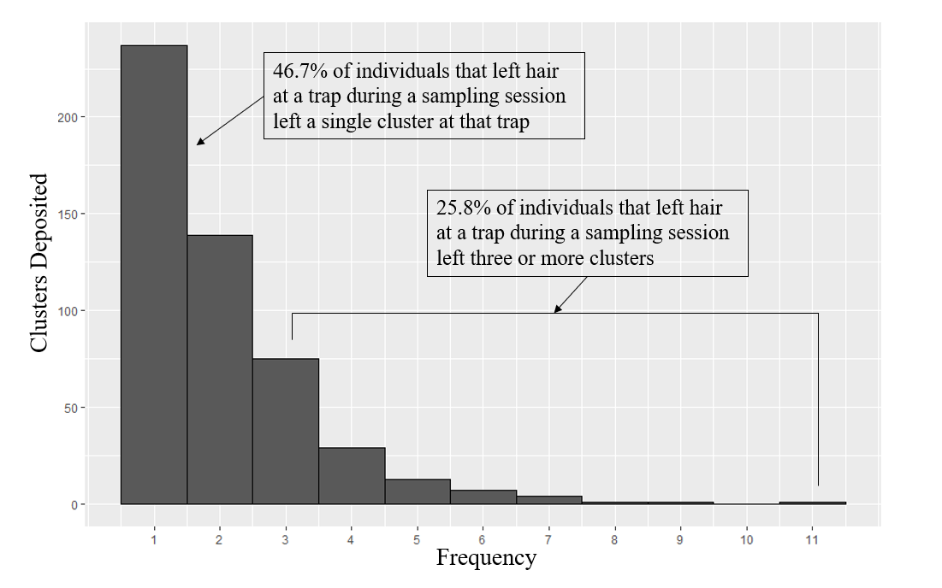

Figure 2. Directed Acrylic Graph of the data simulation process. Triangle nodes represent fixed parameters, circles represent stochastic values, and squares represent deterministic values obtained using stochastic values. All values are defined in Table 1. Ii,k,t is either a deterministic or stochastic node depending on the value of γ.

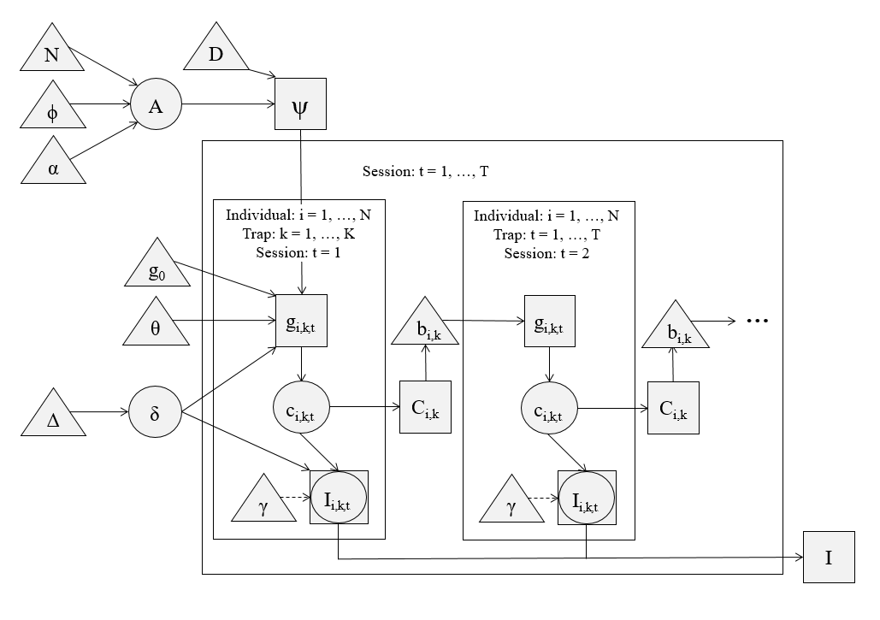

Figure 3. A) Example “Activity Centers” (black) generated using either a heavy skew towards activity centers being located in one half of the grid (α = 0.75) or an absence of skew in the location of activity centers (α=0). Trap locations are represented as gray dots. (B) Example of half-normal capture probability curves for individuals, dependent on their individual propensity of capture $(δ_{i}, mean=0, sd= ∆)$ and whether the given trap has captured the individual in a previous session ( $C_{i,k, t,}, 1 if previously captured, 0 if not).$ Capture probabilities are higher when an individual has been previously captured at a trap ( $C_{i,k,t,}=1)$ and for individuals with large heterogeneity parameters ($δ_{i} ≈ ∆$).

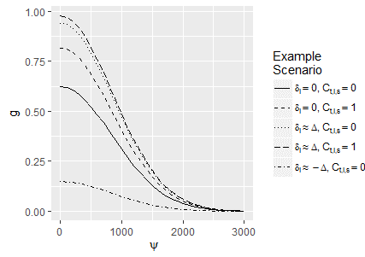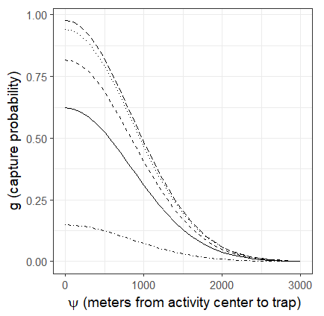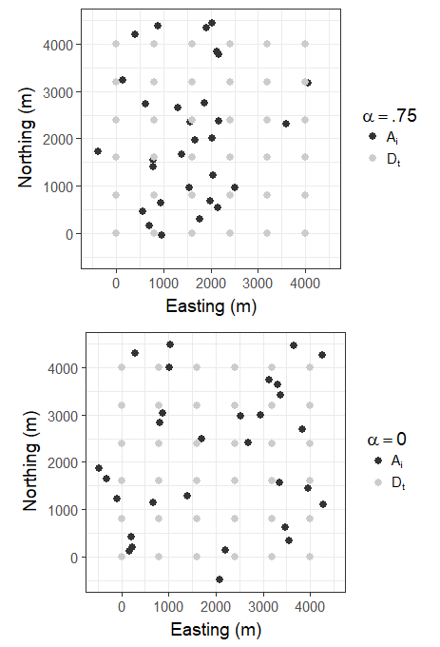Figure 4. Matrix of simulated scenarios investigated in this study. Shaded boxes represent the presence of a given effect on the simulated capture histories.

B

A

|  |  |  |  |  |  |  |  |  |  |  |  |  |
| --- | --- | --- | --- | --- | --- | --- | --- | --- | --- | --- | --- | --- |
| **Effect** | **Description of effect** | **Effect scale** | **Present in** | | | | | | | | **Terms** | |
| **t1** | **t2** | **t3** | **t4** | **t5** | **t6** | **t7** | **t8** | **If Absent** | **If Present** |
| Trap-specific behavior | Bears are more likely to revisit a given trap after visiting that trap | Population |  |  |  |  |  |  |  |  | b = 0 | b = 1 |
| Individual behavioral heterogeneity | Individual bears are more or less likely to visit any trap | Individual |  |  |  |  |  |  |  |  | Δ = 0,  δ = 0 | Δ = 1.25,  δ ~ N(0, Δ) |
| Sample redundancy | Bears leave >1 sample at a site-session | Population if Δ = 0; Individual if Δ > 0 |  |  |  |  |  |  |  |  | γ = 1 | γ = 1 + e(δ) |
| Uneven density of activity centers | Bears are distributed disproportionately on trapping grid | Population |  |  |  |  |  |  |  |  | α = 0 | α = .75 |

Figure 5A. Ratio of density estimates obtained using subsampled simulated datasets relative to the true density of the simulated population.

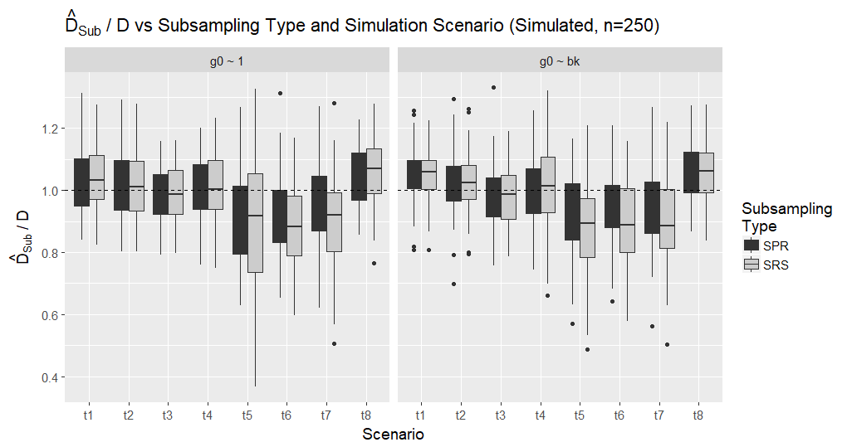

Figure 5B. Ratio of density estimates obtained using subsamples of the simulated and empirical datasets (n = 250, 550 and 850 of 1019 samples) relative to the estimates obtained by fitting the given model on the full dataset. 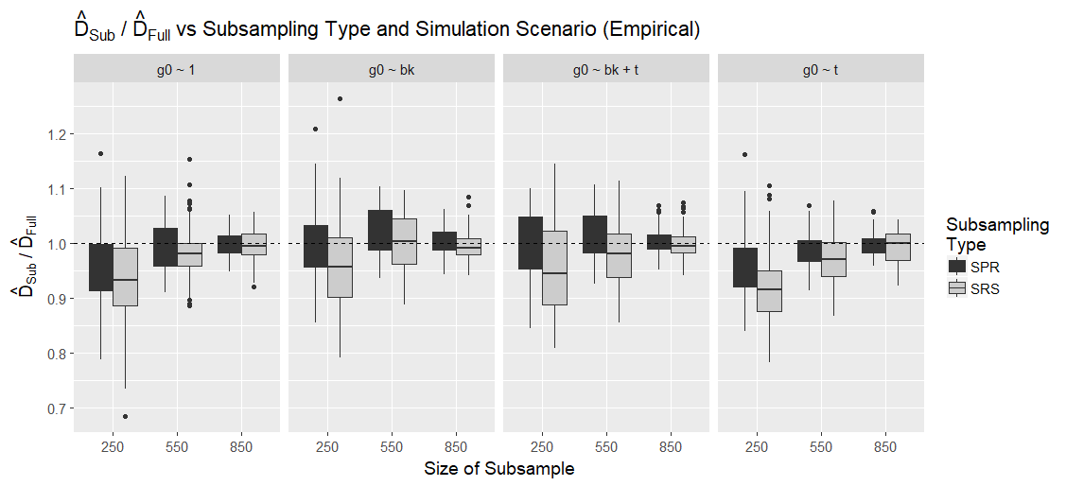

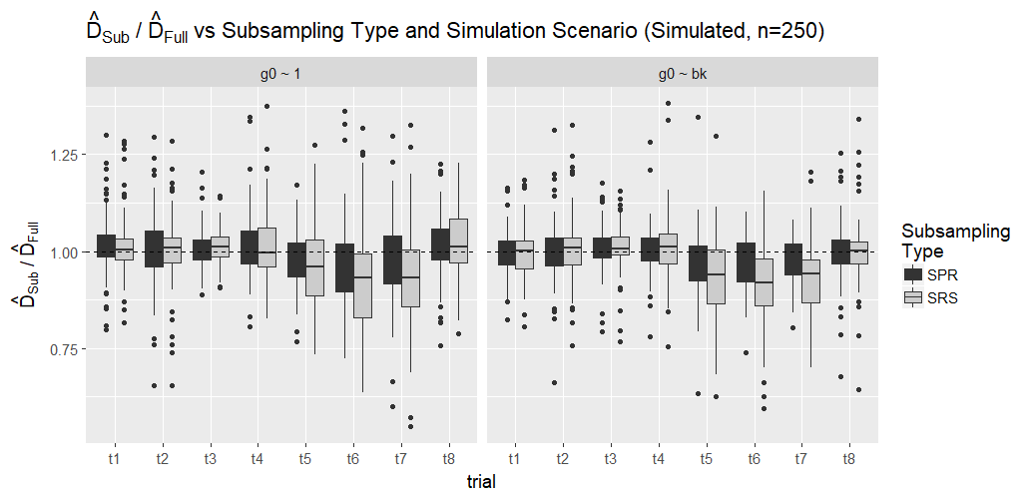

Figure 6. Proportion of redundant samples vs subsampling type for each of the four simulated scenarios where redundancy is possible (t4, t5, t6 and t7; Fig 4). Note that, as redundancy is not introduced for scenarios t1, t2, t3, or t8, the proportion of redundant samples is fixed at 0 for these trials.

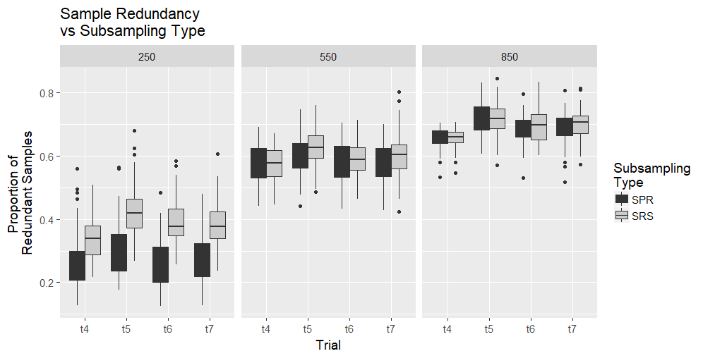

Table 1**.** Model Notation

|  |  |
| --- | --- |
| Term | Definition |
| *N* | Size of bear population |
| *K* | Number of traps on trapping grid during a single simulation |
| *Dk* | Location of trap *k* on trapping grid during a single simulation{*k* = 1, ..., *K*} |
| *T* | Number of trapping sessions |
| *Φ* | Inhibition distance between bear activity centers |
| *α* | Parameter describing intensity of stratification of bear activity centers |
| *Ai* | Locations of bear activity centers {*i* = 1, …, *N*} |
| *Ψi,k* | Euclidean distances between the activity center for individual *i*, *Ai*, and the location of trap *k*, *Dk* |
| *g0* | Logit capture probability at a given trap for a bear whose activity center is exactly at that trap |
| *b* | Difference between logit capture and recapture probabilities |
| *σ* | Inflection point of half-normal distribution which describes capture probability as a function of *Ψ* |
| *δi* | Parameter describing heterogeneity in individual bears’ capture probabilities; this parameter also influences the expected number of redundant samples deposited by an individual. {*i* = 1, …, *N*} |
| *Δ* | Standard deviation of normal distribution of *δi* values |
| *γ* | Parameter describing log expected number of samples deposited by an individual bear after being captured. |
| *gi,t,k* | Capture probability for individual i at trap k during time period t{i = 1,…, N},{k = 1,..., K},{t = 1,..., T} |
| *ci,t,k* | Indicator variable equal to 1 if bear i was captured at trap k during time period t, and 0 otherwise. |
| *Ci,t,k* | Indicator variable equal to 1 if bear i was captured at trap k at any time before period t, and 0 otherwise {i = 1, …, N},{k = 1, ..., K},{t = 1,..., T} |
| *Ii,t,k* | Number of samples deposited and collected during a simulation {i = 1, …, N},{k = 1, ..., K},{t = 1, ..., T} |

1. *Current affiliation: Conservation Metrics Inc, 145 McAllister Way, Santa Cruz, CA 95060 USA*
2. *Email*: jfieberg@umn.edu